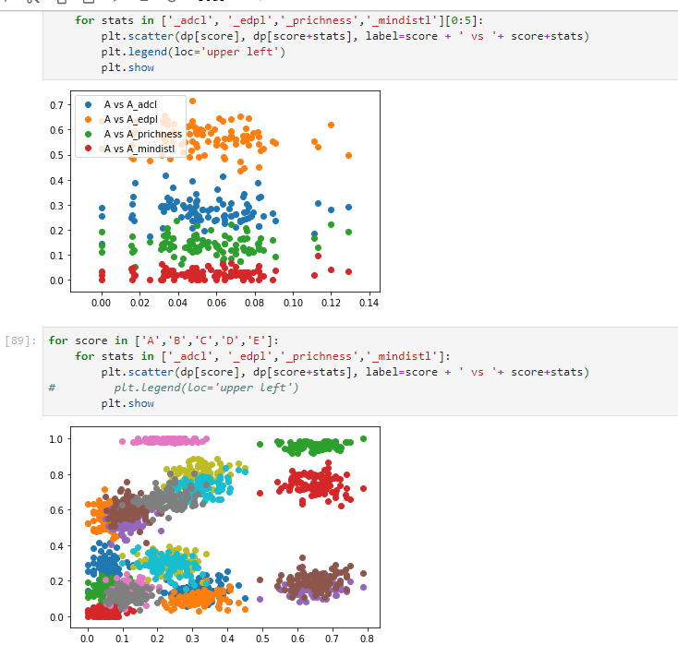

There is no correlation between the score and the pplacer stats as shown above. The figures plotted the reads in all the communities using each reference set.

For difference reference sets, the larger the reference set is, the larger the AUC is.