Physically Grounded Neural Networks: From Physical Substrates to Physics-Integrated Learning
Hongyi Yang¹, Wendi Xia¹, Jun Li¹, Dexin Ye^{1, *}, Haoliang Qian^{1, *}
¹State Key Laboratory of Extreme Photonics and Instrumentation, ZJU-Hangzhou Global Scientific and Technological Innovation Center, College of Information Science and Electronic Engineering, Zhejiang University, Hangzhou, 310027, China.
*Corresponding author: desy@zju.edu.cn; haoliangqian@zju.edu.cn.

Abstract
Neural networks are moving beyond purely digital scaling toward physically grounded forms of computation and learning. Here we review two complementary routes: physical neural networks, in which optical, quantum, memristive or biomolecular substrates perform neural transformations, and physics-integrated learning, in which scientific laws restrict the hypothesis space of neural models. We compare the motivations, advantages and limits of these routes, survey recent progress in trainable physical neural networks, neural operators, hard-constrained scientific machine learning, Kolmogorov–Arnold architectures and agentic scientific machine learning, and discuss how future systems may co-design substrate physics, learning rules and target-domain physical laws. This review connects energy-efficient physical computation with reliable scientific prediction and defines physically grounded neural networks as an emerging rather than established framework for the co-design of physical substrates and physical law.

I. INTRODUCTION
Neural networks have become a general language for function approximation, representation learning and scientific modeling. Their development has moved from the perceptron and multilayer backpropagation to deep representation learning, attention-based sequence modeling, selective state-space architectures and interpretable alternatives such as Kolmogorov–Arnold networks (KANs)¹⁻⁶. This progress has been enabled by large datasets and increasingly specialized digital hardware, but it has also exposed a limit of the usual scaling story. Larger models can be more capable, yet they also intensify energy use, data movement, latency, memory pressure and the difficulty of explaining or constraining predictions⁷⁻⁸.
These pressures are not merely engineering details. They reveal that the physical medium and the physical meaning of a model can no longer be treated as secondary. Digital computation offers programmability and precision, but physical systems compute under finite precision, thermal noise, dissipation, measurement limits and device-to-device variability. Likewise, a data-driven model used in fluid mechanics, climate, materials or biology is not trustworthy simply because it fits observations. It must also respect equations, symmetries, boundary conditions and conservation laws when those structures are known⁹⁻¹⁰.
We therefore focus on two emerging routes. The first is physical implementation: neural computation is performed by a material or dynamical substrate, including optical¹¹⁻¹⁹, quantum²⁰⁻²⁶, memristive²⁷⁻³⁴ and biomolecular³⁵⁻⁴¹ systems. The second is physics integration: neural models are constrained by scientific laws through physics-informed losses, hard constraints, neural differential equations, neural operators and related architectures⁴²⁻⁵⁹. These routes solve different problems. Physical neural networks primarily address hardware and energy bottlenecks. Physics-integrated models primarily address data efficiency, interpretability and scientific reliability. Their convergence is the central opportunity: future neural systems may be trained with explicit knowledge of both the target physics and the non-ideal physics of the hardware that executes the computation.
We should state what would qualify a system as physically grounded, since the term is otherwise only a label for this pairing. Two conditions are required together: the forward map must be realized by a physical process whose non-idealities are accounted for, explicitly through a model or implicitly through hardware-in-the-loop training or calibration, and the learned model must be restricted by the physical laws governing the target domain. Both conditions are necessary and neither alone is sufficient, so each condition on its own names an existing field rather than this one. A physical neural network satisfies the first and is silent about the second; physics-informed machine learning satisfies the second and is silent about the first, since it is normally executed on digital hardware whose own physics is deliberately hidden. Neuromorphic computing is a commitment to a computational style borrowed from neurobiology, with event-driven activity and co-located memory and computation, which may or may not exploit substrate physics for the mathematical operation and makes no claim about target-domain laws. Physical AI is broader still and is usually a statement about where a system is deployed rather than about where physics enters the model. Physically grounded neural networks are, on this reading, the intersection of the first two conditions rather than a further field, and the interest of the term lies in how sparsely that intersection is currently populated, which we return to in Sec. V. For clarity we use one term for each of these throughout: physical substrate for the medium, physical neural network for a system whose forward map is executed by that medium, physics-integrated learning for a model restricted by the laws of its target domain, and physically grounded neural network for a system that satisfies both conditions.
Placing the two literatures side by side yields one claim that neither makes on its own: the two conditions impose a compatibility requirement on each other rather than adding. Substrate error may break an invariant that an architecture was designed to preserve, and a target-domain law may exclude functions that the substrate represents easily. Whether the two conditions actually trade off, and by how much, has to be established for the specific system rather than asserted in general. Section V examines the two demonstrations that come closest to imposing both conditions on one neural network, and in each of them the substrate decides how much of the target-domain law can be enforced, so the requirement is a measured constraint rather than a conjecture. Two consequences follow: the cost of the differentiable twin belongs inside any efficiency claim, and the correct test of convergence is whether both conditions hold within one training loop. Figure 1 places the two routes on a common timeline and marks the point at which they converge.
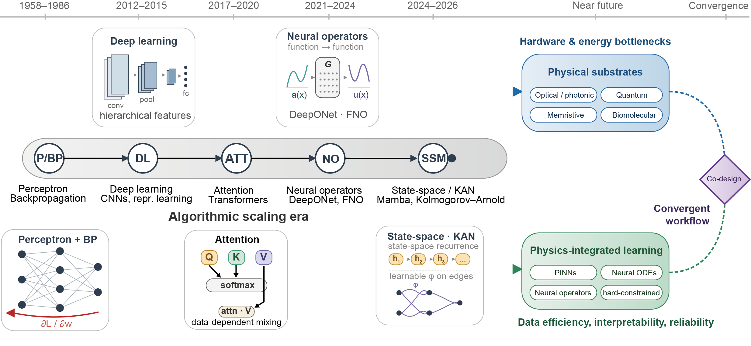
FIG. 1. From digital scaling to physically grounded neural computation. Neural-network research has progressed from early trainable models (perceptron, backpropagation) through deep learning, attention, neural operators and recent state-space or Kolmogorov–Arnold network (KAN) architectures. Driven by hardware and energy bottlenecks on one side and demands for data efficiency, interpretability and reliability on the other, future progress is likely to bifurcate into physical substrates and physics-integrated learning. The two routes are at present largely distinct, and the convergence drawn at the right of the figure is proposed rather than established: it requires substrate non-idealities and target-domain laws to be handled within one training loop. Abbreviations appearing inside the figure: P/BP, perceptron and backpropagation; DL, deep learning; ATT, attention; NO, neural operator; SSM, state-space model; CNN, convolutional neural network; FNO, Fourier neural operator; DeepONet, deep operator network; PINN, physics-informed neural network; ODE, ordinary differential equation.

II. ALGORITHMIC SCALING AND ITS LIMITS
The modern neural network stack rests on a compact set of ideas: trainable nonlinear transformations, compositional depth, differentiable optimization and inductive biases matched to data structure¹⁻⁶. Convolutions exploit local spatial structure, recurrent and state-space models exploit sequential dynamics, attention models learn data-dependent interactions, generative models approximate high-dimensional distributions, and world models support planning in learned environments^{4-5,60-66}. These architectures remain essential background, but a review of every task-specific design would obscure the main point. The issue is that algorithmic innovation has created demands that conventional digital scaling alone cannot satisfy.
The first demand is energy-efficient computation. Neural workloads are dominated by repeated linear algebra and by data movement between memory and compute units. Even when arithmetic becomes efficient, memory access, peripheral control and communication can dominate system cost⁷⁻⁸. Physical neural networks try to reduce this burden by using wave propagation, diffraction and interference in optical systems¹¹⁻¹⁹, quantum-state evolution and measurement in quantum models²⁰⁻²⁶, analog conductance in memristive arrays²⁷⁻³⁴, or molecular reaction networks in biomolecular systems³⁵⁻⁴¹ as part of the computation itself.
The second demand is scalable training and inference beyond idealized device operations. A physical system may perform a transformation rapidly, but useful neural computation also requires encoding, programming, nonlinearity, readout, calibration, error mitigation and training. Recent reviews of physical neural networks emphasize that the training problem is now as important as the substrate problem: backpropagation-compatible, feedback-alignment, equilibrium-propagation, perturbative, digital-twin and physics-aware training methods all trade off scalability, accuracy and hardware realism^{14,16}.
This training requirement carries an energy cost of its own. Schemes that rely on a differentiable twin of the substrate must fit that twin against the underlying field or transport equations, and the cost of a single solve grows steeply with the spatial resolution needed for a faithful model, while fitting requires many such solves rather than one¹⁶. The resulting one-off cost E_{twin} has to be recovered from the per-inference saving ΔE = E_{digital} − E_{physical}, so a physical implementation becomes advantageous only after N_{BE} = E_{twin}/ΔE inferences, and only when ΔE > 0; if conversion and peripheral energy cancel the saving made in the analog core, so that ΔE ≤ 0, no number of inferences recovers the cost. Those N_{BE} inferences must also be completed within the calibration lifetime over which the twin remains valid^{32,33}, and each recalibration restarts the count by adding a further fitting cost to E_{twin}. Adjoint sensitivity analysis, reduced-order or physics-informed twins, twin-free in-situ training schemes, and amortization of one fitted twin across nominally identical devices all reduce this overhead^{14,16}, but the trade-off is intrinsic rather than incidental: physical substrates suit sustained deployment of stable models better than short-lived, task-specific ones.
The third demand is scientific reliability. In scientific machine learning, a model is often used outside the exact distribution on which it was trained. Standard neural networks can violate conservation, ignore boundary conditions, produce unstable long-time trajectories or fail under parameter shifts. Physics-integrated learning addresses this by restricting either the objective, the architecture, the latent dynamics or the learned operator to a physically admissible space⁴²⁻⁵⁹. Figure 2 contrasts the three execution modes and shows the hardware-aware training loop in which the reality gap drives the parameter updates.
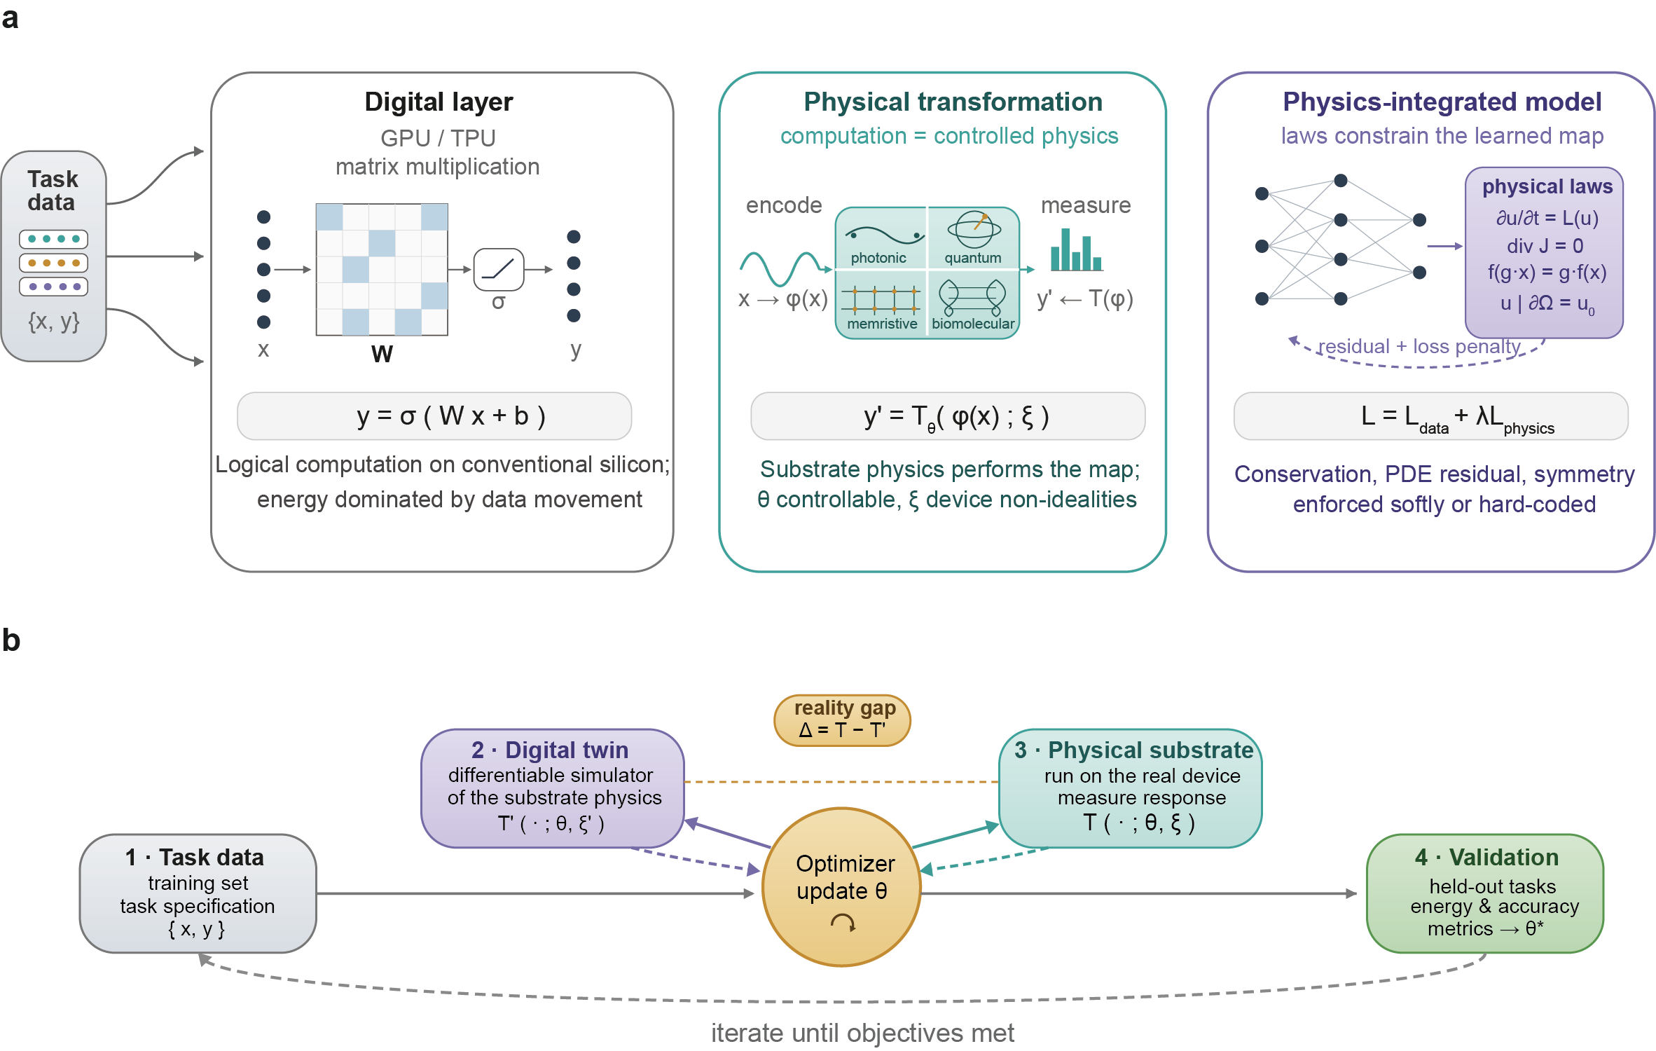
FIG. 2. Neural computation as a physical transformation. (a) Neural computation can be executed as a digital layer, a physical transformation or a physics-integrated model. (b) Hardware-aware training closes the loop between task data, a digital twin of the substrate, measured physical behavior and validation, with the reality gap Δ = T − T′ driving iterative updates of the parameters θ. Abbreviations appearing inside the figure: GPU, graphics processing unit; TPU, tensor processing unit; PDE, partial differential equation.

III. PHYSICAL NEURAL NETWORKS
Physical neural networks use a material, wave or molecular system to perform transformations that are usually computed numerically. Their value should be assessed at the system level, not by isolated operations. A useful physical implementation must account for input and output conversion, weight storage, nonlinearity, training, calibration, robustness and application context.

A. Optical and photonic systems
Optical neural networks (ONNs) exploit propagation, diffraction, interference, modulation and photodetection. They are attractive because light supports high bandwidth and can implement linear transformations through passive or weakly powered components. Integrated photonic circuits have demonstrated coherent matrix operations, diffractive optical layers have shown all-optical classification, and recent reviews summarize rapid progress across free-space optics, integrated photonics, reservoir computing and hybrid optical-electronic architectures^{11-15,18-19}.
The frontier is shifting from isolated optical layers toward trainable physical systems. Deep physical neural networks trained with backpropagation showed that arbitrary controllable physical systems can be incorporated into a hybrid training loop¹⁴. Quantum-limited stochastic ONNs demonstrated that inference can remain accurate when hidden activations operate with only a few photons, provided the training model accounts for the stochastic physics of the process¹⁵. A 2025 Nature review further framed training of physical neural networks as a central challenge for the field rather than a downstream implementation detail¹⁶.
Recent work also reframes optical hardware as a trainable physical system rather than a passive accelerator. If future foundation models stabilize around a small number of large, repeatedly deployed architectures, fixed or semi-fixed optical implementations may become more plausible than in an era of rapidly changing task-specific models. This remains a conceptual direction rather than a demonstrated route to ultra-large-scale artificial intelligence. The barriers are substantial: fabrication precision, programmability, model updating, loss, nonlinear activation, digital interfacing and verification¹⁴⁻¹⁷.
A defensible near-term framing is therefore hybrid and full-stack. Optical systems may provide high-throughput linear transforms, convolution-like propagation, optical front-end processing or physical random features; electronics will likely remain essential for memory, control, nonlinear activation, training orchestration and error management^{13-16,18-19}. Figure 3 collects the four substrate families together with the physical resource each of them uses for computation.
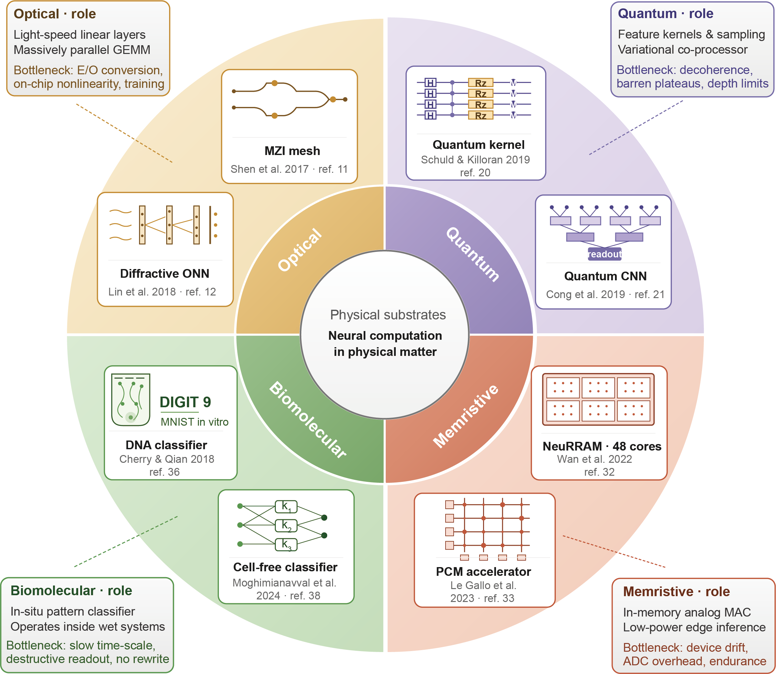
FIG. 3. Physical substrates for neural computation. Optical, quantum, memristive and biomolecular platforms use different native physical resources and therefore support different neural-computing roles. Specifically, optical substrates achieve light-speed linear layers via Mach–Zehnder interferometer (MZI) meshes (ref. 11) or diffractive ONNs (ref. 12); quantum platforms implement feature kernels (ref. 20) and quantum convolutional neural networks (CNNs) (ref. 21); memristive devices enable in-memory analog multiply–accumulate (MAC) operations through NeuRRAM (ref. 32) or phase-change memory (PCM) accelerators (ref. 33); and biomolecular elements function inside wet systems as DNA (ref. 36) or cell-free classifiers (ref. 38). What the figure compares is the full mapping from physical law to neural function and system-level bottleneck, not a single operation. Abbreviations appearing inside the figure: ONN, optical neural network; GEMM, general matrix multiply; E/O, electrical-to-optical; ADC, analog-to-digital converter.

B. Quantum neural networks
Quantum neural networks (QNNs) use parameterized quantum circuits, quantum feature maps or quantum many-body dynamics to process information in Hilbert spaces. Their motivation differs from that of ONNs. Optical systems mainly target high-bandwidth physical signal processing, whereas QNNs target quantum-native representation, quantum data, quantum simulation and possible advantage under carefully specified data-access assumptions²⁰⁻²⁶.
The field has matured toward a more cautious view. Quantum feature maps link quantum learning to kernel methods²⁰. Quantum convolutional neural networks use hierarchical circuits inspired by convolution and renormalization²¹. Studies of quantum neural network capacity suggest potential representational advantages under certain assumptions²², whereas work on data access and classical shadows has narrowed the conditions under which quantum advantage can be claimed²³. Barren plateaus remain a central trainability problem, especially for random parameterized circuits²⁶.
Recent theory adds nuance rather than simple optimism. Quantum neural networks have been shown to form Gaussian processes in large Hilbert-space limits, providing a mathematical connection to infinite-width classical neural-network theory while also revealing severe concentration effects in some settings²⁴. Photonic quantum convolutional neural networks with adaptive state injection have also been proposed as a route to increase expressivity in linear optical platforms²⁵. These results are informative, but they do not by themselves establish broad practical advantage. For this reason, QNNs should be framed as a promising route for quantum-native problems and specialized learning tasks, not as a general replacement for classical deep learning.

C. Memristive and neuromorphic systems
Memristive neural networks use resistive switching devices whose conductance stores synaptic weights and whose crossbar geometry naturally supports matrix-vector multiplication²⁷⁻³¹. Their central appeal is the reduction of data movement: memory and computation occur in the same physical substrate. Demonstrations such as fully hardware-implemented memristor convolutional networks show that end-to-end neural inference can be realized directly in device arrays³¹.
The main challenges are device variability, endurance, asymmetric updates, limited precision, sneak paths and peripheral circuitry²⁹⁻³⁴. The strongest peer-reviewed evidence for a more dynamical view of memristive computation is work on inhomogeneous memristive hardware for sequence learning³⁴. Such systems may not merely emulate predefined neural networks, but use Kirchhoff-constrained transport, resistive switching and evolving internal states as native learning resources.
This distinction matters. A memristive crossbar used as a matrix multiplier is a physical implementation of a familiar operation. A dynamical memristive network is closer to a physical learner whose internal state and signal transport co-evolve. The second view is scientifically richer, but it also makes training, reproducibility and benchmarking more difficult. Progress will require co-design across materials, circuits, algorithms and system-level validation^{9,16,29-34}.

D. Biomolecular neural networks
Biomolecular neural networks use DNA, proteins, enzymes or genetic circuits to compute in the native medium of biological information³⁵⁻⁴¹. Their purpose is not to outperform graphics processing units (GPUs) on conventional benchmarks. It is to enable molecular decision-making for diagnostics, synthetic biology, smart therapeutics, cellular sensing and lab-on-a-chip systems.
DNA strand-displacement cascades showed that molecular reactions can implement neural-network-like associative computation³⁵. DNA-based winner-take-all networks scaled molecular pattern recognition and demonstrated robust classification under noisy molecular inputs³⁶. Recent enzyme-powered DNA computing networks improved modularity by using high-purity enzymatic synthesis, spatial patterning of neuron clusters and rewireable connectivity on DNA backbones³⁷. Biomolecular classifiers with shared resources have also shown how cellular constraints such as resource competition shape decision boundaries³⁸. Reset-free DNA logic circuits, reported in 2026, add a complementary route for real-time input processing and memory, although they are logic circuits rather than full neural networks³⁹.
A balanced conclusion is selective optimism. Biomolecular systems are slow, noisy, crosstalk-prone and difficult to scale into many-layer networks. Yet they are uniquely suited to contexts in which inputs and outputs are molecular. In these settings, computation embedded in chemistry may be more relevant than digital speed.
Table I summarizes the distinct computational roles and bottlenecks of these physical substrates. The comparison shows why physical implementation is not one technology. Each substrate answers a different version of the same question: which part of neural computation is naturally performed by this physical system, and under what complete energy, latency and reliability budget.
TABLE I. Representative physical neural network substrates and current status.
Substrate | Native resource | Main promise | Current frontier | Persistent bottlenecks
Optical and photonic | Diffraction, interference, modulation, photodetection | High-bandwidth linear transforms and signal-native inference | Physics-aware training and few-photon stochastic ONNs¹⁴⁻¹⁷ | Nonlinearity, calibration, memory, conversion overhead
Quantum | Hilbert-space encoding, entanglement, measurement | Quantum-native learning and quantum-state processing | Gaussian-process theory and adaptive photonic quantum convolutional neural networks²⁴⁻²⁵ | Noise, barren plateaus, readout cost, data loading
Memristive | Conductance memory and crossbar transport | In-memory analog computation and neuromorphic edge inference | Hardware CNNs and dynamical memristive learning systems³¹⁻³⁴ | Variability, endurance, update asymmetry, peripheral cost
Biomolecular | DNA and enzyme reaction networks | Molecular decision-making in biochemical environments | Rewireable enzyme-powered networks and reset-free DNA logic³⁷⁻³⁹ | Slow kinetics, crosstalk, limited programmability
Table II gives the corresponding quantitative comparison. Its most useful feature is the pattern across rows: the substrates that operate in picoseconds do so by propagating fields over micrometer-to-centimeter distances, whereas the substrate that computes at molecular dimensions does so over minutes to hours, and no entry combines a nanometer-scale computing element with nanosecond operation: the memristive rows reach nanosecond operation at a micrometer cell pitch, the nanometer figures quoted for them being process nodes rather than element sizes. We report the representative range for each substrate as its own sources give it and do not combine those ranges into a unified speed–size relation, because the underlying demonstrations define an operation, a system boundary, a precision and a task differently. Because the entries are peak values measured within the computing array and the demonstrations do not share a common task, accuracy target or system boundary, the table is a map of operating regimes and of the gaps in the evidence rather than a ranking of the four against one workload; on this reading the families are complementary in the problems they can reach rather than competitors for a single one.
These limits are not accidents of engineering. In each case the dominant limitation originates in the same physics that makes the substrate attractive. Weak optical nonlinearity follows from the weakness of photon–photon interaction in dielectric media, so a useful nonlinearity must be bought with intensity, interaction length or resonant enhancement, each of which trades against loss, bandwidth or footprint; and the transverse scale of an optical element cannot fall far below half a wavelength in the medium, so speed is won at the cost of density rather than alongside it. Memristive variability originates in the stochastic nucleation and growth of a conductive filament and in thermally activated ion migration, which are the same mechanisms that provide non-volatile analog storage, so it is intrinsic rather than a yield problem that better processing will remove^{29,30}. Barren plateaus in variational circuits follow from concentration of measure on the unitary group, so random, highly expressive variational circuits can enter barren-plateau regimes in which the gradient is exponentially small; structured ansätze, local cost functions and informed initialization can avoid or reduce this behavior, so the route out is to leave the generic case rather than to improve the optimizer²⁶. Biomolecular speed is bounded by reaction kinetics and concentration, and cascade depth multiplies the layer time while crosstalk grows with the number of species, so speed and depth cannot both be improved by design. This separation matters for reading Table II: the diffraction-limited footprint, the weakness of optical nonlinearity, concentration of measure in Hilbert space and diffusion-limited kinetics can be designed around but not removed, whereas conversion overhead, peripheral energy, calibration and the cost of the digital twin can, and on the evidence of the table it is the second group that currently decides system-level energy and latency.
TABLE II. Comparative metrics for the four substrate families. Values are order-of-magnitude figures taken from the demonstrations cited. Energy efficiencies are peak values reported at full array utilization and exclude off-chip data movement and buffering and, where applicable, laser and cryogenic overhead; reported values in tera-operations per second (TOPS) use the operation counts and system boundaries of their own sources and have not been converted to a common convention, so they should not be read as a direct comparison. Integration densities are quoted within the computing array rather than at chip level, and each entry states whether laser sources, control electronics, data conversion or cryogenic overhead are included. The entries do not share a common task, accuracy target or system boundary, so Table II does not provide a controlled cross-platform comparison, and where a metric has no defensible value for a substrate the entry states the reason.
Substrate | Operation time | Energy efficiency | Feature scale and integration density | Effective precision | Demonstrated scale and maturity | Training and conversion overhead
Optical and photonic | 10 ps–1 ns per linear transform in propagation; set in practice by 10–60 GHz modulation and detection¹³ | 0.5–6.7 TOPS W⁻¹ for interferometric and phase-change systems; 160 TOPS W⁻¹ for the best reported photonic chiplet^{13,67} | 0.4 µm pitch for diffractive metasurfaces to tens of µm for interferometer meshes; up to ≈10⁶ diffractive units mm⁻² (ref. 13) | 4–8 bits typical; beyond 9 bits for microring synapses¹³ | 10²–10³ weights in laboratory demonstrations, with early commercial accelerators¹³ | In-situ backpropagation and fully forward training demonstrated¹⁶; electro-optic and opto-electronic conversion often dominates system energy
Quantum | Platform-dependent, nanoseconds to microseconds per gate | Not meaningful per gate; dominated by the cryogenic or trapping plant | Tens of µm per qubit; cryostat-scale system | Set by shot noise rather than by a fixed bit depth | 10–10² qubits; noisy intermediate-scale quantum prototypes | Variational optimization by parameter-shift gradients; state preparation and repeated measurement set the shot budget
Memristive | 0.1–10 µs per 256 × 256 matrix–vector multiplication³²; 133–520 ns at 14 nm³³; 60–120 ns for a single analog solve⁶⁸ | 7–43 TOPS W⁻¹ at 130 nm³²; 2.5–9.8 TOPS W⁻¹ at 14 nm³³ | 1.7 µm² cell area at the 130 nm node³², 4.1 µm² per four-device cell at the 14 nm node³³; ≈10⁵–10⁶ devices mm⁻² within the array, so the cell pitch remains micrometer-scale even at a nanometer process node | ≈3–4 bits per device after drift^{32,33}; 24-bit fixed point reached by algorithmic refinement⁶⁸ | 3 × 10⁶ devices on 48 cores at 130 nm³²; 4.2 × 10⁶ weights on 64 cores at 14 nm³³, both foundry-fabricated | Chip-in-the-loop and noise-resilient training; write–verify takes ≈8.5 pulses and ≈56 µs per cell³²; converters take ≈27% of area and ≈50% of static power³³
Biomolecular | Minutes to hours per computation | Set by reagent consumption rather than per operation | 2–10 nm per molecular element; not areal, set by concentration | Not applicable; the output is a concentration | 10–10² gates or strands; proof of concept | Largely offline by sequence design; readout by fluorescence, gel or sequencing over minutes to hours

IV. PHYSICS-INTEGRATED LEARNING
Physics-integrated learning changes the structure of learning rather than the substrate of computation. It is motivated by scientific tasks in which the governing equations, constraints, symmetries or admissible states are partly known. The aim is not to replace numerical analysis with black-box regression, but to combine data and mechanistic structure in ways that improve generalization, interpretability and data efficiency^{42-59,69-71}.

A. Physics-informed neural networks and hard constraints
Physics-informed neural networks (PINNs) embed differential-equation residuals, boundary conditions and initial conditions into the training objective⁴²⁻⁴³. Automatic differentiation allows the residual of a governing equation to be evaluated at collocation points, making PINNs useful for forward and inverse problems when measurements are sparse. Reviews have documented wide adoption across fluids, heat transfer, solid mechanics, materials and biological systems⁴³⁻⁴⁴.
The limitations are now equally clear. PINNs can struggle with stiff dynamics, multiscale solutions, discontinuities, long-time integration and competing loss terms⁴⁴⁻⁴⁶. Soft penalties for boundary and initial conditions require careful weighting and do not guarantee satisfaction outside sampled points. Exact imposition using distance functions, output transformations and specialized architectures has therefore become an important direction for improving reliability⁴⁷⁻⁴⁹.
Hard constraints improve reliability when the constraint is known exactly and can be encoded without destroying expressivity. They are less appropriate when the physics is incomplete, noisy, dissipative or uncertain. The practical frontier is therefore not “hard constraints everywhere”, but adaptive combinations of exact constraints, soft residuals, data terms and uncertainty quantification.
These limitations have distinct origins, and separating them matters because a mitigation aimed at one does not address the others. Competing loss terms arise from negatively aligned gradients of the residual, boundary and data terms within one parameter vector, so the weights act as a poorly conditioned trust region rather than a statement of physical priority; gradient-magnitude balancing removes the imbalance but leaves the directional conflict itself untouched⁷². Slow or partial convergence reflects a wide spread in the associated tangent-kernel eigenvalues, which makes the gradient flow stiff independently of network capacity^{45,46}. Failure on multiscale and sharp-gradient solutions follows from the residual differentiating the network and thereby amplifying high-frequency error against its low-frequency bias, which Fourier-feature embeddings mitigate by shifting the tangent-kernel eigenvectors without removing the underlying bias⁷³; and divergent long-time integration follows from residual collocation being unordered in time, which causal weighting corrects at the cost of a sequential training schedule⁷⁴. Table III maps the standard mitigations onto these origins and, as importantly, records what each one leaves untouched.
TABLE III. Failure mechanisms of physics-informed neural networks, their origins, and what the standard mitigations do and do not address.
Failure mechanism | Underlying cause | Standard mitigations | What they do not fix
Competing loss terms; sensitivity to weighting | Negatively aligned gradients of residual, boundary and data terms in one parameter vector | Adaptive and self-adaptive weighting; gradient projection; augmented-Lagrangian formulations | The conflict itself; weights are rebalanced, not removed
Slow or partial convergence; boundary conditions satisfied only where sampled | Wide spread in tangent-kernel eigenvalues, giving a stiff gradient flow⁴⁵ | Tangent-kernel-informed weighting; exact imposition by distance functions or output transforms⁴⁷⁻⁴⁹ | Cases where the constraint is not known exactly, so exact imposition is inappropriate
Failure on multiscale, high-wavenumber or sharp-gradient solutions | Differentiation amplifies high-frequency error against the low-frequency bias of the network | Fourier or random-feature input embeddings; domain decomposition; residual-based adaptive sampling | Global stiffness across subdomain interfaces; cost grows with the number of subdomains
Divergent long-time integration; solution ignores the initial condition | Residual collocation is unordered in time, so information need not propagate causally⁷⁴ | Time marching and curriculum training; causal residual weighting | Conditioning and gradient conflict, which persist within each time window
Overconfident predictions under sparse or noisy data | No account of epistemic uncertainty in either the data or the constraint | Bayesian physics-informed formulations; ensembles | Model misspecification when the assumed physics is itself incomplete

B. Conservation-aware and neural differential models
Conservation-aware neural networks restrict learned dynamics to physically admissible spaces. Hamiltonian and related geometric neural networks show how energy, symplectic structure or variational principles can be built into learned dynamics⁵⁰. These models are especially useful for long-horizon prediction, where small violations of invariants can accumulate.
Neural ordinary differential equations (neural ODEs) provide a complementary view by treating network depth as continuous time⁵¹. This framing is natural for irregularly sampled time series, latent dynamical systems and reduced-order physical models. In spintronic experiments, neural ODEs have been used to forecast device dynamics from measured data and accelerate simulation relative to more expensive micromagnetic modeling⁵². More generally, hybrid scientific machine-learning models should learn missing dynamics rather than replace well-established physical structure.
These methods expose a useful principle: a model should learn only what the scientist does not already know. When equations, symmetries or invariants are available, they should constrain the hypothesis space.

C. Neural operators and physical foundation models
Neural operators learn mappings between functions, rather than mappings between finite-dimensional vectors⁵³⁻⁵⁶. This is critical for scientific computing because many tasks require solving families of partial differential equations (PDEs) across varying coefficients, forcing terms, geometries or boundary conditions. DeepONet introduced an operator-learning architecture based on branch and trunk networks⁵³. Fourier neural operators parameterized operator kernels in spectral space and enabled efficient learning of parametric PDE solution maps⁵⁴. Graph neural operators and related frameworks extended operator learning to more general domains⁵⁵. Physics-informed neural operators integrate residual constraints with operator learning⁵⁶.
Recent Nature Reviews Physics coverage sets out why neural operators matter: after training, they can provide surrogate simulation and inverse-design capabilities with speedups of several orders of magnitude in multi-query settings, while still requiring careful validation under distribution shift⁵⁷. Applications in fluid mechanics, weather, materials and inverse design illustrate their promise^{57,69-71,75}.
The broader foundation-model paradigm is also entering the physical sciences. Weather and climate foundation models such as Pangu-Weather and GraphCast have shown that large-scale learned surrogates can encode useful structure across many states of a complex dynamical system⁷⁶⁻⁷⁷. These models are not universal solvers for all physical systems, but they demonstrate how large pretrained architectures can support fast prediction, transfer and data assimilation in physically structured domains. For PDEs and engineering design, the analogous goal is a broadly transferable surrogate model that generalizes across parameters, geometries and tasks. Neural operators are one route toward that goal; foundation models for physical systems are a broader ambition that remains under active development.

D. KANs and physics-informed structural innovation
KANs replace fixed node activations and linear weights with learnable univariate functions on edges, typically parameterized by splines or related bases⁶. Their appeal in scientific machine learning is accuracy together with the possibility of more interpretable functional structure and compact representations for low-dimensional laws.
Physics-informed KAN variants have quickly appeared. Kolmogorov–Arnold-informed neural networks have been applied to forward and inverse PDE problems and compared with multilayer perceptron (MLP) based PINNs⁵⁸. Hybrid KAN-PINN formulations with augmented Lagrangian enforcement, DeepOKAN architectures for mechanics and scaled Chebyshev-based physics-informed KANs (PIKANs) for oscillatory PDEs illustrate a broader pattern: KANs are being used not as a replacement for physics, but as a more expressive or interpretable basis inside physics-integrated models^{59,78}.
The emerging body of work on physics-informed KANs and KAN-based operator models is promising, but remains at an early stage. Many current studies are still benchmark-driven, and the computational cost, numerical stability and scaling behavior of KAN variants remain open questions. KANs are therefore best viewed as an important structural innovation for physics-integrated learning rather than as a settled successor to MLPs. Figure 4 distinguishes the paradigms discussed above by where the physics enters: the loss, the architecture, the latent dynamics or the learned object itself.

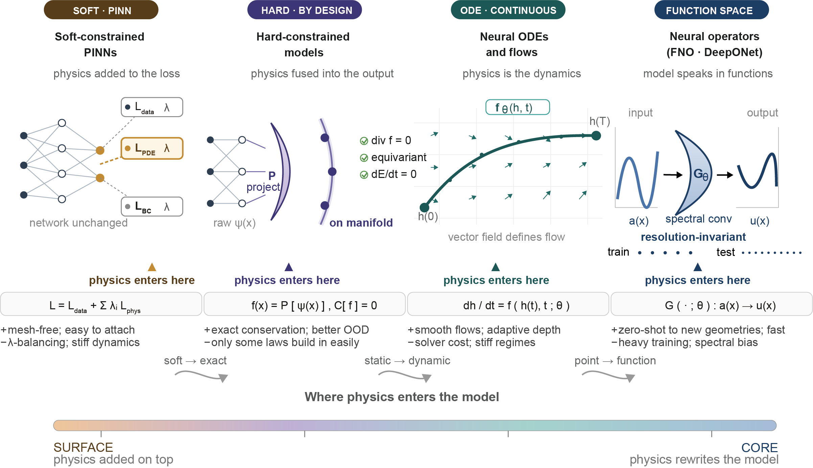

FIG. 4. Physics-integrated learning paradigms. Soft-constrained PINNs add equation residuals and boundary-condition penalties to the loss; hard-constrained models satisfy selected conditions by construction; neural ODEs learn continuous dynamics; and neural operators learn mappings between functions. The four paradigms are arranged along a "depth-of-embedding" axis (bottom), reflecting how deeply physics enters the model, from a soft penalty on the surface to the function space at the core. Short transition phrases between adjacent stations (soft → exact, static → dynamic, point → function) mark the qualitative shifts in how physical knowledge is encoded. Abbreviations appearing inside the figure: PINN, physics-informed neural network; ODE, ordinary differential equation; PDE, partial differential equation; BC, boundary condition; FNO, Fourier neural operator; DeepONet, deep operator network; OOD, out of distribution.

E. Agentic scientific machine learning
Agentic AI is emerging as a workflow layer for scientific discovery rather than as a new neural architecture. In scientific machine learning, agentic systems can propose hypotheses, write code, run simulations, evaluate results and iterate. AgenticSciML specifically frames multi-agent collaboration for scientific-machine-learning design in a Nature Portfolio venue⁷⁹.
These systems could change how physics-integrated models are designed. An agentic scientific machine-learning workflow could search over equations, constraints, neural operators, sampling strategies and validation tests. The risk is equally important: automated discovery can amplify weak benchmarks, unverified physical claims or citation errors. Agentic AI must therefore be grounded in reproducible simulation, physical validation and human scientific judgment.

V. CONVERGENCE OF SUBSTRATES AND CONSTRAINTS
Physical neural networks and physics-integrated learning are often discussed separately, but their convergence is the case of interest. Physical substrates need physics-aware training because their non-idealities are not incidental: they are the computation. Optical systems need to account for shot noise, loss, drift and conversion¹⁴⁻¹⁷; quantum systems face noise, measurement and trainability limits²⁰⁻²⁶; memristive systems are shaped by conductance variability and update asymmetry²⁹⁻³⁴; and biomolecular systems are constrained by kinetics, crosstalk and resource sharing³⁵⁻³⁹. Figure 5 shows the resulting workflow, in which substrate, learning rule and physical law are designed and validated together.
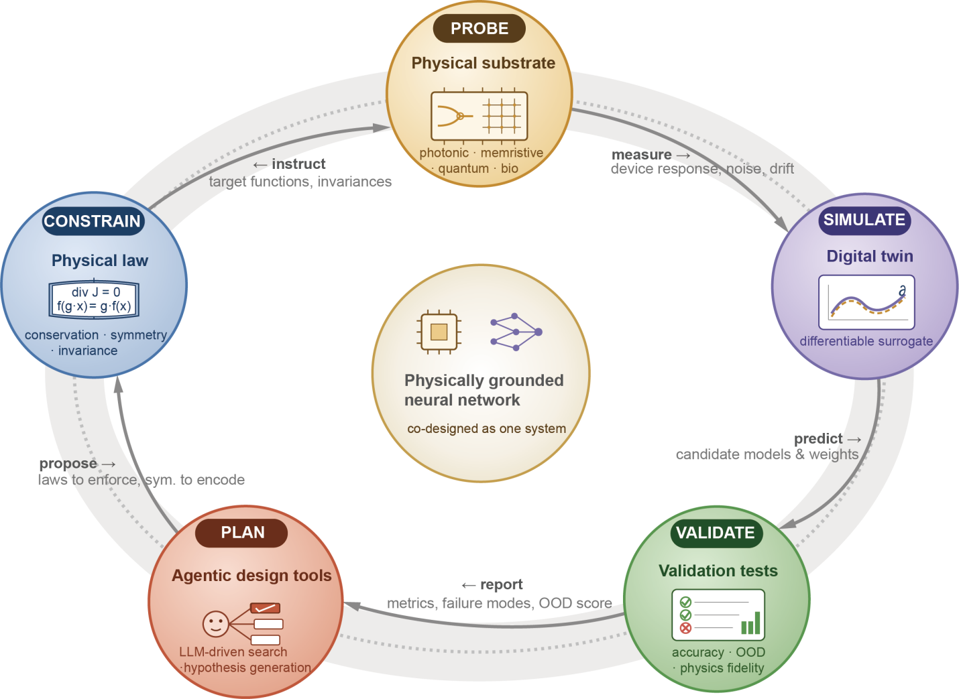
FIG. 5. Proposed convergent workflow for physically grounded neural networks. Physical substrates, differentiable digital twins, scientific laws, validation tests and agentic design tools would form a closed workflow. In this view, the substrate, learning rule and physical law are designed and validated as one system. The five stations are connected by named information flows (measure, predict, report, propose and instruct), each carrying a specific payload. Abbreviations appearing inside the figure: OOD, out of distribution; LLM, large language model.

Physics-integrated models also need specialized hardware. Neural operators, differentiable simulators and large physical surrogate models require repeated evaluation of high-dimensional fields, differential operators and parameterized solution maps^{53-59,76,78}. Optical accelerators, in-memory arrays and neuromorphic systems may eventually support parts of this workload, but only if the hardware is evaluated with full-stack metrics rather than device-level arithmetic alone.
Stated precisely, convergence in the sense defined in Sec. I requires two things at once: that the non-idealities of the computing substrate be accounted for, explicitly through a model or implicitly through hardware-in-the-loop training or calibration, and that the physical laws governing the target domain constrain the learned model. Most of the literature reviewed above meets these requirements separately. Physics-aware training of optical, memristive and biomolecular hardware brings substrate physics fully into the loop, but the benchmarks addressed are classification and regression tasks that carry no governing law to impose^{14,16,31-34}; conservation-aware architectures, neural differential models and residual-constrained operator learning impose the governing law on the hypothesis space, but execute on digital hardware whose own physics is deliberately hidden from the model^{50,53-59,76,78}. Two demonstrations now sit in the intersection, and it is more useful to say where each of them falls short than to report the intersection as empty. In the first, a physics-informed network was trained in situ on a photonic microring weight bank by zeroth-order optimization, so that the loss remained a partial-differential-equation residual while fabrication error and environmental drift were absorbed by a forward-only training loop; a one-dimensional heat equation was solved to a relative error of about 5 × 10⁻³ on four tunable devices⁸⁰. Because the scheme is deliberately calibration-free, the non-idealities are absorbed by the training loop rather than modeled explicitly, and the demonstration remains at four tunable devices, two orders of magnitude below the optical scale reported in Table II. In the second, a Fourier neural operator was trained with its fixed spectral transform executed in situ on eight memristor chips and its tunable weights updated off-chip, solving the one-dimensional Burgers equation to an accuracy of 99.6% against 99.8% for a digital baseline, and extending to a three-dimensional thermal conduction problem⁸¹. Here the analog error genuinely enters the training loop, but the governing equation is not imposed on the model: the operator is learned from solution data, and the engineering effort (exponent pre-alignment and mixed-state conductance mapping to recover floating-point precision) is directed at removing the substrate physics rather than at representing it. We take the two cases to exhibit the same trade-off from opposite sides, and in our view the mechanism is the compatibility requirement stated in Sec. I. Imposing a differential-equation residual requires derivatives of the network output with respect to its inputs, which a physical forward pass does not supply; they must come either from a differentiable twin, in which case the law constrains the twin and not the physical map, or from finite-difference or Stein estimation, whose accuracy is bounded by the effective precision of the substrate, and in the photonic case an effective precision of eight bits was already insufficient for the governing equation to be learned at all⁸⁰. Taking the operator-learning route relaxes that requirement, but only by demanding near floating-point output, so that the design effort is spent suppressing the very non-idealities that the first condition asks to be represented. In each of the two cases examined, imposing the law has cost precision and scale, and recovering the precision has cost the law; we do not generalize this beyond these two cases. The convergence argued for in this section should therefore be read as a direction that the two literatures make available, and the test we would apply to any future claim is whether both conditions hold within one training loop, at a scale comparable with the demonstrations of Table II and against a matched digital baseline.
Several requirements follow. First, energy claims must include peripheral components, calibration and data conversion. Second, speed claims must specify whether they apply to one inference, many-query simulation, training or inverse design. Third, physical reliability must be tested under distribution shifts and long-time rollouts, not only interpolation benchmarks. Fourth, frontier claims should be grounded in peer-reviewed journals or top-tier conference papers, with speculative roadmaps clearly separated from demonstrated results.

VI. OUTLOOK
We have reviewed two routes toward physically grounded computation, one in which the physics of the computing medium enters the learning process and one in which the physics of the target domain restricts the learned model. Two findings from that review bear on what should be attempted next. Table II shows that the four substrate families occupy well-separated regions of the space of operating scales rather than competing for a single one, and Sec. V finds that in the two cases where the conditions of Sec. I have been imposed together, one of them held only in a weakened form, because the substrate and the problem were physically unrelated and each condition had to be bought at the expense of the other. We take these to indicate that the productive next step is not to improve substrates in general but to identify the cases in which a substrate and a problem share a physical structure, so that the two conditions need not be traded against each other. In this section we discuss three directions in which that identification is already partly under way, and in each we state what would count as progress and under what condition we expect the direction to fail. Figure 6 collects the characteristics that follow, together with the demonstrations on which each rests.

A. Substrates that host an operator rather than approximate one
The most successful physical computations of recent years were not networks trained to imitate an operator but structures in which the operator is itself the physics. An inverse-designed metastructure solves a linear Fredholm integral equation of the second kind because the scattering matrix of the structure is the kernel of the equation, and the recursive path of the wave around that kernel performs the Neumann-series iteration, so that the steady-state field is the solution⁸². A cross-point array of resistive devices closed by negative feedback solves a linear system, an eigenvector problem or a differential equation in a single step, because Ohm’s and Kirchhoff’s laws already express the relations that a digital solver reaches by iterating⁸³. Both are physical solvers rather than neural networks: the operator is realized by the structure itself and nothing is trained to imitate it.
These cases share a structure worth stating as a criterion, because it is sharper than the general aspiration to co-design. A substrate hosts an operator when the fixed point of the operator is a steady state of the substrate’s dynamics. Inverse design then has a well-posed target, which is why the metastructure could be found at all. It is also why this class escapes the tension identified in Sec. I. The two conditions do not have to be reconciled, because the law constraining the model and the law governing the medium are the same equation.
The program this suggests is to assemble the correspondence systematically rather than case by case, and to establish which classes of operator admit a steady-state realization. Two limits of the present state should be stated. Every demonstrated instance involves a linear, time-invariant operator, and it is not known whether the criterion extends to nonlinear or explicitly time-dependent ones. And in every instance the operator was specified in advance and the structure designed to host it. No system has yet hosted an operator that was itself learned from data, which is the case that would join this direction to the rest of this review.

B. Accuracy as a property of the algorithm rather than of the device
Table II reports effective precision as though it were a property of a substrate. Recent work indicates that it is not. A foundry-fabricated 3-bit resistive memory chip has solved 16 × 16 matrix inversion problems to 24-bit fixed-point accuracy, comparable to 32-bit floating point, by combining a low-precision analog inversion with a high-precision analog matrix–vector multiplication inside a block algorithm; the precision improves at roughly three bits per cycle, and applied to signal detection in a massive multiple-input multiple-output system the same scheme matches a 32-bit floating-point processor within three iterations⁶⁸. The device precision did not change. The algorithm was chosen so that the substrate was used only for the operation it performs well, and the residual error was removed by an iteration that is itself analog.
This relocates the accuracy problem from fabrication to algorithm design, and it suggests a route through the difficulty raised in Sec. I. If an analog error violates an invariant that an architecture was built to preserve, the invariant need not be defended at the device level. It can be restored by a correction step, provided the iteration contracts and the residual of the physical constraint can be evaluated more cheaply and more accurately than the constraint can be enforced. The question is therefore which physical laws admit such self-correcting iterations. Conservation of a linear functional plausibly does, because its residual is a projection. A nonlinear conservation law, or a constraint whose residual requires solving the same expensive physics, plausibly does not. This direction fails wherever that residual is as costly as the original problem, and locating that boundary would tell us where hard constraints on analog hardware are worth attempting at all.

C. Substrates whose fluctuations are the distribution the problem asks for
This review has treated stochasticity as a defect throughout. Table II quotes precision after noise and drift, Sec. III C lists conductance variability among the persistent bottlenecks of memristive arrays, and Sec. III D treats the slow and noisy kinetics of biomolecular systems as a limitation. One line of work inverts that reading. Solving a linear system, inverting a matrix and computing a determinant can each be mapped onto sampling from the thermodynamic equilibrium distribution of a system of coupled harmonic oscillators, with an asymptotic advantage over digital methods that scales linearly in the matrix dimension⁸⁴. A stochastic processing unit of eight all-to-all coupled resistor–inductor–capacitor cells has demonstrated Gaussian sampling and matrix inversion on hardware, using the fluctuations rather than suppressing them⁸⁵.
The criterion of Sec. VI A has a counterpart here, and stating it makes the two directions one program. A substrate is matched to a problem when the stationary distribution of its dynamics is the distribution the problem asks for, just as it hosts an operator when the operator’s fixed point is a steady state. Where the physics of the target domain is itself distributional, as it is for Bayesian posteriors and for the chemical master equation, the noise of the substrate is not a departure from the model but part of it, and the second condition of Sec. I is satisfied by the fluctuations rather than despite them. The Langevin dynamics underlying diffusion generative models offer a computational analogy here rather than an instance of the condition: the condition is met only where the required distribution is prescribed by the target physics or inference model and the match has been verified by calibration.
This reading also asks for a reassessment of the slowest row of Table II. Biomolecular systems are poorly matched to deterministic arithmetic, which is the task they have generally been given, but chemical kinetics is intrinsically stochastic and its observable is a distribution over molecular counts or concentrations rather than a number. The mismatch may lie with the problems posed rather than with the medium. The condition under which this whole direction fails is the one identified in Sec. II. Exploiting fluctuations requires them to be stationary and characterized, and drift is precisely the failure of that requirement, so a substrate whose noise statistics move on the timescale of a computation is no more usable here than it is elsewhere.

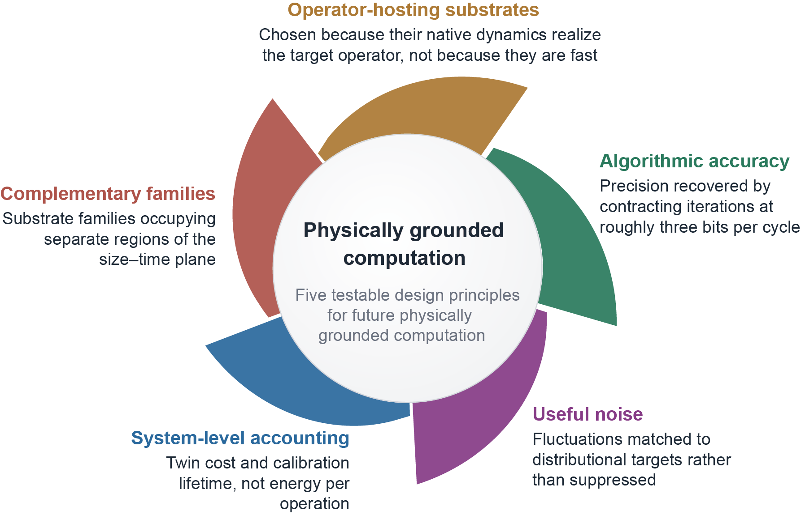
FIG. 6. Five testable design principles for future physically grounded computation. Each blade states a principle in a form that a future demonstration could satisfy or fail, not a topic. Operator-hosting substrates are chosen for native dynamics that realize the target operator, not for speed (Sec. VI A)^{82,83}. Algorithmic accuracy means precision recovered by a contracting iteration, at roughly three bits per cycle, instead of by fabrication (Sec. VI B)⁶⁸. Useful noise means fluctuations matched to a distributional target instead of suppressed (Sec. VI C)^{84,85}. System-level accounting takes the figure of merit to be the cost of the digital twin and the calibration lifetime, not energy per operation (Sec. II). Complementary families refers to the separate regions of the size–time plane that the four substrates occupy (Table II), which makes them complements and not competitors. The demonstrations on which a principle rests are cited here; where no citation is given, the principle follows from the analysis in the section indicated. The figure is a proposed research map, not a summary of established joint demonstrations.

VII. CONCLUSION
Neural networks are becoming physically grounded in two complementary ways. Physical neural networks ask how matter, waves, devices and molecules can perform neural transformations more efficiently or more natively than digital hardware. Physics-integrated learning asks how scientific laws can restrict learning so that predictions remain reliable, interpretable and useful beyond dense training data. The frontier is neither pure hardware acceleration nor pure equation-constrained software. It is co-design, a direction that this review argues for and for which the neural-network evidence is thin rather than absent: the two demonstrations examined in Sec. V each satisfy one of the two grounding conditions fully and the other only in a weakened form, and the physical solvers of Sec. VI are proofs of principle rather than instances of the framework. Physical systems must be trained with models of their own non-ideal dynamics, and scientific machine-learning models must be evaluated with physical constraints, uncertainty and system-level deployment in mind. The most important future systems may therefore be those in which the substrate, the learning rule and the scientific law are designed together as physically grounded neural networks. Section VI sets out three testable adjacent directions, together with two cross-cutting requirements (system-level energy accounting that includes the cost of the digital twin and the calibration lifetime, and evidence reported against a matched digital baseline), and states the condition under which each direction fails. The five design questions of Fig. 6 give the evidence threshold we would apply to any claim that the two routes have converged.

ACKNOWLEDGMENTS
This work was supported by National Key Research and Development Program of China (No. 2022YFA1404704), Natural Science Foundation of China (NSFC) under grant 62471435, the Natural Science Foundation of Zhejiang Province (ZJNSF) under grant LZ24F010002, and the Sichuan Science and Technology Program under grant 2026YFHZ0247.

DATA AVAILABILITY
Data sharing is not applicable to this article, as no new data were created or analyzed in this study.

AUTHOR CONTRIBUTIONS
H. Q. and D. Y. conceived the theme of the manuscript. H. Y., W. X. and J. L. researched data for the article. H. Y., D. Y. and H. Q. led the manuscript writing. All authors contributed to discussion, revision and final approval of the manuscript.

COMPETING INTERESTS
The authors declare no competing interests.

REFERENCES
1. F. Rosenblatt, “The perceptron: a probabilistic model for information storage and organization in the brain,” Psychol. Rev. 65, 386 (1958).
2. D. E. Rumelhart, G. E. Hinton, and R. J. Williams, “Learning representations by back-propagating errors,” Nature 323, 533 (1986).
3. Y. LeCun, Y. Bengio, and G. Hinton, “Deep learning,” Nature 521, 436 (2015).
4. A. Vaswani et al., “Attention is all you need,” Adv. Neural Inf. Process. Syst. (NeurIPS) 30, 5998 (2017).
5. A. Gu and T. Dao, “Mamba: linear-time sequence modeling with selective state spaces,” Proc. 1st Conference on Language Modeling (COLM) (2024).
6. Z. Liu et al., “KAN: Kolmogorov-Arnold networks,” Proc. International Conference on Learning Representations (ICLR) (2025).
7. D. Patterson et al., “The carbon footprint of machine learning training will plateau, then shrink,” Computer 55, 18 (2022).
8. M. Horowitz, “Computing’s energy problem (and what we can do about it),” IEEE International Solid-State Circuits Conference Digest of Technical Papers 10 (2014).
9. D. Marković, A. Mizrahi, D. Querlioz, and J. Grollier, “Physics for neuromorphic computing,” Nat. Rev. Phys. 2, 499 (2020).
10. A. Sebastian, M. Le Gallo, R. Khaddam-Aljameh, and E. Eleftheriou, “Memory devices and applications for in-memory computing,” Nat. Nanotechnol. 15, 529 (2020).
11. Y. Shen et al., “Deep learning with coherent nanophotonic circuits,” Nat. Photonics 11, 441 (2017).
12. X. Lin et al., “All-optical machine learning using diffractive deep neural networks,” Science 361, 1004 (2018).
13. T. Fu et al., “Optical neural networks: progress and challenges,” Light Sci. Appl. 13, 263 (2024).
14. L. G. Wright et al., “Deep physical neural networks trained with backpropagation,” Nature 601, 549 (2022).
15. S.-Y. Ma, T. Wang, J. Laydevant, L. G. Wright, and P. L. McMahon, “Quantum-limited stochastic optical neural networks operating at a few quanta per activation,” Nat. Commun. 16, 359 (2025).
16. A. Momeni et al., “Training of physical neural networks,” Nature 645, 53 (2025).
17. T. Wang et al., “Image sensing with multilayer nonlinear optical neural networks,” Nat. Photonics 17, 408 (2023).
18. J. Feldmann et al., “Parallel convolutional processing using an integrated photonic tensor core,” Nature 589, 52 (2021).
19. A. N. Tait et al., “Silicon photonic modulator neuron,” Phys. Rev. Appl. 11, 064043 (2019).
20. M. Schuld and N. Killoran, “Quantum machine learning in feature Hilbert spaces,” Phys. Rev. Lett. 122, 040504 (2019).
21. I. Cong, S. Choi, and M. D. Lukin, “Quantum convolutional neural networks,” Nat. Phys. 15, 1273 (2019).
22. A. Abbas et al., “The power of quantum neural networks,” Nat. Comput. Sci. 1, 403 (2021).
23. H.-Y. Huang et al., “Power of data in quantum machine learning,” Nat. Commun. 12, 2631 (2021).
24. D. Garcia-Martin, M. Larocca, and M. Cerezo, “Quantum neural networks form Gaussian processes,” Nat. Phys. 21, 1153 (2025).
25. L. Monbroussou et al., “Photonic quantum convolutional neural networks with adaptive state injection,” Adv. Photon. 7, 066012 (2025).
26. J. R. McClean, S. Boixo, V. N. Smelyanskiy, R. Babbush, and H. Neven, “Barren plateaus in quantum neural network training landscapes,” Nat. Commun. 9, 4812 (2018).
27. L. Chua, “Memristor—the missing circuit element,” IEEE Trans. Circuit Theory 18, 507 (1971).
28. D. B. Strukov, G. S. Snider, D. R. Stewart, and R. S. Williams, “The missing memristor found,” Nature 453, 80 (2008).
29. Q. Xia and J. J. Yang, “Memristive crossbar arrays for brain-inspired computing,” Nat. Mater. 18, 309 (2019).
30. D. Ielmini and H.-S. P. Wong, “In-memory computing with resistive switching devices,” Nat. Electron. 1, 333 (2018).
31. P. Yao et al., “Fully hardware-implemented memristor convolutional neural network,” Nature 577, 641 (2020).
32. W. Wan et al., “A compute-in-memory chip based on resistive random-access memory,” Nature 608, 504 (2022).
33. M. Le Gallo et al., “A 64-core mixed-signal in-memory compute chip based on phase-change memory for deep neural network inference,” Nat. Electron. 6, 680 (2023).
34. M. Payvand et al., “Self-organization of an inhomogeneous memristive hardware for sequence learning,” Nat. Commun. 13, 5793 (2022).
35. L. Qian, E. Winfree, and J. Bruck, “Neural network computation with DNA strand displacement cascades,” Nature 475, 368 (2011).
36. K. M. Cherry and L. Qian, “Scaling up molecular pattern recognition with DNA-based winner-take-all neural networks,” Nature 559, 370 (2018).
37. R. C. Lee, A. Corsano, C. Y. Tseng, N. Laohakunakorn, and L. Y. T. Chou, “Rewireable building blocks for enzyme-powered DNA computing networks,” J. Am. Chem. Soc. 146, 26148 (2024).
38. H. Moghimianavval et al., “Engineering sequestration-based biomolecular classifiers with shared resources,” ACS Synth. Biol. 13, 3231 (2024).
39. J. Sim et al., “Reset-free DNA logic circuits for real-time input processing and memory,” Sci. Adv. 12, eaeb1699 (2026).
40. L. M. Adleman, “Molecular computation of solutions to combinatorial problems,” Science 266, 1021 (1994).
41. Y. Benenson, “Biomolecular computing systems: principles, progress and potential,” Nat. Rev. Genet. 13, 455 (2012).
42. M. Raissi, P. Perdikaris, and G. E. Karniadakis, “Physics-informed neural networks: a deep learning framework for solving forward and inverse problems involving nonlinear partial differential equations,” J. Comput. Phys. 378, 686 (2019).
43. G. E. Karniadakis et al., “Physics-informed machine learning,” Nat. Rev. Phys. 3, 422 (2021).
44. S. Cuomo et al., “Scientific machine learning through physics-informed neural networks: where we are and what’s next,” J. Sci. Comput. 92, 88 (2022).
45. S. Wang, X. Yu, and P. Perdikaris, “When and why PINNs fail to train: a neural tangent kernel perspective,” J. Comput. Phys. 449, 110768 (2022).
46. A. Krishnapriyan et al., “Characterizing possible failure modes in physics-informed neural networks,” Adv. Neural Inf. Process. Syst. (NeurIPS) 34, 26548 (2021).
47. N. Sukumar and A. Srivastava, “Exact imposition of boundary conditions with distance functions in physics-informed deep neural networks,” Comput. Methods Appl. Mech. Eng. 389, 114333 (2022).
48. J. Noh and J. Lee, “Exact enforcement of temporal continuity in sequential physics-informed neural networks,” Comput. Methods Appl. Mech. Eng. 430, 117197 (2024).
49. X. Zheng et al., “Physics-specialized neural network with hard constraints for solving multi-material diffusion problems,” Comput. Methods Appl. Mech. Eng. 430, 117223 (2024).
50. S. Greydanus, M. Dzamba, and J. Yosinski, “Hamiltonian neural networks,” Adv. Neural Inf. Process. Syst. (NeurIPS) 32 (2019).
51. R. T. Q. Chen, Y. Rubanova, J. Bettencourt, and D. K. Duvenaud, “Neural ordinary differential equations,” Adv. Neural Inf. Process. Syst. (NeurIPS) 31, 6572 (2018).
52. X. Chen et al., “Forecasting the outcome of spintronic experiments with neural ordinary differential equations,” Nat. Commun. 13, 1016 (2022).
53. L. Lu, P. Jin, G. Pang, Z. Zhang, and G. E. Karniadakis, “Learning nonlinear operators via DeepONet based on the universal approximation theorem of operators,” Nat. Mach. Intell. 3, 218 (2021).
54. Z. Li et al., “Fourier neural operator for parametric partial differential equations,” Proc. International Conference on Learning Representations (ICLR) (2021).
55. N. Kovachki et al., “Neural operator: learning maps between function spaces with applications to PDEs,” J. Mach. Learn. Res. 24, 1 (2023).
56. Z. Li et al., “Physics-informed neural operator for learning partial differential equations,” ACM/IMS J. Data Sci. 1, 9 (2024).
57. K. Azizzadenesheli et al., “Neural operators for accelerating scientific simulations and design,” Nat. Rev. Phys. 6, 320 (2024).
58. Y. Wang et al., “Kolmogorov-Arnold-informed neural network: a physics-informed deep learning framework for solving forward and inverse problems based on Kolmogorov-Arnold Networks,” Comput. Methods Appl. Mech. Eng. 433, 117518 (2025).
59. D. W. Abueidda, P. Pantidis, and M. E. Mobasher, “DeepOKAN: deep operator network based on Kolmogorov Arnold networks for mechanics problems,” Comput. Methods Appl. Mech. Eng. 436, 117699 (2025).
60.

O. Ronneberger, P. Fischer, and T. Brox, “U-Net: convolutional networks for biomedical image segmentation,” Proc. Medical Image Computing and Computer-Assisted Intervention (MICCAI), Lecture Notes in Computer Science 9351, 234 (2015).
61. A. Dosovitskiy et al., “An image is worth 16x16 words: transformers for image recognition at scale,” Proc. International Conference on Learning Representations (ICLR) (2021).
62. I. Goodfellow et al., “Generative adversarial nets,” Adv. Neural Inf. Process. Syst. (NeurIPS) 27, 2672 (2014).
63. J. Ho, A. Jain, and P. Abbeel, “Denoising diffusion probabilistic models,” Adv. Neural Inf. Process. Syst. (NeurIPS) 33, 6840 (2020).
64. R. Rombach, A. Blattmann, D. Lorenz, P. Esser, and B. Ommer, “High-resolution image synthesis with latent diffusion models,” Proc. IEEE/CVF Conference on Computer Vision and Pattern Recognition (CVPR) 10684 (2022).
65. D. Ha and J. Schmidhuber, “World models,” Adv. Neural Inf. Process. Syst. (NeurIPS) 31 (2018).
66. D. Silver et al., “Mastering the game of Go with deep neural networks and tree search,” Nature 529, 484 (2016).
67. Z. Xu, T. Zhou, M. Ma, C. Deng, Q. Dai, and L. Fang, “Large-scale photonic chiplet Taichi empowers 160-TOPS/W artificial general intelligence,” Science 384, 202 (2024).
68. P. Zuo, Q. Wang, Y. Luo, R. Xie, S. Wang, Z. Cheng, L. Bao, Z. Wang, Y. Cai, R. Huang, and Z. Sun, “Precise and scalable analogue matrix equation solving using resistive random-access memory chips,” Nat. Electron. 8, 1222 (2025).
69. S. L. Brunton, B. R. Noack, and P. Koumoutsakos, “Machine learning for fluid mechanics,” Annu. Rev. Fluid Mech. 52, 477 (2020).
70. S. L. Brunton, J. L. Proctor, and J. N. Kutz, “Discovering governing equations from data by sparse identification of nonlinear dynamical systems,” Proc. Natl. Acad. Sci. U.S.A. 113, 3932 (2016).
71. R. Vinuesa and S. L. Brunton, “Enhancing computational fluid dynamics with machine learning,” Nat. Comput. Sci. 2, 358 (2022).
72. S. Wang, Y. Teng, and P. Perdikaris, “Understanding and mitigating gradient flow pathologies in physics-informed neural networks,” SIAM J. Sci. Comput. 43, A3055 (2021).
73. S. Wang, H. Wang, and P. Perdikaris, “On the eigenvector bias of Fourier feature networks: from regression to solving multi-scale PDEs with physics-informed neural networks,” Comput. Methods Appl. Mech. Eng. 384, 113938 (2021).
74. S. Wang, S. Sankaran, and P. Perdikaris, “Respecting causality for training physics-informed neural networks,” Comput. Methods Appl. Mech. Eng. 421, 116813 (2024).
75. D. Kochkov et al., “Machine learning-accelerated computational fluid dynamics,” Proc. Natl. Acad. Sci. U.S.A. 118, e2101784118 (2021).
76. K. Bi et al., “Accurate medium-range global weather forecasting with 3D neural networks,” Nature 619, 533 (2023).
77. R. Lam et al., “Learning skillful medium-range global weather forecasting,” Science 382, 1416 (2023).
78. F. Mostajeran and S. A. Faroughi, “Scaled-cPIKANs: spatial variable and residual scaling in Chebyshev-based physics-informed Kolmogorov-Arnold networks,” J. Comput. Phys. 537, 114116 (2025).
79. Q. Jiang and G. E. Karniadakis, “AgenticSciML: collaborative multi-agent systems for emergent discovery in scientific machine learning,” npj Artif. Intell. 2, 57 (2026).
80. Y. Zhao, X. Xiao, A. Descos, Y. Yuan, X. Yu, G. Kurczveil, M. Fiorentino, Z. Zhang, and R. G. Beausoleil, “Experimental Demonstration of an Optical Neural PDE Solver via On-Chip PINN Training,” in Optical Fiber Communication Conference (OFC) 2025, Technical Digest Series (Optica Publishing Group, 2025), paper W3D.4.
81. J. Li et al., “Memristive floating-point Fourier neural operator network for efficient scientific modeling,” Sci. Adv. 11, eadv4446 (2025).
82. N. Mohammadi Estakhri, B. Edwards, and N. Engheta, “Inverse-designed metastructures that solve equations,” Science 363, 1333 (2019).
83. Z. Sun, G. Pedretti, E. Ambrosi, A. Bricalli, W. Wang, and D. Ielmini, “Solving matrix equations in one step with cross-point resistive arrays,” Proc. Natl. Acad. Sci. U.S.A. 116, 4123 (2019).
84. M. Aifer, K. Donatella, M. H. Gordon, S. Duffield, T. Ahle, D. Simpson, G. Crooks, and P. J. Coles, “Thermodynamic linear algebra,” npj Unconv. Comput. 1, 13 (2024).
85. D. Melanson et al., “Thermodynamic computing system for AI applications,” Nat. Commun. 16, 3757 (2025).
[内部工作备注 — 投稿前删除] 图件修改清单（Word 中无法修改，需回绘图源文件处理）
1. Figure 2：将图内 "GPU / TPU(Tensor Processing Unit )" 改为 "GPU / TPU"。原写法括号前缺空格、括号内有尾随空格；全称已移入 FIG. 2 图注的缩写表。
2. Figure 3：删去 "Schuld & Killoran 2019" 之后孤立的间隔号 "·"，该符号目前单独折到下一行。
3. Figure 4：底部公式行 "L = L_data + Σ λi L_phys" 使用字面下划线，与同一张图方框内 L_data、L_PDE、L_BC 的真下标写法不一致。改为真下标，λ 后的 i 同改为下标。
4. Figure 6：四角留白偏大（对应审阅批注），建议收紧画布或增补子图。另图内五句与图注措辞有小幅出入：图内为 "not because they are fast"、"rather than suppressed"，图注为 "not for speed"、"instead of suppressed"；如需一致，改图内文字较省事。
5. 编辑信另要求：Figures 1–6 各提供一份独立图件文件，Tables I–III 各附描述性说明。

