Sub-Poissonian electroluminescence from resonant inelastic tunnelling in one-dimensional gold atomic chains
Hongyi Yang^{1,†}, Haipeng Zhu^{1,†}, Shiyu Feng², Zexi Lu¹, Xiyao Peng², Hongsheng Chen^{1, *}, Sihan Zhao^{2, *}, Dexin Ye^{1, *}, Haoliang Qian^{1, *}
¹State Key Laboratory of Extreme Photonics and Instrumentation, ZJU-Hangzhou Global Scientific and Technological Innovation Center, College of Information Science and Electronic Engineering, Zhejiang University, Hangzhou, 310027, China.
²School of Physics, Zhejiang Key Laboratory of Micro-Nano Quantum Chips and Quantum Control, and State Key Laboratory of Silicon and Advanced Semiconductor Materials, Zhejiang University, Hangzhou 310058, China.
*Corresponding author: hansomchen@zju.edu.cn; sihanzhao88@zju.edu.cn; desy@zju.edu.cn; haoliangqian@zju.edu.cn.
†These authors contributed equally to this work

Abstract
Electrically driven single-photon sources are central to integrated quantum photonics, but Poissonian carrier injection usually transfers electrical shot noise into classical photon statistics. Here we propose to suppress this bottleneck at its origin by using a one-dimensional (1D) gold atomic chain as an atomic-scale quantum conductor. Density-functional-theory-parameterized non-equilibrium Green’s-function calculations show that resonant tunnelling through a $d_{z^{2}}$-dominated ballistic channel suppresses electronic partition noise and generates a sub-Poissonian current. The same 1D spectrum, through discrete molecular levels and van Hove singularities, suppresses elastic tunnelling while opening a resonant inelastic channel, yielding an intrinsic plasmon-excitation efficiency $η_{inel}$ of about 80%. Coupling this quiet, high-yield electron flow to a nanometre-scale plasmonic antenna enables antibunched electroluminescence with a projected external photon-generation efficiency $η_{EQE}$ ≈ 60% and a high photon purity ($g^{(2)}(0)≈0$). These results identify quantum-statistical engineering of electron transport as a route to electrically driven non-classical light at the atomic limit.
KEYWORDS: single-photon sources, gold atomic chains, inelastic electron tunneling, sub-Poissonian electron transport, surface plasmons, nonequilibrium Green’s functions

Introduction
In the grand blueprint of quantum information science (QIS),¹ the realization of electrically driven and easily integrable single-photon sources (SPS) is a crucial link connecting solid-state quantum devices with quantum communication networks. Whether for quantum key distribution (QKD) protocols aimed at absolute secure communication or linear optical quantum computing (LOQC) pursuing capabilities beyond classical computation,² there are stringent requirements for on-demand emission,³ exceedingly high single-photon purity, and photon indistinguishability.⁴ Over the past two decades, while optically pumped schemes based on semiconductor quantum dots and crystal color centers have achieved remarkable success in photon quality,⁵ their reliance on bulky, expensive, and difficult-to-integrate external laser excitation systems has severely constrained the large-scale deployment of quantum devices in photonic integrated circuits (PICs). In contrast, electrically driven schemes promise to transform quantum light sources into compact electronic devices similar to classical light-emitting diodes (LEDs),⁶⁻⁸ directly generating quantum light streams via current injection and thus achieving seamless compatibility with existing microelectronic fabrication processes.
However, electrically driven schemes confront a more fundamental physical challenge than optical pumping: the statistical nature of the excitation source. In macroscopic conductors, tunnel junctions, or traditional LEDs, the electron transport process typically follows a classical Poisson distribution. This implies that the time intervals between electrons arriving at the emission center are random and mutually independent. The shot noise resulting from this randomness typically causes the generated photon stream to exhibit coherent states ($g^{(2)}(0)=1$) or even the bunching effect of thermal light fields ($g^{(2)}(0)>1$), which runs completely counter to the antibunching characteristic ($g^{(2)}(0)<0.5$) required for a single-photon source.
The core physical contradiction lies in the fact that a random excitation process can hardly produce an ordered quantum outcome directly. To solve this conundrum, traditional approaches often focus on post-generation photon regulation, such as utilizing high-quality-factor optical microcavities to filter photons. However, these post-generation photon regulation approaches inevitably suffer from inherent drawbacks, including severe photon loss that substantially reduces overall emission efficiency and the physical complexity of integrating such filtering structures at the nanoscale. From the reverse perspective, if we could tackle the problem at the source—by proactively "designing" the statistical properties of the electron flow at the quantum transport level to transform it from a random Poissonian flow into a highly ordered sub-Poissonian flow—then generating nonclassical light would become a natural consequence. Consequently, the drawbacks associated with conventional approaches will be completely avoided. Scanning tunneling microscope-induced luminescence, generating photons via the inelastic electron tunneling (IET) mechanism by utilizing an atomically sharp tip and a substrate to construct a nanojunction, provides a unique experimental and theoretical platform for us.⁹⁻¹² Although traditional IET light sources suffer from low efficiencies¹³ and uncontrollable statistical properties, combining localized surface plasmon (LSP) nanocavities with tailored quantum conductors provides a direct pathway to overcome these limitations. Specifically, the large Purcell effect¹⁴ in LSP nanocavities¹⁵ addresses the low-efficiency problem by strongly enhancing light-matter interactions. Building upon this, to address the uncontrollable statistical properties, the present study focuses on utilizing one-dimensional (1D) gold atomic chains¹⁶⁻¹⁸ as the core functional unit. Gold atomic chains not only possess excellent electrical conductivity, but their unique discrete, quantized energy level structure also makes the formation of a ballistic one-dimensional quantum point contact possible.¹⁹⁻²¹ When these levels resonate with the electrodes' Fermi surface, the Pauli exclusion principle and Coulomb blockade effects are significantly enhanced, theoretically predicting the "rectification" of random currents into highly ordered electron sequences. In this work, through first-principles calculations, we systematically demonstrate how this atomic-scale statistical engineering coupled with plasmonic enhancement can break traditional limits to achieve highly efficient and high-purity electrically driven single-photon emission.

Results and Discussion
Theoretical framework and self-energy corrections
To accurately describe the quantum transport and photon emission processes in open atomic-scale systems, we must establish a theoretical framework capable of simultaneously handling electronic structural details and non-equilibrium statistical properties. This study employs a non-equilibrium Green's function (NEGF) framework built on a partitioned tight-binding Hamiltonian in a common nine-spatial-orbital (s, p, d) basis per Au site, represented in spinor form when spin–orbit coupling is included. The finite-chain block is parameterized at the ab initio level via Wannier90 projection of the Quantum ESPRESSO Kohn–Sham states, while the semi-infinite leads are described by a bulk-Au Slater–Koster parametrization that reproduces the correct three-dimensional electrode density of states. This partitioning is standard in atomic-scale transport calculations: it retains DFT-level accuracy while providing a numerically stable, physically faithful description of the semi-infinite reservoirs through energy-dependent self-energies $Σ_{L/R}$(E).²² Specifically, the finite Au10-chain geometry, Kohn–Sham electronic structure, Γ-point vibrational modes and phonon-induced perturbation potentials were obtained from Quantum ESPRESSO calculations. The electron–phonon coupling matrices were constructed by projecting the phonon-induced Kohn–Sham potential variations onto the mass-normalized vibrational modes, and act only on the finite-chain Wannier block. These finite-chain electronic and electron–phonon matrices were then used as microscopic inputs for the NEGF transport calculations. Our core system is constructed as an Au-vacuum-Au (metal-insulator-metal) tunnel junction, as illustrated in Figure 1a. The central scattering region contains two collinear 1D gold atomic chains of 10 Au atoms each, separated by a vacuum gap. To model the interface between the 1D atomic chain and the 3D electrodes, we use nearest-neighbor Slater–Koster couplings in the common nine-spatial-orbital basis. The semi-infinite electrodes enter the NEGF calculation through the embedding self-energies $Σ_{L/R}(E)$.²³

To accurately capture quantum resonances in noble metal systems, we went beyond WBL approximation commonly used in mesoscopic transport. The WBL assumes that the electrode's density of states is constant within the transport window, implying that the self-energy only provides a constant energy level broadening (imaginary part) while ignoring energy level shifts (real part). However, as shown in Figure 1b, due to the strong $s-d$ band hybridization within the gold electrodes, rigorous calculations of the fully energy-dependent self-energy matrix via the recursive Green's function algorithm demonstrate that the real part $\text{Re[Σ]}$ is non-zero and fluctuates strongly with energy. Physically, $\text{Re}\text{[Σ]}$ acts as a powerful energy level renormalization field in the system, analogous to the Stark effect in atomic physics, but here the "field" originates from quantum coupling with the electrodes. As shown in Figure 1c, comparing the conductance spectra calculated under the full model versus the WBL approximation, we find that neglecting the real-part correction leaves the resonance voltages essentially unchanged but substantially overestimates the magnitude of the elastic current, by up to about a factor of two at the main peaks. Since this current sets the tunnelling rate that enters the noise spectrum and the emission efficiency, a WBL-based design would misestimate these quantities even where it places the resonances correctly. This proves that dispersive self-energy corrections must be included in atomic-scale tunnel junctions to ensure physical causality and predictive accuracy; this serves as the theoretical cornerstone for our subsequent sub-Poissonian flow design (see section S1 for detailed derivations of the NEGF Hamiltonian construction and fully energy-dependent self-energy calculations).
Resonant tunnelling and noise suppression
Having established an accurate theoretical model, we further explore how to exploit the electronic structure of the 1D gold chain to achieve an ordered electron flow, namely through a perfectly transmitting resonant channel, as illustrated schematically in Figure 2a. Unlike continuous energy bands in macroscopic wires, finite 1D atomic chain hosts a discrete ladder of molecular orbitals (MOs) $ε_{n}$²⁴ shown as horizontal bars in Figure 2a obtained by diagonalizing the Wannier-projected finite-chain Hamiltonian (section S2). These discrete levels act as "stepping stones" for electron tunneling. As the bias voltage $V_{bias}$ scanned, the chemical potential $μ_{L}$ of the source electrode sequentially sweeps across these levels. Once $μ_{L}$ aligns with a specific energy level $ε_{n}$, the system enters the resonant tunneling regime. As shown by the I−V characteristic curve in Figure 2b, the current exhibits clear step-like features. We find a precise correspondence between the onset voltages of these current steps and the resonant transition energies between the molecular eigenstates (red vertical bars in Figure 2b, with the corresponding eigen-energies shown in the right side-panel), where each step corresponds to the opening of a quantum channel. Under resonant conditions, the transmission probability of this specific channel approaches 1 ($T_{n}→1$). According to the mesoscopic shot noise theory established by Khlus, Lesovik, and Büttiker,²⁵⁻²⁷ the zero-frequency shot noise spectral power density $S(0)$ in a coherent conductor is related to the channel transmission probability $T_{n}$ by:
$$S(0)=2eVG_{0}\sum_{n}{T_{n}}(1-T_{n})$$
where $G_{0}=2e^{2}/h$ is the quantum conductance. When the channel is fully open (i.e., $T_{n}→1$ for a specific orbital due to resonant tunneling), the term $T_{n}(1-T_{n})$ approaches zero. This intrinsically eliminates partition noise and leads to a pronounced drop in the Fano factor ($F$). At this point, the system acts as a ballistic one-dimensional quantum point contact. This phenomenon is an inevitable consequence of the Pauli exclusion principle in a ballistic transport channel; two electrons cannot simultaneously occupy the same quantum state.
The sub-Poissonian picture rests on three energy and impedance scales of the junction, which we quantify explicitly. All of them refer to the metal–insulator–metal junction shown in Figure 1a. The lead-induced broadening of the dominant resonant channel, extracted from a Lorentzian fit to T(E) at V = 1.42 V, is Γ_{T} ≈ 27 meV. The screened Hubbard interaction of the gold-chain 5d manifold, evaluated from the screened Hubbard interaction matrix in this subspace (section S3), is $U_{d}≈4.95$ eV. It remains two orders of magnitude above $Γ_{T}$. Combined with the thermal scale $k_{BT}≈$0.86meV at T=10 K, the junction therefore satisfies $U_{d}$≫$Γ_{T}$≫$k_{B}$T, so that local charging disfavours multiple occupation of the d-dominated resonant channel and the resonance line shape is protected from thermal smearing. We emphasise, however, that Ud is not a fitted parameter in the Landauer–Büttiker transport calculation; the Fano-factor suppression reported below follows directly from the high transmission eigenvalue of the resonant channel, and $U_{d}$ only sets the local charging scale that reinforces the Pauli-imposed single-electron occupation. Moreover, the tunnel resistance $R_{T}∼10$ MΩ off resonance exceeds the resistance quantum $R_{Q}=h/(2e^{2})≈12.9$ kΩ throughout the operating bias range, satisfying the high-impedance criterion²⁸, under which the local charging scale is not washed out by quantum charge fluctuations. The molecular-orbital resonances of Figure 2b are therefore consistent with a supplementary Coulomb-blockade interpretation — in contrast to low-impedance scanning tunneling spectroscopy geometries¹⁶, in which $R≪R_{Q}$ precludes such a mechanism and any observed power-law density of states must be attributed to other physics. In the present vacuum-gapped atomic junction the impedance hierarchy is reversed.
When one electron occupies the resonant state on the chain, subsequent electrons must wait for that electron to tunnel away before entering (illustrated in Figure 2a by the blocked incoming electron). Furthermore, under atomic-scale confinement, the Coulomb repulsive energy between electrons is substantial, further preventing simultaneous multi-electron occupation. This mechanism effectively "rectifies" the random Poissonian electron flow from the thermal reservoir into a highly ordered time sequence. Electrons no longer arrive randomly; instead, like train cars, they pass through rhythmically at characteristic time intervals determined by the tunneling rate. To quantify this degree of ordering, we calculated the Fano factor ($F=S(0)/2eI$) of the electron flow. For a perfectly ordered electron flow, $F→0$. Our calculations indicate that at resonant voltages, the Fano factor of the gold atomic chain drops significantly, meaning the noise of the electron flow is deeply suppressed, exhibiting strong antibunching properties. This sub-Poissonian electron flow, produced by the combined effects of quantum confinement and Pauli blockade, provides the necessary low-noise driving source for the subsequent generation of nonclassical photons (for a detailed analysis of the energy level distribution of finite-length atomic chains and their mapping to resonant voltages, see section S4).

Having obtained a low-noise electron flow, the next critical question is to reveal its microscopic origin and explore the impact of disorder on statistical properties. Before turning to the noise, we note that Figure 3 refers to a single ten-atom gold wire contacted directly at both ends, without a vacuum gap, and not to the 10Au–vacuum–10Au junction of Figure 2. The two systems have different resonance conditions, so the conductance maxima of Figure 2b are not expected to coincide with the Fano-factor minima of Figure 3a. Our simulation results show that for a pristine 10-atom gold chain at resonant voltages, the Fano factor drops to a minimum of $F≈0.28$ at V ≈ 0.85 V, as shown in Figure 3a (solid orange line). To investigate the orbital origin of this deep noise suppression, we projected the transmission eigenchannels onto atomic orbitals. The orbital-resolved eigenchannel decomposition in Figure 3b shows that the low-noise behavior originates almost entirely from a single dominant transmitting channel of overwhelmingly d-orbital character. All orbital decompositions in Figure 3b–d are taken at the same bias, V = 0.85 V, where this channel has an (s, p, d) weight of (0.035, 0.030, 0.936). The equilibrium conductance of a gold single-atom contact is known to be carried by a single, predominantly 6s channel.^{29,30} The channel identified here is not that equilibrium channel: it is a d-derived molecular resonance of the finite chain that the applied bias brings into the transport window, and the large inter-site overlap of the d states aligned along the chain axis is what makes it the most coherent transmitting channel at resonance. At resonance, this channel is almost perfectly transparent, thereby eliminating partition noise and realizing a silent electron flow.
To verify the orbital origin of noise suppression, we examined the system's response to two distinct perturbations: realistic electron–phonon (e–ph) scattering and chemical disorder via carbon doping (quantitative analysis of d-orbital coherence under electron–phonon coupling and chemical disorder is provided in section S5). The results, summarized in Figure 3a, reveal a clear hierarchy in the robustness of the silent electron flow: it is resilient against electron–phonon dephasing but fragile to chemical disorder. Including e–ph coupling in the pristine chain (solid blue line) leaves the deep noise-suppression dip largely intact, with the Fano factor reaching F $≈$ 0.38 near V $≈$ 0.85 V — comparable to, and over a wide bias range slightly above, the purely elastic case (solid orange line, F $≈$ 0.28 at V $≈$0.85 V). Orbital decomposition at this common bias (Figure 3c) shows that the dominant transmitting eigenchannel retains overwhelming d-orbital character, with an (s, p, d) weight of (0.029, 0.037, 0.934). Phonon-induced dephasing thus modestly redistributes spectral weight and shifts the resonance position, but does not collapse the d-orbital ballistic channel.
Carbon doping (solid green line) produces a markedly different response: the resonant dip is washed out across the full bias window and F rebounds to 0.5–0.9. The statistics remain weakly sub-Poissonian, but the deep noise suppression characteristic of the pristine chain is lost. Orbital analysis at the same common bias (Figure 3d) exposes the microscopic mechanism: chemical disorder collapses the d-channel weight from 0.936 (pristine) to 0.104 (C-doped), and transport becomes dominated by s orbitals (0.597) with non-negligible p contribution (0.299). The disorder-broadened transmission distribution opens multiple partially transmitting channels, which — per the mesoscopic shot-noise formula — maximize partition noise and drive F back toward the Poisson limit.
Taken together, this two-step analysis robustly confirms the critical role of d-orbital coherence in establishing a "silent" current: it survives realistic e–ph scattering yet is fragile to chemical disorder. More importantly, the contrast between Figure 3c (d-dominated, quiet) and Figure 3d (s-dominated, noisy) provides a tangible physical mechanism for "in situ noise modulation" through controlled doping, with impurities acting as an active switch that toggles the system between d-dominated quiet transport and s-dominated Poissonian transport.

Inelastic electron tunnelling spectroscopy
Finally, we convert the "quiet" electron flow into a photon stream and verify the transduction of statistical properties. To overcome the inherently low efficiency of inelastic electron tunneling (IET),^{24-28,31,32} we integrate the gold atomic chain into the gap of a silver nanocube dimer, as illustrated in Figure 4a. This structure supports a broadband LSP resonance mode, acting as an optical antenna that vastly increases the local density of optical states (LDOS). The radiative response is obtained from a frequency-domain electromagnetic simulation of this dimer: the emitter is represented by a point dipole oriented along the gap axis and placed at the position of the tunnel junction, and the decomposition of the total power dissipated by the dipole into its radiative and non-radiative parts yields the optical LDOS ρ_{opt}(ω) and the radiation efficiency η_{rad}(ω).³³ These two quantities enter the observable emission spectrum as multiplicative factors on the current–current noise spectrum obtained from the transport calculation, I_{emission}(ω) ∝ S_{jj}(ω,V) ρ_{opt}(ω) η_{rad}(ω), and the full simulation parameters are given in Section S6. Both are shown in Figure 4b: the LDOS is dominated by a strong resonance at ℏω_{LSP} ≈ 0.84 eV, with weaker features near 1.4 and 1.95 eV, and the radiation efficiency is highest around the main resonance and falls off towards higher photon energies. Through this resonance the dimer acts as an optical nanoantenna that enhances the coupling between tunnelling electrons and far-field radiation via the Purcell effect. Both quantities depend only on the geometry and permittivities of the dimer and not on the applied bias, so the bias dependence of the emission enters entirely through S_{jj}. The emission spectrum of the IET process exhibits a hallmark quantum cutoff characteristic ($hν≤eV_{bias}$), as shown in Figure 4c, where the spectra are computed at bias voltages of 0.5, 1.0 and 1.57 V, confirming that the radiation originates from single-electron events. The cutoff is not imposed in our calculation but follows from the structure of the current–current noise spectrum, S_{jj}(ℏω) = ∫dE Tr[M G<(E) M† G>(E − ℏω)]: because G< carries weight only in occupied states below μ_{L} and G> only in empty states above μ_{R}, the overlap vanishes once ℏω exceeds μ_{L} − μ_{R} = eV_{bias}. The cutoff is therefore a signature of single-electron emission, since radiation above it would require two or more electrons to contribute to one photon. Our calculations reveal a voltage-tuned "spectral overlap" mechanism: at low bias (e.g., $V=0.5$ V), the quantum cutoff restricts the generation of high-frequency noise, leaving electrons unable to excite the higher-energy plasmon modes, thus suppressing light emission (Figure 4c). As the voltage increases to $V=1.0$ V, emission begins to emerge, but limited by the noise cutoff frequency, its overlap with the LSP peak remains marginal. However, when the voltage reaches $1.57$ V, the broad tail of the current noise spectrum fully covers the plasmon resonance peak, maximizing the phase space for electron-plasmon interactions and thereby achieving a resonant enhancement of the emission intensity. The selection of the plasmon resonance mode centered at 0.84 eV is due to the fact that at the optimal resonant bias of 1.57 V, the finite-frequency current noise spectrum $S_{jj}$ exhibits a prominent and sharp resonance peak at this exact energy (Figure 4c). Furthermore, the energy diagram in Figure 4d provides a clear physical picture of this branching ratio inversion governed by energy conservation. Under the optimal resonant bias, an electron in the initial state emits a plasmon with an energy of $ℏω_{LSP}≈0.84$ eV, precisely landing in an inelastic final state characterized by a high density of states (DOS). According to Fermi's Golden Rule, the inelastic transition rate is directly proportional to this inelastic-final-state DOS. Concurrently, the elastic final state falls outside the van Hove peaks, so its DOS is exceedingly low, effectively closing the elastic channels. This pronounced contrast in the available DOS inherently suppresses elastic transport and drives the system into a regime of highly efficient resonant inelastic electron tunneling (RIET).³⁴
As a result of this intrinsic mechanism, we predict that the intrinsic inelastic excitation efficiency, defined as $η_{inel}=Γ_{inel}/(Γ_{inel}+Γ_{el})$, can reach ~80% purely at the electronic level. This high efficiency is not accidental, but stems from the "elastic channel suppression" mechanism brought about by the unique discrete energy level structure of the 1D atomic chain. Under resonant conditions ($V≈1.57$V), due to atomic-scale quantum confinement and electronic van Hove singularities, the elastic tunneling channels that originally dominated transport are effectively closed or suppressed (Figure 4e). This inherently allows the inelastic tunneling channel to dominate, yielding the high intrinsic inelastic tunneling efficiency (Figure 4f). By integrating this structure with the silver nanoantenna, the enhancement of the local density of optical states further facilitates the coupling of this inelastic tunneling to the plasmonic mode with antenna radiation efficiency $η_{rad}$ around 75% at $ℏω_{LSP}≈0.84$ eV (section S6). This microscopic inversion of the branching ratio, combined with the high radiation efficiency of the nanoantenna, enables the vast majority of injected electrons to be converted into free-space photons, thereby realizing an external quantum efficiency $η_{EQE}$ = $η_{inel}$× $η_{rad}$ ≈ 60%, several orders of magnitude higher than that of conventional tunnel junctions and previously reported electrically driven plasmonic sources³⁵ (section S7: Details on emission efficiency calculations and the derivation of the statistical transduction model).

Transduction of quantum statistics
The further depth of this study lies in confirming that the sub-Poissonian statistical properties of the electrons can be "transcribed" into the photon stream. The multi-scale temporal dynamics of this transduction process are summarized in Figure 5a. On the picosecond scale (Figure 5a, top panel), the sub-Poissonian arrival statistics of the electrons are imprinted onto the photon output on a one-to-one basis, as further evidenced by the waiting-time distribution P(Δt) shown in the inset, which approaches zero at Δt → 0 — a hallmark of antibunching that is absent from a classical Poissonian source. This high-fidelity transduction of quantum statistics depends on the system being in the "fast-emission" regime. Zooming into a single transduction event at the femtosecond scale (Figure 5a, bottom panel) reveals its underlying three-stage causal chain: a discrete electron tunneling event excites a localized surface plasmon, which subsequently decays into a photon wavepacket. Thanks to the large Purcell effect of the plasmonic nanocavity, its radiative decay rate ($Γ_{em}$ ~ 10¹⁴ Hz) exceeds the electron tunnelling rate ($Γ_{tunnel}$ ≈ 2 × 10¹² Hz) by nearly two orders of magnitude. Within this hierarchy of time scales, the delay introduced by the finite lifetime of the plasmons ($τ_{pl}$ ~ 10 fs) remains short compared to the mean inter-electron spacing (Δt = e/I ≈ 0.5 ps), so that the photon emission events stay tightly locked to the arrival times of the electrons; residual deviations from the fast-emission limit are of the order of the rate ratio, a few per cent. Based on theoretical derivations by Beenakker and Schindele,³⁶ in the fast-emission limit, the relationship links the zero-delay second-order photon correlation function $g^{(2)}(0)$ directly to the electronic noise properties:
$$g^{(2)}(0)≈1-\frac{2}{N_{eff}}(1-F)×η$$
where $N_{eff}$ represents the number of transmission channels, $η$ represents the intrinsic efficiency and $F$ is the electronic Fano factor. This expression underscores that sub-Poissonian electron statistics ($F<1$) is a prerequisite for generating nonclassical light ($g^{(2)}(0)<1$).^{37,38}
By substituting the transport parameters derived from our atomic chain model—specifically, the single-channel dominance ($N≈1$) (Figure 5b) and the strongly suppressed Fano factor at resonance—we evaluate the photon statistics across different bias regimes (Figure 5c). We reveal an inherent trade-off between emission efficiency and single-photon purity. At an operating voltage of 1.57 V, the system exhibits a nearly perfect antibunching dip with $g^{(2)}(0)≈0$, simultaneously achieving a total emission efficiency exceeding 60%. Our results demonstrate that the 1D gold chain acts as a high-fidelity quantum interface, effectively converting a "quiet" and controlled electron flow into an antibunched single-photon stream.
The Fano factor plotted in Figure 5b is calculated for the 10Au–vacuum–10Au junction shown in Figure 1a and can be compared directly with that of the gapless contacted wire in Figure 3. Introducing the vacuum gap makes the electron flow less ordered over most of the bias range. The gap is a low-transparency barrier that carries almost the entire junction resistance. Away from resonance, each incident electron is therefore transmitted or reflected essentially at random. The electron flow is correspondingly more disordered, and the Fano factor increases. The resonance condition is also more restrictive than in the contacted wire. Transmission across the gap requires an occupied level ε_{n} of the source chain to coincide with an empty level ε_{m} of the drain chain, V = ε_{m} − ε_{n}, and this two-level coincidence is met only near discrete resonance voltages. Consequently, the Fano factor of the metal–insulator–metal junction is generally higher than that of the contacted wire, whose lead-broadened resonances keep it sub-Poissonian across a wide bias window with a minimum of F ≈ 0.28. In the junction the suppression is instead confined to narrow dips at the resonant voltages, the deepest of which reaches F ≈ 0.44 at the operating bias of 1.57 V. Quiet operation of the junction therefore requires it to be biased at a resonance, although the orbital origin of the quiet channel is the same in both geometries.

Conclusions
In summary, this work deeply explores the physical mechanisms of an electrically driven single-photon source based on 1D gold atomic chains by constructing a rigorous NEGF-DFT theoretical framework. By combining the plasmon enhancement effect of a silver nanoantenna with the unique elastic-channel suppression mechanism inherent to 1D systems, we achieved an intrinsic inelastic excitation efficiency $η_{inel}$ ≈ 80% at the atomic scale and theoretically confirmed the high-fidelity transduction of a sub-Poissonian electron flow into an antibunched photon stream. This value is several orders of magnitude higher than that of typical metallic tunnel junctions. We observed a voltage-tunable quantum cutoff in the emission spectrum, which is consistent with the single-electron inelastic process contained in our model and distinguishes the emission from a thermal process.
Beyond intensity enhancement, our work clarifies the fundamental hierarchy of time scales governing light-matter interactions at the nanoscale. We demonstrate that in the fast-emission regime—where the plasmonic radiative decay rate is much faster than the electron tunneling rate—the tunnel junction functions as a high-fidelity transducer of quantum statistical properties. The sub-Poissonian characteristics of charge carriers originating from single-channel ballistic transport are faithfully mapped onto the photon output, thereby generating antibunched light with $g^{(2)}(0)≈0$ under continuous-wave excitation. This direct link between current noise ($F<1$) and photon correlation ($g^{(2)}<1$) provides a robust framework for modulating the quantum states of light by controlling electrical conductance.
While our theoretical framework presents a highly promising architecture, translating these atomic-scale phenomena into experimental reality requires navigating stringent boundary conditions. Maintaining the device's ultra-high photon purity and emission efficiency relies on several key prerequisites: first, cryogenic temperatures are essential to suppress phonon-induced decoherence and thermal broadening, which could otherwise compromise the ballistic transport; second, ultra-high vacuum environments are necessary to maintain the structural stability of the pristine one-dimensional gold atomic chain and prevent contamination-induced noise; and finally, non-radiative quenching, a common challenge in nanometre-scale plasmonic cavities, must be maximally minimized by optimizing the antenna geometry and material quality. The gap modelled here is nevertheless well outside the regime in which quantum plasmonic effects dominate: tunnelling-induced quenching of a gap mode requires appreciable overlap of the electron wavefunctions of the two metal surfaces and is reported to set in below about 0.5 nm,^{39,40} while the quantum-corrected model reduces to the local classical result beyond roughly that separation,⁴¹ so that the 1.5 nm gap used here lies several times above the onset (Section S6).
The most demanding of these constraints concerns the survival of the chain under bias, and the essential point is that the chain does not sustain the applied 1.57 V. The mechanical and the thermal question are settled by the same impedance hierarchy: the vacuum gap carries almost all of the junction resistance, so the voltage dropped within the chain and its two interfaces is estimated at a few millivolts and almost all of the dissipated power is released in the electrodes rather than in the wire, the only lattice-heating channel being phonon emission, a percent-level process in ballistic gold chains.⁴² On this basis the thermally activated breaking model established for suspended gold chains⁴³ gives a lifetime far beyond any experimental time scale at 10 K, the current-induced force⁴⁴ stays well below the measured Au–Au rupture force,⁴⁵ the steady-state temperature rise of the chain is of order 1 K under ideal ballistic heat extraction, and the operating current of 0.33 μA (according to Figure 2b at V=1.57V, I=0.33 μA) is smaller than the saturation current of a metallic carbon nanotube by a factor of about 76;⁴⁶ for graphene nanoribbons the reported quantity is a breakdown current density rather than a device current, so no directly comparable figure is quoted here;⁴⁷ and it is smaller than the current at which a gold single-atom contact fails by a factor of about 420.⁴⁸ The failure mechanism also differs from that of micrometre-long carbon conductors, in which carriers scatter repeatedly and accumulate non-equilibrium optical phonons in a thermally isolated channel, whereas our chain is far shorter than the electron–phonon scattering length and is heat-sunk to bulk gold about one nanometre away. The calculations, parameters and numerical values behind these statements are given in Section S8. Two caveats should nevertheless be stated: freely suspended gold chains of about seven atoms are the current experimental limit,⁴⁹ so that N = 10 is at or beyond the state of the art, although the mechanism reported here does not depend on this particular length; and reduced-bias or low-duty-cycle pulsed operation remains available as a mitigation strategy at the cost of some efficiency.
A further and more basic limitation concerns the geometry itself. The two-chain junction modelled here is a construct chosen to isolate the physics of interest, not a structure that has been demonstrated. The stability of two facing single-atom-terminated chains held at tunnelling distance has not, to our knowledge, been shown, and approaching two such apexes would very likely lead to their reconnection into a single contacted chain, since the attractive interaction at these separations is comparable to the forces that drive chain formation in the first place.⁴⁹ The geometry modelled here should therefore not be read as a blueprint that an experiment could copy directly: an experimental realization of the mechanism will require further planning — for instance replacing the vacuum gap by a molecular or single-atom spacer that preserves the tunnelling character of the barrier, which would itself need extensive further investigation — rather than a direct transcription of the model junction. Recent advances also point to improved strategies for experimentally stabilizing atomic chains: micrometre-long copper single-atom chains encased in a protective carbon sheath have recently been synthesized at milligram scale under high pressure and reported to be air-stable, isolable by exfoliation, and two to three orders of magnitude longer than atomic chains formed in conventional break-junction experiments.⁵² Although this encapsulated geometry differs from the suspended junction considered here, it demonstrates that substantially longer and more stable single-atom chains are becoming experimentally accessible.
The 1D atomic chain serves not only as an ideal model for electron transport but also as a bridge connecting mesoscopic electronics with quantum optics,^{50,51} offering a scalable pathway for on-chip quantum information processing. Unlike conventional semiconductor quantum dots or defects, this all-metal architecture operates without the need for high-Q microcavities or complex optical pumping schemes. This capability to electrically drive and statistically tailor photon emission at the miniaturization limit opens avenues for developing ultrafast, integrated quantum interconnects and electron-photon logic circuits.

Methods
DFT calculations and electron–phonon matrices. First-principles calculations for the finite Au10 chain were performed using Quantum ESPRESSO with the PBE exchange-correlation functional and a fully relativistic PAW pseudopotential for Au, in which the 5d¹⁰ 6s¹ electrons are treated as valence states. The isolated chain was placed in a 14 × 14 × 42 Å³ supercell and sampled at the Γ point, which is appropriate for a finite cluster in a large vacuum box. Structural relaxation was carried out with ecutwfc = 60 Ry and ecutrho = 240 Ry. The relaxed geometry was then used for the final self-consistent and density-functional perturbation theory calculations with ecutwfc = 70 Ry and ecutrho = 280 Ry. Γ-point phonon modes were calculated using ph.x and subsequently diagonalized with dynmat.x using the zero-dimensional acoustic-sum-rule correction, as required for an isolated finite chain rather than a periodic crystal. The electron–phonon coupling matrix elements were constructed from the change of the Kohn–Sham potential induced by the mass-normalized phonon eigenvectors and then used as the microscopic input for the transport calculations.
Tight-binding transport Hamiltonian. The transport problem was evaluated in an orthogonal Slater-Koster basis containing $s, p_{x}, p_{y}, p_{z}, d_{xy}, d_{yz}, d_{zx}, d_{x^{2}-y^{2}},$and${ d}_{3z^{2}-r^{2}}$ orbitals on each Au atom. Spin–orbit coupling is included, and this nine-spatial-orbital basis is therefore represented in spinor form. The finite-chain block H_{device} was obtained by Wannier90 projection of the Quantum ESPRESSO Kohn–Sham states of the relaxed chain onto maximally-localized Wannier functions in this nine-spatial-orbital basis, and was diagonalized directly to obtain the molecular-orbital ladder used in the resonant-tunnelling analysis. The semi-infinite electrodes were represented by principal layers in the same nine-spatial-orbital basis using an orthogonal Slater–Koster parametrization of bulk Au; the common basis ensures that the device–lead coupling $V_{CL/R}$ is well defined. Thus the discrete levels and channel projections used in the NEGF calculation come from the ab initio finite-chain Hamiltonian itself, not from a projected periodic-band construction.
NEGF transport formalism. Quantum transport properties were evaluated using the non-equilibrium Green's function (NEGF) formalism. The applied bias is imposed in the step (rigid-shift) approximation: the electrostatic potential is constant across each electrode together with the chain bonded to it, so that the entire potential difference falls at the vacuum gap between the two terminal Au atoms, this is an assumption of the transport model rather than a self-consistent Poisson–NEGF result, and Section S8 estimates the residual on-chain drop at a few millivolts at the operating bias. The fully interacting retarded Green's function of the central scattering region was rigorously computed as $G^{r}(E,V)=[EI-H_{C}(V)-Σ_{L}^{r}(E,V)-Σ_{R}^{r}(E,V)-Σ_{e-ph}^{r}(E,V)]^{-1}$. The self-energy matrices ($Σ_{L,R}^{r}$) for the semi-infinite leads were calculated using the recursive Green's function algorithm, while the electron-phonon scattering was treated within the self-consistent Born approximation (SCBA) to rigorously capture finite-temperature decoherence. The elastic current was evaluated using the standard Landauer-Büttiker formula. To analyze the quantum shot noise, the transmission amplitude matrix $t$ was extracted, and a singular value decomposition (SVD) was subsequently performed to obtain the independent transmission eigenvalues $τ_{i}$. These eigenvalues were then utilized to quantitatively determine the Fano factor via $F=\sum_{i}{τ_{i}}(1-τ_{i})/\sum_{i}{τ_{i}}$.
Optical simulations. Optical simulations were performed in COMSOL Multiphysics using the frequency-domain finite-element solver. The plasmonic cavity was modelled as two edge-to-edge aligned Ag nanocubes with a lateral size of 300 nm and a thickness of 30 nm, separated by a gap of ~1.5 nm. The frequency-dependent dielectric function of Ag was taken from Johnson and Christy. To evaluate the optical response of the tunnelling junction, an electric dipole was placed in the center of the gap. The local density of optical states (LDOS) was calculated from the total power dissipated by the dipole and normalized to that of the same dipole in vacuum, such that the LDOS is given in units of the vacuum density of states. The radiation efficiency was defined as $η_{rad}=Γ_{rad}/(Γ_{rad}+Γ_{nr})$, where $Γ_{rad}$ and $Γ_{nr}$ are the radiative and non-radiative decay rates, respectively. A sufficiently fine mesh was used in the gap region, and perfectly matched layers were applied at the simulation boundaries.

ASSOCIATED CONTENT
Supporting Information
The Supporting Information is available free of charge at https://pubs.acs.org/doi/XXXXXXX.
Detailed derivation of the NEGF Hamiltonian construction and the fully energy-dependent self-energy (S1); molecular-orbital spectrum of the finite chain (S2); screened Hubbard interaction of the 5d manifold (S3); mapping of the energy-level distribution to resonant voltages (S4); d-orbital coherence under electron–phonon coupling and chemical disorder (S5); COMSOL frequency-domain simulation of the silver nanocube dimer and optical Purcell-factor calculations (S6); emission-efficiency calculations and derivation of the statistical-transduction model (S7); mechanical and thermal integrity of the gold chain under bias — bias division, chain lifetime, current-induced force, Joule-heating budget and comparison with low-dimensional conductors (S8) (PDF).
Data Availability Statement
The data that support the plots within this paper and the other findings of this study are available from the corresponding authors upon reasonable request. The source code underlying the findings of this study is freely available at https://github.com/HTskyeye/1D_Quantum_transport.
AUTHOR INFORMATION
Corresponding Authors
Hongsheng Chen – State Key Laboratory of Extreme Photonics and Instrumentation, ZJU-Hangzhou Global Scientific and Technological Innovation Center, College of Information Science and Electronic Engineering, Zhejiang University, Hangzhou 310027, China; Email: hansomchen@zju.edu.cn
Sihan Zhao – School of Physics, Zhejiang Key Laboratory of Micro-Nano Quantum Chips and Quantum Control, and State Key Laboratory of Silicon and Advanced Semiconductor Materials, Zhejiang University, Hangzhou 310058, China; Email: sihanzhao88@zju.edu.cn
Dexin Ye – State Key Laboratory of Extreme Photonics and Instrumentation, ZJU-Hangzhou Global Scientific and Technological Innovation Center, College of Information Science and Electronic Engineering, Zhejiang University, Hangzhou 310027, China; Email: desy@zju.edu.cn
Haoliang Qian – State Key Laboratory of Extreme Photonics and Instrumentation, ZJU-Hangzhou Global Scientific and Technological Innovation Center, College of Information Science and Electronic Engineering, Zhejiang University, Hangzhou 310027, China; Email: haoliangqian@zju.edu.cn
Author Contributions
H.Y., H.Z. and S.F. performed the theoretical DFT and NEGF transport calculations. Z.L. and X.P. carried out the optical simulations. H.Y., H.Z., D.Y. and H.Q. conceived the theoretical framework. All authors contributed to writing the manuscript and discussing the results. H.C., S.Z., D.Y. and H.Q. supervised this study. H.Y. and H.Z. contributed equally to this work.
Notes
The authors declare no competing financial interest.
ACKNOWLEDGMENTS
The authors acknowledge funding support from the National Key Research and Development Program of China under Grants 2022YFA1404704, 2023YFA1407900 and 2022YFA1203400, the National Natural Science Foundation of China (Nos. 62471435 and 92580112), the Natural Science Foundation of Zhejiang Province (ZJNSF) under Grant LZ24F010002, and the Sichuan Science and Technology Program 2026YFHZ0247.
References
(1) Lin, Y. T.; Ye, Y. Z.; Fang, W. Electrically driven single-photon sources. J. Semicond. 2019, 40, 071901.
(2) Sparrow, C.; Martín-López, E.; Maraviglia, N.; Neville, A.; Harrold, C.; Carolan, J.; Joglekar, Y. N.; Hashimoto, T.; Matsuda, N.; O’Brien, J. L.; Tew, D. P.; Laing, A. Simulating the vibrational quantum dynamics of molecules using photonics. Nature 2018, 557, 660–667.
(3) Darquié, B.; Jones, M. P. A.; Dingjan, J.; Beugnon, J.; Bergamini, S.; Sortais, Y.; Messin, G.; Browaeys, A.; Grangier, P. Controlled single-photon emission from a single trapped two-level atom. Science 2005, 309, 454–456.
(4) Ding, X.; He, Y.; Duan, Z.-C.; Gregersen, N.; Chen, M.-C.; Unsleber, S.; Maier, S.; Schneider, C.; Kamp, M.; Höfling, S.; Lu, C.-Y.; Pan, J.-W. On-demand single photons with high extraction efficiency and near-unity indistinguishability from a resonantly driven quantum dot. Phys. Rev. Lett. 2016, 116, 020401.
(5) García de Arquer, F. P.; Talapin, D. V.; Klimov, V. I.; Arakawa, Y.; Bayer, M.; Sargent, E. H. Semiconductor quantum dots: Technological progress and future challenges. Science 2021, 373, eaaz8541.
(6) Yuan, Z.; Kardynal, B. E.; Stevenson, R. M.; Shields, A. J.; Lobo, C. J.; Cooper, K.; Beattie, N. S.; Ritchie, D. A.; Pepper, M. Electrically driven single-photon source. Science 2002, 295, 102–105.
(7) Schuler, B.; Cochrane, K. A.; Kastl, C.; Barnard, E.; Wong, E.; Borys, N.; Schwartzberg, A. M.; Ogletree, D. F.; García de Abajo, F. J.; Weber-Bargioni, A. Electrically driven photon emission from individual atomic defects in monolayer WS2. Sci. Adv. 2020, 6, eabb5988.
(8) Guo, S.; Germanis, S.; Taniguchi, T.; Watanabe, K.; Withers, F.; Luxmoore, I. J. Electrically driven site-controlled single photon source. ACS Photonics 2023, 10, 2549–2555.
(9) Pommier, D.; Bretel, R.; Parra López, L. E.; Fabre, F.; Mayne, A.; Boer-Duchemin, E.; Dujardin, G.; Schull, G.; Berciaud, S.; Le Moal, E. Scanning tunneling microscope-induced excitonic luminescence of a two-dimensional semiconductor. Phys. Rev. Lett. 2019, 123, 027402.
(10) Doppagne, B.; Neuman, T.; Soria-Martinez, R.; Parra López, L. E.; Bulou, H.; Romeo, M.; Berciaud, S.; Scheurer, F.; Aizpurua, J.; Schull, G. Single-molecule tautomerization tracking through space- and time-resolved fluorescence spectroscopy. Nat. Nanotechnol. 2020, 15, 207–211.
(11) Rosławska, A.; Merino, P.; Große, C.; Leon, C. C.; Gunnarsson, O.; Etzkorn, M.; Kuhnke, K.; Kern, K. Single charge and exciton dynamics probed by molecular-scale-induced electroluminescence. Nano Lett. 2018, 18, 4001–4007.
(12) Große, C.; Merino, P.; Rosławska, A.; Gunnarsson, O.; Kuhnke, K.; Kern, K. Submolecular electroluminescence mapping of organic semiconductors. ACS Nano 2017, 11, 1230–1237.
(13) Qian, H.; Hsu, S.-W.; Gurunatha, K.; Riley, C. T.; Zhao, J.; Lu, D.; Tao, A. R.; Liu, Z. Efficient light generation from enhanced inelastic electron tunnelling. Nat. Photonics 2018, 12, 485–488.
(14) Purcell, E. M. Spontaneous emission probabilities at radio frequencies. Phys. Rev. 1946, 69, 681.
(15) Gutzler, R.; Garg, M.; Ast, C. R.; Kuhnke, K.; Kern, K. Light-matter interaction at atomic scales. Nat. Rev. Phys. 2021, 3, 441–453.
(16) Blumenstein, C.; Schäfer, J.; Mietke, S.; Meyer, S.; Dollinger, A.; Lochner, M.; Cui, X. Y.; Patthey, L.; Matzdorf, R.; Claessen, R. Atomically controlled quantum chains hosting a Tomonaga-Luttinger liquid. Nat. Phys. 2011, 7, 776–780.
(17) Reimer, M. E.; Bulgarini, G.; Akopian, N.; Hocevar, M.; Bavinck, M. B.; Verheijen, M. A.; Bakkers, E. P. A. M.; Kouwenhoven, L. P.; Zwiller, V. Bright single-photon sources in bottom-up tailored nanowires. Nat. Commun. 2012, 3, 737.
(18) Dudy, L.; Aulbach, J.; Wagner, T.; Schäfer, J.; Claessen, R. One-dimensional quantum matter: Gold-induced nanowires on semiconductor surfaces. J. Phys.: Condens. Matter 2017, 29, 433001.
(19) Fève, G.; Mahé, A.; Berroir, J.-M.; Kontos, T.; Plaçais, B.; Glattli, D. C.; Cavanna, A.; Etienne, B.; Jin, Y. An on-demand coherent single-electron source. Science 2007, 316, 1169–1172.
(20) Pekola, J. P.; Vartiainen, J. J.; Möttönen, M.; Saira, O.-P.; Meschke, M.; Averin, D. V. Hybrid single-electron transistor as a source of quantized electric current. Nat. Phys. 2008, 4, 120–124.
(21) Yoo, S.; Zhao, S.; Wang, F. Infrared light-emitting devices from antenna-coupled Luttinger liquid plasmons in carbon nanotubes. Phys. Rev. Lett. 2021, 127, 257702.
(22) Brandbyge, M.; Mozos, J.-L.; Ordejón, P.; Taylor, J.; Stokbro, K. Density-functional method for nonequilibrium electron transport. Phys. Rev. B 2002, 65, 165401.
(23) Pillet, J.-D.; Quay, C. H. L.; Morfin, P.; Bena, C.; Levy Yeyati, A.; Joyez, P. Andreev bound states in supercurrent-carrying carbon nanotubes revealed. Nat. Phys. 2010, 6, 965–969.
(24) Nilius, N.; Wallis, T. M.; Ho, W. Development of one-dimensional band structure in artificial gold chains. Science 2002, 297, 1853–1856.
(25) Khlus, V. A. Current and voltage fluctuations in microjunctions between normal metals and superconductors. Sov. Phys. JETP 1987, 66, 1243–1250.
(26) Lesovik, G. B. Excess quantum noise in 1D ballistic point contacts. JETP Lett. 1989, 49, 592–594.
(27) Büttiker, M. Scattering theory of thermal and excess noise in open conductors. Phys. Rev. Lett. 1990, 65, 2901–2904.
(28) Devoret, M. H.; Esteve, D.; Grabert, H.; Ingold, G.-L.; Pothier, H.; Urbina, C. Effect of the electromagnetic environment on the Coulomb blockade in ultrasmall tunnel junctions. Phys. Rev. Lett. 1990, 64, 1824–1827.
(29) Scheer, E.; Agraït, N.; Cuevas, J. C.; Levy Yeyati, A.; Ludoph, B.; Martín-Rodero, A.; Rubio Bollinger, G.; van Ruitenbeek, J. M.; Urbina, C. The signature of chemical valence in the electrical conduction through a single-atom contact. Nature 1998, 394, 154–157.
(30) Agraït, N.; Levy Yeyati, A.; van Ruitenbeek, J. M. Quantum properties of atomic-sized conductors. Phys. Rep. 2003, 377, 81–279.
(31) Berndt, R.; Gimzewski, J. K.; Johansson, P. Inelastic tunneling excitation of tip-induced plasmon modes on noble-metal surfaces. Phys. Rev. Lett. 1991, 67, 3796–3799.
(32) Persson, B. N. J.; Baratoff, A. Inelastic electron tunneling from a metal tip: The contribution from resonant processes. Phys. Rev. Lett. 1987, 59, 339–342.
(33) Martín-Jiménez, A.; Fernández-Domínguez, A. I.; Lauwaet, K.; Granados, D.; Miranda, R.; García-Vidal, F. J.; Otero, R. Unveiling the radiative local density of optical states of a plasmonic nanocavity by STM. Nat. Commun. 2020, 11, 1021.
(34) Muniain, U.; Esteban, R.; Aizpurua, J.; Greffet, J.-J. Unified treatment of light emission by inelastic tunneling: Interaction of electrons and photons beyond the gap. Phys. Rev. X 2024, 14, 021017.
(35) Qian, H.; Li, S.; Hsu, S.-W.; Chen, C.-F.; Tian, F.; Tao, A. R.; Liu, Z. Highly-efficient electrically-driven localized surface plasmon source enabled by resonant inelastic electron tunneling. Nat. Commun. 2021, 12, 3111.
(36) Beenakker, C. W. J.; Schomerus, H. Counting statistics of photons produced by electronic shot noise. Phys. Rev. Lett. 2001, 86, 700–703.
(37) Schindele, J.; Baumgartner, A.; Schönenberger, C. Near-unity Cooper pair splitting efficiency. Phys. Rev. Lett. 2012, 109, 157002.
(38) Arend, G.; Huang, G.; Feist, A.; Yang, Y.; Henke, J.-W.; Qiu, Z.; Jeng, H.; Raja, A. S.; Haindl, R.; Wang, R. N.; Kippenberg, T. J.; Ropers, C. Electrons herald non-classical light. Nat. Phys. 2025, 21, 1855–1862.
(39) Savage, K. J.; Hawkeye, M. M.; Esteban, R.; Borisov, A. G.; Aizpurua, J.; Baumberg, J. J. Revealing the quantum regime in tunnelling plasmonics. Nature 2012, 491, 574–577.
(40) Scholl, J. A.; García-Etxarri, A.; Koh, A. L.; Dionne, J. A. Observation of quantum tunneling between two plasmonic nanoparticles. Nano Lett. 2013, 13, 564–569.
(41) Esteban, R.; Borisov, A. G.; Nordlander, P.; Aizpurua, J. Bridging quantum and classical plasmonics with a quantum-corrected model. Nat. Commun. 2012, 3, 825.
(42) Agraït, N.; Untiedt, C.; Rubio-Bollinger, G.; Vieira, S. Onset of energy dissipation in ballistic atomic wires. Phys. Rev. Lett. 2002, 88, 216803.
(43) Smit, R. H. M.; Untiedt, C.; van Ruitenbeek, J. M. The high-bias stability of monatomic chains. Nanotechnology 2004, 15, S472–S478.
(44) Todorov, T. N.; Hoekstra, J.; Sutton, A. P. Current-induced embrittlement of atomic wires. Phys. Rev. Lett. 2001, 86, 3606–3609.
(45) Rubio-Bollinger, G.; Bahn, S. R.; Agraït, N.; Jacobsen, K. W.; Vieira, S. Mechanical properties and formation mechanisms of a wire of single gold atoms. Phys. Rev. Lett. 2001, 87, 026101.
(46) Yao, Z.; Kane, C. L.; Dekker, C. High-field electrical transport in single-wall carbon nanotubes. Phys. Rev. Lett. 2000, 84, 2941–2944.
(47) Murali, R.; Yang, Y.; Brenner, K.; Beck, T.; Meindl, J. D. Breakdown current density of graphene nanoribbons. Appl. Phys. Lett. 2009, 94, 243114.
(48) Yasuda, H.; Sakai, A. Conductance of atomic-scale gold contacts under high-bias voltages. Phys. Rev. B 1997, 56, 1069–1072.
(49) Yanson, A. I.; Rubio Bollinger, G.; van den Brom, H. E.; Agraït, N.; van Ruitenbeek, J. M. Formation and manipulation of a metallic wire of single gold atoms. Nature 1998, 395, 783–785.
(50) Tame, M. S.; McEnery, K. R.; Özdemir, Ş. K.; Lee, J.; Maier, S. A.; Kim, M. S. Quantum plasmonics. Nat. Phys. 2013, 9, 329–340.
(51) Khitrova, G.; Gibbs, H. M.; Kira, M.; Koch, S. W.; Scherer, A. Vacuum Rabi splitting in semiconductors. Nat. Phys. 2006, 2, 81–90.
(52) Zhang, J.; Dong, X.; Qiu, S.; Yang, X.; Li, C.; Ma, H.; Fei, Y.; Zeng, Q.; Li, F.; Xie, Y.; et al. Ultralong sheathed single-metal-atom chains synthesized under high pressure. Science 2026, 393, 826–830.
Figures and Tables
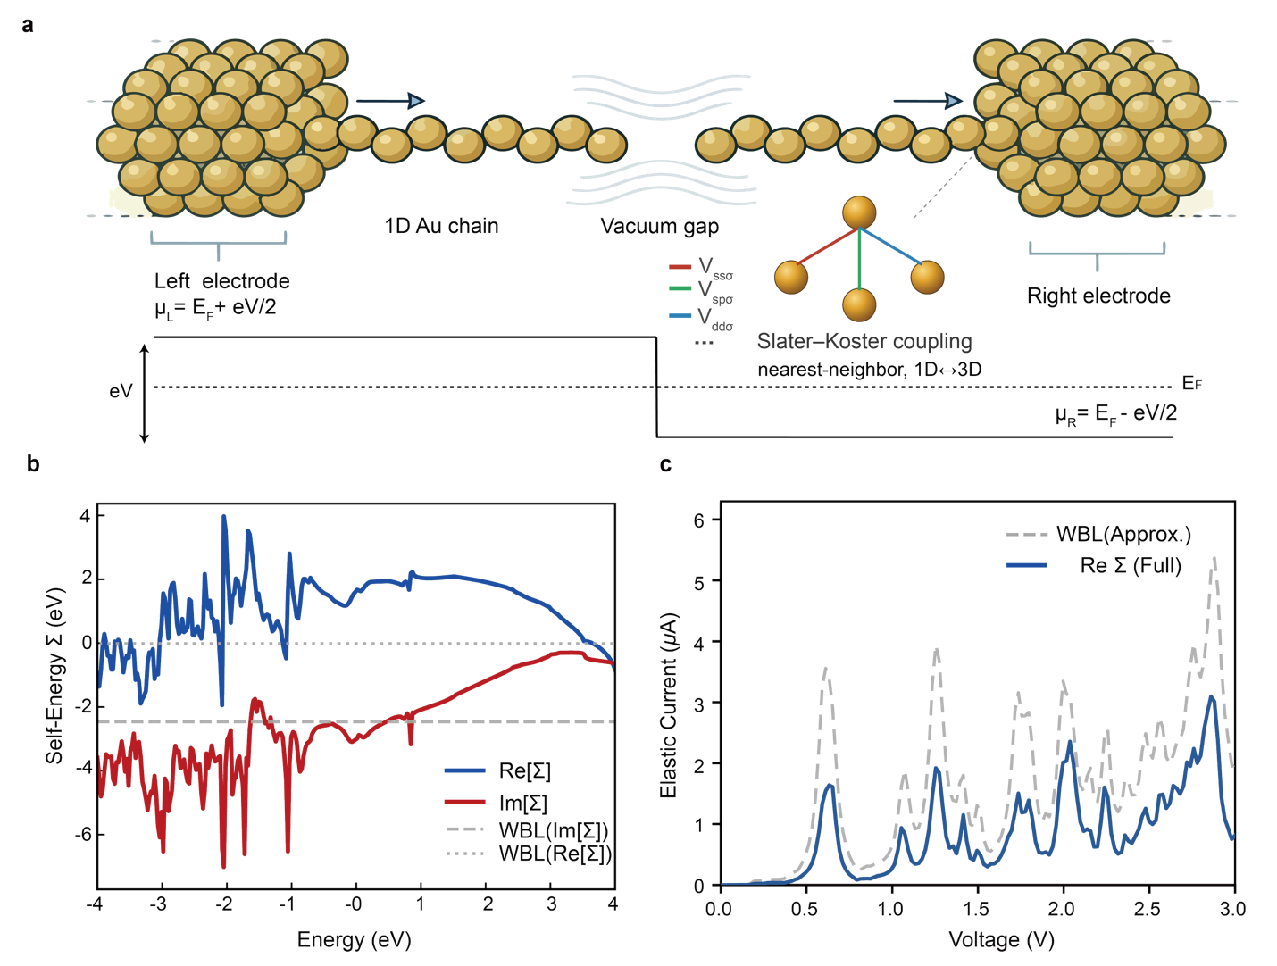
Figure 1 | Atomic-scale junction and self-energy renormalization. a, Schematic of the metal–insulator–metal junction studied throughout this work. The central scattering region consists of two collinear 1D gold atomic chains of 10 Au atoms each, separated by a vacuum gap that defines the tunneling region and contacted symmetrically to two semi-infinite three-dimensional Au electrodes (3×3 cross-section, indicated by the bracketed labels). The lower diagram shows the corresponding electrostatic potential profile under an applied bias V: the chemical potentials of the source and drain reservoirs are shifted to $μ_{L}$ = $E_{F}$+eV/2 and $μ_{R}$ = $E_{F}$−eV/2 about the equilibrium Fermi level $E_{F}$ (dotted line), producing a bias window of width eV. The bias is imposed in the step (rigid-shift) approximation: the electrostatic potential is constant across each electrode together with the ten-atom chain bonded to it, so that the whole potential difference eV appears as a single step at the vacuum tunnelling gap — the tip-to-tip separation between the two terminal Au atoms — and the field along each chain is neglected; Section S8 estimates the residual on-chain drop at a few millivolts. The right inset zooms into the 1D ↔ 3D contact region and illustrates the nearest-neighbor Slater–Koster coupling between the terminal chain atom and the surface atoms of the electrode, decomposed into orbital-symmetry channels (e.g. $V_{ssσ}$, $V_{spσ}$, $V_{ddσ}$). b, Real (solid blue) and imaginary (solid red) parts of the electrode self-energy Σ(E) calculated using the recursive Green's function technique. The complex energy dependence originates from the d-band hybridization within the gold electrodes. The dashed grey lines indicate the WBL approximation, which assumes a constant imaginary self-energy and a vanishing real part. c, Comparison of the calculated elastic current spectra obtained with the full energy-dependent self-energy (solid blue line) and the WBL approximation (dashed grey line). Inclusion of the real part of Σ(E) markedly reduces the magnitude of the elastic current relative to the WBL result, highlighting the critical role of dispersion corrections for accurately predicting the transport properties of atomic-scale junctions.
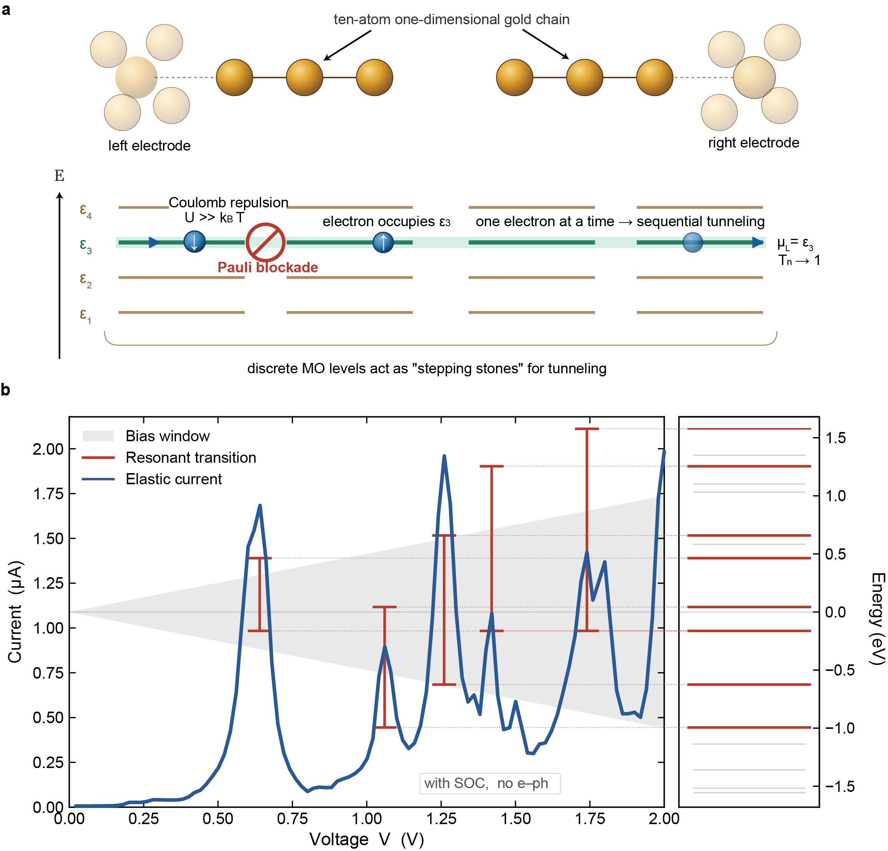
Figure 2 | Resonant tunnelling in the metal–insulator–metal junction and its correspondence with the discrete molecular orbitals of the 1D gold chain. a, Schematic of resonant electron tunneling between two ten-atom one-dimensional gold chains suspended between semi-infinite Au electrodes and separated by a sub-nanometer vacuum gap. Quantum confinement, combined with the on-site spin–orbit coupling of the Au 5d states, produces in each chain a discrete ladder of Kramers-degenerate molecular orbitals (MOs) {$ε_{n}$}. Under biased V, the source-chain levels rigidly shift by +V/2 and the drain-chain levels by −V/2; energy-conserving elastic tunneling across the gap is enabled whenever an occupied source level $ε_{n}$ aligns with an empty drain level $ε_{m}$, i.e. when V = $ε_{m}$ − $ε_{n}$, at which point the transmission of the (n, m) channel approaches unity (τ → 1). Pauli exclusion together with strong on-site Coulomb repulsion (U ≫ $Γ_{T}$) enforces single-electron occupation of the resonant state, blocking a second incoming electron until the resident one has tunneled to the drain. This Pauli/Coulomb gating rectifies the Poissonian electron injection from the reservoirs into a sub-Poissonian output flow. b, Correspondence between the calculated elastic current and the microscopic MO spectrum of the 10Au–vacuum–10Au junction. The solid blue line is the elastic current as a function of bias V. The grey trapezoidal region delimits the bias window [−V/2, +V/2]. The grey region and the red T-bars are referred to the energy axis on the right, not to the current axis on the left, so the grey region does not imply a finite current at zero bias or a positive current at negative bias. Each red T-bar marks a resonant MO-to-MO transition: it is centered at V = $ε_{m}-ε_{n}$ and spans from $ε_{n}$ to $ε_{m}$ on the energy axis, so that its length equals the bias-window height at that voltage. The coincidence of the bar length with the bias-window height is precisely the resonance condition: the applied bias has brought two levels that were misaligned at zero bias into alignment, opening an elastic channel and producing the conductance maximum seen directly below. The comparison to be made is therefore between the bar length and the window height on the energy axis, and between the bar position and the peak position on the voltage axis. Red dotted lines connect the bar endpoints to the corresponding eigenstates {$ε_{n}$} of the isolated chain, displayed as horizontal lines in the right panel (red: levels participating in the marked resonances; grey: remaining levels). Each current peak coincides within 20 meV with such an alignment, confirming that the I–V structure is built up channel-by-channel from coherent MO-to-MO transitions, in line with the picture of panel a. Spin–orbit coupling is included self-consistently throughout; electron–phonon coupling is omitted here to isolate the coherent resonance structure, and its impact on the noise is examined in Fig. 3 and Fig. 4.
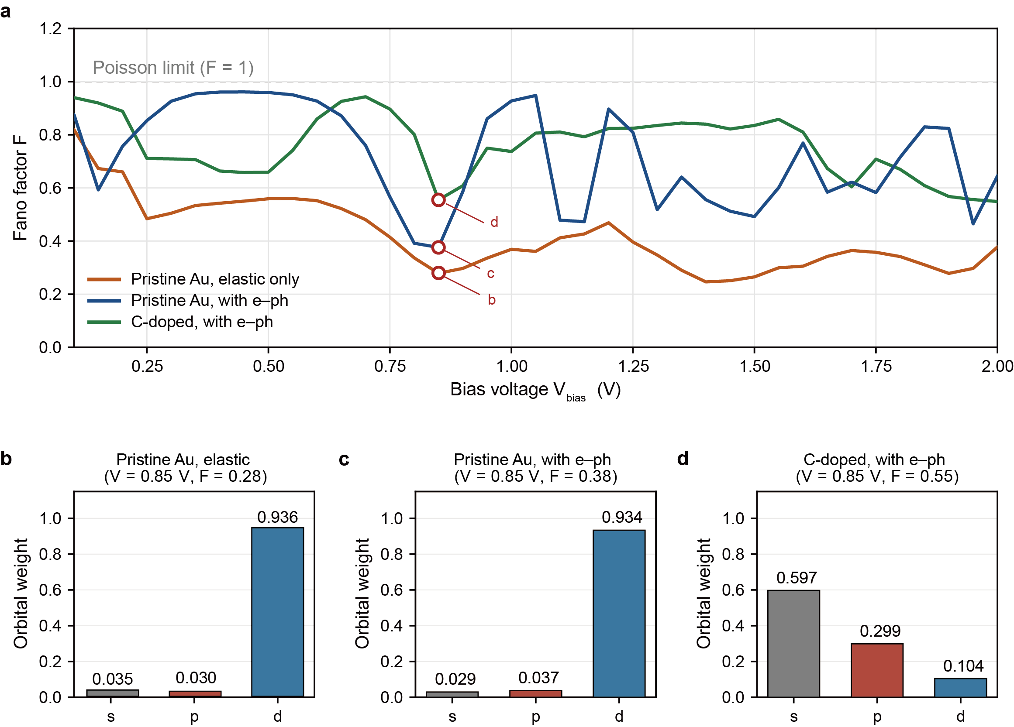
Figure 3 | Orbital origin of noise suppression and the impact of electron–phonon coupling and disorder. a, Fano factor F as a function of bias voltage for three configurations of a 10-atom 1D wire: pristine gold chain in the purely elastic regime (orange), pristine gold chain with electron–phonon coupling included (blue), and a carbon-doped chain with electron–phonon coupling (green). The Poisson limit (F = 1) is indicated by the dashed grey line. The pristine wire achieves deep noise suppression (F ≈ 0.28) at resonance, driven by the formation of a high-transmission d-orbital channel. Electron–phonon scattering moderately raises the minimum Fano factor to F ≈ 0.38, while carbon doping further degrades coherence and pushes the statistics back toward the Poisson limit (F ≈ 0.55). b–d, Orbital decomposition (s, p, d) of the dominant transmitting eigenchannel at the common bias V = 0.85 V (red dots in a) for the pristine elastic case (b), the pristine wire with e–ph coupling (c), and the carbon-doped wire with e–ph coupling (d). Evaluating the three configurations at the same bias means that any difference between them reflects the electron–phonon coupling or the doping rather than a change of operating point. The suppression of shot noise is strongly correlated with d-orbital dominance (blue bars): the pristine elastic channel is almost purely d (0.936), e–ph scattering leaves this essentially untouched (d = 0.934), whereas C-doping collapses the d-channel down to 0.104 and shifts transport toward s-orbital dominance (0.597), accompanied by the rebound of F toward the Poisson limit.

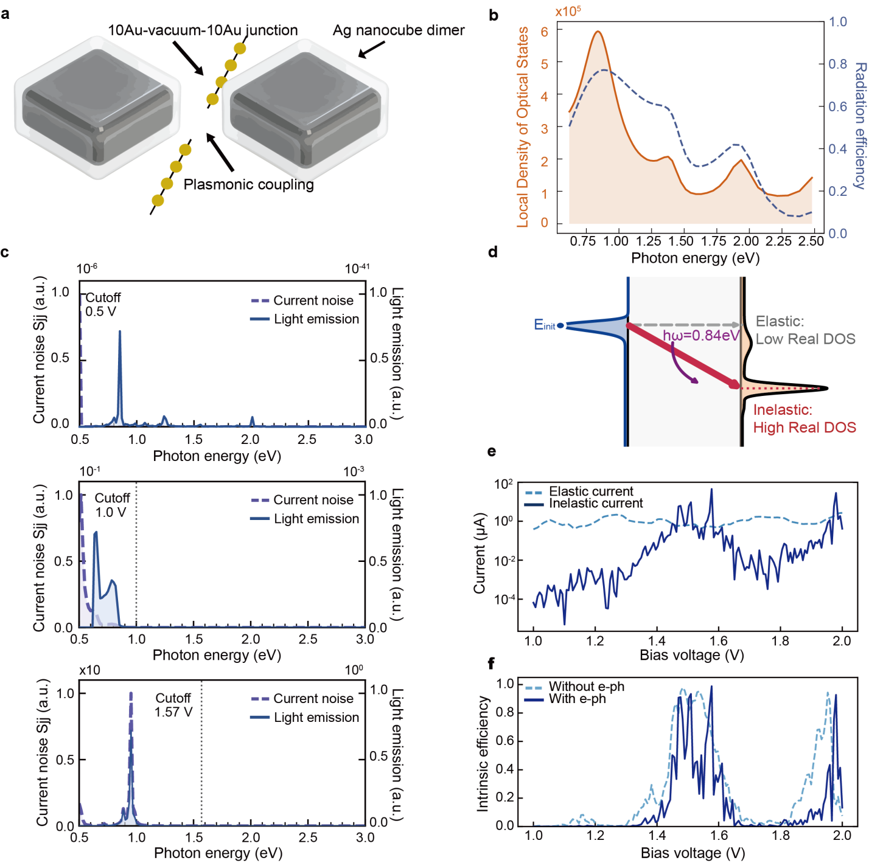
Figure 4 | Resonant inelastic tunnelling enhanced by a plasmonic antenna. a, Ag nanocube dimer containing a 10Au–vacuum–10Au atomic-chain junction in the gap. The dimer provides a localized surface-plasmon mode coupled to the tunnelling current. b, Calculated optical local density of states and radiation efficiency, showing a broad plasmon resonance near 0.84 eV. c, Bias-dependent finite-frequency current noise and emission spectra at 0.5, 1.0 and 1.57 V. Dashed curves: the current–current noise spectrum S_{jj}(ℏω) obtained from the transport calculation. Solid curves: the resulting emission spectrum, that is S_{jj}(ℏω) weighted by the plasmon LDOS and the radiation efficiency of panel b. Each pair of curves terminates at its own quantum cutoff ℏω = eV_{bias}. At 0.5 V, the quantum cutoff lies below the plasmon resonance and emission is suppressed. At 1.0 V, spectral overlap begins. At 1.57 V, the noise spectrum overlaps strongly with the plasmon resonance, maximizing emission. d, Energy-level picture of branching-ratio inversion: elastic tunnelling is suppressed by a low-DOS final state which corresponds to the elastic tunneling, whereas plasmon emission transfers the electron into a high-DOS final state. e, Bias dependence of elastic and inelastic tunnelling currents. f, Intrinsic inelastic excitation efficiency $η_{inel}$ with and without electron–phonon scattering. Including electron–phonon coupling reduces the peak efficiency from near unity to about 80%, which is used as the realistic operating value.
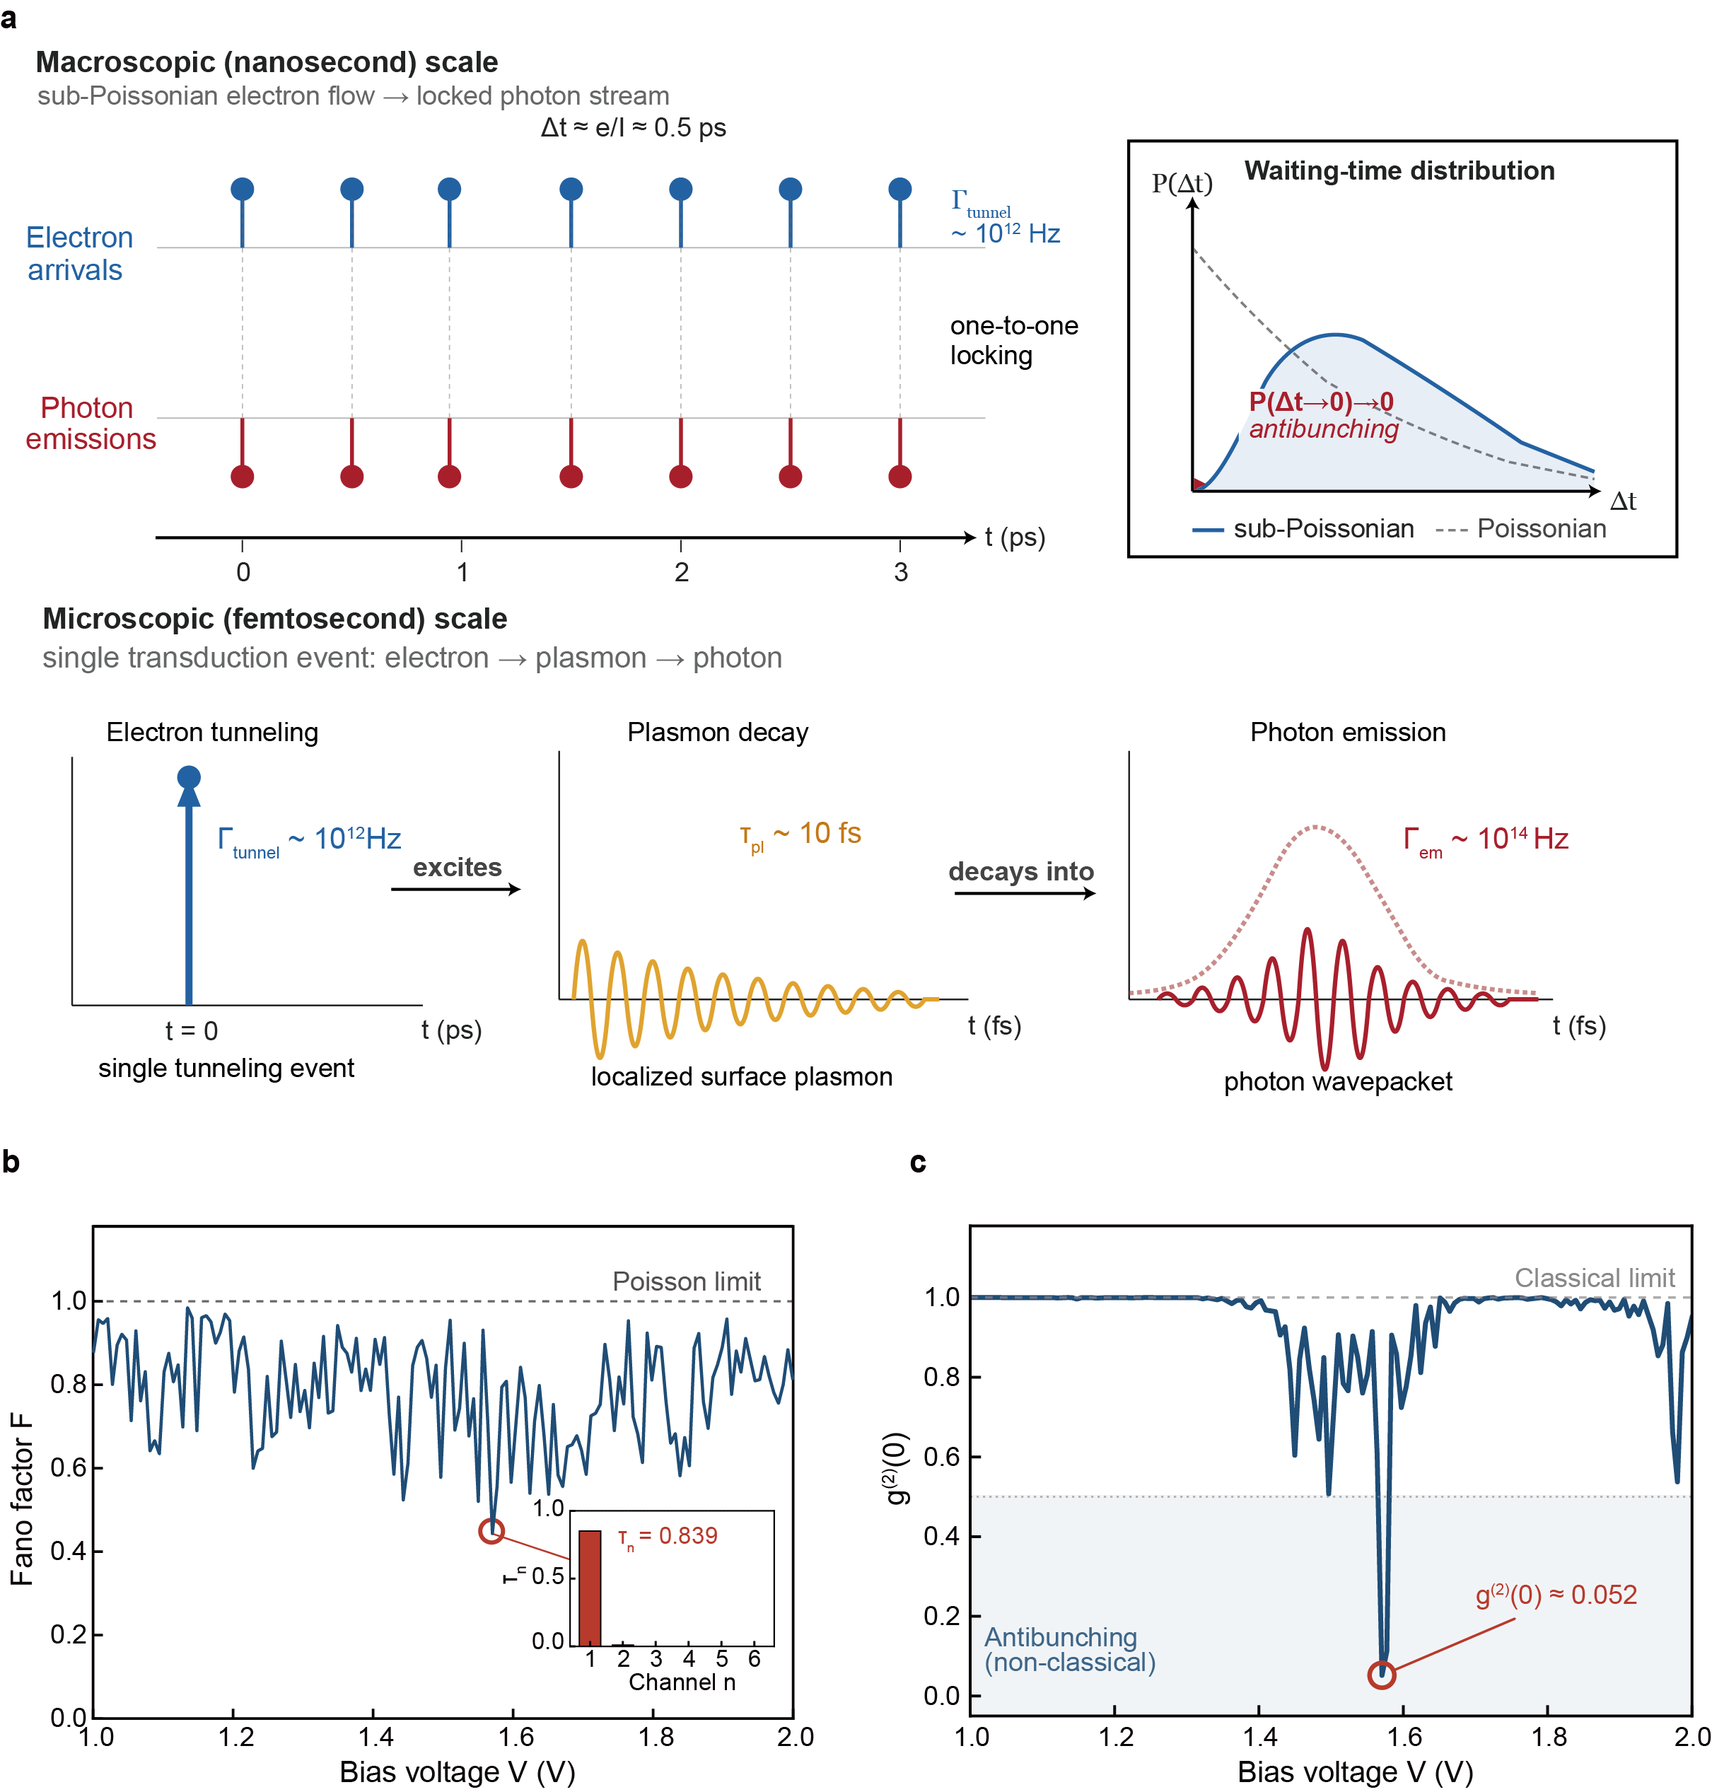
Figure 5 | Electron-to-photon transduction of quantum statistics. a, Temporal picture of statistical transduction. On the picosecond scale, sub-Poissonian electron arrivals are mapped onto photon emission events. The waiting-time distribution vanishes near zero delay, in contrast to a Poissonian source. On the femtosecond scale, each tunnelling event excites a localized plasmon that decays into a photon wavepacket. Because the plasmon decay rate exceeds the tunnelling rate by nearly two orders of magnitude, the antenna acts as a fast transducer rather than a temporal filter. b, Bias-dependent electronic Fano factor and transmission eigenvalues at the operating point, showing that transport is dominated by a single high-transmission channel. c, Calculated zero-delay photon correlation $g^{(2)}(0)$ derived from the electronic noise model. The operating point near 1.57 V combines high inelastic external excitation efficiency $η_{EQE}$ ≈ 60% with deeply sub-Poissonian photon statistics (g⁽²⁾(0) ≈ 0).

Supplementary Information
This PDF file includes:
Sections S1 to S8
Fig. S1

