**Final Report--Yipeng Hong 001228971**

**App introduction:**

An app to share your food

This is an app that can allow people to share what kind of food can be recommended to each other. If someone has some special food that want to share or discuss with other, he(she) can post it to the app. Other can search other user and check what he(she) posted. And user can follow or unfollow others, so user can know what other post on time. Also, user can comment on below.

**How to use:**

If you do not have an account, you need to sign in as a new user. And you can also select a picture for yourself.

Then, you can login as a user and you will be guided to home page. And you will see five buttons in the tabbar.

**1.** In the home page, you can see what you posted and the post time. If you had followed others, you can also see what he(she) posted in the home page.

The items in home page are sorted in home page.

Each item has its owner’s above and there are some buttons below the item. User can click on heart button to decide like to unlike it. Also, user can add comments by clicking on the message button and it will show all the comments of current item. The third button will be the chat button that allow user to send private message or have a chat with the owner of the item. The top right button of each item can allow user to check the item’s detail.

In the home page, you can take a new photo by clicking the top left button ( navigation bar ).



**2.** In the search page, you can see a list of other users and here is a search bar on the top of the screen.

By entering key words, you can search other users. After searching, you can click on the user and you will be guided to his(her) detail page which shows what he(she) posted before. And then you will see a button that allows you to decide whether to follow this user.

If you follow this user, what he(she) posted or what he(she) will post will be shown in your home page.

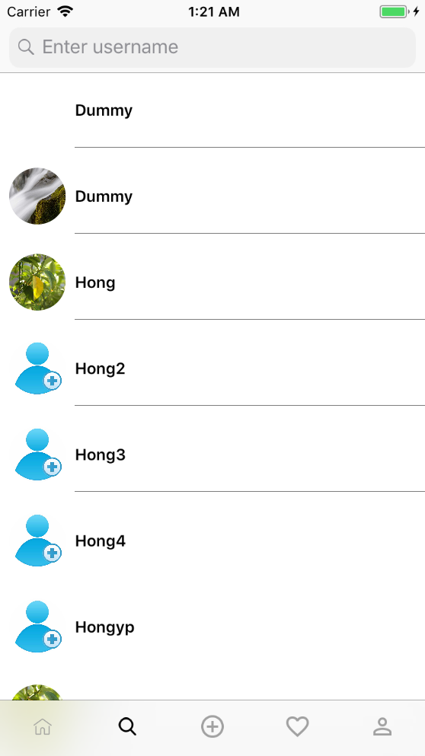 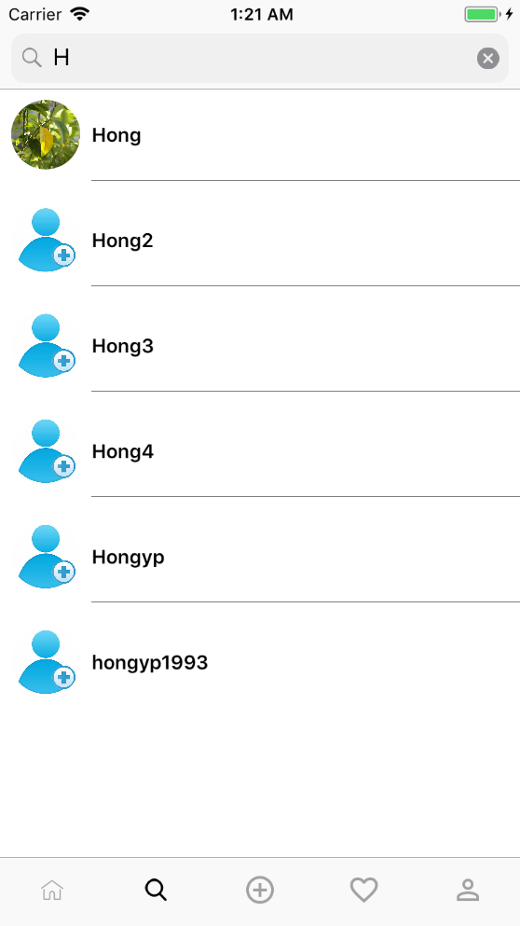

**3.** The third button in the tabbar allows user to post a new item to home page. It will show the picture from your photo library. After completing the information of the item, user will be guided to home page and can see the item posted with the time.

 

**4.**The fourth button will list out the items that you clicked on the heart button of specific item.

**5.** The last button in the tabbar is user’s account. It will show out all items of current user and the basic information of current user.

In this page, you can see the sign out button in top right.

The app will remember your login status and you don’t need to enter username and password every time. If you logout, you have to enter username and password to login.

The number of the posts, followers and following should change.

This page also use paginating that when user scroll down it will automatically show out the pictures from the library.

