
RTB Project
OpenRTB Dynamic Native Ads API Specification Version 1

February 2015

Introduction

The Native Ads sub-group of the IAB OpenRTB Project assembled in May 2014 to develop a new supplementary API specification for companies interested in an open protocol for the automated trading of Native Ads enabled media across a broader range of platforms, devices, and advertising solutions. This document is the culmination of those efforts.

About the IAB’s Networks & Exchanges Committee:
The IAB Networks & Exchanges Committee is comprised of senior leaders of ad networks and ad exchanges member companies. The committee is dedicated to furthering the interests of digital ecosystem in today's complex ad marketplace. Committee objectives are to foster the highest standards of professionalism and accountability in relationships with publishers, advertisers, intermediaries, and the agency community, to develop programs that enable revenue growth, and to create best practices that protect consumers and the industry.

The OpenRTB Project is a working group within the IAB Advertising Technology Council.

This document can be found at www.iab.net

IAB Contact Information:

Brendan Riordan-Butterworth Director of Technical Standards, IAB brendan@iab.net

License

OpenRTB Specification by OpenRTB is licensed under a Creative Commons Attribution 3.0
License, based on a work at openrtb.info. Permissions beyond the scope of this license may be available at http://openrtb.info. To view a copy of this license, visit http://creativecommons.org/licenses/by/3.0/ or write to Creative Commons, 171 Second Street, Suite 300, San Francisco, CA 94105, USA.

Table of Contents

Before You Get Started ...............................................................................................5

1 Introduction.........................................................................................................6
1.1 Mission / Overview ..............................................................................................................................6
1.2 Credits / Project History ....................................................................................................................6
1.3 Resources.................................................................................................................................................. 7
1.4 Version History ...................................................................................................................................... 7

2 Native Ads Basics .................................................................................................7
2.1 IAB Core Six ............................................................................................................................................. 7
2.2 Data Format ............................................................................................................................................. 9
2.3 Versioning ................................................................................................................................................9
2.4 Customization and Extensions.........................................................................................................9

3 Bid Request Details ............................................................................................ 10
3.1 Native Object Hierarchy .................................................................................................................. 10

4 Native Ad Request Markup Details ..................................................................... 11
4.1 Native Markup Request Object ..................................................................................................... 11
4.2 AssetObject ........................................................................................................................................... 12
4.3 Title Object ............................................................................................................................................ 13
4.4 Image Object......................................................................................................................................... 13
4.5 Video Object.......................................................................................................................................... 14
4.6 Data Object ............................................................................................................................................ 15

5 Native Ad Bid Response Markup ........................................................................ 16
5.1 Native Ad Creative JSON .................................................................................................................. 16
5.2 Native Object ........................................................................................................................................ 16
5.3 Asset Object .......................................................................................................................................... 17
5.4 Title Object ............................................................................................................................................ 18
5.5 Image Object......................................................................................................................................... 18
5.6 Data Object ............................................................................................................................................ 19
5.7 Video Object.......................................................................................................................................... 19
5.8 Link Object ............................................................................................................................................ 20

6 Bid Request/Response Samples.......................................................................... 21
6.1 App Wall Example .............................................................................................................................. 21
6.1.1 Bid Request ............................................................................................................ 21
6.1.2 Bid Response.......................................................................................................... 22
6.2 Chat List Example............................................................................................................................... 24
6.2.1 Bid Request ............................................................................................................ 24
6.2.2 Bid Response.......................................................................................................... 25
6.3 Content Stream with Video Element Example ....................................................................... 26
6.3.1 Bid Request ............................................................................................................ 26
6.3.2 Bid Response.......................................................................................................... 28
6.4 Google Text Ad..................................................................................................................................... 29
6.4.1 Bid Request ............................................................................................................ 29
6.4.2 Bid Response.......................................................................................................... 30

7 Reference Lists/Enumerations ............................................................................ 31
7.1 Native Layout IDs ............................................................................................................................... 31
7.2 Native Ad Unit IDs .............................................................................................................................. 31
7.3 Data Asset Types................................................................................................................................. 32
7.4 Image Asset Types ............................................................................................................................. 33

8 Implementation Notes ....................................................................................... 34
8.1 Multi Placement Bid Requests ...................................................................................................... 34

Before You Get Started

This specification contains a detailed explanation of a sub-protocol of the OpenRTB real-time bidding interface. Not all objects are required, and each object may contain a number of optional parameters. To assist a first time reader of the specification, we have indicated which fields are essential to support a minimum viable real time bidding interface for various scenarios (banner, video, mobile, etc.).

A minimal viable interface should include the required and recommended parameters, but the scope for these parameters may be limited to specific scenarios. In these cases, the scope will be qualified with the applicable scenarios (e.g., required for native impressions and recommended for native impressions). Conversely, if the scope is not qualified, it applies to all scenarios.

Optional parameters may be included to ensure maximum value is derived by the parties.

Required parameters must be included.

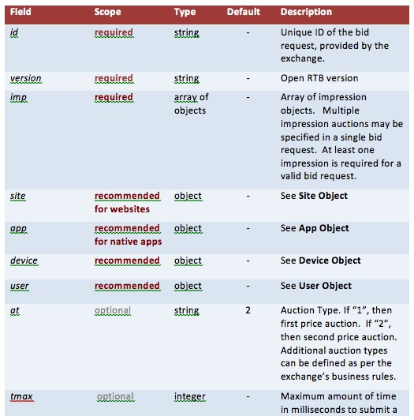Recommended parameters should be included unless there is a compelling reason to omit them.

Optional parameters may be included at your discretion.

IMPORTANT: Since recommended parameters are not required, they may not be available from all supply sources. It is suggested that all parties to OpenRTB transaction complete the integration checklist (please refer to OpenRTB 2.3) to identify which parameters the supply side supports in the bid request, and which parameters the demand side requires for ad decisioning.

1 Introduction

1.1 Mission / Overview

The mission of the OpenRTB Native project is to spur standardization and greater growth in the Real-Time Bidding (RTB) marketplace for Native Ads by providing open industry standards for communication between buyers of advertising and sellers of publisher inventory.

This specification is a sub-protocol of OpenRTB 2.3 to allow for the delivery of native advertising formats, as their specifics differ from publisher to publisher. In May 2013, a separate IAB subcommittee has been formed to define the request and response structures of native ad units.

Establishing a true open standard for this new format will be instrumental to native ads
adoption by app publishers and demand side platforms. With a common framework on the buy- side, the industry as a whole will benefit from increased demand for native ad formats.

1.2 Credits / Project History

Neal Richter & Avinash Shahdadpuri, Rubicon Project

Jim Butler, Nexage

Adam Morgenlender & Gabor Cselle, Twitter Narayanan Balakrishnan & Anand Narayanan, InMobi Giuseppe Di Mauro, PubMatic
Ilya Kaplun, Visible Measures Jennifer Lum, Adelphic Wesley Biggs, Byyd
Benoit Grouchko & Elisabeth Rotrou, Criteo

David Hernandez, AOL

Rajaraman Periasamy, RocketFuel

Jin Yu, OpenX

Anton Roslov, Phorm Andraž Tori, Zemanta Osvaldo Doederlein, Google

1.3 Resources

Resource Location
OpenRTB Website http://openrtb.info
OpenRTB Native Ads Project Page http://github.com/openrtb/OpenRTB/NativeAds.html
Developer / Product Manager http://groups.google.com/group/openrtb-native
Mailing List

1.4 Version History

Version 0.99.10.24 PUBLIC DRAFT October 24, 2014

Version 0.99.10.27 PUBLIC DRAFT October 27, 2014

Version 1.0.0.0 EXTERNAL DRAFT November 19, 2014

Version 1.0.0.1 EXTERNAL DRAFT December 14, 2014

Version 1.0.0.2 FINAL DRAFT January 23, 2015

2 Native Ads Basics

Native advertising is an online advertising method in which the advertiser attempts to gain attention by providing content in the context of the user's experience. Native ad formats match both the form and function of the user experience in which it is placed. This is in contrast to traditional banner or interstitials ads, which are displayed in a separate space of predefined and universal size, without regard to their surroundings.

2.1 IAB Core Six

The IAB Native Advertising Playbook lists six types of native ad units:

● In Feed Units
● Paid Search Units
● Recommendation Widgets
● Promoted Listings
● IAB Standard with Native Elements
● Custom / “Can’t be contained”
Some examples for native ad formats are shown below.

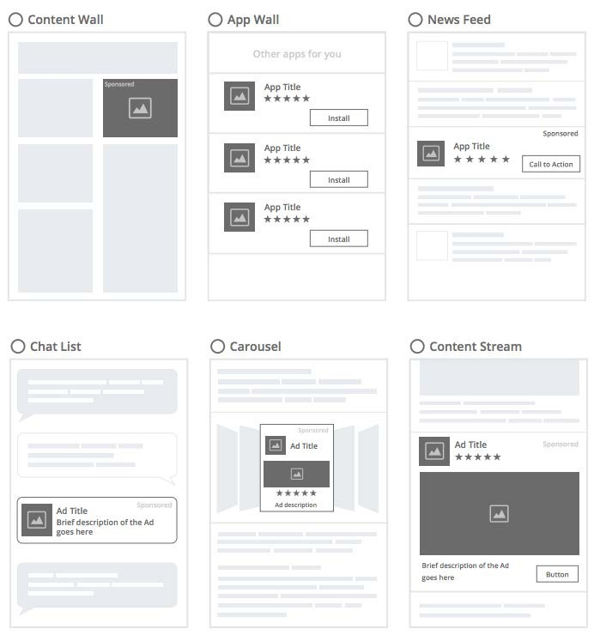

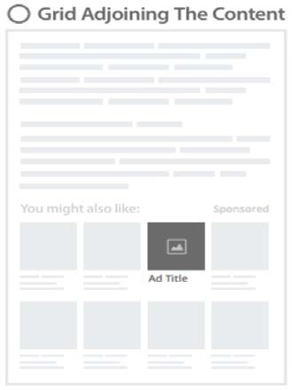

2.2 Data Format

As this specification outlines an optional sub-protocol of the main OpenRTB protocol payload, the format must follow that of its parent. Please refer to the main OpenRTB specification for details of various formats that may be used

2.3 Versioning

The Native Object in the Bid Request (OpenRTB 2.3) contains a “ver” field defining the version of the OpenRTB native extension.

2.4 Customization and Extensions

The OpenRTB Native Ads spec allows for exchange specific customization and extensions of the specification. Any object may contain extensions. In order to keep extension fields consistent across platforms, they should consistently be named ‘ext’.

3 Bid Request Details

RTB transactions are initiated when an exchange or other supply source sends a bid request to a bidder. The bid request consists of a bid request object, at least one impression object, and may optionally include additional objects providing impression context.

3.1 Native Object Hierarchy

Following is the object hierarchy for a bid request. The new Native Object is another optional element of the impression object, and can be specified as an alternative to or in conjunction with a banner object or video object.

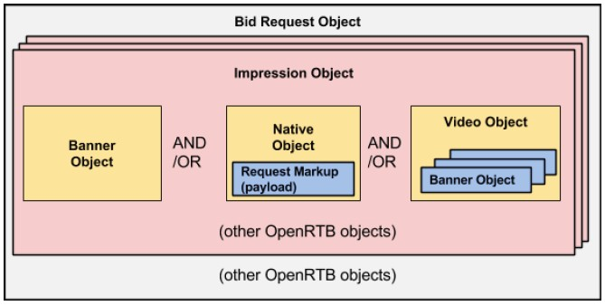

4 Native Ad Request Markup Details

4.1 Native Markup Request Object

The Native Object defines the native advertising opportunity available for bid via this bid request. It must be included directly in the impression object if the impression offered for auction is a native ad format.

The Default column dictates how optional parameters should be interpreted if explicit values are not provided.

Field Scope Type Default Description
ver optional string 1 Version of the Native Markup version in use.
layout recommended integer - The Layout ID of the native ad
unit. See the table of Native
Layout IDs below.
adunit recommended integer - The Ad unit ID of the native ad
unit. See the Table of Native Ad Unit IDs below for a list of supported core ad units.
plcmtcnt optional integer 1 The number of identical
placements in this Layout. Refer to Section 8.1 Multi Placement Bid Requests.
seq optional integer 0 xx (see the IAB Core Six layout
types). 0 for the first ad, 1 for the second ad, and so on. This is not the sequence number of the content in the stream.
assets required array of - An array of Asset Objects. Any
objects bid must comply with the array of elements expressed by the Exchange.
ext optional object - This object is a placeholder that
may contain custom JSON agreed to by the parties to support flexibility beyond the standard defined in this specification

4.2 AssetObject

The main container object for each asset requested or supported by Exchange on behalf of the rendering client. Any object that is required is to be flagged as such. Only one of the
{title,,img,video,data} objects should be present in each object. All others should be null/absent. The id is to be unique within the AssetObject array so that the response can be aligned.

Field Scope Type Default Description
id required int - Unique asset ID, assigned by exchange. Typically a counter for the array.
required optional int 0 Set to 1 if asset is required
(exchange will not accept a bid without it)
title optional1 object - Title object for title assets. See
Title Object definition.
img optional1 object - Image object for image assets.
See Image Object definition.
video optional1 object - Video object for video assets.
See the Video Object definition.
Note that in-stream video ads are not part of Native. Native ads may contain a video as the ad creative itself.
data optional1 object - Data object for ratings, prices
etc. See Data Object definition.
ext optional object - This object is a placeholder that
may contain custom JSON agreed to by the parties to support flexibility beyond the standard defined in this specification

1: asset object may contain only one of title, img, data or video.

4.3 Title Object

The Title object is to be used for title element of the Native ad.

Field | Scope | Type | Default | Description
len | required | integer | - | Maximum length of the text in
 |  |  |  | the title element.
ext | optional | object | - | This object is a placeholder that
 |  |  |  | may contain custom JSON
 |  |  |  | agreed to by the parties to
 |  |  |  | support flexibility beyond the
 |  |  |  | standard defined in this
 |  |  |  | specification

4.4 Image Object

The Image object to be used for all image elements of the Native ad such as Icons, Main Image, etc.

Field Scope Type Default Description
type optional integer - Type ID of the image element supported by the publisher. The publisher can display this information in an appropriate format. See Table Image Asset Types for commonly used examples.
w optional integer - Width of the image in pixels.
wmin recommended integer - The minimum requested width
of the image in pixels. This
option should be used for any rescaling of images by the client. Either w or wmin should be transmitted. If only w is
included, it should be considered an exact requirement.
h optional integer - Height of the image in pixels.

hmin recommended integer - The minimum requested height of the image in pixels. This option should be used for any rescaling of images by the client. Either h or hmin should be transmitted. If only h is included, it should be considered an exact requirement.

mimes optional array of strings

All types allowed

Whitelist of content MIME types supported. Popular MIME types include, but are not limited to “image/jpg” “image/gif”.

Each implementing Exchange should have their own list of supported types in the integration docs. See
Wikipedia's MIME page for more information and links to all IETF RFCs.

If blank, assume all types are allowed.

ext optional object - This object is a placeholder that may contain custom JSON agreed to by the parties to support flexibility beyond the standard defined in this specification

4.5 Video Object

The video object to be used for all video elements supported in the Native Ad. This corresponds to the Video object of OpenRTB 2.3. Exchange implementers can impose their own specific restrictions. Here are the required attributes of the Video Object. For optional attributes please refer to OpenRTB 2.3.

Field | Scope | Type | Default | Description
mimes | required | array |  | Content MIME types supported.
 |  | of strings |  | Popular MIME types include,but are not limited to “video/x-ms- wmv” for Windows Media, and “video/x-flv” for Flash Video.

minduration required integer - Minimum video ad duration in seconds.

maxduration required integer - Maximum video ad duration in seconds.

protocols required array of integers

- An array of video protocols the publisher can accept in the bid response. See OpenRTB 2.3
Table 5.8 Video Bid Response Protocols for a list of possible values.

ext optional object - This object is a placeholder that may contain custom JSON agreed to by the parties to support flexibility beyond the standard defined in this specification

4.6 Data Object

The Data Object is to be used for all non-core elements of the native unit such as Ratings, Review Count, Stars, Download count, descriptions etc. It is also generic for future of Native elements not contemplated at the time of the writing of this document.

Field Scope Type Default Description
type required integer - Type ID of the element supported by the publisher. The publisher can display this information in an appropriate format. See Table 7.3 Data Asset Types for commonly used examples.
len optional integer - Maximum length of the text in
the element’s response.
ext optional object - This object is a placeholder that
may contain custom JSON
agreed to by the parties to support flexibility beyond the standard defined in this specification

5 Native Ad Bid Response Markup

The structure and contents of the Bid Response is the same as in the OpenRTB standard. The difference is how ad creative is returned. The native creative is returned as a JSON-encoded string in the adm field of the Bid Object, or in response to calling the URL given in the nurl field of the Bid Object.

5.1 Native Ad Creative JSON

The JSON returned in adm or in response to nurl is a JSON string with the following attributes:

Field | Scope | Type | Default | Description
native | required | object | - | Top level Native object

5.2 Native Object

The native object is the top level JSON object which identifies a native response. The native object has following attributes

Field Scope Type Default Description
ver optional integer 1 Version of the Native Markup version in use.
assets required array of - List of native ad’s assets.
objects
link required object - Destination Link. This is default
link object for the ad. Individual assets can also have a link object which applies if the asset is activated (clicked). If the asset doesn’t have a link object, the parent link object applies. See LinkObject Definition
imptrackers[] optional array of - Array of impression tracking
strings URLs, expected to return a 1x1 image or 204 response - typically only passed when using 3rd
party trackers.

jstracker | optional | string | - Optional JavaScript impression  tracker. This is a valid HTML, Javascript is already wrapped in  <script> tags. It should be executed at impression time where it can be supported.
ext | optional | object | - This object is a placeholder that  may contain custom JSON agreed to by the parties to support flexibility beyond the standard defined in this specification

5.3 Asset Object

Corresponds to the Asset Object in the request. The main container object for each asset requested or supported by Exchange on behalf of the rendering client. Any object that is required is to be flagged as such. Only one of the {title,img,video,data} objects should be present in each object. All others should be null/absent. The id is to be unique within the AssetObject array so that the response can be aligned.

Field Scope Type Default Description
id required int - Unique asset ID, assigned by exchange, must match one of the asset IDs in request
required optional int 0 Set to 1 if asset is required.
(bidder requires it to be displayed).
title optional1 object - Title object for title assets. See
Title Object definition.
img optional1 object - Image object for image assets.
See Image Object definition.
video optional1 object - Video object for video assets.
See Video Object definition.
Note that in-stream video ads are not part of Native. Native ads may contain a video as the ad creative itself.
data optional1 object - Data object for ratings, prices
etc.

link | optional | object | - Link object for call to actions.  The link object applies if the asset item is activated (clicked). If there is no link object on the asset, the parent link object on the bid response applies.
ext2 | optional | object | - This object is a placeholder that  may contain custom JSON agreed to by the parties to support flexibility beyond the standard defined in this specification

1: asset object may contain only one of title, img, data or video.

2: Bidders are encouraged not to use asset.ext for exchanging text assets. Use data.ext with custom type instead.

5.4 Title Object

Corresponds to the Title Object in the request, with the value filled in.

Field | Scope | Type | Default | Description
text | required | String | - | The text associated with the text
 |  |  |  | element.
ext | optional | object | - | This object is a placeholder that
 |  |  |  | may contain custom JSON
 |  |  |  | agreed to by the parties to
 |  |  |  | support flexibility beyond the
 |  |  |  | standard defined in this
 |  |  |  | specification

5.5 Image Object

Corresponds to the Image Object in the request. The Image object to be used for all image elements of the Native ad such as Icons, Main Image, etc.

Field | Scope | Type | Default | Description
url | required | string | - | URL of the image asset.

w | recommended | integer | - Width of the image in pixels.
h | recommended | integer | Height of the image in pixels.
ext | optional | object | - This object is a placeholder that
 |  |  | may contain custom JSON
 |  |  | agreed to by the parties to
 |  |  | support flexibility beyond the
 |  |  | standard defined in this
 |  |  | specification

5.6 Data Object

Corresponds to the Data Object in the request, with the value filled in. The Data Object is to be used for all miscellaneous elements of the native unit such as Ratings, Review Count, Stars, Downloads, Price count etc. It is also generic for future of Native elements not contemplated at the time of the writing of this document.

Field Scope Type Default Description
label optional string - The optional formatted string name of the data type to be displayed.
value required string - The formatted string of data to
be displayed. Can contain a formatted value such as “5 stars” or “$10” or “3.4 stars out of 5”.
ext optional object - This object is a placeholder that
may contain custom JSON agreed to by the parties to support flexibility beyond the standard defined in this specification

5.7 Video Object

Corresponds to the Video Object in the request, yet containing a value of a conforming VAST tag as a value.

Field | Scope | Type | Default | Description
vasttag | required | string | - | VAST xml.

5.8 Link Object

Used for ‘call to action’ assets, or other links from the Native ad. This Object should be associated to its peer object in the parent Asset Object or as the master link in the top level Native Ad response object. When that peer object is activated (clicked) the action should take the user to the location of the link.

Field Scope Type Default Description
url required string - Landing URL of the clickable link.
clicktrackers[] optional array of - List of third-party tracker URLs to
strings be fired on click of the URL.
fallback optional string - Fallback URL for deeplink. To be
(URL) used if the URL given in url is not
supported by the device.
ext optional object - This object is a placeholder that
may contain custom JSON agreed to by the parties to support flexibility beyond the standard defined in this specification

6 Bid Request/Response Samples

6.1 App Wall Example

The ad might look like -

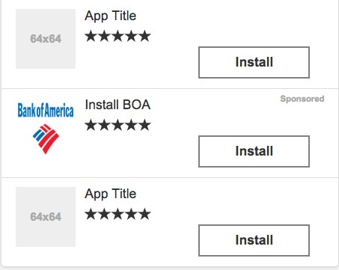

6.1.1 Bid Request

{
"native": { "assets": [
{
"id": 1, "required": 1, "title": {
"len": 30
}
},
{
"id": 2, "required": 0, "data": {
"type": 3,
"len": 5
}

},
{
"id": 3, "required": 1, "img": {
"type": 1, "w": 64, "h": 64, "mimes": [
"image/png"
]
}
},
{
"id": 4, "required": 0, "data": {
"type": 2,
"len": 10
}
}
]
}
}

6.1.2 Bid Response

{
"native": { "ver": 1, "link": {
"url": "deeplink://deeplink/url/into/app", "fallback": "http: //i.am.a/URL", "clicktrackers": [
"http: //a.com/a",
"http: //b.com/b"
]
},
"imptrackers": [
"http: //a.com/a",
"http: //b.com/b"
],
"assets": [
{
"id": 1, "title": {
"text": "InstallBOA"
},

"link": {
"url": "http: //i.am.a/URL"
}
},
{
"id": 2, "data": {
"value": 5
}
},
{
"id": 3, "img": {
"url": "http: //cdn.mobad.com/ad.png", "w": 64,
"h": 64
}
},
{
"id": 4, "data": {
"value": "Install"
},
"link": {
"url": "http: //i.am.a/URL"
}
}
]
}
}

6.2 Chat List Example

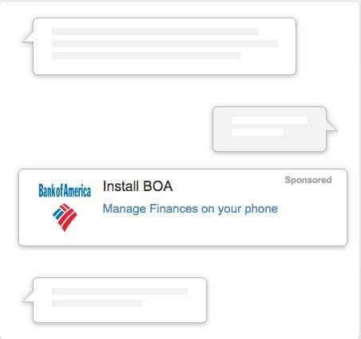

6.2.1 Bid Request

{
"native": { "layout": 4, "assets": [
{
"id": 1, "required": 1, "title": {
"len": 30
}
},
{
"id": 2, "required": 0, "data": {
"type": 2,
"len": 100
}

},
{
"id": 3, "required": 1, "img": {
"type": 1, "w": 64, "h": 64, "mimes": [
"image/png"
]
}
}
]
}
}

6.2.2 Bid Response

{
"native": { "ver": 1, "link": {
"url": "deeplink://deeplink/url/into/app", "fallback": "http: //i.am.a/URL", "clicktrackers": [
"http: //a.com/a",
"http: //b.com/b"
]
},
"imptrackers": [
"http: //a.com/a", "http: //b.com/b"
],
"assets": [
{
"id": 1, "title": {
"text": "Install BOA"
}
},
{
"id": 2, "data": {
"value": "Manage Finances on your phone"
}
},
{

"id": 3, "img": {
"url": "http://cdn.mobad.com/ad.png",
"w": 64, "h": 64
}
}
]
}
}

6.3 Content Stream with Video Element Example

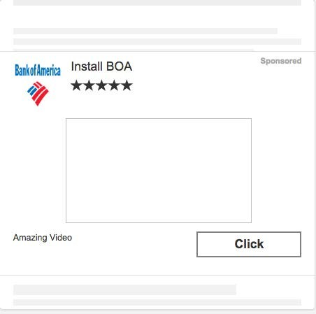

6.3.1 Bid Request

{
"native": { "layout": 6,

"assets": [
{
"id": 1, "required": 1, "title": {
"len": 30
}
},
{
"id": 2, "required": 0, "data": {
"type": 3,
"len": 10
}
},
{
"id": 3, "required": 1, "img": {
"w": 64, "h": 64, "mimes": [
"image/png"
]
}
},
{
"id": 4, "video": {
"linearity": 1, "minduration": 15, "maxduration": 30, "protocols": [
"VAST 2.0"
]
}
},
{
"id": 5, "required": 0, "data": {
"type": 2,
"len": 10
}
}
]
}
}

6.3.2 Bid Response
{
"native": { "ver": 1, "link": {
"url": "deeplink://deeplink/url/into/app", "fallback": "http: //i.am.a/URL", "clicktrackers": [
"http: //a.com/a",
"http: //b.com/b"
]
},
"assets": [
{
"id": 1, "title": {
"text": "Install BOA"
}
},
{
"id": 2, "data": {
"value": 5
}
},
{
"id": 3, "img": {
"url": "http://cdn.mobad.com/ad.png", "w": 1200,
"h": 627
}
},
{
"id": 4, "video": {
"vasttag": "<VAST version=’2.0’></VAST>"
}
},
{
"id": 5, "data": {
"value": "Click"
},
"link": {
"url": "http://i.am.a/URL"
}
}
]
}

}

6.4 Google Text Ad

An Google text ad with title, description 1, description 2 and display url can be represented as -

6.4.1 Bid Request

{

"native": { "assets": [
{

"id": 1, "title": {
"len": 25

}

},

{

"id": 2, "data": {
"type": 2,

"len": 35

}

},

{

"id": 3, "data": {
"type": 10,

"len": 35

}

},

{

"id": 4, "data": {
"type": 11, "len": 35

}

}

]

}

}

6.4.2 Bid Response
{
"native": { "ver": 1, "link": {
"url": "deeplink://deeplink/url/into/app", "fallback": "http: //i.am.a/URL", "clicktrackers": [
"http: //a.com/a",
"http: //b.com/b"
]
},
"assets": [
{
"id": 1, "title": {
"text": "Plasma Television"
}
},
{
"id": 2, "data": {
"value": "Huge range of equipment on sale"
}
},
{
"id": 3, "data": {
"value": "Free delivery. Order now."
}
},
{
"id": 4, "data": {
"value": "mybestplasmatvstore.com"
}
}
]
}
}

7 Reference Lists/Enumerations

7.1 Native Layout IDs

Below is a list of the core layouts described in the introduction above.

An implementing exchange may not support all asset variants or introduce new ones unique to that system.

Layout ID Description
1 Content Wall
2 App Wall
3 News Feed

4 Chat List

5 Carousel
6 Content Stream
7 Grid adjoining the content

500+ Reserved for Exchange specific layouts.

7.2 Native Ad Unit IDs
Below is a list of the core ad unit ids described by IAB here http://www.iab.net/media/file/IABNativeAdvertisingPlaybook120413.pdf

In feed unit is essentially a layout, it has been removed from the list. The in feed units can be identified via the layout parameter on the request.

An implementing exchange may not support all asset variants or introduce new ones unique to that system.

Ad Unit ID Description
1 Paid Search Units
2 Recommendation Widgets
3 Promoted Listings
4 In-Ad (IAB Standard) with Native Element Units

5 Custom /”Can’t Be Contained”
500+ Reserved for Exchange specific formats.

7.3 Data Asset Types

Below is a list of common asset element types of native advertising at the time of writing this spec. This list is non-exhaustive and intended to be extended by the buyers and sellers as the format evolves.

An implementing exchange may not support all asset variants or introduce new ones unique to that system.

Type Name Description Format
ID
1 sponsored Sponsored By message where response should text contain the brand name of the sponsor.

2 desc Descriptive text associated with the product or text service being advertised.
3 rating Rating of the product being offered to the user. number
For example an app’s rating in an app store from formatted as
0-5. string
4 likes Number of social ratings or “likes” of the product number being offered to the user. formatted as
string

5 downloads Number downloads/installs of this product number formatted as string

6 price Price for product / app / in-app purchase. Value number should include currency symbol in localised formatted as format. string

7 saleprice Sale price that can be used together with price to number indicate a discounted price compared to a regular formatted as price. Value should include currency symbol in string localised format.

8 phone Phone number formatted string

9 address Address text
10 desc2 Additional descriptive text associated with the text product or service being advertised
11 displayurl Display URL for the text ad text
12 ctatext CTA description - descriptive text describing a ‘call text to action’ button for the destination URL.
500+ XXX Reserved for Exchange specific usage numbered Unknown above 500

7.4 Image Asset Types

Below is a list of common image asset element types of native advertising at the time of writing this spec. This list is non-exhaustive and intended to be extended by the buyers and sellers as the format evolves.

An implementing exchange may not support all asset variants or introduce new ones unique to that system.

Type
ID
Name Description

1 Icon Icon image
2 Logo Logo image for the brand/app.
3 Main Large image preview for the ad
500+ XXX Reserved for Exchange specific usage numbered above 500

8 Implementation Notes

8.1 Multi Placement Bid Requests

If the bid request has a placement count (“plcmtcnt”) greater than 1, then the implication is that the bidder is submitting bids to a Generalized Second Price auction where multiple identical placements are being offered in the same content feed or stream.

Example: If a bid request is for 5 ad placements within a feed based layout. The bidder can return 1-5 bids. The exchange runs a generalized second price auction across these bids. The bidder can potentially win between 0-5 placements in the auction.

An example bid response would look like

{

"id": "1234567890", "seatbid": [{
"bid": [{

"id": "1", "impid": "1", "price": 10,
"nurl": "http://adserver.com/WinNoticeUrlThatReturnsNative1",

"adm":"<native response>"

},

"bid": [{

"id": "2", "impid": "1", "price": 20,
"nurl": "http://adserver.com/WinNoticeUrlThatReturnsNative2"

"adm":"<native response>"

}]

}]

}

