**Structural Properties of Copper, Silver and Gold Nanorods under Strain: Molecular Dynamics Simulations**

Hüseyin Yağlı1, Şakir Erkoç1,2

# Abstract

Structural properties of copper, silver and gold nanowires with three different widths generated from low-index surfaces (100), (110), (111) have been investigated under strain. Classical molecular dynamics simulations have been performed at 1 K and 300 K using an atomistic potential consisting of two body interactions among the atoms. Strain has been applied to the nanowires along the uniaxial wire direction. It has been found that uniaxial strain shows cross section geometry and temperature dependent characteristics. The nanowires generated from (100) and (110) surfaces are relatively stronger against uniaxial strain than the nanowires generated from (111) surface. Temperature has a positive effect to the ductility of the nanowires. The nanowires under strain, could not form 1-D structures without fragmentation.

**Keywords:** atomistic potential, molecular dynamics, copper nanowires, silver nanowires, gold nanowires, strain

Çalışmada (100), (110), (111) düşük indisli yüzeylerden üretilmiş üç farklı kalınlıktaki bakır, gümüş ve altın nanotellerin yapısal özellikleri tek eksen boyunca uygulanan gerinim altında incelenmiştir. Klasik moleküler dinamik benzetişimleri 1 K ve 300 K sıcaklıklarında, atomlar arası iki parça etkileşimlerinden oluşan atomistik bir potansiyel kullanılarak gerçekleştirilmiştir. Gerinim nanotellere tek eksen ve tel boyunca uygulanmıştır. Gerinimin kesit geometrisine ve sıcaklığa bağımlılık gösterdiği bulunmuştur. (100) ve (110) yüzeylerinden üretilen nanotellerin (111) yüzeyinden üretilen nanotellere göre gerinim altında daha dayanıklı olduğu bulunmuştur. Sıcaklığın sünekliğe olumlu bir etkisi vardır. Nanoteller gerinim altında, parçalanmadan tek boyutlu formlar alamamıştır.

**Anahtar kelimeler:** atomistik potansiyel, moleküler dinamikler, bakır nanoteller, gümüş nanoteller, altın nanoteller, gerinim

# Introduction

Important advances in the research and development of nanowires and nanorods took place after advances in microscopy and characterization techniques reached smaller length scales down to individual atoms.

Nanowires exhibit some properties that are very different from their bulk counterparts. What makes the nanowires interesting is that material properties that are not changeable in bulk materials can be controlled to fit the requirements of the intended application area (Wang, Yin, Wang, Buldum, & Zhao, 2001). It has been shown that using nanowires, highly flexible and mechanically bendable electronics and sensors can be produced to develop an artificial skin that can give the sense of touch (Takei, et al., 2010).

Characterization of nanowires is important in order to establish a reproducible relationship with the characteristics of nanowires and the desired functionality. Because of the high surface to volume ratio in nanowires, their properties depend very much on the surface conditions and geometry. Nanowires of the same material can show different mechanical properties depending on their aspect ratios, surface conditions and miller indices (Chen, Shi, Zhang, Zhu, & Yan, 2006).

The small sizes and high surface-to-volume ratios of one-dimensional nanostructures endow them with a variety of interesting and useful mechanical properties. Their high stiffness and strength lend them to applications in tough composites and as nanoscale actuators, force sensors and calorimeters (Wang, et al., 2006). One-dimensional nanostructures also showcase unique stability effects driven by the dominance of their surfaces and internal interfaces. As the scale of materials reduces to nanometers, the tendency of surfaces to minimize their free energy may drive structural changes that propagate into the bulk (Liang, Zhou, & Ke, 2005). Nanowire synthesis techniques can yield single-crystalline structures with a much lower density of line defects than is typically found in bulk materials. As a result, one-dimensional nanostructures often feature a mechanical strength, stiffness, and toughness approaching the theoretical limits of perfect crystals, making them attractive for use in composites and as actuators in nanoelectromechanical systems (NEMS) (Lu & Panchapakesan, 2006).

While silicon is the most popular material in nanowire synthesis; gold, copper and silver are also largely researched as nanowire materials. The materials selected vary according to intended application area.

For example, many studies have focused on the fabrication of copper nanowires because of their potential applications in the micro/nanoelectronics industry and, in particular, for interconnection in electronic circuits. Copper is one of the most important metals in modern electronic technology (Bowler, 2004).

Gold nanowires that are 30nm axially and up to 20 microns in length are finding use as an alternative or complimentary material to carbon nanotubes. They are highly conductive, more transparent, and unlike silver nanowires, are resistant to corrosion or oxidation. Nanowires have shown to be useful as a carbon nanotube replacement in touchscreen displays and transparent electrodes (Haberer, Joo, Hodelin, & Hu, 2009). Gold nanowires have also shown promise when used as highly sensitive electronic biosensors (Parab, et al., 2009).

Gold nanorods are being researched in photothermal cancer therapies and in enhancing in-vivo imaging using photoacoustics and highly efficient non-linear optics such as four wave mixing (Fourkal, et al., 2009).

Silver nanowires have a lot of optical usages and surface functionalized silver nanorods allow for the particles to be preferentially adsorbed at the surface interface using chemically bound polymers (Zhu, et al., 2011).

Nanotechnology has various potential military applications, especially in the field of sensors, transducers, nanorobotics, nanoelectronics, propellants & explosives to enhance the performance of weapon systems and devices. Nanotechnology is going to play a very important role in the development of materials and devices that will have major roles in military applications as well as societal changes. An example is the usage of nanowires capable of conducting electricity in various new forms of memories and storage devices (Chappert, Fert, & Van Dau, 2007). The reduction in size of the systems from computers to wireless phones is a continuing trend for electronic defense systems (Kharat, Muthurajan, & Praveenkumar, 2006). Another example would be the use of nanowire chemical sensors in biological and chemical warfare threat detection (Walter, et al., 2002).

A technique for fabrication of metal nanowires with controlled widths was presented by Natelson et.al. allowing the production of nanowires from a variety of materials on a size scale below 10 nm (Natelson, Willett, West, & Pfeiffer, 2000).

Previous simulation studies on this area focus on molecular dynamics (MD) simulations on Cu and Au nanowires. Mechanical responses of FCC nanowires dependent on size and strain have been investigated and revealed that momentum induced disorder plays an important role in the phase transformations during the deformation (Koh & Lee, 2006). Their study simulates circular nanowires resembling the models in this study. The simulations are conducted using an embedded-atom model and results show strain values in excess of 60% with low strain rates which agree with results of the current study. Another study on the stress-strain relationship of thin nanowires have applied MD simulation and showed that high temperatures exhibit more complex stress-strain phenomena (Ju, Lin, & Lee, 2004). Dunn et al. have performed atomistic simulations on square cross-section FCC gold nanowires aligned in the <100> and <111> directions and found an increase in Young’s modulus with a decrease of cross-sectional area (Dunn, Gall, & Martin, 2004). In another study, mechanical deformations of Cu {100} nanowires have been investigated in cases of elongation, shearing, rotation and rotated elongation and different yielding and fracturing mechanisms has been shown (Hwang & Ho-Jung, 2001). H.A. Wu applied an embedded-atom model to study mechanical properties of copper nanowires using MD simulations and obtained results showing the importance of surface atoms in mechanical behavior of nanostructures (Wu, 2006).

“In addition to the novel optical, electronic, and thermal properties of nanowires, technological advances have been achieved based on the mechanical properties of nanowires. Due to the high surface-to-volume ratio of nanowires, their mechanical properties are strongly influenced by the nature of the surface atoms. In addition to a different bonding nature of surface atoms, surface stresses play an important role in the mechanical properties of nanowires (Dasgupta, et al., 2014).”

In this study, mechanical properties of copper, silver and gold nanowires are investigated under a uniaxial strain. Classical MD simulations have been conducted on nanowires generated from three low-index surfaces (100), (110) and (111) for all three materials. Three cylindrical models with different widths for each surface of each material have been prepared. The simulations have been performed at two different temperatures; 1K and 300K. The stability of the materials under a 5% strain per one step has been investigated.

# Method of calculation

To prepare the inputs, appropriate working cells have been generated using positions from the face centered cubic (FCC) lattice sites. This resulted in different coordinates for different surfaces. The working cells have been repeated along all 3 dimensions to obtain the desired sizes for the nanowires. Outer atoms at the corners of the obtained rectangular nanowires have been removed to obtain cylindrical models resembling real nanowires obtainable from synthesis. The results were 3 different sized models for each surface and 9 different model in total. These models are shown in Figure 1. The lattice positions of these 9 different models were similar for each of the three materials since all were FCC materials. The only difference was the proportions of the models changing relative to their lattice constants. The initials models are shown below as the basis models for all three materials. Geometrical parameters of all the models are given in Table 1. The system is made pseudo–infinite by the application of periodic boundary conditions in the three Cartesian directions. This is achieved by the “nearest image convention” (Schofield, 1973).

All of the prepared models were inputted into the simulations under 1K and 300K to observe the effect of the temperature on the mechanical properties of the nanowires.

|  |  |  |  |
| --- | --- | --- | --- |
| a) | **C:\Users\Huseyin\Documents\Tez\resimler\inputs\Birlestir\Cu-100-big.jpg** | d) | **C:\Users\Huseyin\Documents\Tez\resimler\inputs\Birlestir\Cu-110-big.jpg** |
| b) | **C:\Users\Huseyin\Documents\Tez\resimler\inputs\Birlestir\Cu-100-medium.jpg** | e) | **C:\Users\Huseyin\Documents\Tez\resimler\inputs\Birlestir\Cu-110-medium.jpg** |
| c) | **C:\Users\Huseyin\Documents\Tez\resimler\inputs\Birlestir\Cu-100-small.jpg** | f) | **C:\Users\Huseyin\Documents\Tez\resimler\inputs\Birlestir\Cu-110-small.jpg** |
| g) | **C:\Users\Huseyin\Documents\Tez\resimler\inputs\Birlestir\Cu-111-big.jpg** | i) | **C:\Users\Huseyin\Documents\Tez\resimler\inputs\Birlestir\Cu-111-small.jpg** |
| h) | **C:\Users\Huseyin\Documents\Tez\resimler\inputs\Birlestir\Cu-111-medium.jpg** |  |  |
| Figure 1: Initial models common for all materials: a) 100-A b) 100-B c) 100-C d) 110-A e) 110-B f) 110-C g) 111-A h) 111-B i) 111-C | | | |

Table 1: Geometrical parameters of the ideal models

|  |  |  |  |  |  |  |  |  |  |
| --- | --- | --- | --- | --- | --- | --- | --- | --- | --- |
| **Models** | **Radius (Å)** | | | **Length (Å)** | | | **# of atoms** | | |
| **Cu** | **Ag** | **Au** | **Cu** | **Ag** | **Au** | **Cu** | **Ag** | **Au** |
| 100-A | 8.07 | 9.15 | 9.14 | 23.53 | 26.59 | 26.52 | 147 | | |
| 100-B | 5.71 | 6.47 | 6.45 | 84 | | |
| 100-C | 3.61 | 4.09 | 4.08 | 35 | | |
| 110-A | 12.75 | 14.46 | 14.41 | 24.23 | 27.47 | 27.41 | 300 | | |
| 110-B | 7.66 | 8.68 | 8.66 | 140 | | |
| 110-C | 5.1 | 5.78 | 5.76 | 70 | | |
| 111-A | 8.84 | 10.02 | 9.99 | 22.91 | 25.97 | 25.91 | 148 | | |
| 111-B | 5.89 | 6.67 | 6.65 | 76 | | |
| 111-C | 2.96 | 3.35 | 3.34 | 28 | | |

When the absence of external forces is assumed, the total energy of *N* interaction particles can be expressed as

|  |  |
| --- | --- |
|  | (1) |

where represents the sum of *n*-body interaction energy. If the particles are non-interacting the equation becomes

|  |  |
| --- | --- |
|  | (2) |

The difference between these two energies gives us the interaction energy of N interacting particles as a function of their position.

|  |  |
| --- | --- |
|  | (3) |
|  | (4) |
|  | (5) |

where represent two-body interactions. The quantity is defined as the total configuration energy of the system and is a measurable quantity. In this many-body expansion, the series has a quick convergence and the higher moments can be neglected so that the complexity of the computations can be reduced and the size of the simulated systems can grow (Murrell, Carter, Farantos, Huxley, & Varandas, 1984). The contribution of these truncated terms can be included into the empirical potential energy function with the use of various linear or non-linear parameters (Erkoç, Empirical many-body potential energy functions used in computer simulations of condensed matter properties, 1997).

In these atomistic level computer simulations the Erkoc empirical model potential was used (Erkoç, 1994). The potential energy function (PEF) is formed from pair interactions, which contains many-body effects and it has been parameterized for the FCC metal elements copper, silver and gold. The total energy of the system is expressed as the linear combination of two two-body functions (Erkoç, 2001):

*Φ* = D21*ϕ*21 + D22*ϕ*22 (6)

*ϕ*21 and*ϕ*22 are the two-body energies and two body interactions are:

(7)

(8)

The pair interaction function is split into two parts to allow the insertion of more linear parameters. The parts consist of a repulsive term and an attractive term. D21 and D22 are many body expansion terms. *ϕ*21 and *ϕ*22 are the two body energies. The equation (8) is the atomic interactions in terms of inter-atomic distances. This equation contains there parameters (A, alpha and lambda) which will be changed according to material used and the repulsive-attractive term.

Table 2: Parameters used for the materials studied (Erkoç, 1994).

|  |  |  |  |
| --- | --- | --- | --- |
| Parameters | **Cu** | **Au** | **Ag** |
| ***A1*** | 110.766008 | 345.923364 | 220.262366 |
| ***λ1*** | 2.09045946 | 1.0428923 | 1.72376253 |
| ***α1*** | 0.394142248 | 0.750775965 | 0.673011507 |
| ***A2*** | -46.1649783 | -38.9245908 | -26.0811795 |
| ***λ2*** | 1.49853083 | 1.05974062 | 1.81484791 |
| ***α2*** | 0.207225507 | 0.229377368 | 0.120620395 |
| ***D21*** | 0.436092895 | 0.888911352 | 1.00610152 |
| ***D22*** | 0.245082238 | 0.254280292 | 0.221234242 |

The MD time step is calculated as (Erkoç, 2004);

(9)

where m is mass of the atom, r0 is the equilibrium distance and ϵ0 is the equilibrium energy. The velocities and positions of the particles are calculated using the velocity summed form of Verlet algorithm. The initial velocities of the particles are determined from the Maxwell distribution at the given temperature. To achieve the constant temperature, simple velocity scaling thermostat method is used in the simulations (Erkoç, Lecture notes on simulations of many-particle systems, METU, 2004).

The MD simulation software was completely written by the authors using FORTRAN. Then for performance purposes, it has been ported to ANSI C++ and was modified to use OpenMP. At its final version, it could fully utilize all the cores of the CPU of the system it’s running on. The simulations were carried out on multiple 8-core PCs.

The first phase of the simulations was to repeat the MD steps using constant stress to remove the initial stresses of the systems. After the first relaxations, the systems were elongated by 5% and MD steps were repeated for the systems to reach equilibrium again. This strain and relaxation process will be called a strain step. The strain and relaxation processes were repeated until fragmentation occurred along the nanowires.

# Results

While the smaller models needed only a few ten thousands steps to reach equilibrium at 1K, a minimum of 100,000 steps were repeated for each model. Larger models required more than 20,000,000 steps to reach equilibrium at 300K. The following list shows the relaxed state of the nanowires, the state with highest strain and the state after the fracturing occurs. The images are presented with a view from the z axis which is the axis of the strain and a view from the x axis which shows the length of the nanowire.

## Cu Nanowires at 1 K and 300 K

**Cu-100A:** At 1K, the crystal structure is preserved until strain step 5 (22% strain). Then the structure takes an amorphous form and continues to stretch until strain step 11 where necking occurs at the periodic boundaries. Along with the necking, some clustering occurs at the center of the wire. The fracturing occurs near the periodic boundary location after a 63% strain.

At 300K, when the system was relaxed, the nanowire bent due to the formation of new bonds and the need for space of the crystal structure being suppressed at the periodic boundaries. The crystal structure is preserved with little deformation at strain step 14 (89% strain). This strain is the longest one among all the simulations. At this point a dislocation occurred at the middle of the wire and the fractured wire formed a cluster with no apparent crystal structure. The clustering did not occur at 1K.

1K: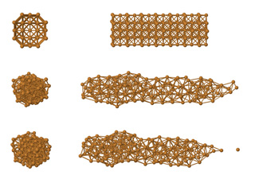 300K: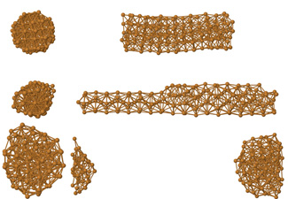

Figure 2: Cu-100A 1K and 300K

**Cu-100B:** At 1K, the structure could only stretch 2 strain steps (10% strain). At 300K the same model could stretch 5 strain steps (28% strain) even though some clustering occurred at a region. No clustering was present in either temperatures.

1K: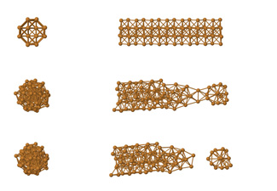 300K: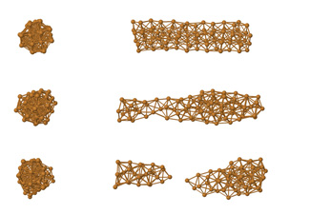

Figure 3: Cu-100B 1K and 300K

**Cu-100C:** The model 100C has a very brittle initial form due to the lattice positions of the FCC model and the narrow size of the nanowire. But as the nanowire relaxed, the model took a more tubular form. At 1K, the model stretched 4 steps (16%) and fractured near the periodic boundary resulting with little clustering. But at 300K, due to the temperature, the system clustered and fractured at the first relaxation without any strain applied.

1K: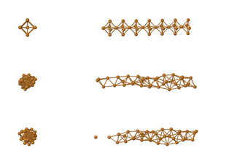300K: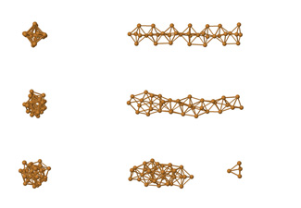

Figure 4: Cu-100C 1K and 300K

**Cu-110A:** In order to have a tubular model, due to different lattice positions, the 110A model had to be larger than the models of other miller indices. Despite the larger size, 110A model didn’t show a behavior as ductile as the 100A model at 300K but could stretch to same length at 1K. While the model displayed a brittle fracture at 1K and ductile fracture at 300K, the final length that the model reached at both temperatures was the same 63% strain at the 10th strain step. At both temperatures, the model preserved its crystal structure even with some clustering.

1K: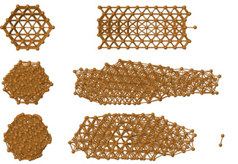 300K: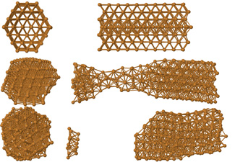

Figure 5: Cu-110A 1K and 300K

**Cu-110B:** For copper, 110B model was the most ductile of the medium sized models. At 1K, the model stretched until strain step 7 (41% strain) where it fractured at the periodic boundary. At 300K the model stretched until strain step 7 (41% strain)

1K: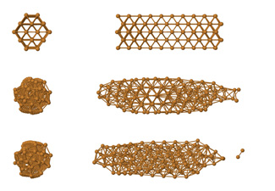 300K: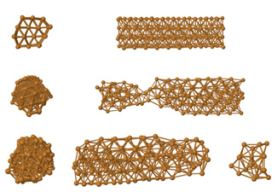

Figure 6: Cu-110B 1K and 300K

**Cu-110C:** While forming tubular models, the 110 face had the best lattice positions at the smallest size of the model. Due to the ideal initial structure of the model, the 110 face was the most ductile of the small models for copper, gold and silver. The model stretched 7 strain steps for both cryo and room temperatures resulting a 41% strain. The model fractured near the periodic boundary with a brittle fracture at 1K. The fracture occurred at a necking point in a ductile fashion at 300K after which some clustering occurred.

1K: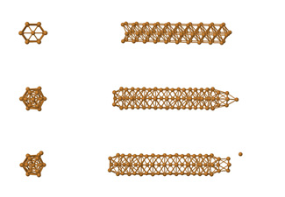 300K: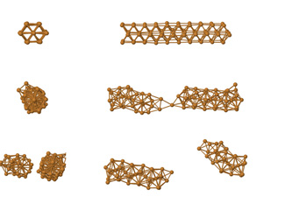

Figure 7: Cu-110C 1K and 300K

**Cu-111A:** The lattice positions for this model were very ideal for a round wire and formed a very ideal initial model. But the model was very brittle at 1K and fractured easily at the periodic boundary location at the fifth strain step (34% strain). The model was relatively more ductile at 300K and stretched 8 strain steps (48% strain) before the occurrence of a ductile fracture with two necking locations and some clustering present. After fracturing the wire cluttered. The 111 miller indices was the least ductile for copper models. The model also required nearly 10,000,000 time steps to relax at each strain step at 300K. The same model required only 100,000 time steps to relax at 1K.

1K: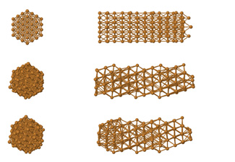 300K: 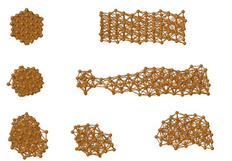

Figure 8: Cu-111A 1K and 300K

**Cu-111B:** At 1K, The model fractured at the strain step 3 (16% strain). At 300K, the wire stretched until strain step 5 (28% strain). Both simulation resulted with brittle fractures and no clustering occurred.

1K: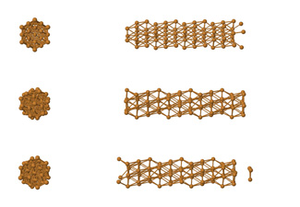 300K: 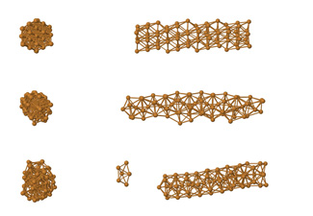

Figure 9: Cu 111B 1K and 300K

**Cu-111C:** The initial form of the 111C model was very fragile at the beginning of the simulation with a single atom at each third atomic plane. But the model gained a tubular form after relaxation. Especially at 1 K, the model took a form similar to a nanotube. At 1K the model fractured after 2 strain steps (10% strain) at the periodic boundary location. At 300K the model could not stretch and fractured at the first relaxation and formed a cluster.

1K: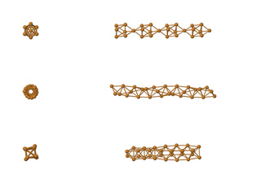 300K: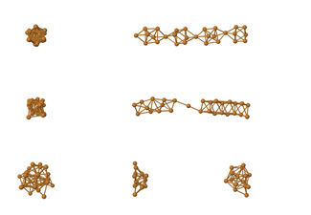

Figure 10: Cu 111C 1K and 300K

## Ag Nanowires at 1K and 300K

**Ag-100A:** At 1K, the structure fractured at the periodic boundary locations at strain step 3 (16% strain) and suffered little clustering and preserved its crystal structure even at this point. At 300K the model could stretch two times longer than at 1K and could withstand 6 strain steps (34% strain) with some deformation and necking at the center. The model suffered a ductile fracture.

1K: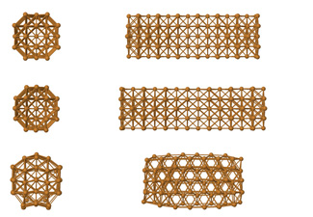 300K: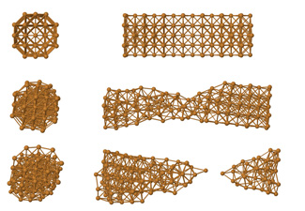

Figure 11: Ag 100A 1K and 300K

**Ag-100B:** The same fracture mechanisms of the Ag-100A model were apparent at this model at 1K and the model stretched 3 strain steps (16% strain) without any deformation. At 300K, the model fractured and clustered at strain step 2 (10% strain).

1K: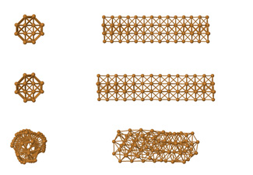 300K: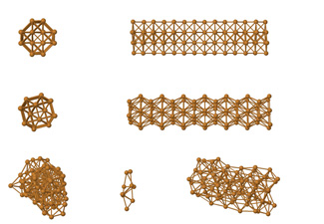

Figure 12: Ag 100B 1K and 300K

**Ag-100C:** Relative to copper, the smaller 100C model was more ductile and could stretch 3 strain steps (16% strain) at 1K and 4 strain steps (22% strain) at 300K. The model took a tubular form at both temperatures after relaxing. No clustering occurred after the fracture.

1K: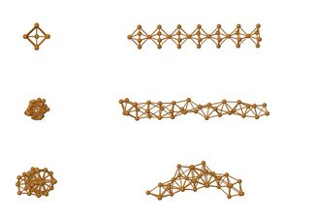 300K: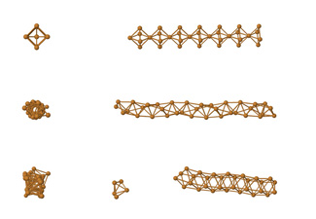

Figure 13: Ag 100C 1K and 300K

**Ag-110A:** The largest model of the simulations 110A was more ductile compared to 100A model but wasn’t as ductile as the copper model. It stretched a 6 strain steps (34% strain) at 1K and stretched 9 strain steps (55% strain) at 300K. The system preserved it crystal structure at 1K but some local deformations and necking at the center occurred at 300K.

1K: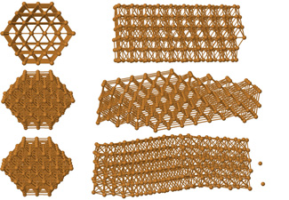 300K: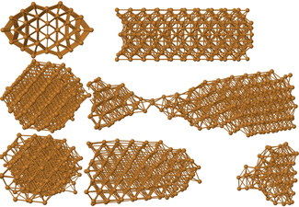

Figure 14: Ag 110A 1K and 300K

**Ag-110B:** This model was the most ductile for Ag compared to Cu and Au. The model could stretch 6 strain steps (34% strain) at 1K and 8 strain steps (48% strain) at 300K. After the necking occurred the model tends to form a crystal structure which is not aligned to z-axis.

1K: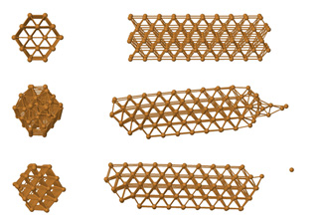 300K: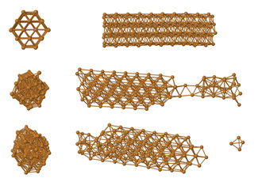

Figure 15: Ag 110B 1K and 300K

**Ag-110C:** The model stretched without any crystal deformations and fractured after 4 strain steps (16% strain) at 1K and 5 strain steps (22% strain) at 300K. Clustering was observed at 300K.

### 1K:C:\Users\Huseyin\Documents\Tez\resimler\Sec\Sec-Ag-110\Ag-110C-1K.jpg 300K:C:\Users\Huseyin\Documents\Tez\resimler\Sec\Sec-Ag-110\Ag-110C-3K.jpg

Figure 16: Ag 110C 1K and 300K

**Ag-111A:** Despite its large size, the model was very brittle at 1K and fractured at the periodic boundary locations after only 3 strain steps (16% strain). The model was the most ductile in all three simulated materials and could stretch 10 strain steps (63% strain). Some clustering occurred at center of the model.

### 1K:C:\Users\Huseyin\Documents\Tez\resimler\Sec\Sec-Ag-111\Ag-111a-1K.jpg 300K:C:\Users\Huseyin\Documents\Tez\resimler\Sec\Sec-Ag-111\Ag-111A-3K.jpg

Figure 17: Ag 111A 1K and 300K

**Ag-111B:** This model’s ductility was equal for both temperatures and had brittle fractures at 3rd strain step (16% strain). Clustering was observed at 1K.

### 1K:C:\Users\Huseyin\Documents\Tez\resimler\Sec\Sec-Ag-111\Ag-111B-1K.jpg 300K:C:\Users\Huseyin\Documents\Tez\resimler\Sec\Sec-Ag-111\Ag-111B-3K.jpg

Figure 18: Ag 111B 1K and 300K

**Ag-111C:** For both temperatures this model could only stretch one stain step (5% strain) and fractured at periodic boundary locations and clustered.

1K: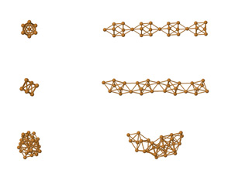 300K: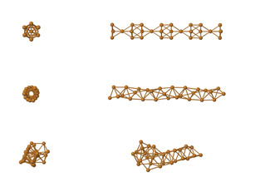

Figure 19: Ag 111C 1K and 300K

## Au Nanowires at 1K and 300K

**Au-100A:** This model wasn’t very ductile for Au. At 1K, it fractured at the 3rd strain step (16% strain). At 300K, it fractured at the 4th strain step (22% strain). The crystal structure was preserved at both temperatures and no clustering occurred.

1K: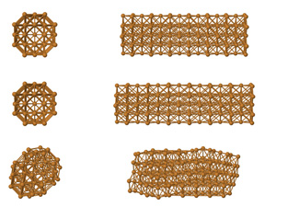 300K: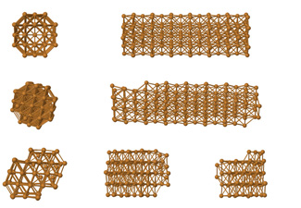

Figure 20: Au 100A 1K and 300K

**Au-100B:** Brittle fractures occurred at 3rd strain step (10% strain) for both temperatures. No clustering was observed.

1K: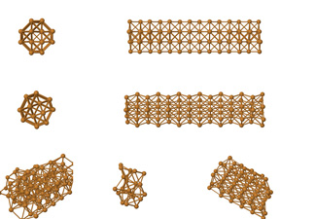 300K: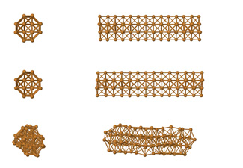

Figure 21: Au 100B 1K and 300K

**Au-100C:** The model easily fractured at 1K at the first strain step (5% strain) but could stretch 3 strain steps (16% strain) at 300K then fractured without clustering.

1K: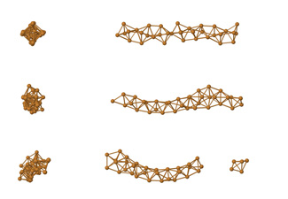 300K: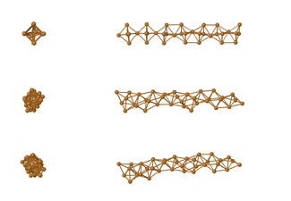

Figure 22: Au 100C 1K and 300K

**Au-110A:** Like the other materials, this miller indices was the most ductile for Au too. At 1K the model took an interesting shape at the first relaxation and stretched until strain step 7 (41% strain). At 300K, the same model stretched until strain step 8 (48% strain) and fractured with some clustering.

1K: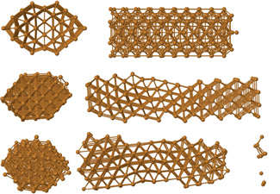 300K: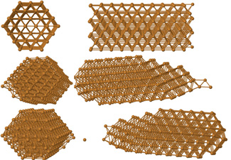

Figure 23: Au 110A 1K and 300K

**Au-110B:** After the first strain step, the model fractured near periodic boundary locations and showed the same tendency as Ag to form a crystal lattice not aligned to the initial z-axis. The model fractured at strain steps 5 (28% strain) and 6 (34% strain) at 1K and 300K respectively. No clustering was observed.

1K: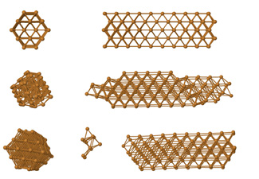 300K: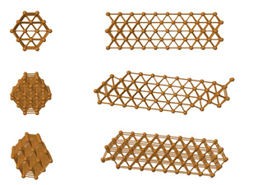

Figure 24: Au 110B 1K and 300K

**Au-110C:** This model was very stable for Au and could stretch 4 strain steps (22% strain) at 1K and 6 strain steps (34% strain) at 300K. No clustering was observed.

### 1K:C:\Users\Huseyin\Documents\Tez\resimler\Sec\Sec-Au-110\Au-110C-3K.jpg 300K:C:\Users\Huseyin\Documents\Tez\resimler\Sec\Sec-Au-110\Au-110C-1K.jpg

Figure 25: Au 110C 1K and 300K

**Au-111A:** The model easily fractured at 1K at step 4 (22% strain). At 300K the model fractured at step 6 (34% strain) with a necking location at the center. No clustering was observed.

### 1K:C:\Users\Huseyin\Documents\Tez\resimler\Sec\Sec-Au-111\Au-111A-1K.jpg 300K:C:\Users\Huseyin\Documents\Tez\resimler\Sec\Sec-Au-111\Au-111A-3K.jpg

Figure 26: Au 111A 1K and 300K

**Au-111B:** The model was very brittle at both temperatures and fractured at the 2nd strain step (10% strain). The brittle fracture occurred at the periodic boundary location at 300K. No clustering was observed and the crystal structure was preserved at both temperatures.

### 1K:C:\Users\Huseyin\Documents\Tez\resimler\Sec\Sec-Au-111\Au-111B-3K.jpg 300K:C:\Users\Huseyin\Documents\Tez\resimler\Sec\Sec-Au-111\Au-111B-1K.jpg

Figure 27: Au 111B 1K and 300K

**Au-111C:** The model tended to cluster at both temperatures after fracturing at the 1st strain step (5% strain). Unlike the other two materials, 111C model of gold did not take a tubular form. No clustering was observed.

1K: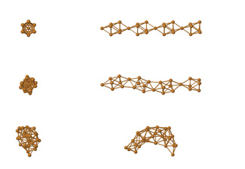 300K: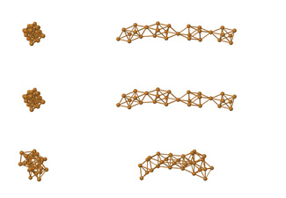

Figure 28: Au 111C 1K and 300K

## Energy graphics

Graphics for the strain and total system energy changes of the nanowires are given in Figures 29 to 34. The strain values are calculated as percent change compared to the initial size of the nanorods. The energy changes are given as the amount of energy changes in the total energies of the systems compared to the initial relaxed state. The energies of the systems advance towards zero as the systems are stretched and the negative potential energy between the atoms decrease. As the nanowire fractures, the energy of the system suddenly drops because of the clustering of the atoms in the fractured parts.

Figure 29: Strain energy with respect to strain for different sizes of Cu nanowires at 1K.

Figure 30: Strain energy with respect to strain for different sizes of Cu nanowires at 300K

Figure 31: Strain energy with respect to strain for different sizes of Ag nanowires at 1K

Figure 32: Strain energy with respect to strain for different sizes of Ag nanowires at 300K

Figure 33: Strain energy with respect to strain for different sizes of Au nanowires at 1K

Figure 34: Strain energy with respect to strain for different sizes of Au nanowires at 300K

E0 being the total energy of the system after the first relaxation, Ei is calculated as the total energy of the system after each strain step. So ***ΔE*** in the graphics is calculated as Ei – E0 for each strain step and is show in the graphics with respect to percent strain obtained after the related strain step.

L0 being the length of the nanowire at the initial configuration, Li is calculated as the length of the nanowire after each strain step. ***ΔL*** is calculated as:

(10)

The high peak of strain energy for the largest model of (100) face at 1 K (Figure 33) shows that the nanowire has stretched without any deformations resulting an increase in the distance of atoms and the total negative energy of the system is at its highest.

# Conclusion

For each simulation result, the mechanics of crystalline dislocation deformation due to strain was analyzed from the atomic structural rearrangements of the nanowires.

When the nanowires are first allowed to relax without any strain, an initial tensile strength is present and the nanowires were bent along the z-axis. These initial tensile stresses were similarly observed in other works (Koh & Lee, 2006). The magnitude of these initial tensile stresses vary inversely with the proportion of surface atoms present in the nanowires.

For all three materials, the effect of the width is the most important parameter in the ductility of the nanowires. While the nanowires with 8 Å width (A models) have the most tendency to stretch without fracturing, the smallest nanowires with 3-to-4 Å width (C models) do not stretch at all in most cases. While six of the C models could not stretch more than one strain step, only three of the models were ductile enough not to fracture before the fourth strain step. This is mainly due to the high ratio of surface atoms in the smaller nanowires. Surface atoms have relatively less interaction energy with respect to the bulk atoms. This, coupled with asymmetrical bonding of surface atoms with neighboring atoms, results in surface tension in restrained surfaces and surface contraction in unrestrained surfaces (Koh & Lee, 2006). This results in a higher tendency to fracture and to cluster in these small nanowires. As another effect of size, Koh and Lee reported in their work that since thermal induced disorder mainly affects the surface atoms, this effect was predominant in nanowires with diameters smaller than 5 Å, which have the largest proportion of surface atoms (Koh & Lee, 2006).

The change of temperature towards 300 K (room temperature) has a positive effect in the ductility of the materials. The materials stretch in an average 32% more at 300 K than 1 K in the simulations. It is well known for conventional high-purity FCC metals that, while their yield strength is insensitive to temperature and strain rate, their strain hardening is strongly temperature, and to a lesser extent, strain rate dependent. The uniform and efficient storage of dislocations leads to a high strain hardening rate at low temperatures. The main cause is the annihilation of dislocations through thermally activated cross slips. Another cause is the depression of climb at grain boundaries (Wang & Ma, 2003). Another effect of temperature is the increased yield strength at lower temperatures. The effect is apparent in simulations for the Cu-111A model. While the crystal structure is preserved at 1 K, the same model suffers plastic deformations at 300 K. These simulation results are coherent with real experiments (Wang & Ma, 2003). The effect is caused by a thermally activated deformation mechanism operative at room temperature and especially at slow strain rates, but not at lower temperatures.

Crystal orientations is also another important parameter for the nanowires in the amount of strain before fracturing. It has been shown that uni-axial strain shows cross-section geometry dependent characteristics. Nanowires which span the (110) face along the z-axis tend to have the most ductility for all the three metals while the (111) face is the most brittle. This is mainly due to the number of bonds between the planes being the least for the (111) face and the most for the (110). Also the gap between the planes is the largest for (111) plane. Another cause would be that that plastic elongation of a gold face-centered cubic crystal structure involves the sliding of (111) planes with respect to each other (Sorensen, Brandbyge, & Jacobsen, 1998). The transition states and energies for slip mechanisms have been determined in that work by Sorensen using the nudged elastic band method. A size-dependent crossover from a dislocation-mediated slip to a homogeneous slip is detected when the contact diameter becomes less than a few nm which is the case in our simulations.

As a conclusion, according to results of the present simulations, Cu nanowires seem to be more ductile, whereas Au nanowires seem to be more brittle with respect to the other materials studied in this work. These results could help future researches for metallic nanowire applications for their mechanical strength properties.

As a future work, more detailed study of the deformation mechanisms of the nanowires under strain could be conducted. Another interesting study could be to simulate the torsion effect on the same materials instead of strain effect. The molecular dynamics simulation study of the torsion effect could show interesting mechanical properties of these metals.

# References

Bowler, D. R. (2004). Atomic-scale nanowires: physical and electronic structure. *Journal of Physics: Condensed Matter, 16*(24), R721.

Chappert, C., Fert, A., & Van Dau, F. N. (2007). The emergence of spin electronics in data storage. *Nature materials, 6*(11), 813-823.

Chen, C. Q., Shi, Y., Zhang, Y. S., Zhu, J.-L., & Yan, Y. J. (2006). Size Dependence of Young's Modulus in ZnO Nanowires. *Phys. Rev. Lett., 96*(7), 075505.

Dasgupta, N. P., Sun, J., Liu, C., Brittman, S., Andrews, S. C., Lim, J., . . . Yang, P. (2014). 25th Anniversary article: semiconductor nanowires--synthesis, characterization, and applications. *Advanced Materials*, 2137-2184.

Dunn, J. D., Gall, K., & Martin, L. (2004). Atomistic simulation of the structure and elastic properties of gold nanowires. *Journal of the Mechanics and Physics of Solids, 52*(9), 1935 - 1962.

Erkoç, Ş. (1994). An Empirical Many-Body Potential Energy Function Constructed from Pair-Interactions. *Zeitschrift für Physik D Atoms Molecules and Clusters Vol.32*, 257.

Erkoç, Ş. (1997). Empirical many-body potential energy functions used in computer simulations of condensed matter properties. *Physics Reports, 278*(2), 79--105.

Erkoç, Ş. (2001). Empirical Potential Energy Functions Used in the Simulations of Materials Properties. *Annual Review of Computational Physics Vol.9, World Scientific Ltd. pp1-103*.

Erkoç, Ş. (2004). *Lecture notes on simulations of many-particle systems, METU.* (Unpublished).

FINBOW, B. G., MCDONALD, R. L.-B., & IR. (2010). Atomistic simulation of the stretching of nanoscale metal wires. *Molecular Physics, 92*(4), 705-714.

Fourkal, E., Velchev, I., Taffo, A., Ma, C., Khazak, V., & Skobeleva, N. (2009). Photo-Thermal Cancer Therapy Using Gold Nanorods. *World Congress on Medical Physics and Biomedical Engineering, IFMBE Proceedings*(25), 761-763.

Haberer, E. D., Joo, J. H., Hodelin, J. F., & Hu, E. L. (2009). Enhanced photogenerated carrier collection in hybrid films of bio-templated gold nanowires and nanocrystalline CdSe. *Nanotechnology, 20*(41), 415206. doi:10.1088/0957-4484/20/41/415206

Hwang, J.-W. K., & Ho-Jung. (2001). Mechanical deformation study of copper nanowire using atomistic simulation. *Nanotechnology, 12*(3), 295.

Jmol. (2013). *an open-source Java viewer for chemical structures in 3D*. Retrieved from jmol: http://www.jmol.org

Ju, S.-P., Lin, J.-S., & Lee, W.-J. (2004). A molecular dynamics study of the tensile behaviour of ultrathin gold nanowires. *Nanotechnology, 15*(9), 1221.

Kharat, D., Muthurajan, H., & Praveenkumar, B. (2006). Present and Futuristic Military Applications of Nanodevices. *Synthesis and Reactivity in Inorganic, Metal-Organic, and Nano-Metal Chemistry, 36*(2), 231-235.

Koh, S. J., & Lee, H. P. (2006). Molecular dynamics simulation of size and strain rate dependent mechanical response of FCC metallic nanowires. *Nanotechnology, 17*(14), 3451.

Liang, W., Zhou, M., & Ke, F. (2005). Shape Memory Effect in Cu Nanowires. *Nano Letters, 5*(10), 2039-2043.

Lu, S., & Panchapakesan, B. (2006). Hybrid platinum/single-wall carbon nanotube nanowire actuators: metallic artificial muscles. *Nanotechnology, 17*(3), 888.

Murrell, J., Carter, S., Farantos, S., Huxley, P., & Varandas, A. (1984). Molecular Potential Energy Functions. *Wiley*.

Natelson, D., Willett, R., West, K., & Pfeiffer, L. (2000). Fabrication of extremely narrow metal wires. *Applied Physics Letters, 77*(13), 1991-1993.

Parab, H. J., Chen, H. M., Lai, T.-C., Huang, J. H., Chen, P. H., Liu, R.-S., . . . Hwu, Y.-K. (2009). Biosensing, Cytotoxicity, and Cellular Uptake Studies of Surface-Modified Gold Nanorods. *The Journal of Physical Chemistry C*(113), 7574-7578.

Schofield, P. (1973). Computer simulation studies of the liquid state. *Computer Physics Communications, 5*(1), 17-23.

Sorensen, M. R., Brandbyge, M., & Jacobsen, K. W. (1998). Mechanical deformation of atomic-scale metallic contacts: structure and mechanisms. *Physical Review B, 57*(6), 3283.

Takei, K., Takahashi, T., Ho, J. C., Ko, H., Gillies, A. G., & Paul W. Leu, R. S. (2010). Nanowire active-matrix circuitry for low-voltage macroscale artificial skin. *Nature Materials, 9*, 821–826. doi:10.1038/nmat2835

Walter, E. C., Penner, R. M., Liu, H., Ng, K. H., Zach, M. P., & Favier, F. (2002). Sensors from electrodeposited metal nanowires. *Surf. Interface Anal., 34*, 409–412. doi:10.1002/sia.1328

Wang, B., Yin, S., Wang, G., Buldum, A., & Zhao, J. (2001). Novel Structures and Properties of Gold Nanowires. *Phys. Rev. Lett., 86*(10), 2046-2049.

Wang, X., Zhou, J., Song, Liu, J., Xu, N., & Wang, Z. L. (2006). Piezoelectric Field Effect Transistor and Nanoforce Sensor Based on a Single ZnO Nanowire. *Nano Letters, 6*(12), 2768-2772.

Wang, Y., & Ma, E. (2003). Temperature and strain rate effects on the strength and ductility of nanostructured copper. *Applied physics letters, 83*(15), 3165--3167.

Wu, H. (2006). Molecular dynamics study on mechanics of metal nanowire. *Mechanics Research Communications, 33*(1), 9-16.

Zhu, R., Chung, C.-H., Cha, K. C., Yang, W., Zheng, Y. B., Zhou, H., . . . Yang, Y. (2011). Fused Silver Nanowires with Metal Oxide Nanoparticles and Organic Polymers for Highly Transparent Conductors. *ACS Nano, 5*(12), 9877-9882. doi:10.1021/nn203576v

