**ELEC 4700**

**Assignment 2**

**Name: Hongzhao Zheng**

**Student number: 100965369**

**Part 1**

1. 2D plot of V(x) for the case where V=1 at x=0 and V=0 at x=L. And dV/dy=0.

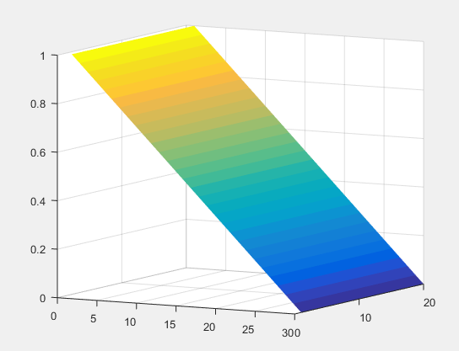

Figure 1: 2D plot of V(x)

1. Surface plot for V(x,y) using Finite Difference method is shown in Figure 2.

Surface plot for V(x,y) using Analytical Solution method is shown in Figure 3.

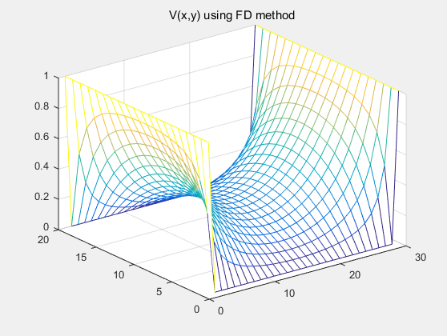

Figure 2: V(x,y) using FD method

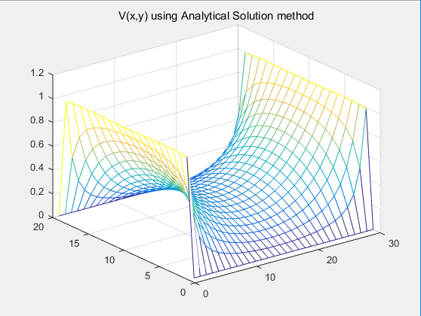

Figure 3: V(x,y) using AS method

Conclusion:

As the size of the meshing grid becomes moderately smaller, the surface plot gets smoother. However, if the size of meshing grid gets too small, the error generated by FD method becomes obvious. Both numerical and analytical methods have some error. For analytical method,

$$V\left(x,y\right)=\frac{4V_{0}}{π}\sum_{n=1,3,5…}^{∞}{\frac{1}{n}\frac{cosh\left(\frac{nπx}{a}\right)}{cosh\left(\frac{nπb}{a}\right)}sin⁡\left(\frac{nπy}{a}\right) }$$

As n goes beyond certain value, the plot does not agree with the plot generated by FD method. The analytical solution works for n less than a certain value.

**Part 2**

1. Surface plot for sigma(x,y) is shown in Figure 4.

Surface plot for V(x,y) is shown in Figure 5.

Surface plot for Ex(x,y) is shown in Figure 6.

Surface plot for Ey(x,y) is shown in Figure 7.

Plot for J(x,y) is shown in Figure 8.

Notice: The conductor is set to be 1V on the left side and 0V on the right side with two boxes in between. The current being investigated is the one coming out from the right side of the conductor.

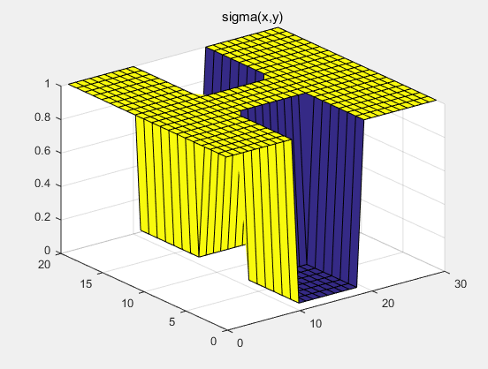

Figure 4: sigma(x,y)

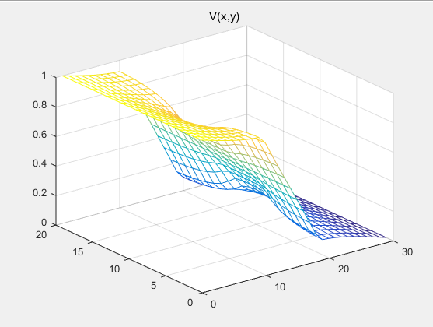

Figure 5: V(x,y)

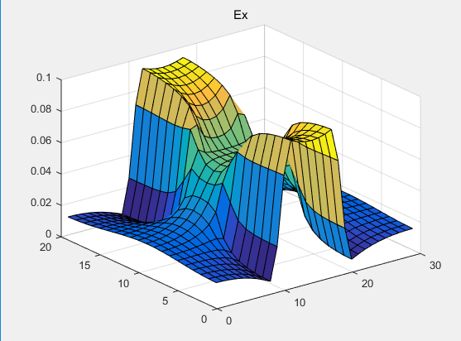

Figure 6: Ex(x,y)

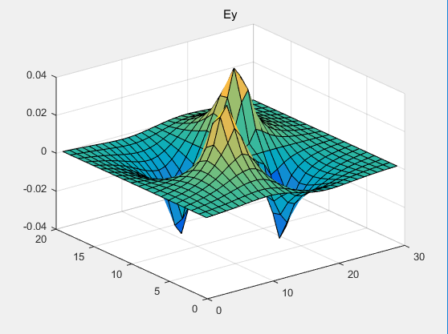

Figure 7: Ey(x,y)

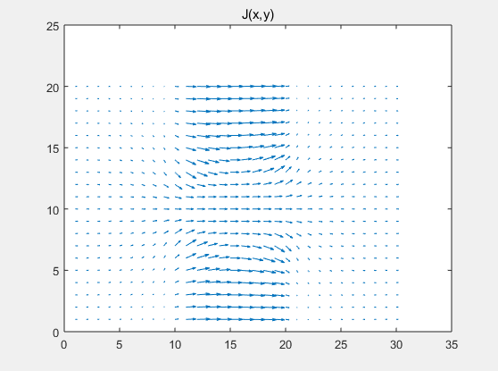

Figure 8: J(x,y)

1. As mesh density becomes larger (W and L both get larger), the current coming out from the right side of the conductor varies, and it converges to about 0.25. The graph of current vs mesh size is shown in Figure 9 below.

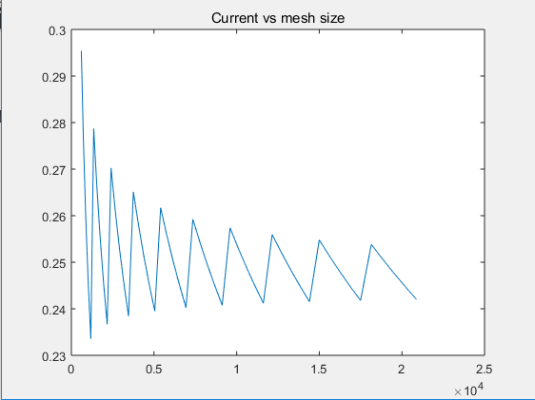

Figure 9: Current vs mesh size (current converges gradually to around 0.25)

1. As the width of the bottle-neck (the spacing between two boxes) becomes larger, the current coming out from the right side of the conductor gets larger. The graph of current vs the width of bottle-neck is shown in Figure 10 below.

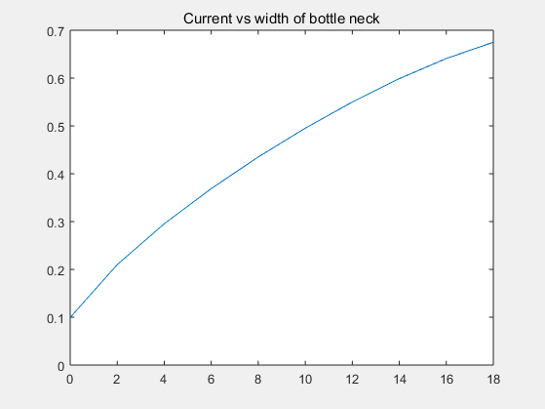

Figure 10: Current vs width of bottle-neck

1. As the conductivity of the box becomes larger, the current coming out from the right side of the conductor gets larger. The graph of current vs the conductivity of box is shown in Figure 11 below.

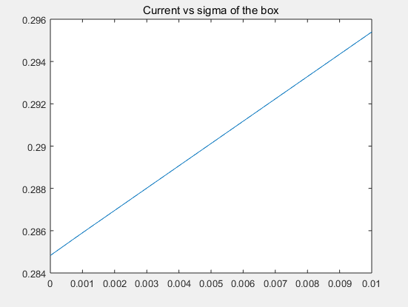

Figure 11: Current vs sigma of the box