**ELEC 4700**

**Assignment 3**

**Name: Hongzhao Zheng**

**Student number: 100965369**

**Part 1**

The electron charge is 1.6*10-19 C. And the potential difference between two boundaries is 0.1V. The effective mass of electron (mn) is 0.26*me=2.37*10-31 kg.

1. The 2D plot of particle trajectories after first 284 steps is shown in Figure 1 below. The number of electrons N is 20.

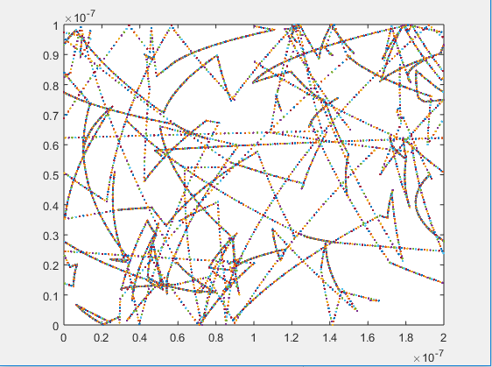

Figure 1: Electron trajectories plot after the first 284 steps (N=20)

1. The current density formula and the current formula are given in the equations below.

Where n is the electron concentration which is given by 1015 cm-2, q is the electron charge, vxAvg is the average velocity along x direction.

Where W is the width of the conductor, which is 10-7m.

The plot of current over time in x direction is given in Figure 2. In this case, the number of electrons, N, is 1000.

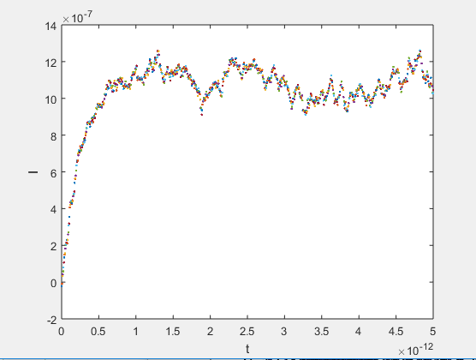

Figure 2: Plot of current over time in x direction (N=1000)

As the number of electrons is fairly large, the current tends to increase for a while, and then it stops increasing anymore because of the effect of scattering.

1. The electron density and temperature plot are given as follows.

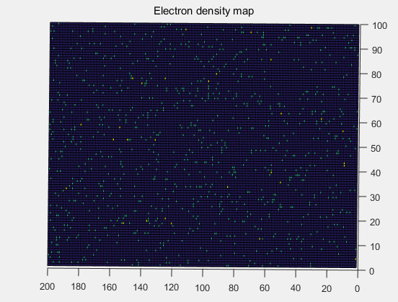

Figure 3: Plot of 2D electron density map (N=1000)

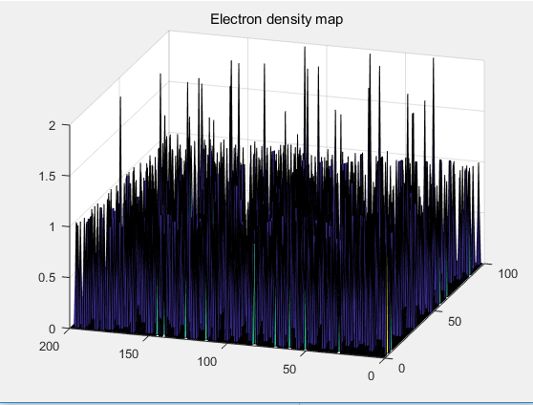

Figure 4: Plot of 3D electron density map (N=1000)

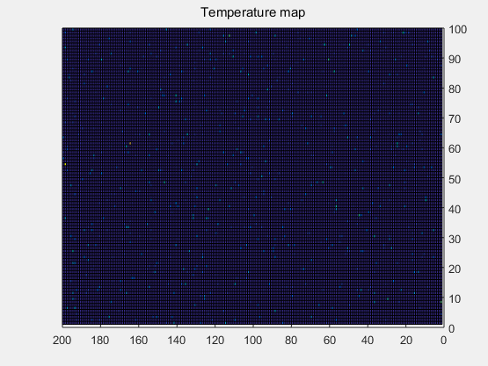

Figure 5: Plot of 2D temperature map (N=1000)

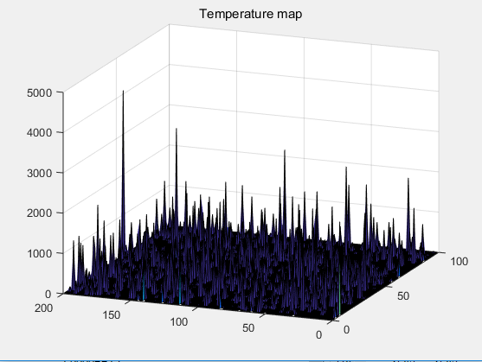

Figure 6: Plot of 3D temperature map (N=1000)

**Part 2**

1. The surface plot of potential is given in Figure 7.

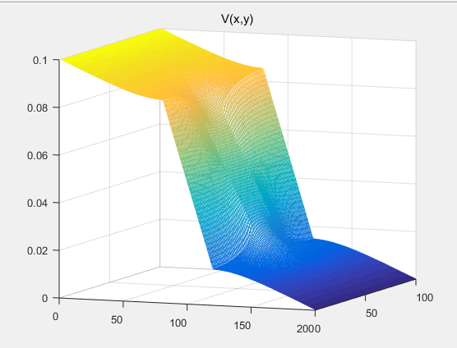

Figure 7: Surface plot of potential (W=100, L=200)

1. The electric field vector plot is given in Figure 8.

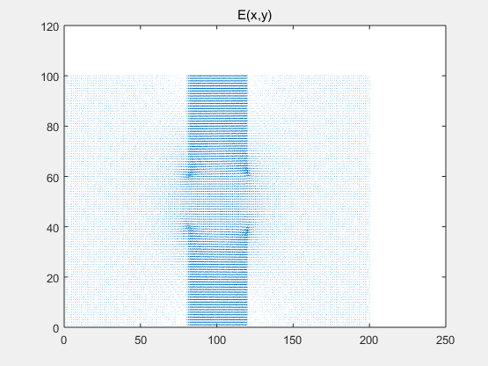

Figure 8: 2D electric field vector plot (W=100, L=200)

**Part 3**

1. The 2D plot of electron trajectories is given below.

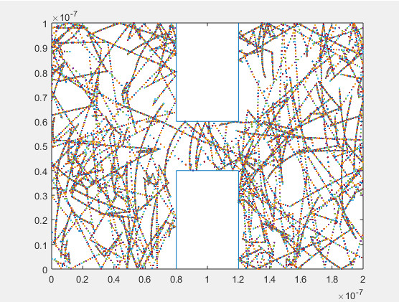

Figure 9: Electron trajectories after 111 steps (N=100)

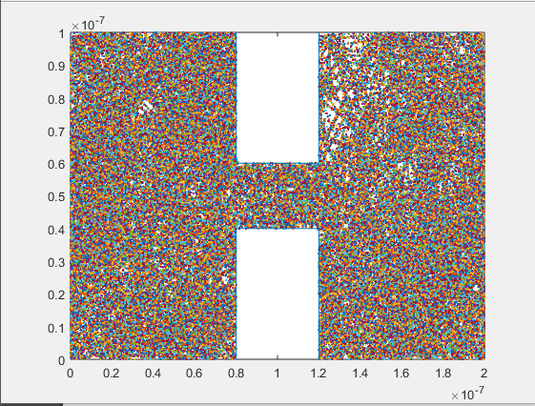

Figure 10: Electron trajectories at the end (N=100)

1. Electron density plot

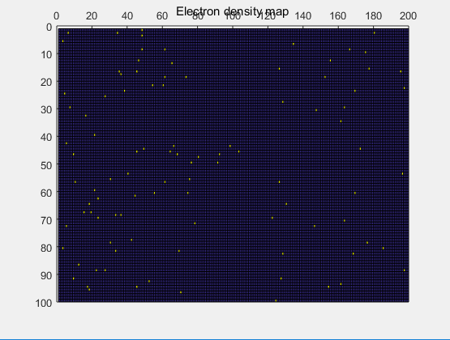

Figure 11: 2D Electron density plot (deltaV=0.1V, N=100)

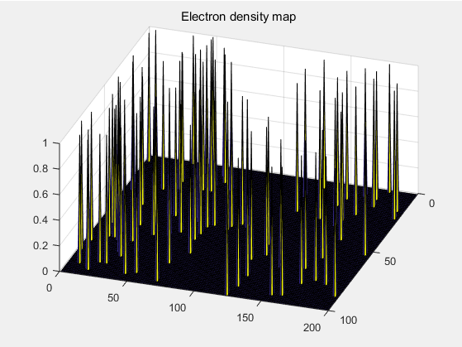

Figure 12: 3D Electron density plot (deltaV=0.1V, N=100)

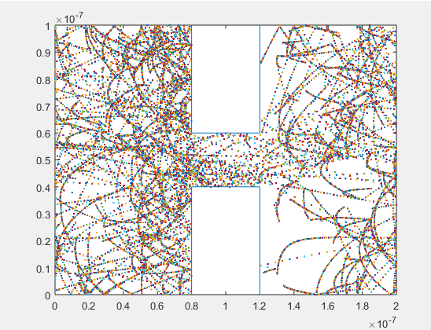

Figure 13: Electron trajectories plot after 121 steps (N=100)

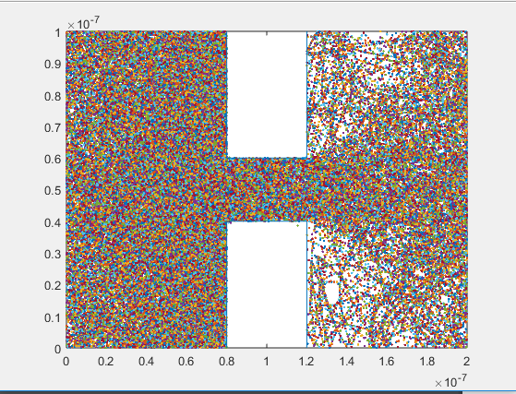

Figure 14: Electron trajectories at the end (N=100)

Comment:

As the potential difference become larger, the electrons are more concentrated on the left side of the conductor with the direction of electric force exerted on electrons pointing to the right. There are two triangle-regions on the right of the two boxes where the electrons usually do not pass through.

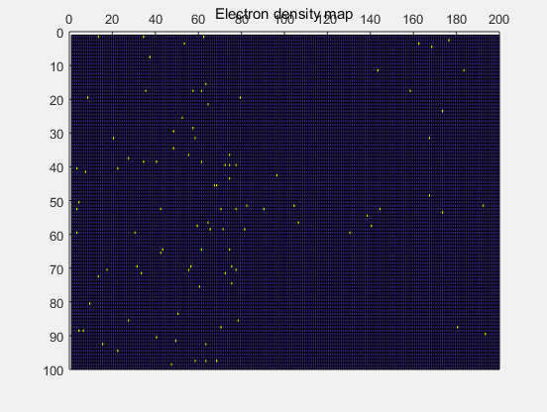

Figure 15: 2D Electron density plot (deltaV=0.8V, N=100)

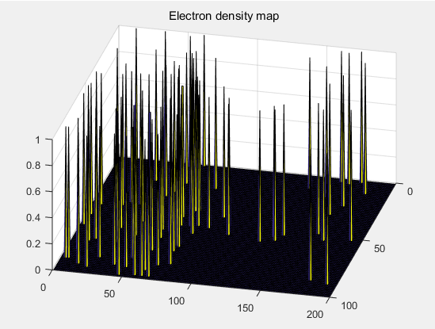

Figure 16: 3D Electron density plot (deltaV=0.8V, N=100)

1. We can introduce the Coulomb force between electrons to make this simulation more accurate. The Coulomb force will be larger as two electrons move closer to each other, vice versa.