**ELEC 4700**

**Assignment 4**

**Name: Hongzhao Zheng**

**Student number: 100965369**

**Part 1**

1. C and G matrices
$$C=\left[\begin{matrix}0 & \begin{matrix}C & C & \begin{matrix} 0 & 0 & \begin{matrix}0 & 0 & 0\end{matrix}\end{matrix}\end{matrix} \\ \begin{matrix}0 \\ 0 \\ \begin{matrix}0 \\ 0 \\ \begin{matrix}0 \\ 0 \\ 0\end{matrix}\end{matrix}\end{matrix} & \begin{matrix}\begin{matrix}-C & C & \begin{matrix} 0 & 0 & \begin{matrix}0 & 0 & 0\end{matrix}\end{matrix}\end{matrix} \\ \begin{matrix}0 & 0 & \begin{matrix} 0 & 0 & \begin{matrix}0 & 0 & 0\end{matrix}\end{matrix}\end{matrix} \\ \begin{matrix}\begin{matrix} 0 \\ 0 \\ \begin{matrix}0 \\ 0 \\ 0\end{matrix}\end{matrix} & \begin{matrix} 0 \\ 0 \\ \begin{matrix} 0 \\ 0 \\ 0\end{matrix}\end{matrix} & \begin{matrix}\begin{matrix}0 & 0 & \begin{matrix}0 & 0 & 0\end{matrix}\end{matrix} \\ \begin{matrix}0 & 0 & \begin{matrix}0 & 0 & 0\end{matrix}\end{matrix} \\ \begin{matrix}\begin{matrix}-L & 0 & \begin{matrix}0 & 0 & 0\end{matrix}\end{matrix} \\ \begin{matrix}0 & 0 & \begin{matrix}0 & 0 & 0\end{matrix}\end{matrix} \\ \begin{matrix}0 & 0 & \begin{matrix}0 & 0 & 0\end{matrix}\end{matrix}\end{matrix}\end{matrix}\end{matrix}\end{matrix}\end{matrix}\right]$$

$$G=\left[\begin{matrix}-1 & \begin{matrix}1/R1 & -1/R1 & \begin{matrix} 0 & 0 & \begin{matrix}0 & 0 & 0\end{matrix}\end{matrix}\end{matrix} \\ \begin{matrix}0 \\ 0 \\ \begin{matrix}0 \\ 0 \\ \begin{matrix}0 \\ 0 \\ 0\end{matrix}\end{matrix}\end{matrix} & \begin{matrix}\begin{matrix}-1/R1 & 1/R1+1/R2 & \begin{matrix} 1 & 0 & \begin{matrix}0 & 0 & 0\end{matrix}\end{matrix}\end{matrix} \\ \begin{matrix}0 & 0 & \begin{matrix}-1 & 1/R3 & \begin{matrix}0 & 0 & 0\end{matrix}\end{matrix}\end{matrix} \\ \begin{matrix}\begin{matrix}0 \\ 0 \\ \begin{matrix}0 \\ 1 \\ 0\end{matrix}\end{matrix} & \begin{matrix}0 \\ 0 \\ \begin{matrix}1 \\ 0 \\ 0\end{matrix}\end{matrix} & \begin{matrix}\begin{matrix}0 & 0 & \begin{matrix}-1 & 1/R4 & -1/R4\end{matrix}\end{matrix} \\ \begin{matrix} 0 & 0 & \begin{matrix}0 & -1/R4 & 1/R4+1/R0\end{matrix}\end{matrix} \\ \begin{matrix}\begin{matrix}0 & -1 & \begin{matrix} 0 & 0 & 0\end{matrix}\end{matrix} \\ \begin{matrix}0 & 0 & \begin{matrix} 0 & 0 & 0\end{matrix}\end{matrix} \\ \begin{matrix} 0 & α/R3 & \begin{matrix}0 & -1 & 0\end{matrix}\end{matrix}\end{matrix}\end{matrix}\end{matrix}\end{matrix}\end{matrix}\right]$$

2. Plot of DC sweep

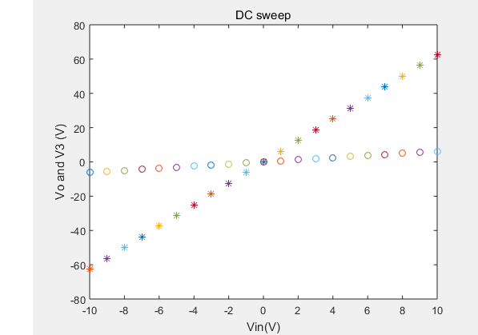

1. Plot of AC gain

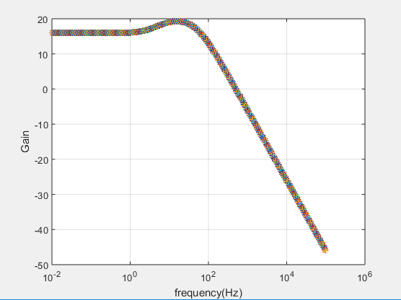

1. Step transition at t=0.03s

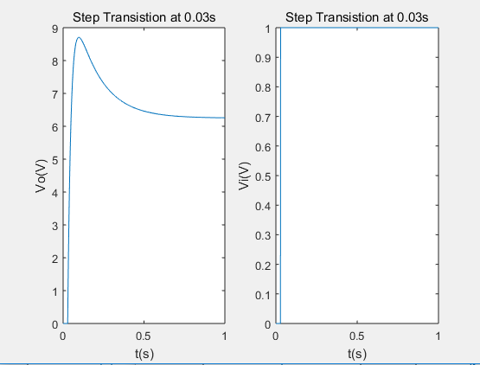

Sinusoidal Input

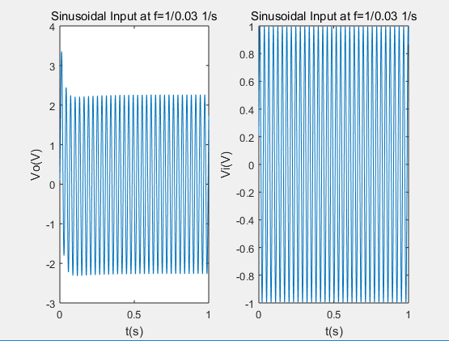

Gaussian pulse

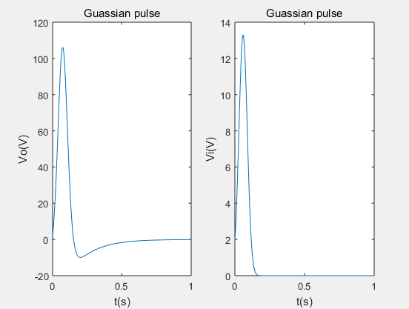

1. Fourier Transform plots of frequency response

Step Transition

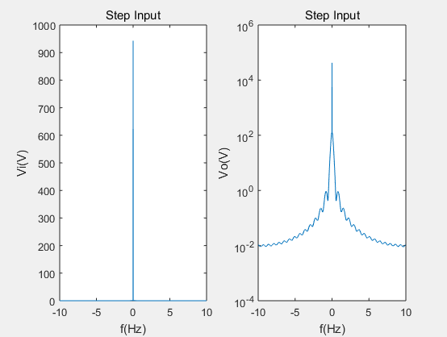

Sinusoidal Input

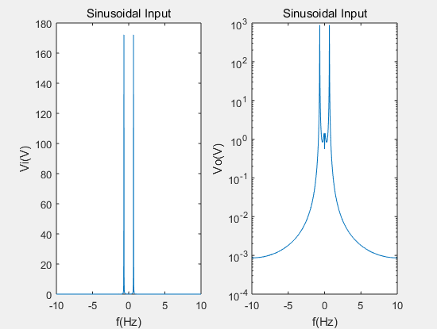

Gaussian pulse

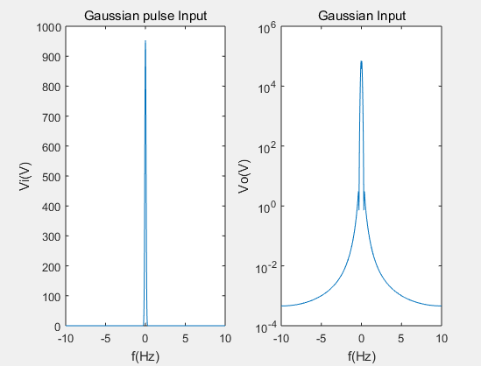

**PART 2**

1. Updated C matrix
$$C=\left[\begin{matrix}0 & \begin{matrix}C & C & \begin{matrix} 0 & 0 & \begin{matrix}0 & 0 & 0\end{matrix}\end{matrix}\end{matrix} \\ \begin{matrix}0 \\ 0 \\ \begin{matrix}0 \\ 0 \\ \begin{matrix}0 \\ 0 \\ 0\end{matrix}\end{matrix}\end{matrix} & \begin{matrix}\begin{matrix}-C & C & \begin{matrix} 0 & 0 & \begin{matrix}0 & 0 & 0\end{matrix}\end{matrix}\end{matrix} \\ \begin{matrix}0 & 0 & \begin{matrix} 0 & Cn & \begin{matrix}0 & 0 & 0\end{matrix}\end{matrix}\end{matrix} \\ \begin{matrix}\begin{matrix} 0 \\ 0 \\ \begin{matrix}0 \\ 0 \\ 0\end{matrix}\end{matrix} & \begin{matrix} 0 \\ 0 \\ \begin{matrix} 0 \\ 0 \\ 0\end{matrix}\end{matrix} & \begin{matrix}\begin{matrix}0 & 0 & \begin{matrix}0 & 0 & 0\end{matrix}\end{matrix} \\ \begin{matrix}0 & 0 & \begin{matrix}0 & 0 & 0\end{matrix}\end{matrix} \\ \begin{matrix}\begin{matrix}-L & 0 & \begin{matrix}0 & 0 & 0\end{matrix}\end{matrix} \\ \begin{matrix}0 & 0 & \begin{matrix}0 & 0 & 0\end{matrix}\end{matrix} \\ \begin{matrix}0 & 0 & \begin{matrix}0 & 0 & 0\end{matrix}\end{matrix}\end{matrix}\end{matrix}\end{matrix}\end{matrix}\end{matrix}\right]$$

2. Plot of Vout with noise source

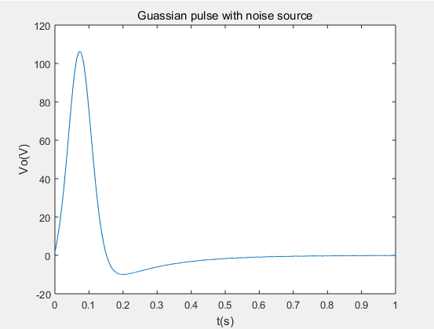

Vout vs t (Cn=0.00001, dt=0.001)

Plot of Vout with noise source (Zoomed in version)

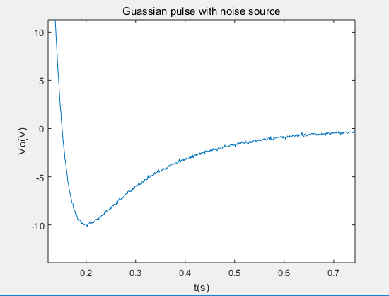

1. Fourier Transform plot

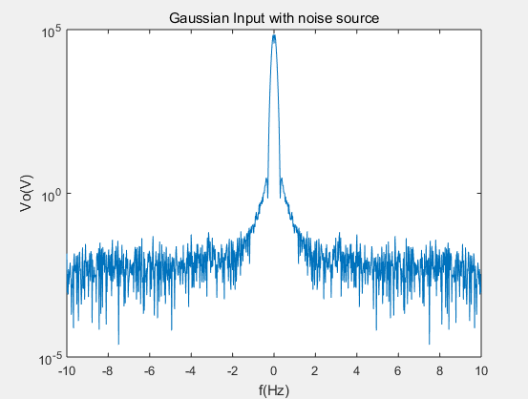

1. Vout with different Cn

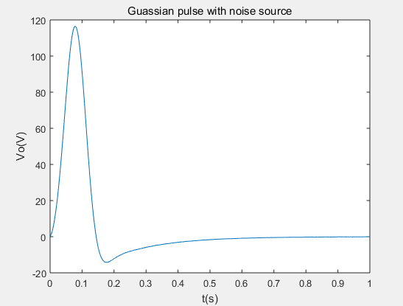

Vout vs t (Cn=0.001)

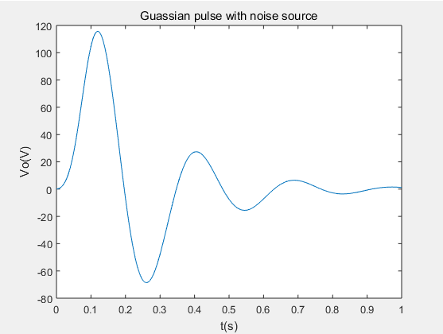

Vout vs t (Cn=0.01)

1. Vout with different time steps

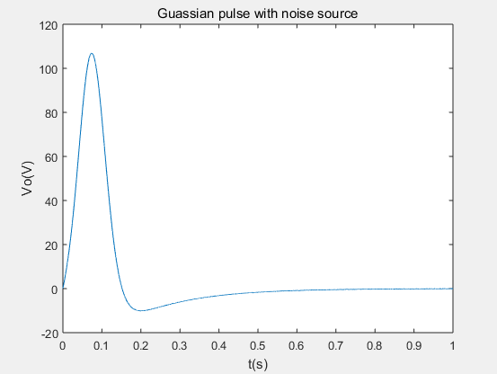

Vout vs t (dt=0.0001)

**Part 3 (i.e. question 4)**

In this case, $V=αI_{3}+β{I_{3}}^{2}+γ{I_{3}}^{3}$, we will need a B matrix so that the network of the circuit can be described by the following equation.

$$C\frac{dV}{dt}+GV+B=F$$