**抽象语法树设计：**

1、specification -> definition { definition}

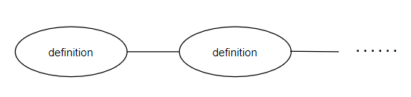

2、definiton -> type_decl“**;**”| module “**;**”

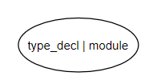

3、module -> “**module**”ID “**{**” definition { definition } “**}**”

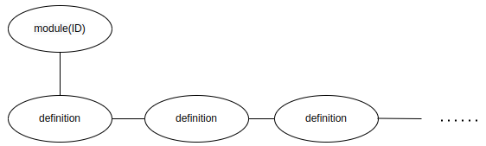

4、type_decl -> struct_type | “**struct**” ID

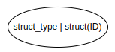

5、struct_type->**“struct”** **ID “{”** member_list **“}”**

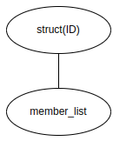

6、member_list-> { type_spec declarators **“;”** }

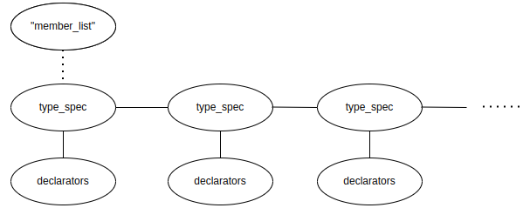

7、type_spec -> scoped_name | base_type_spec | struct_type

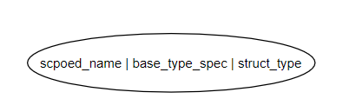

8、scoped_name -> [**“::”**] ID {**“::”** ID}



9、base_type_spec->floating_pt_type|integer_type|**“char”**|**“string”**|**“boolean”**

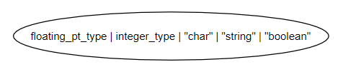

10、floating_pt_type -> **“float”** | **“double”** | **“long double”**

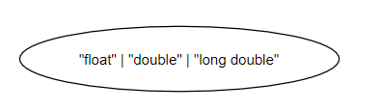

11、integer_type -> signed_int | unsigned_int

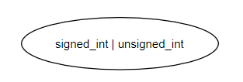

12、signed_int->(**“short”**|**“int16”**)

|(**“long”**|**“int32”**)

|(**“long”** **“long”**|**“int64”**)

|**“int8”**

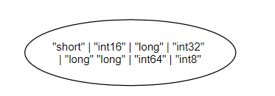

13、unsigned_int -> (**“unsigned”“short”**| **“uint16”**)

| (**“unsigned”“long”**| **“uint32”**)

| (**“unsigned” “long” “long”** | **“uint64”**)

| **“uint8”**

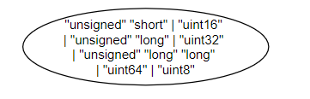

14、declarators -> declarator {**“,”** declarator }

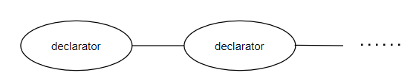

15、declarator -> simple_declarator | array_declarator

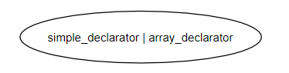

16、simple_declarator -> ID [**“=”** or_expr]

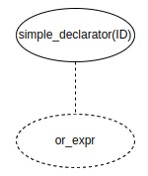

17、array_declarator -> ID “[” or_expr “]” [**“=”** exp_list ]

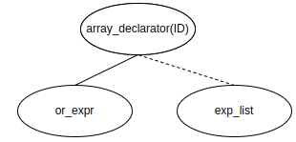

18、exp_list -> **“[”** or_expr { **“,”**or_expr } **“]”**

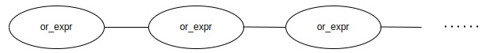

19、or_expr -> xor_expr {**“|”** xor_expr }

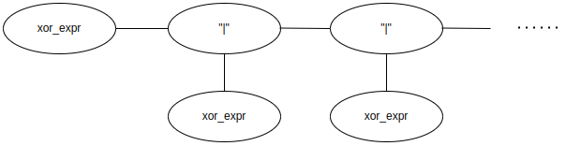

20、xor_expr -> and_expr {**“^”** and_expr }

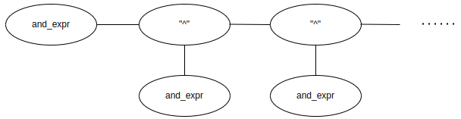

21、and_expr -> shift_expr {**“&”**shift_expr }

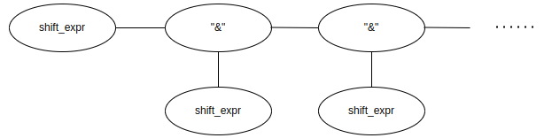

22、shift_expr -> add_expr { (**“≥≥”** | **“<<”**) add_expr }

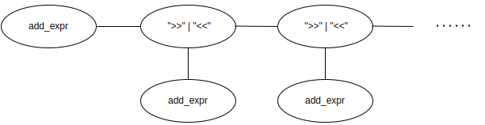

23、add_expr -> mult_expr { (**“+”** | **“-”**) mult_expr }

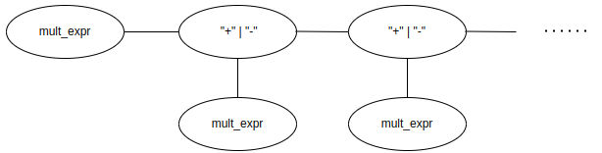

24、mult_expr -> unary_expr { (**“*”** |**“/”**|**“%”**) unary_expr }

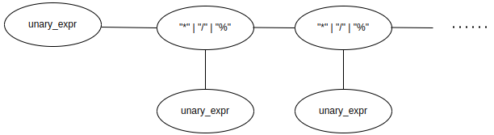

25、unary_expr -> [**“-”**| **“+”** | **“~”**] literal

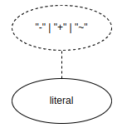

**或者改成**：

不存在 “- | + | ~” 时为：

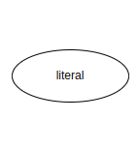，

存在“- | + | ~”时为：

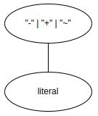

26、literal -> **INTEGER** | **FLOATING_PT** | **CHAR** | **STRING** | **BOOLEAN**

