Full guide: <https://www.doxygen.nl/manual/index.html>

# Doxygen Format

## File Header

Put at the top of the file.

/**

 * @file  doxygen.h

 * @brief  File containing example of doxygen usage for quick reference.

 * @author  My Self

 * @date  9 Sep 2012

* @copyright GNU Public License

 */

## Function

/**

 * @brief  Brief description of what the function does

 *

 * Details into how it does

 * @param  param1 Description of the first parameter of the function.

 * @param  param2 The second one, which follows @p param1.

 * @return  Describe what the function returns.

 * @see  http://website/

 * @code

 * Sometimes it is also convenient to include an example of usage:

 * int out = func(param1, param2);

 * printf("something...\n");

 * @note  Something to note.

 * @warning  Something to warn.

 */

int BoxStruct func(int param1, int param2 /*, ...*/);

## Struct

/**

 * @brief Use brief, otherwise the index won't have a brief explanation.

 *

 * Detailed explanation.

 */

typedef struct _BoxStruct {

  int a;    /**< Some documentation for the member BoxStruct#a. */

  int b;    /**< Some documentation for the member BoxStruct#b. */

  double c; /**< Etc. */

} BoxStruct;

## Enum

/**

 * @brief Use brief, otherwise the index won't have a brief explanation.

 *

 * Detailed explanation.

 */

typedef enum _BoxEnum {

  BOXENUM_FIRST,  /**< Some documentation for first. */

  BOXENUM_SECOND, /**< Some documentation for second. */

  BOXENUM_ETC     /**< Etc. */

} BoxEnum;

## Variable

Various ways:

int var; /**< Detailed description after the member */

int var; /*!< Detailed description after the member */

int var; ///< Detailed description after the member

         //!<

int var; //!< Detailed description after the member

         //!<

int var; //!< Brief description after the member

int var; ///< Brief description after the member

## Preprocessor

Same as variables

# Grouping

Each source code file has a group to contain all its implementations (global variables, functions, enumerations, structures, etc.).

/**

* @addtogroup <name> [(title)]

* @{

*/

// Code of global variable, functions, enum, structure, etc.

/**

* @}

*/ /* End of group */

**Example:**

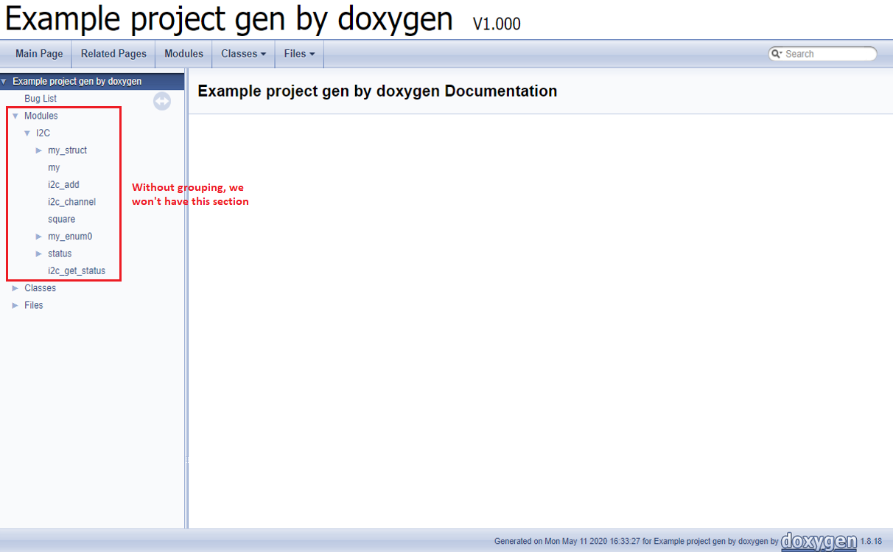

# Tips

## Working with Preprocessors

**Way #1: Apply for all preprocessors:**

# In the Doxygen configuration file

ENABLE_PREPROCESSING = YES

# Or

# ENABLE_PREPROCESSING = NO

* YES 🡪 If a preprocessor is not defined (#ifdef … is false), the document for members of that preprocessor will not be generated.
* NO 🡪 Don't care about the preprocessor. So all members will be generated.

**Way #2: Apply for some specific preprocessors:**

# In the Doxygen configuration file

ENABLE_PREPROCESSING = YES

PREDEFINED = <name-of-preprocessor>

Now if your code is like:

#if defined ISA

    int a;  ///< a is ...

#endif

And you define:

# In the Doxygen configuration file

ENABLE_PREPROCESSING = YES

PREDEFINED = ISA

Then document for variable a will be generated.