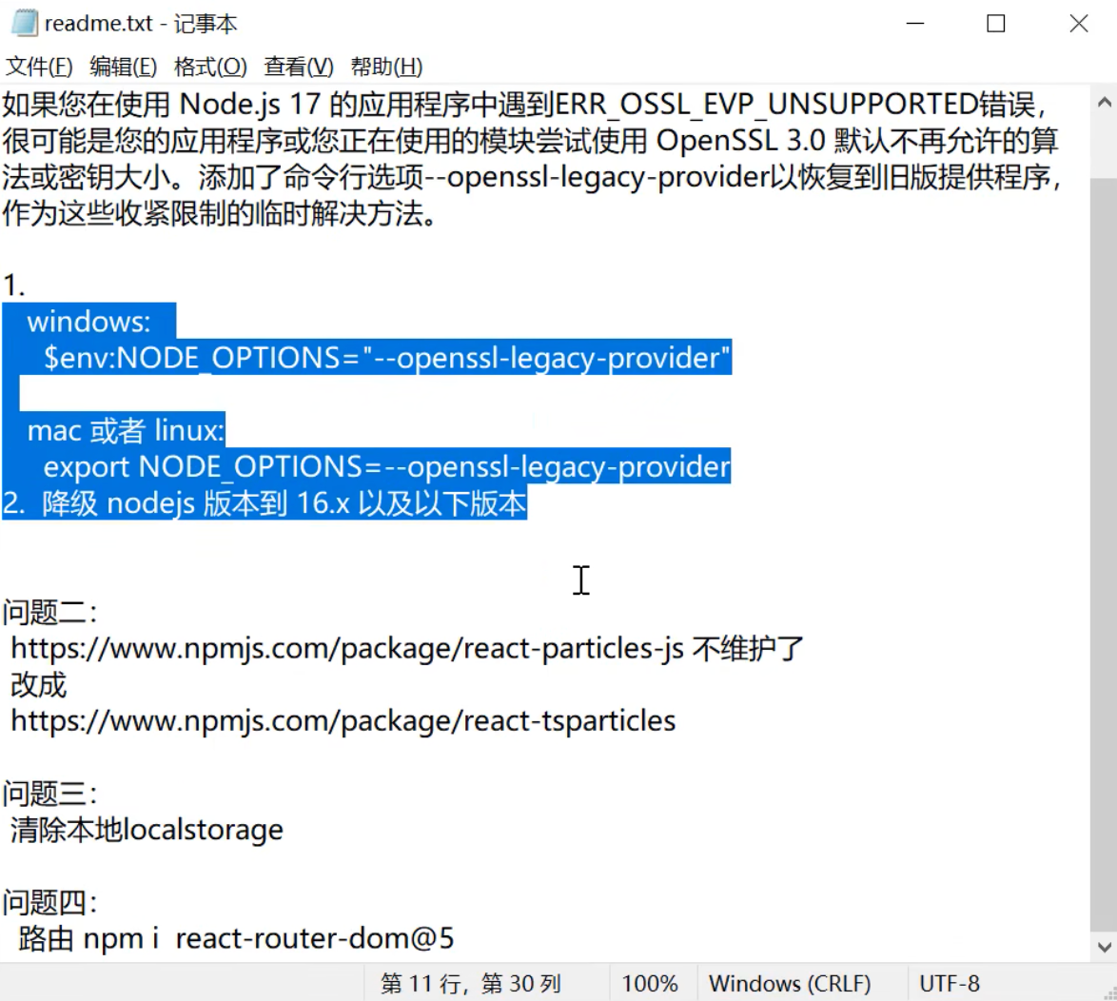

npm create-react-app newssystem

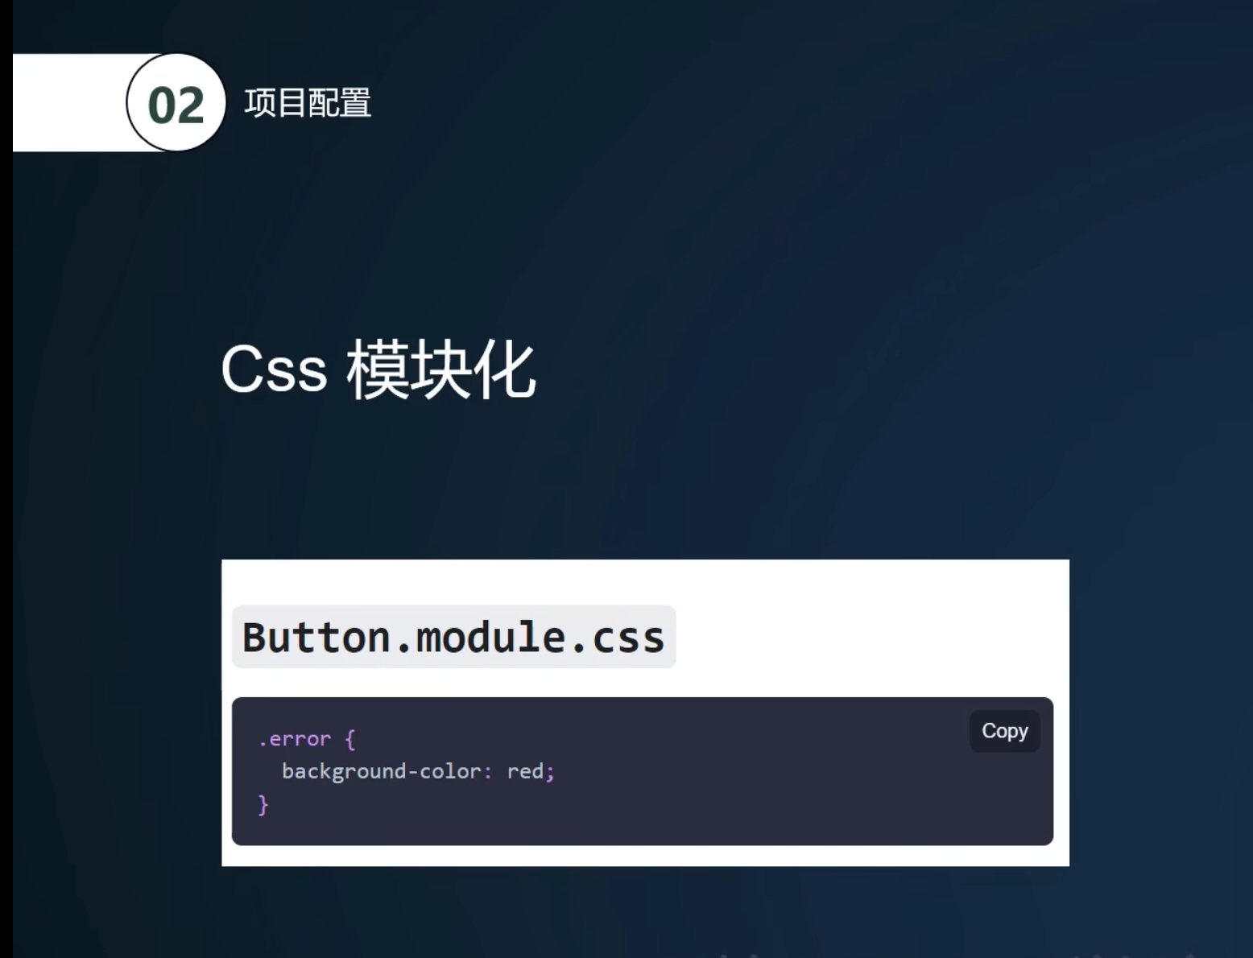
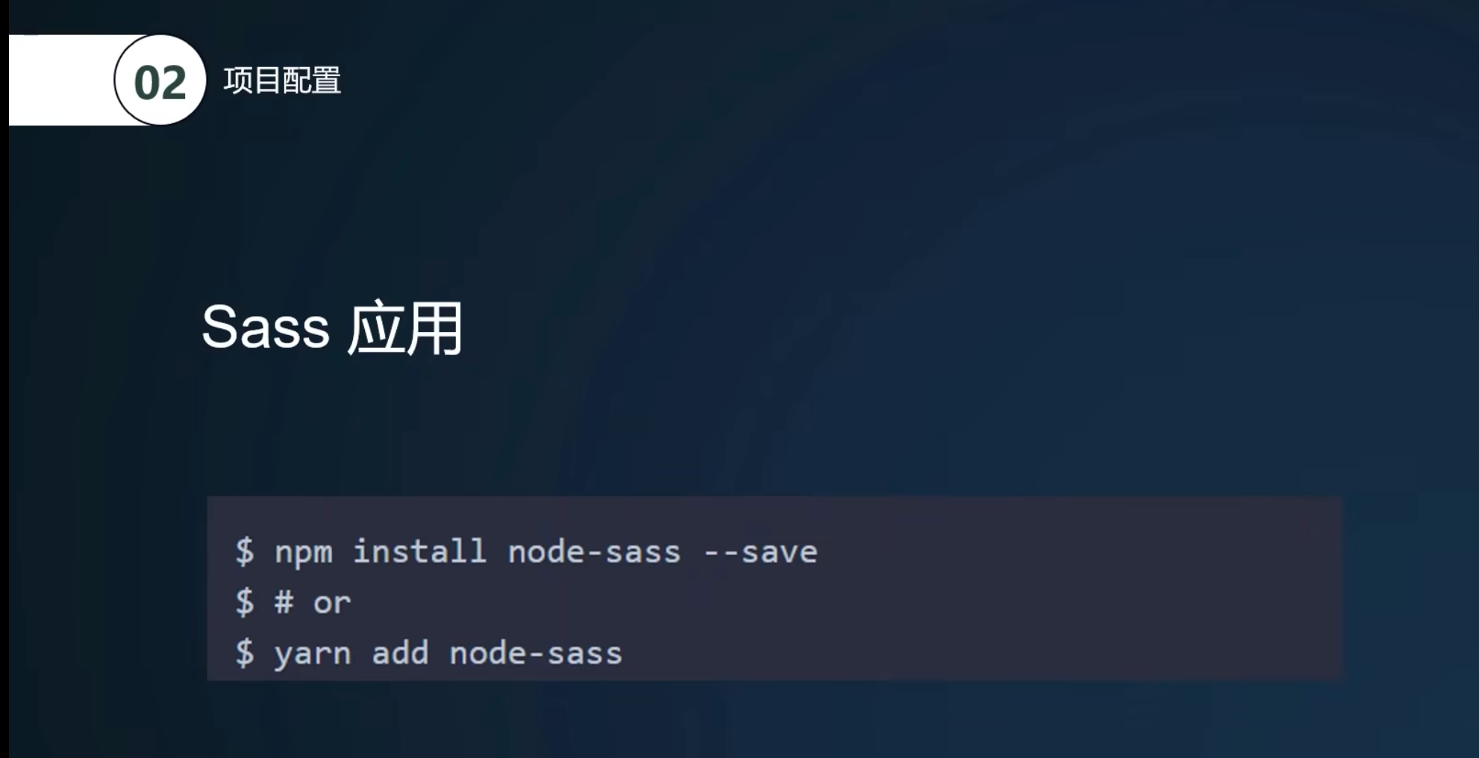
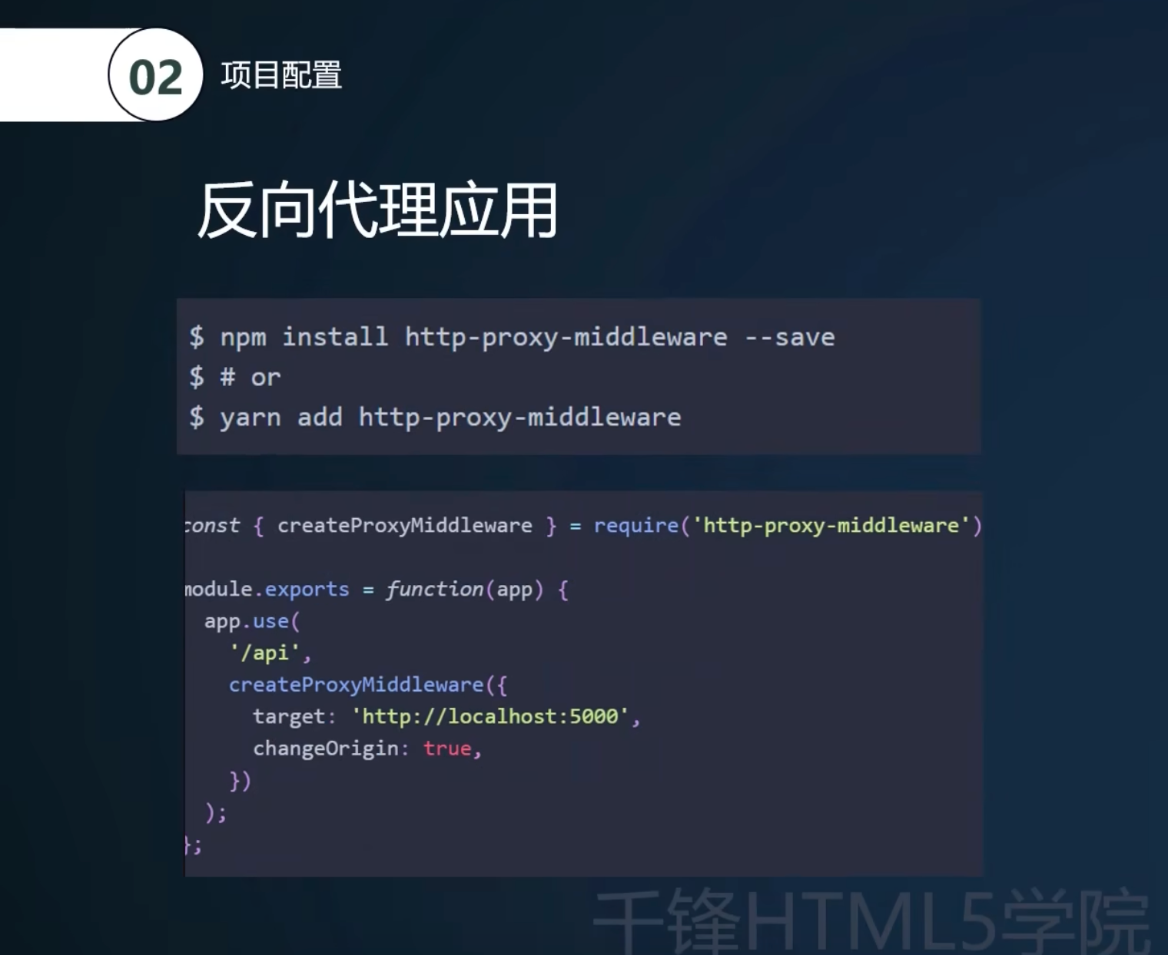

npm i --save sass

npm i --save axios

安装中间件 https://create-react-app.dev/docs/proxying-api-requests-in-development/
npm i --save-dev http-proxy-middleware

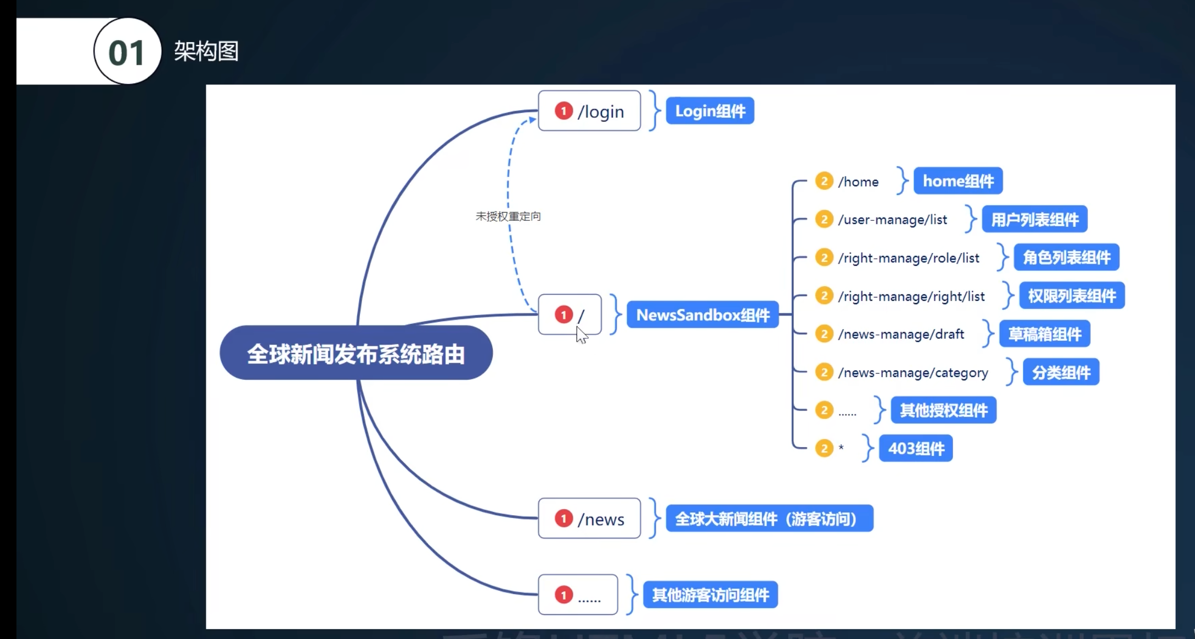

npm i --save-dev react-router-dom@6.2.2

npm i --save antd

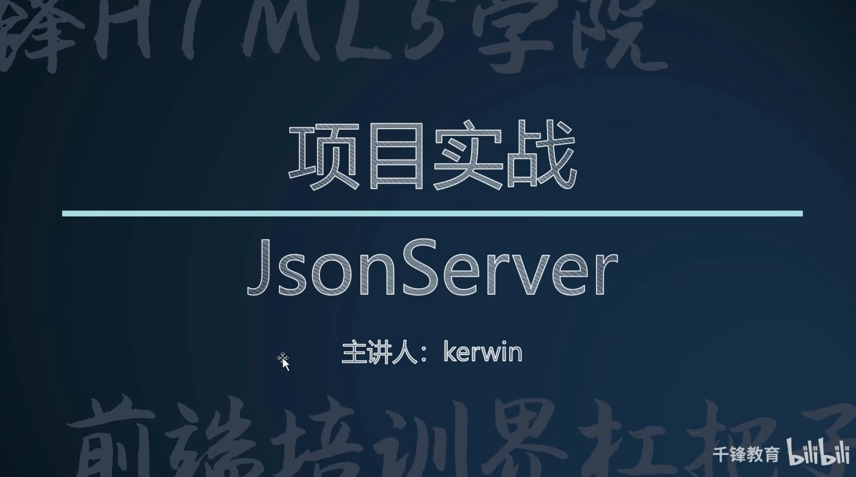
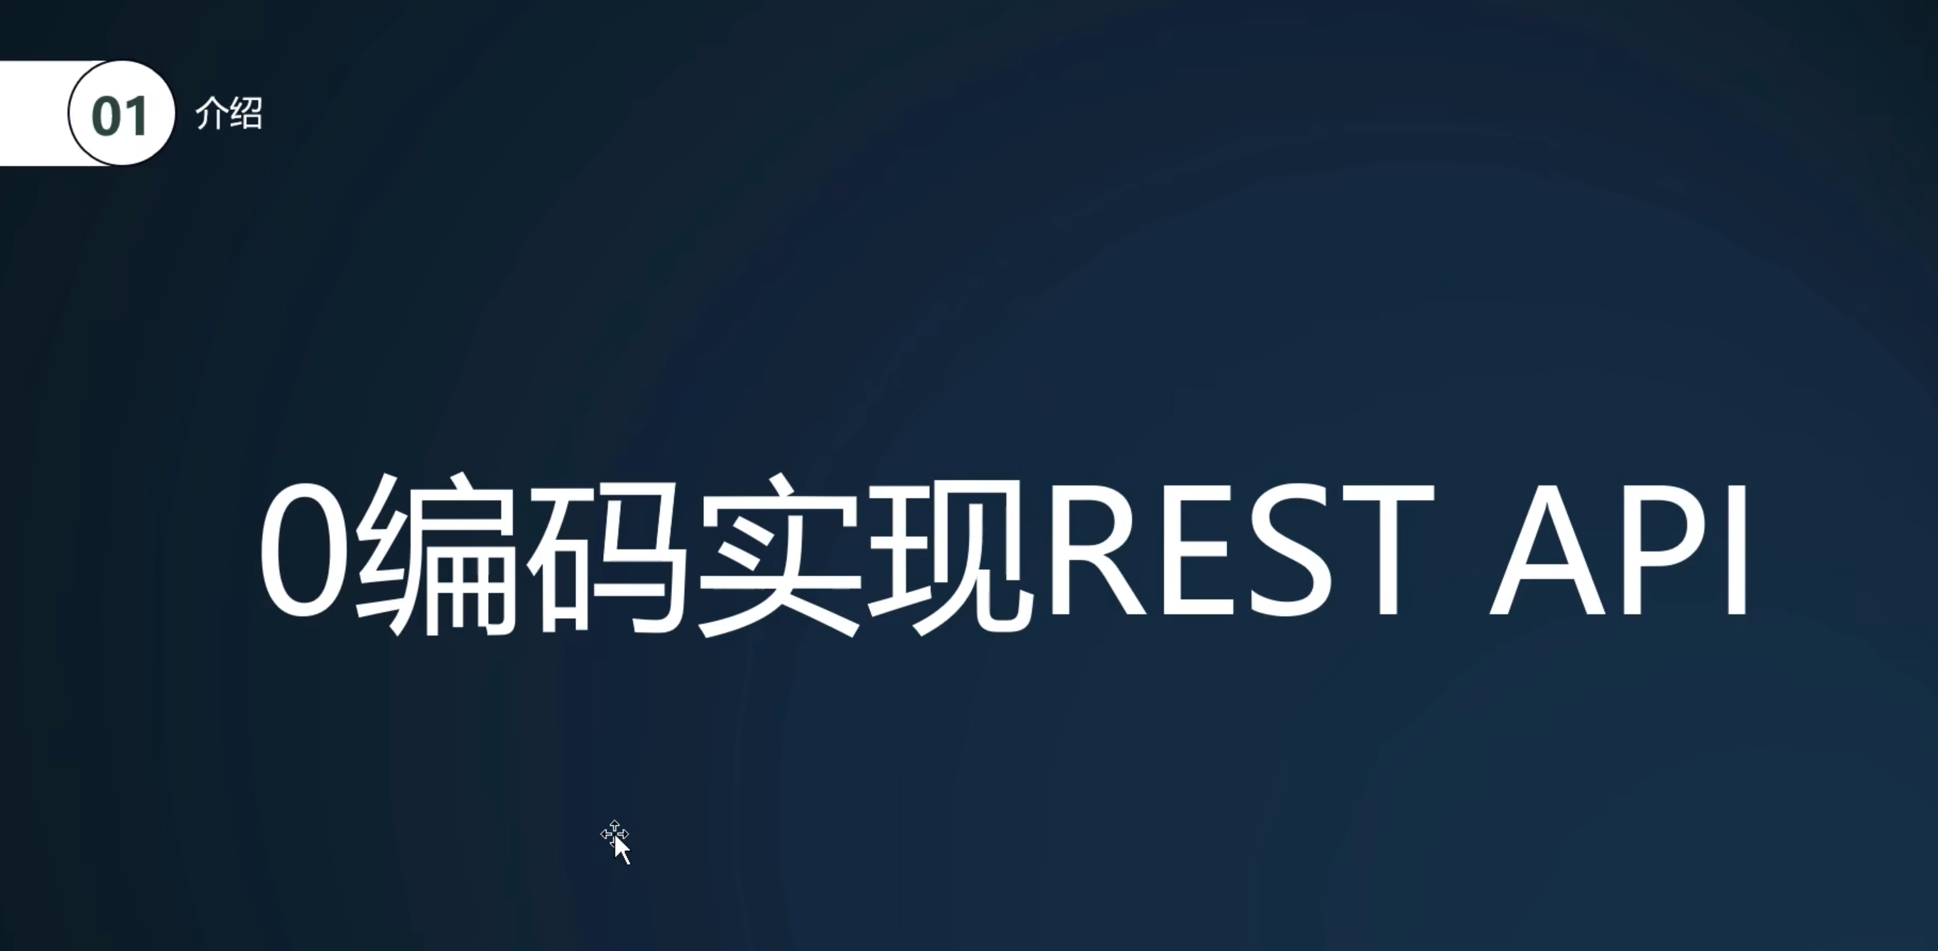

https://www.npmjs.com/package/json-server

全局安装
npm install -g json-server

json-server --watch ./test.json --port 8000

