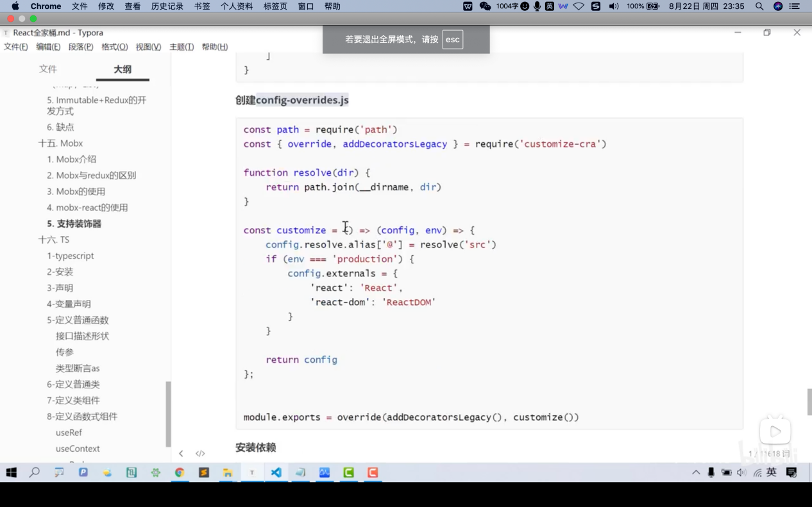
config-overrides.js
const path = require('path')
const {override, addDecoratorsLegacy} = require('customize-cra')

function resolve(dir) {
return path.join(__dirname, dir)
}

const customize = () => (config, env) => {
config.resolve.alias['@'] = resolve('src')
if (env === 'production') {
config.externals = {
'react': 'React',
'react-dom': 'ReactDOM'
}
}
return config
}

module.exports = override(addDecoratorsLegacy(), customize())

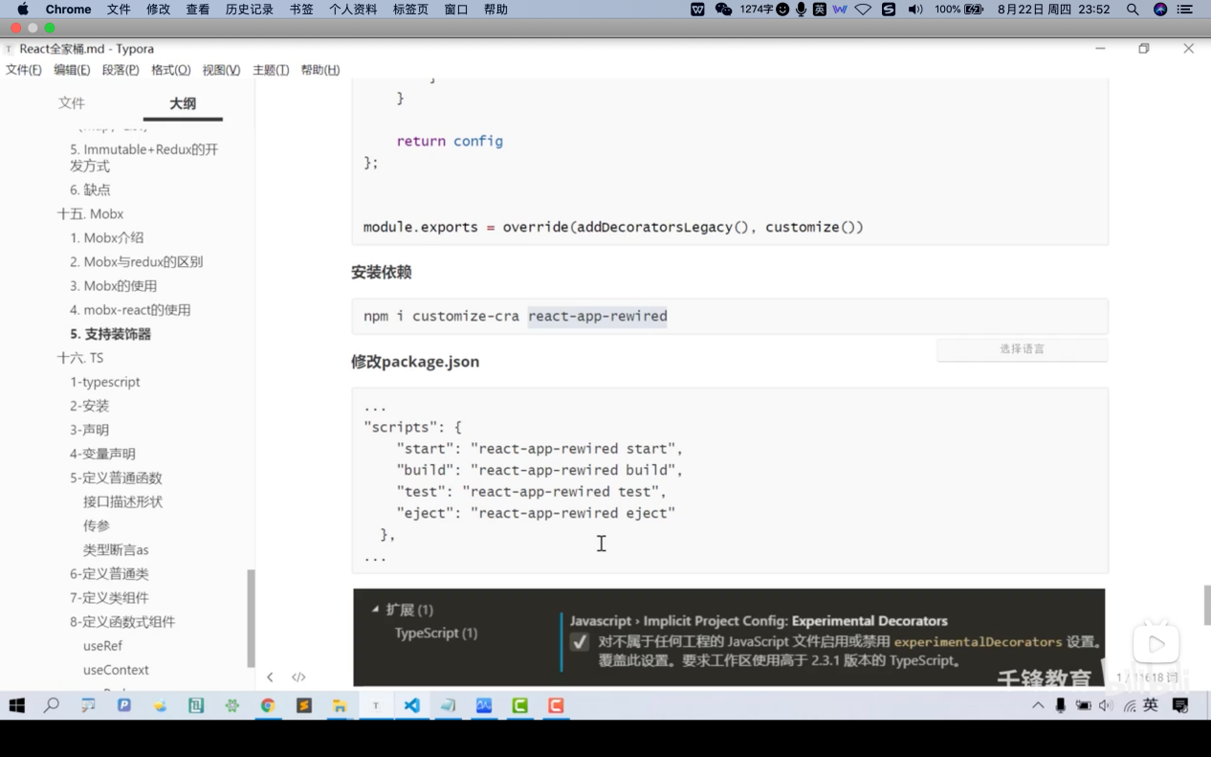
修改package.json文件
修改前
"scripts": {
"start": "react-scripts start",
"build": "react-scripts build",
"test": "react-scripts test",
"eject": "react-scripts eject"
},
修改后
"scripts": {
"start": "react-app-rewired start",
"build": "react-app-rewired build",
"test": "react-app-rewired test",
"eject": "react-app-rewired eject"
},

create-react-app myapp
npm i redux
npm i redux-thunk
npm i redux-promise
npm i react-redux
npm i redux-persist
// pc
npm i antd
// mobile
npm i --save antd-mobile
npm i immutable
npm i mobx@5
npm i @babel/core @babel/plugin-proposal-decorators @babel/preset-env
npm i customize-cra react-app-rewired
npm i mobx-react@5

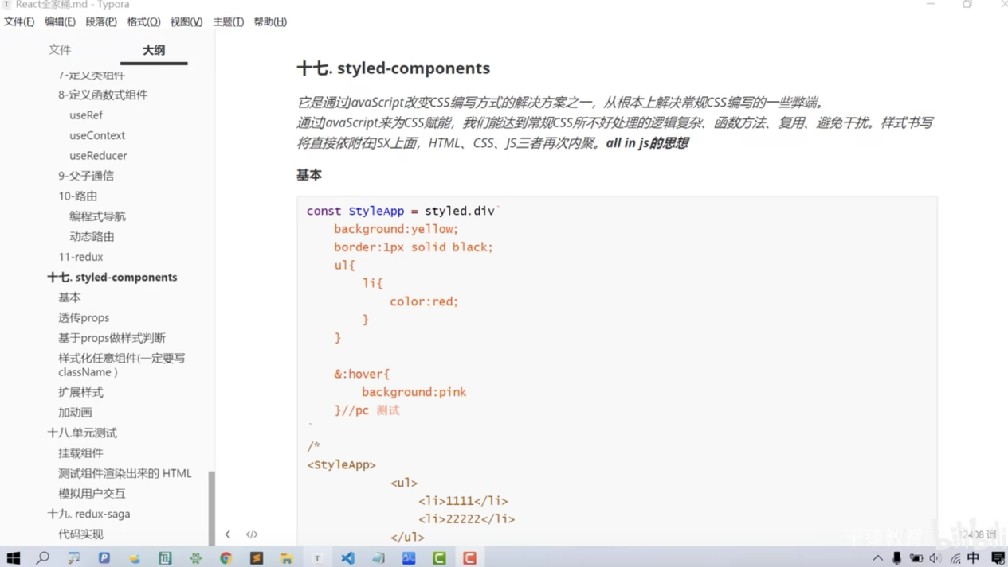

安装styled-components
npm i styled-components

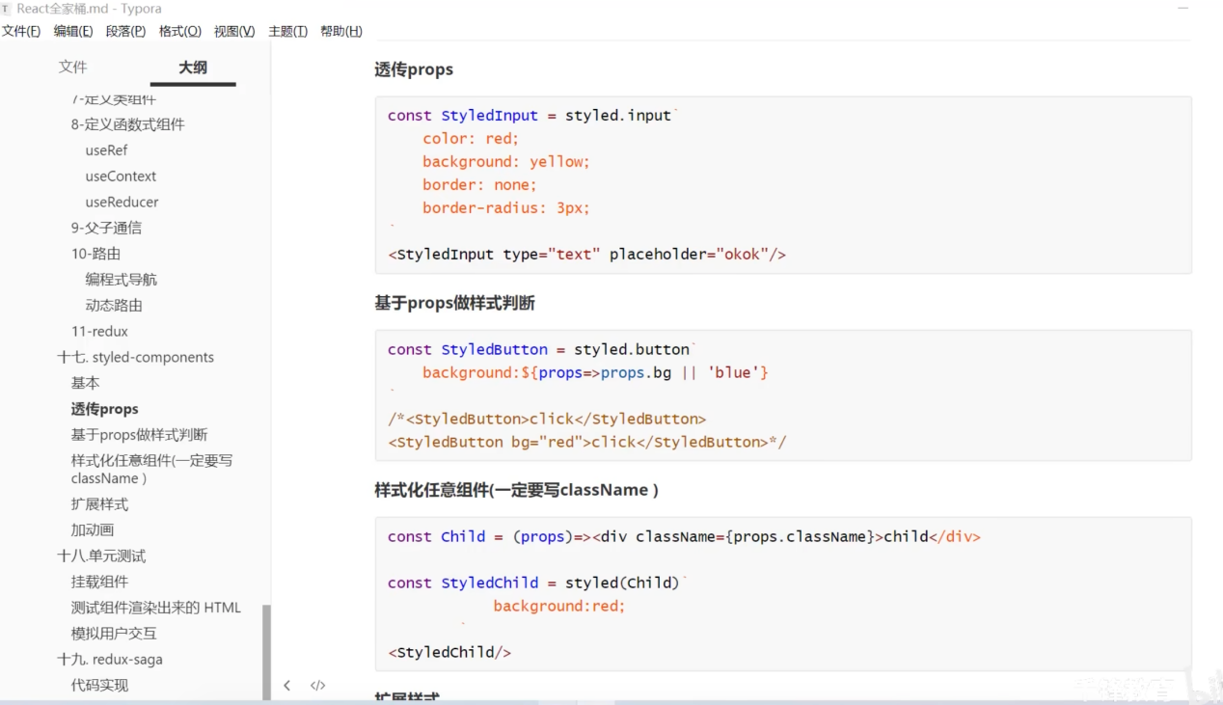
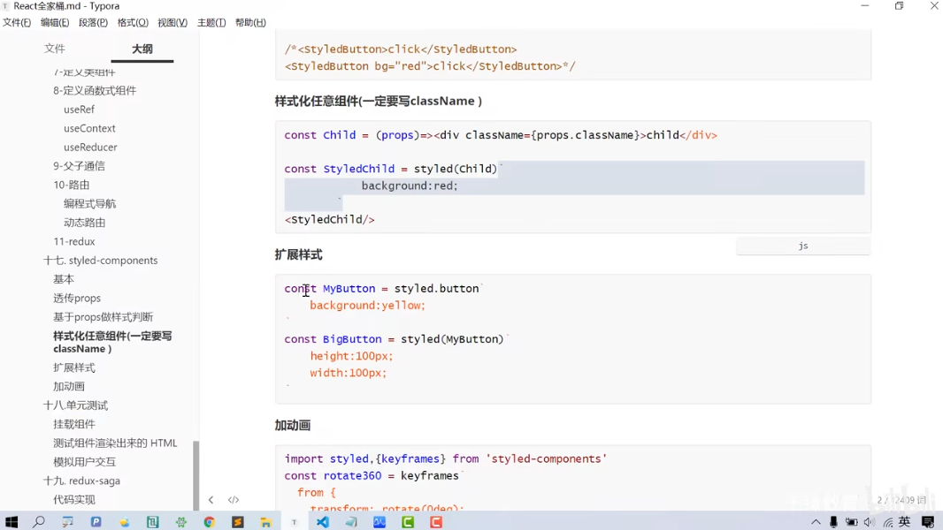

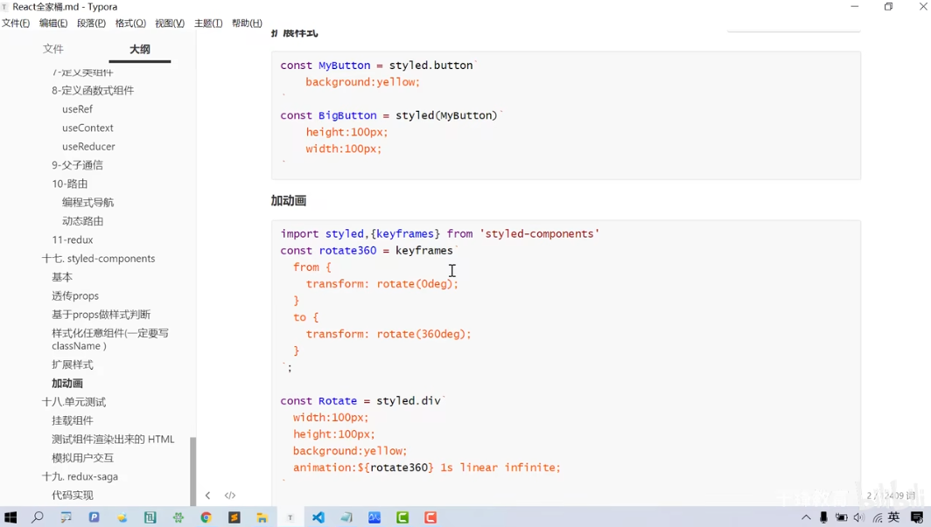
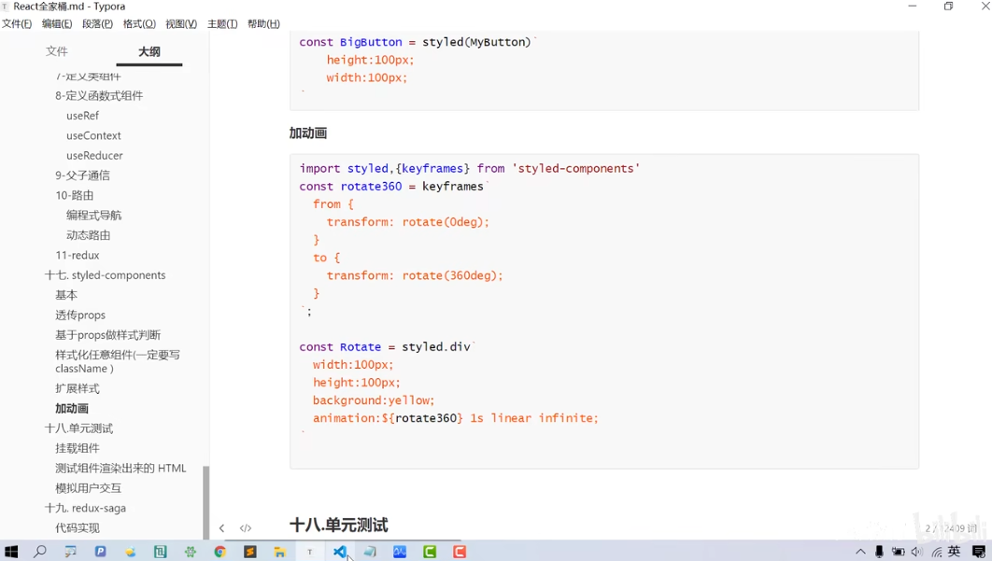

安装测试模块
npm i react-test-renderer // 太旧了，已废弃
npm install react-shallow-renderer --save-dev 推荐使用 ✅

安装enzyme测试模块
npm i enzyme
安装适配器
npm i @wojtekmaj/enzyme-adapter-react-17 // 太旧了，当前版本无效
当前版本18，未能正确使用enzyme该测试模块，只是按视频敲了代码

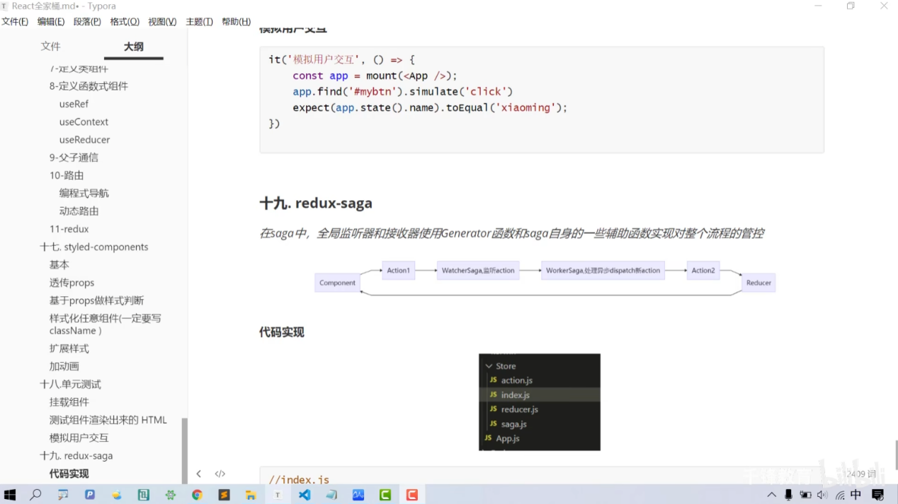

安装saga
npm i redux-saga

