
Case Study: Localization, Motion Planning and Sensor Fusion
DLMDSEAAD02
Task 1:
LiDAR Data Processing for Car and Pedestrian
Detection and Tracking
Author: Pravin Pramod Honmute
Matriculation number: 92130088
Tutor: Prof. Florian Simroth
Date: 20.10.2026
Place: Bangalore, India

Table of contents
Contents
Table of contents I
List of figures II
List of tables II
List of abbreviations III
1 Introduction 1
2 Information about the LiDAR 1
2.1 LiDAR measurement principle and scanning 1
2.2 background 2
2.3 Performance measures 2
3 Sensor review 3
3.1 Assessment of automotive requirements 3
3.1.1 Range definition for LiDAR sensor 3
3.1.2 field of view definition for LiDAR sensor 4
3.1.3 field of view definition for angular resolution 4
3.2 sensor data and sanity check: 5
5 Detection pipeline 8
5.1 System architecture 8
5.2 Algorithms 9
5.2.1 Ground removal with RANSAC 9
5.2.2 Static background suppression by voxel persistence 10
5.2.3 Down-sampling and DBSCAN clustering 10
5.2.4 Rule-based classification with hysteresis 11
5.2.5 multi-object tracking 12
5.2.6 Tuning parameters 13
6 Results 13
6.1 Root cause for lower accuracy 14
6.2 Strategies for improvement 15
7 Conclusion 15
Bibliography 16
Appendix A: Software environment and files 18

List of figures
Figure 1. Relation between number of scan lines and frame rate 2
Figure 2. Sensor coordinates system of the Cube 1 (top and side view) 6
Figure 3. Distribution of point ranges in the 100-frame sample 6
Figure 4. Module architecture of the detection and tracking application 8
Figure 5. Data flow and data types for one frame 9
Figure 6. First iteration with ground removal 10
Figure 7. Class regions in the length–height plane with hysteresis bands 11
Figure 8. Critical speed below which the static filter starts to remove parts of an object 14

List of tables
Table 1. LiDAR detection range based on vehicle speed 3
Table 2. The required opening with different curved radii 4
Table 3. Cube 1 compared with typical requirements for an automotive perception LiDAR 4
Table 4. Comparison of the Cube 1 with other LiDAR sensors 5
Table 5. data sanity check between specifications and sample data 6
Table 6. Classification rules (L = filtered length, H = height) 11
Table 7. Tuning parameters of the final configuration 13
Table 8. Object-level evaluation against the video reference 13
Table 9. Proposed improvements 15

1 Introduction
An automated vehicle can only plan a safe motion if it knows where the other road users are, what they are and where they are going. LiDAR (Light Detection and Ranging) is one of the main sensors used for this task because it measures distance directly, works independently of ambient light and gives a three-dimensional picture of the scene (You Li, 2020). Cameras are cheaper and see color and texture, radar measures velocity and works in bad weather, but the LiDAR point cloud is the modality in which the size and position of an object can be read off most directly
Point cloud is a set of coordinates in the raw data which are dense, closer to sensor and get sparse with range (Figure 3). In raw data ground, buildings, poles and parked vehicles produce far more returns than the few pedestrians or cars that matter for driving.in this case study we will work on recording of a Blickfeld Cube 1 LiDAR with 718 frames and objective of case study is, to review the specifications of LiDAR, sanity check if recorded data, object detection algorithm that detects, tracks and classifies pedestrian and vehicles with CCR (correct classification rate) of 0.99 and FAR (false alarm rate) of 0.01 per hour.
A classical, non-learning pipeline was selected, because no labelled training data is available. The pipeline was implemented in Python with Open3D and consists of ground removal with RANSAC, a voxel-based filter that suppresses the static background, DBSCAN clustering, oriented bounding boxes from a principal component analysis (PCA) of the footprint, a rule-based size classifier, and a tracker with hysteresis on class and motion state. We will record the detection framewise as well as information like speed, dimension, volume, center etc. in excel report(“moving_objects_report.xls”) and shows the result in an interactive 3D viewer. We will summaries results and further recommendation followed by the conclusion.

2 Information about the LiDAR

2.1 basic working of LiDAR sensor
A LiDAR emits short laser pulses and measures the time t until the reflected light returns. With the speed of light c the range follows as r = c·t/2. Together with the two deflection angles of the beam (azimuth φ and elevation θ) each return gives one point in Cartesian coordinates (Lue Fan, 2021). The Cube 1 uses two oscillating MEMS mirrors for the deflection. The horizontal mirror sweeps the beam quickly while the vertical mirror moves it slowly, so that the scene is covered by a set of scan lines (Figure 1), one complete pass over the field of view (FoV) is one frame. (CUBE, 2022)
The number of scan lines and the frame rate are coupled. The deflection unit can produce a fixed number of scan lines per second, so more lines per frame (a finer vertical resolution) automatically means fewer frames per second. For Cube 1 the manual gives more than 500 scan lines per second. A pattern with 100 lines therefore runs at about 5 Hz, and a pattern with 500 lines would run at about 1 Hz. This trade-off between vertical resolution and update rate becomes important, as the data provided for the assignment has frame rate of only 2.435 Hz.
Figure 1. Relation between number of scan lines and frame rate (1: 30 lines at 1 Hz, 2: 10 lines at 3 Hz, 3: 6 lines at 5 Hz)
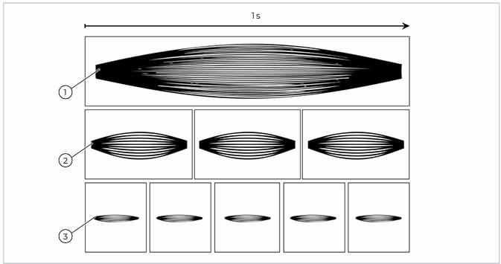
Source: Blickfeld GmbH (CUBE, 2022), Cube 1 user manual, Fig. 4

2.2 strategy for detection with LiDAR data
Before deep learning became common, and still in many embedded or infrastructure applications, LiDAR objects are found with a chain of geometric steps. First, the ground is separated from the rest of the scene, with a plane fit such as RANSAC (Bolles, 1981). The remaining points are then grouped into objects. Density-based clustering with DBSCAN (Ester, 1996) is popular because it does not need the number of objects in advance and it labels isolated points as noise. For each cluster a bounding box is estimated, and the box dimensions, sometimes together with point statistics, are used to assign a class.

2.3 Performance measures
The correct classification rate (CCR) is the share of true objects that are detected and assigned to the right class. It can be computed per object (one decision per physical object). The false alarm rate (FAR) counts reported objects that do not exist here expressed per hour of operation. In our assignment its difficult to know base line hence adding standard matrix will not make much sense however what we will do it to estimate the how many actual detection seen the video provided in assignment vs what we will get from our implementation and will also compare the number frames the object is visible in both video and in our code.

3 Sensor review
In this section we will focus on assessment of typical requirements for LiDAR will compare it with the Cube1, technical comparison with typical other LiDAR manufactures, and will check the distribution of sensor cloud point to optimize the model performance (range optimization).

3.1 Assessment of automotive requirements for typical LiDAR sensors
No single standard gives the default LiDAR requirements however I will take the reference to work done by Zhuoqun Dai (Dai, 2022) on assessment on what should be the typical specification for LiDAR sensor. Dai suggest that LiDAR specifications depend on the boundary conditions of the application, so we must be derived from it. Hence for the scope of this assignment, we have assumed the boundy condition for ‘next generation sadan’ as below.
- Sadan will travel 140 km/h.
- Forward vehicle collision warning, should work with curve class III (ISO-15623)
- Should have 200m distance visibility.

3.1.1 Range requirement for LiDAR sensor
To determine the range of lidar we can use the basic kinematic formulation (Dai, 2022).
$$d=vt_{r}+ \frac{v^{2}}{2a}$$
Here, d - Warning distance for a stationary obstacle, basic (range of LiDAR),
T = 1.5 s — brake reaction time, covering 98 % of drivers
a = 5.3 m/s² — emergency braking on a dry, level road
by using above equation, we can summaries required level of LiDAR range needed at different speeds. Hence the LiDAR specification for range given for this assignment is in good range as for 140km/h vehicle.
Table 1. Min range requirement for LiDAR sensor based on vehicle speed
Typical Speed of vehicle (Km/h) | Typical Speed of vehicle (m/s) | Break reaction time (S) | Braking deceleration (m/s²) | Required range of Lidar sensor
90 | 25 | 1.5 | 5.3 | 96
100 | 27.78 | 1.5 | 5.3 | 114
110 | 30.56 | 1.5 | 5.3 | 134
120 | 33.33 | 1.5 | 5.3 | 155
130 | 36.11 | 1.5 | 5.3 | 177
140 | 38.89 | 1.5 | 5.3 | 201
150 | 41.67 | 1.5 | 5.3 | 226
160 | 44.44 | 1.5 | 5.3 | 253
Source: own analysis based on (Dai, 2022)

3.1.2 field of view requirement for LiDAR sensor
As we have defined the range requirement for LIDAR sensor in case of straight road in table above which are dictated by the speed of sedan however when it comes to the curved surface it’s all about the turn radii and same can classified as class I, II, III (ISO-15623) as the turn radius becomes lesser and lesser we need to have higher FOV. Minimum requirement for assignment with class III is complaint with cube1 FOV specifications (Table 2).

Table 2. The required opening FOV for sensor with different curved radii
Curve Class | Curve Radius | Full Horizontal FOV | Full Vertical FOV
Class I | ≥500 m | 12.4° | 5.2°
Class II | ≥250 m | 18.0° | 6.8°
Class III | ≥125 m | 32.6° | 10.2°
Source: (Dai, 2022)

3.1.3 angular resolution requirement for LiDAR sensor
The angular resolution is defined by the minimum angular distance between two objects which can be resolved by LiDAR systems (R, 2016). It determines not how accurately an object is measured. As the spacing between beams grows linearly with distance, a fixed angular resolution translates into a physical sampling interval that widens with range: at 0.4° of Cube 1 offers, neighboring beams lie 0.21 m apart at 30 m and 1.40 m apart at 200 m. An object narrower than that interval may be missed entirely, and one spanning a single column of points cannot be assigned to length, a width or an orientation, this will have significant impact on detection which we will see in the later section.
Summery the specification given for cube1 in the (Table 3) below where I have added my feedback based on above mentioned assessment.
Table 3. Cube 1 compared with typical requirements for an automotive perception LiDAR
Requirement | Typical specifications | Cube 1 specifications | feedback
Range@140km/hr. | 200 m | 5-250m | Okey
Horizontal field of view | 32.6° (140° for 3 lanes) | 70° spec,  73.5° measured | Okey
Vertical field of view | 10.2° | 30° spec,  29.7° measured | Okey
Angular resolution | 0.075° car, 0.04° cyclist | 0.4° – 0.6° horizontal | Not okey ~ 10× coarse
Frame rate | ≥ 10 Hz | 2.435 Hz in the recording | Not okey ~ ×4 short
Laser class | Class 1 | 905 nm, Class 1 | Okey

Source: own analysis based on specifications given for assignment
Four criteria are met (FOV, range, class), angular resolution is poor will have huge impact on detecting the pedestrian/cyclist on mid-high range spectrum. Frame rate as recorded from the data provided or project stands at 2.4Hz which is very low compared to typical automative requirements.

3.2 Market comparison
Table 4 compares Cube 1 with two automotive-grade sensors that are widely used in industry for ADAS implementation. I could not find the accurate prices hence I have excluded for comparison, but price might be the deciding factor for comparison.
Table 4. Comparison of the Cube 1 with other LiDAR sensors
Factor | Blickfeld Cube 1 | Hesai AT128 | RoboSense  M1 Plus | Livox Mid-360
Technology | MEMS mirrors | hybrid solid-state, | MEMS solid-state | rotating mirror
Range | 5-250m | 200m | 200m | 40m (70m at 80 %)
FoV (H × V) | 70° × 30° | 120° × 25.4° | 120° × 25° | 360° × 59°
Angular resolution | 0.4°–0.6° H | 0.1° × 0.2° | 0.2° × 0.2° | -
Point rate | ≈ 45,000 pts/s | 1.53 million pts/s | 1.575 million pts/s | 200,000 pts/s
Frame rate | 2.435 Hz in data) | 10 Hz | 10 Hz | 10 Hz
Main use | short/medium range | ADAS, long range | ADAS, long range | low-speed robots

Source: Blickfeld GmbH (CUBE, 2022); Hesai Technology (Hensai, 2025); RoboSense (RoboSense, 2022); Livox Technology (Livox, 2024)
The gap is largest where it matters most for detection pipeline. The two automotive units reach about 2-4 times Cube 1's angular resolution, cover >120° instead of 70° and deliver more than thirty times its point rate The two frames the tracker needs to confirm an object occupy 0.821 s, which at ~50 km/h is 11.4 m of road travelled before the object is reported. Hence having better frame rates help in early detection.

3.2 sensor data and sanity check:
The Cube 1 is a compact solid-state LiDAR with MEMS beam steering and a 905 nm, eye-safe (Class 1) laser. Its scan pattern is configurable, and the frame rate follows from the chosen opening angles and the number of scan lines. The sensor coordinate system, which is also the one of the recorded data, has the y axis pointing forward along the boresight, x to the side and z upwards (Figure 2).
Figure 2. Sensor coordinates system of the Cube 1 (top and side view)
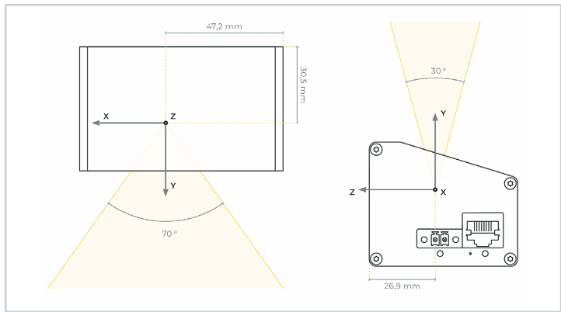
Source: Blickfeld GmbH (CUBE, 2022), Fig. 5
The data were recorded by a sensor with the address 192.168.26.26 on 25 November 2020, starting at 20:01:45, and are stored as one semicolon-separated CSV file per frame in four sub-folders. Each file contains the columns X, Y, Z, DISTANCE, INTENSITY, POINT_ID, RETURN_ID, AMBIENT and TIMESTAMP. There are total of 714 frames in all four-folders put together.
Figure 3. Distribution of point ranges in the 100-frame sample (image is scaled to fit all the data in single image)
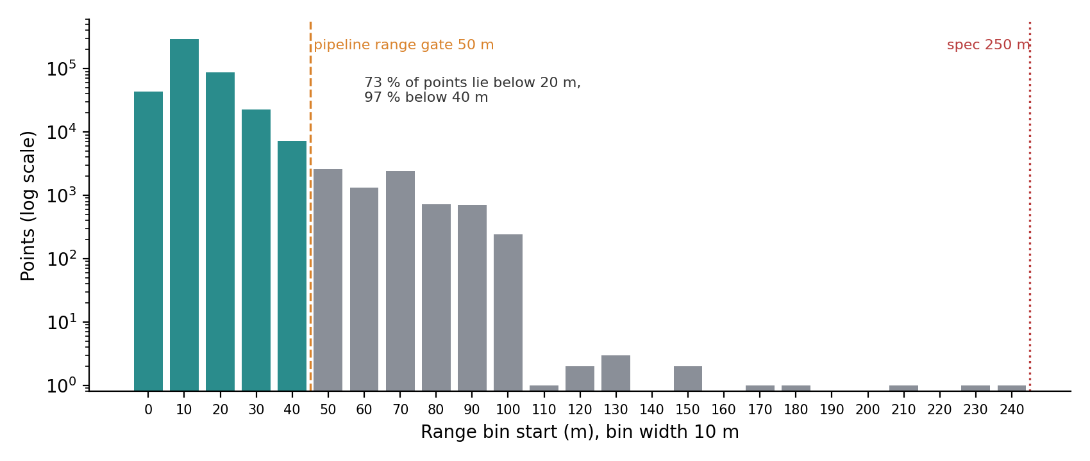
Source: own analysis
Referring to (Figure 3) cloud points in data set range from ~4m to 268m and distribution explains 73 % of all points lie below 20 m and 97 % below 40 m, while the returns past 100 m are isolated single points that carry no object information. Hence to optimize the time we can safely ignore everything beyond 50 m in detection pipeline.
All the frames are checked for the consistency of specifications. Except for the H-FOV, all values match the data and specifications.
Table 5. data sanity check between specifications and sample data
Folders analyzed |  |  | 4
Total frames |  |  | 718
Total points |  |  | 13322833
Missing / NaN values |  |  | 0
Metric | Spec | N |  | Mean |  | StdDev |  | Min |  | Max | Median
Points per frame | - | 718 |  | 18555 |  | 84.114 |  | 18136 |  | 18740 | 18576.5
Range (m) | 5 - 250 | 1E+07 |  | 18.885 |  | 9.76 |  | 4.5 |  | 268.094 | 17.211
Horizontal FOV | <= 70 | 718 |  | 73.469 |  | 0.02 |  | 73.422 |  | 73.582 | 73.461
Vertical FOV | <= 30 | 718 |  | 29.672 |  | 0.034 |  | 29.628 |  | 29.751 | 29.658
Update rate (Hz) | 1 - 30 | 714 |  | 2.435 |  | 0 |  | 2.435 |  | 2.435 | 2.435
Frame period (s) | - | 714 |  | 0.411 |  | 0 |  | 0.411 |  | 0.411 | 0.411

3.4 Conclusion on the sensor and the data
The recording is of good quality: complete, consistent, free of missing values and stable in frame size, so it is a sound basis for developing a detection chain. The field of view is 3.5° wider than documented, which is harmless. The scene is short-range, which justifies the 50 m range gate of the pipeline. And the update rate of 2.435 Hz, although within specification, is both too low for driving, which later turns out to be the single most consequential property of this data set.
For this case study the sensor is adequate, since Cube 1 resolves pedestrians, a cyclist and cars well enough to develop and test the algorithm.

5 Detection pipeline
From this section onward we will dive deep into the actual implementation of project pipeline, we will start with system architecture, algorithms, tuning of parameters.

5.1 System architecture
Project code is divided into two sections via worker and GUI thread Figure 4, worker thread handles the cloud points from LiDAR data starting from loading the CSV frame to finally classifications. GUI thread receives finished geometry for each frame and draws it using Open3D.
Figure 4. Module architecture of the detection and tracking application
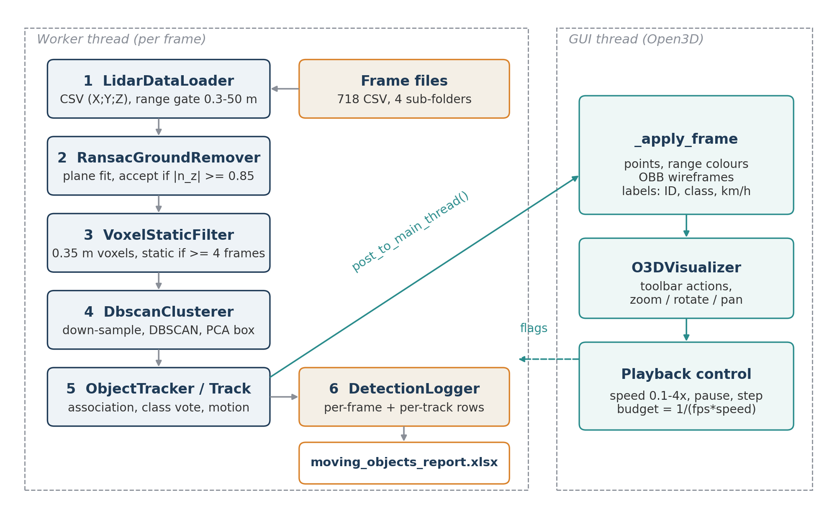
Source: own illustration
Figure 5, follows one frame through the pipeline. A raw file with about 18,500 points and nine columns is reduced to an N×3 array, converted into an Open3D point cloud and then thinned out twice, first by removing the ground and then by removing the static background. Only what is left, typically moving objects plus some clutter. From there on the data are no longer points but detections and then tracks. Only tracks that are confirmed and moving leave the pipeline, both to the viewer and to the Excel report.
Figure 5. Data flow and data types for one frame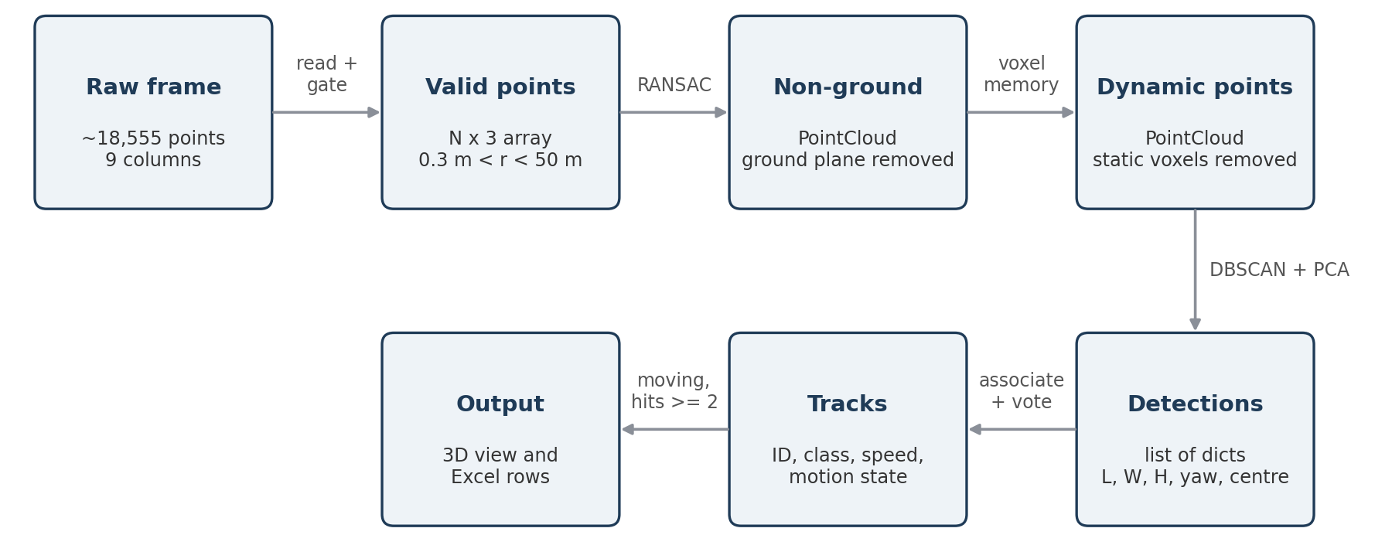
Source: own illustration

5.2 Algorithms

5.2.1 Ground removal with RANSAC
RansacGroundRemover uses the plane segmentation of Open3D, which implements RANSAC, in every iteration three points are drawn at random, the plane ax + by + cz + d = 0 through them is computed, and all points closer than the distance threshold (0.18 m) are counted as inliers. After 500 iterations the plane with the most inliers is returned, and its inliers are removed from the cloud.
RANSAC finds the largest plane, which is not necessarily the ground. In this scene a building wall or the side of a lorry can collect more points than the road. The fitted plane is therefore only accepted if its normal is close to vertical, i.e. if the z component of the unit normal is at least 0.85. This corresponds to a maximum inclination of arccos(0.85) ≈ 31.8°, which is far more than any road slope and still reliably rejects walls. If the plane is rejected, or if fewer than 200 points are left, the frame is passed on unchanged.
The threshold of 0.18 m is a compromise. A value that is too small (a few centimetres) leaves road texture, kerb edges and sensor noise in the cloud, which then show up as many small false clusters. A value that is too large (around 0.5 m) removes the lower part of real objects such as a object legs, a small animal or a low cyclist. A useful way to think about the value is the effect of a small tilt: at 50 m, an angular error of only 0.2° between the true ground and the fitted plane already produces a height offset of 50 m · tan(0.2°) ≈ 0.18 m.
The number of iterations was checked with the usual RANSAC formula. To draw at least one sample of three ground points with probability p, when a fraction w of all points belongs to the ground, the number of iterations must be
k = ln(1 − p) / ln(1 − w³)
in 1st iteration I have only considered to remove the ground removal and clustering and keep other points as it for detection. As Figure 6 shows, this produced many false detections, because buildings, fences, poles and parked cars were all clustered and classified. This result led to the idea of removing everything that does not move.
Figure 6. First iteration with ground removal only: static structures are detected as pedestrians, cyclists and big vehicles
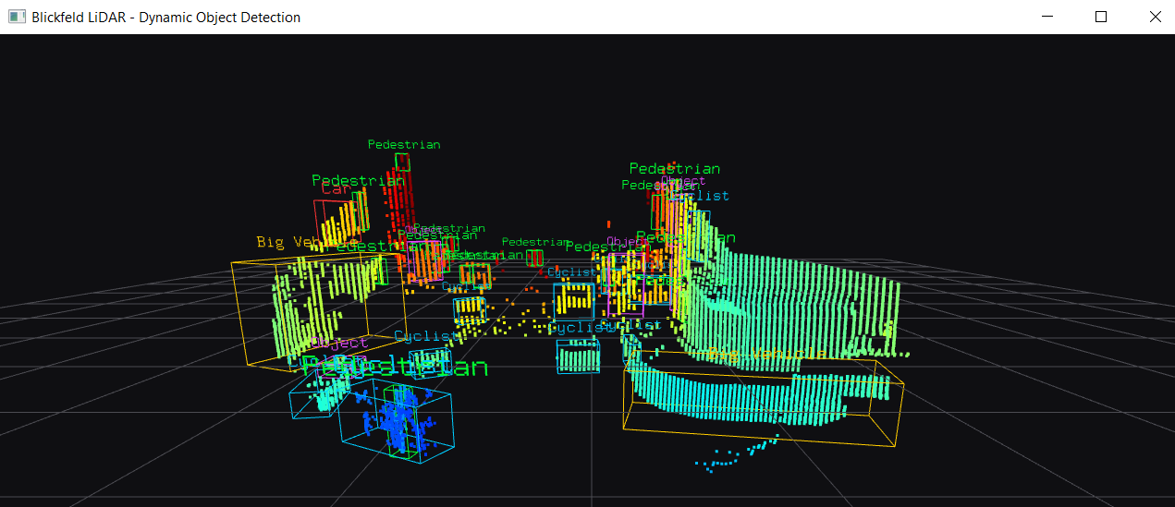
Source: own screenshot

5.2.2 Static background suppression by voxel persistence
VoxelStaticFilter acts as a memory of where points have appeared before. Because the point positions differ slightly from frame to frame, individual points cannot be compared directly. Instead, space is divided into cubes (voxels) with an edge length of 0.35 m. Each point is mapped to its voxel index ⌊p/0.35⌋, and the three integer indices are packed into one 64-bit key (21 bits per axis), so that a plain dictionary can be used as a sparse grid.
For every voxel the filter stores how many frames it has been occupied in and when it was last seen. In each frame all occupied voxels are counted once and points whose voxel has been seen in at least four frames are treated as background and removed. The first two frames are passed through unchanged, because the memory is still empty. Every 30 frames, voxels that have not been seen for more than 60 frames are deleted, so that the dictionary does not grow without limit and so that a parked car that drives away is eventually forgotten.
This step removed most of the clutter from Figure 6 and was the single largest improvement during development. It has two limitations. It only works because the sensor does not move; on a vehicle, the background would have to be transformed into a fixed frame using an ego-motion estimate. And an object that stays in the same place long enough becomes part of the background itself.

5.2.3 Down-sampling and DBSCAN clustering
DbscanClusterer first reduces the remaining cloud to one point per 12 cm voxel. Near the sensor the Cube 1 delivers many more points per object than far away, so without this step an eps value that separates two pedestrians at 5 m would break a car at 35 m into pieces. After down-sampling the density is more uniform, at least up to the range where the natural point spacing exceeds 12 cm. An optional radius outlier filter is available, but it is switched off in the final configuration.
DBSCAN then groups the points. A point is a core point if at least min_points = 12 points lie within the radius eps = 0.65 m. Clusters are formed by connecting core points that are within eps of each other, together with their neighbors; all other points are noise. The value of 0.65 m is smaller than the typical gap between two people walking side by side at a normal distance and larger than the gaps that appear inside a car body at 30 m to 40 m. It is the most sensitive parameter of the whole pipeline. Clusters with fewer than 12 points or with a box volume outside 0.05 m³ to 100 m³ are discarded.

5.2.4 Rule-based classification with hysteresis
The class is derived only from the box dimensions, using the rules in Figure 7 and Table 6. The rules are checked from top to bottom, and a cluster that does not match any rule is labelled Object. The limits were chosen from typical dimensions of road users mentioned in the below table 6
Table 6. Classification rules (L = filtered length, H = height)
Class | Rule | Hysteresis on length limit
Big Vehicle | L ≥ 5.0 m and H ≥ 2.3 m | 5.0 m ± 0.35 m
Car | L ≥ 2.6 m and 0.8 m ≤ H ≤ 2.5 m | 2.6 m ± 0.35 m
Cyclist | L ≥ 1.1 m and 0.7 m ≤ H ≤ 2.0 m | 1.1 m ± 0.35 m
Pedestrian | L < 1.1 m and 0.5 m ≤ H ≤ 2.1 m | 1.1 m ± 0.35 m
Object | none of the above | –
Source: own definition
Figure 7. Class regions in the length–height plane with hysteresis bands
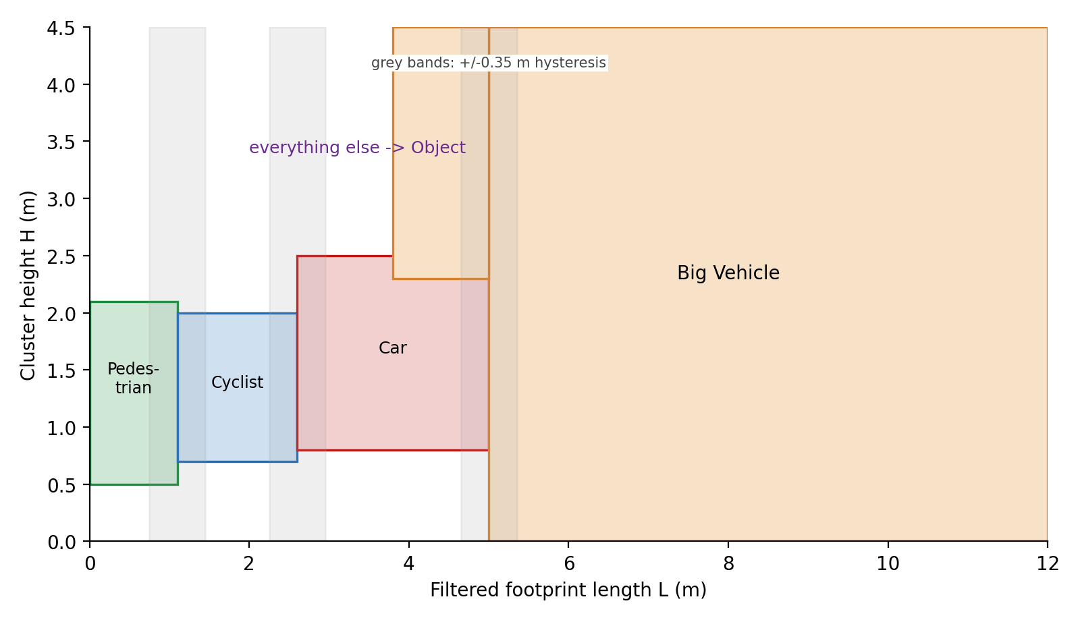
Source: own illustration
A pure threshold classifier flickers when an object's size is close to a limit, for example a cyclist whose measured length varies between 1.0 m and 1.2 m. To prevent this, the length limits are shifted by 0.35 m depending on the class the track currently has. For a track that is already a car, the car limit is lowered to 2.25 m; for a track that is not yet a car it is raised to 2.95 m. An object therefore needs a clear size change to change class but can keep its class through moderate measurement noise. The same logic is applied to the cyclist and big vehicle limits. The height limits have no hysteresis.

5.2.5 multi-object tracking
The tracker (ObjectTracker with one Track object per physical object) has four jobs: associate new detections with existing tracks, estimate the velocity, stabilize size and class, and decide which tracks are shown.

5.2.5.1 Association
Each track and each detection are represented by its centroid (x, y) and the lowest point z_{min}. All pairwise distances are computed, and the globally closest pair is assigned repeatedly until no pair is closer than 2.5 m. Detections that remain unassigned start new tracks. Tracks that have not been updated for more than three frames are deleted.

5.2.5.2 Velocity
The velocity is the displacement of the centroid divided by the elapsed time; exponentially weighted moving average (EWMA) is used as centroid also moves when a different side of the object becomes visible:
v_{k} = 0.4 · v_{k−1} + 0.6 · (c_{k} − c_{k−1}) / Δt , Δt = (frame gap) / fps (5)
The speed used for the motion decision is the horizontal part of this vector.

5.2.5.3 Motion state and output
Only moving objects are reported. The motion state is a small state machine with two thresholds a track becomes moving when its speed exceeds 0.6 m/s and becomes stationary again only after its speed has been below 0.33 m/s (0.55 × 0.6 m/s) for five consecutive updates. A track is drawn if it is moving, has been detected at least twice and was updated in the current frame or in one of the two previous ones.

5.2.6 Tuning parameters
As we have not received any other information about actual detection data sets hence tuning the parameter was very tricky hence, I have chosen iterative way below are list of important parameter values used for final configuration.
Table 7. Tuning parameters of the final configuration
Module | Parameter | Value | Effect of a larger value / rationale
Loader | min_range_m / max_range_m | 0.3 / 50 m | wider gate keeps more far points; 97 % of points are below 40 m
Ground | distance_threshold | 0.18 m | removes more of low objects; smaller leaves road texture
Ground | num_iterations / ransac_n | 500 / 3 | more iterations raise the chance of finding the ground
Cluster | min_points | 12 | larger suppresses noise but loses far pedestrians
Cluster | min_volume / max_volume | 0.05 / 100 m³ | removes specks and merged structures
Cluster | outlier_radius / neighbours | off / 4 | optional; ≈ 0.5 m helps if objects merge
Tracker | min_hits | 2 | confirmation delay vs. false tracks
Tracker | min_speed_mps / release_ratio | 0.6 m/s / 0.55 | enter / exit threshold of the moving state
Tracker | release_frames | 5 | updates below exit speed before a track stops
Tracker | coast_frames / max_age | 2 / 3 | display through misses / delete after
Tracker | dim_decay | 0.97 | closer to 1 keeps the largest size longer
Source: own configuration

6 Results
We have received video of the recording with assignment. I have used as a reference to note down every moving road user the time at which it appeared and disappeared and converted this interval into an expected number of frames (about 1.39 frames per second of video). The same objects were then looked up in the output of the algorithm, and the first and last frames in which a confirmed moving track existed were noted together with the class it was given. An object was counted as correctly classified if it was detected as moving and its predominant stable class was the right one.
Seven moving road users were found in the video: four pedestrians, one cyclist and two cars. This is a small sample, and the reference itself is manual, so the numbers below should be read as an indication rather than as a precise measurement.
Note : the excel output I have considering the object after the fame 10 as first 10 frames are still removing the moving background hence to good for considering as detections.
Table 8. Object-level evaluation against the video reference
No. | Object | Video start–end | Expected frames | Detected frames (algorithm) | Detected Frames | Detected class in pipeline | Counted as correct
1 | Pedestrian 1 | 0:14–0:42 | 39 | 53–89 | 36 | Pedestrian (walking around) | yes
2 | Pedestrian 2 | 0:14–0:42 | 39 | 59–78 | 19 | Pedestrian (walking around) | yes
3 | Pedestrian 3 | 2:22–2:38 | 23 | 199–204 | 5 | Pedestrian (driver walking to car) | yes
4 | Car 1 | 2:45–2:50 | 7 | 205–208 | 3 | Object (only part of the car visible) | no
5 | Cyclist 1 | 4:41–5:14 | 46 | 348–389 | 41 | Cyclist, partly Pedestrian | yes (majority)
6 | Car 2 | 4:42–5:10 | 39 | 359–372 | 13 | Car, partly Big Vehicle | yes (majority)
7 | Pedestrian 4 | 7:11–8:27 | 105 | 516–588 | 72 | Pedestrian, partly Cyclist | yes (majority)
Source: own evaluation
Six of the seven objects were detected and classified correctly, which gives an object-level correct classification rate of
CCR = 6 / 7 = 85.7 %
The required CCR of 0.99 is not reached. The measured 0.857 is clearly below required for the project completion, the root cause analysis is done in next section.
Apart from the less CCR rate the change is identity of object is one of the critical issues observed during the project and add the majority voting before counted as specific class, but not sure in actual project if this would be real challenge.

6.1 Root cause for lower accuracy
The following are the reasons for poor detections.
- Partial visibility at the edge of the field of view:
Car 1: was only visible for a few frames and only partly, because it passed the edge of the 73.5° field of view. The cluster therefore had the length of a car's front section only, which the size rules classified as Object. The rule-based classifier has no way of knowing that an object is cut off by the FoV border or hidden behind another object, so it always treats the visible extent as the full extent.
Pedestrian 3: who walked next to a car, suffered from the same effect through occlusion.
- Absorption of slow objects as the background:
The voxel filter counts an object if it’s in same voxel in four frames, then that part is removed. For an object of extent L moving at speed v, occupied L/(v·T) frames, V_{critical} = L / (4 · T). Hence some part of object is gets partially considered to be part of the background. We can see this effect for pedestrians 1 and 2 while they are walking, as they slow down and detection was poor during this time.
Figure 8. Critical speed below which the static filter starts to remove parts of an object

Source: own analysis
- Association gate without motion prediction
The tracker compares the new detection with the last known position of the track, not with a predicted position. A match is therefore only possible if the object moved less than 2.5 m between two frames. Or 2.5 m/0.411 s ≈ 6.1 m/s or about 22 km/h. Pedestrians and cyclists are well inside this limit, but a car at normal urban speed moves 4 m to 7 m per frame. Its detections are then not associated with the existing track, a new track is created in every frame, and because a new track needs two hits before it is shown, the car may not be displayed at all or only when it slows down. This we can see for car 2 as well covered in only a third of its expected frames.

6.2 Strategies for improvement
To address the root cause of lower accuracy, we can explore the below options to further increase the detection rate.
Table 9. Proposed improvements
No. | Measure | Expected effect | Effort
1 | Protect voxels inside confirmed tracks from being learnt as background | slow and stopping objects kept | low
2 | Range-dependent eps / range-image segmentation | fewer split and merged clusters | Medium
3 | L-shape fitting and truncation flag at FoV border | correct size for partly visible cars | Medium
4 | Feature-based classifier (size, speed, point statistics, intensity) | better separation of neighboring classes | Medium
5 | Improve the LiDAR data collection and labeling | Better co-relation | High
These are the proposals for future implementation however I am not sure if these improvements will bring drastic improvement as current LiDAR data collection labeling is not good. Need the strong improvement there as well.

7 Conclusion
In this case study we have reviewed Blickfeld Cube 1, checked the quality of a 718-frame recording and developed a complete, classical pipeline for detecting, classifying and tracking moving road users.
The sensor review showed that the Cube 1 is compact, precise and eye-safe and has a good vertical field of view, but its angular resolution do not meet the requirements of a main perception sensor for a self-driving car. The sanity check confirmed a clean, consistent data set with no missing values and a very stable frame size. It also revealed a horizontal field of view of 73.5°, which is 3.5° above the specification, a few returns outside the specified range limits, and a frame rate of only 2.435 Hz.
Detection pipeline combines RANSAC ground removal, a voxel-based background memory, DBSCAN clustering, PCA-based boxes, size rules with hysteresis and a tracker with class voting and a latched motion state. The background memory was the most effective single step, and the hysteresis and voting mechanisms made the output stable enough to follow individual objects. In the evaluation against the video, all seven moving road users were detected and six were given the right class, which corresponds to a correct classification rate of 85.7 %.
The target of 0.99 correct classification and 0.01 false alarms per hour was not reached, and it could not have been demonstrated with a recording of less than five minutes in any case. The main technical reasons are the loss of partly visible objects at the edge of the field of view, the gradual absorption of slow objects into the background. The most useful next steps are to start with labeled LiDAR data collection, flag object detected near FoV border etc. also we need to have sufficient data to train the model and label on LiDAR data instead of judged by eye.

Bibliography
Bolles, R. C. (1981). A RANSAC-based approach to model fitting and its application to finding cylinders in range data. Proceedings of the 7th International Joint Conference on Artificial Intelligence (IJCAI'81), Vol. 2, 637–643.
CUBE, B. (2022). BLICKFELD CUBE 1 USER MANUAL.
Dai, Z. W.-P. (2022). Requirements for Automotive LiDAR Systems 22(19), 7532. doi:https://doi.org/10.3390/s22197532
Ester, M. K.-P. (1996). A density-based algorithm for discovering clusters in large spatial databases with noise. Second International Conference on Knowledge Discovery and Data Mining (KDD-96), 226-231.
Hensai. (2025). AT128P 128-Channel Hybrid Solid-State Lidar User Manual. Retrieved from https://www.hesaitech.com/wp-content/uploads/2025/04/AT128P_User_Manual_A02-en-250410.pdf
ISO-15623. (n.d.). International Organization for Standardization. 2013.
Livox. (2024). Livox mid 360 user manual V1.2. Retrieved from https://terra-1-g.djicdn.com/851d20f7b9f64838a34cd02351370894/Livox/Livox_Mid-360_User_Manual_EN.pdf
Lue Fan, X. X. (2021). RangeDet: In Defense of Range View for LiDAR-based 3D Object Detection.
R, T. (2016). Scanning LIDAR in Advanced Driver Assistance Systems and Beyond: Building a road map for next-generation LIDAR technology. IEEE Consum. Electron. Mag. , 48–54.
RoboSense. (2022). M1 Plus Users Guide v1.3.0 CN. Retrieved from https://www.robosense.ai/en/resources-11
You Li, J. I.-G. (2020). Lidar for Autonomous Driving: The principles, challenges, and trends for automotive lidar and perception systems. IEEE Signal Processing Magazine. doi:https://arxiv.org/abs/2004.08467

Appendix A: Software environment and files
The pipeline was developed and run in PyCharm on Windows with a virtual environment. The main libraries are NumPy, pandas, SciPy (distance matrix for association), Open3D (point cloud operations, RANSAC, DBSCAN, visualisation) and openpyxl (Excel export). The following files belong to this work:
Table 11: Files of the project
File | Purpose
lidar_tracking_clean.py | final detection, classification and tracking pipeline with viewer and playback controls
LIDAR SANITY CHECK.py | plausibility checks on a frame sample (Table 6)
statistics script (stats_row) | summary statistics and Cpk over all frames (Table 5)
moving_objects_report.xlsx | output: sheets Per Frame and Moving Detections

