ทดลองเปลี่ยน Isolation Level เป็น Repeatable Read และ Serializabl

1. Repeatable Read ให้ใช้คำสั่ง SQL ดังต4อไปนี้

Terminal 1: start transaction;

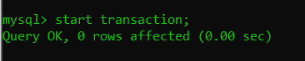

Terminal 2: set session tx_isolation='REPEATABLE-READ';

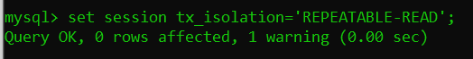

Terminal 2: start transaction;

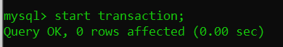

Terminal 1: select * from trantest;

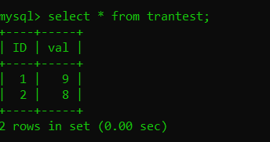

Terminal 2: select * from trantest;

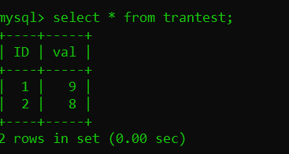

Terminal 1: update trantest set val = val + 5 where ID=1;

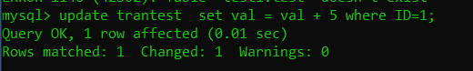

Terminal 2: select * from trantest;

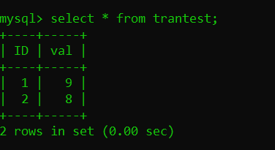

Terminal 1: commit



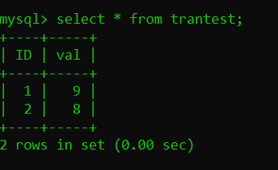Terminal 2: select * from trantest;

Terminal 2: commit;

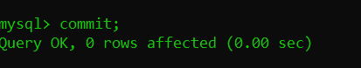

Terminal 2: select * from trantest;

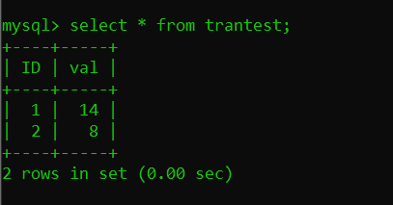

Serializable ให6ใช6คำสั่ง SQL ดังต่อไปนี้

Terminal 1: start transaction;



Terminal 2: set session tx_isolation='Serializable';

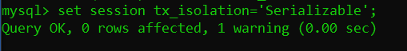

Terminal 2: start transaction;

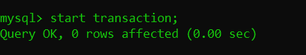

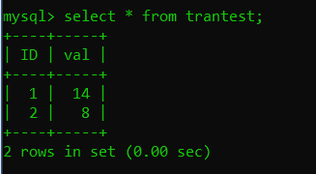Terminal 1: select * from trantest;

Terminal 1: update trantest set val = val + 3 where ID=1;

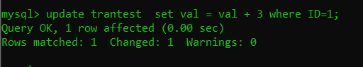

Terminal 2: select * from trantest;

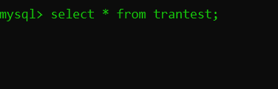

Terminal 1: commit

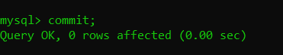

Terminal 2: select * from trantest;

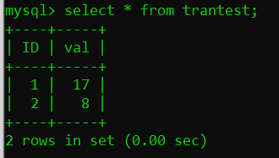

Terminal 2: commit;

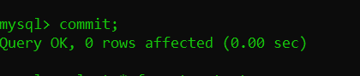

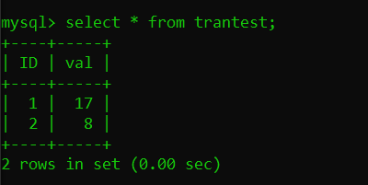Terminal 2: select * from trantest;