研究会紹介 環境情報学部

**青山　敦研究会**

「Measurement and analysis of neural information」

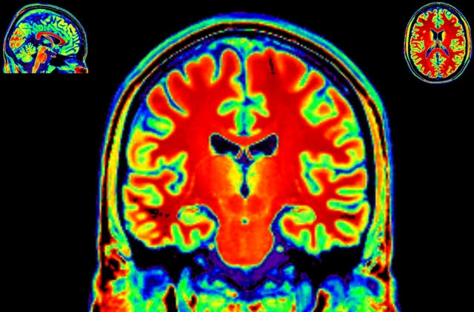

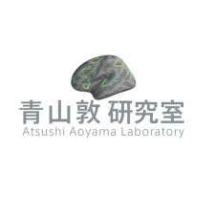

We promote basic studies about ‘neural information science’ by measuring and analyzing neural information and apply the findings to generalization of brain information, VR/AR, media, health, and so on. Recent advances in non-invasive brain measurement techniques enable us to see the human brain objectively. We study how to clarify the brain mechanism using EEG (electroencephalography), tES (transcranial electrical stimulation), MEG (magnetoencephalography), and MRI (magnetic resonance imaging), and promote research to achieve not only good graduation projects but also conference presentations and journal publications.

In the first half of the class, we hold ‘journal clubs’ or ‘progress reports’. In the second half, I explain how to measure and analyze neural information (‘seminar/workshop’) in addition to the journal club and the progress report. A higher priority will be given to the seminar/workshop in this semester. In research activity, we mainly use the 64-channel whole-head EEG system, the tES system, the 32-channel wireless EEG system, and the 16-channel simple EEG system (OpenBCI) to aquire and to analyze neural information. We also perform simultaneous measurement with head mounted display and behavioral/biophysical measurement, and make hardware/software as needed. Anyone who meets the provided conditions can be involved in a research project using MEG and MRI installed in the other institution.

Individual, group work

**安宅　和人研究会**

「Value design in AI x Data age」

Instead of learning to learn, we aim to become a place where you learn to think, learn in practice, and acquire highly versatile skills. We will evolve dynamically through the trial and error of the management of this workshop itself. The following is a provisional plan at the present stage. Firstly, each person has some theme according to the fundamental formula of value design society (Future = Dream / Issue × Technology × Design), each person has their own theme, and autonomously promote from assignment setting to execution. At each stage of assignment setting, analysis design, extraction of meaning and consolidation, guidance on issue driven and data driven problem solving is conducted separately and throughout, and mutual learning is done. (Promotion direction is provisional)

Promoted by individuals or several group work depending on the size of the theme. Depending on the theme, there may be one that ends in about a month, while others may last for about a year. (Please let me know what you really want to do at the stage of entry to this research group.)

2019年度ORF出展有り

**今井　むつみ研究会**

「Cognitive Science: Language processing and learning」

The theme of this seminar is language acquisition in children, second language acquisition, and language processing. The seminar also deals with broad topic of cognitive science, with a special focus on learning and reasoning.

Group work

**牛山　潤一研究会**

「Human Movement Neuroscience　～Considering the Brain and Body as A System～」

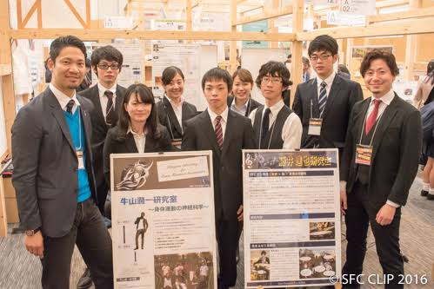

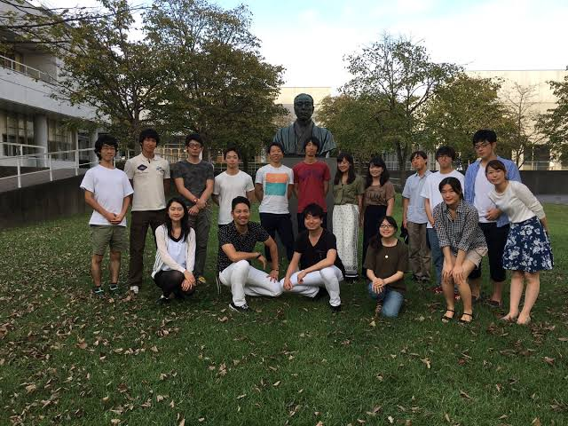

Our brain and body are always interacting each other by sending information named "neural signals", and being essentials for our movements and sensations. In this seminar, by considering the brain and body as a system, we are trying to learn the control and learning mechanisms of our bodily movements and to understand the secrets and essentials of humans. The PI is basically an electro-physiologist, measuring EEG and EMG and/or stimulating the brain and nerve using evoked-EMG and transcranial magnetic stimulation (TMS) techniques. However, we don't get research ideas from methodologies. Depending on your aims and interests, we would like to consider the way to satisfy your intellectual curiosity together.

2019年度ORF出展有り

Group work

**大木　聖子研究会**

「Earthquake Disaster Laboratory -Social Design for Disaster Prevention-」

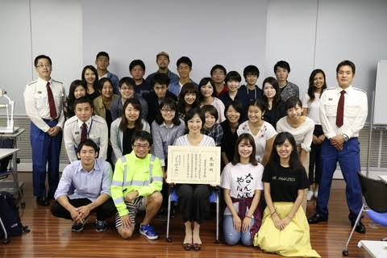

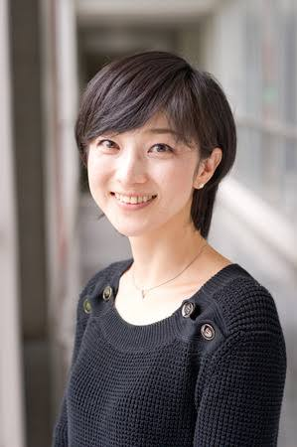

グループ研究

**オオニシ　タクヤ研究会**

「Energy Design Program」

Designing Energy for Better Society We engage to deliver the unique design solution with various researches to our society/environment/planet earth. Energy is one of the most important elements for our modernized society. But at the same time, energy causes many problems, such as a conflict between some countries for energy resources, disparity in wealth, monopolized energy market, danger in disastrous accident, politic background, technical limitation, affordability and profitability etc. “Can Design -that always provides some kind of positive lights in society- create brighter Energy Future? “ Our Energy Solution would cover urban scale, space/architecture to human scale device, passive and active, minimizing the consumption of energy or generate more of it actively. Furthermore, the energy situations are very different between developed and developing countries, and high-tech energy and versatility low-tech energy, social solution and entertainment solution – e.g. Apps-. There are still many areas that needed to be solved by talented young designers in this field. We are aiming to create open-minded, wisely-realistic and positive-driven energy design project together.

**大堀　壽夫研究会**

「Linguistic science: from basics to original research」

認知言語学の研究

We study linguistics, especially that with a cognitive-functional orientation. We will view language not as an autonomous formal system but as a resource for constructing and sharing meaning. The course will consist of a period for acquiring adequate knowledge for research and that for developing each participant's interest which will hopefully result in original research.

ORF あり

個人研究・グループ研究

**加藤　貴昭研究会**

「Human Performance」

The purpose of this seminar is to analyze the human behavior and performance from the psychological and physiological aspects of various experimental methods from the field of ergonomics and sports psychology.In the field of ergonomics, in order to solve human and environmental problems that will be seen in our life, we aim at practical applications to achieve harmony between humans and the environment that based on impression evaluation and biological reactions.In the field of sports psychology, we are considering nonverbal and inclusive knowledge such as visual characteristics supporting high performances by experts, and psychological characteristics required. As we have a lot of students who are actually dedicated to sports competitions, we aim to find not only academic significance but also practical value.

グループ・個人研究

**加藤　文俊研究会**

「Exploring the power of place」

In this seminar (kenkyu-kai), we attempt to explore the notions of "place" and "placemaking" from the standpoint of media and communication studies. When we reflect upon the nature of our social relationships, being with someone or being on-site (at the time of the event) is becoming more and more important. It points to the idea of "design of sharing," and that is realized through raising our consciousness about our problems at hand. Our research projects aim to promote a sense of belonging to the community, and the nature of human relationships therein, through a series of field research and qualitative analyses. I do welcome foreign students to join my kenkyu-kai, but classes and field trips will be operated mainly in Japanese. Thus we may need to find ways to cope with various communication issues, and I am eager to do so.

**厳　網林研究会**

「Data-driven Research for the Development of Smart City and Region」

This kenkyukai focuses on the development of smart city and region by data-driven approach. We use Geographic Information Systems (GIS) and other advanced technologies to monitor, analyze, and model environmental issues for sustainable development in urban and regions. What you can learn at this kenkyukai is Statistics, Geospatial data processing, Fieldwork, Quantitative and Qualitative Survey, Logical thinking, Human Geography, Physical Geography. The geographic information system (GIS) lets us visualize, question, analyze and interpret data to understand relationships, patterns and trends. GIS has been used in a wide range of fields such as medical, commercial, disaster prevention, agriculture, security, tourism and urban development. It is said that more than 70% of the information is related to GIS. Thus, applying GIS studies to your research will increase the persuasiveness of your reseach dramatically.

Group work

**神成　淳司研究会**

「Agri-Informatics and Data platform」

In out Kenkyukai, we have 4 main themes. 1. We collaborate with skilled producers all over the country to research and develop AI agriculture (currently collaborating with Tochigi, Saga, Ishikawa, Kagawa, Shizuoka, etc.) 2. R & D and study on a wide range of smart agriculture, including the Agricultural Data Collaboration Platform (WAGRI) and smart food chains. 3. R & D / examination of harbor-related data linking infrastructure and health-related data linking infrastructure, which we are working on separately. 4. Work for a

diverse social innovations that have been undertaken by research groups in the past. For the specific research topic, it will be determined through interviews.

Group work

**諏訪　正樹研究会**

「Designing life knowledge in practice」

This Kenkyukai’s objectives are 1. Feeling and thinking what the own body does and feel, 2.describing what conditions and history the current body is rooted in, 3.finding various aspects, structures and processes of intelligence, and thereby 4.designing own ways of life knowledge in practice.

Group work

**高汐　一紀研究会**

「Social Cloud Robotics」

From the viewpoint of the sociality, the perception and context capturing function possessed by robots themselves is an important factor in determining behaviors of robots in human interactions. We are focusing attention on the emotional recognition of the communication partner, that is, the acquisition mechanism of human’s emotional changes, which is indispensable for realizing “social and emotional interaction”, and have been exemplifying its principles, implementation methods, and application examples. We have exemplified many-to-many human robot interactions in various usage scenes by implementing “sympathizing robot”, “remote ice breaking robot system”, etc. Topics covered in this lab range over “pseudo-emotional behaviors of robot in HRI”, “the personality of robot naturally being built by HRI”, “creating moderate interval and proximity in HRI” and so on. They are examples of next generation social and emotional human robot interactions.

ORFあり

**武田　圭史研究会**

「UAV(Drone) and Advanced Technology Development and Application」

Research topic include UAV(Drone) and advanced technology such as cyber security, web, VR(Virtual Reality) and AI(Artificial Intelligence) .UAV(Drone)Development and Application Goal: Conduct research on control over physical devices by developing racing drone, drone flight test, flight characteristics analysis, operation practice, software development for flight controller/ESC/OSD etc., attending competition such as FPV drone racing or FPV freestyle, video processing with low latency, development automated flight system and flight support system. Students who join the seminar for the first time are given new student assignments. By completing the assignments those new students are allowed to enroll actual research projects. Completion of the assignments is mandatory to continue enrolling this seminar after 2nd semester. Assignments for Cyber Security, Web Application, VR and AI involves basic knowledge on information technology and their skills. (Examples include creating web site, knowledge test, data analysis etc.). Students in UAV Development would be required to pass official examination for Amateur Fourth-Class Radio Operator and basic operation of UAV.

Group work

2019年度ORF展示あり

**田中　浩也研究会**

「Digital Fabrication for the Next city and city life」

デジタル・ファブリケーション技術 (特に3D/4Dプリンティング, モデリング, センシング)を軸とし、課題領域ごとの核心的なソリューションを生み出すデザインメソッドを創出しながら、来たるべき2020年代に求められる「新しい都市(生活)のためのデザイン」を先見的に探求する研究室です。

Focusing on digital fabrication technology(especially 3D/4D printing, modeling, and sensing), while creating design method which creates core solutions for “The design for a new cities(lifestyles) “.What we have as projects are 1.Body Fit Products - Shoes and Prosthesis 2.Furniture - 3D Printed Chair 3. Architectural Element- Environmental Facade Design 4. Island, Plaza and Park Scale - Super Large 3D Printer.

**中澤　仁研究会**

「City, Human, and Media」

Our lab also emphasizes demonstration through international collaborative research projects with various external organizations including domestic and foreign universities, companies and local governments. Students are strongly encouraged to participate in such projects, to collaborate with industry, government and academia, and to have international experience.

Group work

中西　泰人研究会

「Experience Design in Human Computer Interaction」

In our Kenkyukai, we design based on HCI( Human Computer Interaction) by using various technologies such as censer, camera, robots and HMD. Our main themes are Robot Experience / Human Robot Interaction, Augmented Human / Embodied Interaction, Augmented Space / Spatial User Interaction, Creative Activity Support.

Group work

**中浜　優子研究会**

「Second Language Acquisition, Cross-cultural Communication and Foreign Language Education」

In this seminar, students will discuss and explore the process of second language learning and teaching through studying textbooks and research articles. Students will learn how to conduct research such as how to develop research themes and research questions, how to design research, and data analysis, as well as how to write a research paper. Students will work on their individual studies, giving each other feedback in weekly discussions. This lab has about 25 students including graduate students,and most of them have had experience living or studying abroad and are proficient speakers of English.

Discussions will be conducted in both English and Japanese, and I am hopeful that both Japanese and international students can improve English and Japanese proficiency respectively by being in this seminar.

**長谷部　葉子研究会**

「How to Realize Social Transformation Based on Collaboration and Sustainable Relationship with Locality in the Field of Education」

Yoko Hasebe’s laboratory conduct and create what is thought to be necessary but does not exist in the local field in and outside of Japan through field activities and practices in the perspective of education, cross-cultural and cross-linguistic communication. Here, interpersonal communication skills, flexible judgement and action skills in variety of fields will be improved. The students are divided into mainly 6 projects and each carry activities according to the field each are in charge of such as schools, rural areas and Africa. Please refer to the websites for details on each project.

グループ研究

**増井　俊之研究会**

「Real-world interface design」

In our Kenkyukai, we conducts various research related to user interfaces, such as information visualization, information research, for instance prediction interface, ext input system, real world oriented programming and real world GUI.

ORFあり

**松川　昌平研究会**

「Algorism - (in)computability of architecture」

This Kenkyukai explores the computability of architecture and cities by writing down all design processes related to architecture and cities into computer algorithms.

Group work

**脇田　玲研究会**

「How to Live as an Artist」

In this Kenkyukai, we learn contemporary art in a broad sense and research the evolution and prospects of contemporary art , media art, street art and relational art in a narrow sense. Moreover, we create products as an artist or as an curator and students in this Kenkyukai will have chance to participate in Wakita’s production sites and learn how to make and live as an artist.

Group work, Workshop

● プライバシーポリシーについて

This privacy policy sets out how SFC Kenkyukai page uses and protects any information that you give us when you use this website.

SFC Kenkyukai page is committed to ensuring that your privacy is protected. Should we ask you to provide certain information by which you can be identified when using this website, then you can be assured that it will only be used in accordance with this privacy statement.

SFC Kenkyukai page may change this policy from time to time by uploading this page. You should check this page from time to time to ensure that you are happy with any changes.

● サイトについての説明

Our aim is to help you reach a skill level high enough to be able to respond in English to any situation and any environment. We hope that you will be able to take full advantage of your 4 years in SFC’s learning environment, featuring an innovative and advanced learning curriculum for higher education in Japan.