**総合政策**

**Makiko Nakamura Kenkyukai**

“Academic Economics”

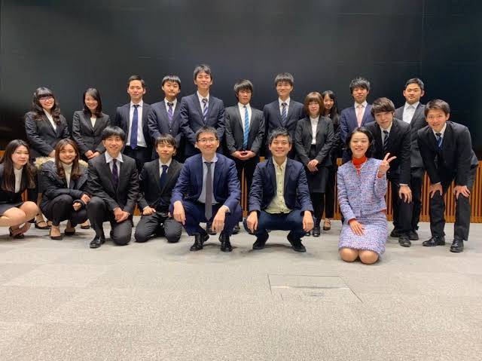

In this seminar, students will learn how to empirically prove the effects of educational politics in Japan or at world by using basic theory or methods of economics.

Every semester, we will hold “Mini Conference” where students will present their research results.

We will conduct reading and discussion of the specified papers, learning how to use SPSS, STATA, R, Python, etc., as well as regular training and quizzes to improve English skills from the bottom up.

Participants in the “Mini Conference” and submitting their research plan will be notified of the interview schedule. We put emphasis on intensive education with a small number of students, therefore maximum number of students will be around 15. The competitive ratio is about 3 times. See the syllabus for more details.

-Personal Study

-Has joint Kenkyukai

**Isagai Yoshinori Kenkyukai**

“Effective Platform Design for Community Innovation in Maebashi City”

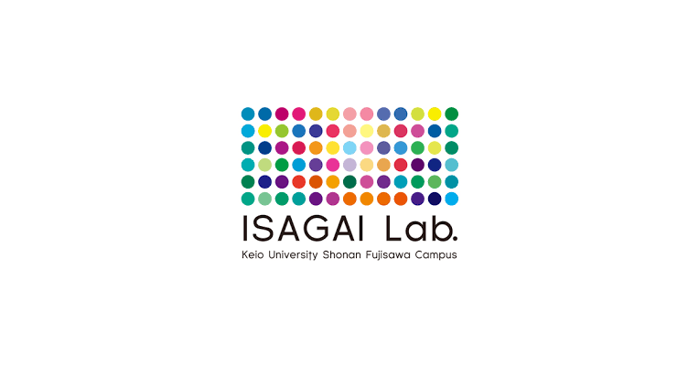

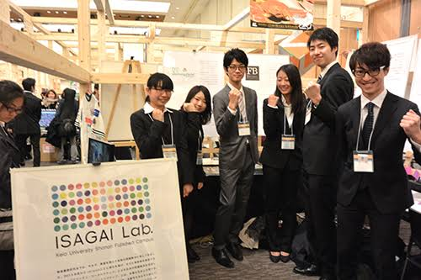

In this seminar, we look at specific measures related to how effective platforms are designed in the context of community innovation. The platform is defined as, “tools and mechanisms that serve as the basis for communication, which promotes cooperation when various constituents are cooperating.” If designs are carried out effectively, platforms have the potential to form connections between diverse constituents such as people and groups and bring about emergence based on interactions.

Action Research and Project Based Learning are partially incorporated in order to create practical wisdom.

Project Examples:

Yugawara Project, Shiraoka Genki Project, Ootakichou Genki Project, Koochi Machikatsu Project, FamilyBusinesProject…etc

プロジェクト単位

-2019 ORF Exhibit

**Takashi Iba Kenkyukai**

“Natural & Creative Living Lab”

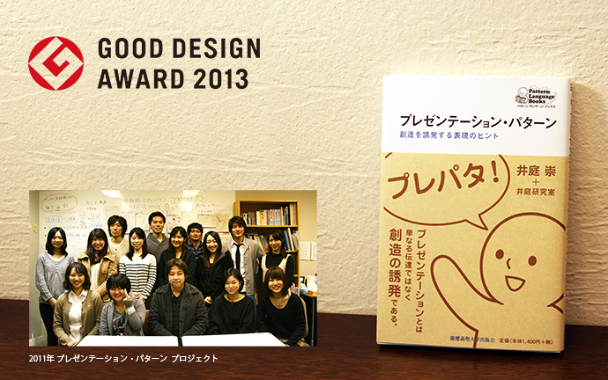

In this seminar, students study ways of natural and creative living and how to shift our society to be more natural and creative.

So far, Iba Kenkyukai has created various pattern languages, focusing mainly on a trilogy called "Learning Pattern" for creative learning, "Presentation Pattern" for stimulating creative presentation, and "Collaboration Pattern" for creative collaboration. We have positioned such pattern languages in "human behavior" as "Pattern Language 3.0" and are in the process of pioneering the study.

This year, we are creating a pattern language in a completely new area such as disaster prevention, education, organizational change, global way of life, revitalizing Japanese methods, etc. We also work to help those who create their own pattern language.

-プロジェクト単位

-2019 ORF Exhibit

**Taro Ozawa Kenkyukai**

“Game theory”

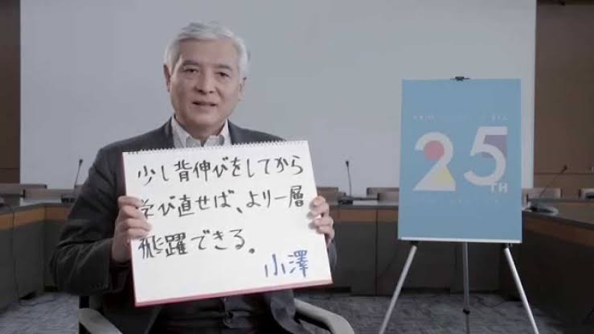

In recent years, we have not only read in detail textbooks dealing with the social choice theory and the application of game theory to public choice, but also examined the decision analysis beyond "rational choice", for example, the Gilboa's decision theory. This year we will read an intermediate textbook of game theory. In this semester, we will continue to read an intermediate textbook on game theory.

I hope to encourage competition among the participants of my seminar and build a tense relationship to work hard together.

**Tomoki Kamo Kenkyukai**

“China Perspectives: Chiese Politics and Japan's Policy towards China”

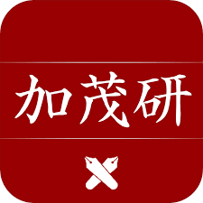

This seminar will focus on Chines politics and Japan-China relations. In this seminar students are requested to pick up your own topic and make presentations. It also means students need to devote their time and other resources to prepare for their researches outside usual class time. Any topics on China or Japan-China relations are welcomed. At the begging of a semester and end of a semester we have a research camp outside SFC. Students make their final presentations and submit their papers.

-Has Joint Kenkyukai

**Takeo Kuwahara Kenkyukai**

“Marketing Communication / Scientific and Technical Communication”

In this seminar, we will explore the communication strategies for consumers and organizations mainly about various subjects in the fields of [marketing / consumer research](http://vu.sfc.keio.ac.jp/course2014/summary/syll_view_c.cgi?yc=2019_36605&lang=ja&ks=A1101#marketing%20/%20consumer%20research) and [science and technology](http://vu.sfc.keio.ac.jp/course2014/summary/syll_view_c.cgi?yc=2019_36605&lang=ja&ks=A1101#science%20and%20technology). Based on the students' research interest, we design and implement research projects. Up to now, the following projects were implemented：Marketing Communication, Science and Technology Communication.

The student belongs to one of the project teams mentioned above, spends considerable time, designing the plan, conducting and managing the survey, and fighting with the data. Almost every week, I will report the analysis plan and the progress situation, and will discuss the whole thing. Ultimately, we will create a comprehensive report.

-Personal study/ Group study

**Takeshi Kawazoe**

“Art and Math”

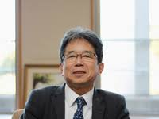

Since the name of the Kawazoe Kenkyukai is "Mathematics and Art", there are many students who are doing research related to mathematics used in art works such as art, music, literary arts, and the mathematics hidden there. However, any research related to mathematics is accepted. Some people are doing research that mathematically delves into the fields they were studying at other Kenkyukais.

-Personal study

**Fumio Shimpo Kenkyukai**

“Cyber-Law Project“

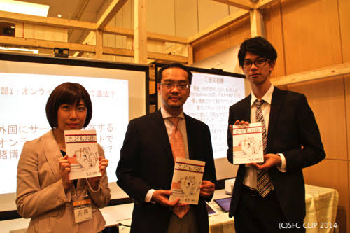

This Kenkyukai is studying new legal issues that have arisen in a networked society.

Network-related legal issues are emerging in various forms that cannot be captured by the existing legal system. Therefore, we study what kind of problems occur on the network, and what kind of response is required based on case study. The actual contents of research include intellectual property and copyright law, big data, privacy, stealth marketing, information law, etc. There are other studies related to legal issues too. The current number of students is about 40.

-Personal study

**Eiichi Tajima Kenkyukai**

“Aiming at Social Self-Governance - Reflections on Publicness form the Viewpoint of the Lifeworld.”

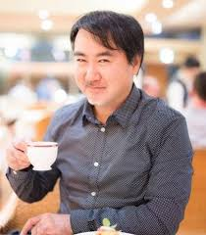

The Tajima Laboratory has two Kenkyukais. Kenkyukai (1) "Society from ‘Value’ and ‘Significance’ :" Sociology of Religion, Nationalism, and Faith" is studying the role of religion in society and nationalism, taking the case of the “third area” which is as an Collaboration work of citizens in social capital such as intermediate organizations and mutual aid networks, as an example. Kenkyukai (2) “Chinese Studies A to Z (thinking China from the living world)” analyzes Chinese society while focusing on the living world, such as local culture, family systems, religions, and private organizations. .

-Chinese allowed

-Personal study

**Masatoshi Tamamura Kenkyukai**

“Social Marketing”

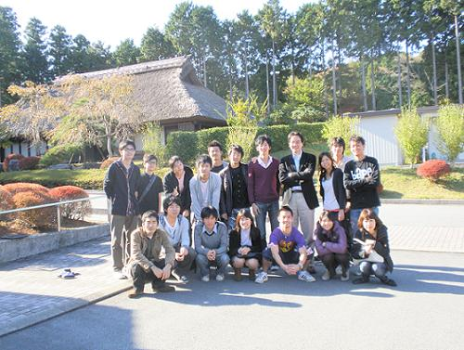

In this Kenkyukai, we mainly focuse on social marketing, social innovation, and community theory, and apply it to the real world. Some students are studying to clarify the phenomenon -How the recent change in the town happened- by targeting one of the "three major Doya districts in Japan", Kotobukicho, Yokohama-shi.

-Personal study/ Group study

**Yoko Hirose Kenkyukai**

“Searching for the Fusion and Dialogue between Academic Disciplines and Regional Studies”

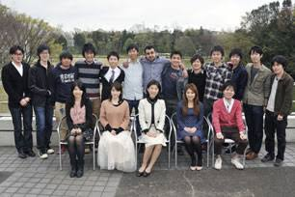

In this seminar, we will try to apply regional studies to more general academic context seeking dialogue and fusion of regional studies and academic disciplines. To give an example, in the case of that you choose regional conflict as the research theme, it would be needed study whole problems such as history, political problems, economics, religion, ethnic problem, social problems, geopolitical problems and so on, in the area, because the reasons of conflicts are really complicated. In addition, trying to generalize by comparing with other cases or regions, applying some disciplines, making general theories and so on would be also important. I would like to stress not to complete regional research by regional research alone, but make it available in a wider academic context, enable dialogue with experts from other regions and researchers of other disciplines, and make academic contributions.

For this aim, we will study general theories or discussions by reading books, and hear and discuss about each students’ research. All students must participate to the reading, make presentation and write term paper or graduate thesis on individual research.

Hirose's regional field is the former USSR, so I can make give the good comments on the regional studies on the former USSR or Yugoslavia, however all students who want to study everywhere are welcome.

-Group Study

**Ikumi Waragaki Kenkyukai**

“Media Studies (1) Comparative Media Studies / Medienvergleich (2) Learning Design Project (LDP)”

In this Kenkyukai, not only undergraduate and graduate students, but also full-time faculty members of the German language laboratory, external researchers, graduates who work for companies, international students participate in the design of language learning environments. Utilizing their respective skills, such as programming and website creation, we develop teaching materials utilizing IT and multimedia, and conduct joint research with other Kenkyukais. We aim to further enhance the language learning environment while referring to the feedback of users of the teaching materials.

-German allowed

-Group study

**Vu Le Thao Chi Kenkyukai**

“Risk Analysis: Policy and Daily Life”

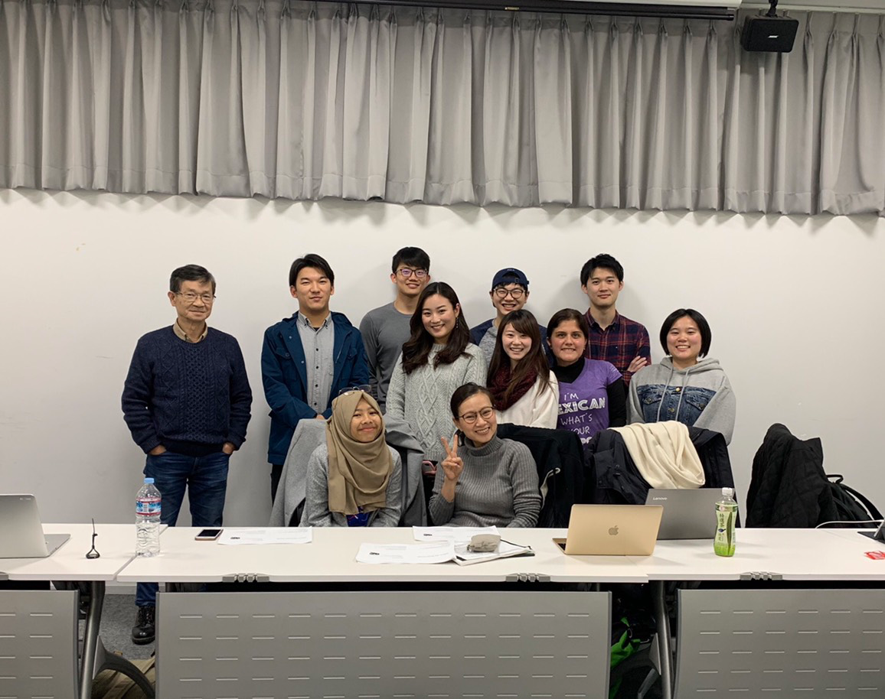

In this Kenkyukai, which work on theme of risk = Asia, the goal is to “create a space” where people can work together to observe things, move their bodies and seek solutions to problems. Therefore, we come up with new ideas by “moving together”, modifying existing ones, and sharing various ideas. One of such space is Vietnam, which has survived a long war. We are working on a project to create a weekend school for children (disabled children) who have been exposed to defoliants during the war, and to develop a "normal" life for children with disabilities.

-Many International students

-2019 ORF Exhibit