Honorable app changes and features
A simple guide to what has changed, what each tool does and what remains before a wider release.
The app now has a built Android internal candidate with local photo and video editing, existing on-device AI assistance and guest access. It is ready for an internal device test. It has not passed a physical-phone acceptance test and is not being presented as a finished public release.

Four additions in this update
Saved photo looks Keep a named set of color and light adjustments and reuse it without replacing another photo’s framing or text.
Audio-only export Save the edited video project’s sound as an AAC M4A copy, including enabled clip audio and the soundtrack.
Create an image Start a new white square, portrait or landscape image and add text or use photo adjustments.
Guest on-device AI Use the existing free local AI editing tools without sign-in. This adds access to existing engines; it adds no new AI engine.

From the oldest saved version
The oldest Git commit, 424cf33, contained a ZIP with the original Android Compose interface, local media database, TinyCLIP search and vision-enrichment foundations. Those foundations were preserved. The React Native app, practical native editors and the workflows described here were developed afterward. This report describes the cumulative product changes rather than claiming every item was added today.

Try the local tools
Install the internal ARM64 APK on a compatible Android phone. Choose Edit without an account, then create an image or select a photo or video. Export a new copy and check it in Files. Hosted account sign-in remains unavailable in this build.

Photo editing tools
Implemented in the Android candidate. Physical output, touch and lifecycle acceptance remain open.
Framing Crop the picture, rotate in quarter turns and choose original, square, portrait, wide or vertical output.
Mirroring Flip the image horizontally or vertically.
Light and color Adjust brightness, contrast, saturation and exposure; create a monochrome image.
White balance Make colors warmer or cooler and adjust the green or magenta tint.
Shadows and highlights Balance darker and brighter parts of the image within the detail already present.
RGB tone curve Shape dark, middle and bright tones using the curve controls.
Local light Place a feathered circular exposure adjustment over a selected area.
Finishing Add an adjustable vignette or sharpening.
Photo text Add a short caption, position and size it, and choose dark or light lettering with an optional backplate.
History and comparison Undo, redo, reset and compare with the original.
Saved looks Save up to 20 named adjustment presets, apply one to another image or delete it. Framing, text and person masks stay with their own image.
Blank image creation Start a white square, portrait or landscape canvas, add text and use the photo tools. This is manual creation, not prompt generation.
Copy export Save a new PNG, or JPEG at 70, 85 or 95 percent quality. JPEG places transparency on white.
Recovery and file protection Recover bounded edits after supported activity recreation. Exports check the destination and saved copy to protect the original; device validation remains open.

Video editing tools
Implemented in the Android candidate. Physical output, touch and lifecycle acceptance remain open.
Multiple sources Bring several videos into one project and select clips from the timeline.
Trim and split Choose in and out points, apply a trim or split inside a clip.
Clip organization Duplicate, delete and move clips left or right in playback order.
Timing and sound Choose supported playback speeds, change clip volume or mute a clip.
Timeline preview Seek using the filmstrip, step backward or forward and preview the project composition.
Color and white balance Adjust exposure, contrast, saturation, warmth and tint for a clip.
Apply color to all Copy one clip’s color settings across the project as one undoable edit.
Output framing Choose original, square, vertical, wide or portrait canvas; fit with bars or center crop, rotate and mirror.
Titles Add a short title and choose position, size, text polarity and an optional background plate.
Visual fades Fade through black at clip edges. Overlapping transitions are still unfinished.
Soundtrack and fades Add one looping soundtrack, adjust or remove it, and fade the mixed project audio at its ends.
Timed captions Create and edit source-timed caption cues that follow trims, splits, order and speed.
Subtitle files Import an SRT file into a clip and export SRT timestamps for the edited project. Automatic transcription is unfinished.
Audio copy Export the edited project’s enabled audio and soundtrack to an AAC M4A file, without a video track. Cancel an active audio export.
History and drafts Undo, redo and reset. Signed-in accounts retain encrypted local drafts; guest activity recovery is not a durable project library.
Video copy export Render a new MP4 through the shared composition pipeline. Saved output and imported-original protection are checked; phone playback acceptance remains open.

AI search and everyday use
Implemented in the Android candidate. Physical output, touch and lifecycle acceptance remain open.
Photo looks On-device scene labels and image statistics suggest Auto, Cinematic, Portrait, Vivid or Mono adjustments. Review the result and undo it if needed.
Person cutout A bundled person model creates a transparent-background cutout. It is people-only, and hair and edge quality still need phone checks.
Person background tools Blur a person’s background or replace it with white, black or gray. These are not generated backgrounds.
Text recognition Recognize supported Latin-script image text on the device, review it and explicitly copy it.
Video looks Sampled local frame analysis proposes a color look for the selected clip. It does not generate new frames.
Scene assistance Experimental sampled-frame labels suggest relevant video material. Results need preview and quality checks.
Rough cut assistance Assemble existing footage toward a 15, 30 or 60 second draft. Review before applying; undo restores the previous timeline.
Guest editing Open a selected photo or video without an account or whole-library indexing. Existing free on-device editing AI is available to guests.
Seran memories The preserved local search engine indexes supported media and finds memories from descriptions. Search remains on the account route; hosted sign-in is not configured in this build.
Library and viewer The current app includes media presentation, search results, playback, selected-media Studio entry and permission or empty-library guidance.
Editor panels Contextual tools and inspector panels organize the native editors. The white-majority mobile design is preserved; owner visual acceptance is still open.
Account and privacy work Identity, session and credit safeguards were strengthened. Search pricing and server authority are preserved. Hosted service, store purchases and production operations remain incomplete.

The Obsidian project board
This is an export of the saved Obsidian Canvas board, not a desktop screenshot. The owner requested no further computer-use tools, so no new screenshot was captured. Green means implemented and build checked. Orange identifies remaining work or acceptance checks. Green does not mean that a phone test has passed.
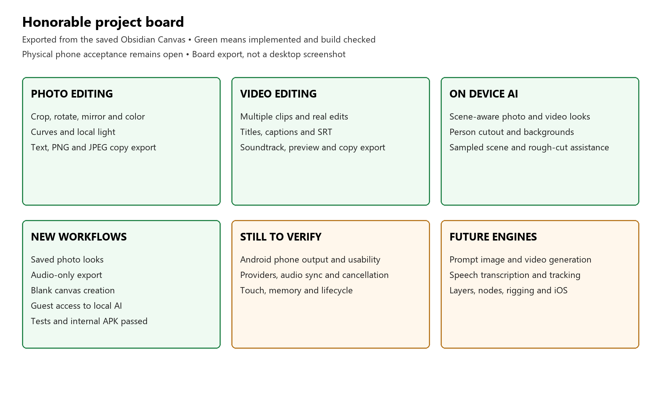
The vault holds the current handoff, feature register, work queue, decisions and milestone logs. The board is saved as HONORABLE_RELEASE_BOARD.canvas so progress can be updated as work is verified.

How we record progress
Features, fixes and unfinished foundations are recorded separately. Tests and a successful APK build support an implementation claim. Actual phone behavior, user acceptance and store readiness require their own evidence.

What remains before a wider release
Phone acceptance Install the latest APK and verify saved image pixels, video playback, audio sync, subtitles, model results, cancellation, permissions, rotation and memory behavior. No Android phone is currently available.
Generative creation Text-to-image, reference or sketch generation, text-to-video, image-to-video, storyboards and character-consistent generation still need real engines and validation.
Advanced editing General layers, arbitrary tracks and compositing, keyframes, overlapping transitions, tracking, stabilization, object masks, generative fill and RAW support remain unfinished.
Animation and professional workspaces Photo rigging, face or object animation, camera or 3D scenes, node processing and safe code execution are not completed native tools.
Creative assistant Full natural-language edit execution is unfinished. Current looks and rough cuts are specific local assistance tools, not a general creative agent.
Accounts and stores Hosted account service, production billing, private signing, operational security and store distribution remain separate release gates. The owner has deferred hosting and billing.
iOS iOS requires native feature parity, a macOS and Xcode build, and device acceptance. An Android build does not prove iOS readiness.

Checks completed for this candidate
112 shared Android and 95 React Native Android unit tests passed. 56 React Native tests and TypeScript passed; lint had no errors. Android integration tests compiled but were not executed. The full ARM64 APK was checked for its package, bundled models, certificate and ZIP alignment.
The APK uses the public debug certificate for internal testing. No new paid service was activated and no personal media or search queries were uploaded by this work.

Source and evidence
Repository: github.com/honrablecom-source/Honorable-mobile-app
Branch: codex/android-internal-readiness
Review: pull request 1
Detailed records: HONORABLE_FEATURE_STATUS, CREATIVE_OUTPUTS_WORKLOG and SESSION_HANDOFF in the docs vault.
APK SHA256: fc665a2dc7b6b8fd5d763196ffbc32a72ec1100d5c84ec74984467d09766f5f2

