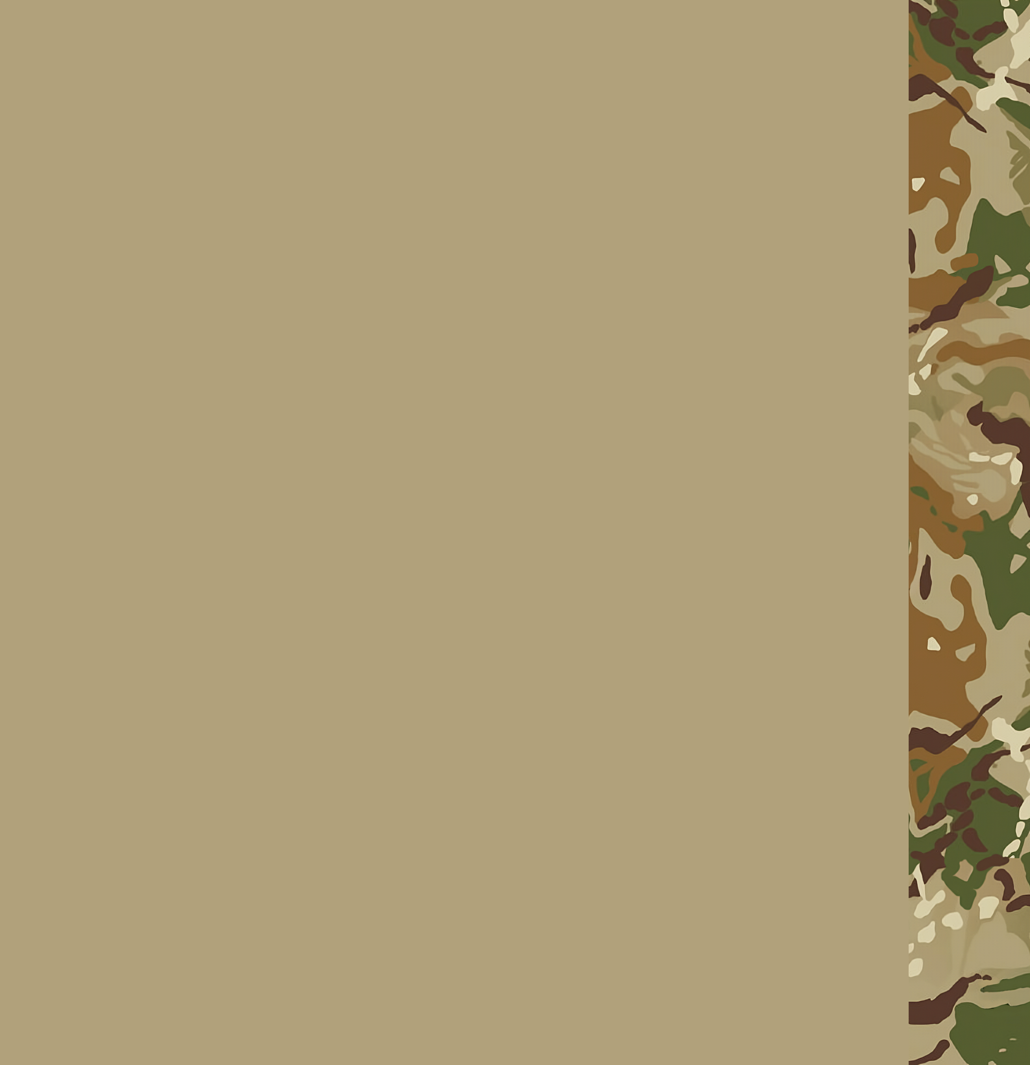MH Unified Basic and rifleman training Program

Basic Training guide

2023.06.02

MH Unified Basic and rifleman training Program 1

Basic Training guide 1

Logistics 3

Ammo conserving 3

Vehicle security 3

Ace 4

First aid 4

Radio usage 4

Basics 5

SERE 5

Pistol and rifle knowledge 5

Logistics

Ammo conserving

Ammo conserving is the most important aspect for an unit, without ammo there is no security, without ammo we cannot achieve any of our objectives. Hence why we have different techniques on ammo conserving.

* Methods of ammo conserving
  + Fireorders
  + Positioning
  + Preparing

Vehicle security

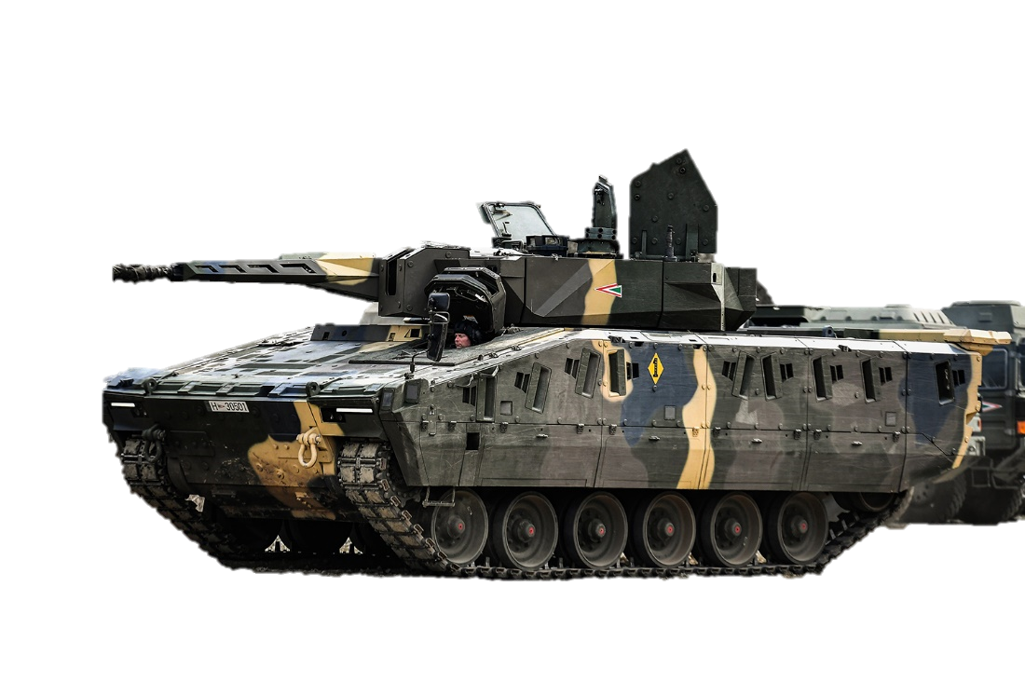Personel Carriers, should be stored a safe distance away from combat, and should be used properly. Tanks and other fighting vehicles should be kept at proper distances, using the proper terrain. Any loss of vehicle is unaccaptable.

Ace

First aid

For first aid we use ACE medical menu (AMM). pressing H we have access tot he healing menu where we can interact with the wounded. Its important to keep three things in mind while working with the patient.

There should be no open wounds

He should be able to breath properly

His blood pressure is stable

Radio usage

Every soldier has access to a shortrange radio, which they can access using ctrl + p. We can set multiple channels for frequencies depending on the radio. On the radio the only talk which is permitted is formatted, well put together sentences containing all necessary information. Inside your fireteam, speaking your native tongue, while outside of your fireteam, speaking english. If somebody is transmitting on the radio, they will be unable to hear anything ont hat frequency until they stopped transmitting, thats why its important to use over and out to signal if we want an answer for our transmission, or that we finished with what we had to say. There is many outside factors that influence radio usage, the terrain, enemy jammers, etc. Make sure to talk in short transmissions as the enemy can track down our radio signals. The format is the following:

Who

To

Message

Over/Out

Basics

SERE

If you ever get lost, or your entire fireteam gets lost, it should be reported as soon as possible. Performing a long stop, you or your fireteam should reorient while maintaing security, then head towards the general area of friendly lines. Dont forget to drink from your canteen at short/long stops to be able to perform your duties without problems.

Pistol and rifle knowledge

Every soldier should be able to use his weapons efficently and safely.

Always treat weapons as if they were loaded.

Do not ever aim at things you dont want to destroy.

Only put your finger on the trigger when you want to fire the weapon.

Know what you are shooting at, and whats behind it.

