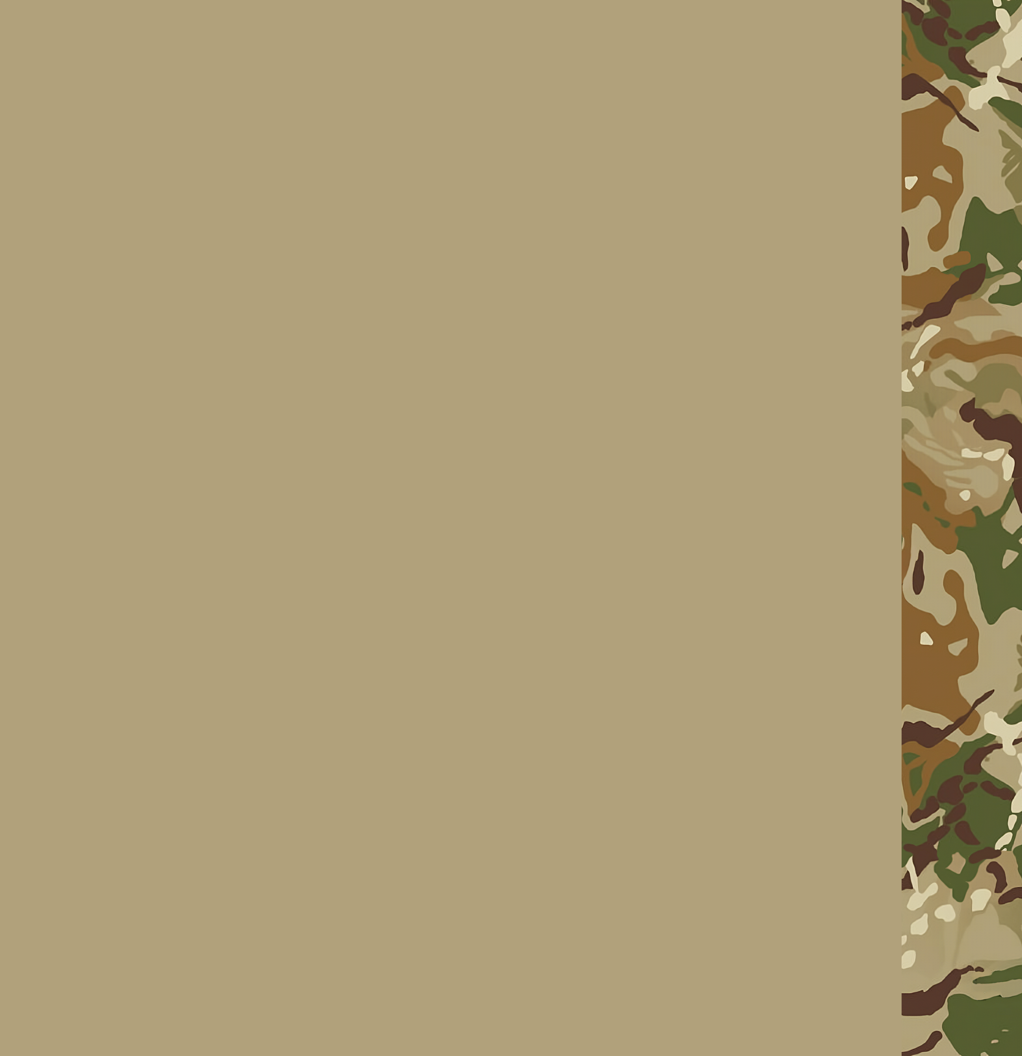MH Unified Basic and rifleman training Program

RIFLEMAN TRAINING GUIDE

2023.06.02

MH Egységes Alapkiképzési és Lövész Alapozó Felkészítési Program 1

Lövész alapozó Hiba! A könyvjelző nem létezik.

Tűzharc Hiba! A könyvjelző nem létezik.

Tűzparancsok **Hiba! A könyvjelző nem létezik.**

Pontostűz **Hiba! A könyvjelző nem létezik.**

Kontakt **Hiba! A könyvjelző nem létezik.**

Zárótűz **Hiba! A könyvjelző nem létezik.**

Alakzatok **Hiba! A könyvjelző nem létezik.**

Menet alakzatok 4

Tűzharc alakzatok 4

Álcázás és fedezék **Hiba! A könyvjelző nem létezik.**

Álcázás **Hiba! A könyvjelző nem létezik.**

Fedezék **Hiba! A könyvjelző nem létezik.**

A járművekből való biztonságos ki- és beszállás **Hiba! A könyvjelző nem létezik.**

MENETELÉS Hiba! A könyvjelző nem létezik.

A menetelés **Hiba! A könyvjelző nem létezik.**

Vezényszavak **Hiba! A könyvjelző nem létezik.**

fIREFIGHT

Fireorders

Accurate fire

Contact

Suppressing fire

Accurate fire

Once accurate fire have been declared, the soldier will shoot at identified, specified and visible enemy. His weapon should be put on semi auto mode, and will only take the next shot once the last one lands and hits. In one fireteam, soldiers shoot alternativly, taking turns. This fireorder is perfect for ammo conserving but provides extremely ineffective fire against enemy forces.

Contact

Contact fire order is the general procedure for a firefight. The soldier shoots at identified, specified enemy. His weapon put on semi auto, taking shots in 3-5 second intervarls. In a fireteam, everyone will be assigned to a sector called, right flank, center, left flank. They take up the firefight in these defined sectors.

Suppressing fire

Suppressing fire is used to control an area or enemy group. The soldier fires at identified target. The weapon put onto semi auto / auto depending on the situation. He takes shots in a manner to limit and deter any movement on the assigned target. This fire order takes a lot ammo to upkeep, but its extremely effective. It should be used only in case of emergeny.

Formations

Formations are used according to terrain. Formations are a general, and they should be interpretended with the terrain in mind. Use logical judgement when using formations.

Marching formations

We use marching orders when we are on the move.

Convoy formation

Herringbone formation

Bounding overwatch

Travelling overwatch

Diamond formation

Column formation

Line formation

Firefight formations

Wedge formation

Right echelon formation

Left echelon formation

Fireline

Baseline

Security (360)

Camouflague and cover

Every soldier needs to constantly scan his enviroment for camoflague and cover, and should take positions up around these things when taking contact.

Camouflague

Camouflague hides the soldier, but doesnt offer any protection for him.

Cover

Cover offers safety against enemy fire. Its effectiveness depends on the enemies firepower capabilities.

Safely getting/bailing out of vehicles

Dismounting and mounting up a vehicle is something every soldier should know from head. The procedure for it should be learnt and put into memory.

Marching

The march

The marching is a way of giving each other the respect and attention, marching is used at the end of operation to have an orderly ceremony of giving rewards and briefing on the mission.

Command words

Attention

At ease

Right face

Left face

Back face

March

Halt