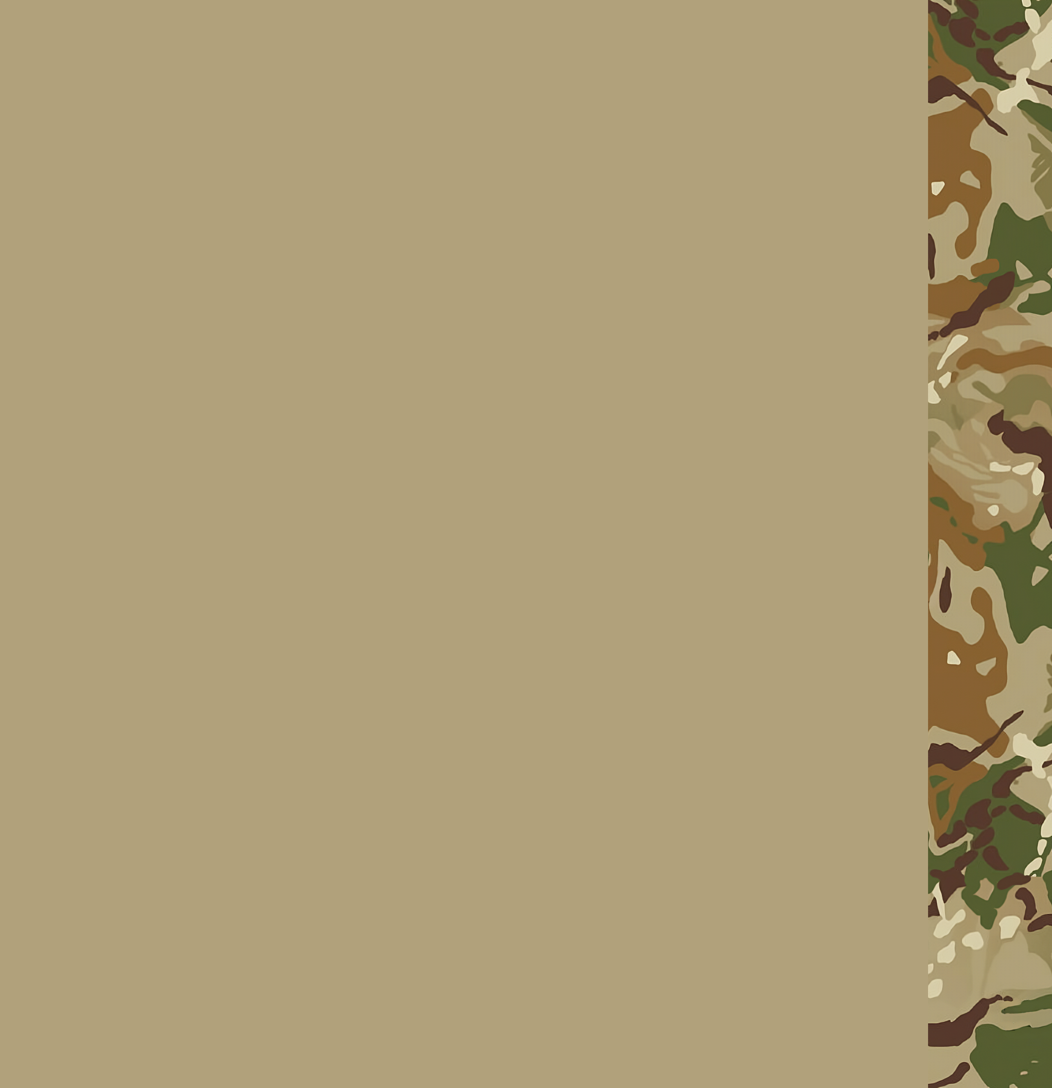MH UNITED MEdical training guide

Medical guide

2023.05.24

MH UNITED MEdical training guide 1

Medical guide 1

Medical basics 3

How to check injuries 3

Checking the pulse 3

Alert the wounded 3

Check the injuries 3

Healing 4

Waking up those who got knocked out 4

Equipment 5

Radio 5

Medical equipment 5

Splints 5

Tourniquets (CAT) 5

Morphine 5

Epinephrine 6

Adenosine 6

Surgical Kits 6

Personal Aid Kits (PAK) 6

Bandages 6

IV bags 7

Medical basics

How to check injuries

1. Checking the pulse
2. Alert the wounded
3. Check the injuries
4. Healing

Checking the pulse

Managing your time as a doctor is important, thus you should save as much you can. Always check the pulse before you start to work, so you don’t waste time on dead soliders. However the pulse can be abnormaly high, but that can be helped with the wonders of modern medicine.

Alert the wounded

Whenever someone gets injured you will have to alert them to step aside to a safe spot. Your patient will also have to stop moving.

Check the injuries

Before you start the tedious process of healing your patient, you must check if he had any recent injuries. You don’t want anyone to be overdosed, because it can be fatal.

Healing

You must always get the wounded to a safe place. Always consider others who need your aid. Healing the most important can ensure that you save multiple people.

Waking up those who uncouncious

There will be many cases where you have to wake up someone who is uncouncious. You can do the following to ensure success:

1. Make sure there is a pulse
2. Stop the bleeding.
3. Give blood
4. Stich the wounds
5. Epinephrine boosts the chance to wake them up

Equipment

Radio

Communication is very important. Doctors can use multiple frequencies at the same time so they can help out other squads in case it is needed.

Medical equipment

Splints

Tourniquets (CAT)

Morphine

Epinephrine

Adenosine

Surgical Kit

Personal Aid Kit (PAK)

Bandages

Splints

If someone breaks a bone you can give them a second chance. Applying a splint will make them regain some of their speed.

Tourniquets (CAT)

A device that halts bloodflow in the arms and legs.

It will reduce blood loss.

It is forbidden to leave a tourniquet on someone.

Morphine

Slows pulse, acts as a painkiller.

Overdosing causes a heart attack.

Epinephrine

Increases pulse.

Adenosine

Lowers pulse while stabilizes it.

Surgical Kits

You can patch open wounds with it.

Wounds that were sewed together will not reopen.

Personal Aid Kits (PAK)

Heals every wound

Bandages

Field Dressings:

Default bandage, only usefuel if you don’t have anything else.

Packing bandages:

Stops bleedings, but wounds will reopen.

Elastic bandages:

Fast to apply, wounds will reopen quickly.

Quick-Cloths:

Closes the wounds, but they are insignificant, because it will reopen quickly.

IV bags

Fluids that can be applied through the vein.

Blood

Plasma

Saline

Blood:

Humans need blood. Make sure your patient got enough to live.

Plasma:

It is used to raise blood pressure.

Saline:

Cleans the wounds, slows heart rate.