**SWE3048_43**

**웹프로그래밍 실습**

**Midterm**

**소프트웨어학과**

**2016313844**

**박정훈**

**1. The design or structure matching with topic**

This website is created for searching vegetarian food near SKKU.

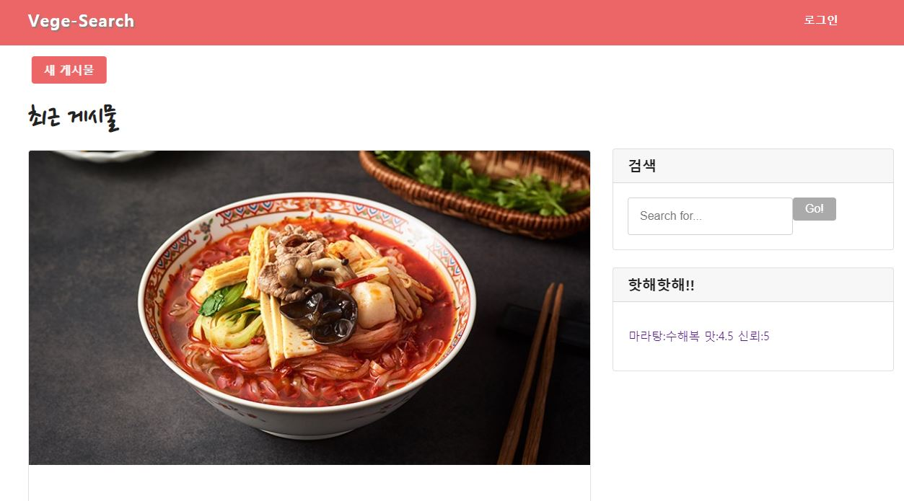

**2. Make more than 3 html files. And the three html files should be able to move meaningfully to each other than with links.**

로그인 클릭 : base.html -> login.html 확인 클릭 : login.html -> base.html

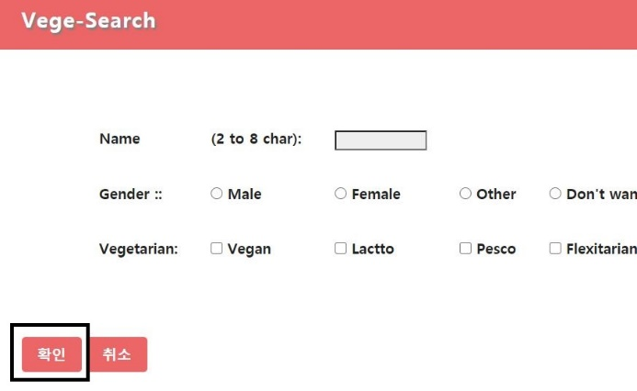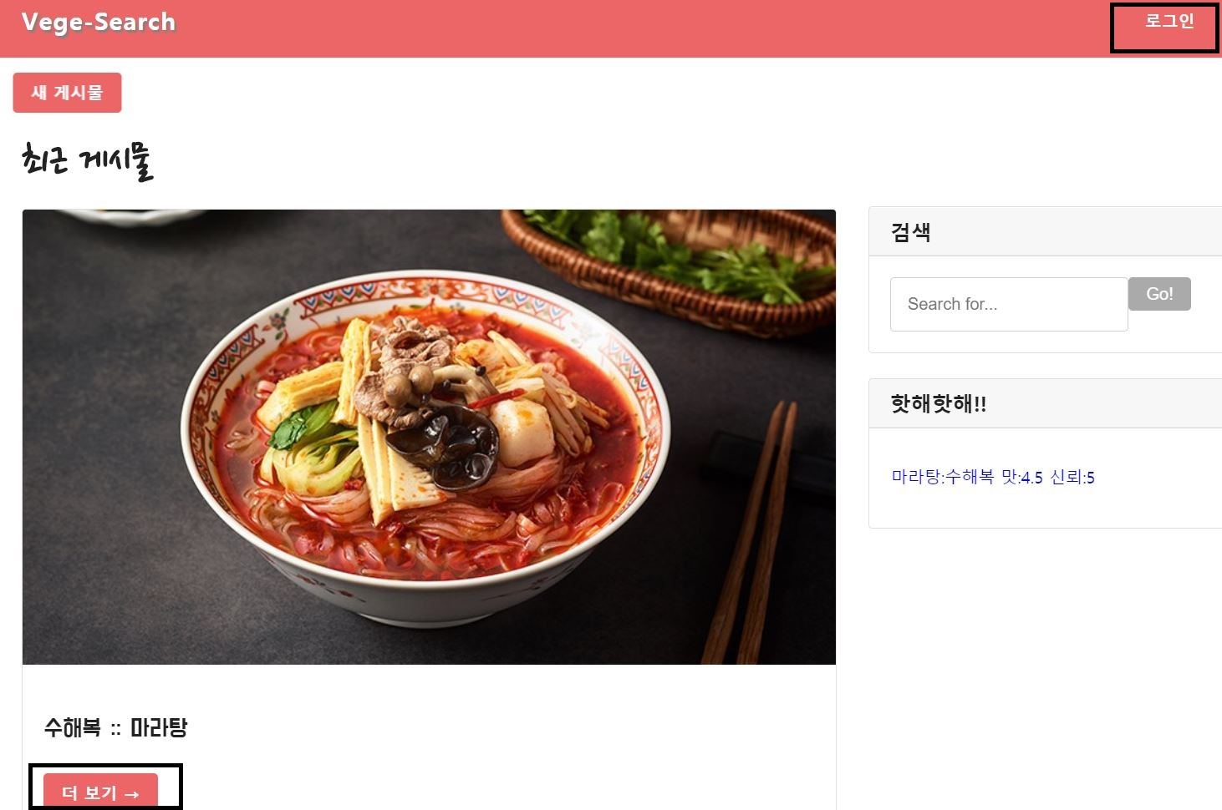더보기 클릭 : base.html -> detail.html 확인 클릭 : detail.html -> base.html

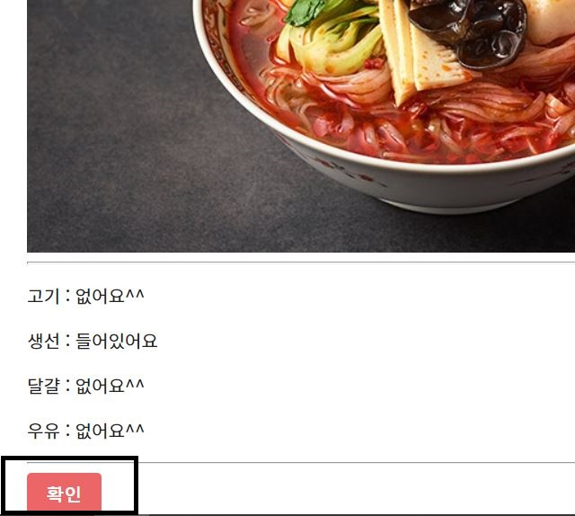

**3. Keep the basic form header, nav, content, footer**

I did it.

**4. Do not use frameworks**.

No I didn’t use it.

**5. Make the page that collects user information using form tag with radio boxes and check boxes.**

**10. Use table tag.**

I used table tag inside the form tag.

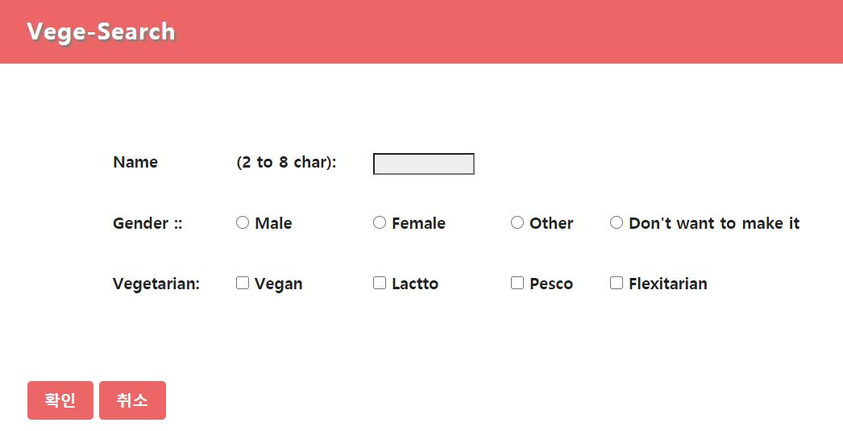

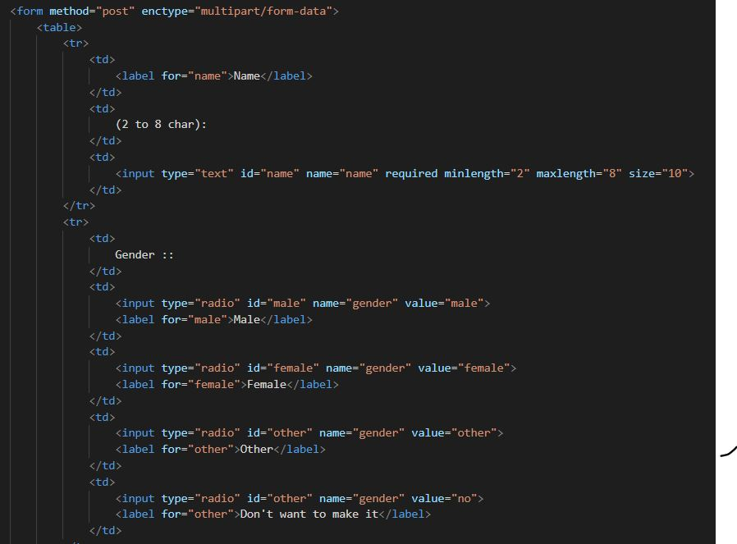

**6. Create more than 3 external css files.**

Yes, I made it. Each of them is FIT.css, FIT_detail.css, form.css

**7. Construct a website based on reactive.**

I changed the container size.

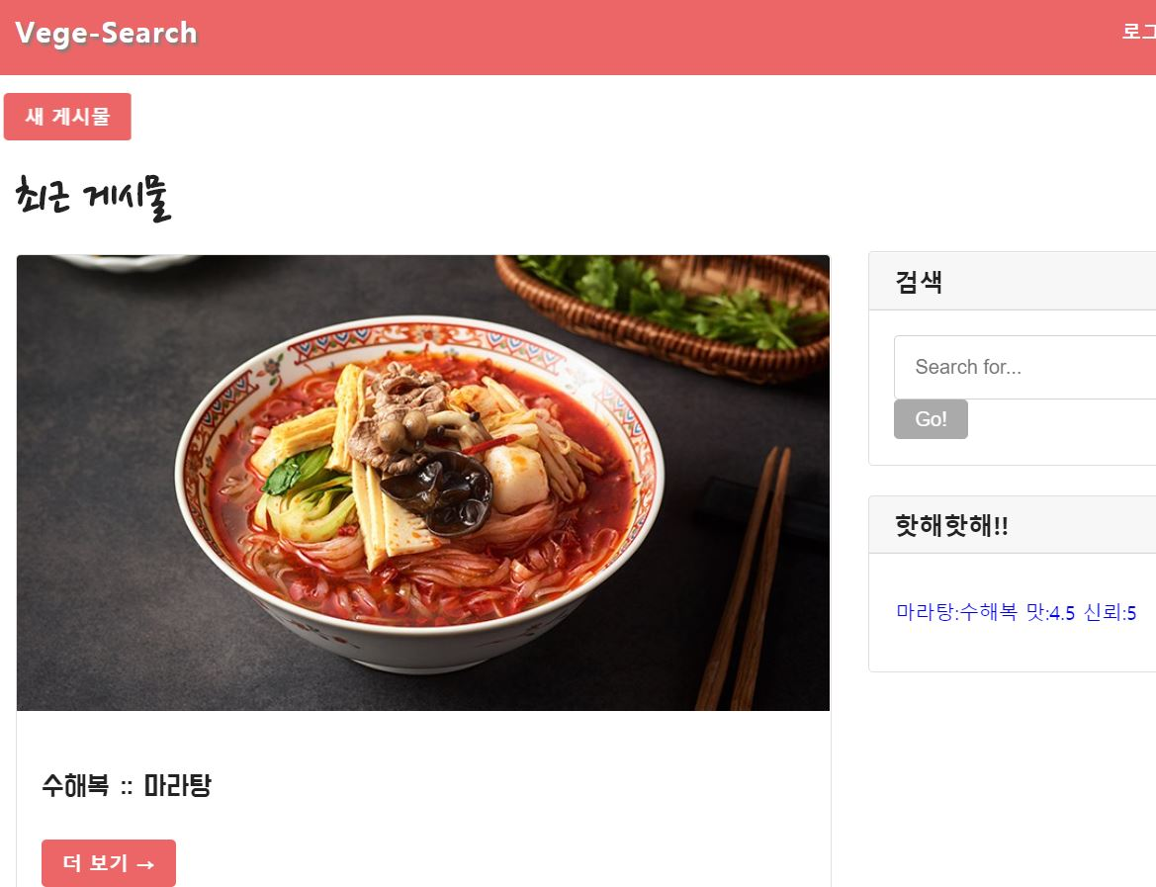

depending on the size of the screen 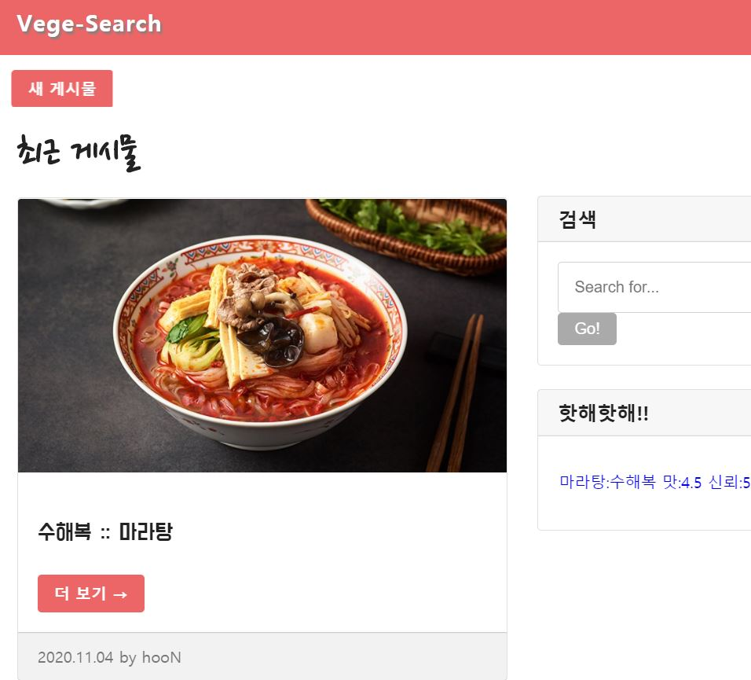

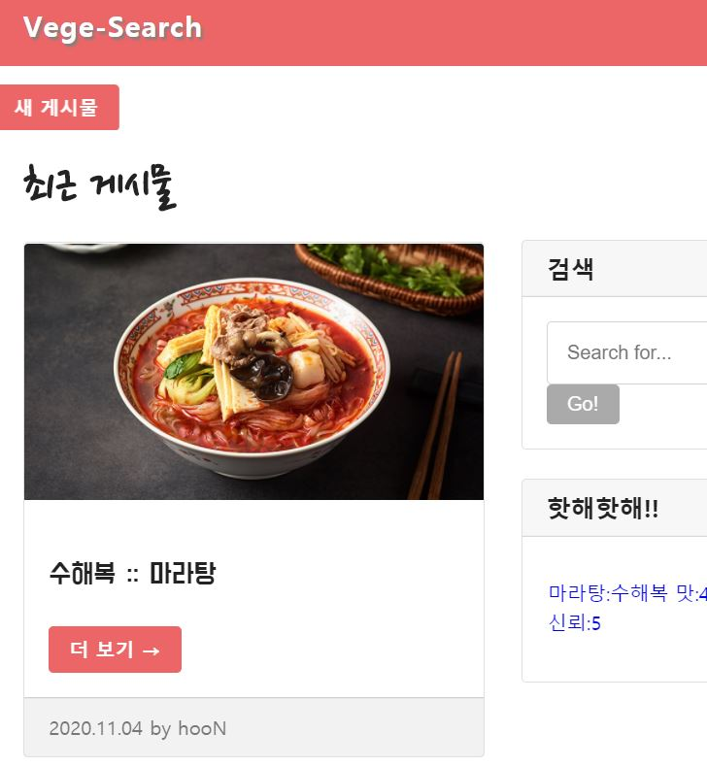

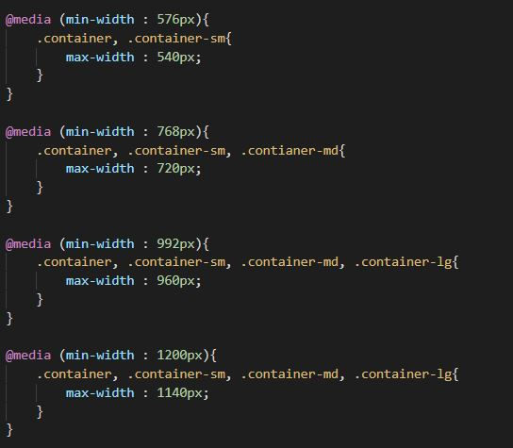

**8. Homepage should include more than 2 multimedias.**

Yes, you might see it. One is the picture of 마라탕, another is the picture of 비지찌개.

**9. Use text-style to make it pretty.**

**11. Create effective pages by using more than 3 web fonts.**

I used lots of text style properties for decorating. 3 web fonts are used in this website. DoHyeon, Nanum Pen Script and Noto Sans KR are it.

**12. Use the flex property to create flex box containers.**

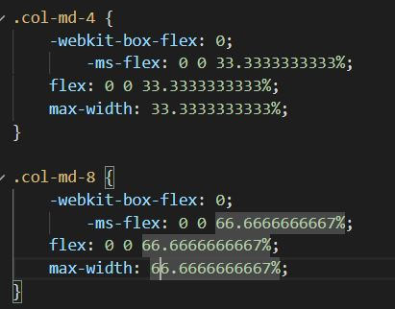There are two large div tags inside the container. The tags are each applied with flex properties under class names col-md-8, col-md-4.

**13. Use transform property.**

**14. Use the @keyframes property and animation-duration, animation-name, animation-iteration-count for the Animation.**

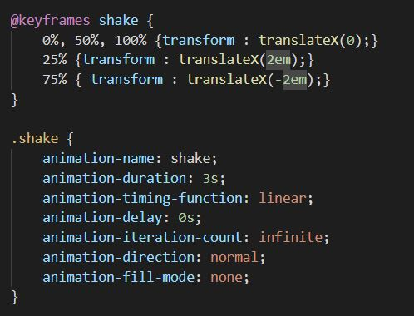I made the ‘새 게시물’ button moves left and right.