**OTT-EPG 集群安装配置说明**

## 1.1 文档目的

文档供现场搭建商用环境参考使用，2台EPG通过nginx+keepalivied实现集群负载均衡（主备），经过相关功能验证测试各项功能正常，现发布给现场安装配置使用。

功能实现：nginx+keepalived与EPG合设安装， keepalived采用热备方式实现主备切换，keepalived在配置文件中配置nginx脚本，通过检测nginx进程，当单点故障发生时自动切换VIP挂载到另一台正常运行的服务器上，实现业务的自动切换，达到负载均衡高可用目的。

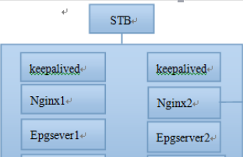

服务器IP规划：

EPG VIP：172.16.199.174

EPG1 IP: 172.16.199.172

EPG2 IP: 172.16.199.136

## 1.3 keepalived安装配置：

1、在epg1、epg2服务器上解压3rd_party_keepalived-1.2.23.tar.gz，再进入解压目录执行 ./install.sh（注意查看是否可执行权限）完成安装。

**2、keepalived配置（主）：**

[root@fonsview ~]# vim /etc/keepalived/keepalived.conf

|  |
| --- |
| global_defs {  notification_email {  }  notification_email_from Alexandre.Cassen@firewall.loc  router_id LVS_DB1  }  vrrp_script nginx_pid {  script "/etc/keepalived/nginx_pid.sh"  interval 5 #时间间隔  weight 20 #  }  vrrp_instance VI_DB {  state MASTER #主用  interface eth0 #使用的网卡  virtual_router_id 131 #同一实例保持一致  priority 100 #权重值，master一定要大于backup  advert_int 1  authentication {  auth_type PASS  auth_pass 1111  }  track_script {  nginx_pid  }  virtual_ipaddress {  172.16.199.174/24 dev eth0  }  } |

**3、keepalived配置（备）：**

[root@fonsview ~]# vim /etc/keepalived/keepalived.conf

|  |
| --- |
| global_defs {  notification_email {  }  notification_email_from Alexandre.Cassen@firewall.loc  router_id LVS_DB1  }  vrrp_script nginx_pid {  script "/etc/keepalived/nginx_pid.sh"  interval 5  weight 20  }  vrrp_instance VI_DB {  state BACKUP  interface eth0  virtual_router_id 131  priority 90  advert_int 1  authentication {  auth_type PASS  auth_pass 1111  }  track_script {  nginx_pid  }  virtual_ipaddress {  172.16.199.174/24 dev eth0  }  } |

keepalived调用 /etc/keepalived/nginx_pid.sh启动控制脚本，主备配置均一致：

[root@zjott-epg1 keepalived]# vim nginx_pid.sh

|  |
| --- |
| #!/bin/bash  A=`ps -C nginx --no-header | wc -l`  if [ $A -eq 0 ] ;  then  service nginx start  sleep 3  if [ `ps -C nginx --no-header | wc -l` -eq 0 ] ;  then  echo "start kill" >> /etc/keepalived/log.txt  /etc/init.d/keepalived stop  echo "end kill" >> /etc/keepalived/log.txt  fi  fi |

启动主备服务器上keepalived服务：

[root@zjott-epg1 install]# systemctl start keepalived.service

检查VIP是否已经挂载到EPG1（主）的eth0上

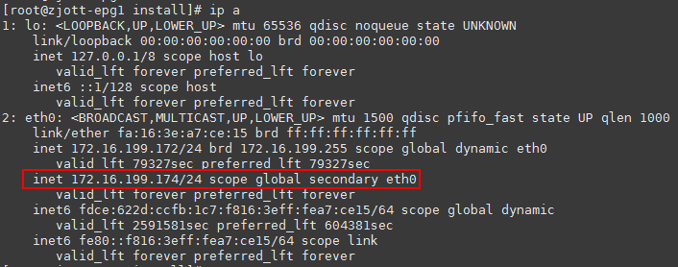

## 1.4 nginx安装方法：

解压 nginx_1.10.1_24260.tar.gz，进入解压后的目录执行 install.sh 脚本即可完成安装，完成后进入安装目录查看版本：

[root@fonsview nginx_1.10.1_24260]# cd /opt/fonsview/3RD/nginx/bin/

[root@fonsview bin]# ./nginx -v

nginx version: nginx/1.10.1

nginx配置文件说明--在原默认配置文件的目录下新建epg1.conf，epg2.conf, 2台EPG上的nginx的配置文件均一致：

vim /opt/fonsview/3RD/nginx/conf/conf.d/epg1.conf

|  |
| --- |
| upstream epg {  ip_hash;  server 172.16.199.172:6601; # epg1的tomcat ip+port  server 172.16.199.136:6601; # epg2的tomcat ip+port  }  server {  listen 6600; #/nginx监听epg集群的端口，注意与nginx的default.conf里监听端口设置不能相同  server_name localhost;  charset utf-8;  #access_log /opt/fonsvew/3RD/nginx/log/host.access.log main;  location ~ /(epg|favorite) {  #root /opt/fonsview/data/media;  #index index.html index.htm;  proxy_next_upstream http_502 http_504 error timeout invalid_header;  proxy_pass http://epg;  proxy_set_header Host $host:$server_port;  proxy_set_header X-Forwarded-For $remote_addr;    proxy_redirect http://172.16.199.174 http://172.16.199.174:6600; #EPG的VIP  } |

**附件：**

epg1.conf 位置：

主EPG /opt/fonsview/3RD/nginx/conf/conf.d/

Epg2.conf 位置：

从EPG /opt/fonsview/3RD/nginx/conf/conf.d/

keepalived.conf主 位置：

主EPG /etc/keepalived/

Keepalived.conf从 位置：

从EPG /etc/keepalived/

nginx_pid.sh位置

主从EPG /etc/keepalived/

注意：keepalived.conf文件名后面“主/从”两字在使用时候去掉，此处仅供区别而添加。

