**BIFX-550  
ChemSketch Hands-on  
 Last updated 05/2017  
S. Ravichandran, Ph.D.**

**How to draw small molecules (< 900 Daltons; most drug molecules are small molecules) on a computer? (Need ACD ChemSketch software)**

**You can use the following link to download the software (ACD/ChemSketch free for Academic and Personal Use).**[**http://www.acdlabs.com/resources/freeware/chemsketch/**](http://www.acdlabs.com/resources/freeware/chemsketch/) **Start ACD/ChemSketch from your computer**

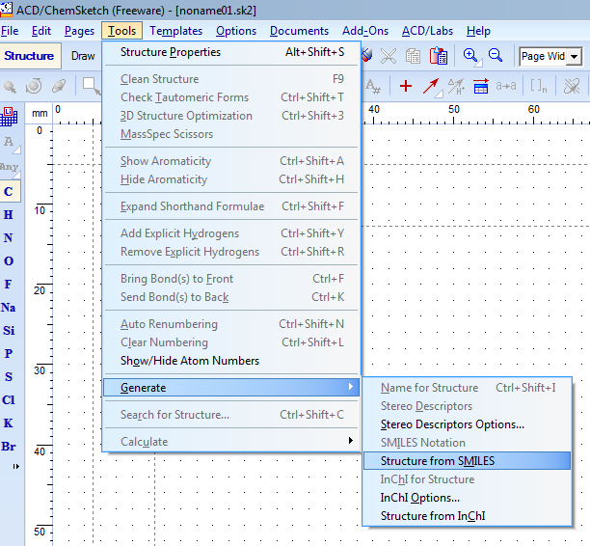

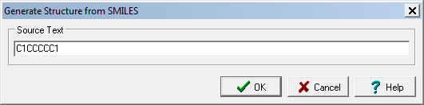

**C:\Users\ravichandrans\Documents\noname01.tif**

For example, C1CCCCC1, should create cyclohexane (shown above). Lower case version of the same will create benzene.

For example, Tylenol ( Acetoaminophen) has the following Molecular Input formats:   
SMILES: **CC(=O)NC1=CC=C(C=C1)O**InChi: **InChI=1S/C8H9NO2/c1-6(10)9-7-2-4-8(11)5-3-7/h2-5,11H,1H3,(H,9,10)**

To create the molecular structure of Tylenol, follow the steps shown here: Tools 🡪 Generate 🡪 Structure from SMILES or Structure from InChi will create a pop-in radio box. Copy the appropriate string shown above to create the molecular form of Tylenol. Molecular formula of Tylenol is shown below for your convenience.  
  
C:\Users\ravichandrans\Documents\noname02.tif

In the previous classes, we had discussed the genetic aspects of the Lactose intolerance/persistence in humans. Let us take a look at the chemical structure of Lactose. Lactose is a disaccharide of Glucose and Galactose and is present in human and cow’s milk.   
  
You can learn about the chemistry (& properties) of Lactose in the following PubChem entry, <https://pubchem.ncbi.nlm.nih.gov/compound/6134>

To create Lactose, use either one of the following SMILES strings:

**Cannonical SMILES:** C(C1C(C(C(C(O1)OC2C(OC(C(C2O)O)O)CO)O)O)O)O  
**Isomeric SMILES:** C([C@@H]1[C@@H]([C@@H]([C@H]([C@@H](O1)O[C@@H]2[C@H](O[C@H]([C@@H]([C@H]2O)O)O)CO)O)O)O)O

**Exploring the chemistry of the Single-stranded DNA molecule**

**How to draw a Single stranded DNA using ChemSketch?**

1. Here is a dsDNA molecule, you can use this as a guidance to draw ssDNA using ChemSketch

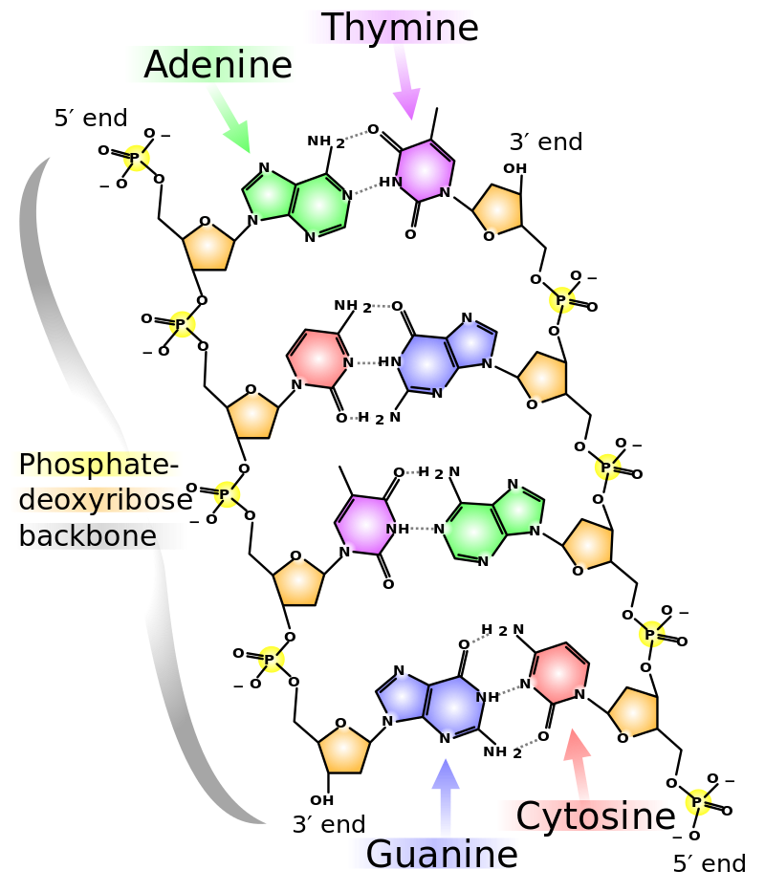

1. Start ChemSketch (Windows-Start 🡪 ACDLabs Freeware 2015 🡪 ChemSketch)
2. From the top menu of ACD ChemSketch, Click on **Templates** (see below) 🡪 **Templates Window**  
     
   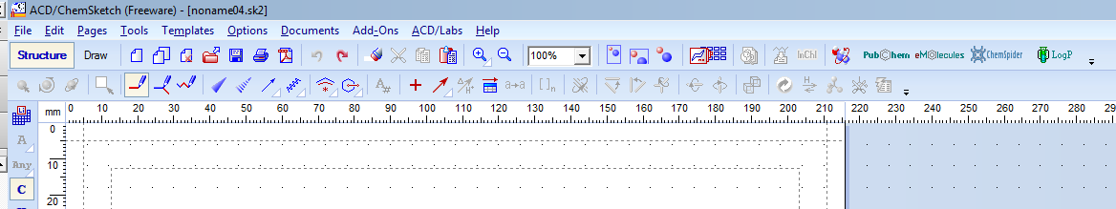
3. Click on DNA/RNA kit on the left-hand side menu

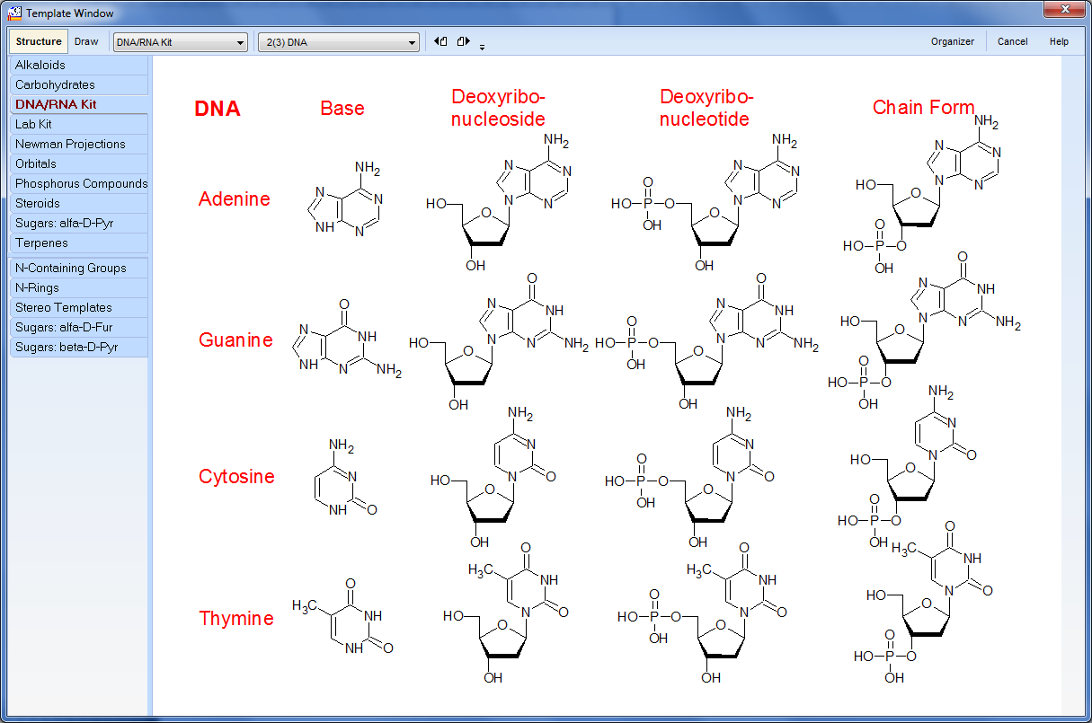

Click on the base of your interest and take it to the main window. Without clicking Escape/Right-click, continue to string the bases to build the single stranded DNA.