2022



Review from Property Transaction in the UK

Fong Siu Hin, 210123559

Leung Wan Chi, 210091649

Wong Chau Wai, 210552606

IT114116

7 December 2022

Table of Contents

Introduction 2

Setting and Utilization of Github 3

Roles 4

Member List 4

Product Backlog items 5

Sprint Backlog items 6

Answering the client's concerns 9

1. Generate (5 to 10 rows) processed renting post records. 9

2. What kind of property has the most number of bathrooms on average? 10

3. What is the contribution of house type in the record? What is the most common type of property in the UK? 11

4. What is the value distribution of the number of Reception between the semi-detached house and terraced house? 12

5. What kind of property contains the second most turnover? 13

6. Is there any relationship between the number of bedrooms and bathrooms and the average price of a different property? 14

Extra suggestion and Conclusion 15

Reference (Harvard & MLA) 16

# Introduction

Immigration to British has the raising concerns in recent years. The first consideration regards immigration is the recommendation. There is a growing market for property transactions. A client employed us to have a feasibility study on the circumstance of renting transactions in the UK, and your report is required to answer the following questions

1. Generate (5 to 10 rows) processed renting post records.
2. What kind of property has the most number of bathrooms on average?
3. What is the contribution of house type in the record?
4. What is the proportion of room facilities on average in the detached house?
5. Which date has the more renting post?
6. Is there any relationship between the number of bedrooms and bathrooms?

# Setting and Utilization of Github

Link: <https://github.com/hooh777/FongSiuHin_4887Project.git>

Provide the link to your Github project and some screen capture, including treeviews and document changing capture.

# Roles

## Member List

|  |  |  |
| --- | --- | --- |
| **Name** | **Role** | **Responsibilities** |
| Fong Siu Hin | Product Owner  The development team | 1. Data Understanding 2. Data Cleansing 3. Set up and Utilization of GitHub 4. Documentation of Product Backlog items and Sprint Backlog items 5. Report documentation |
| Wong Chau Wai | The development team | 1. Data Understanding 2. Evaluation (answering the clients' concerns) 3. Data visualization |
| Leung Wan Chi | Scrum master | 1. Data Understanding 2. Business understanding (extra suggestions and conclusion) 3. Report documentation |

## Product Backlog items

|  |  |  |  |  |  |
| --- | --- | --- | --- | --- | --- |
| **Sprint** | **Task** | **Category** | **Priority** | **Status** | **Update Date** |
| 1 | Data Cleansing | Cleansing | High | Committed | 30/11/2022 |
| 2 | Uploading data to SAS | Data | Low | Committed | 3/12/2022 |
| 3 | Generate renting records | Data | Middle | Committed | 3/12/2022 |
| 4 | Finding the most number of bathrooms on average | Modelling | Middle | Committed | 5/12/2022 |
| 5 | Finding the contribution of house type | Modelling | High | Committed | 5/12/2022 |
| 6 | Finding the proportion of room facilities in a detached house | Modelling | High | Committed | 5/12/2022 |
| 7 | Finding a date having more renting post | Modelling | High | Committed | 5/12/2022 |
| 8 | Finding the relationship between price and bedroom numbers | Modelling | High | Committed | 7/12/2022 |

## Sprint Backlog items

|  |  |  |  |  |  |  |  |  |  |  |
| --- | --- | --- | --- | --- | --- | --- | --- | --- | --- | --- |
| **ID** | **User Story** | **Tasks** | **Owner** | **Status** | **Estimated effort** | **Day 1** | **Day 2** | **Day 3** | **Day 4** | **Day 5** |
| 1 | As a client, I would like to know about renting transactions in the UK | Generate 5 to 10 rows of processed renting post records | Hazel Wong | Completed | 4 | 2 | 0 | 0 | 0 | 0 |
| Describe the result | 2 | 0 | 0 | 0 | 0 |
| 2 | As a client, I would like to know what kind of property has the greatest number of the bathroom on average | Generate a bar chart for comparison | Hazel Wong  , Alice Leung | Completed | 8 | 3 | 0 | 0 | 0 | 0 |
| Generate a summary table for a detailed comparison | 3 | 0 | 0 | 0 | 0 |
| Describe the observation and analyze the result | 2 | 0 | 0 | 0 | 0 |
| 3. | As a client, I would like to know the contribution of house type and the most common type of property in the UK | Generate a bar chart for comparison | Hazel Wong  , Alice Leung | Completed | 8 | 0 | 3 | 0 | 0 | 0 |
| Generate a summary table for a detailed comparison | 0 | 3 | 0 | 0 | 0 |
| Describe the observation and analyze the result | 0 | 2 | 0 | 0 | 0 |
| 4 | As a client, I would like to know the value distribution of the number of Reception between the semi-detached house and the terraced house | Generate boxplot for comparison | Hazel Wong  , Alice Leung | Completed | 5 | 0 | 0 | 3 | 0 | 0 |
| Describe the observation and analyze the result | 0 | 0 | 2 | 0 | 0 |
| 5 | As a client, I would like to know what kind of property contains the second most turnover | Generate a bar chart for comparison | Hazel Wong | Completed | 5 | 0 | 0 | 0 | 3 | 0 |
| Describe the observation and analyze the result | 0 | 0 | 0 | 2 | 0 |
| 6 | As a client, I would like to know what kind of property contains the second most turnover | Generate a bubble plot for comparison and regression | Hazel Wong  , Alice Leung | Completed | 5 | 0 | 0 | 0 | 0 | 3 |
| Describe the observation and analyze the result | 0 | 0 | 0 | 0 | 2 |

# Answering the client's concerns

1. **Generate (5 to 10 rows) processed renting post records.**

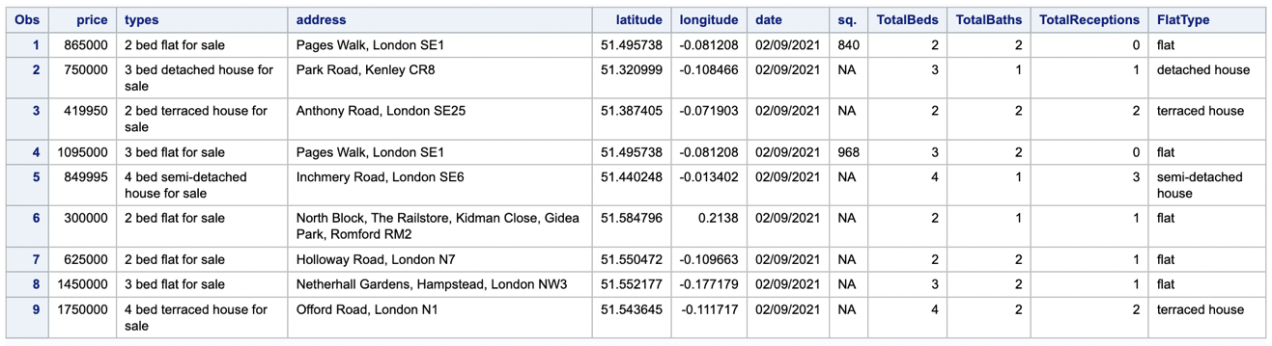

The above table shows the first 9 rows of renting post records.

1. **What kind of property has the most number of bathrooms on average?**

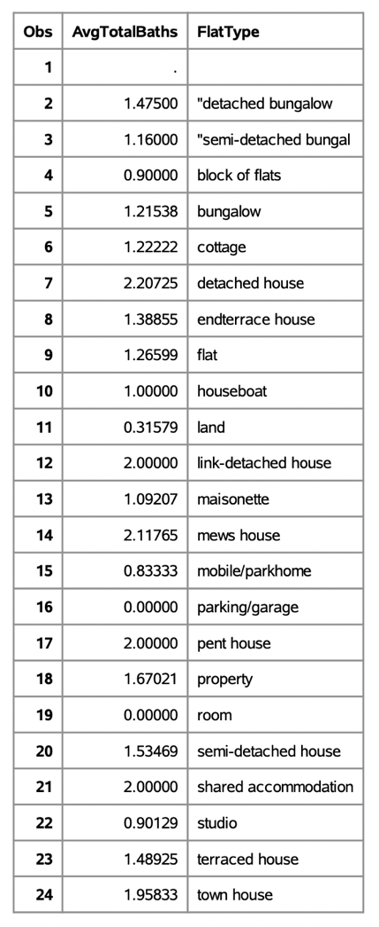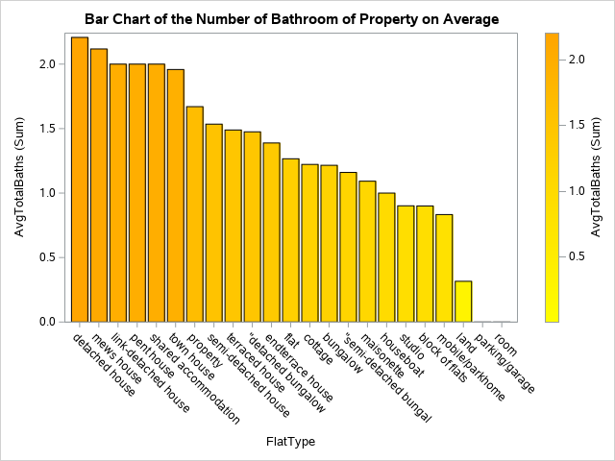

The above bar chart shows the level of bathrooms of each property on average, detached house has the greatest number of bathrooms on average which is 2.207354.

1. **Chart, pie chart

   Description automatically generated**Table

   Description automatically generated**What is the contribution of house type in the record? What is the most common type of property in the UK?**

The most common property type in the UK is "Flat" which has 5940 renting post records, and the second common is the “Terraced house”, there are 1116 records, and the third common property type is the “Semi-detached house”, which has 836 records. "Other" contains the rest property type which accounts for 4% or less of the total, for example, the “bungalow” and the “mews house”.

1. **What is the value distribution of the number of Reception between the semi-detached house and terraced house?**

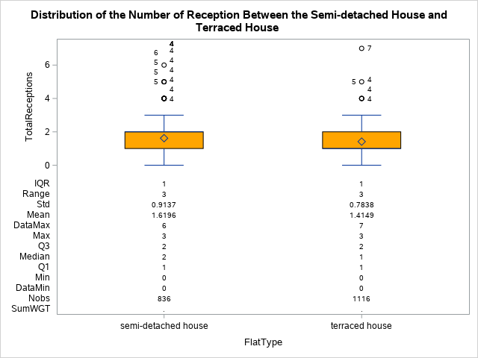

The above boxplot shows the value distribution of the number of receptions between the semi-detached house and the terraced house.

As for semi-detached houses, the median is 2, outliners contain 4-6.

As for terraced houses, the median is 1, outliners contain 4,5,7.

Therefore, the number of receptions in semi-detached houses is more than in terraced houses in general.

1. **What kind of property contains the second most turnover?**

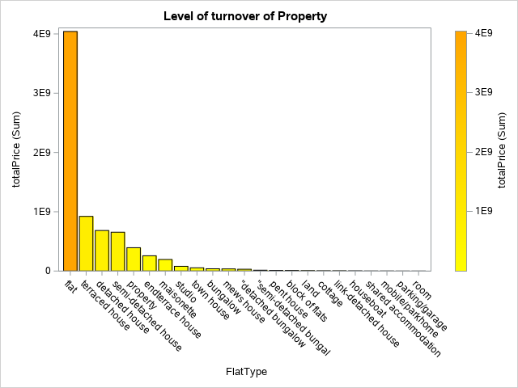

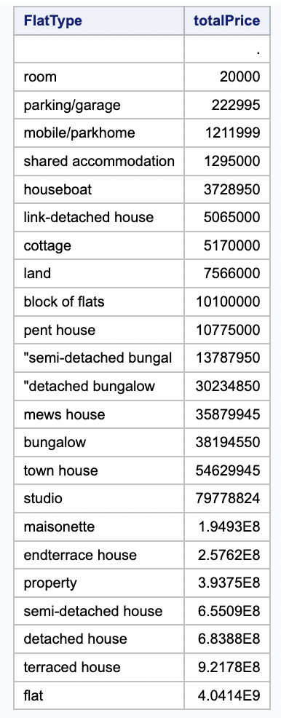

The level of turnover of each property type is shown above, terraced house contains the second most turnover which has 921780000.

1. **Is there any relationship between the number of bedrooms and bathrooms and the average price of a different property?**

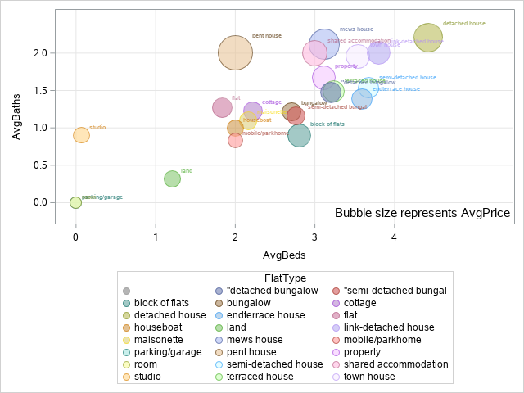

For answering this question, it takes the number of total bedrooms, total bathrooms, and price to average to avoid bubbles duplicates appearing in the chart.

Regarding the bubble chart, it shows the relation between the number of bedrooms, bathrooms, and price. There is a proportional relationship between these three variables, as you can see, when the number of bedrooms and bathrooms increases, the bubble size also increases. Therefore, the number of bedrooms and bathrooms will affect the price of the property.

# Extra suggestion and Conclusion

To conclude, the overview of the second-hand turnover property market is strong in UK in August and September of 2021. Since the transaction of the total price is more than billion GBP among these two months. The Top three of the most turnover in UK property market is “Flat”, “Terrace house” and “Detached house”, their total selling price is GBP4,000,000,000, GBP900,000,000 and GBP680,000,000 in total among the datasets. Also, we can discover that the most renting posts in the dataset are emphasized that the number of bedrooms and bathrooms instead of the size of the properties, the tenant should search the properties based on their demand for the numbers of rooms.

**Fig. which date has the more renting post?**

The most renting post date is 1st September 2022; 815 renting posts.

The second most renting post date is 27th August 2022; 679 renting posts.

The third most renting post date is 31st August 2022; 654 renting posts.

**Suggestions:**

1. **First/ the mid of each month is a good time to search some new rental properties**

Besides, our client might get more chances to find their dream properties at the first day of each month or the mid of the month as the most renting posts are posted during the above period.

1. **“Flat” is the most turnover property type in the second-hand market.**

we can summarize if the client is a property investor, we suggest that “Flat” is a good choice for investment which got the highest transaction rate in the when compared with the other kinds of residential properties in the UK.

# References

“UK Housing Market Update - August 2021.” *Savills UK | UK Housing Market Update - August 2021*, <https://www.savills.co.uk/research_articles/229130/317325-0#article>.

“UK Rental Review Q2 2021.” Cluttons, 26 Apr. 2022, https://www.cluttons.com/property-market-research/research-articles/uk-rental-review-q2-2021/.