曲谱

简谱C语言表示方法(M5,50)为(音调，音长)200表示为一个音长(节拍)，100位半个音长(节拍)，25位八分之一音长(节拍)

//A调对换法则：L1=L6 L2=L7 L3=B1 L4=M2 L5=M3 L6=B4 L7=B5 M1=M6 M2=M7 M3=C1 M4=H2 M5=H3 M6=C4 M7=C5 H1=H6

//B调兑：L1=L7 L2=B1 L3=B2 L4=M3 L5=B4 L6=B5 L7=B6 M1=M7 M2=C1 M3=C2 M4=H3 M5=C4 M6=C5 M7=C6 H1=H7

//D:

//E:

//F:

//G:

//1=C 3/4 以四分音符为一拍T/4 每节有三拍

//此处一拍的值是100 一节300 全音符时值为400

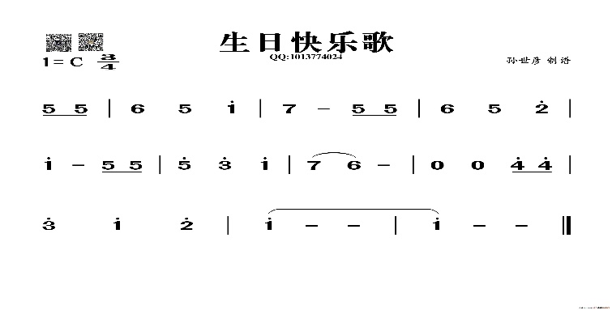

//生日快乐

{M5,50,M5,25,M5,25,

M6,100,M5,100,H1,100,

M7,100,M7,100,M5,50,M5,25,M5,25,

M6,100,M5,100,H2,100,

H1,100,H1,100,M5,50,M5,25,M5,25,

H5,100,H3,100,H1,100,

M7,100,M6,100,P,100,P,100,H4,50,H4,25,H4,25,

H3,100,H1,100,H2,100,H1,100,H1,100

}

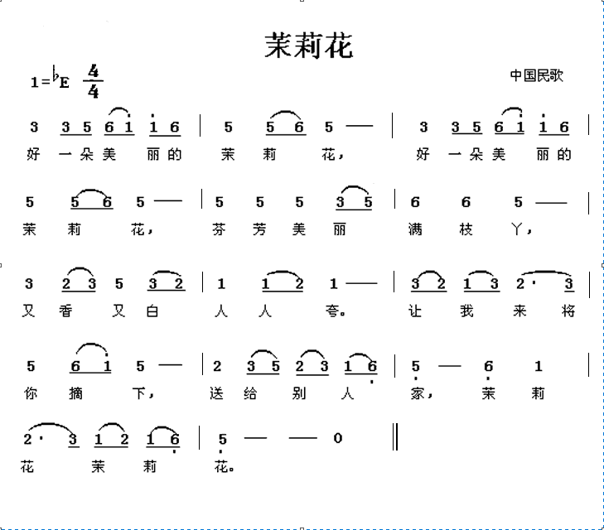

// 定义乐曲：《茉莉花》

{M3,100,M3,50,M5,50,M6,50,H1,50,H1,50,M6,50,

M5,100,M5,50,M6,50,M5,100,

M3,100,M3,50,M5,50,M6,50,H1,50,H1,50,M6,50,

M5,100,M5,50,M6,50,M5,100,

M5,100,M5,100,M5,100,M3,50,M5,50,

M6,100,M6,100,M5,100,

M3,100,M2,50,M3,50,M5,100,M3,50,M2,50,

M1,100,M1,50,M2,50,M1,100,

M3,50,M2,50,M1,50,M3,50,M2,150,M3,50,

M5,100,M5,100,M6,50,H1,50,M5,100,

M2,100,M3,50,M5,50,M2,50,M3,50,M1,50,L6,50,

L5,100,L5,100,L6,100,M1,100,

M2,150,M3,50,M1,50,M2,50,M1,50,L6,50,L5,150,P0,100,

}

//转调的谱（极致的音准）{

M5,100,M5,50,B6,50,H1,50,C2,50,C2,50,H1,50,

B6,100,B6,50,H1,50,B6,100,

M5,100,M5,50,B6,50,H1,50,C2,50,C2,50,H1,50,

B6,100,B6,50,H1,50,B6,100,

B6,100,B6,100,B6,100,M5,50,B6,50,

H1,100,H1,100,B6,100,

M5,100,M4,50,M5,50,B6,100,M5,50,M4,50,

B2,100,B2,50,M4,50,B2,100,

M5,50,M4,50,B2,50,M5,50,M4,150,M5,50,

B6,100,B6,100,H1,50,C2,50,B6,100,

M4,100,M5,50,B6,50,M4,50,M5,50,B2,50,M1,50,

A6,100,A6,100,M1,100,B2,100,

M4,150,M5,50,B2,50,M4,50,B2,50,M1,50,A6,150,P0,100,}

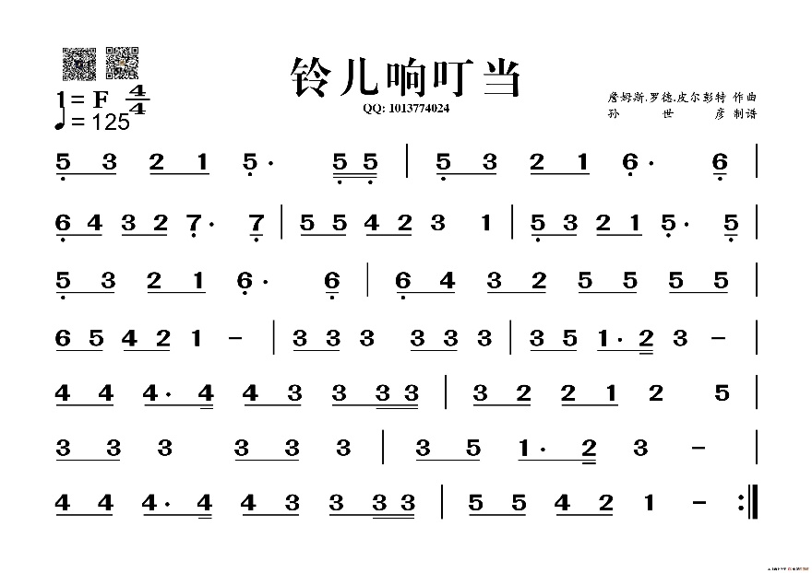

// 定义乐曲：《铃儿响叮当》

{L5,50,M3,50,M2,50,M1,50,L5,150,L5,25,L5,25,L5,50,M3,50,M2,50,M1,50,L6,150,L6,50,

L6,50,M4,50,M3,50,M2,50,L7,150,L7,50,M5,50,M5,50,M4,50,M2,50,M3,100,M1,100,L5,50,M3,50,M2,50,M1,50,L5,150,L5,50,

L5,50,M3,50,M2,50,M1,50,L6,150,L6,50,L6,50,M4,50,M3,50,M2,50,M5,50,M5,50,M5,50,M5,50,

M6,50,M5,50,M4,50,M2,50,M1,100,M3,50,M3,50,M3,100,MM3,50,M3,50,M3,100,M3,50,M5,50,M1,75,M2,25,M3,100,

M4,50,M4,50,M4,75,M4,25,M4,50,M3,50,M3,50,M3,25,M3,25,M3,50,M2,50,M2,50,M1,50,M2,100,M5,100,

M3,50,M3,50,M3,100,M3,50,M3,50,M3,100,M3,50,M5,50,M1,75,M2,25,M3,100,

M4,50,M4,50,M4,75,M4,25,M4,50,M3,50,M3,50,M3,25,M3,25,M5,50,M5,50,M4,50,M2,50,M1,100,

}

//转调的谱（极致的音准）{

M1,50,M6,50,M5,50,M4,50,M1,150,M1,25,M1,25,M1,50,M6,50,M5,50,M4,50,M2,150,M2,50,

M2,50,B6,50,M6,50,M5,50,M3,150,M3,50,H1,50,H1,50,B6,50,M5,50,M6,100,M4,100,M1,50,M6,50,M5,50,M4,50,M1,150,M1,50,

M1,50,M6,50,M5,50,M4,50,M2,150,M2,50,M2,50,B6,50,M6,50,M5,50,H1,50,H1,50,H1,50,H1,50,

H2,50,H1,50,B6,50,M5,50,M4,100,M6,50,M6,50,M6,100,M6,50,M6,50,M6,50,M6,50,H1,50,M4,75,M5,25,M6,100,

B6,50,B6,50,B6,75,B6,25,B6,50,M6,50,M6,50,M6,25,M6,25,M6,50,M5,50,M5,50,M4,50,M5,100,H1,100,

M6,50,M6,50,M6,100,M6,50,M6,50,M6,100,M6,50,H1,50,M4,75,M5,25,M6,100,

B6,50,B6,50,B6,75,B6,25,B6,50,M6,50,M6,50,M6,25,M6,25,H1,50,H1,50,B6,50,M5,50,M4,100,

}

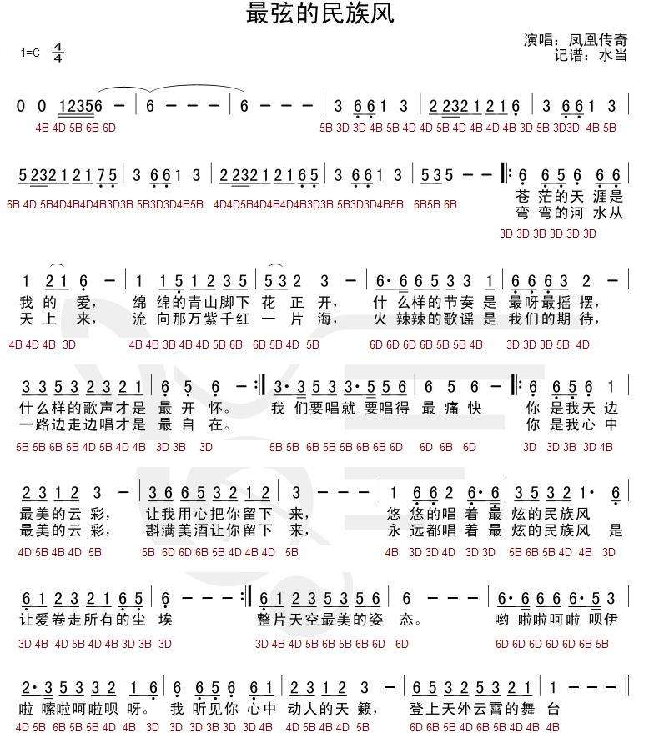  
// 定义乐曲：《最炫民族风》  
{  
L6,100,L6,50,L5,50,L6,100,L6,50,M1,50,

M1,100,M2,50,M1,50,L6,200,

M1,100,M1,50,L5,50,M1,50,M2,50,M3,50,M5,50,

M5,50,M3,50,M2,100,M3,200,

M6,50,M6,50,M6,50,M5,50,M3,50,M3,100,M1,50,

L6,50,L6,50,L6,50,M3,50,M2,200,

M3,50,M3,50,M5,50,M3,50,M2,50,M3,50,M2,50,M1,50,

L6,100,L5,100,L6,200, //摆，什么样的歌声才是最呀最摇

M3,50,M3,50,M5,50,M3,50,M3,50,M5,50,M5,50,M6,50,

H1,50,M6,50,M5,100,M6,200, //我们要唱就要唱的最痛快

L6,100,L6,50,L5,50,L6,100,M1,100,

M2,50,M3,50,M2,50,M1,50,M2,50,M3,200,

L6,50,M6,50,M6,50,M5,50,M2,50,M3,50,M2,50,M1,50,M2,50,M3,200,//留下来

M1,50,L6,50, M1,50,M2,100,L5,50,L5,50,

M3,50,M5,50,M3,50,M2,50,M1,200,

L6,50,M1,50,M2,50,M3,50,M2,50,M1,50,L5,50,L3,50,

L6,200,L6,100,L6,50,L5,50,L6,100,M1,100,M2,50,M3,50,M2,50,M1,50,M2,50,M3,200,

L6,50,M6,50,M6,50,M5,50,M2,50,M3,50,M2,50,M1,50, //留下来  
M1,50,L6,50,L6,50,M1,50,M2,100,L5,50,L5,50,

M3,50,M5,50,M3,50,M2,50,M1,100+50,

M1,50,L6,50,M1,50,M2,50,M5,50,M5,50,

M3,50,M3,50,M5,50}//不转了

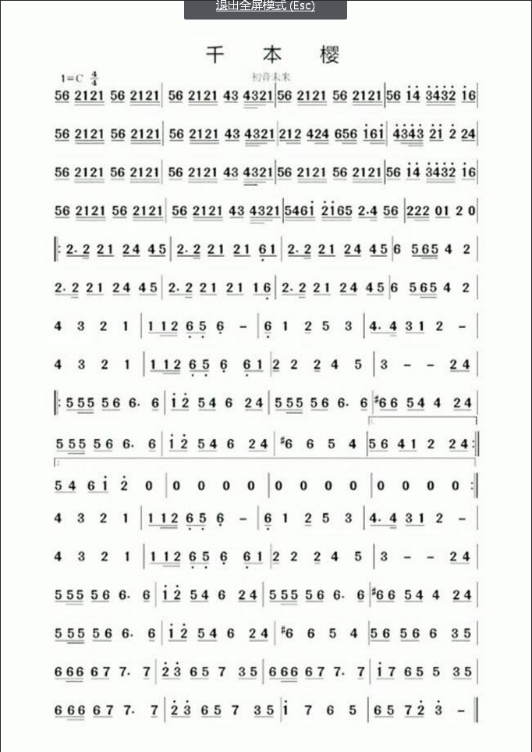

// 定义乐曲：《千本樱》

{ M5,50,M6,50,M2,25,M1,25,M2,25,M1,25,M5,50,M6,50,M2,25,M1,25,M2,25,M1,25, M5,50,M6,50,M2,25,M1,25,M2,25,M1,M4,50,M3,50,M4,12,M3,12,M2,25,M1,50, M5,50,M6,50,M2,25,M1,25,M2,25,M1,25,M5,50,M6,50,M2,25,M1,25,M2,25,M1,25, M5,50,M6,50,H1,50,H4,50,H3,25,H4,25,H3,25,H2,25,H1,50,M6,50,

M5,50,M6,50,M2,25,M1,25,M2,25,M1,25,M5,50,M6,50,M2,25,M1,25,M2,25,M1,25, M5,50,M6,50,M2,25,M1,25,M2,25,M1,M4,50,M3,50,M4,12,M3,12,M2,25,M1,50,

M2,50,M1,25,M2,25,M4,50,M2,25,M4,25,M6,50,M5,25,M6,25,H1,50,M6,25,H1,25, H4,50,H3,25,H4,12,H3,12,H2,50,H1,50,H2,100,M2,50,M4,50,

M5,50,M6,50,M2,25,M1,25,M2,25,M1,25,M5,50,M6,50,M2,25,M1,25,M2,25,M1,25, M5,50,M6,50,M2,25,M1,25,M2,25,M1,M4,50,M3,50,M4,12,M3,12,M2,25,M1,50, M5,50,M6,50,M2,25,M1,25,M2,25,M1,25,M5,50,M6,50,M2,25,M1,25,M2,25,M1,25, M5,50,M6,50,H1,50,H4,50,H3,25,H4,25,H3,25,H2,25,H1,50,M6,50,

M5,50,M6,50,M2,25,M1,25,M2,25,M1,25,M5,50,M6,50,M2,25,M1,25,M2,25,M1,25, M5,50,M6,50,M2,25,M1,25,M2,25,M1,M4,50,M3,50,M4,12,M3,12,M2,25,M1,50,

M5,25,M4,25,M6,25,H1,25,H2,25,H1,25,M6,25,M5,25,M2,75,M4,25,M5,50,M6,50, M2,50,M2,25,M2,25,P0,50,M1,50,M2,100,P0,100,

M2,75,M2,25,M2,50,M1,50,M2,50,M4,50,M4,50,M5,50, M2,75,M2,25,M2,50,M1,50,M2,50,M1,50,L6,50,M1,50, M2,75,M2,25,M2,50,M1,50,M2,50,M4,50,M4,50,M5,50, M6,100,M5,50,M6,25,M5,25,M4,100,M2,100,

M2,75,M2,25,M2,50,M1,50,M2,50,M4,50,M4,50,M5,50, M2,75,M2,25,M2,50,M1,50,M2,50,M1,50,M1,50,L6,50, M2,75,M2,25,M2,50,M1,50,M2,50,M4,50,M4,50,M5,50, M6,100,M5,50,M6,25,M5,25,M4,100,M2,100,

M4,100,M3,100,M2,100,M1,100, M1,50,M1,25,M2,25,L6,50,L5,50,L6,100, L6,50,M1,100,M2,50,M5,100,M3,100, M4,75,M4,25,M3,50,M1,50,M2,100,

M4,100,M3,100,M2,100,M1,100, M1,50,M1,25,M2,25,L6,50,L5,50,L6,100,L6,50,M1,50, M2,50,M2,100,M2,50,M4,100,M5,100, M3,100,M3,100,M3,100,M2,50,M4,50,

M5,50,M5,25,M5,25,M5,50,M6,50,M6,75,M6,25, H1,50,H2,50,M5,50,M4,50,M6,100,M2,50,M4,50, M5,50,M5,25,M5,25,M5,50,M6,50,M6,75,M6,50, B6,50,M6,50,M5,50,M4,50,M4,100,M2,50,M4,50,

M5,50,M5,25,M5,25,M5,50,M6,50,M6,75,M6,25, H1,50,H2,50,M5,50,M4,50,M6,100,M2,50,M4,50, B6,100,M6,100,M5,100,M4,100, M5,50,M6,50,M4,50,M1,50,M2,100,M2,50,M4,50,

M5,50,M4,50,M6,50,H1,50,H2,100,P0,100,P0,1200,

M4,100,M3,100,M2,100,M1,100, M1,50,M1,25,M2,25,L6,50,L5,50,L6,100, L6,50,M1,100,M2,50,M5,100,M3,100, M4,75,M4,25,M3,50,M1,50,M2,100,

M4,100,M3,100,M2,100,M1,100, M1,50,M1,25,M2,25,L6,50,L5,50,L6,100,L6,50,M1,50, M2,50,M2,100,M2,50,M4,100,M5,100, M3,100,M3,100,M3,100,M2,50,M4,50,

M5,50,M5,25,M5,25,M5,50,M6,50,M6,75,M6,25, H1,50,H2,50,M5,50,M4,50,M6,100,M2,50,M4,50, M5,50,M5,25,M5,25,M5,50,M6,50,M6,75,M6,50, B6,50,M6,50,M5,50,M4,50,M4,100,M2,50,M4,50,

M5,50,M5,25,M5,25,M5,50,M6,50,M6,75,M6,25, H1,50,H2,50,M5,50,M4,50,M6,100,M2,50,M4,50, B6,100,M6,100,M5,100,M4,100, M5,50,M6,50,M5,50,M6,50,M6,100,M3,50,M5,50,

M6,50,M6,25,M6,25,M6,50,M7,50,M7,150,M7,50, H2,50,H3,50,M6,50,M5,50,M7,100,M3,50,M5,50, M6,50,M6,25,M6,25,M6,50,M7,50,M7,75,M7,25, H1,50,M7,50,M6,50,M5,50,M5,100,M3,50,M5,50,

M6,50,M6,25,M6,25,M6,50,M7,50,M7,150,M7,50, H2,50,H3,50,M6,50,M5,50,M7,100,M3,50,M5,50, H1,100,M7,100,M6,100,M5,100, M6,50,M5,50,M7,50,H2,50,H3,100,

}