Title: Effects of maternal host versus larval host plant on developmental time

Methods:
The input data set was in csv format. Two different host plants were investigated for maternal and larval development phases. To investigate the data is normally distributed, aov() function was performed on analysis of variance. Then, ANOVA analysis was done on the input data. There were means, standard deviation of error and mathematics computation done on the data.

Table 1: The head part of the input data set

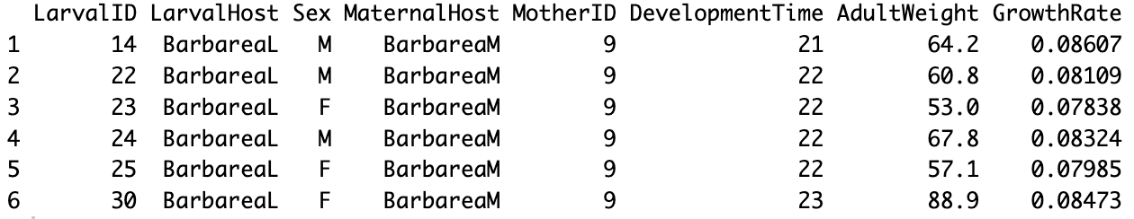

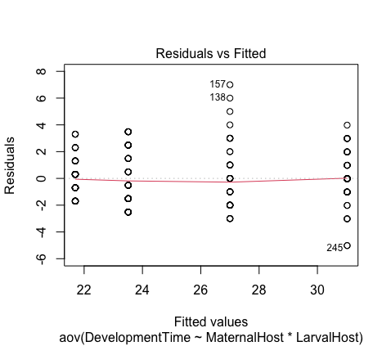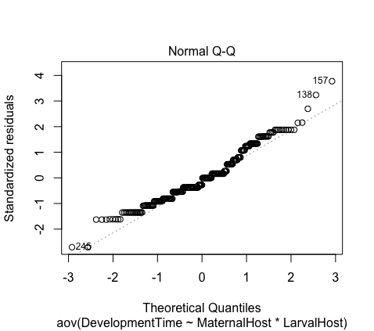
Figure 1. Residuals vs Fitted values(left), Standardized residuals vs Theorectical Quantiles (right)
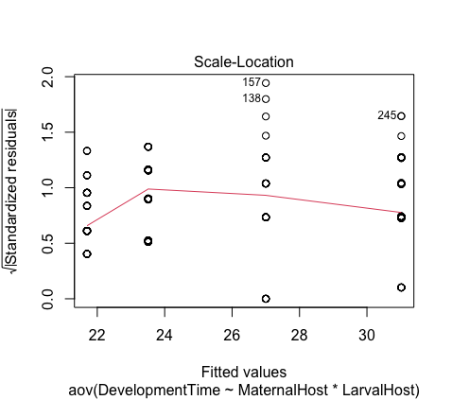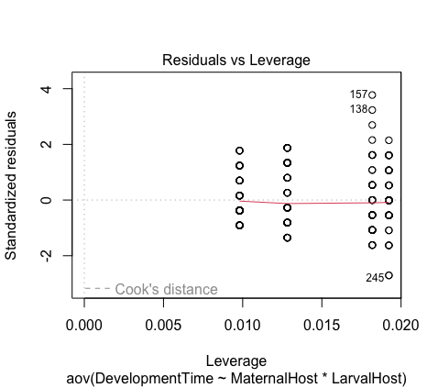
Figure 2. Square root of Standardized residuals vs Fitted values (left), Standardized residuals vs aov(DevelopmentTime~MaternalHost*LarvalHost (right)

Table 2. Summary of linear model -> lm(formula = DevelopmentTime ~ MaternalHost * LarvalHost, data = dat)

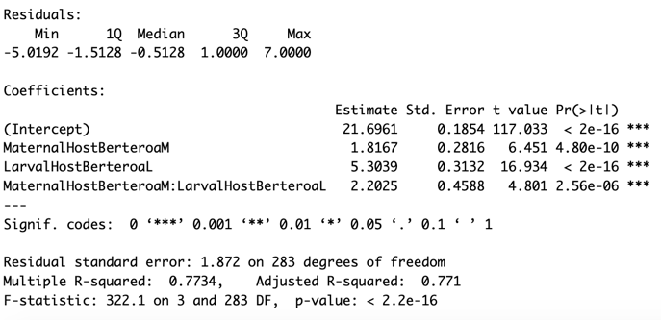

Table 3. ANOVA of maternal host versus larval host and interactions between host plant

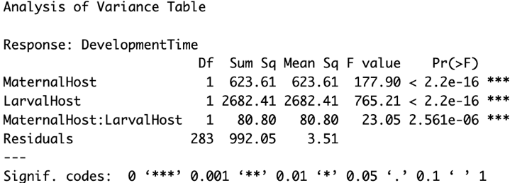

Table 4. Mean values between maternal host versus larval host plant
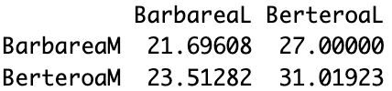

Table 5. Column and row means
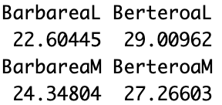
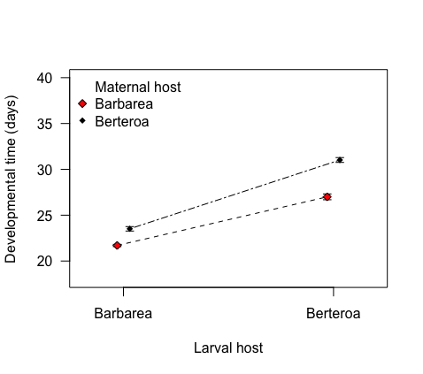

Figure 3. Larval development time depending on larval and maternal host plants

Results:
The input data set contained of 8 variables with 287 objects (Table 1). The analysis of variance suggested that the response variable "DevelopmentTime" is influenced by both "MaternalHost" and "LarvalHost," as well as their interaction ("MaternalHost*LarvalHost"), and the data was normally distributed (Table 1, Figure 1-2). Residual standard error (= √Σ(y – ŷ)²/df) is small (1.872 on 283 degree of freedom) indicated that the data fitted well with the regression model (Table 2). The sum of square values within the larval host is the largest compared to the maternal host, suggesting a larger variance and there were effects on both the larval and maternal hosts (F₁ ₂₈₃ = 765.21, 177.9). On the other hand, the variance for the interaction between maternal and larval host is the smallest, indicating that there was a lesser effect on the interaction between two hosts (Table 3). Effect size implied how meaningful the relationship between variables or the difference between groups is. Computation by using the mean (Table 4) by the row and the column were reported (Table 5). Larval grown faster (22.1%) on the Barbarea host and had shorter developmental time (mean development time = 22.6). Similarly larval whose mother were grown on the Barbarea host grown 10.7% faster than the Berteroa host plant (mean development time = 24.3 and 27.3) (Table 5). Barbarea host appeared to be the better oviposit place for the larval, in which the larval’s mother had grown either on the Barbarea or Berteroa host. The development time is smaller on Barbarea (19.6%) compared to the Berteroa host (24.1%) (Table 4).

