Tephritis conura flies utilise two different host plants (Cirsium heterophyllum and C. oleraceum), stable host races
Individuals of both host races were collected both in sympatry and in allopatry from eight
different populations in northern Europe
hatched in a common lab
one female and one male from each bud

Patry: Denotes whether individual is from a sympatric or allopatric population.
Hostplant: Whether the individual is a C. heterophyllum specialist or a C. oleraceum
specialist.
Sex: Individual sex.
BL: Measurements of body length in millimeter.
OL: Measurements of ovipositor length in millimeter.
Wing length: Measurements of wing length in millimeter.
Wing width: Measurements of wing width in millimeter.
Wing area: Wing length multiplied with wing width for an estimation of wing area.
Melanized area: Area of the wing which is melanised, measured with an automated script.
Melanized ratio: The ratio of dark and white area of the wing, measured with an automated
script.
Baltic: Whether the population of the individual is East or West of the Baltic sea

Title:

Background (10%):
Research questions

Methods (20%):
Choice, justification and presentation of the analysis methods

model_1 = lm(OL ~ BL + Wing_length, data = Oleraceum)
model_2 = lm(OL ~ BL * Wing_length, data = Oleraceum)
model_3 = lm(OL ~ BL, data = Oleraceum)
model_4 = lm(OL ~ Wing_length, data = Oleraceum)

df AIC logLik delta w
model_3 3 -207.3541 106.6770 0.00 0.56
model_1 4 -205.9213 106.9606 1.43 0.27
model_2 5 -204.9134 107.4567 2.44 0.17
model_4 3 -158.2546 82.1273 49.10 0.00

model 3 is considered OL, BL Oleraceum
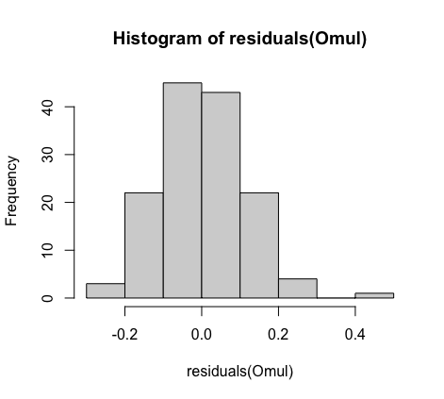
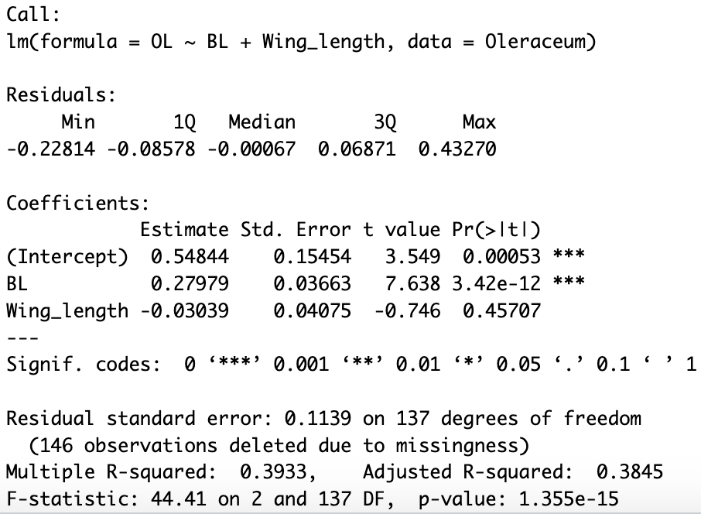
Call:
lm(formula = OL ~ BL + Wing_length, data = Oleraceum)

Residuals:
Min 1Q Median 3Q Max
-0.22814 -0.08578 -0.00067 0.06871 0.43270

Coefficients:
Estimate Std. Error t value Pr(>|t|)
(Intercept) 0.54844 0.15454 3.549 0.00053 ***
BL 0.27979 0.03663 7.638 3.42e-12 ***
Wing_length -0.03039 0.04075 -0.746 0.45707
---
Signif. codes: 0 ‘***’ 0.001 ‘**’ 0.01 ‘*’ 0.05 ‘.’ 0.1 ‘ ’ 1

Residual standard error: 0.1139 on 137 degrees of freedom
(146 observations deleted due to missingness)
Multiple R-squared: 0.3933, Adjusted R-squared: 0.3845
F-statistic: 44.41 on 2 and 137 DF, p-value: 1.355e-15
This output is from a linear regression analysis using the `lm()` function in R to model the relationship between the outcome variable `OL` and predictor variables `BL` (presumably "Body Length") and `Wing_length` using data from the `Oleraceum` dataset.

Let's break down the key components of this output:

### Residuals:
- The residuals represent the differences between the observed values and the predicted values by the model.
- Minimum (`Min`), first quartile (`1Q`), median (`Median`), third quartile (`3Q`), and maximum (`Max`) values of the residuals are displayed.

### Coefficients:
- `Estimate`: These are the estimated coefficients for the intercept and the predictor variables (`BL` and `Wing_length`).
- `Std. Error`: Standard error estimates for the coefficients.
- `t value`: The t-statistic value for testing the null hypothesis that the coefficient is zero.
- `Pr(>|t|)`: The p-value associated with the t-statistic, indicating the significance of each coefficient.

### Residual standard error:
- This is an estimate of the standard deviation of the residuals.
- Indicates the average distance of data points from the fitted regression line.
- In this case, it's 0.1139.

### Degrees of freedom and Model summary:
- `Multiple R-squared`: The proportion of variance in the dependent variable (`OL`) explained by the independent variables (`BL` and `Wing_length`). Here, it's 0.3933, indicating that about 39.33% of the variance in `OL` is explained by `BL` and `Wing_length`.
- `Adjusted R-squared`: A modified version of R-squared that penalizes additional predictors.
- `F-statistic`: A test statistic for the overall significance of the model.
- `p-value`: The significance level associated with the F-statistic. In this case, it's very low (1.355e-15), indicating that the model as a whole is significant in explaining the variation in `OL`.

### Interpretation:
- `BL` has a highly significant positive association with `OL`, as indicated by its low p-value (`***`).
- `Wing_length` does not appear to have a statistically significant association with `OL`, as its p-value is higher than the conventional threshold of significance (0.05).
- The intercept is statistically significant as well.
- The model as a whole is statistically significant, explaining about 39.33% of the variance in `OL`.

This output suggests that while `BL` is strongly associated with `OL`, `Wing_length` doesn't seem to have a significant relationship with `OL` in the context of this model.

Heterophyllum
model_1 = lm(OL ~ BL + Wing_length, data = Heterophyllum)
model_2 = lm(OL ~ BL * Wing_length, data = Heterophyllum)
model_3 = lm(OL ~ BL, data = Heterophyllum)
model_4 = lm(OL ~ Wing_length, data = Heterophyllum)

df AIC logLik delta w
model_1 4 -182.7811 95.39053 0.00 0.45
model_2 5 -182.5636 96.28180 0.22 0.40
model_3 3 -180.2123 93.10613 2.57 0.12
model_4 3 -176.9217 91.46084 5.86 0.02

model 1 is considered OL, BL+wing-length Heterophyllum

These parameters are commonly associated with model selection using AIC (Akaike Information Criterion). Let's break down each parameter and then compare the models based on these values:

- **df (Degrees of Freedom):**
- Indicates the number of parameters in the model.
- `model_1` has 4 degrees of freedom (df), `model_2` has 5 df, and `model_3` and `model_4` both have 3 df.

- **AIC (Akaike Information Criterion):**
- A measure used for model selection. Lower values indicate a better trade-off between goodness of fit and model complexity.
- Among the listed models: `model_4` has the lowest AIC (-176.9217), followed by `model_3` (-180.2123), `model_2` (-182.5636), and `model_1` (-182.7811).

- **logLik (Log-Likelihood):**
- The log-likelihood of the model. It indicates how well the model predicts the observed data.
- Higher logLik values indicate a better fit to the data.
- In this case, `model_1` has a logLik of 95.39053, `model_2` has 96.28180, `model_3` has 93.10613, and `model_4` has 91.46084.

- **delta (AIC Difference):**
- Represents the difference in AIC between each model and the model with the lowest AIC.
- `delta` for `model_1` is 0.00, `model_2` has a delta of 0.22, `model_3` has 2.57, and `model_4` has 5.86.
- Lower delta values indicate models that are closer in fit to the best model (the one with the lowest AIC).

- **w (Akaike weight):**
- A measure of the relative likelihood of each model being the best model among those considered.
- Higher `w` values indicate a higher probability of the model being the best.
- In this case, the `w` values suggest that `model_1` has a probability of 0.45, `model_2` has 0.40, `model_3` has 0.12, and `model_4` has 0.02 of being the best model.

Comparing the models:

- `model_4` has the lowest AIC, indicating the best balance between goodness of fit and model complexity among the listed models.
- `model_3` has the second-lowest AIC but a relatively higher AIC difference (delta) compared to `model_4`.
- `model_1` and `model_2` have higher AIC values and are less likely to be the best models among those considered based on their lower `w` values.

Remember, while AIC is a valuable criterion, other considerations specific to your context should be evaluated before finalizing the choice of the best model.

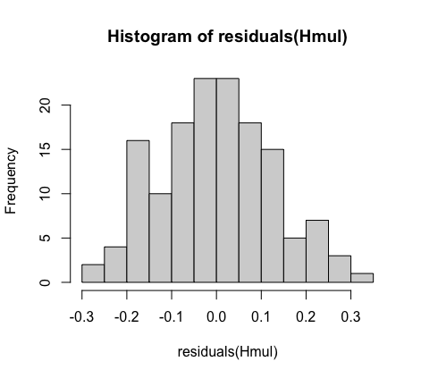
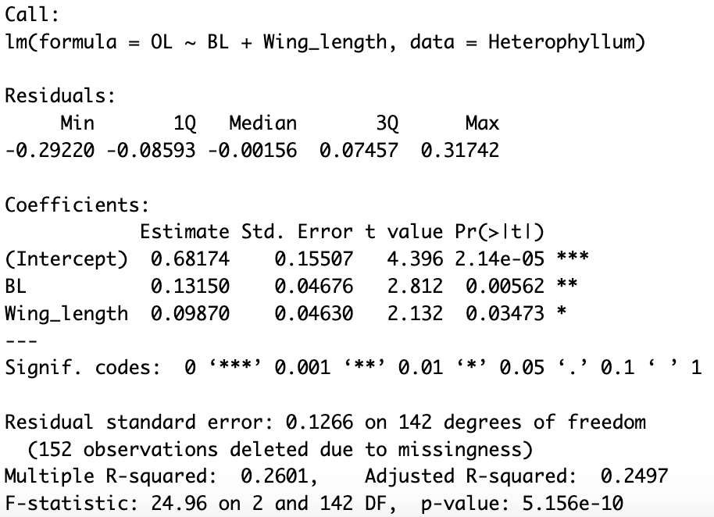

Call:
lm(formula = OL ~ BL + Wing_length, data = Heterophyllum)

Residuals:
Min 1Q Median 3Q Max
-0.29220 -0.08593 -0.00156 0.07457 0.31742

Coefficients:
Estimate Std. Error t value Pr(>|t|)
(Intercept) 0.68174 0.15507 4.396 2.14e-05 ***
BL 0.13150 0.04676 2.812 0.00562 **
Wing_length 0.09870 0.04630 2.132 0.03473 *
---
Signif. codes: 0 ‘***’ 0.001 ‘**’ 0.01 ‘*’ 0.05 ‘.’ 0.1 ‘ ’ 1

Residual standard error: 0.1266 on 142 degrees of freedom
(152 observations deleted due to missingness)
Multiple R-squared: 0.2601, Adjusted R-squared: 0.2497
F-statistic: 24.96 on 2 and 142 DF, p-value: 5.156e-10

This summary contains a lot of information. First, we can see some quantiles of the residual distribution,
which confirms what we have already seen from the histogram: the residuals are fine because the median is
close to zero, the 1st and 3rd quartile are symmetrical, and the min and max values are nearly symmetrical
too.
The most important thing to notice here is that the sample size n is in the denominator of the expression
for the standard error, so that larger sample size will lead to a smaller standard error, and thus a greater
t-value.
The P -value is the probability of observing the observed value of the test statistic given that the null
hypothesis (here, a slope of zero) is true, or Pobs = P r(T > tobs = t(Xobs|H0)). In other words, it represents
the probability that we would have obtained our results by chance.
Now, let us return to how we interpret the results of our linear regression. The slope of y on x is about 0.43.
Recall that the regression slope is given by the ratio of the covariance between y and x, and the variance in
x, Cov(y, x)/V ar(x).
Although regression slopes are very often reported without any units, it is important to remember that the
slopes in fact carry the units of both the response and predictor variables. In our example the response and
predictor are both measured in mm, and the slope is therefore 0.43 mm/mm. When we report this in the
text, we generally want also to report the standard error, i.e. slope = 0.43 ± 0.04 mm/mm. Thus, in our
example, the response variable increases by 0.43 mm per mm increase in the predictor. The small standard
error (relative to the slope estimate) directly indicates the strong statistical support

This output is from a linear regression analysis using the `lm()` function in R to model the relationship between the outcome variable `OL` and predictor variables `BL` (probably "Body Length") and `Wing_length` (presumably the length of wings) using data from the `Heterophyllum` dataset.

Here's a breakdown of the key sections of the output:

### Residuals:
- These are the differences between the observed values and the predicted values by the model.
- Minimum (`Min`), first quartile (`1Q`), median (`Median`), third quartile (`3Q`), and maximum (`Max`) values of the residuals are shown.

### Coefficients:
- `Estimate`: These are the estimated coefficients for the intercept and the predictor variables (`BL` and `Wing_length`).
- `Std. Error`: Standard error estimates for the coefficients.
- `t value`: The t-statistic value for testing the null hypothesis that the coefficient is zero.
- `Pr(>|t|)`: The p-value associated with the t-statistic, indicating the significance of each coefficient.

### Residual standard error:
- This is an estimate of the standard deviation of the residuals.
- Indicates the average distance of data points from the fitted regression line.
- In this case, it's 0.1266.

### Degrees of freedom and Model summary:
- `Multiple R-squared`: The proportion of variance in the dependent variable (`OL`) explained by the independent variables (`BL` and `Wing_length`). Here, it's 0.2601, indicating that about 26.01% of the variance in `OL` is explained by `BL` and `Wing_length`.
- `Adjusted R-squared`: A modified version of R-squared that penalizes additional predictors.
- `F-statistic`: A test statistic for the overall significance of the model.
- `p-value`: The significance level associated with the F-statistic. In this case, it's very low (5.156e-10), indicating that the model as a whole is significant in explaining the variation in `OL`.

### Interpretation:
- Both `BL` and `Wing_length` are significantly associated with `OL` based on their p-values (indicated by `***`, `**`, or `*`).
- The intercept is statistically significant as well.
- The model as a whole is statistically significant, as indicated by the low p-value of the F-test.

This output suggests that `BL` and `Wing_length` have a statistically significant association with `OL`, with the model explaining about 26.01% of the variance in `OL`.
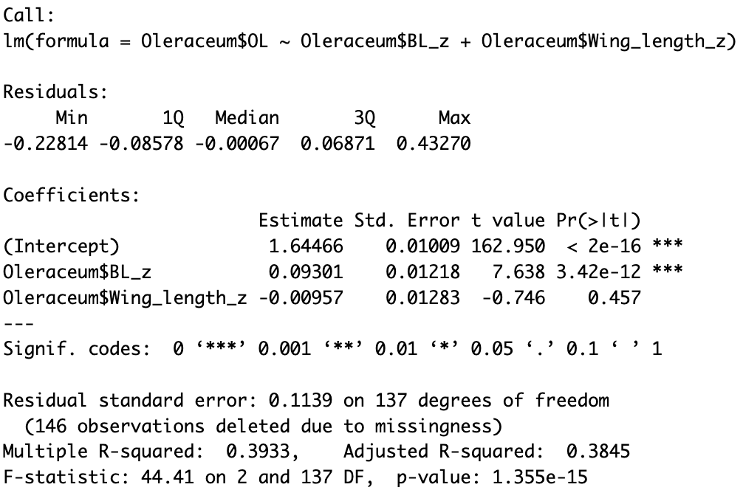
Call:
lm(formula = Oleraceum$OL ~ Oleraceum$BL_z + Oleraceum$Wing_length_z)

Residuals:
Min 1Q Median 3Q Max
-0.22814 -0.08578 -0.00067 0.06871 0.43270

Coefficients:
Estimate Std. Error t value Pr(>|t|)
(Intercept) 1.64466 0.01009 162.950 < 2e-16 ***
Oleraceum$BL_z 0.09301 0.01218 7.638 3.42e-12 ***
Oleraceum$Wing_length_z -0.00957 0.01283 -0.746 0.457
---
Signif. codes: 0 ‘***’ 0.001 ‘**’ 0.01 ‘*’ 0.05 ‘.’ 0.1 ‘ ’ 1

Residual standard error: 0.1139 on 137 degrees of freedom
(146 observations deleted due to missingness)
Multiple R-squared: 0.3933, Adjusted R-squared: 0.3845
F-statistic: 44.41 on 2 and 137 DF, p-value: 1.355e-15

Note that the model fit (e.g. the r2) has not changed, but the parameter estimates have. First, the intercept
can now be interpreted as the mean of y, because it represents the value of y when both predictors have a
value of 0 (i.e. their mean after the z-transform). This effect can be obtained also by mean-centering the
variables without scaling them to a standard deviation of 1.
Second, the slopes now have units of standard deviations, i.e. they describe the change in y per standard
deviation change in each predictor. This shows directly that the predictor x2 explains more variance in y
than does x1.

This output appears to be the result of a linear regression analysis performed using the `lm()` function in R. The model attempts to predict the dependent variable `Oleraceum$OL` (presumably some measurement associated with Oleraceum) based on the independent variables `Oleraceum$BL_z` (standardized values of BL) and `Oleraceum$Wing_length_z` (standardized values of Wing_length).

Let's break down the components of this output:

### Residuals:
- These are the differences between the observed values and the predicted values by the model.
- Minimum (`Min`), first quartile (`1Q`), median (`Median`), third quartile (`3Q`), and maximum (`Max`) values of the residuals are shown.

### Coefficients:
- `Estimate`: These are the estimated coefficients for the intercept and the predictor variables (`Oleraceum$BL_z` and `Oleraceum$Wing_length_z`).
- `Std. Error`: Standard error estimates for the coefficients.
- `t value`: The t-statistic value for testing the null hypothesis that the coefficient is zero.
- `Pr(>|t|)`: The p-value associated with the t-statistic, indicating the significance of each coefficient.

### Residual standard error:
- This is an estimate of the standard deviation of the residuals.
- Indicates the average distance of data points from the fitted regression line.
- In this case, it's 0.1139.

### Degrees of freedom and Model summary:
- `Multiple R-squared`: The proportion of variance in the dependent variable (`Oleraceum$OL`) explained by the independent variables (`Oleraceum$BL_z` and `Oleraceum$Wing_length_z`). Here, it's 0.3933, indicating that about 39.33% of the variance in `Oleraceum$OL` is explained by the model.
- `Adjusted R-squared`: A modified version of R-squared that penalizes additional predictors.
- `F-statistic`: A test statistic for the overall significance of the model.
- `p-value`: The significance level associated with the F-statistic. In this case, it's very low (`1.355e-15`), indicating that the model is highly significant in explaining the variation in `Oleraceum$OL`.

### Interpretation:
- `Oleraceum$BL_z` has a statistically significant positive association with `Oleraceum$OL`, as indicated by its very low p-value (`3.42e-12` and `***`).
- `Oleraceum$Wing_length_z` does not appear to have a statistically significant relationship with `Oleraceum$OL`, as indicated by its relatively high p-value (`0.457`).
- The model as a whole is statistically significant, explaining about 39.33% of the variance in `Oleraceum$OL`.
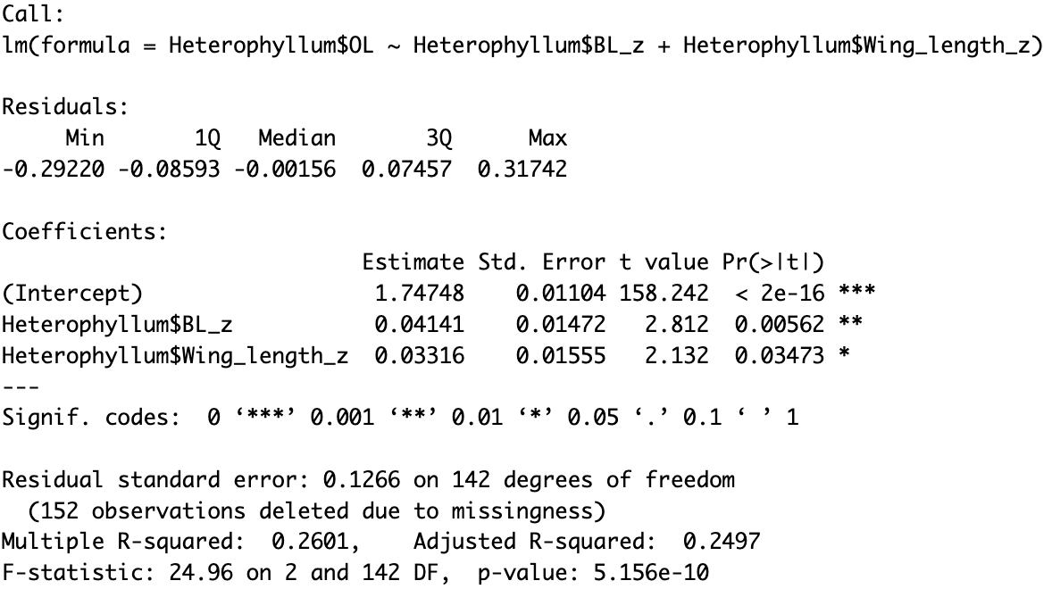

Call:
lm(formula = Heterophyllum$OL ~ Heterophyllum$BL_z + Heterophyllum$Wing_length_z)

Residuals:
Min 1Q Median 3Q Max
-0.29220 -0.08593 -0.00156 0.07457 0.31742

Coefficients:
Estimate Std. Error t value Pr(>|t|)
(Intercept) 1.74748 0.01104 158.242 < 2e-16 ***
Heterophyllum$BL_z 0.04141 0.01472 2.812 0.00562 **
Heterophyllum$Wing_length_z 0.03316 0.01555 2.132 0.03473 *
---
Signif. codes: 0 ‘***’ 0.001 ‘**’ 0.01 ‘*’ 0.05 ‘.’ 0.1 ‘ ’ 1

Residual standard error: 0.1266 on 142 degrees of freedom
(152 observations deleted due to missingness)
Multiple R-squared: 0.2601, Adjusted R-squared: 0.2497
F-statistic: 24.96 on 2 and 142 DF, p-value: 5.156e-10

Graph:
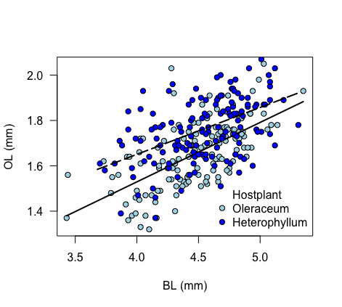
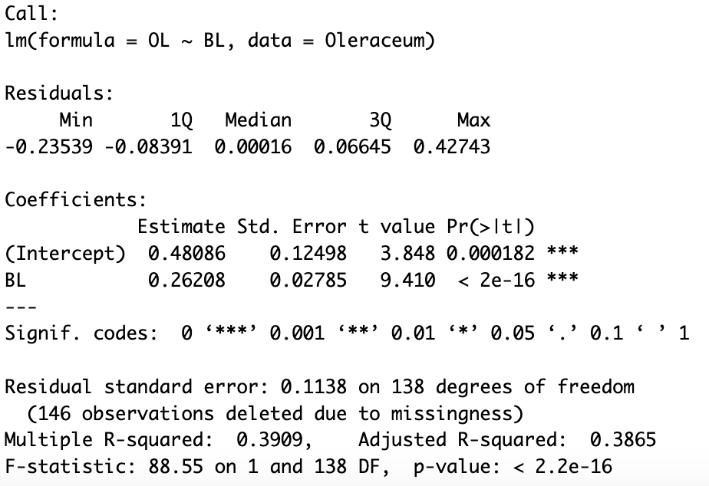
Call:
lm(formula = OL ~ BL, data = Oleraceum)

Residuals:
Min 1Q Median 3Q Max
-0.23539 -0.08391 0.00016 0.06645 0.42743

Coefficients:
Estimate Std. Error t value Pr(>|t|)
(Intercept) 0.48086 0.12498 3.848 0.000182 ***
BL 0.26208 0.02785 9.410 < 2e-16 ***
---
Signif. codes: 0 ‘***’ 0.001 ‘**’ 0.01 ‘*’ 0.05 ‘.’ 0.1 ‘ ’ 1

Residual standard error: 0.1138 on 138 degrees of freedom
(146 observations deleted due to missingness)
Multiple R-squared: 0.3909, Adjusted R-squared: 0.3865
F-statistic: 88.55 on 1 and 138 DF, p-value: < 2.2e-16

This output is from a simple linear regression analysis using the `lm()` function in R to model the relationship between the outcome variable `OL` and a single predictor variable `BL` (presumably "Body Length") using data from the `Oleraceum` dataset.

Let's break down the key components of this output:

### Residuals:
- The residuals represent the differences between the observed values and the predicted values by the model.
- Minimum (`Min`), first quartile (`1Q`), median (`Median`), third quartile (`3Q`), and maximum (`Max`) values of the residuals are displayed.

### Coefficients:
- `Estimate`: These are the estimated coefficients for the intercept and the predictor variable `BL`.
- `Std. Error`: Standard error estimates for the coefficients.
- `t value`: The t-statistic value for testing the null hypothesis that the coefficient is zero.
- `Pr(>|t|)`: The p-value associated with the t-statistic, indicating the significance of each coefficient.

### Residual standard error:
- This is an estimate of the standard deviation of the residuals.
- Indicates the average distance of data points from the fitted regression line.
- In this case, it's 0.1138.

### Degrees of freedom and Model summary:
- `Multiple R-squared`: The proportion of variance in the dependent variable (`OL`) explained by the independent variable (`BL`). Here, it's 0.3909, indicating that about 39.09% of the variance in `OL` is explained by `BL`.
- `Adjusted R-squared`: A modified version of R-squared that penalizes additional predictors.
- `F-statistic`: A test statistic for the overall significance of the model.
- `p-value`: The significance level associated with the F-statistic. In this case, it's extremely low (`< 2.2e-16`), indicating that the model is highly significant in explaining the variation in `OL`.

### Interpretation:
- `BL` has a highly significant positive association with `OL`, as indicated by its very low p-value (`< 2e-16` and `***`).
- The intercept is statistically significant as well.
- The model as a whole is statistically significant, explaining about 39.09% of the variance in `OL`.

This output suggests that `BL` is strongly associated with `OL`, and the model built using just `BL` as a predictor is highly significant in explaining the variation observed in `OL`.

Explain for the graph:
In the given paragraph, a linear regression model `Om` is fitted using the `lm()` function in R to model the relationship between the outcome variable `OL` and the predictor variable `BL` using data from the `Oleraceum` dataset. The paragraph further describes steps to visualize the regression line over a scatterplot.

Let's break down the relevant parts of the code:

1. `Om = lm(OL ~ BL, data = Oleraceum)`: This line fits a linear regression model (`Om`) where `OL` is the dependent variable and `BL` is the independent variable using the `lm()` function.

2. `Om_x1 = seq(min(Oleraceum$BL), max(Oleraceum$BL), length.out=30)`: This line creates a sequence of 30 equally spaced values (`Om_x1`) spanning the range of the `BL` variable in the `Oleraceum` dataset.

3. `Om_y1 = Om$coef[1] + Om$coef[2]*Om_x1`: Here, `Om$coef[1]` represents the intercept of the regression model `Om`, and `Om$coef[2]` represents the coefficient for the `BL` variable. Multiplying each `Om_x1` value by `Om$coef[2]` and adding the intercept `Om$coef[1]` calculates the predicted `OL` values (`Om_y1`) corresponding to each `Om_x1`. This step generates the points for the fitted regression line based on the model coefficients.

4. `plot(Oleraceum$BL, Oleraceum$OL, xlab="BL (mm)", ylab="OL (mm)", las=1, pch=21, col="black", bg="lightblue")`: This command plots the scatterplot of `BL` against `OL` with specified axis labels and formatting for points.

5. `lines(Om_x1, Om_y1, lwd = 2)`: Utilizing the `lines()` function, this line adds the fitted regression line (represented by `Om_x1` and `Om_y1`) onto the scatterplot. The `lwd = 2` argument specifies the line width for the added regression line.

The expression `Om$coef[1] + Om$coef[2]*Om_x1` calculates the predicted `OL` values based on the linear relationship between `BL` and `OL` from the linear regression model (`Om`). This process generates points for the regression line, allowing visualization of the fitted line over the scatterplot of `BL` and `OL` points from the dataset.
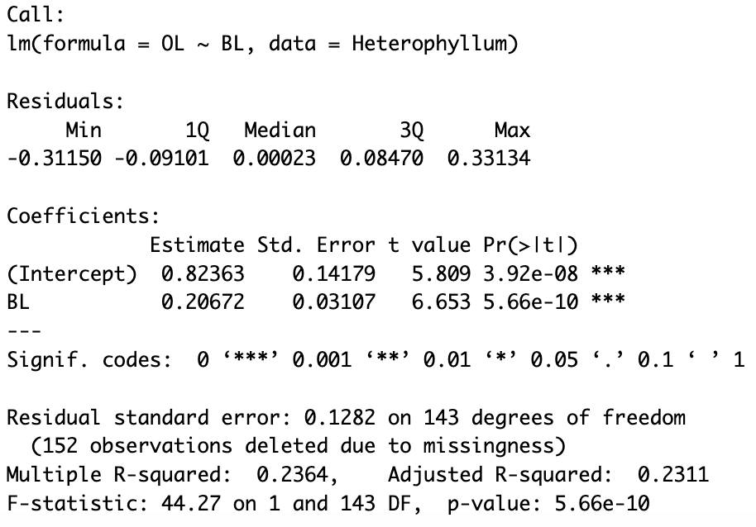
Call:
lm(formula = OL ~ BL, data = Heterophyllum)

Residuals:
Min 1Q Median 3Q Max
-0.31150 -0.09101 0.00023 0.08470 0.33134

Coefficients:
Estimate Std. Error t value Pr(>|t|)
(Intercept) 0.82363 0.14179 5.809 3.92e-08 ***
BL 0.20672 0.03107 6.653 5.66e-10 ***
---
Signif. codes: 0 ‘***’ 0.001 ‘**’ 0.01 ‘*’ 0.05 ‘.’ 0.1 ‘ ’ 1

Residual standard error: 0.1282 on 143 degrees of freedom
(152 observations deleted due to missingness)
Multiple R-squared: 0.2364, Adjusted R-squared: 0.2311
F-statistic: 44.27 on 1 and 143 DF, p-value: 5.66e-10

This output is the result of a simple linear regression analysis using the `lm()` function in R, modeling the relationship between the outcome variable `OL` and the predictor variable `BL` (which could represent "Body Length") using data from the `Heterophyllum` dataset.

Let's break down the key components of this output:

### Residuals:
- These are the differences between the observed values and the predicted values by the model.
- Minimum (`Min`), first quartile (`1Q`), median (`Median`), third quartile (`3Q`), and maximum (`Max`) values of the residuals are displayed.

### Coefficients:
- `Estimate`: These are the estimated coefficients for the intercept and the predictor variable `BL`.
- `Std. Error`: Standard error estimates for the coefficients.
- `t value`: The t-statistic value for testing the null hypothesis that the coefficient is zero.
- `Pr(>|t|)`: The p-value associated with the t-statistic, indicating the significance of each coefficient.

### Residual standard error:
- This is an estimate of the standard deviation of the residuals.
- Indicates the average distance of data points from the fitted regression line.
- In this case, it's 0.1282.

### Degrees of freedom and Model summary:
- `Multiple R-squared`: The proportion of variance in the dependent variable (`OL`) explained by the independent variable (`BL`). Here, it's 0.2364, indicating that about 23.64% of the variance in `OL` is explained by `BL`.
- `Adjusted R-squared`: A modified version of R-squared that penalizes additional predictors.
- `F-statistic`: A test statistic for the overall significance of the model.
- `p-value`: The significance level associated with the F-statistic. In this case, it's extremely low (`5.66e-10`), indicating that the model is highly significant in explaining the variation in `OL`.

### Interpretation:
- `BL` has a highly significant positive association with `OL`, as indicated by its very low p-value (`5.66e-10` and `***`).
- The intercept is statistically significant as well.
- The model as a whole is statistically significant, explaining about 23.64% of the variance in `OL`.

This output suggests that `BL` is strongly associated with `OL`, and the linear regression model using `BL` as the predictor variable is highly significant in explaining the variation observed in `OL`.
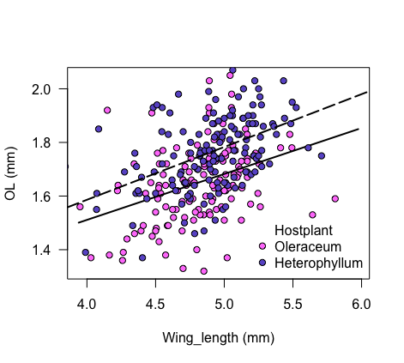
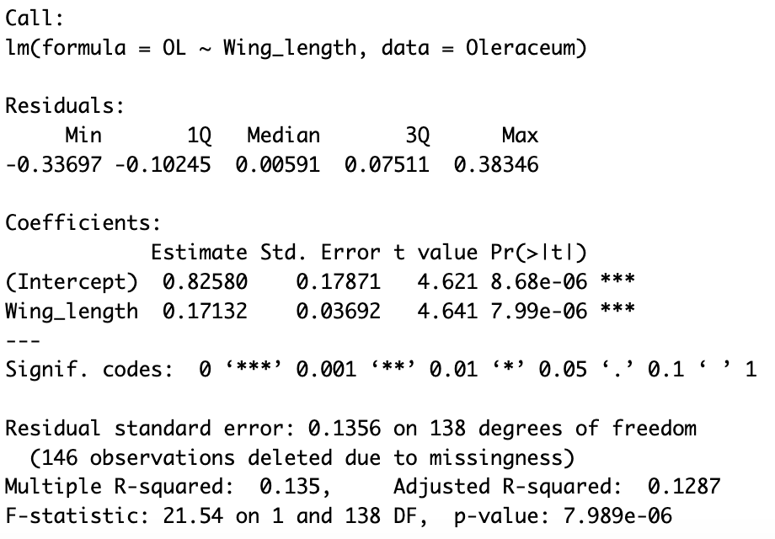
Call:
lm(formula = OL ~ Wing_length, data = Oleraceum)

Residuals:
Min 1Q Median 3Q Max
-0.33697 -0.10245 0.00591 0.07511 0.38346

Coefficients:
Estimate Std. Error t value Pr(>|t|)
(Intercept) 0.82580 0.17871 4.621 8.68e-06 ***
Wing_length 0.17132 0.03692 4.641 7.99e-06 ***
---
Signif. codes: 0 ‘***’ 0.001 ‘**’ 0.01 ‘*’ 0.05 ‘.’ 0.1 ‘ ’ 1

Residual standard error: 0.1356 on 138 degrees of freedom
(146 observations deleted due to missingness)
Multiple R-squared: 0.135, Adjusted R-squared: 0.1287
F-statistic: 21.54 on 1 and 138 DF, p-value: 7.989e-06

This output is from a linear regression analysis using the `lm()` function in R, modeling the relationship between the outcome variable `OL` and the predictor variable `Wing_length` using data from the `Oleraceum` dataset.

Let's break down the components of this output:

### Residuals:
- These are the differences between the observed values and the predicted values by the model.
- Minimum (`Min`), first quartile (`1Q`), median (`Median`), third quartile (`3Q`), and maximum (`Max`) values of the residuals are displayed.

### Coefficients:
- `Estimate`: These are the estimated coefficients for the intercept and the predictor variable `Wing_length`.
- `Std. Error`: Standard error estimates for the coefficients.
- `t value`: The t-statistic value for testing the null hypothesis that the coefficient is zero.
- `Pr(>|t|)`: The p-value associated with the t-statistic, indicating the significance of each coefficient.

### Residual standard error:
- This is an estimate of the standard deviation of the residuals.
- Indicates the average distance of data points from the fitted regression line.
- In this case, it's 0.1356.

### Degrees of freedom and Model summary:
- `Multiple R-squared`: The proportion of variance in the dependent variable (`OL`) explained by the independent variable (`Wing_length`). Here, it's 0.135, indicating that about 13.5% of the variance in `OL` is explained by `Wing_length`.
- `Adjusted R-squared`: A modified version of R-squared that penalizes additional predictors.
- `F-statistic`: A test statistic for the overall significance of the model.
- `p-value`: The significance level associated with the F-statistic. In this case, it's very low (`7.989e-06`), indicating that the model is highly significant in explaining the variation in `OL`.

### Interpretation:
- `Wing_length` has a statistically significant positive association with `OL`, as indicated by its very low p-value (`7.99e-06` and `***`).
- The intercept is statistically significant as well.
- The model as a whole is statistically significant, explaining about 13.5% of the variance in `OL`.

This output suggests that while `Wing_length` is significantly associated with `OL`, it explains a relatively small proportion of the variance in `OL`, as indicated by the modest `Multiple R-squared` value of 0.135.
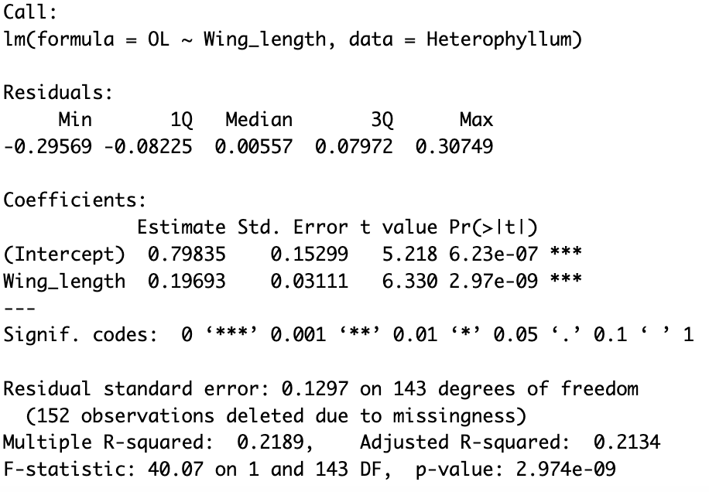
Call:
lm(formula = OL ~ Wing_length, data = Heterophyllum)

Residuals:
Min 1Q Median 3Q Max
-0.29569 -0.08225 0.00557 0.07972 0.30749

Coefficients:
Estimate Std. Error t value Pr(>|t|)
(Intercept) 0.79835 0.15299 5.218 6.23e-07 ***
Wing_length 0.19693 0.03111 6.330 2.97e-09 ***
---
Signif. codes: 0 ‘***’ 0.001 ‘**’ 0.01 ‘*’ 0.05 ‘.’ 0.1 ‘ ’ 1

Residual standard error: 0.1297 on 143 degrees of freedom
(152 observations deleted due to missingness)
Multiple R-squared: 0.2189, Adjusted R-squared: 0.2134
F-statistic: 40.07 on 1 and 143 DF, p-value: 2.974e-09
This output is the result of a linear regression analysis performed using the `lm()` function in R. It models the relationship between the dependent variable `OL` and the predictor variable `Wing_length` using data from the `Heterophyllum` dataset.

Let's break down the key components of this output:

### Residuals:
- These are the differences between the observed values and the predicted values by the model.
- Minimum (`Min`), first quartile (`1Q`), median (`Median`), third quartile (`3Q`), and maximum (`Max`) values of the residuals are shown.

### Coefficients:
- `Estimate`: These are the estimated coefficients for the intercept and the predictor variable `Wing_length`.
- `Std. Error`: Standard error estimates for the coefficients.
- `t value`: The t-statistic value for testing the null hypothesis that the coefficient is zero.
- `Pr(>|t|)`: The p-value associated with the t-statistic, indicating the significance of each coefficient.

### Residual standard error:
- This is an estimate of the standard deviation of the residuals.
- It represents the average distance of data points from the fitted regression line.
- In this case, it's 0.1297.

### Degrees of freedom and Model summary:
- `Multiple R-squared`: The proportion of variance in the dependent variable (`OL`) explained by the independent variable (`Wing_length`). Here, it's 0.2189, indicating that about 21.89% of the variance in `OL` is explained by `Wing_length`.
- `Adjusted R-squared`: A modified version of R-squared that penalizes additional predictors.
- `F-statistic`: A test statistic for the overall significance of the model.
- `p-value`: The significance level associated with the F-statistic. In this case, it's very low (`2.974e-09`), indicating that the model is highly significant in explaining the variation in `OL`.

### Interpretation:
- `Wing_length` has a statistically significant positive association with `OL`, as indicated by its very low p-value (`2.974e-09` and `***`).
- The intercept is statistically significant as well.
- The model as a whole is statistically significant, explaining about 21.89% of the variance in `OL`.

This output suggests that `Wing_length` is significantly associated with `OL`, and the model using `Wing_length` as the predictor variable is highly significant in explaining the variation observed in `OL`, although it explains a relatively moderate proportion of the variance in `OL` (21.89%).
Result (20%):
In text

Result (20%):
Figures/Tables

Conclusion (20%):
Interpretation

Code (10%):
Documentation/comments

