Consider a fish population that grows according to the provided equation,

where r and K are positive constants.

*2a) What is the (non-trivial) equilibrium population size? (1p)*

I solved question 2a by solving equation dn/dt mathematically by assigning dn/dt = 0 and rearranging the equation.

Figure 1. Answer for question 2a.

*2b) Show that it is a stable equilibrium. (1p)*

To analyse the stability, I computed the derivative of the function dn/dt at the equilibrium by solving d’n/dt’ = 0. I used product rule to further solve the derivative.

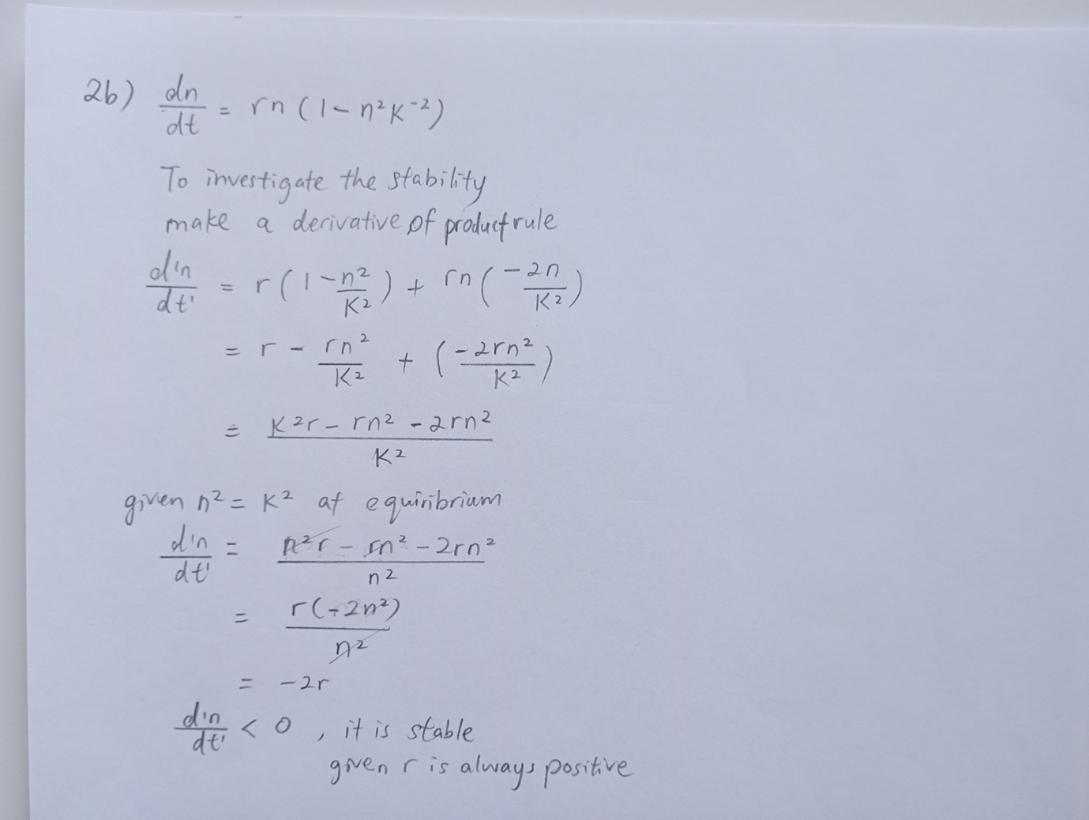

Figure 2. Answer for question 2b.

*Now assume the population is harvested, such that a proportion h is harvested per time unit.*

*2c) Add the harvesting to the population dynamic model! (1p)*

The introduction of harvesting at a rate *hn* modifies the population growth equation. I subtracted the harvesting *hn* from the total population growth rate. The modified equation becomes:

Figure 3. Answer for question 2c.

*2d) Where is the new equilibrium population size? (1p)*

I solved 2d equilibrium points by solving dn/dt = 0.

**

*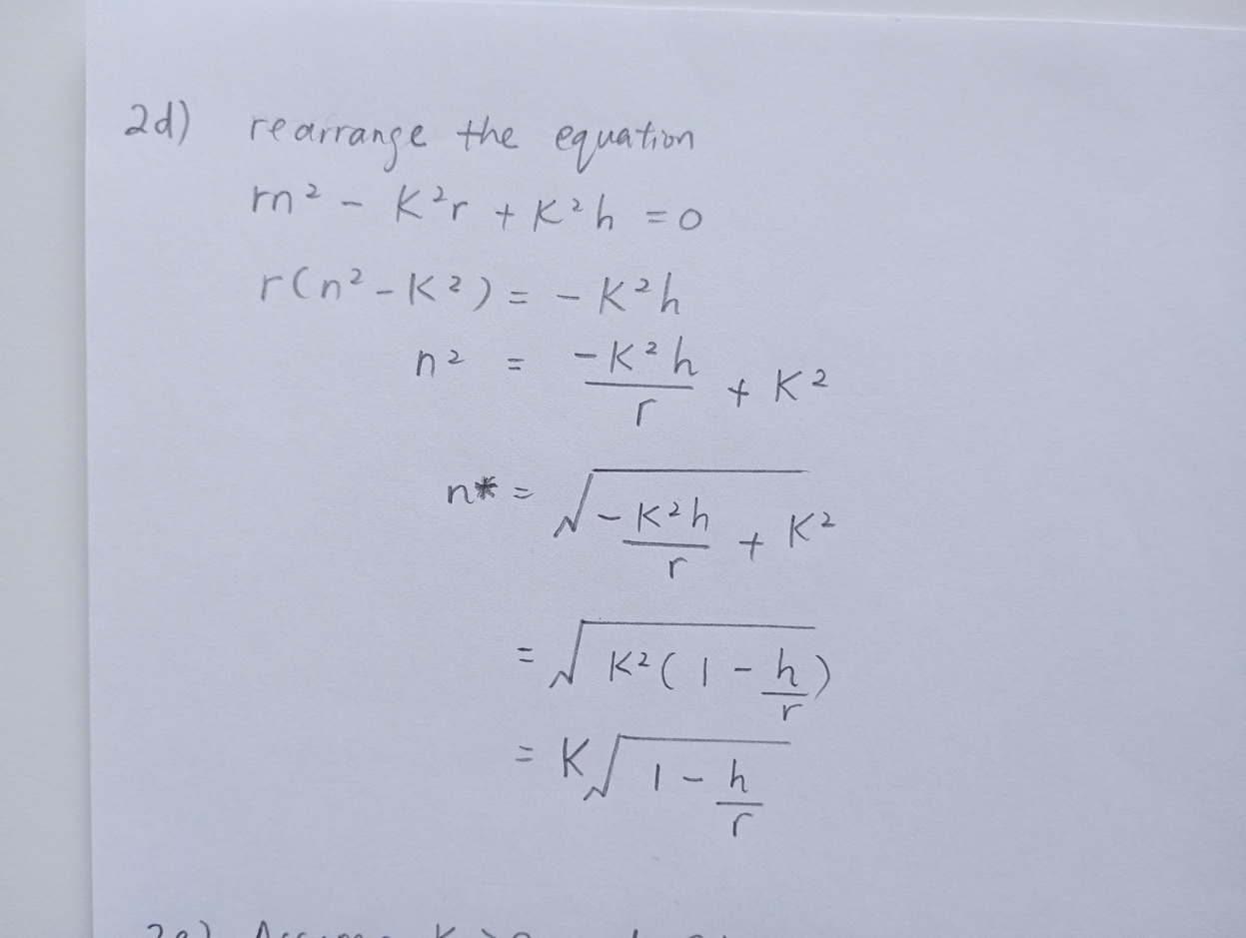*

Figure 4. Answer for question 2d.

*2e) At what harvest rate does the population go extinct? (1p)*

As long as 𝑛∗>0 we can assume the population will not go extinct.

**

Figure 5. Answer for question 2e.

*f) At what harvest rate is the yield, i.e. the total number of harvested individuals, maximized? (1p)*

I solved 2f by defining the yield, the hn\*, at equilibrium becomes 0. I used product rule to mathematically solve the derivative.

*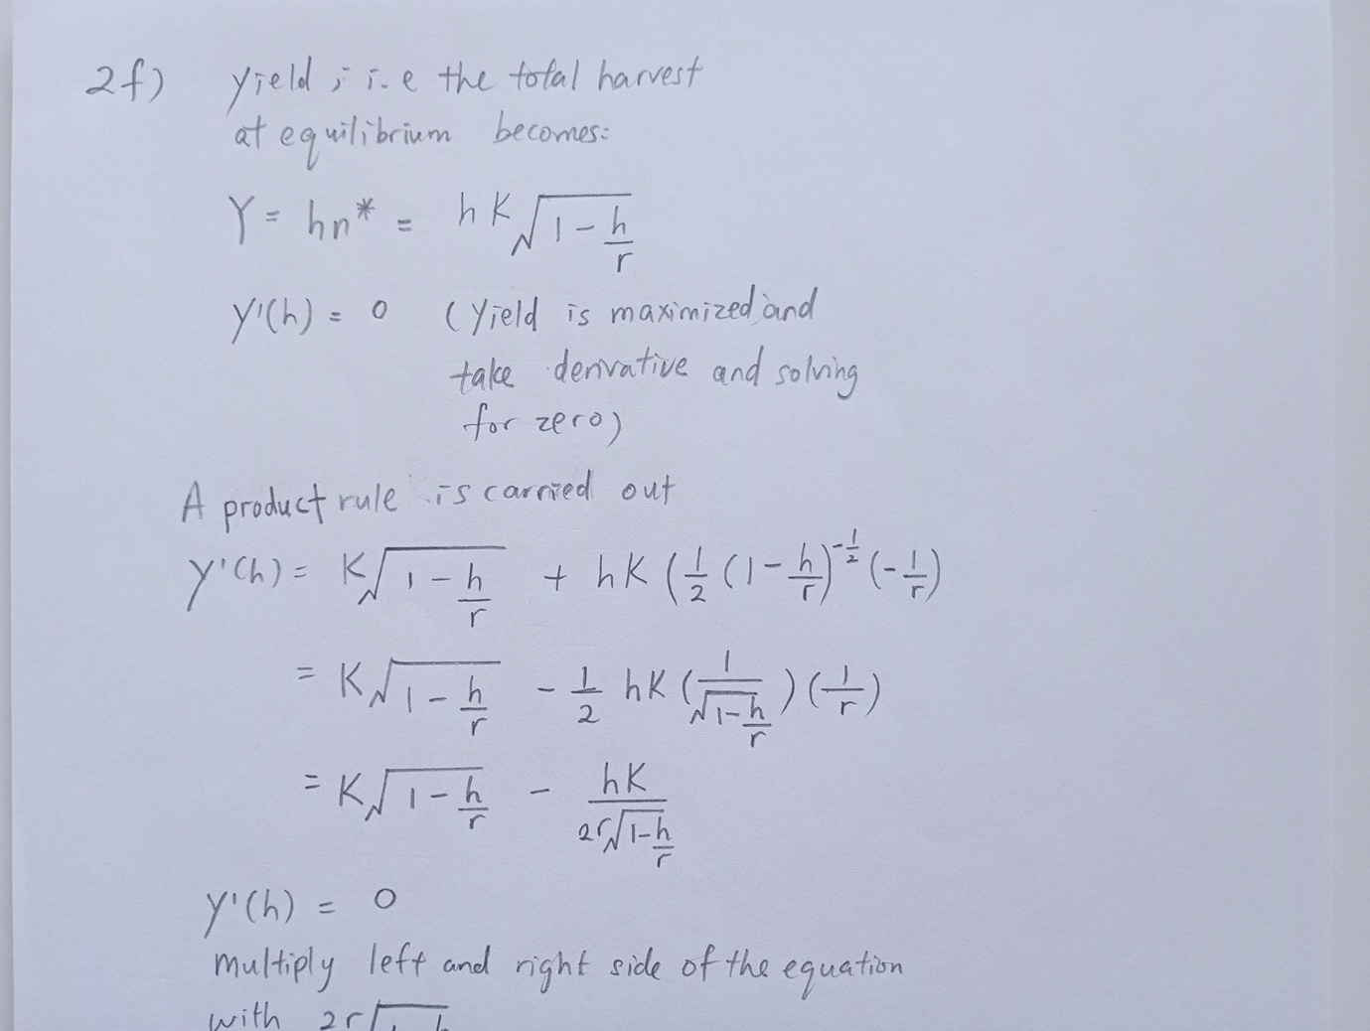*

Figure 6a. Answer for question 2f, see more on the next page.

**

Figure 6b. Answer for question 2f