COMP 3123 – Full Stack Development I
Assignment 1 – Backend
Secure Employee Management REST API – Test Screenshots
Hooman Abedi
Student #101570367
GitHub repository | https://github.com/hooman-abedi/101570367_COMP3123_Assignment1
Deployed API (Vercel) | https://101570367-comp-3123-assignment1.vercel.app
Local base URL | http://localhost:3000
Database | MongoDB Atlas – comp3123_assignment1
Test users | userA / usera@example.com / Password123 | userB / userb@example.com / Password123
Testing tool | Postman (collection in postman/ folder of the repository)

1. Health Check & Security Headers

1.1 Health check – 200 OK
GET /health returns status "ok", uptime, timestamp and "database": "connected".
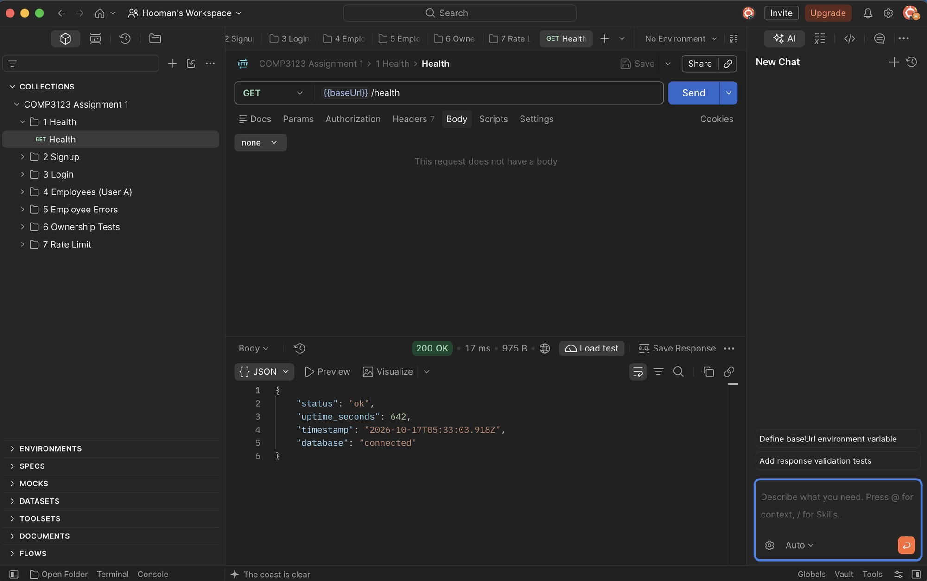

1.2 Helmet security headers
Response headers added by Helmet (Content-Security-Policy, X-Content-Type-Options, Strict-Transport-Security, etc.).
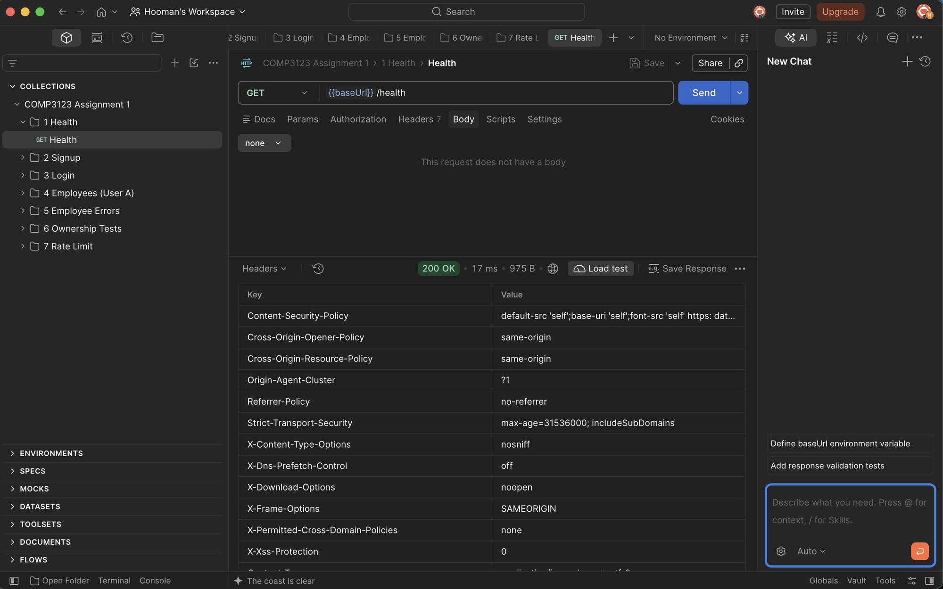

2. User Signup

2.1 Signup – User A (201 Created)
POST /api/v1/user/signup with valid data. The password is not returned in the response.
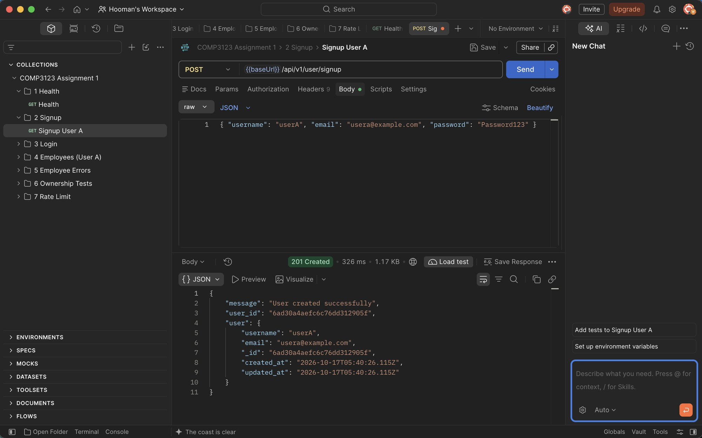

2.2 Signup – User B (201 Created)
Second test user created for the ownership tests.
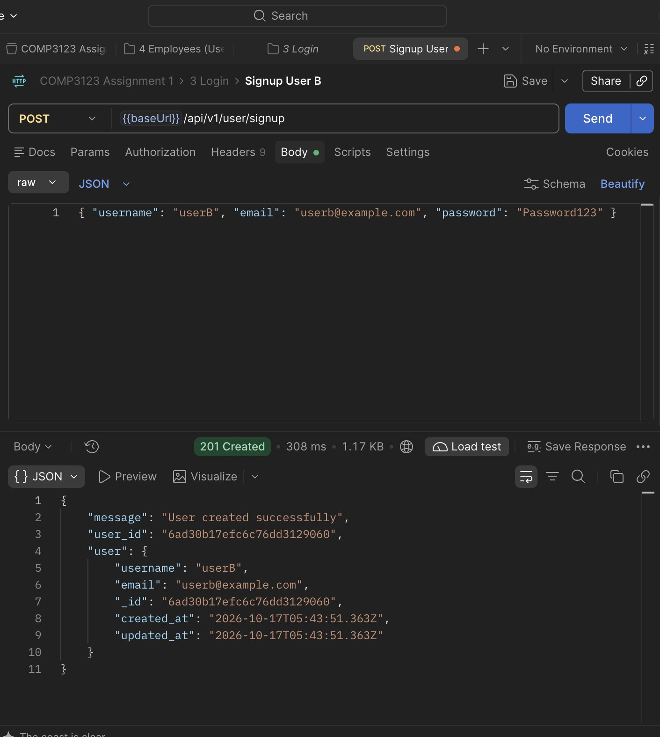

2.3 Signup – Duplicate username (409 Conflict)
Registering an existing username is rejected.
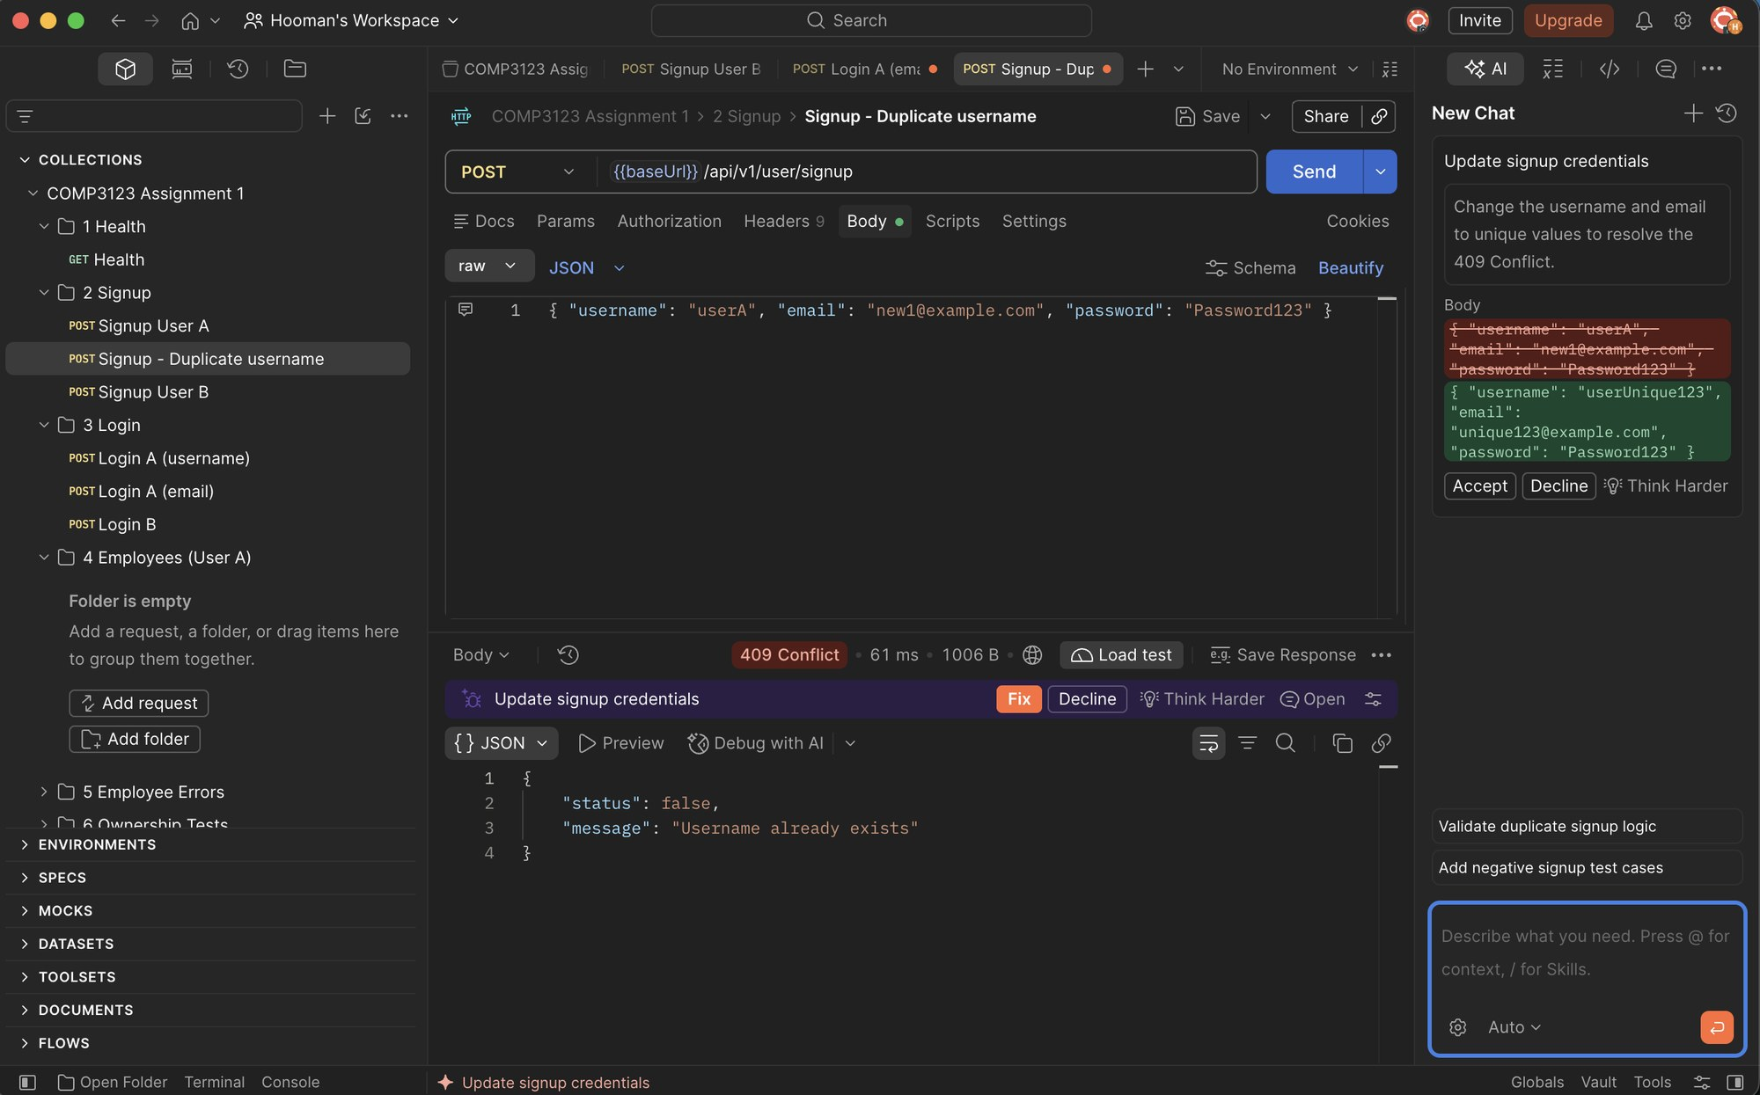

2.4 Signup – Duplicate email (409 Conflict)
Registering an existing email is rejected.
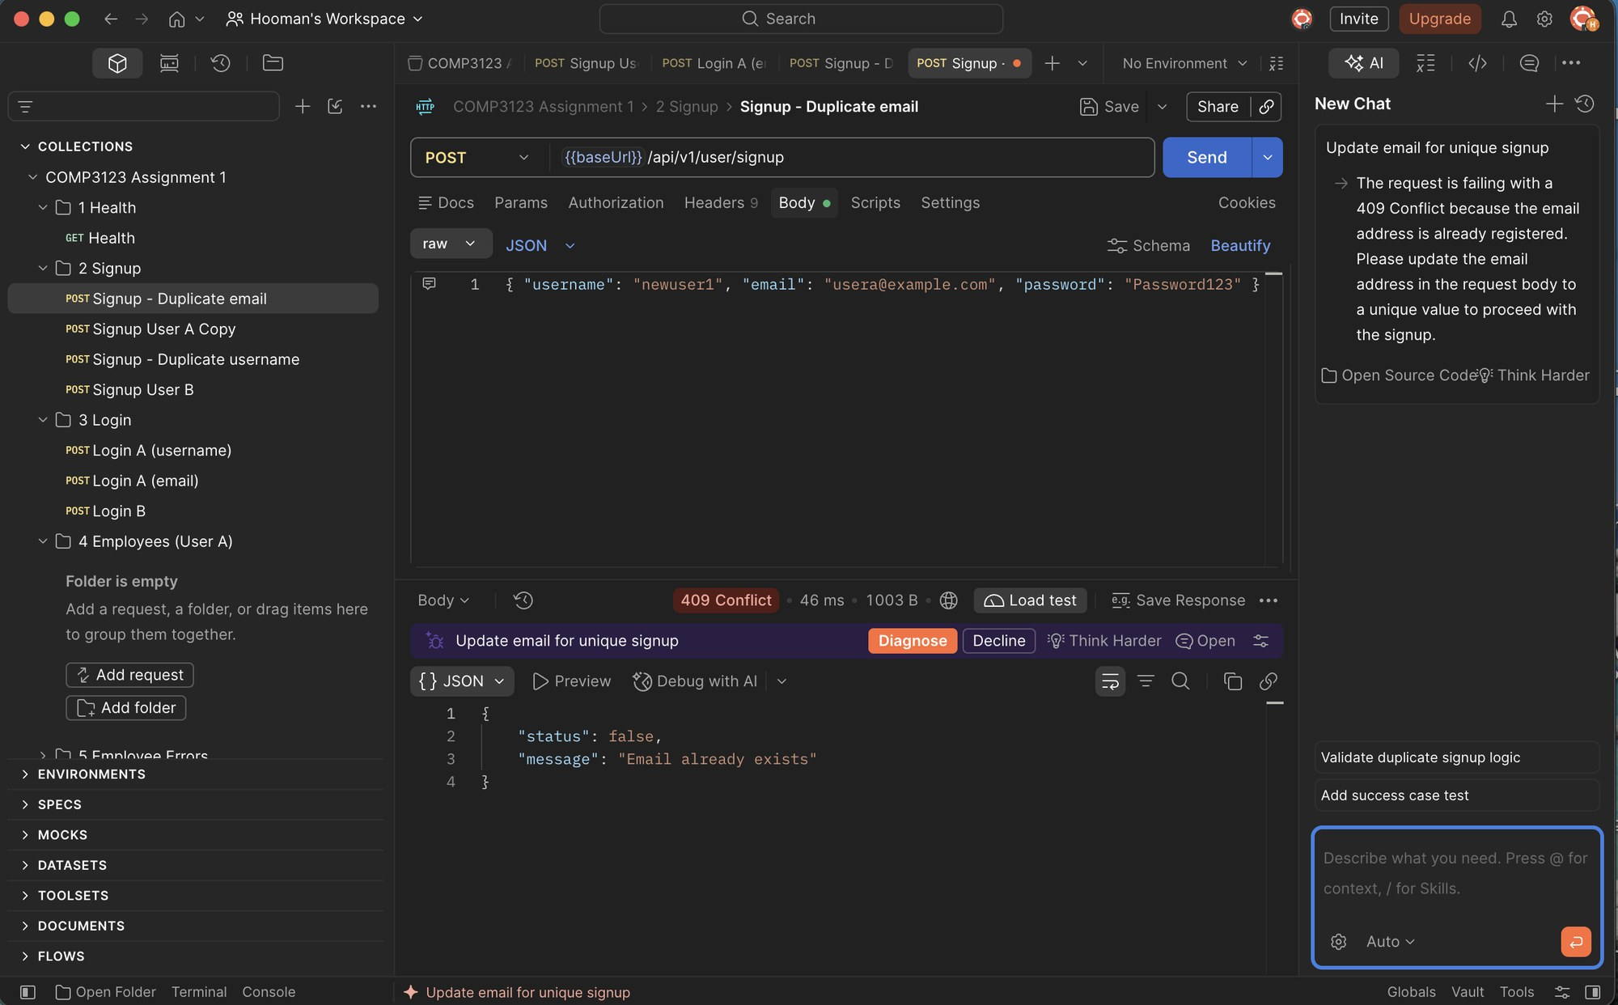

2.5 Signup – Invalid email (400 Bad Request)
Email format validation.
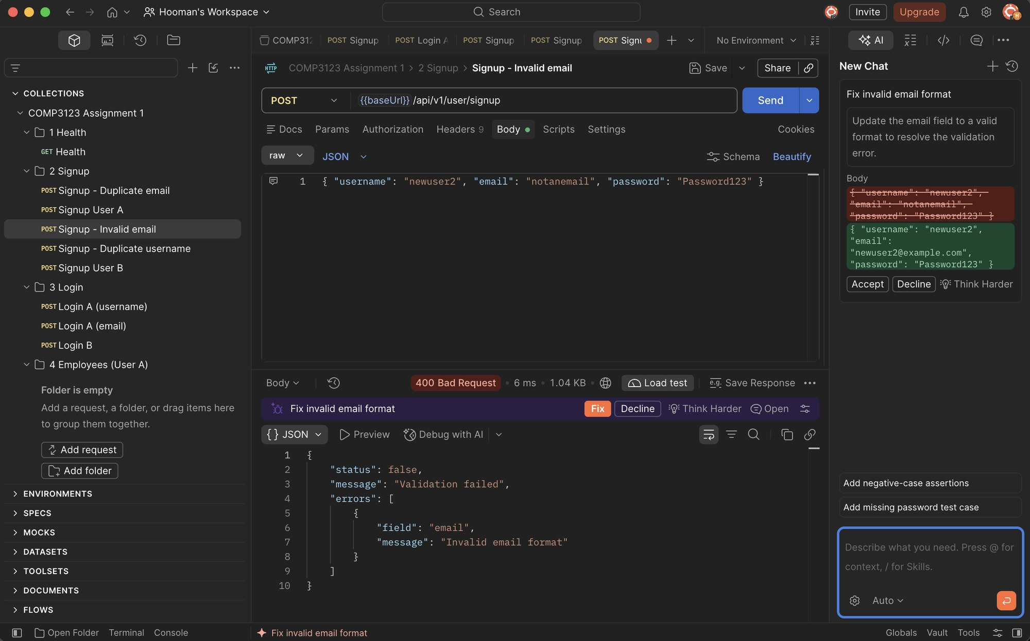

2.6 Signup – Invalid password (400 Bad Request)
Password must be 8–64 characters with uppercase, lowercase and a number.
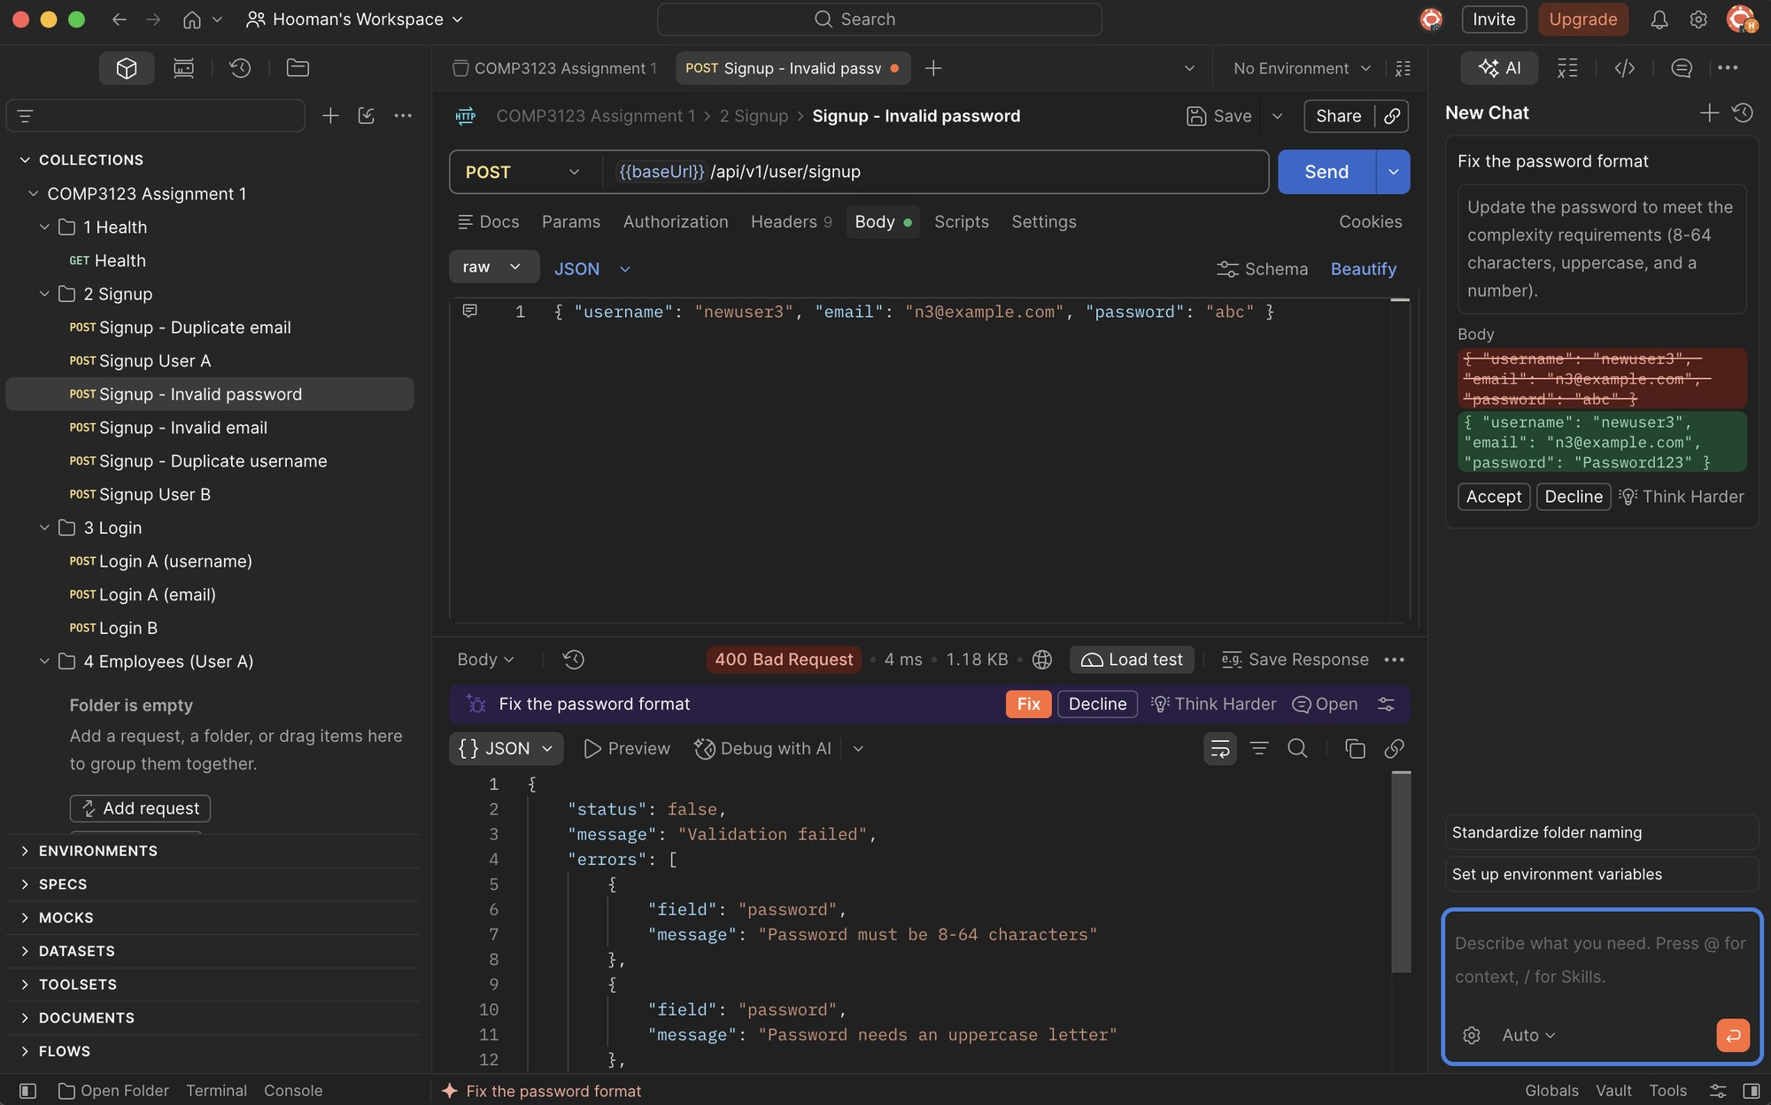

2.7 Signup – Missing fields (400 Bad Request)
Empty body returns validation errors for username, email and password.
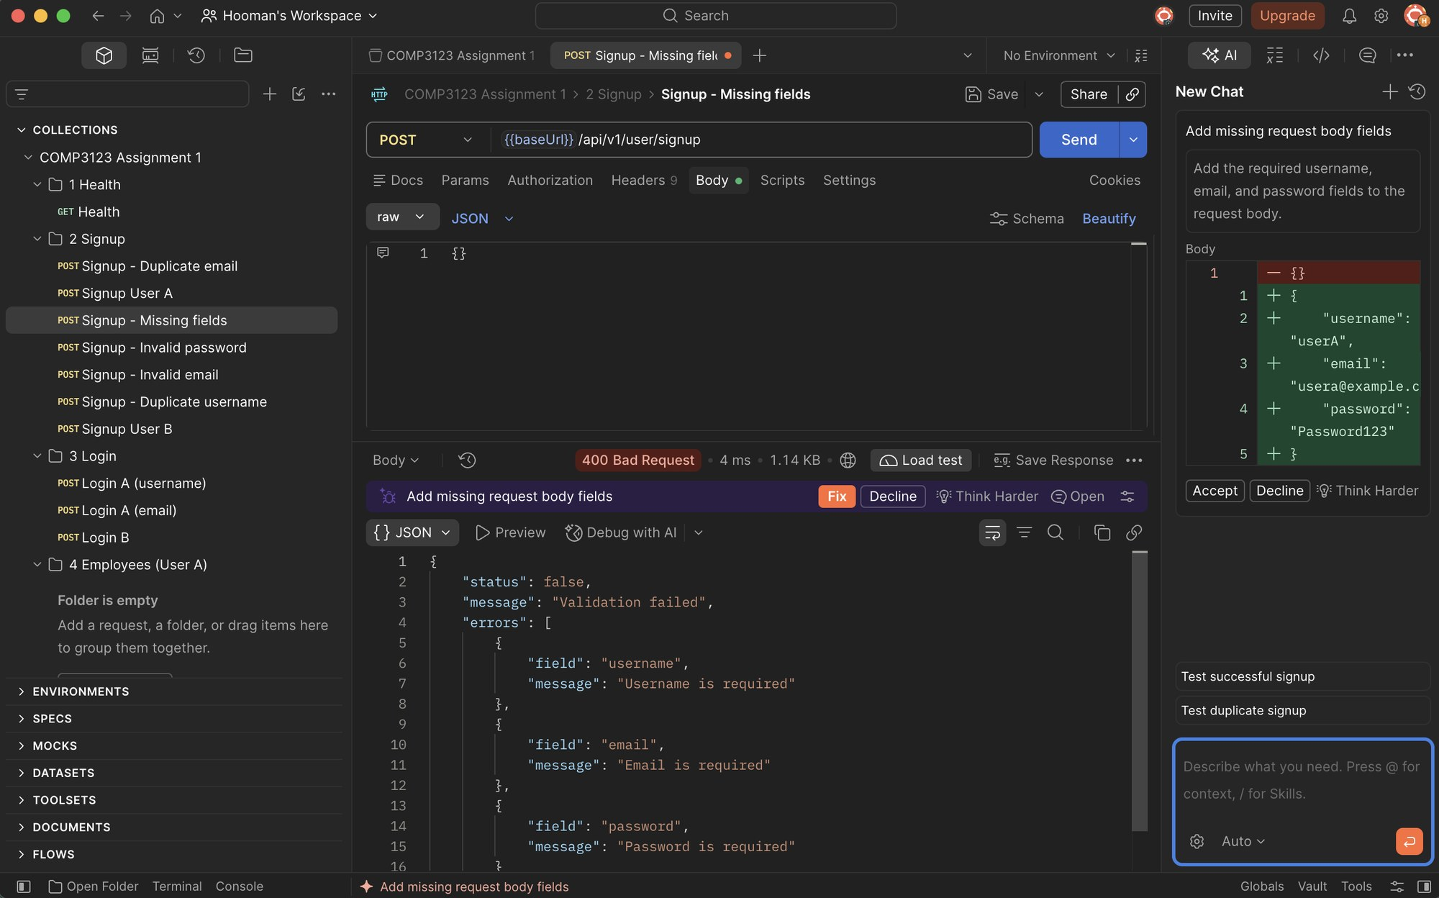

3. User Login & JWT

3.1 Login – User A with username (200 OK)
POST /api/v1/user/login with username + password returns a JWT.
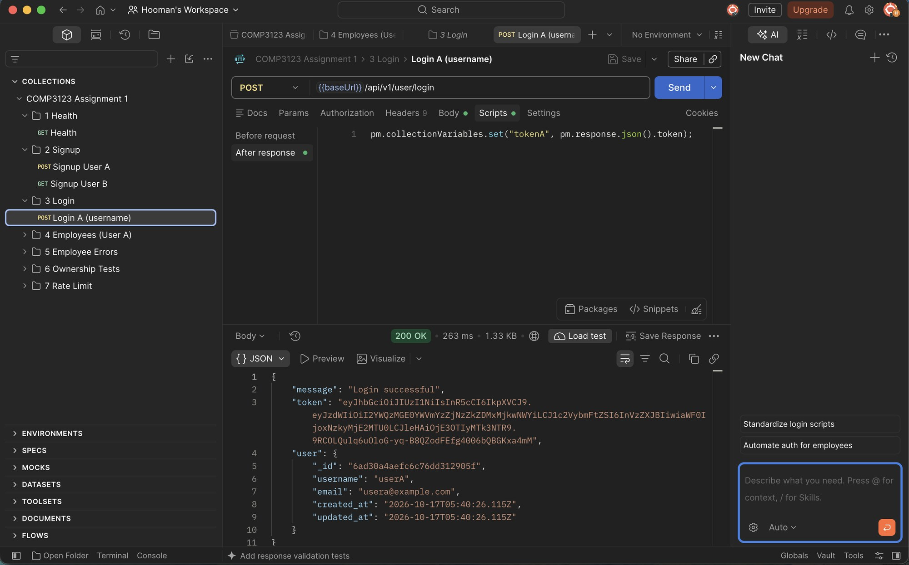

3.2 Login – User A with email (200 OK)
Login also works with email + password.
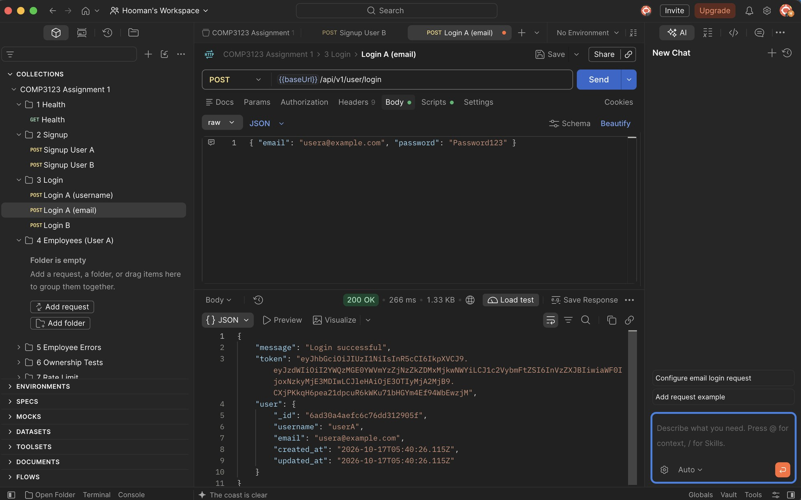

3.3 Login – User B (200 OK)
User B receives their own JWT.
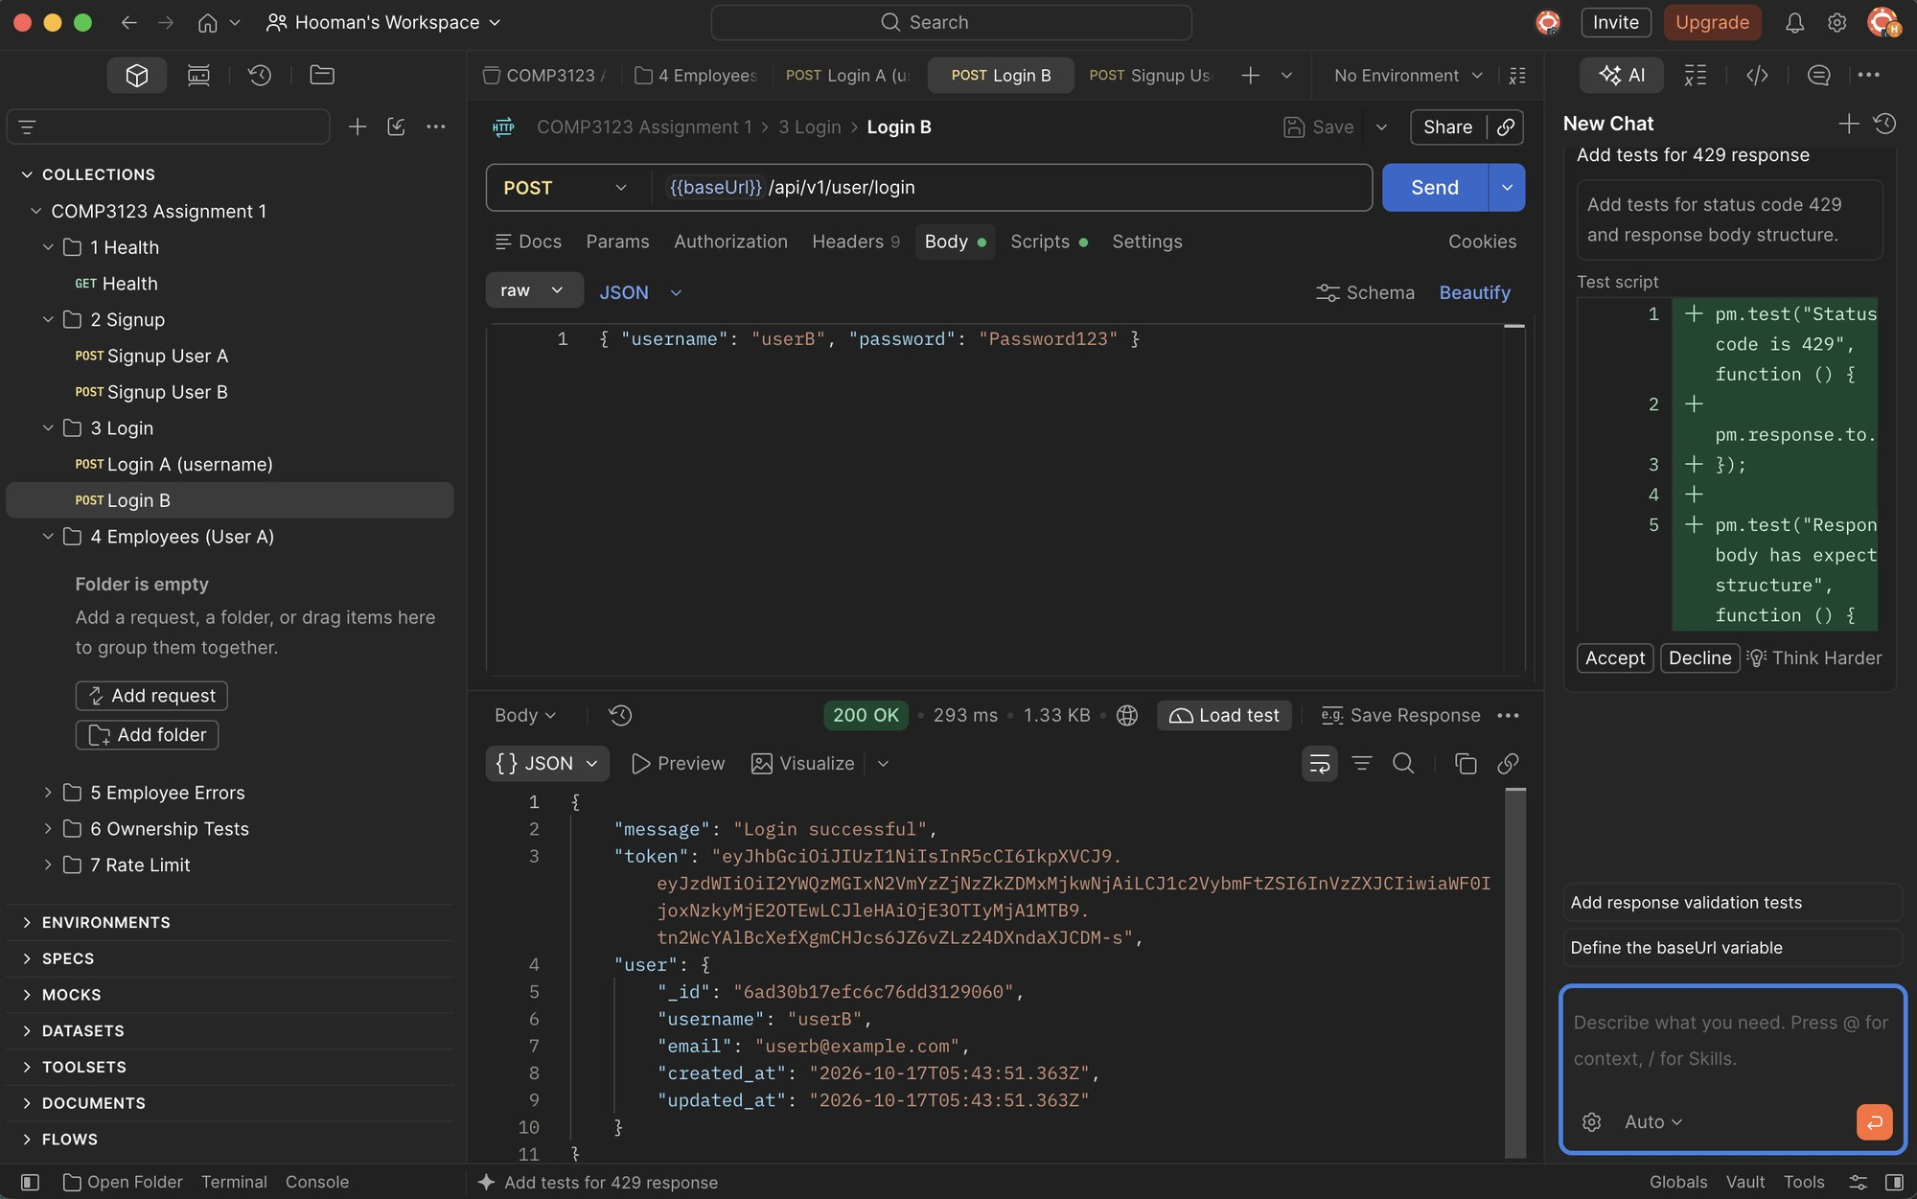

3.4 Login – Wrong password (401 Unauthorized)
Invalid credentials return a generic message that does not reveal whether the username exists.
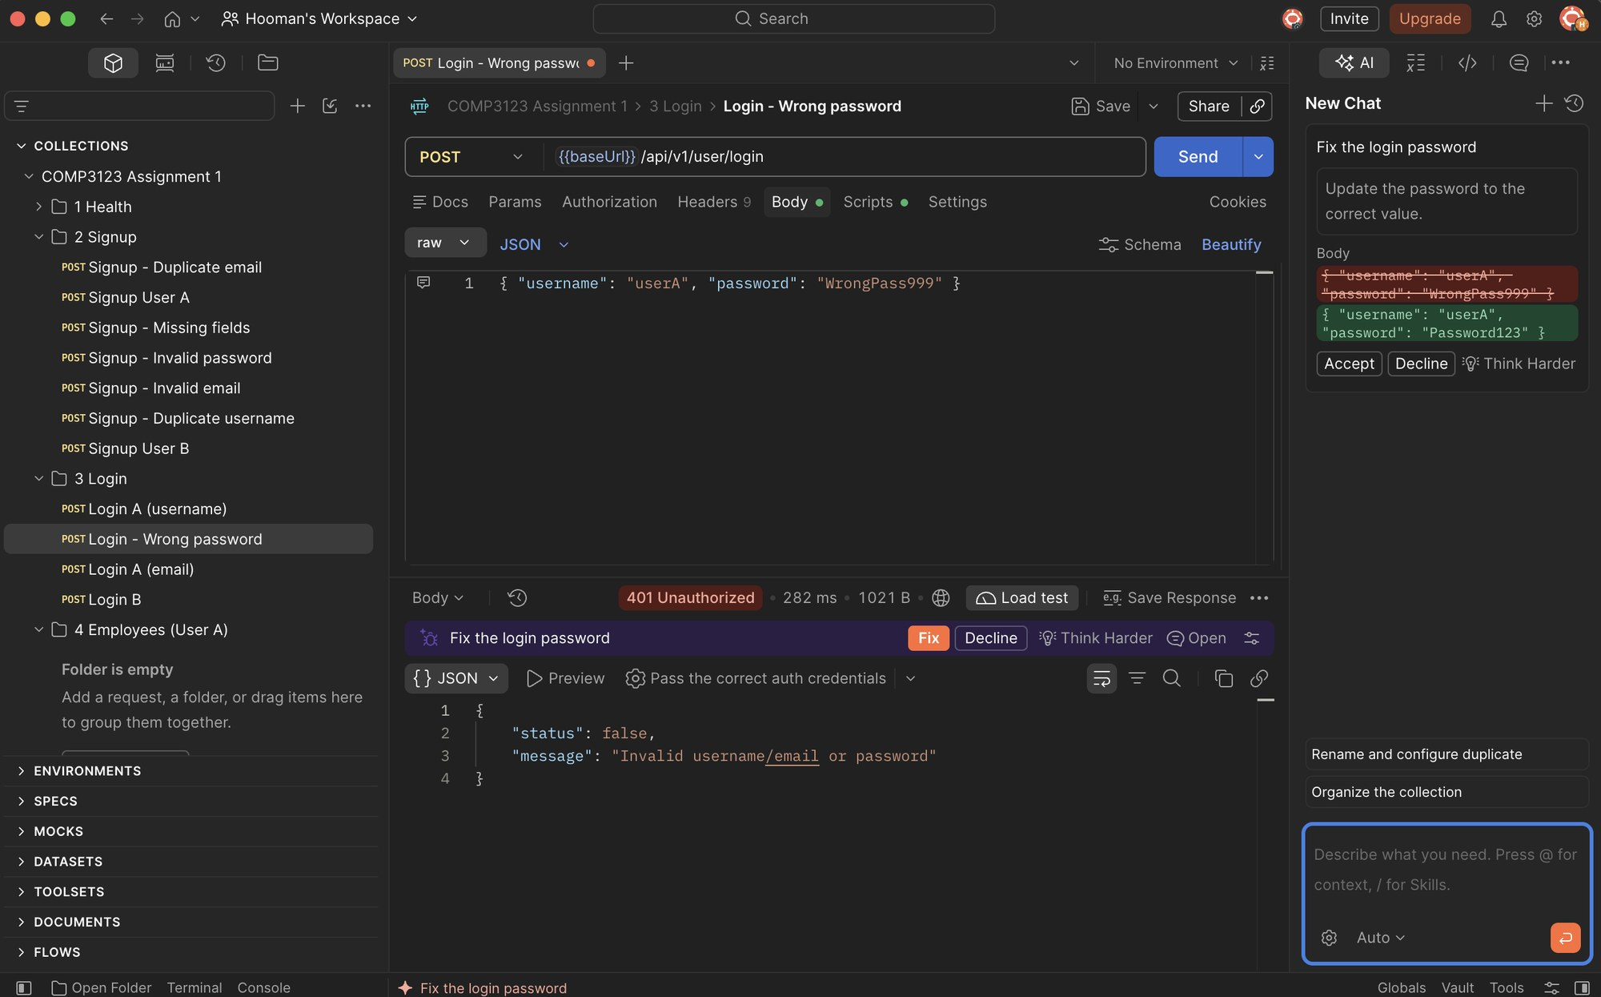

3.5 Login – Missing credentials (400 Bad Request)
Username/email and password are required.
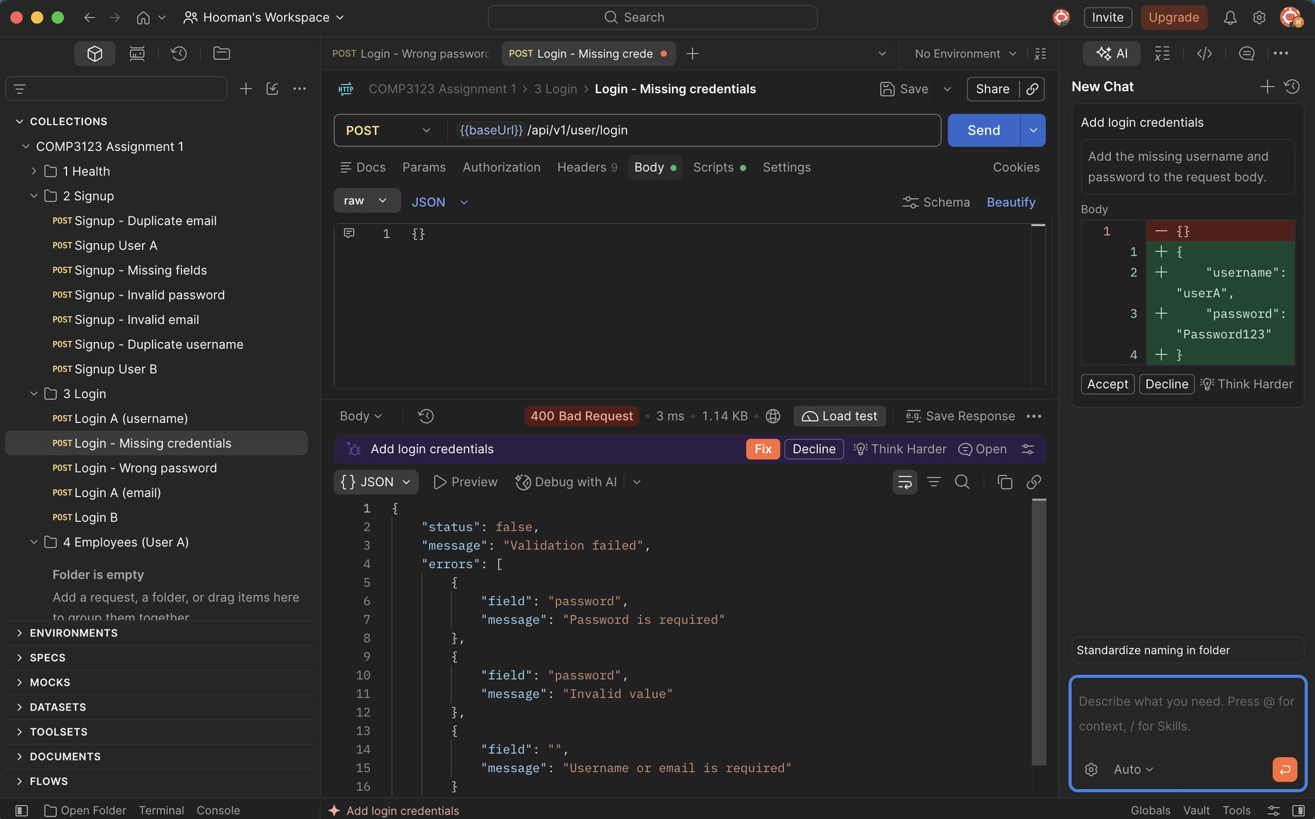

4. Employee CRUD (User A)

4.1 Create employee (201 Created)
POST /api/v1/emp/employees with Bearer token. The owner (user) is taken from the JWT.
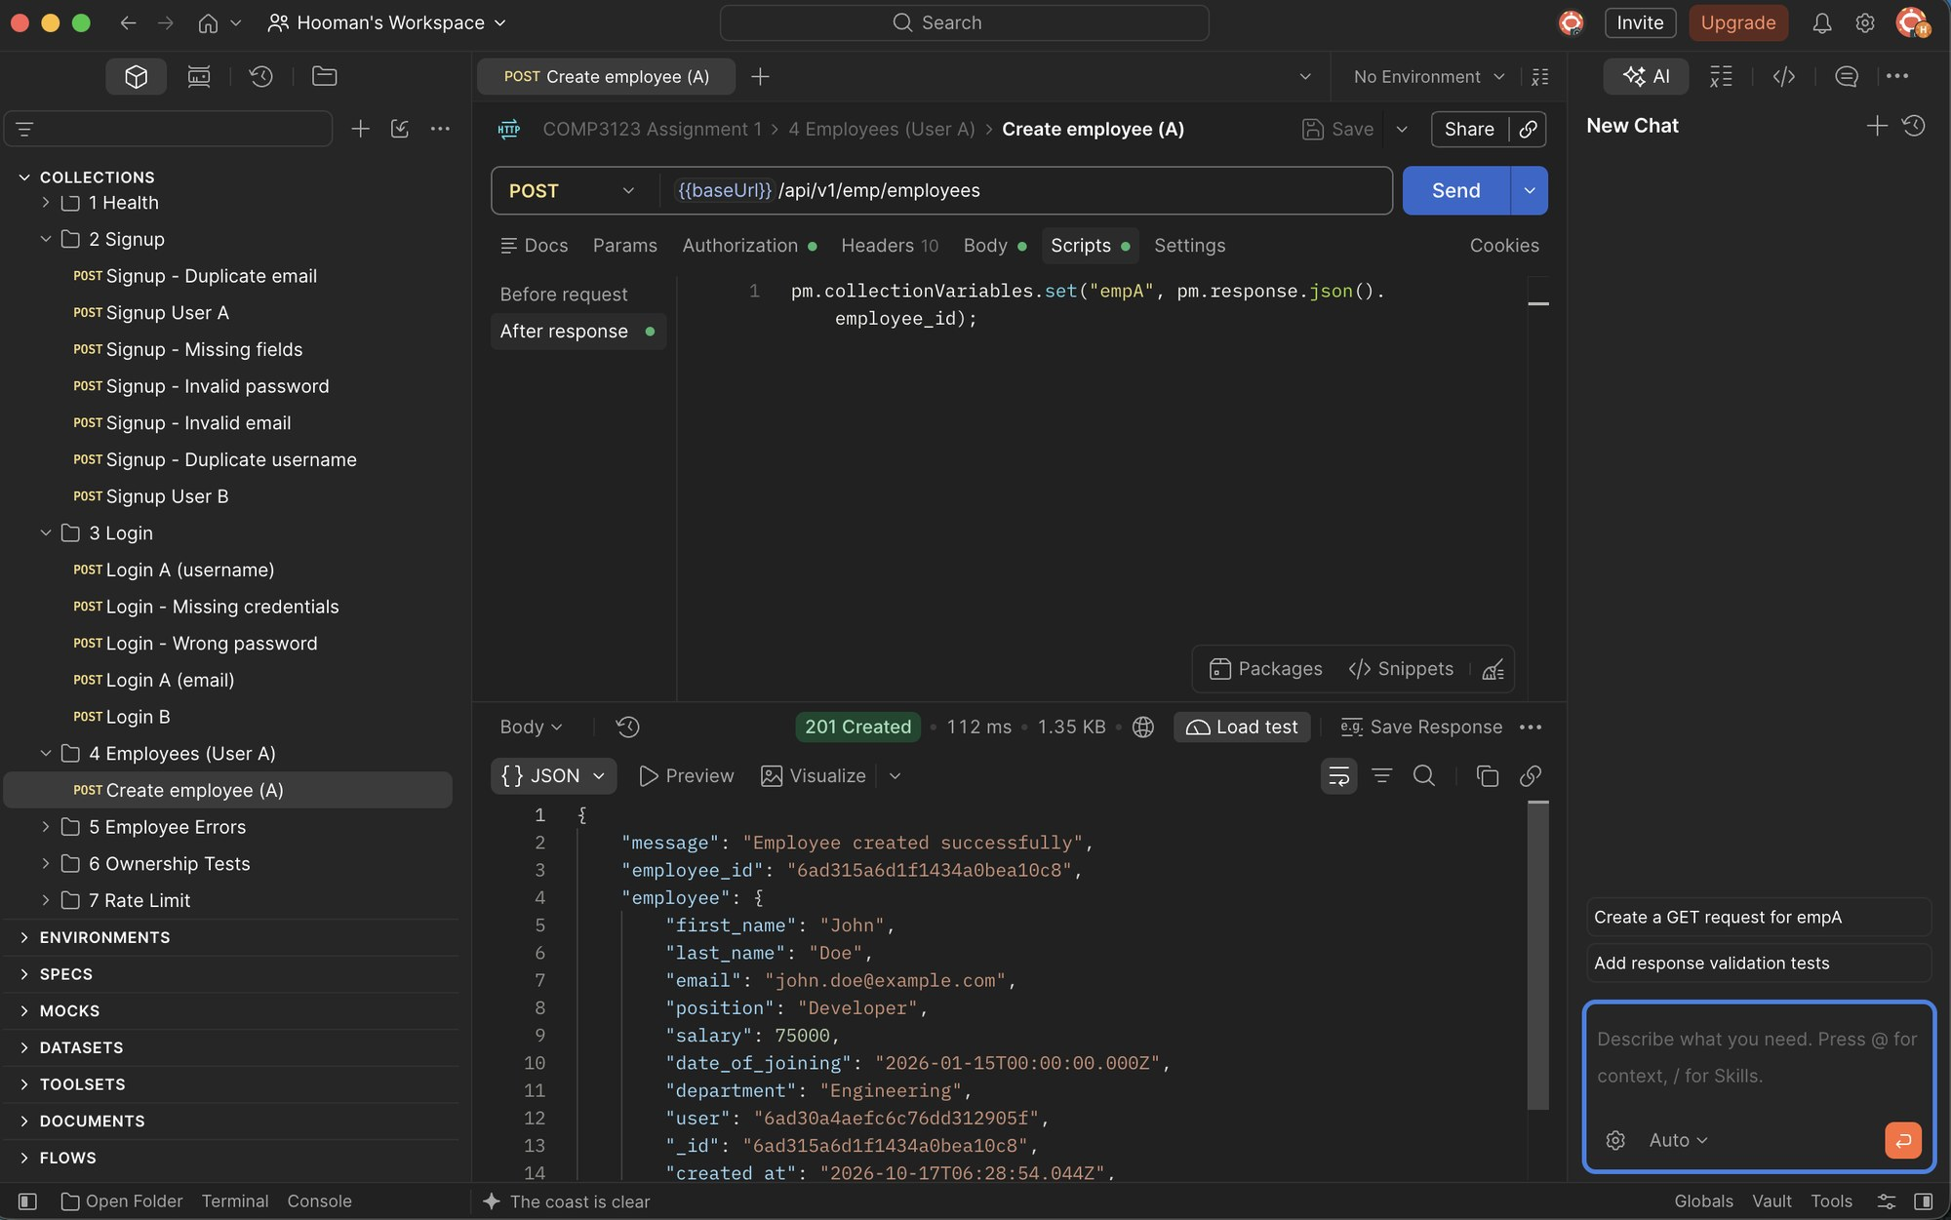

4.2 Get all employees (200 OK)
GET /api/v1/emp/employees returns only the authenticated user's employees.
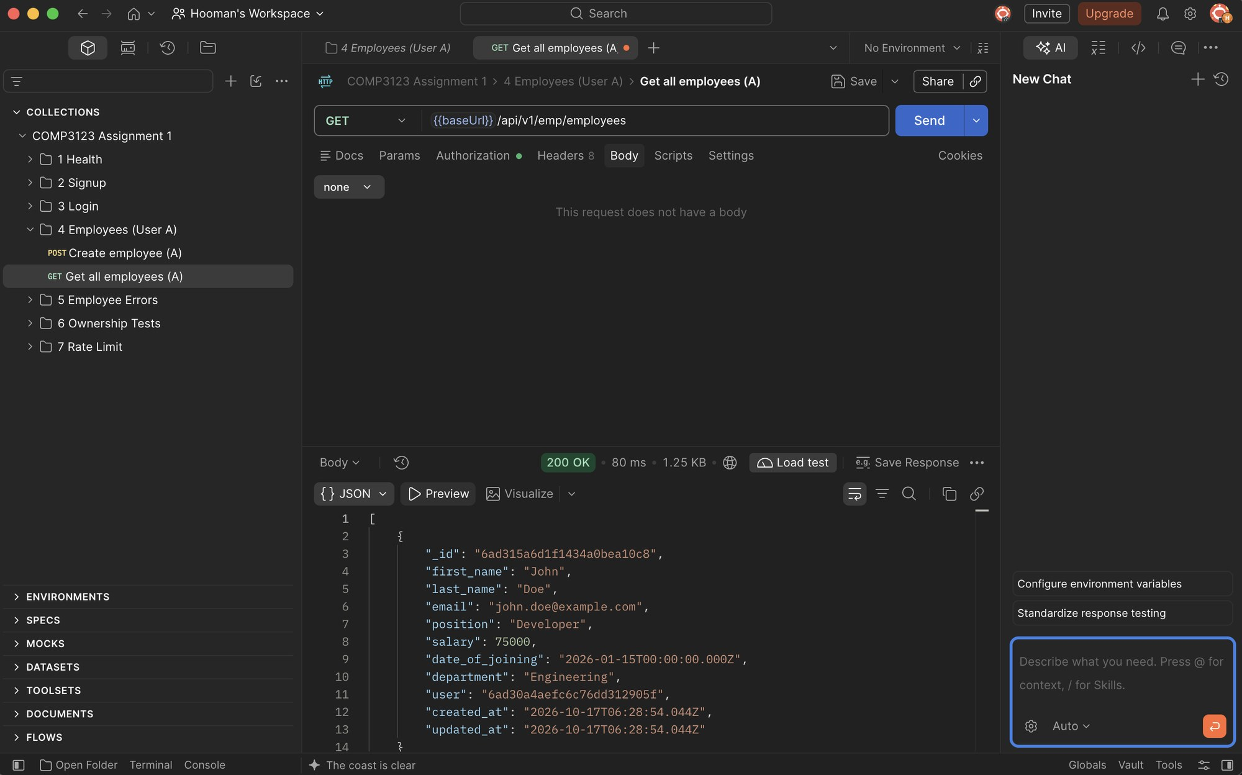

4.3 Get employee by ID (200 OK)
GET /api/v1/emp/employees/{eid}.
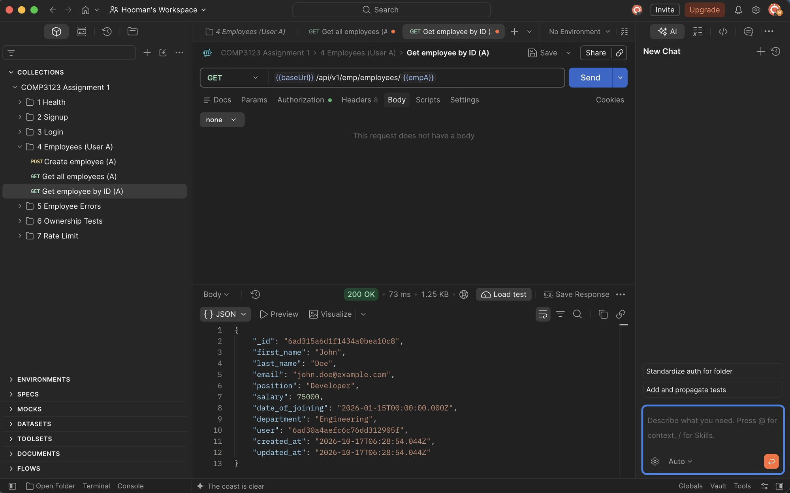

4.4 Update employee (200 OK)
PUT /api/v1/emp/employees/{eid} updates salary and position.
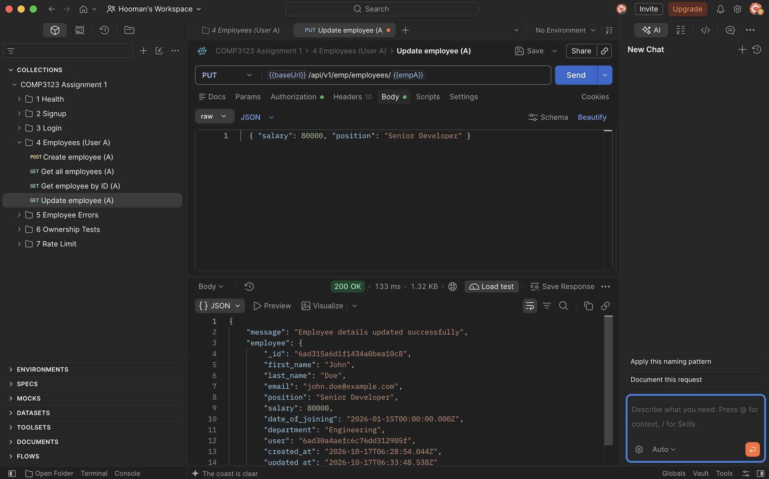

4.5 Delete employee (204 No Content)
DELETE /api/v1/emp/employees?eid={eid} deletes the employee and returns no body.
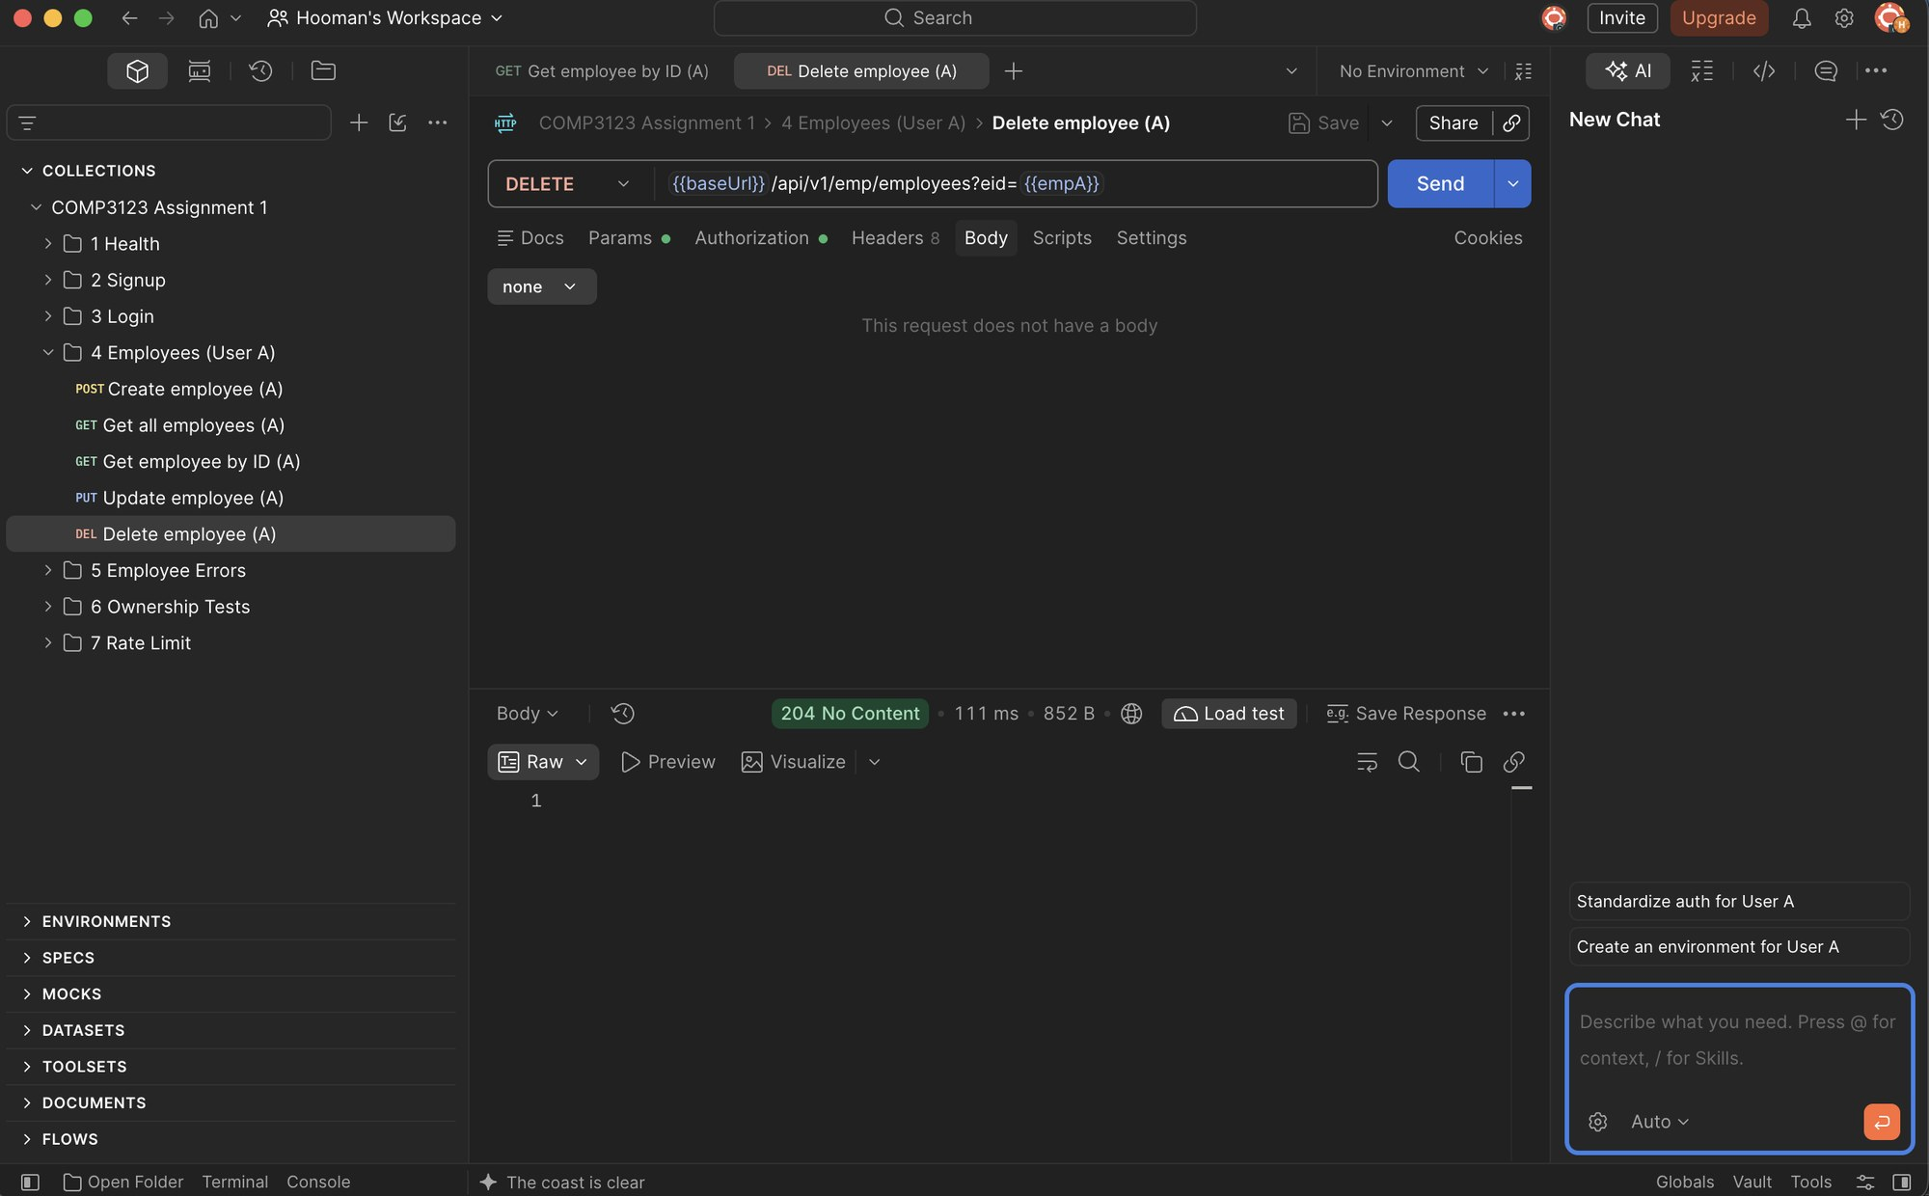

4.6 Get deleted employee (404 Not Found)
The deleted employee no longer exists.
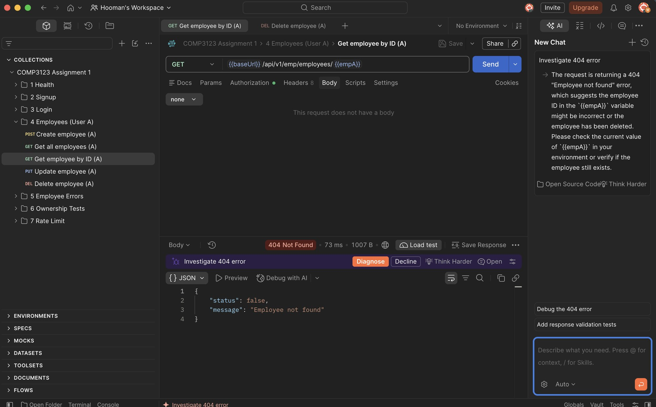

5. Input Validation & Error Handling

5.1 Create employee – Missing fields (400)
All required employee fields are validated.
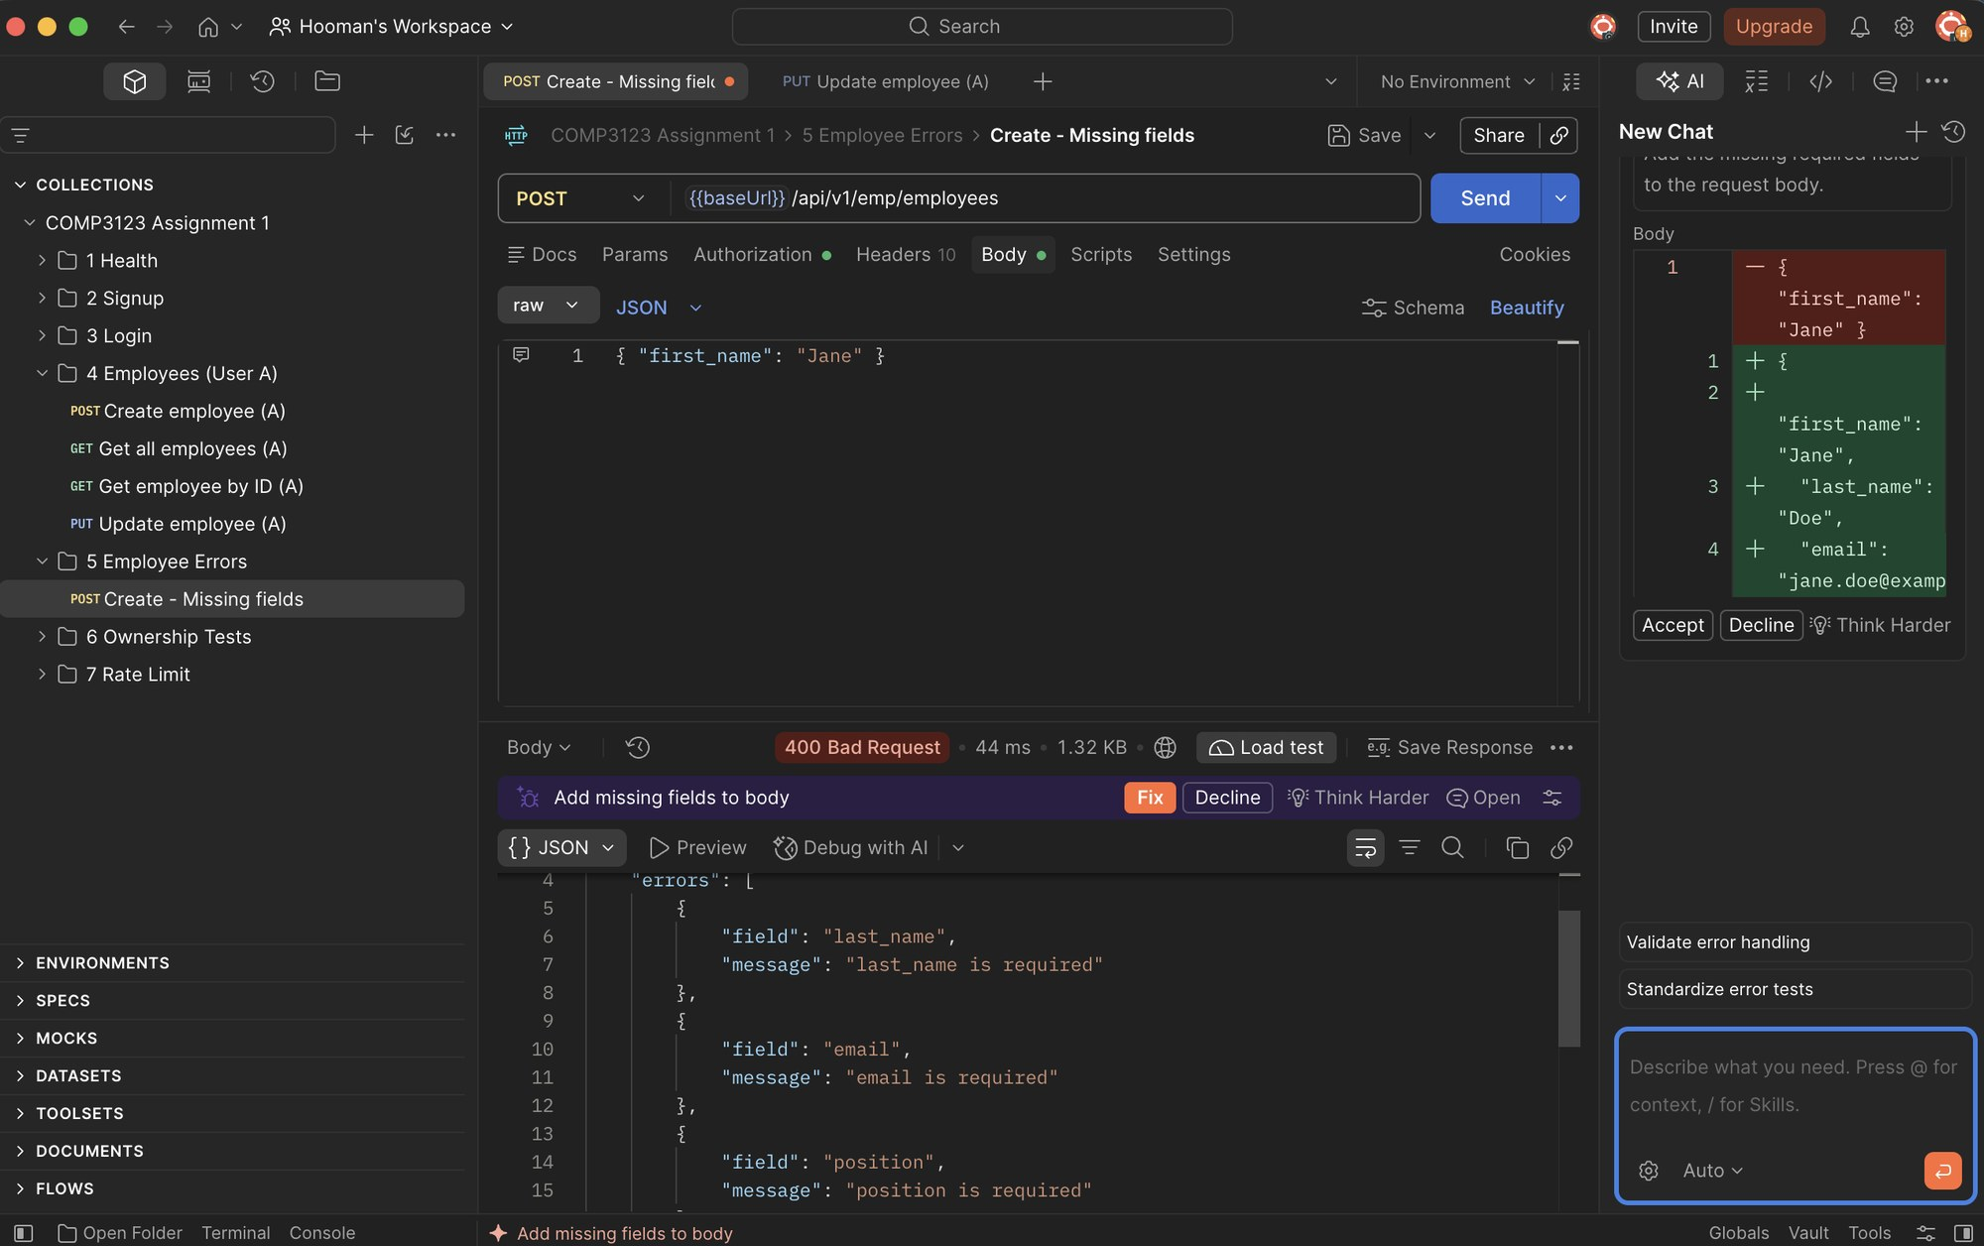

5.2 Create employee – Invalid email (400)
Employee email format validation.
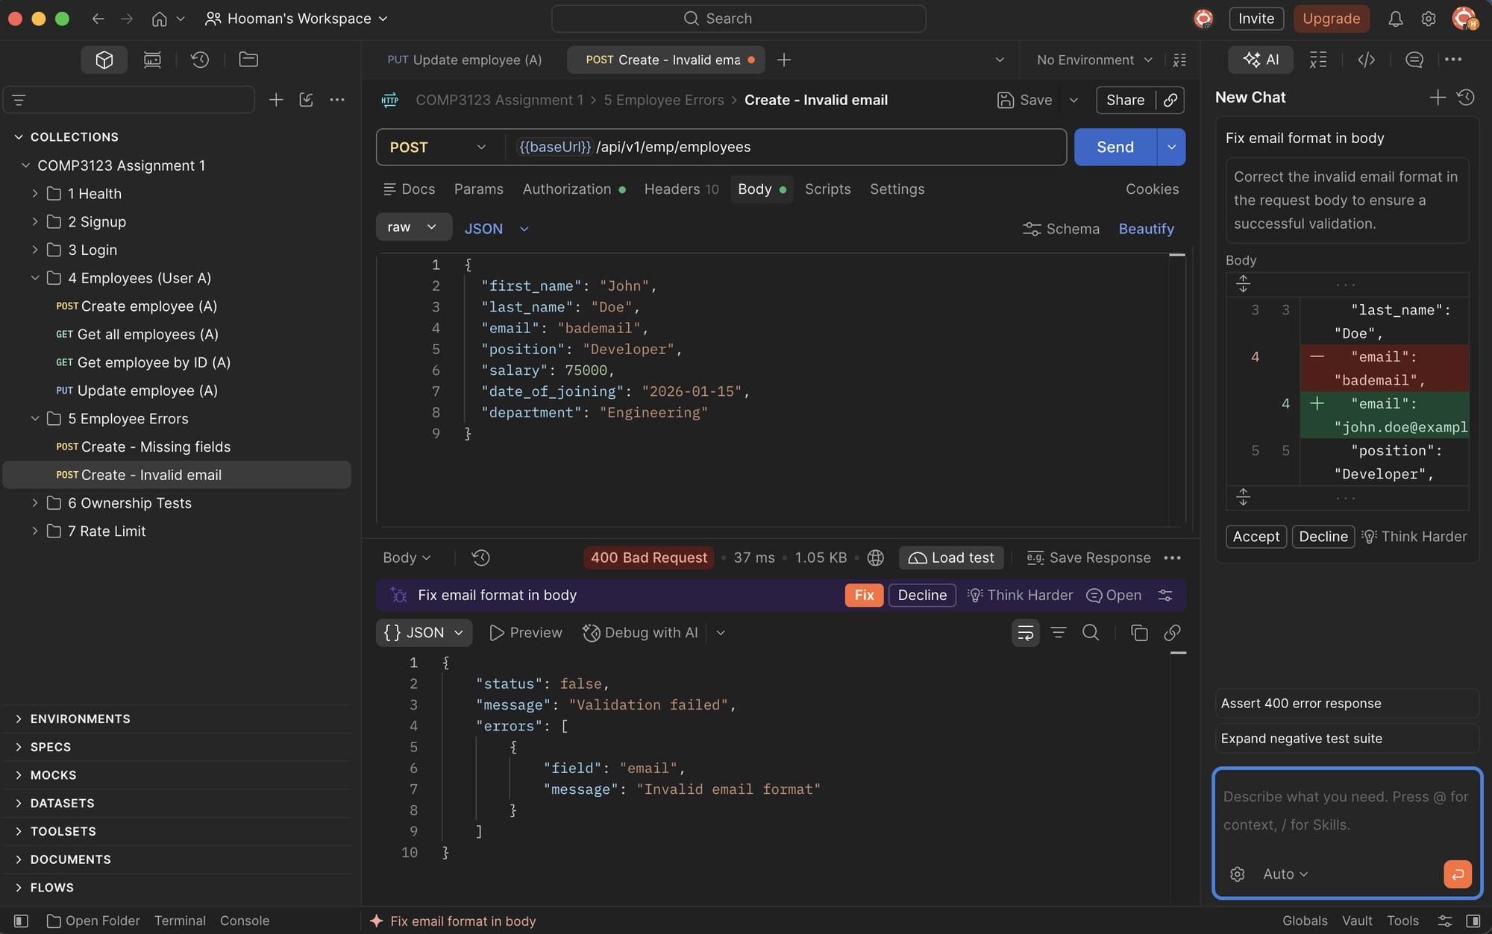

5.3 Create employee – Invalid salary (400)
Salary must be a positive number.
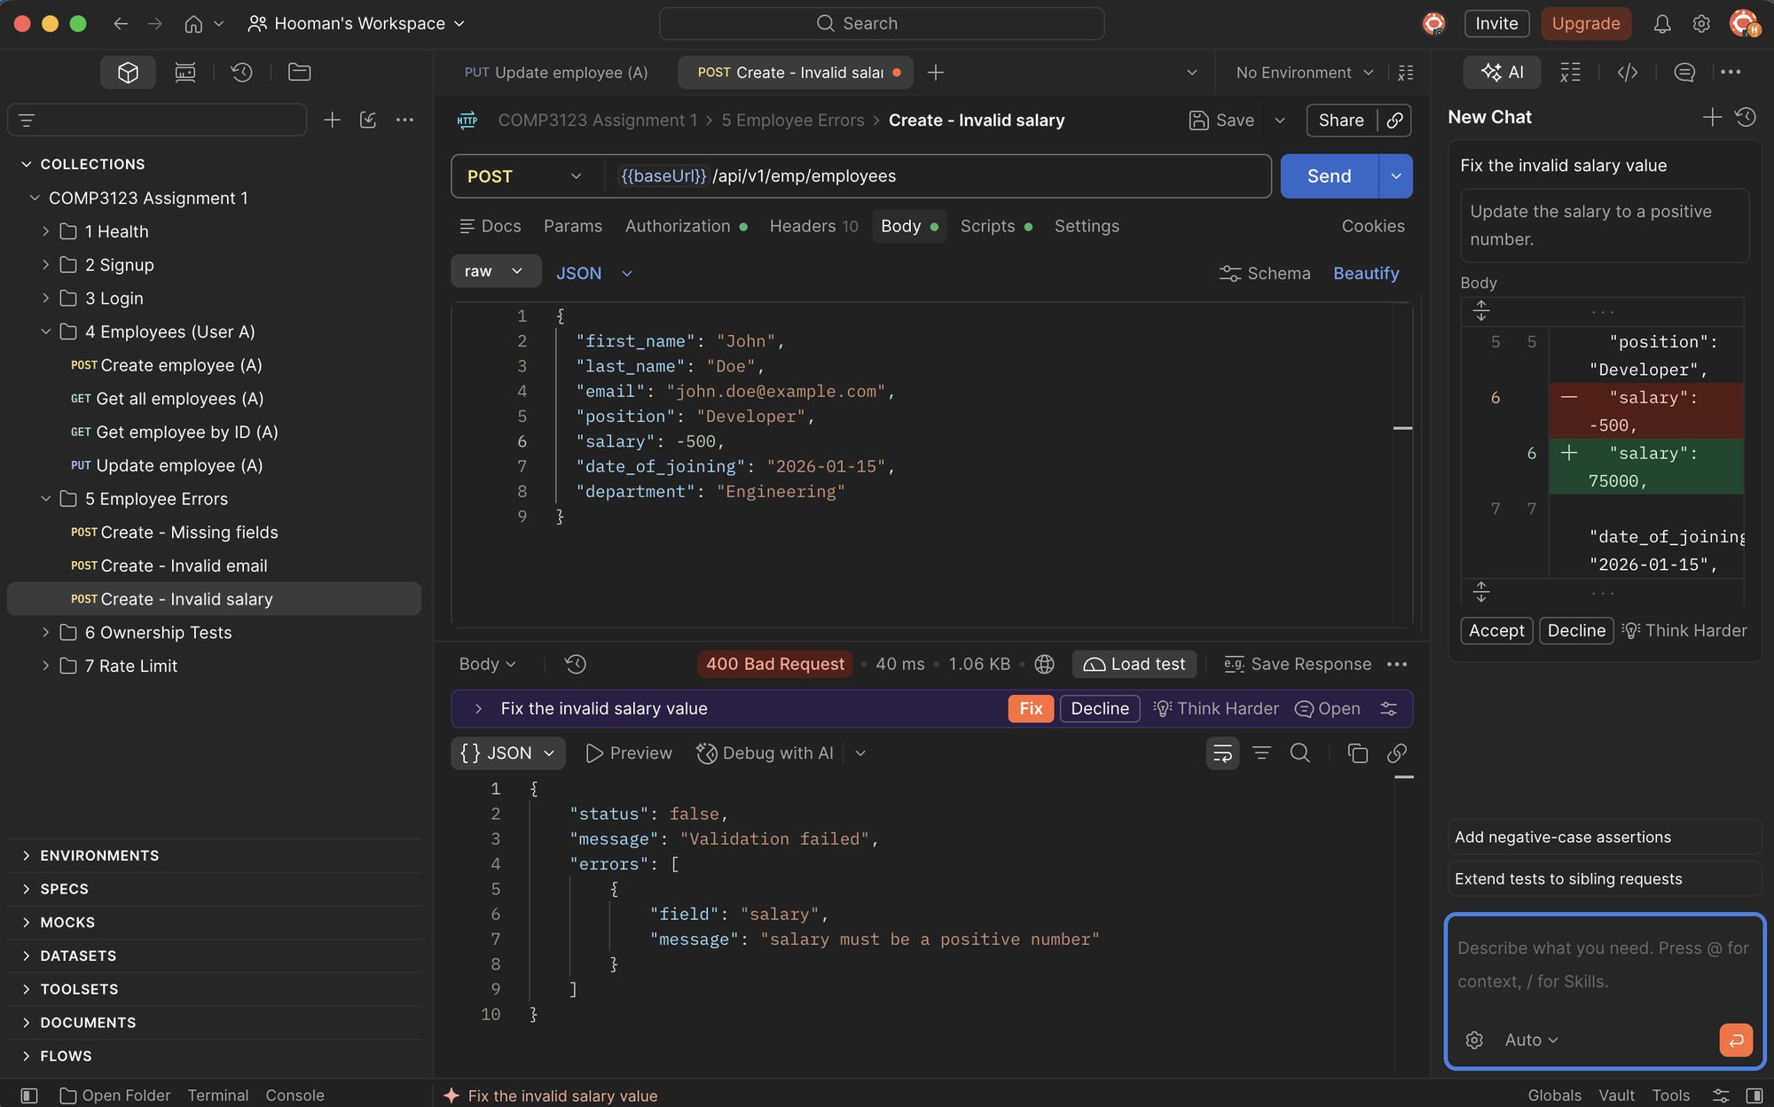

5.4 Create employee – Invalid date (400)
date_of_joining must be a valid date.
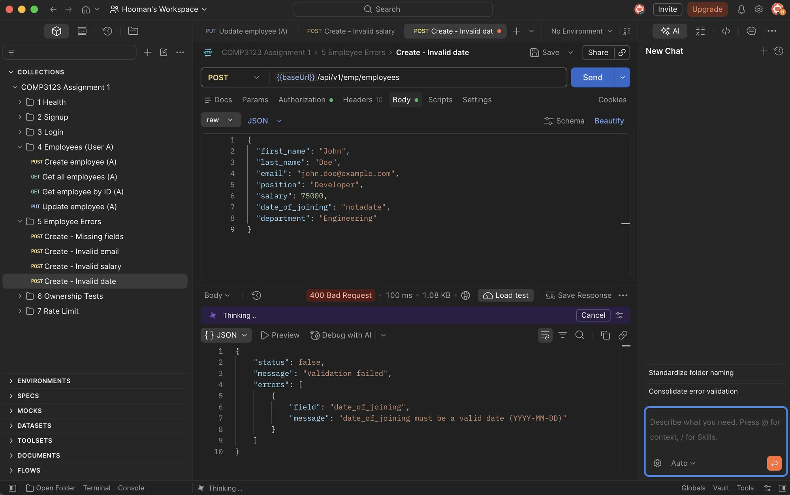

5.5 Create employee – Malformed JSON (400)
Broken JSON body is handled by the central error handler.
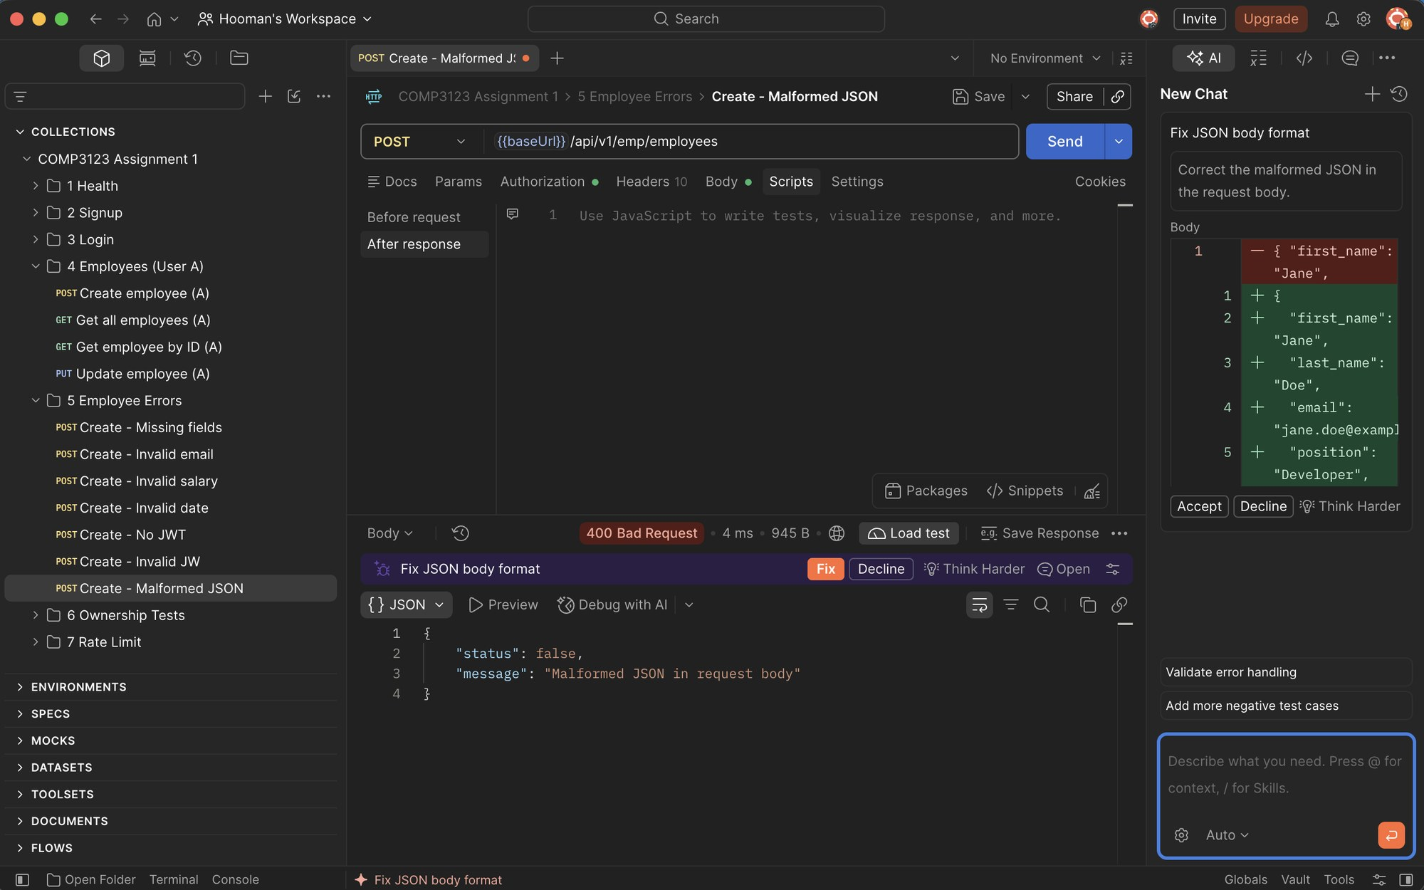

5.6 Create employee – Client tries to set owner (400)
The "user" field cannot be supplied by the client; ownership always comes from the JWT.
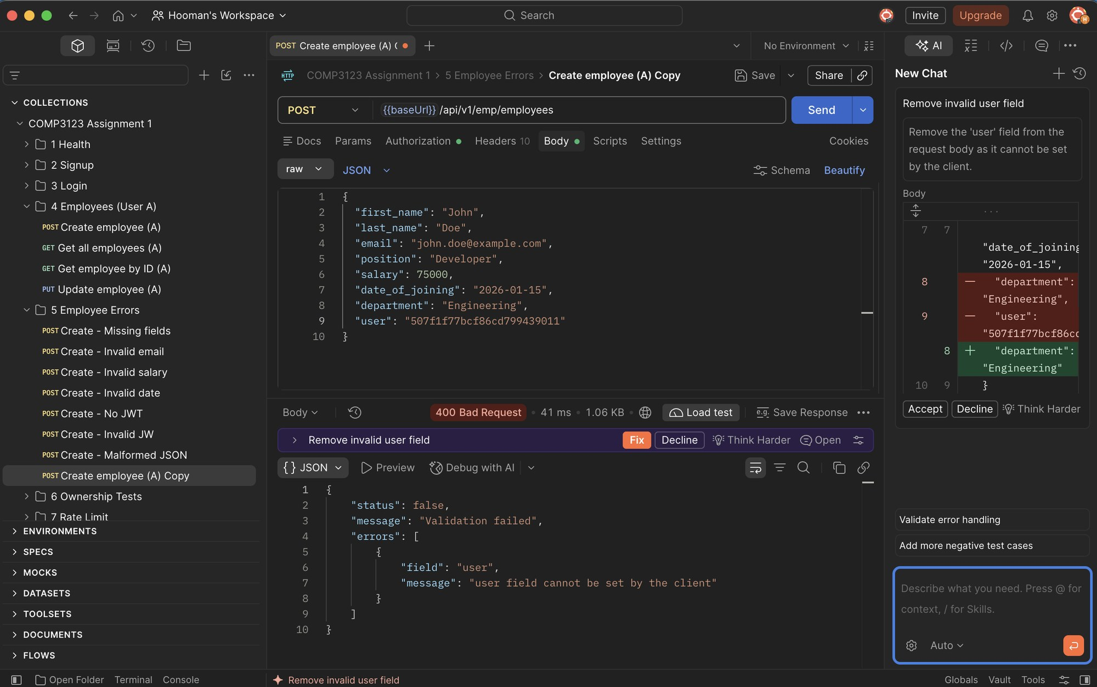

5.7 Get employee – Invalid ID format (400)
Non-ObjectId value for eid is rejected.
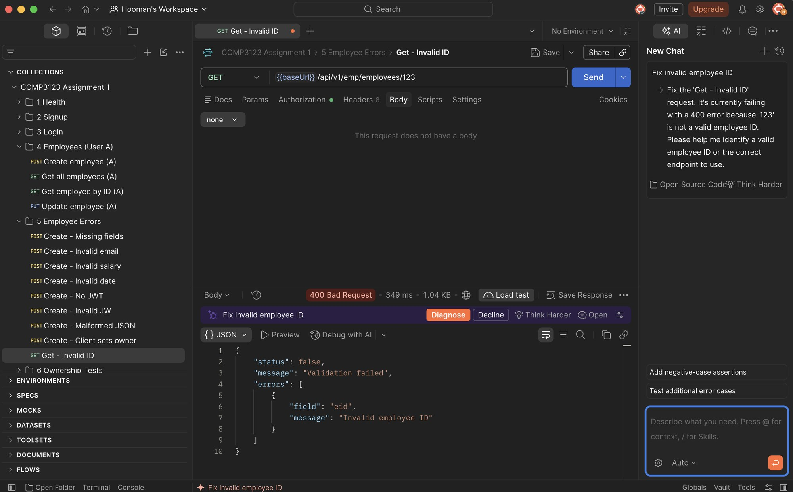

5.8 Get employee – Non-existent ID (404)
Valid ObjectId format but no matching employee.
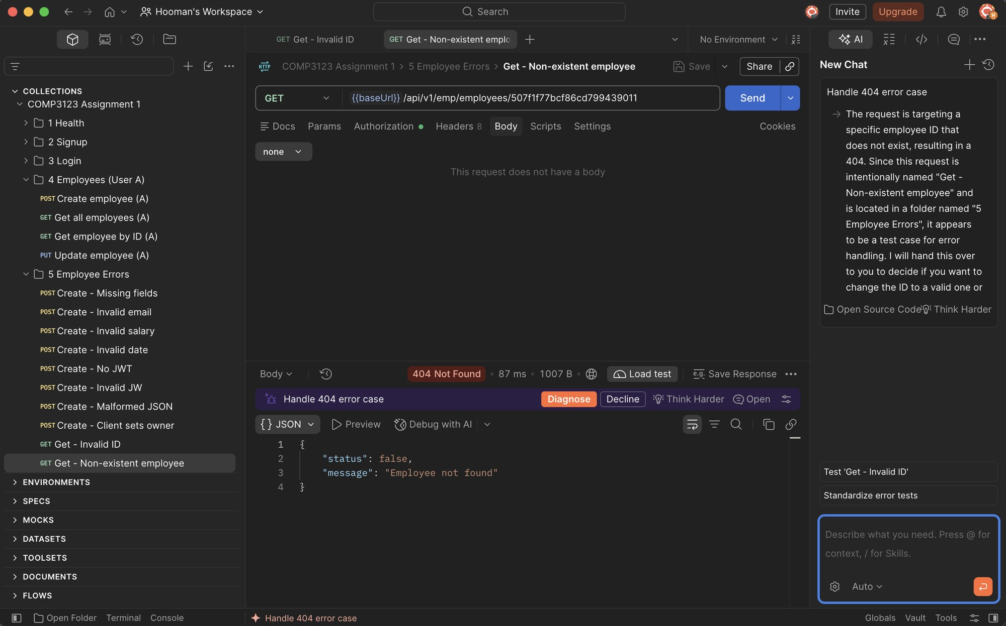

5.9 Unknown route (404)
Unsupported routes return a JSON 404 response.
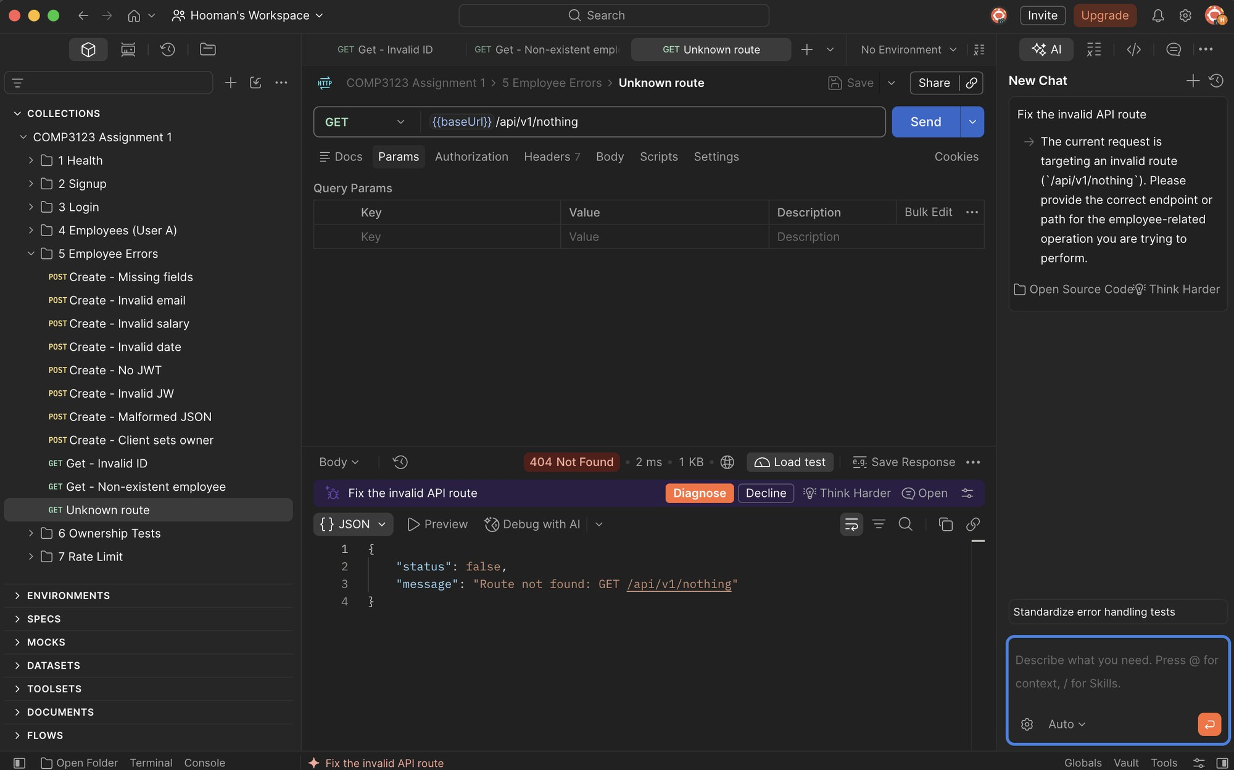

6. JWT Authentication Errors

6.1 Missing JWT (401 Unauthorized)
Employee endpoints reject requests without an Authorization header.
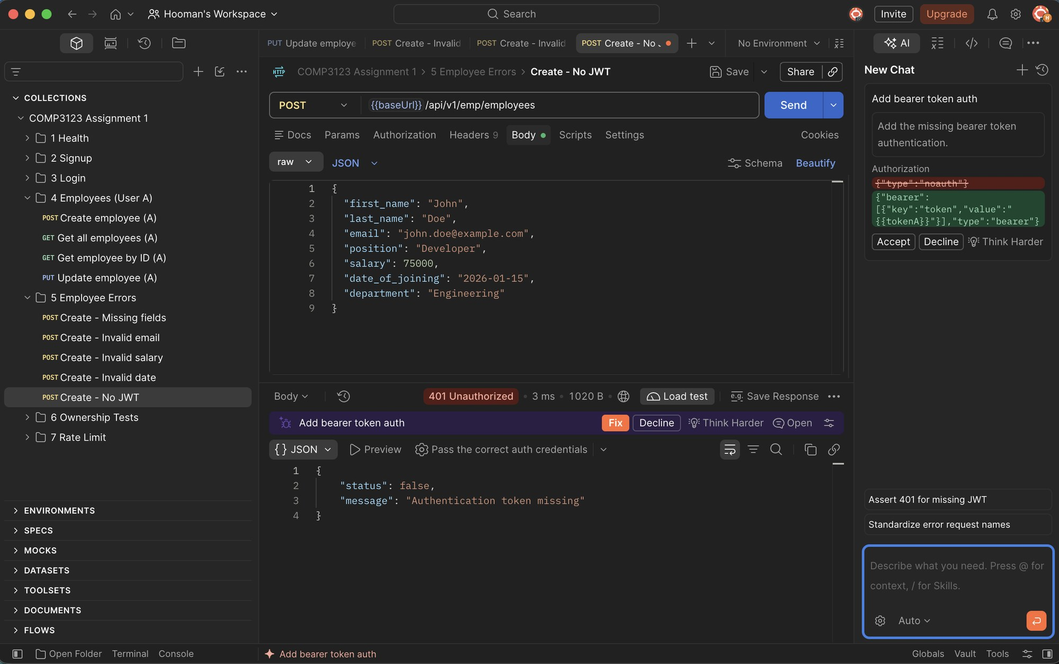

6.2 Invalid JWT (401 Unauthorized)
A malformed or tampered token is rejected.
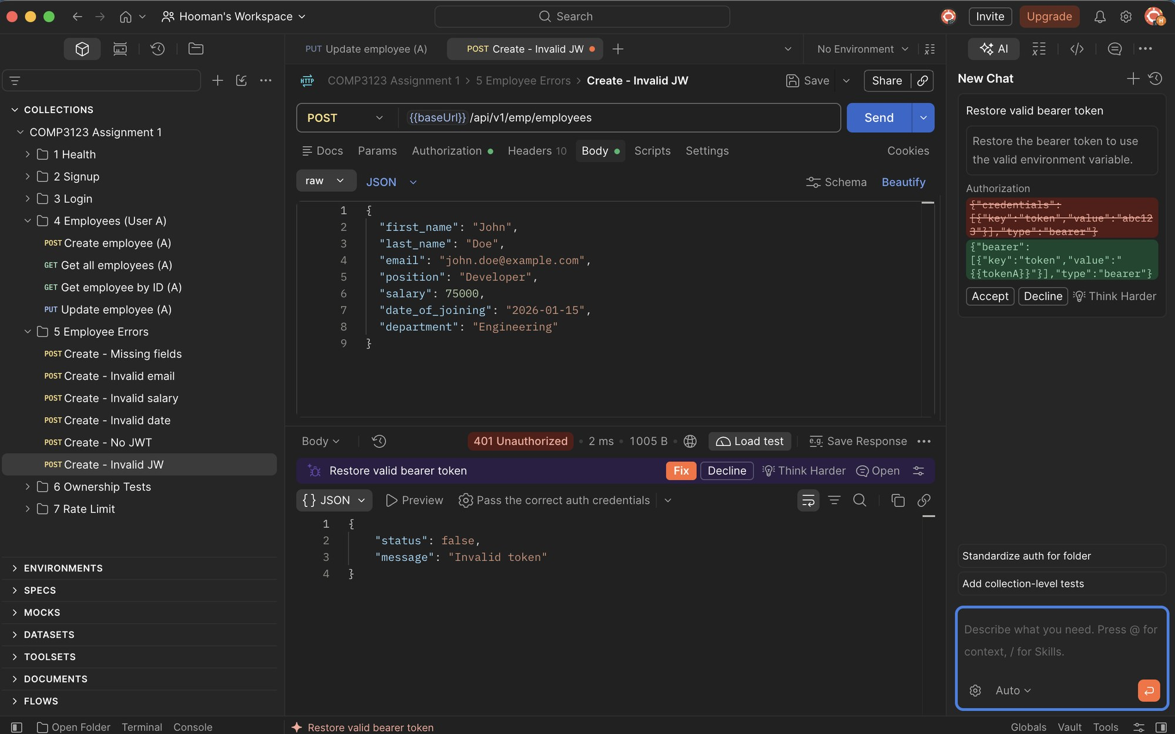

6.3 Expired JWT (401 Unauthorized)
A token older than JWT_EXPIRES_IN (1h) is rejected with "Token expired".
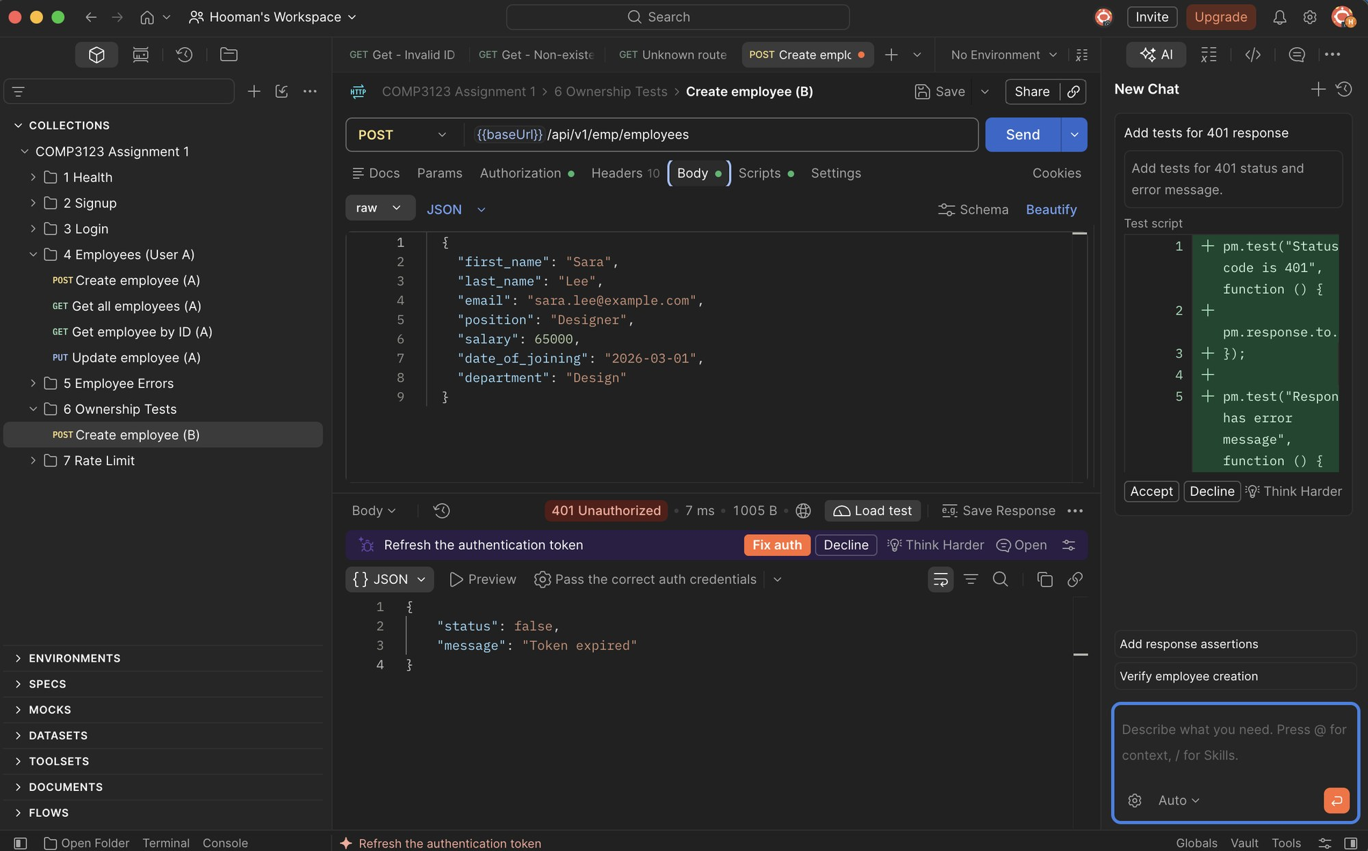

7. Two-User Ownership / Authorization Tests

7.1 User B creates an employee (201 Created)
Employee owned by User B.
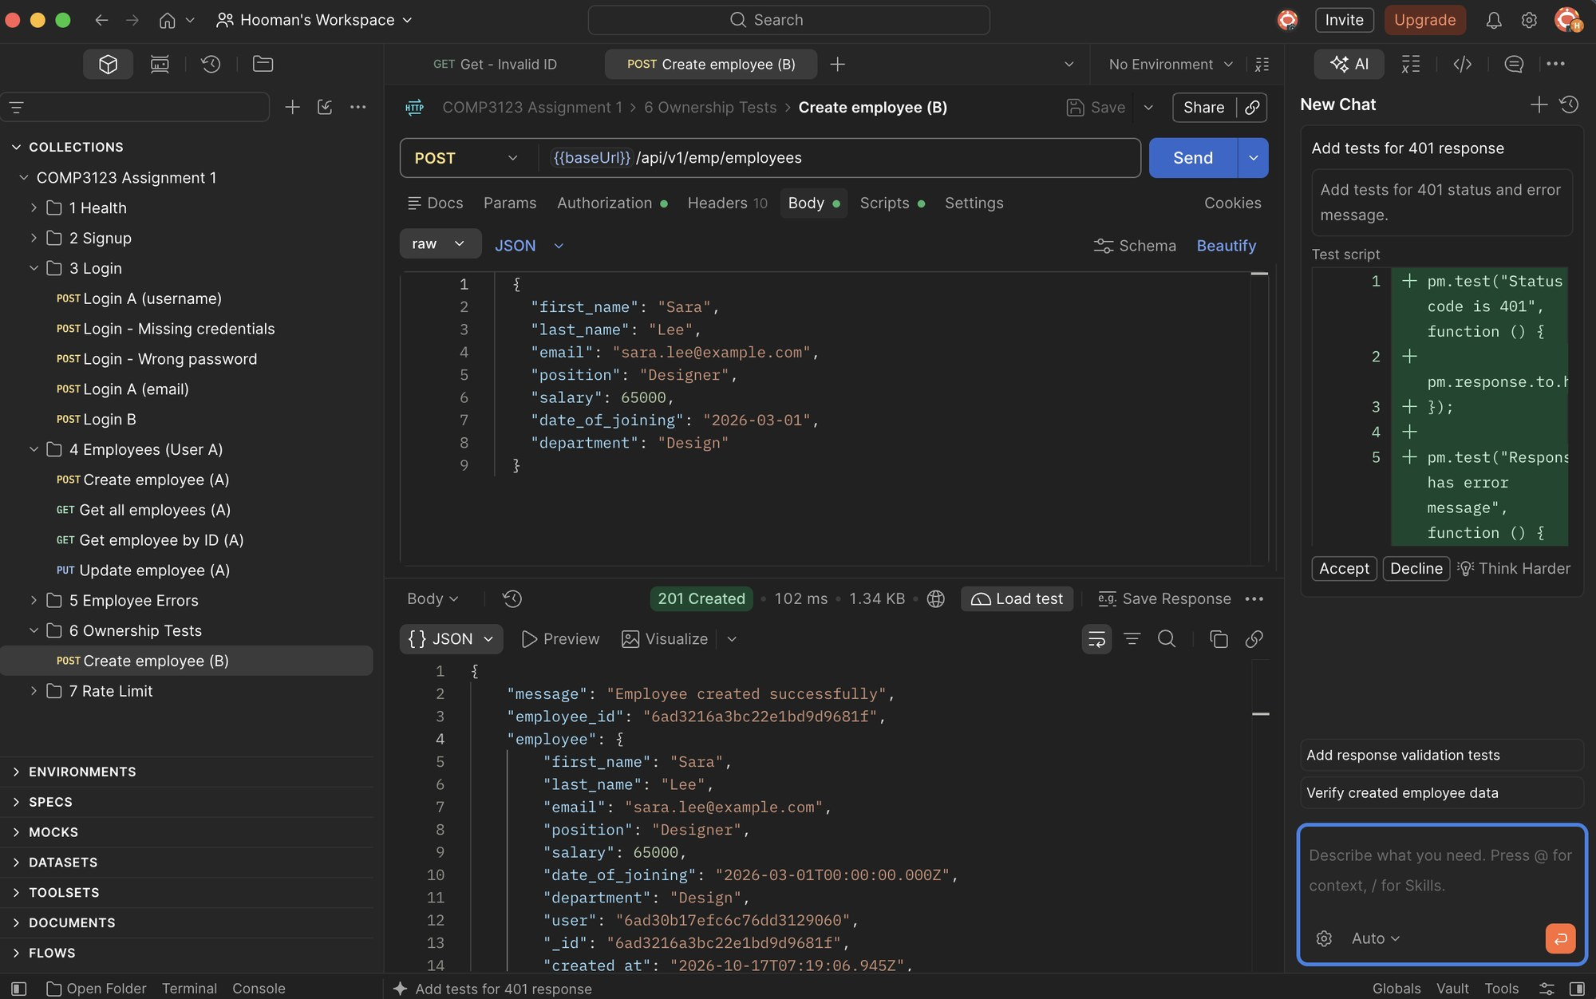

7.2 User B lists employees (200 OK)
User B sees only their own employee.
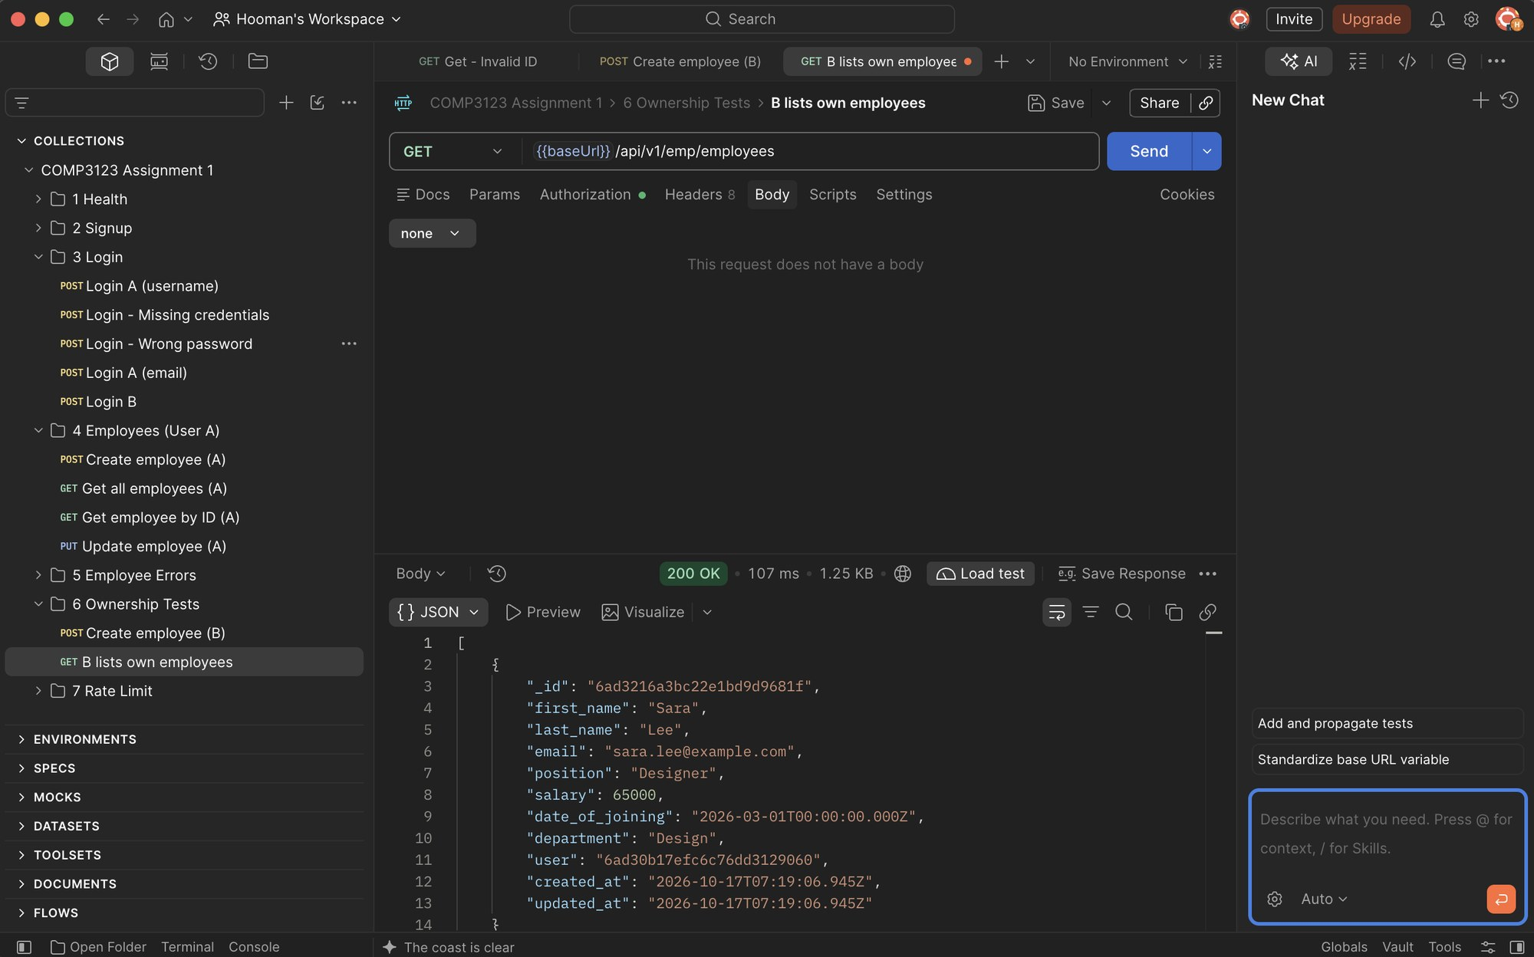

7.3 User A lists employees (200 OK)
User A sees only their own employees – User B's employee is not included.
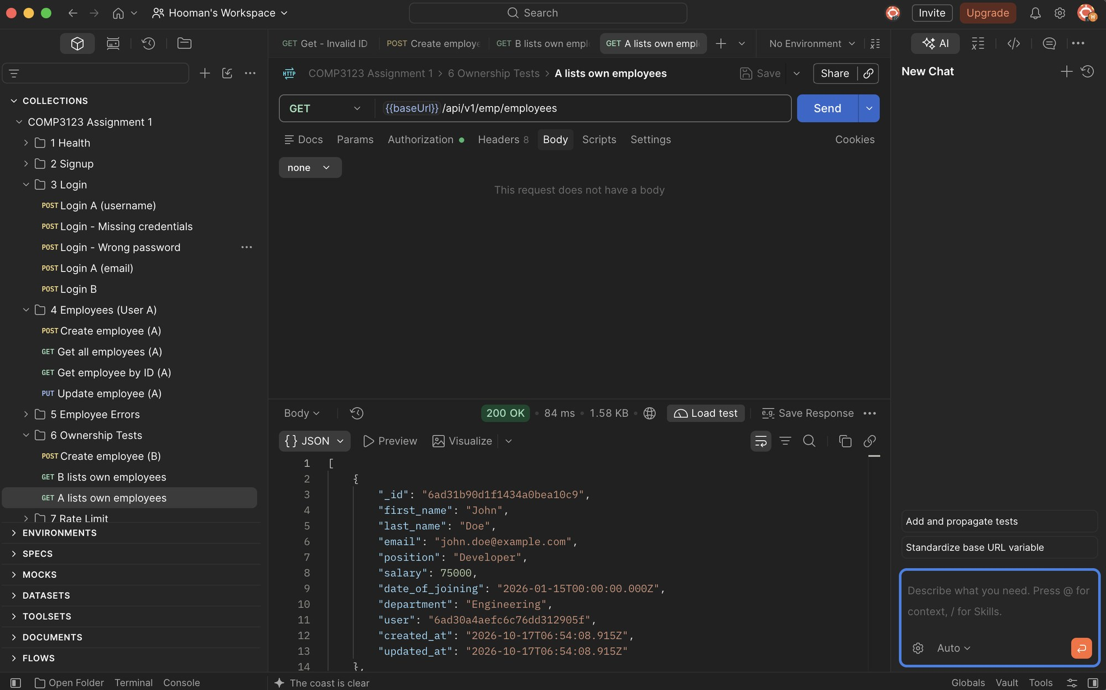

7.4 User A tries to GET User B's employee (403 Forbidden)
Cross-user read is rejected.
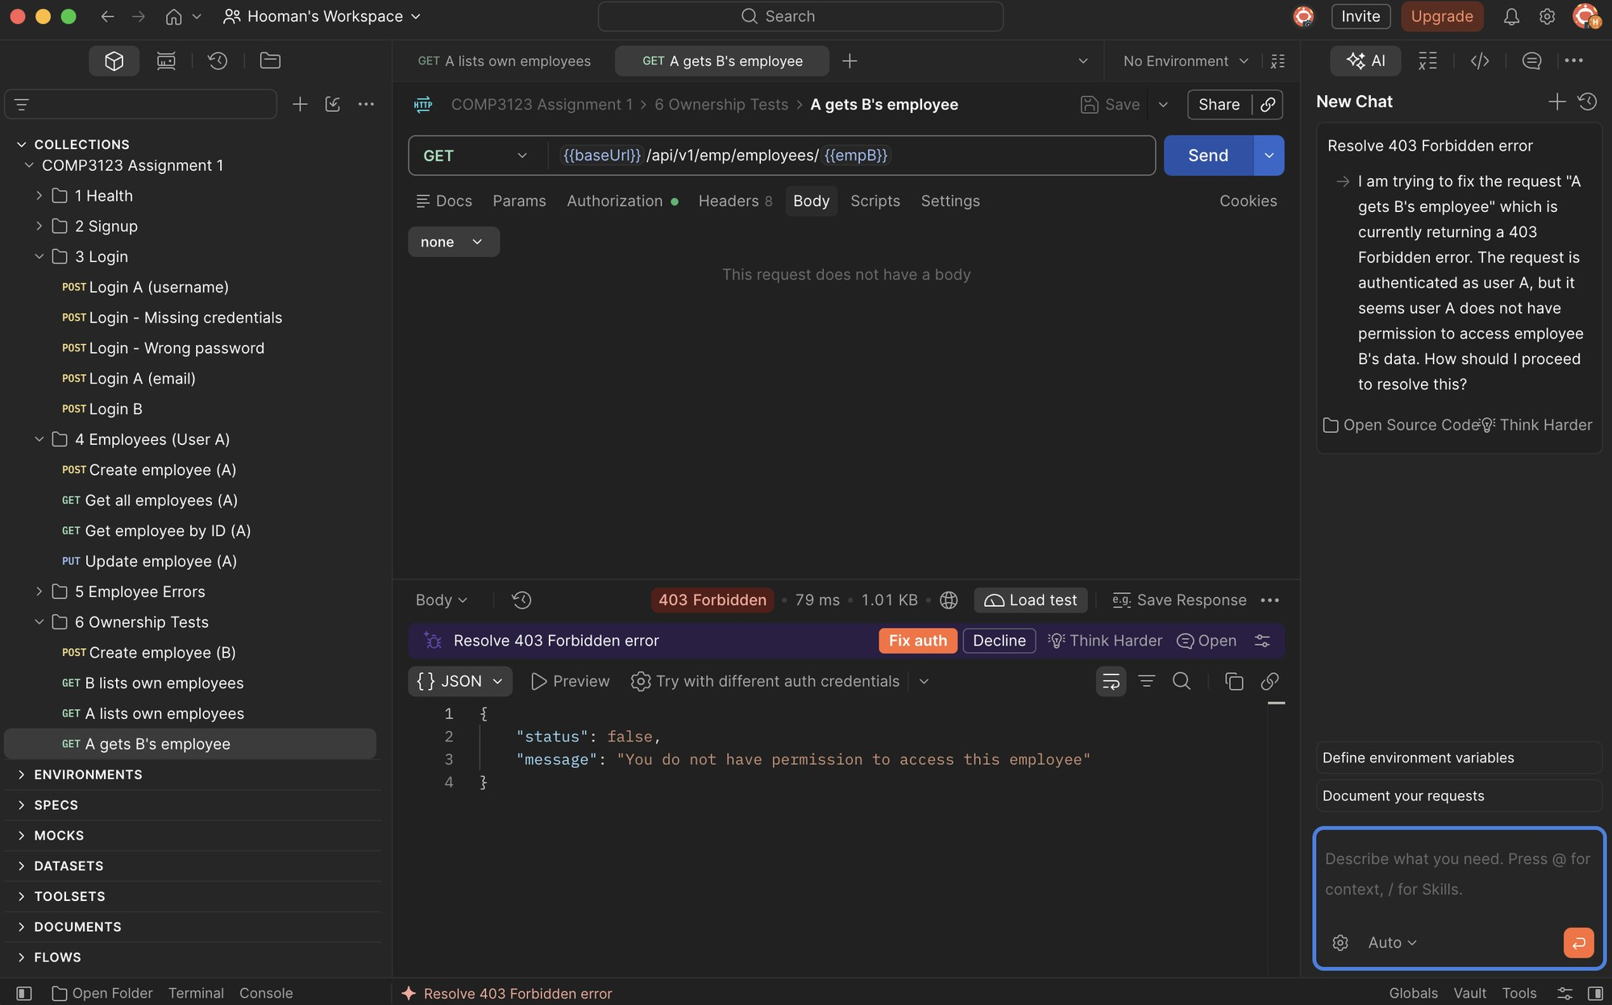

7.5 User A tries to UPDATE User B's employee (403 Forbidden)
Cross-user update is rejected.
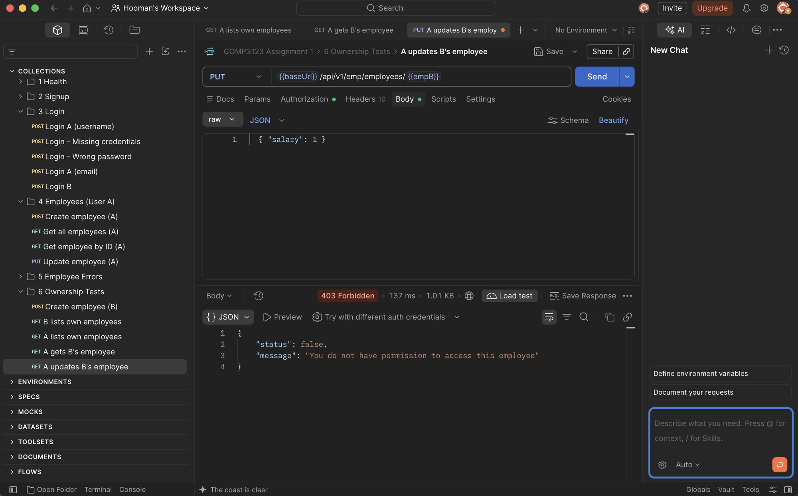

7.6 User A tries to DELETE User B's employee (403 Forbidden)
Cross-user delete is rejected.
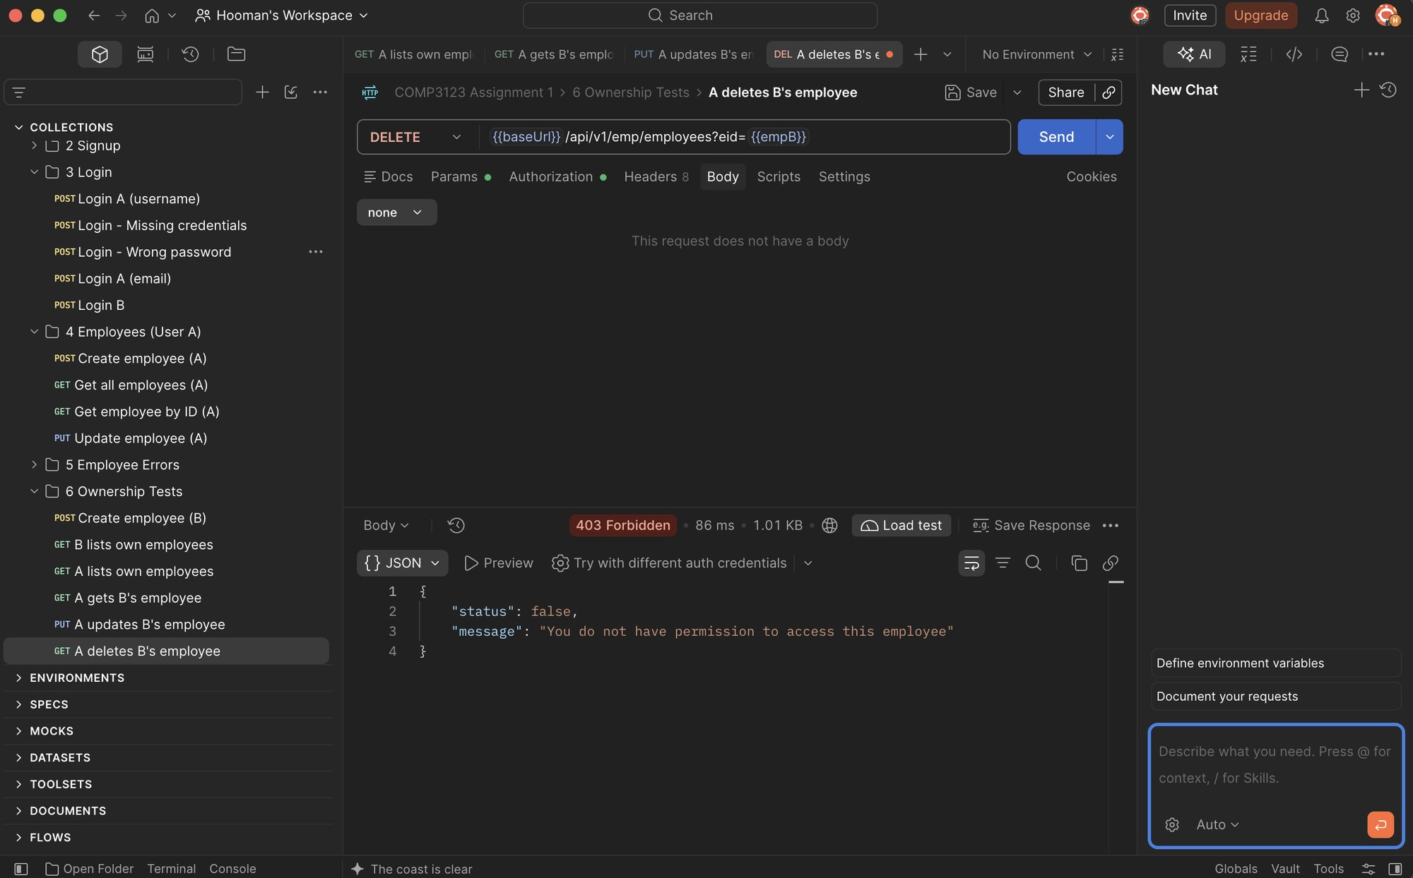

7.7 User B tries to GET User A's employee (403 Forbidden)
Cross-user read is rejected.
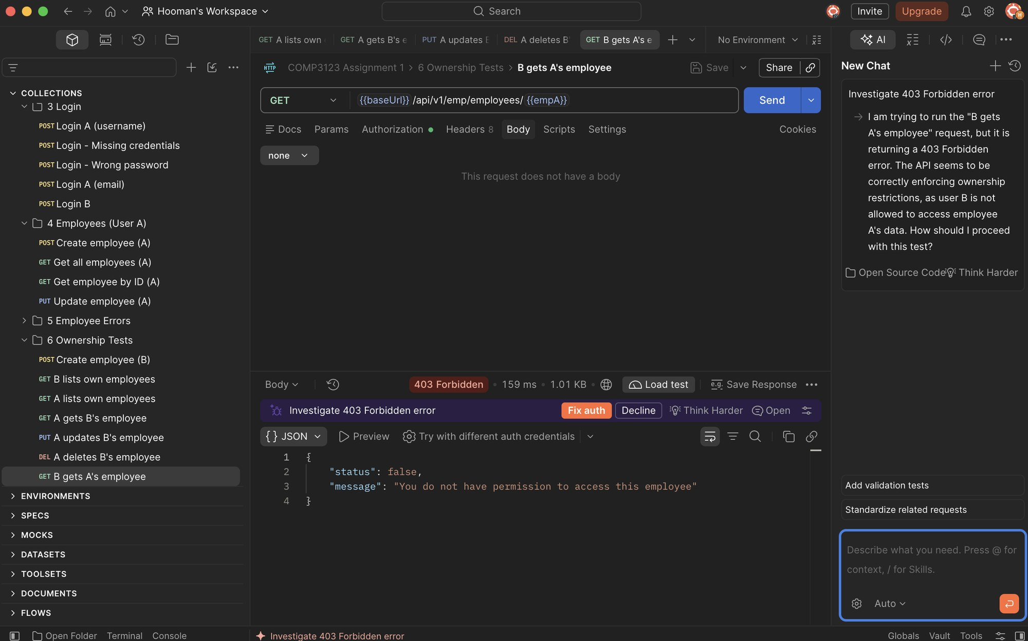

7.8 User B tries to UPDATE User A's employee (403 Forbidden)
Cross-user update is rejected.
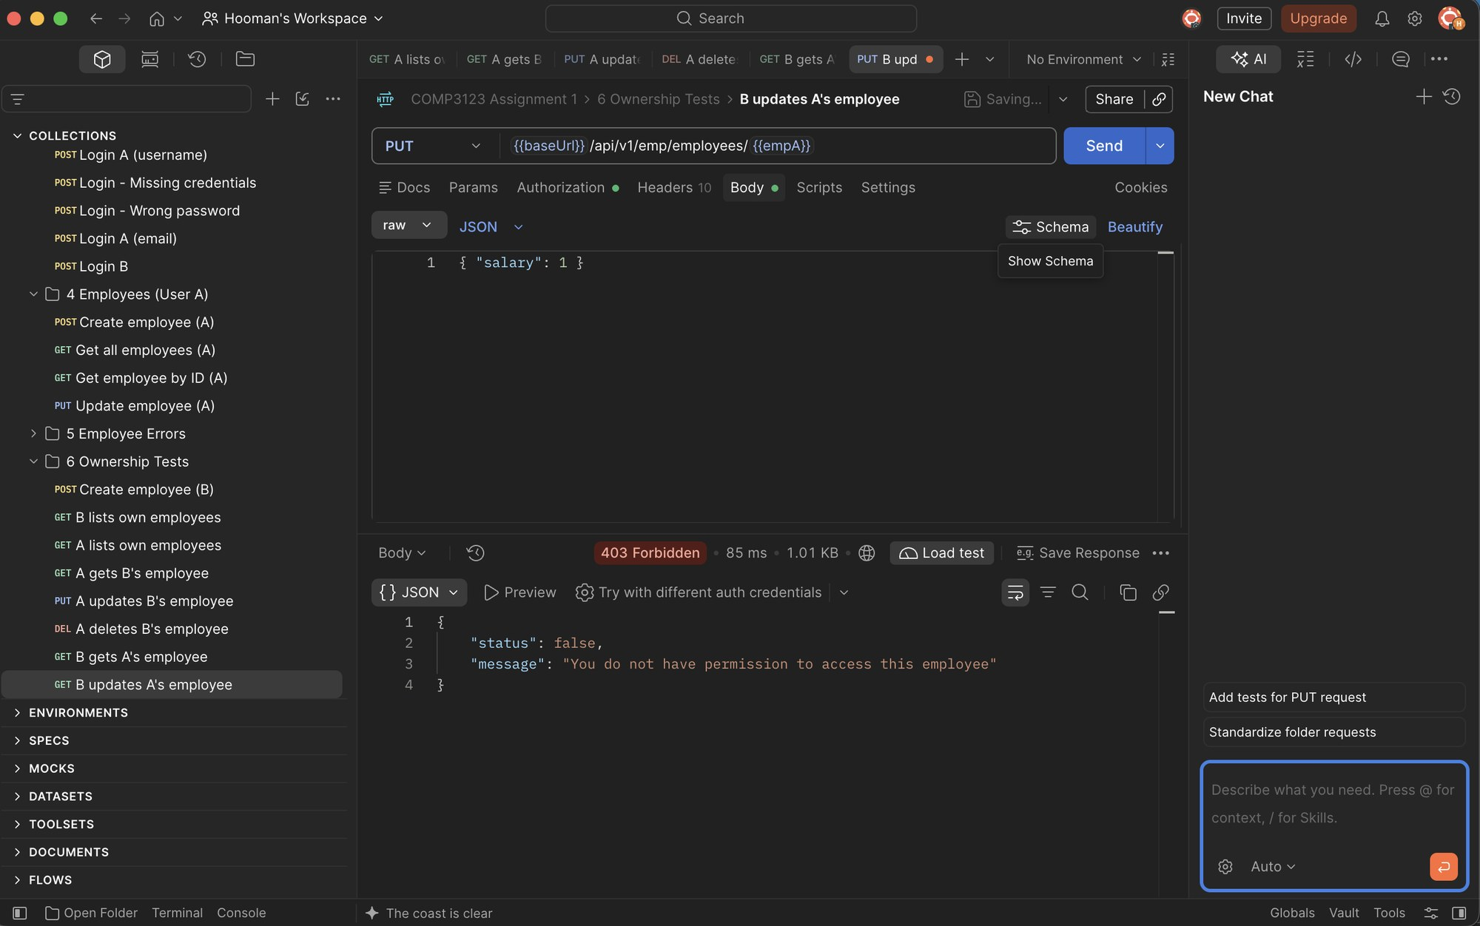

7.9 User B tries to DELETE User A's employee (403 Forbidden)
Cross-user delete is rejected.
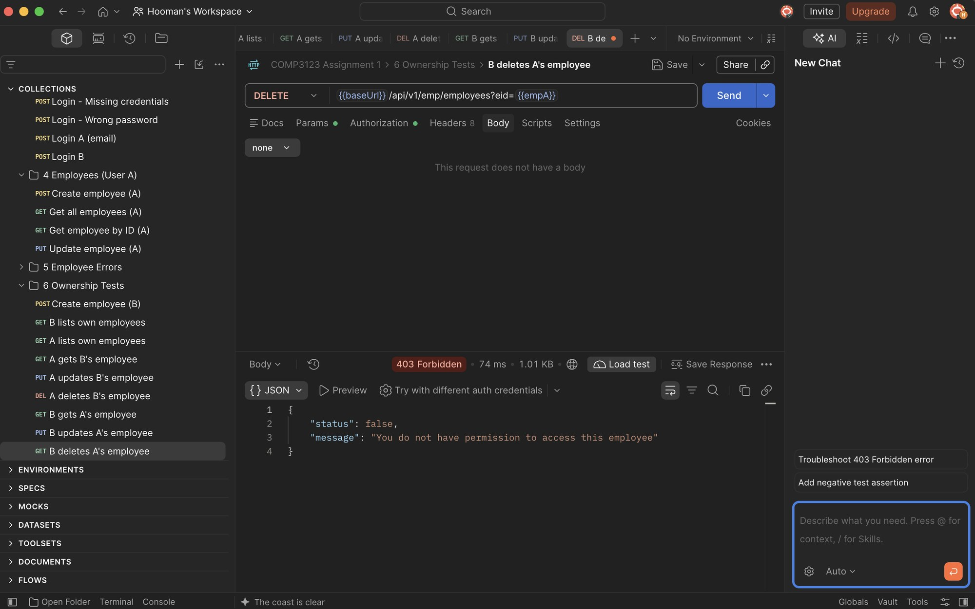

7.10 User A's employee unchanged after attacks
Salary is still 80000 – the rejected update had no effect.
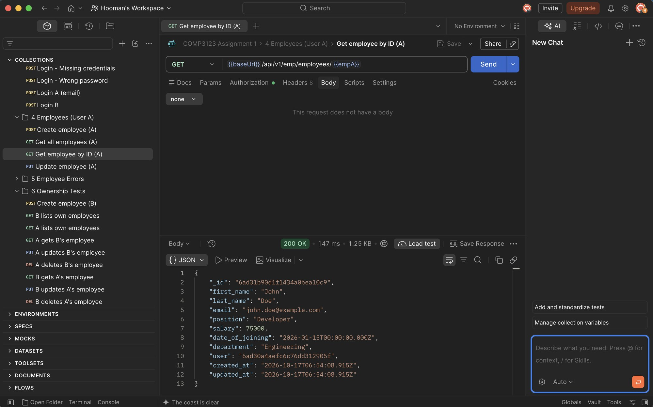

8. Rate Limiting

8.1 Rate limit exceeded (429 Too Many Requests)
Auth endpoints allow 5 requests per 15 minutes per IP; the next request is rejected.
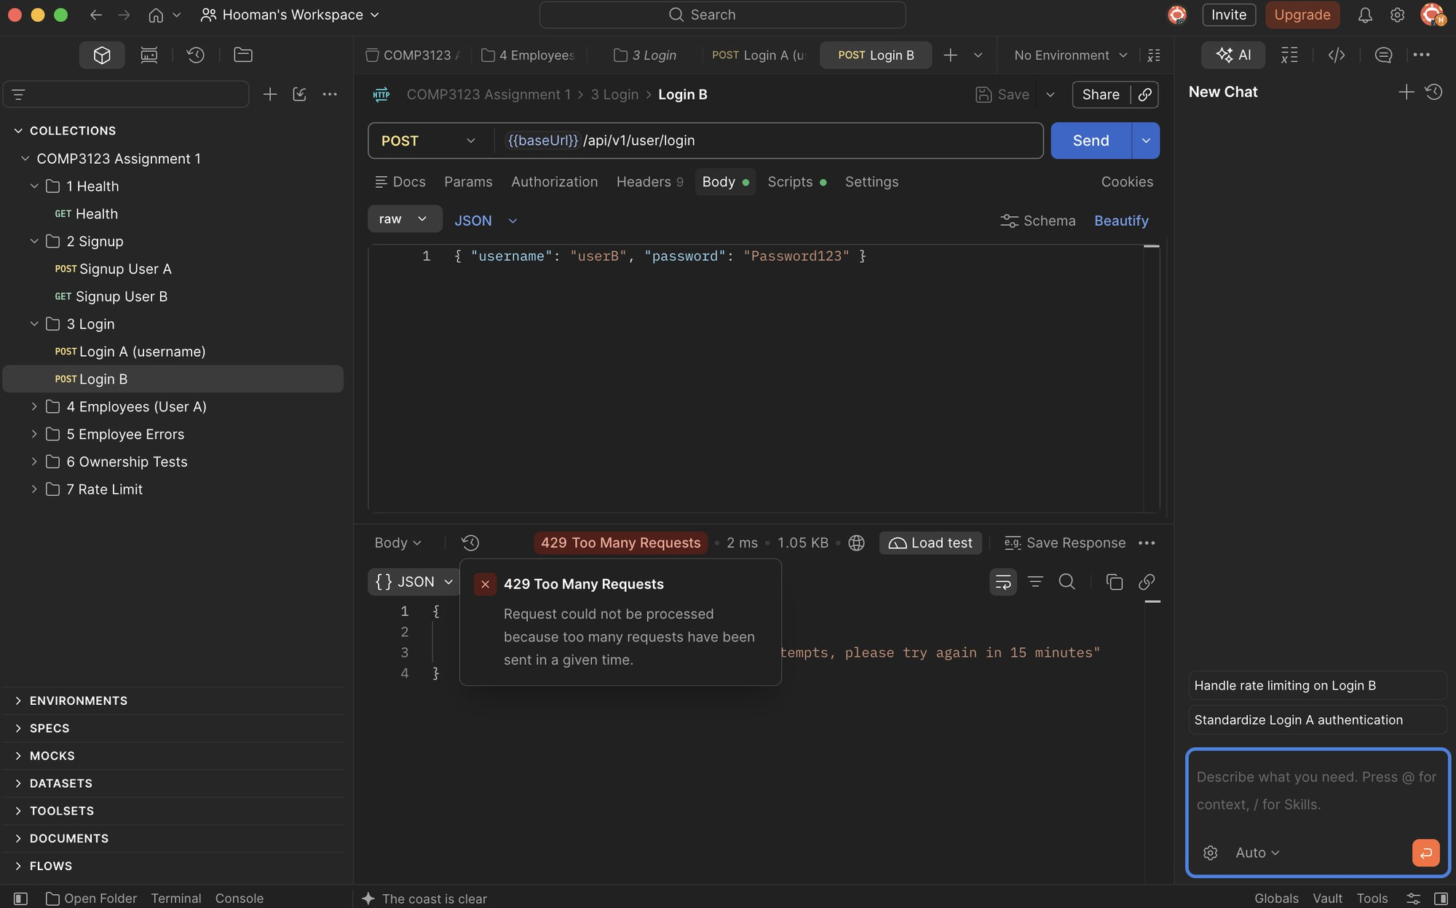

9. MongoDB Evidence

9.1 Database comp3123_assignment1
MongoDB Atlas database with users and employees collections.
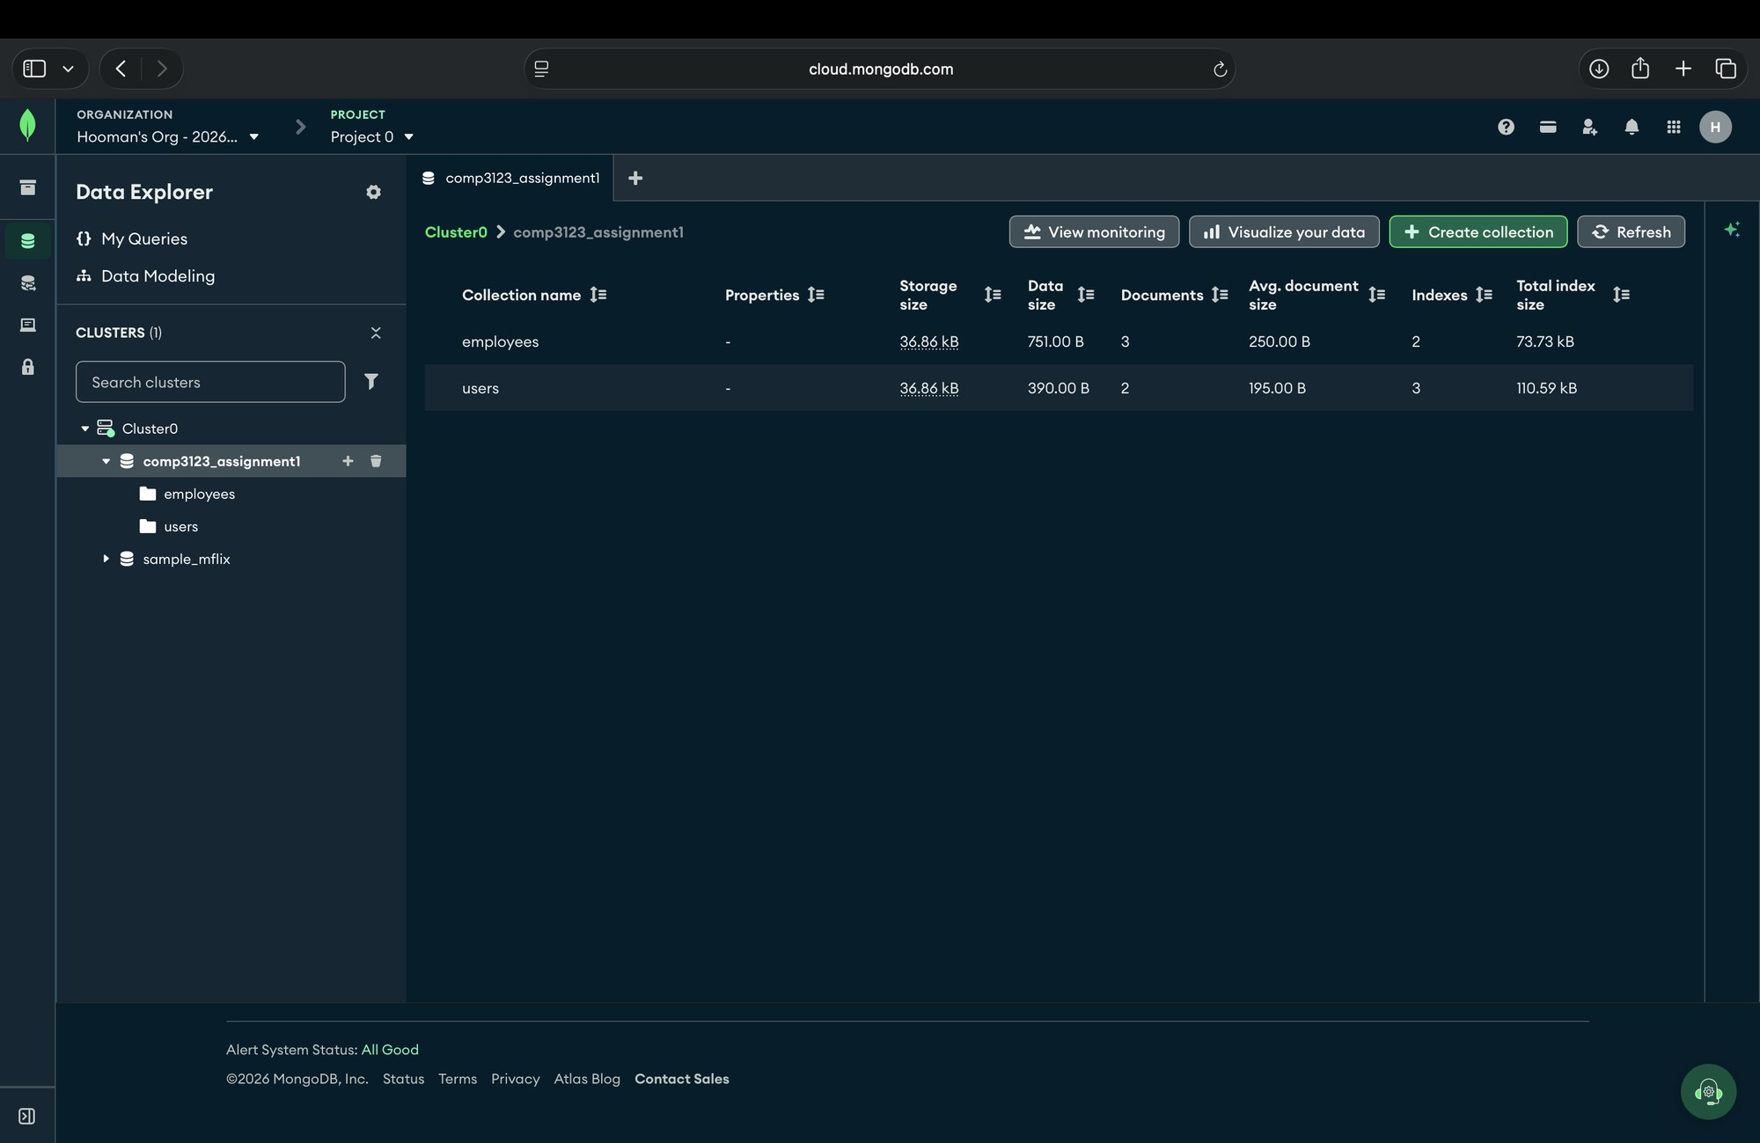

9.2 Users collection – hashed passwords
Passwords are stored as bcrypt hashes ($2b$12$...), never plain text.
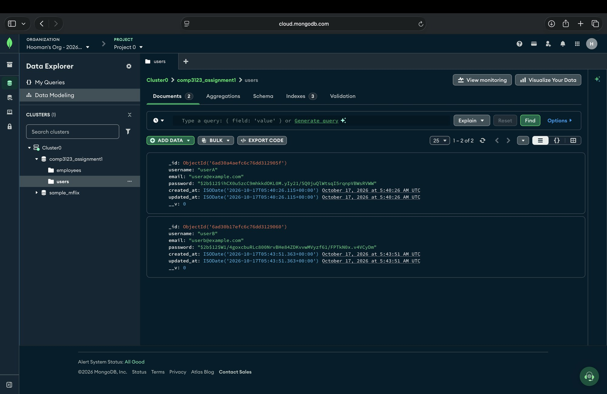

9.3 Employees collection
Each employee has a "user" field referencing its owner.
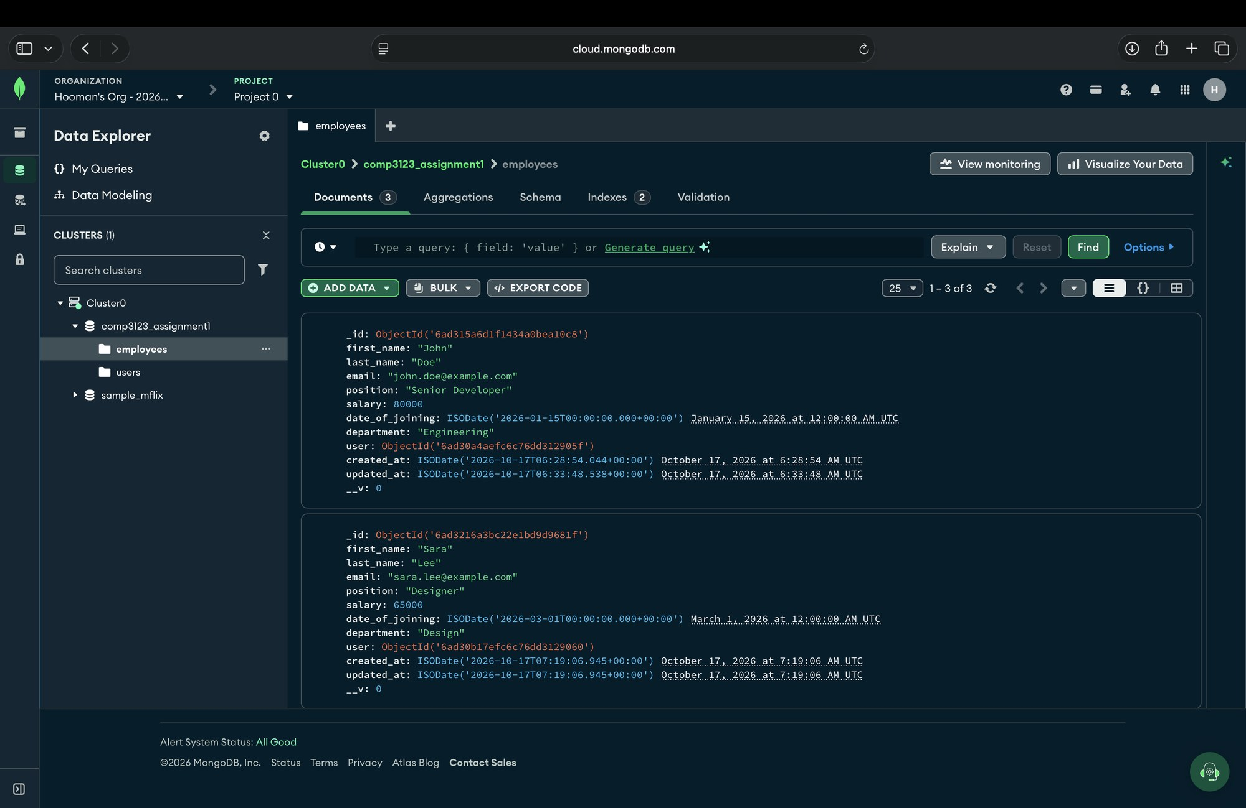

9.4 User – Employee relationship
employees.user matches users._id (green: userA → John Doe, orange: userB → Sara Lee).
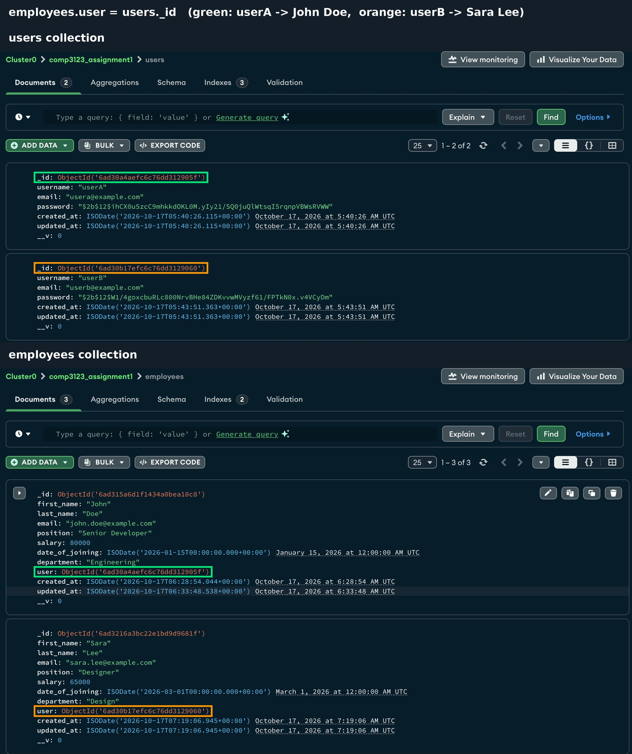

10. Local Logging

10.1 Application log (logs/app.log)
Timestamped JSON logs for startup, requests, auth/validation/authorization failures and errors. No passwords or tokens are logged.
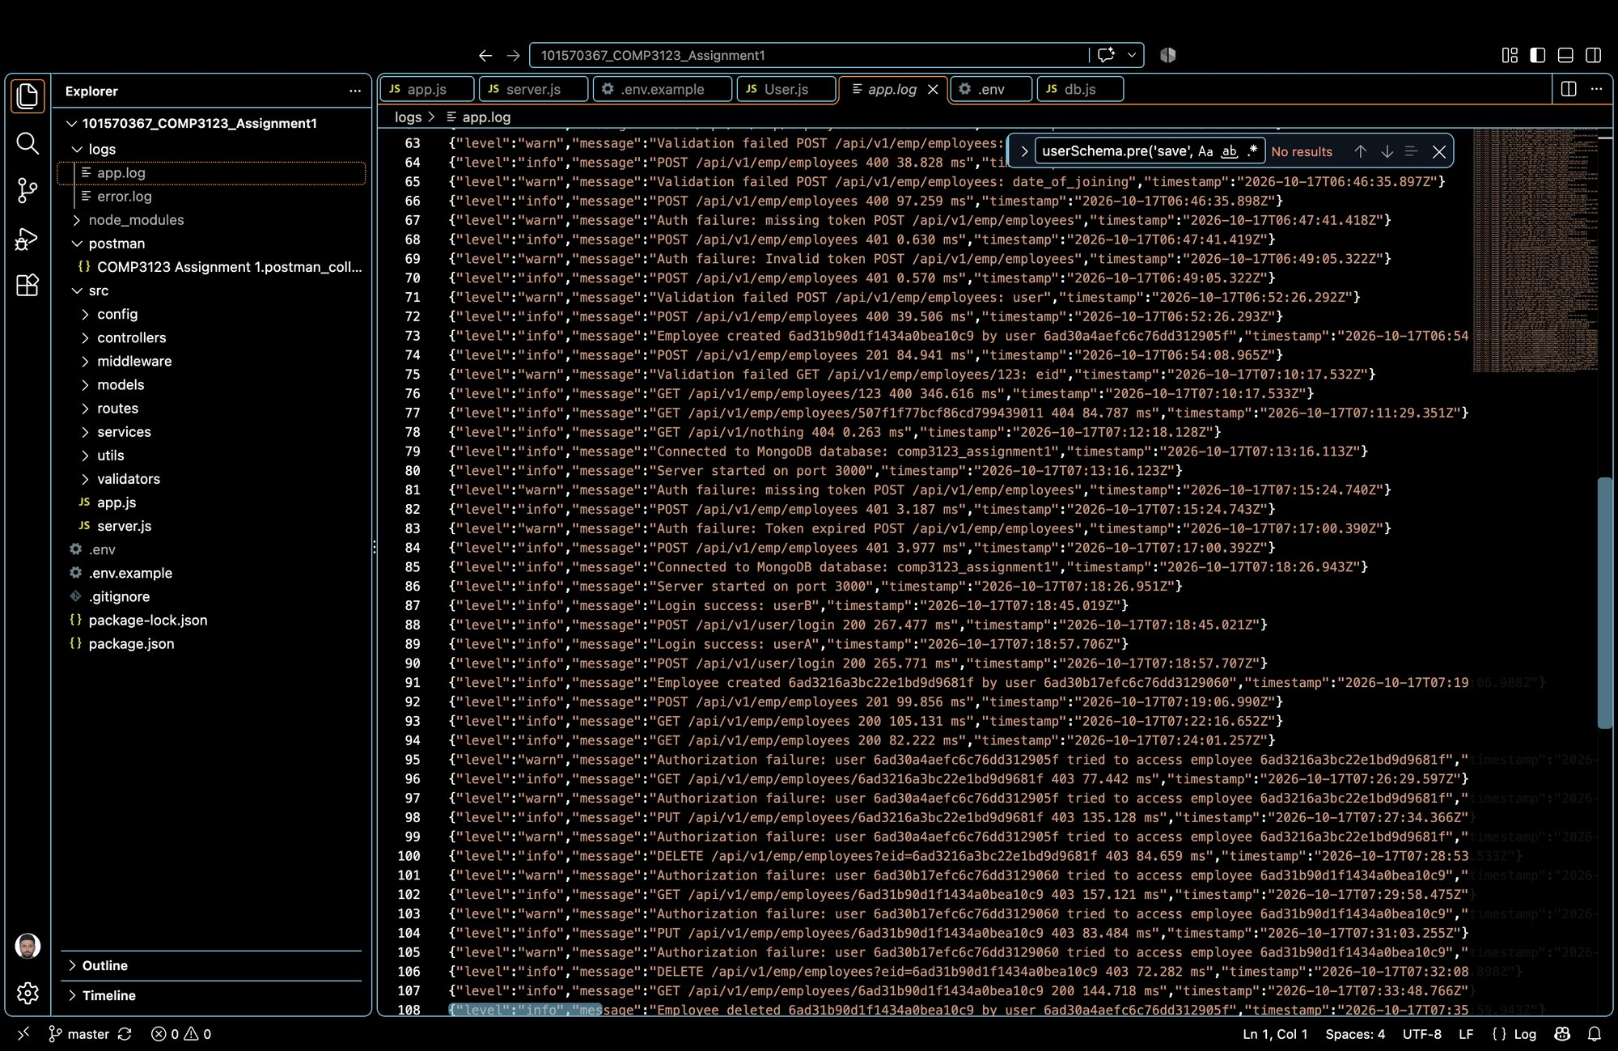

11. Vercel Deployment

11.1 Vercel – Health check (200 OK)
https://101570367-comp-3123-assignment1.vercel.app/health – database connected.
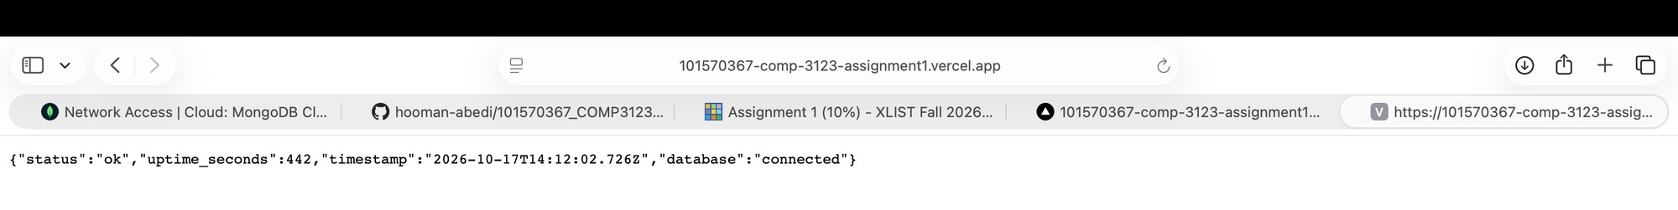

11.2 Vercel – Login (200 OK)
Login against the deployed API returns a JWT.
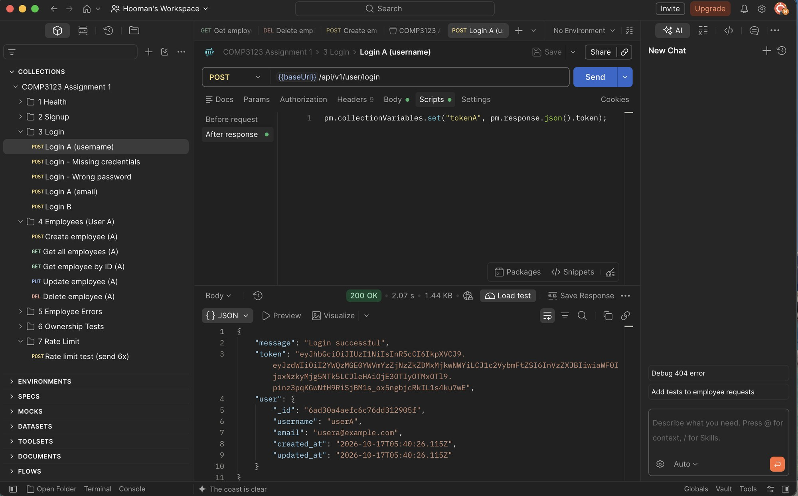

11.3 Vercel – Create employee (201 Created)
Employee created through the deployed API.
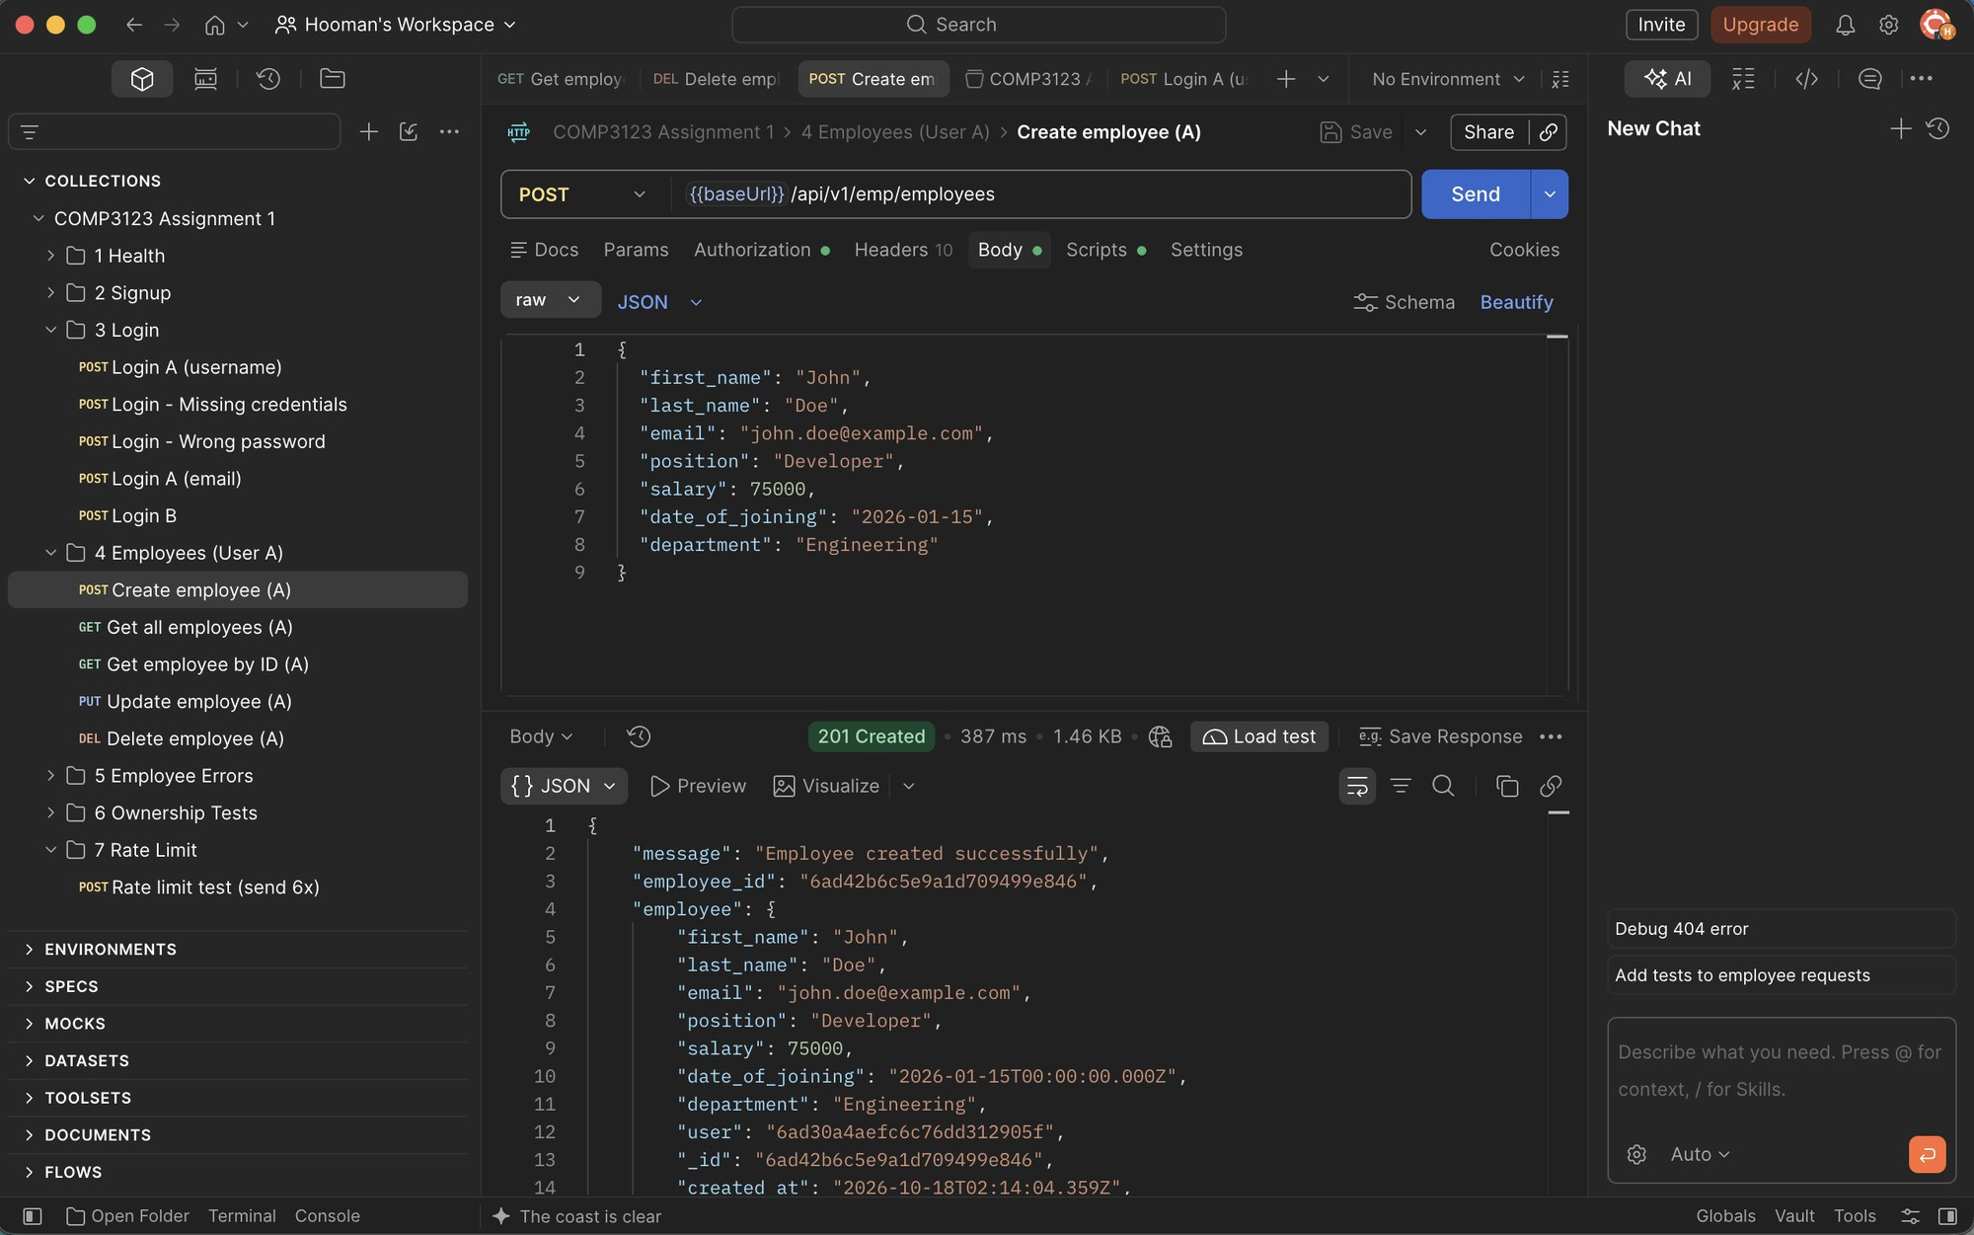

11.4 Vercel – Get all employees (200 OK)
Deployed API returns only the authenticated user's employees.
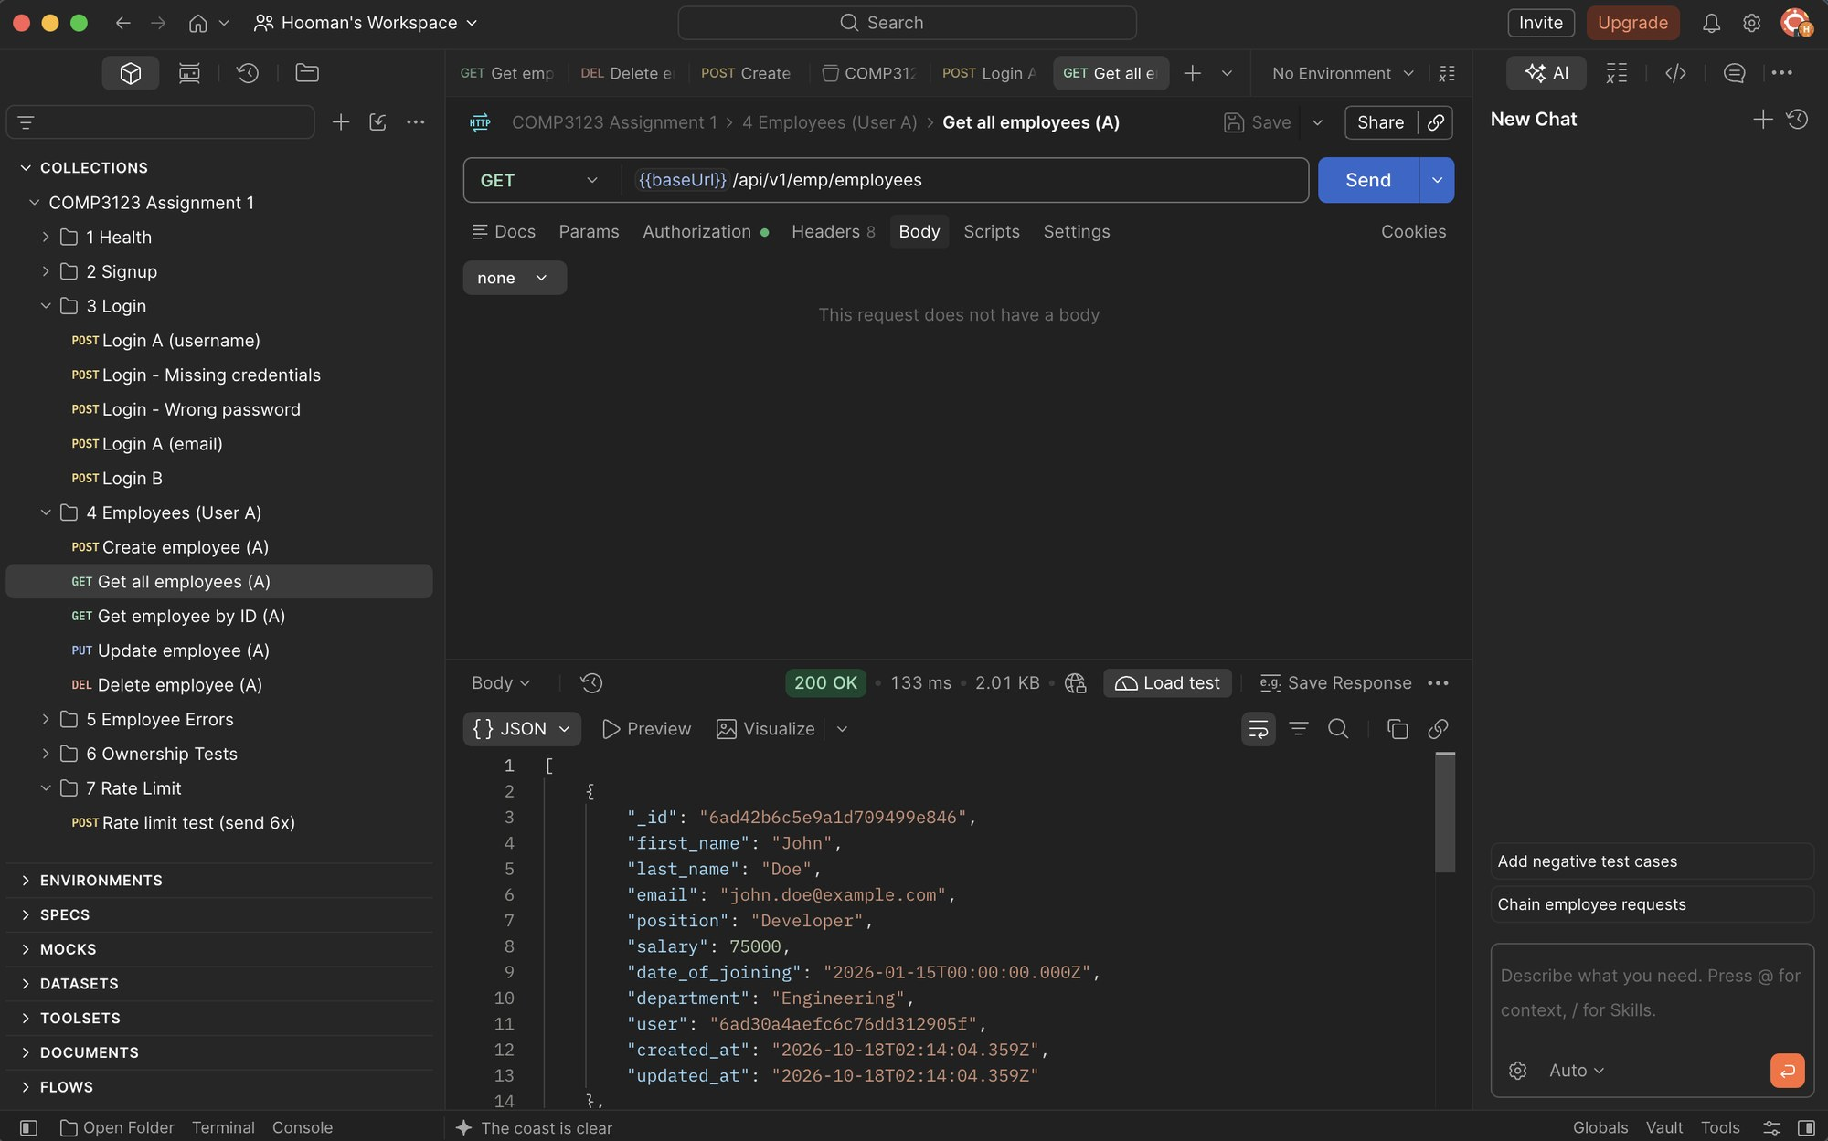

11.5 Vercel – Cross-user access (403 Forbidden)
Ownership is enforced on the deployed API as well.
