**Setting Variables:**

1. Go to Variables.css and add a new variable in root:
   1. 
2. Go to style.css and replace all **1400px** with **var(--container-width)**
3. Go to variables.css navigate to the bottom of the code and add media query:
   1. Target all and max-width of 1400px
   2. A black screen with white text

      Description automatically generated
4. Add :root selector with new value for container-width variable
   1. A screenshot of a computer program

      Description automatically generated
   2. When browser’s width gets less than 1400px, all your container will become 1140px width.
5. Do the same for other breakpoints.
   1. A screen shot of a computer program

      Description automatically generated
6. Go to style.css
   1. Add a media query for max-width 1400px at the end of the code
   2. A screen shot of a computer

      Description automatically generated
7. Hero section:
   1. A screen shot of a computer

      Description automatically generated
   2. A screen shot of a computer program

      Description automatically generated
   3. A screen shot of a computer program

      Description automatically generated
   4. A screen shot of a computer

      Description automatically generated

**Project Section:**

1. Go to Style.css and add:
2. 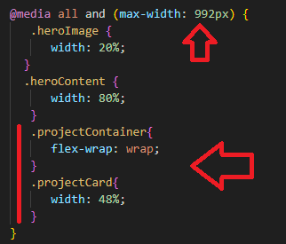
3. 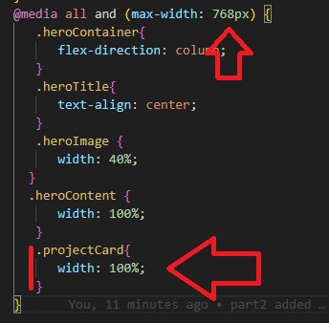

**Navigation:**

1. Go to variables.css
2. Go to top and add fontawsome cdn:
   1. @import url('https://cdnjs.cloudflare.com/ajax/libs/font-awesome/6.4.2/css/all.min.css');
   2. 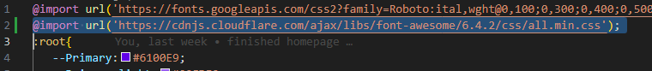
3. Go to index.html and locate top navigation
   1. A computer screen shot of text

      Description automatically generated
4. Add hamburger menu icon:
   1. Add a new line after ul closing tag
   2. Then add the code below: This is a place holder for the burger menu on mobile view
   3. 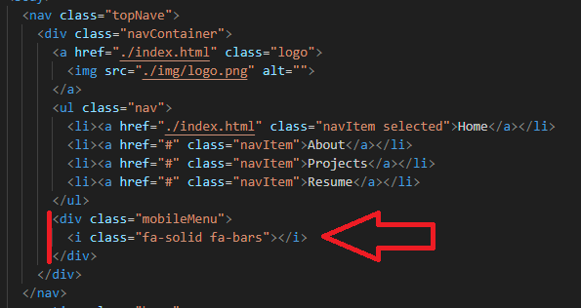
5. Go to style.css
   1. On top after .navItem.selected selector add a new selector to target **mobileMenu** and set the display to none.
   2. 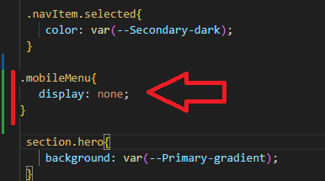
6. Go to the end of the page and add a media query:
7. 