Screenshots showing how to run the Mininet-based MapReduce Code

To run the code base using Mininet for HW3 (and also for assignment #4), first create the topology for the desired number of map and reduce tasks, and the number of racks using the -M, -R and -r switches, respectively.

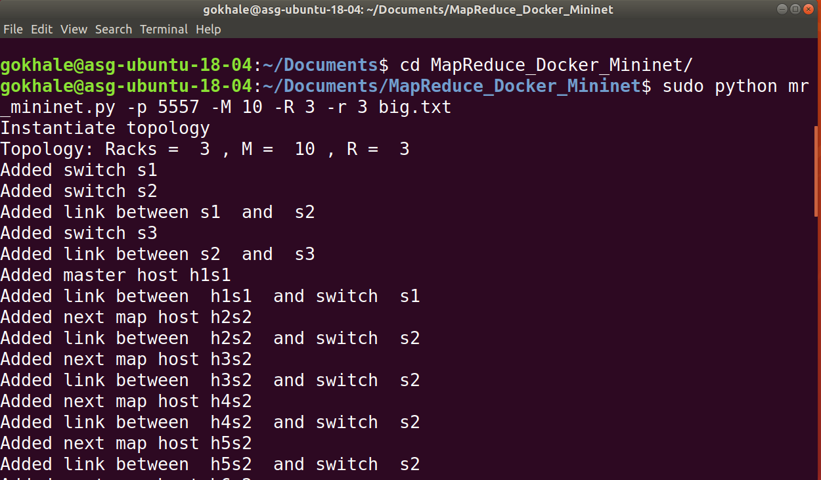

The topology should now be ready and you will see a Mininet prompt

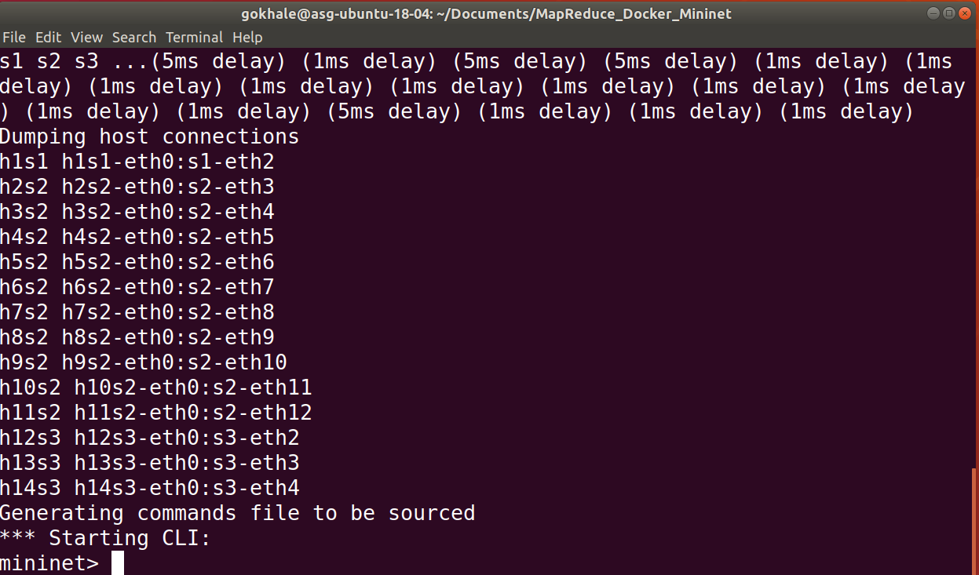

Open an Xterm to run on host which is named h1s1 as shown. A xterm (black colored window) will pop up (the font is too small ☹). To make it larger, press the control key and simultaneously click the right mouse button. This will pop up a font selection. I selected “Huge”

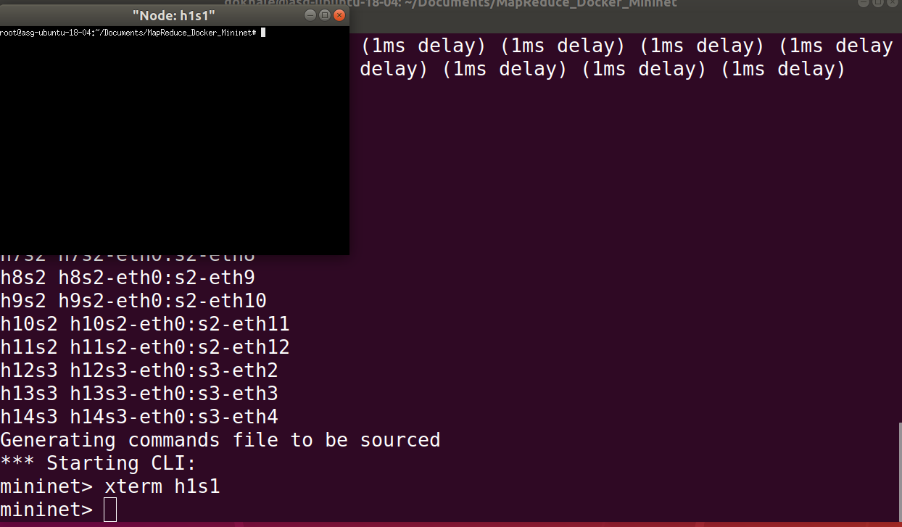

After making the font larger, you see the following.

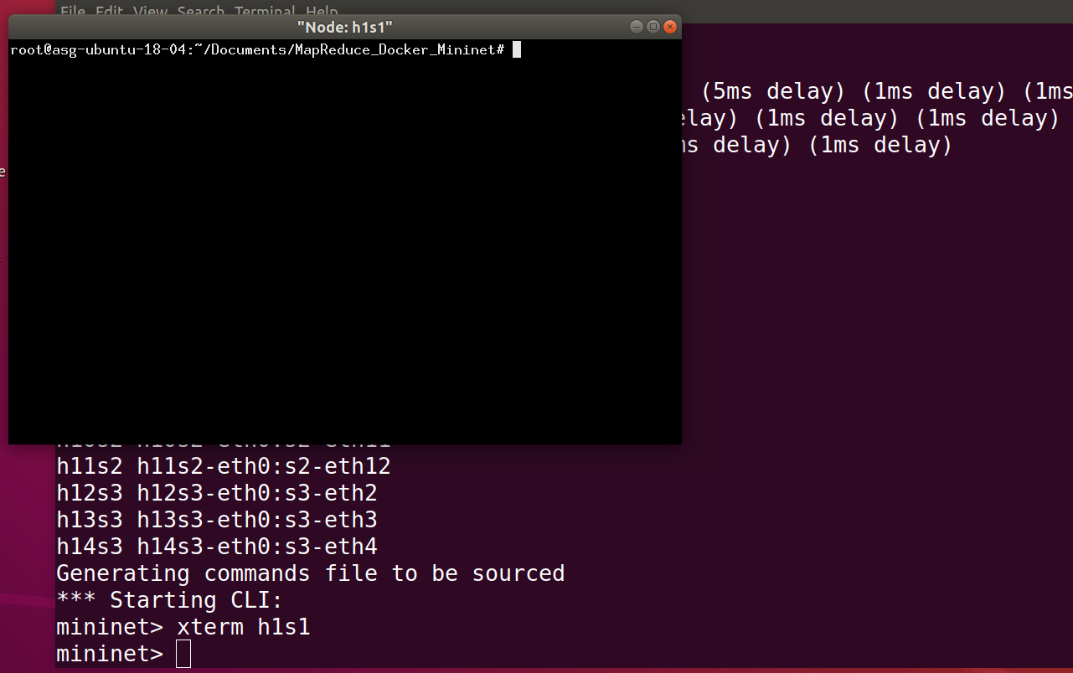

As part of the topology generation, a file called commands.txt is created, which has contents that look like this:

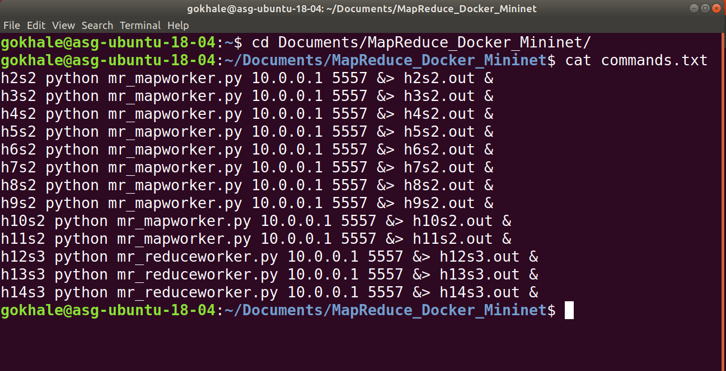

This file can be sourced and will execute the map and reduce workers on the specified hosts as shown.

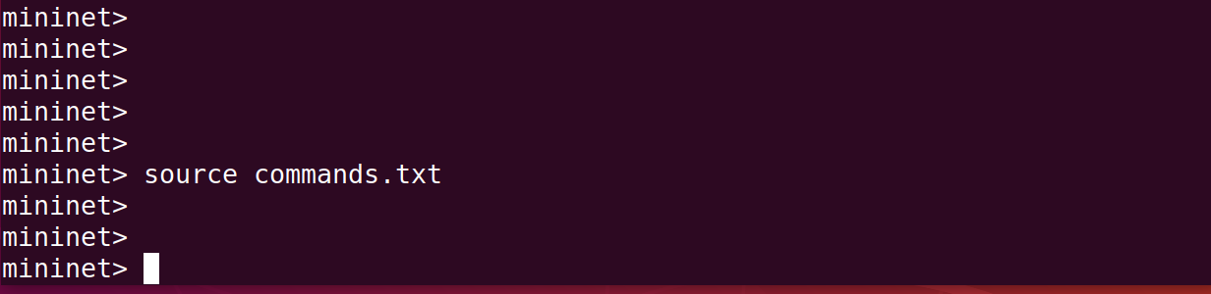

Now go to the Xterm window and use the exactly same number of map and reduce tasks to start the master program

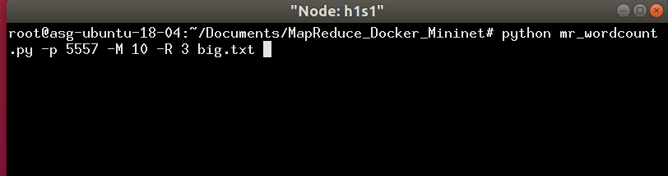

As the code executes for the number of iterations (default 20), a file called metrics.csv keeps getting filled with results for each of the phase of the Map Reduce

