Assignment 1

The Source Data
I have downloaded all the 12 files, and combined them into combined.txt in original_data so that it can be used as input data for Task 1 (the input data does have duplicate words).

Task 1
- the filtering rule: select words that are made solely of English letters without special symbols such as the apostrophe, comma, and hyphen.
- the coreutils tools used: awk (to use regex to apply the filtering rule) and sort (to remove duplicates)
- the number of words of length 3 to 15 letters in the dataset: 1,367,007 words
- the performance on my machine (Intel(R) Core(TM) i7-4710MQ CPU @ 2.50GHz):
- time ./Task1.sh => 5.319s (an average time of 5 executions)
- time ./Task1Filter ../original_data/combined.txt ../input.txt => 5.751s (an average time of 5 executions)
Many hours were spent to come up with a way to shuffle both of the filtered datasets such that they are identical. Because of the limitation not to use the same coreutils tools used in the bash script in the corresponding C program, I couldn’t just use the system() call in my C program to shuffle identically. I finally devised a simple yet effective way to shuffle b y creating a 2d array to store the filtered data and then transposing it both in the bash script and the C program only to be told by the course coordinator that shuffling is in fact unnecessary at odds with the specification. I believe this implementation, which is now commented out, be recognised as a deed exceeding the assignment requirements.

Task 2
- the performance (I have chosen to use the perf tool because it allows for profiling on per-thread and per-process basis, which is necessary to optimise thread performance as required in Task 4; perf record collects samples for event cycles, which then can be analysed to find out the workload of each thread or process):
- Run Time: 3.962s
As seen below, it takes twice as much of the total clock cycle for the map2() to sort and write outputs as for the reduce2() to perform 13 to 1 merge operations; a 91.7% of the total clock cycle can be attributed to operations within map2() in which reduce2() is also called with its share being 33.6% of the total clock cycle.
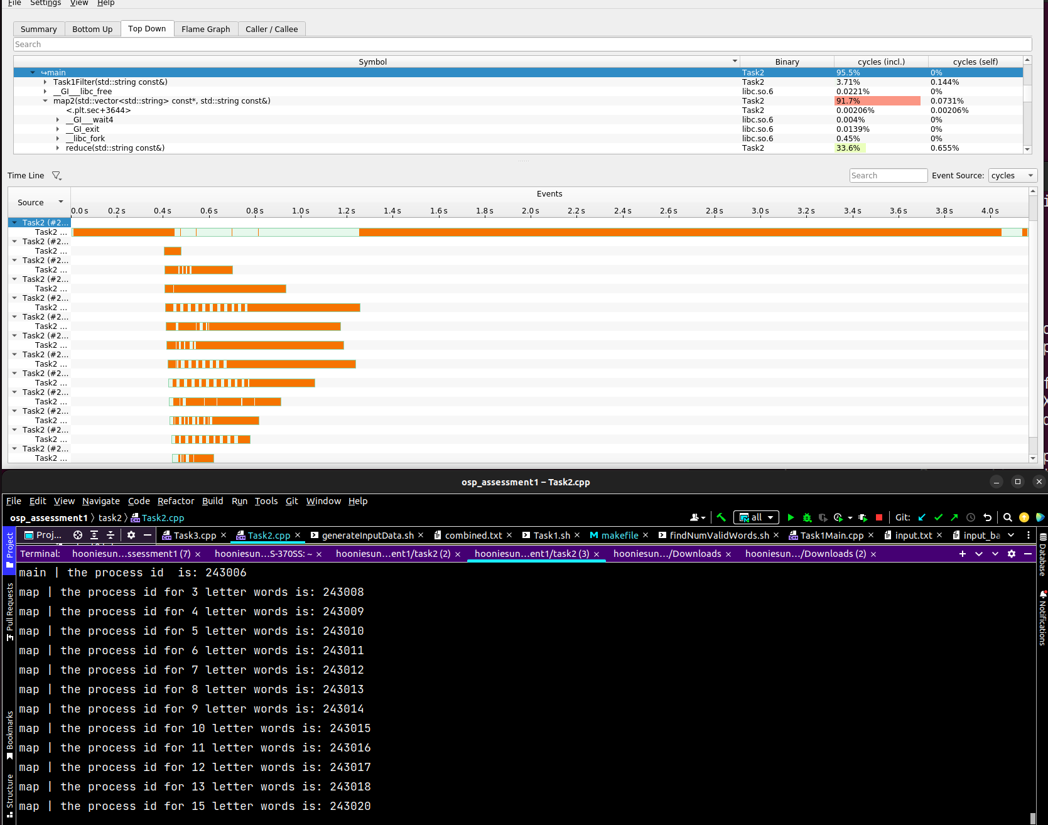

Task 3
- the performance:
- Run time: 7.761s
As seen below, the reduce3() accounts for 55.8% of the total clock cycle, which is a significantly greater proportion than the reduce2()’s share of its own clock cycle. By the design of the program, reduce3() starts its operation only when every thread spawned from map3() finishes its sorting.
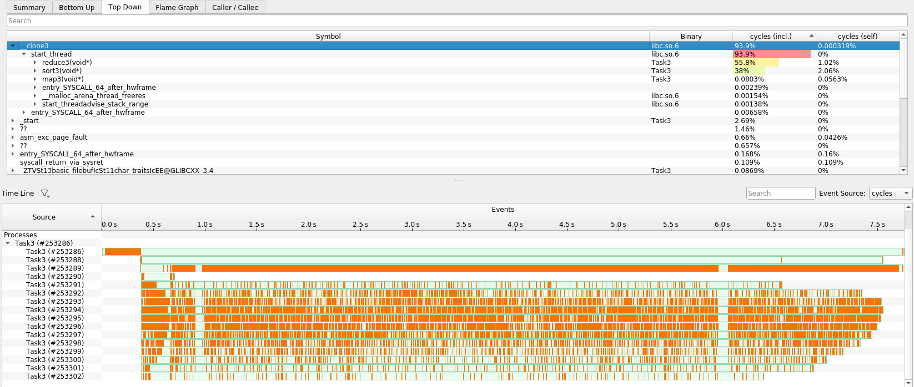
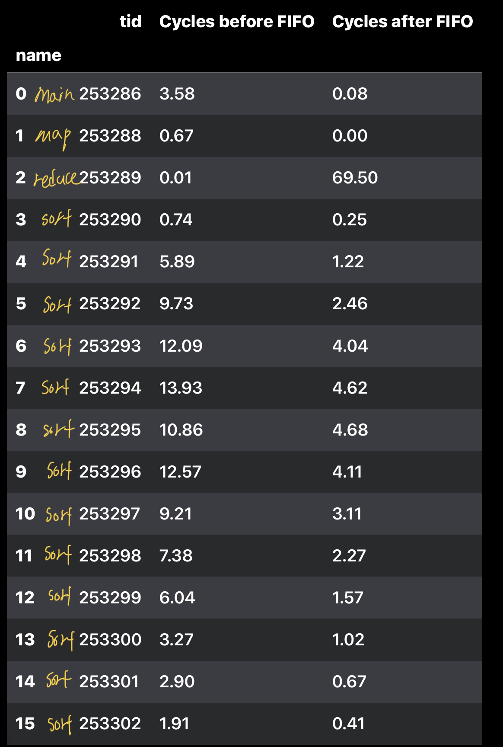
From the left screenshot, it is clear that some threads require more time to sort their respective index array as indicated by the column “Cycles before FIFO” (this information was derived from the visualisation above coupled with the command perf report -s pid –time x%-y% where x is the starting time and y is the finishing time). The rightmost column shows that reduce3() will be the workhorse when every FIFO file is open for writing and reading.

Task 4
- the performance:
- Run time: 5.994s
As per the table above as well as the total number of permissible nice values a user can set being 20 (0 to 19), we can derive nice values for the threads spawned from map4() in the initial sorting phase. To begin with, the 7-letter-sorting thread will receive the nice value of 0 as it requires the largest timeslice.
To decide on reasonable nice values to tweak later on, the following knowledge was applied: the Linux Completely Fair Scheduler calculates a weight based on the niceness. The weight can be calculated using the formula: 1024 / (1.25 ^ niceValue). The timeslice given to a process is in proportion to the weight of the process divided by the total weight of all runnable threads.
The images below detail the reasoning behind the initial nice values for the threads (each number in pink represents the identical number of letters in words assigned to each thread [e.g. 7 below represents a thread that is given an index array for 7-letter words]).
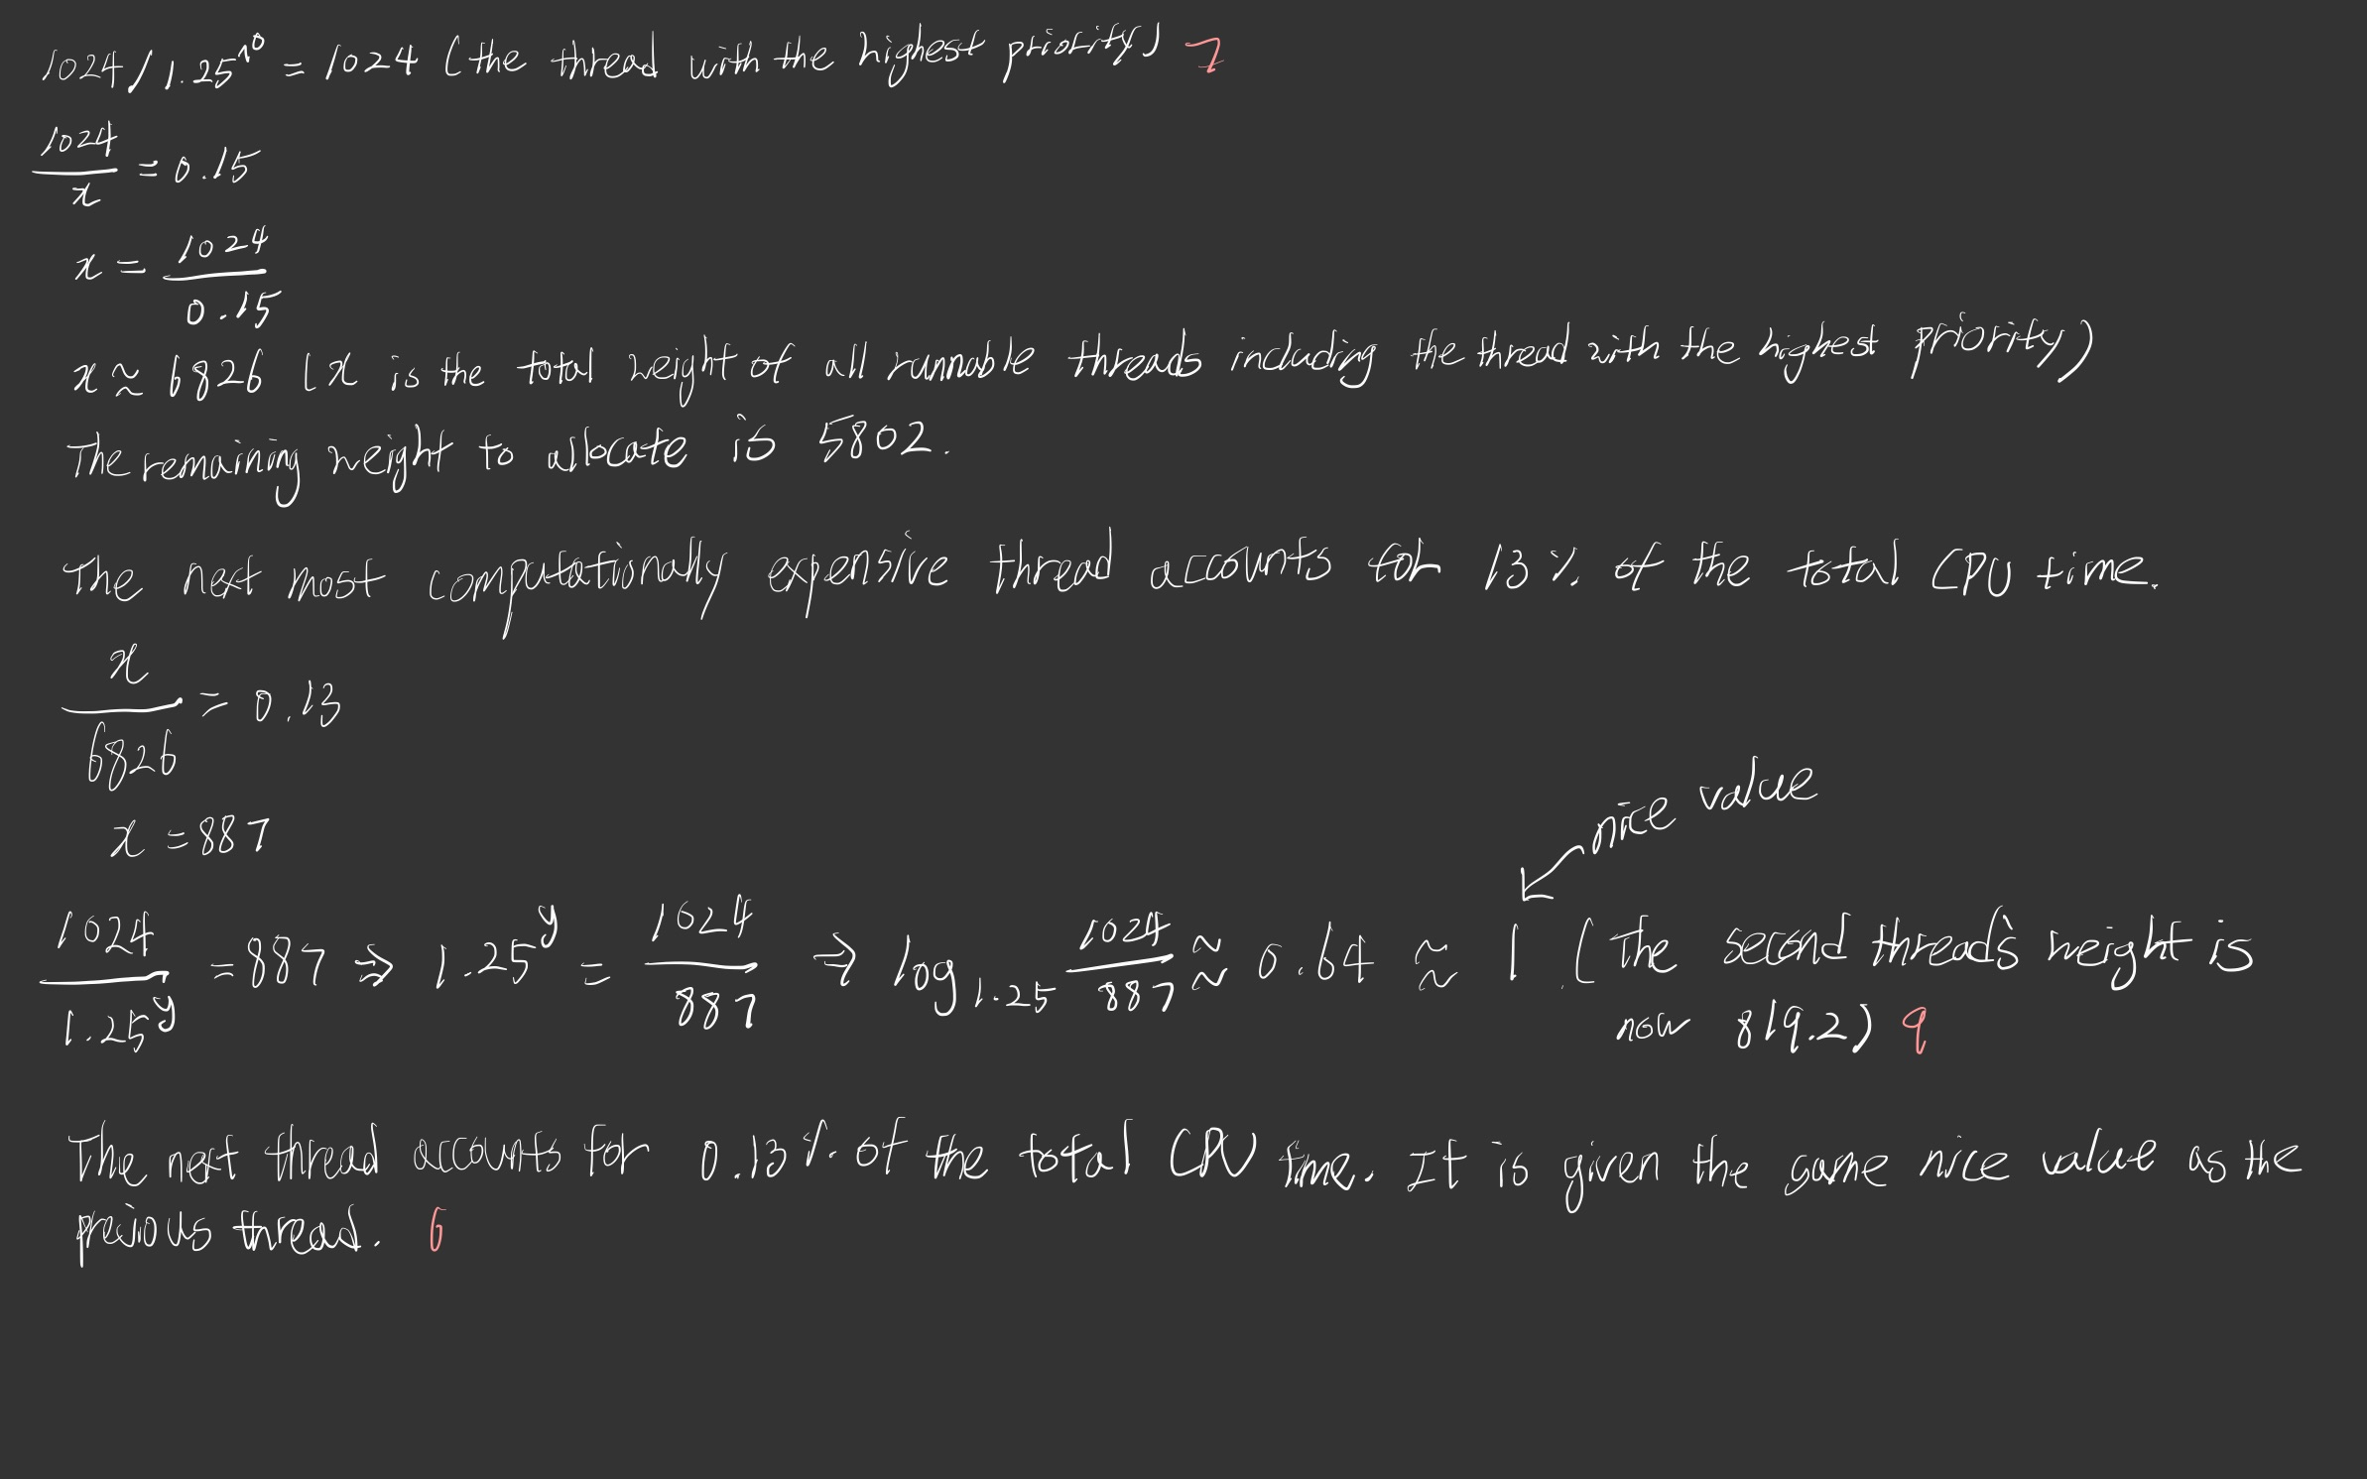

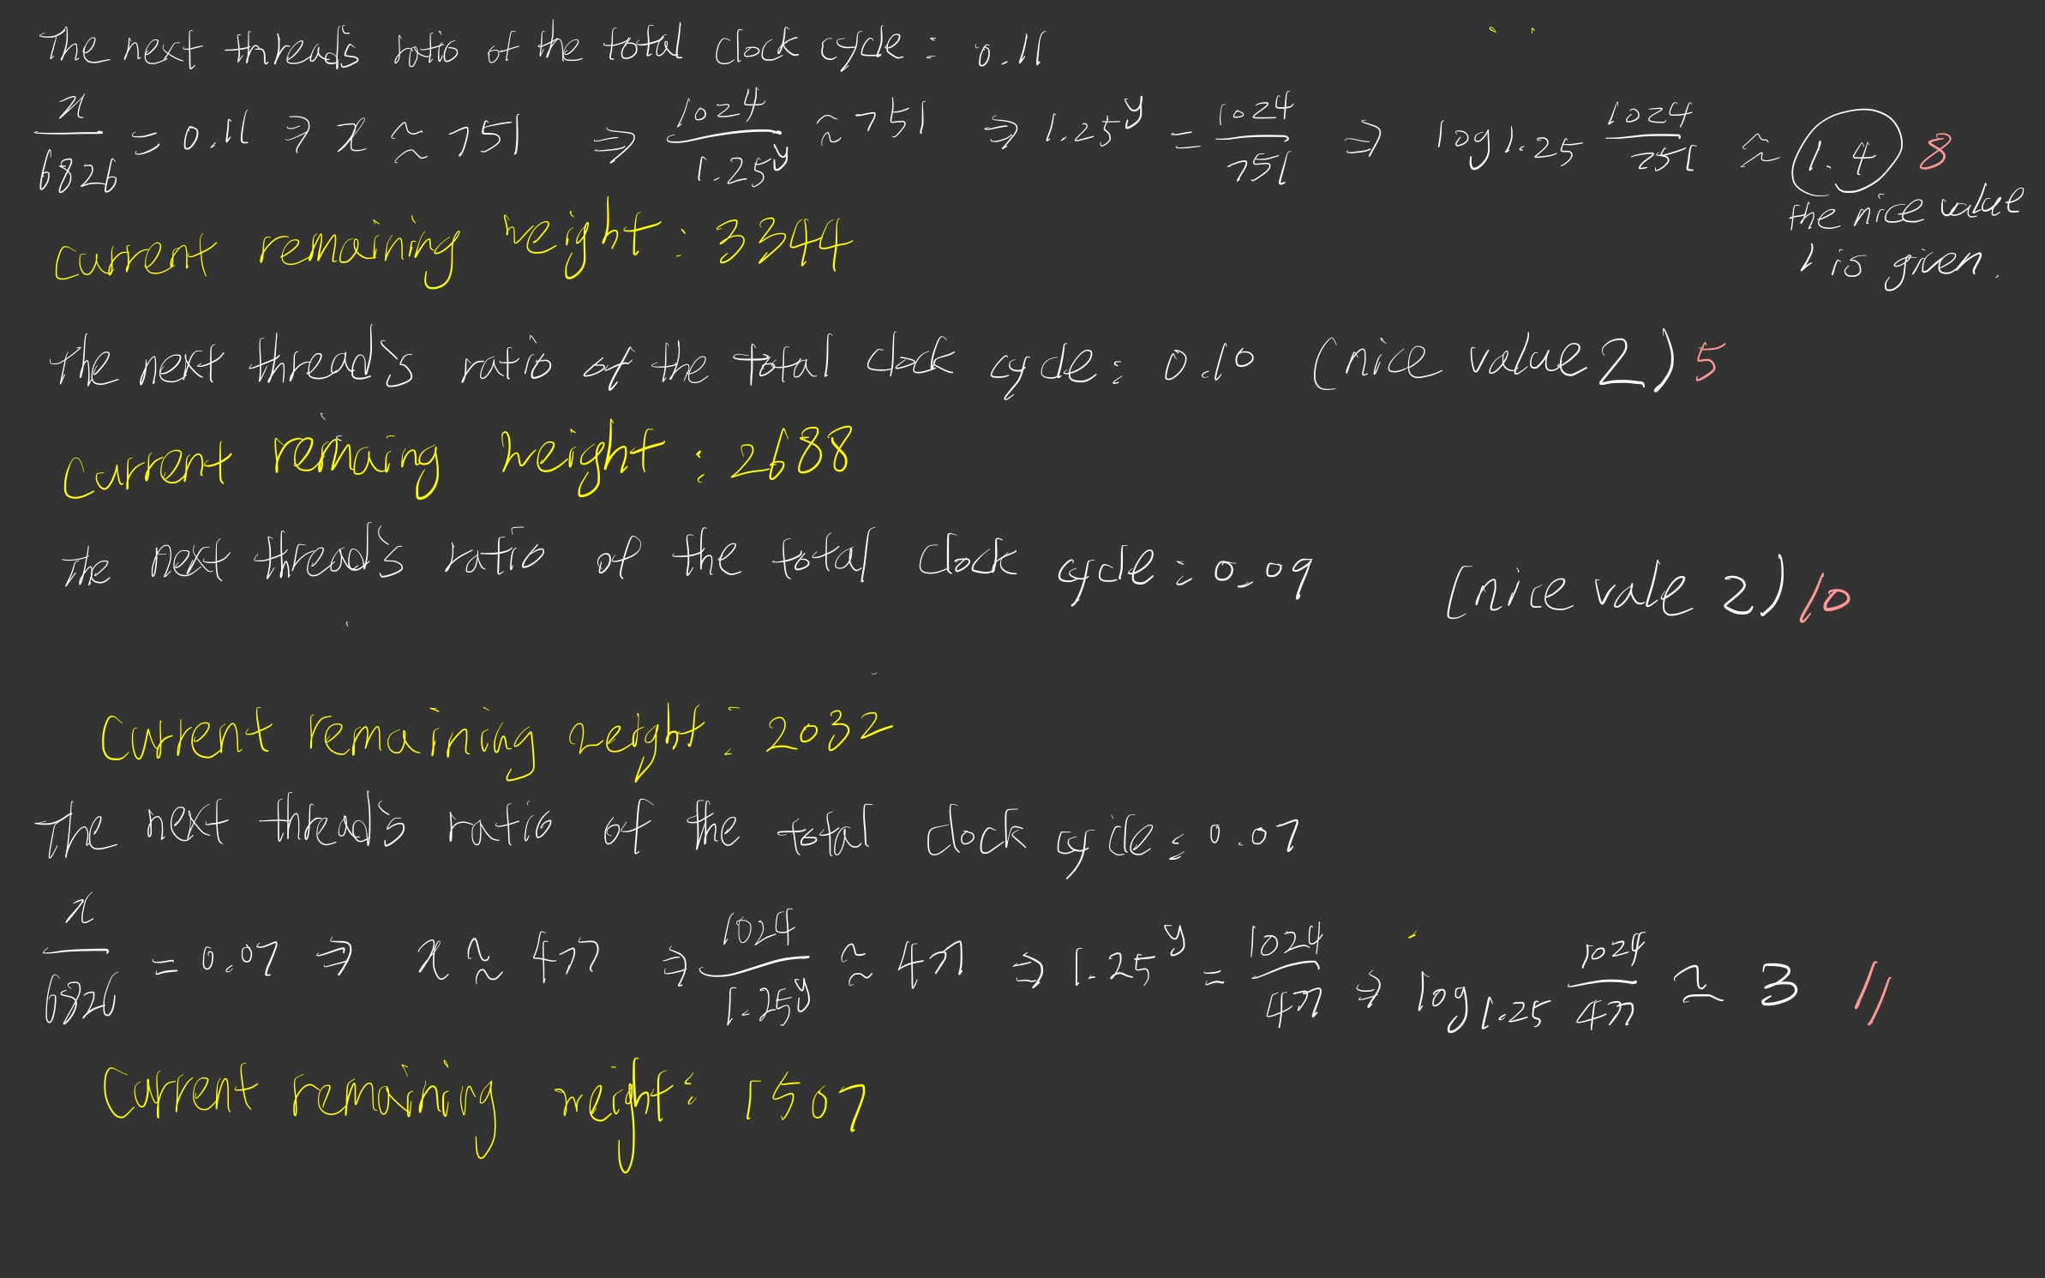
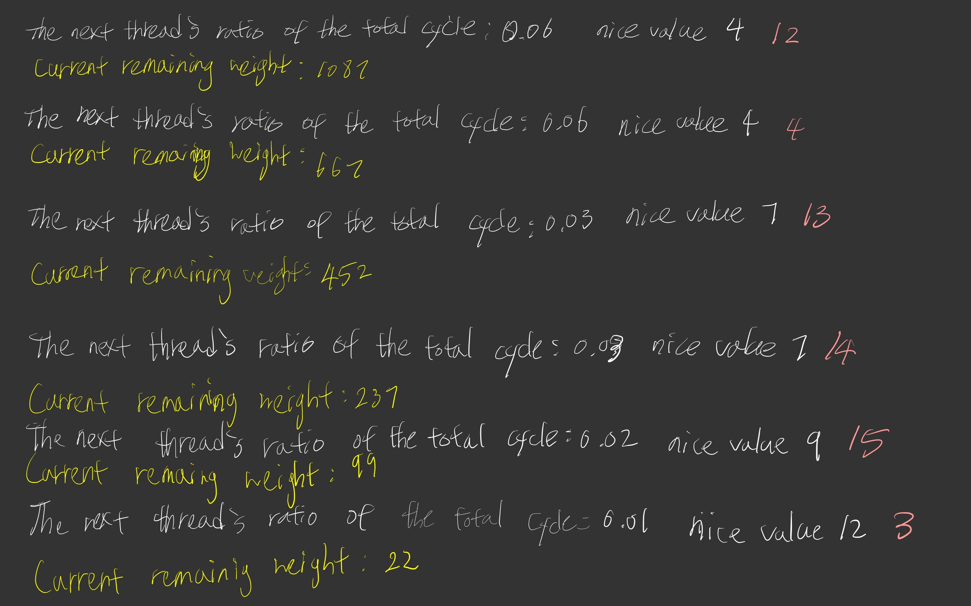

The finalised nice values applicable to the initial sorting phase can be found in the map data structure named niceValueBeforeFIFO in Task4.cpp. After the index arrays are all sorted, the reduce4 does all the CPU-bounded work whereas the threads spawned from map4() are IO bounded. For this reason, IO bounded threads are given the nicest value of 19 to let the reduce4() thread claim more CPU time.
As seen from the screenshot below, all the threads in the phase of sorting index arrays now finish at about the same time thanks to the tweaked nice values.
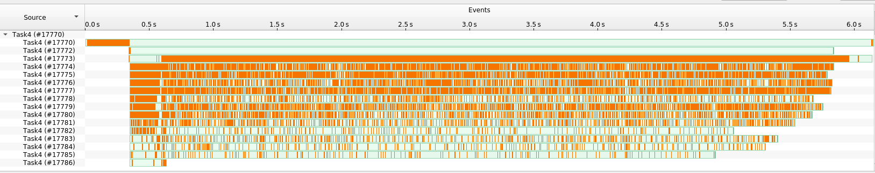
On the other hand, the screenshot below shows the result from the initial nice values. We can see that many threads roughly finish at the same time except for the thread #20495, 20496, and a few others. After changing the nice values for these threads and others, the screenshot above illustrates all the threads can finish at about the same time.
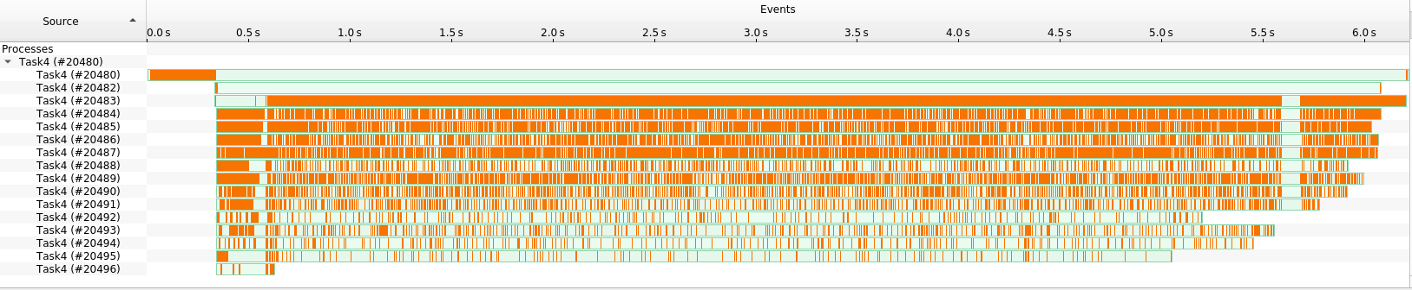
As seen in the screenshots above, the majority of the program’s running time is spent in reduce4() in which words are read from FIFO files and then sorted to determine the lowest word in lexical order. Therefor, all the changes so far made in places other than reduce4() have brought about improvement too small to contribute to the overall performance.
As for the last question “what is the time complexity of the program?”, we can divide the program into two parts where most computationally expensive operations execute: one before FIFO files are open for writing (during which the sorting of index arrays takes places) and the other after FIFO files are read (during which the files are read and the 13 words at a time are sorted).
- O(nlogn) – n words are divided into 13 parts and the largest part determines the time complexity; the largest part can be no greater than n.
- O(n) – 13 words are sorted n number of times (n*(13log13))
In conclusion, the multi-threaded programming has helped decrease the role the first part plays in the time complexity of the whole program, as this most computational work is now divided across multiple threads. The time dominating time complexity is O(n) with the caveat that the constant in front of n is large, resulting in the time complexity of O(nlogn) in practice. The empirical performance does not reflect the theoretical time complexity as it would in single-thread programming since these threads run with varying priorities.

Task 5
- cat - | sort (cat’s output becomes input of sort; when all of the lines are read [a binary tree is built with each node containing a block of data and sorting it in a multi-threaded fashion and, all the nodes then get merged to the root node], sort then sorts them, after which you “get to see the output”)

