**Computer Networks**

**HOMEWORK #2**

**Due date: 2021/05/03**

NOTE: WRITE YOUR ANSWERS IN ENGLISH.

ID#: 2014310375 Name: (Kor.) 이지훈 (Eng.) Lee Jihoon

**Problem #1.**

1. Users can check the header before downloading
2. Users can search the strings of the emails before downloading
3. Users can partially download emails

**Problem #2.**

1. Yes. Because closest peer with N>=k is called the successor of k.
2. No. Because only node can have predecessor.

**Problem #3.**

Because TCP provides reliable service. There can be uneven delays when using UDP.

**Problem #4.**

Go-Back-N protocol can use receive window as size of 2^m-1, otherwise Selective-Repeat protocol use size of 2^(m-1) which is smaller than GBN protocol. Go-Back-N protocol can be inefficient when underlying network loses a lot of packets because it has to send all of lost packets again, while Selective-Repeat protocol send only lost packets.

**Problem #5.**

Every network devices must have all their own IP address. So there are 2^32 IP addresses in IPv4. Also subnet masks and private IP help these IPs divide and use efficiently. Otherwise, port numbers are just protocols when using TCP/IP networking between network devices. So there needs no that much port numbers in contrast with IP addresses.

**Problem #6.**

1. 0045
2. 57088
3. 58 bytes
4. 50 byyes
5. Server to client
6. DNS, SNMP, DHCP, RIP

**Problem #7.**

The server is like below.

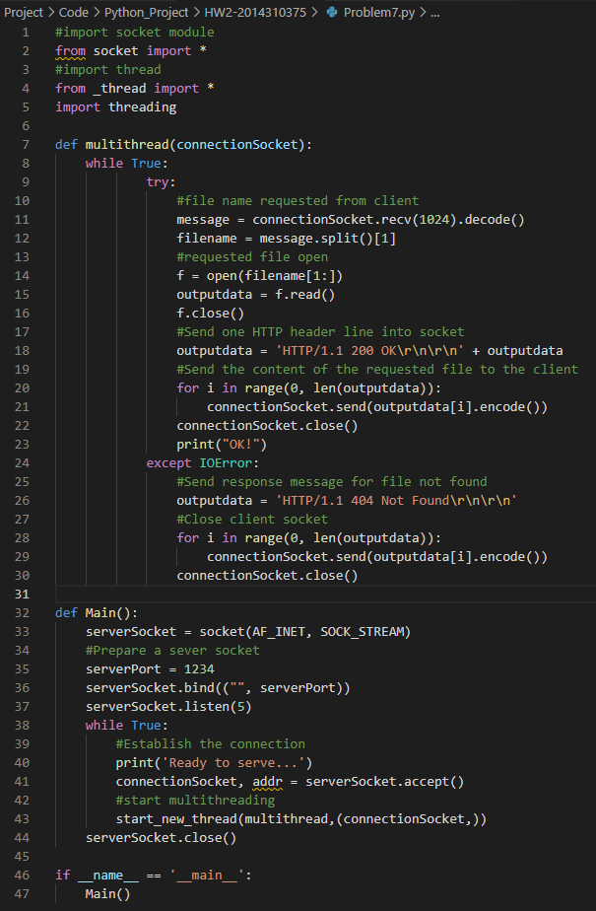

Multithreading test using three same clients :

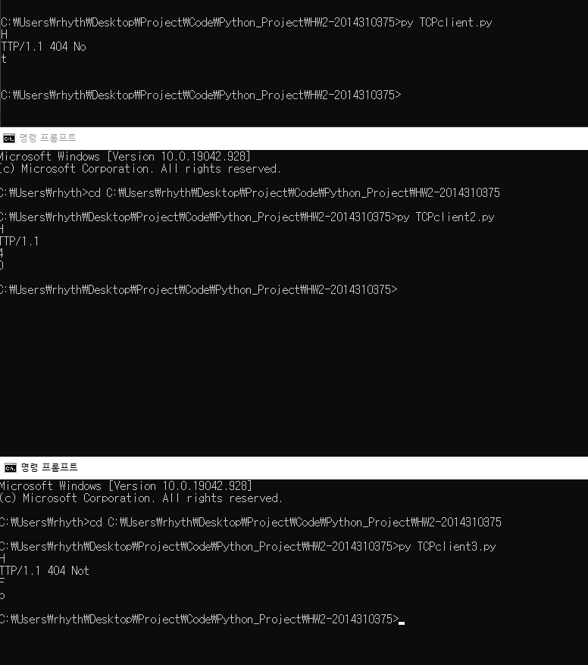

**Problem #8.**

this is the server and client code.

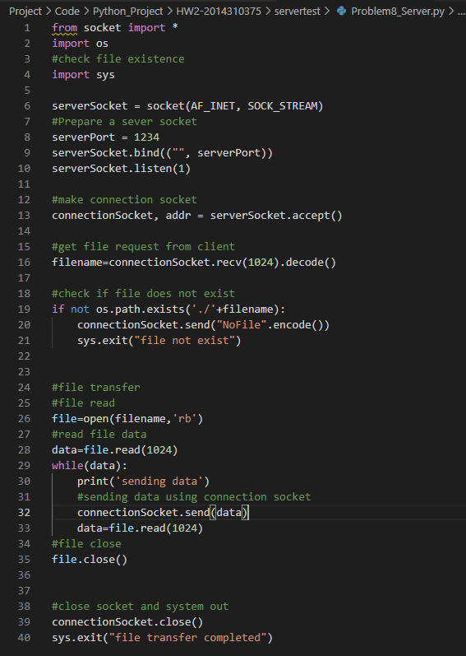

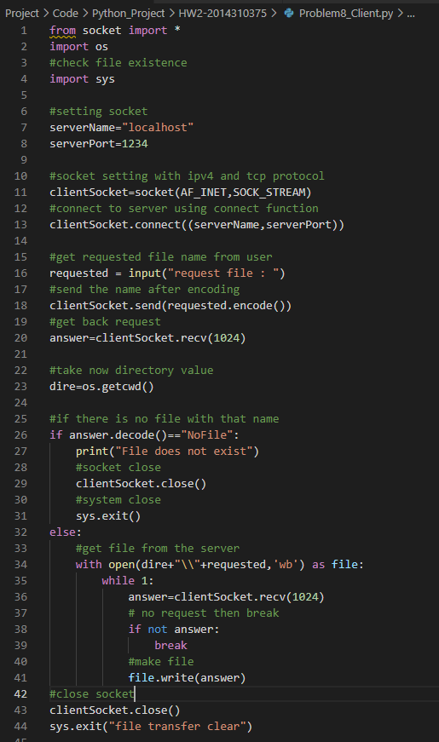

1. When requesting existing file to server

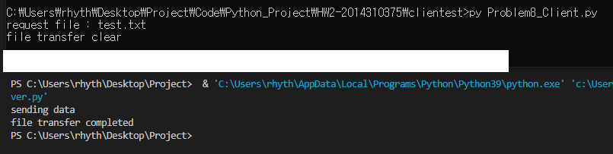

Upper one is client side, and last one is the server side.

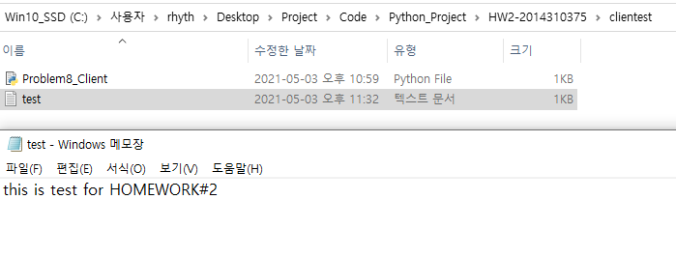

1. When requesting not existing file to server

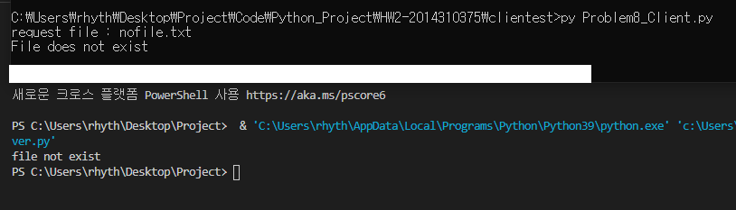

The first one is client side. Second one is server side.