CS-340 Dashboard
Date submitted: Saturday, October 17th, 2026
Instructor: Dr. Helen Gebre-Amluk
CS340-13407-M01

About
This project is a dashboard created for Grazioso Salvere in order to allow for identifying suitable breeds for different types of rescues such as Water, Mountain or Wilderness, and Disaster or Individual Tracking. This dashboard connects to a MongoDB database containing data from an animal shelter in Austin, Texas using CRUD_Python_Module in order to create a table of breeds matching the required criteria for a specific type of rescue. This dashboard also displays a pie chart showing the distribution of breeds matching the selected type of rescue and an interactive map showing the location of a breed selected from the table.

Required Tools
- Python3: Python 3 is the latest version of Python, which is a widely used programming language that is easy to use and has many use cases. The Project 2 Dashboard is written in Python 3.
- MongoDB: This is a NoSQL database that can handle data that is unstructured in BSON format while being adaptable to changing database requirements while also allowing for fast read/write operations. Additionally, MongoDB can interface with Python using the pymongo library.
- Pymongo: This is a Python library that allows a Python application to interact with a MongoDB database.
- Dash: Dash is a Python framework that allows building interactive web based dashboards using Python code without the need to create code using web development languages such as HTML, CSS, and Javascript. It is commonly used for data visualization and has builtin support for graphs and tables, such as the interactive data table and the pie chart used in the Project 2 dashboard. Additionally, callback functions are used to decorate plain Python functions, allowing a function to be called upon an input change with the app layout being updated accordingly.
- Plotly Express: Plotly Express is a python module that allows for the creation of figures such as graphs. In the Project 2 dashboard, this is used in order to allow for the use of a pie chart showing the distribution of animals breeds according to the specified filter chosen by the dropdown menu.
- Dash Leaflet: Dash Leaflet is a wrapper that allows using Dash syntax to display a map via the Leaflet, which is a popular JavaScript library for displaying interactive maps. In the Project 2 dashboard, Dash Leaflet is used to show an interactive map that displays the location of an animal chosen from the interactive data table.
- JupyterLab: JupyterLab is a web-based development environment that allows creating notebooks containg code. This was chosen as a dependency as the Project 2 dashboard runs on top of Jupyter lab.
- Jupyter Dash: Jupyter Dash is a library that allows developing Plotly Dash applications inside of a Jupyter Notebook. This was chosen in order to allow the use of the Dash framework in the Project 2 dashboard, which runs on top of a Jupyter notebook.
- CRUD_Python_Module (included with project submission): CRUD_Python_Module is a Python module that makes use of PyMongo to allow the use of the AnimalShelter class, which allows one to connect to a MongoDB collection (such as the animals collection used in this project), in order to perform Create, Read, Update, and Delete (CRUD) operations on that collection.

Getting Started
The following steps are required in order to get this project to work:
1. Import the Animal Shelter Outcomes CSV file via mongodb using a command like the following:
mongoimport --db --collection animals --type csv --file ./aac_shelter_outcomes.csv --headerline
2.Using mongosh, use the aac database and create an a simple index on the breed key along with a compound index for the breed and outcome_type keys.
3. Create a user (aacuser is used in this submission) with readwrite access to the aac database.
4. Authenticate the user in mongodb. For example, one can launch mongosh, use the aac database, and then run the following command:
db.auth(‘aacuser’, passwordPrompt())
5. Install the required Python and the required Python libraries.
6. Modify the authentication variables in the ProjectTwoDashboard.ipynb file (username, password, hostname, port, database, collection) accordingly in order to ensure CRUD_Python_Module is using the correct variables to connect to the database.
7. Run the code in ProjectTwoDashboard.ipynb file in JupyterLab. A link to the program should be output that allows the user to open the dashboard.

Functionality
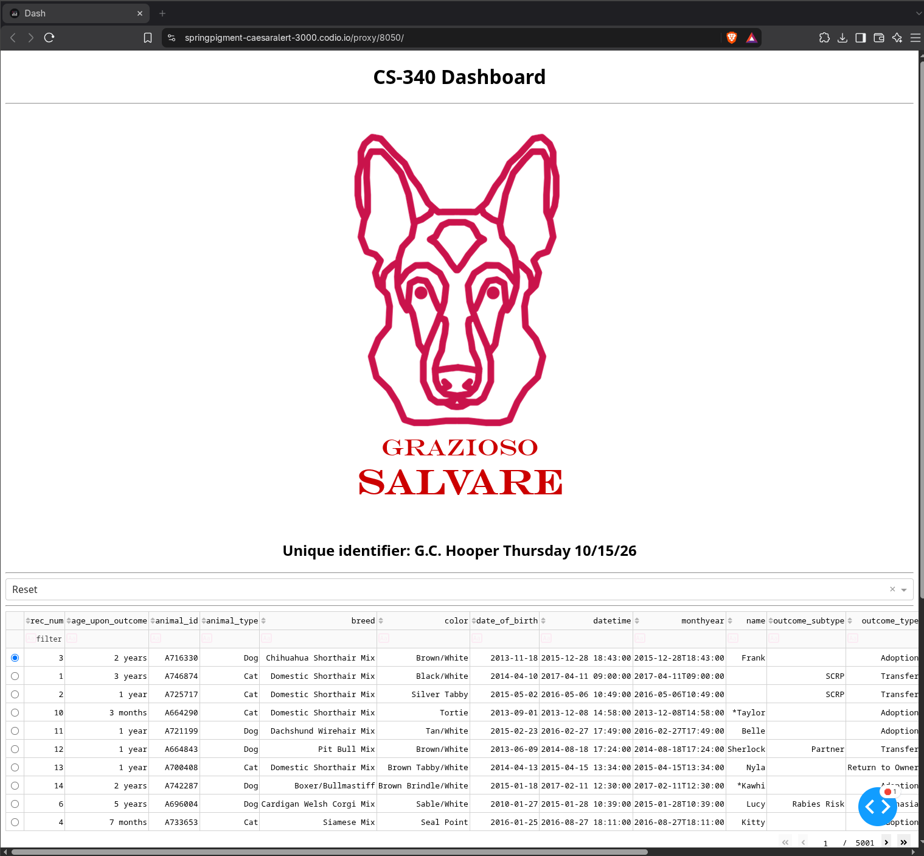
Upon configuring the application and running it, a dashboard, as shown in the two screenshots below, will display the logo of Grazioso Salvare, along with a drop down menu containing the following options: Water, Mountain or Wilderness, Disaster or Individual Tracking, and Reset, the latter of which resets the filter options. Furthermore, an interactive data table containing breeds matching the selected criteria is shown, along with a pie chart displaying the distribution of breeds matching the selected criteria and a map showing the location of a specific animal selected from the interactive data table. The two screenshots shown below are an example of the dashboard and its widgets in the original, unfiltered state.
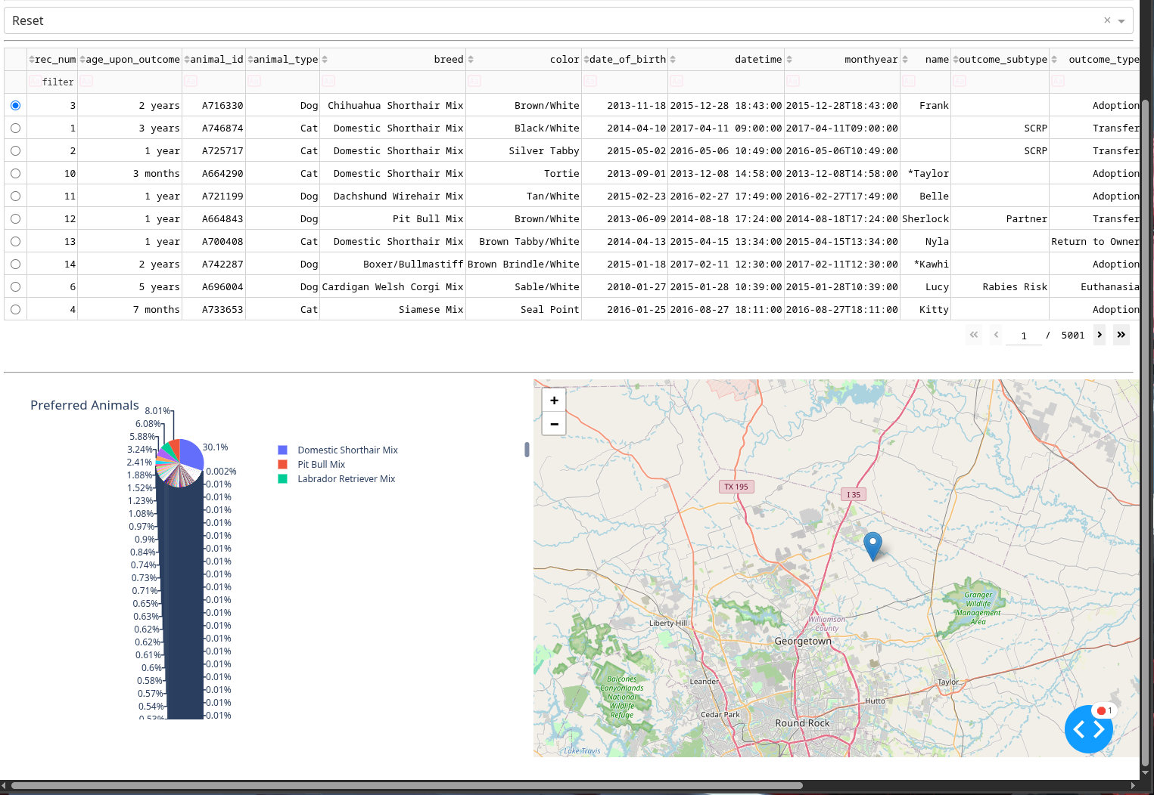

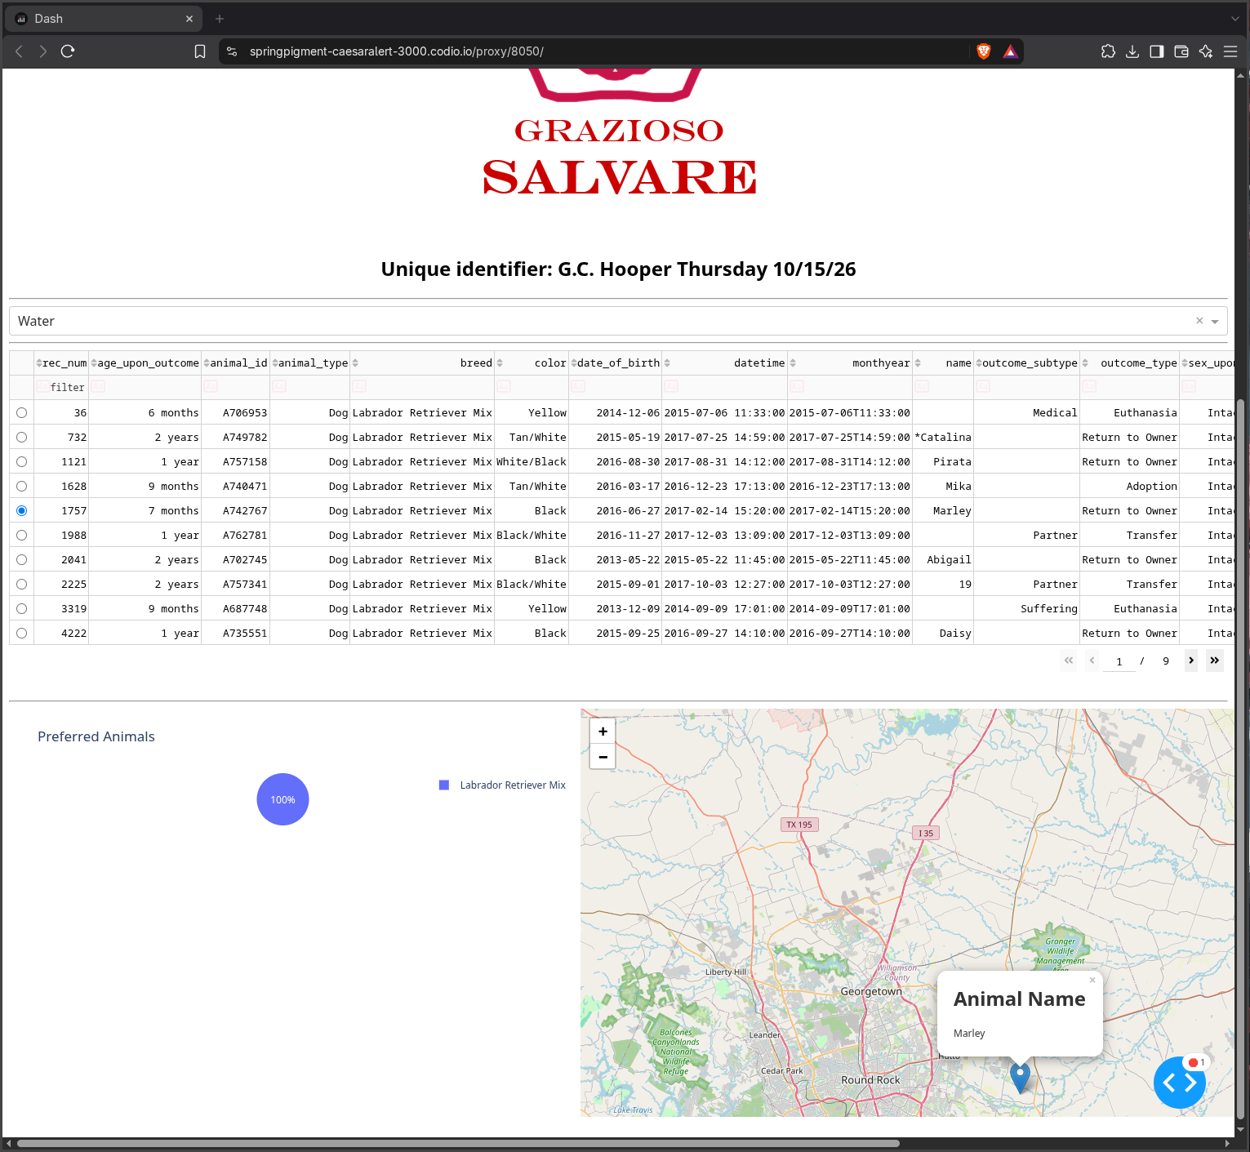
Shown below is an example of the Water rescue option being selected, along with the interactive map showing the location of a selected breed, in this case being the animal with the name Marley. Additionally, it is shown from the pie chart that 100% of Dogs suitable for Water rescues are of the breed Labrador Retriever Mix:

The following is an example of the Mountain or Wilderness rescue option being selected. Additionally, the Dog with the name Papa is selected, with its location shown on the map. Furthermore, the pie chart indicates that 40% of dogs suitable for a Mountain or Wilderness rescue are of Siberian Huskies, 20% are Rottweilers, 20% are German Shepherds, and 20% are Alaskan Malamutes.
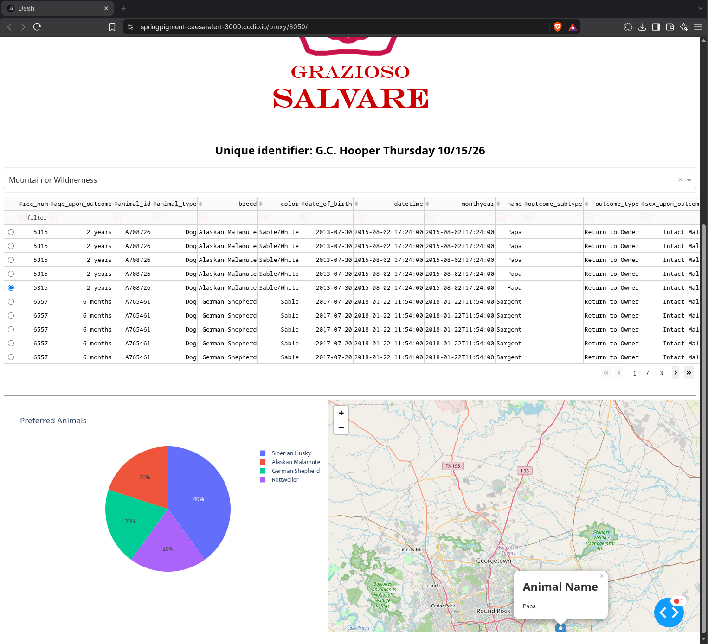
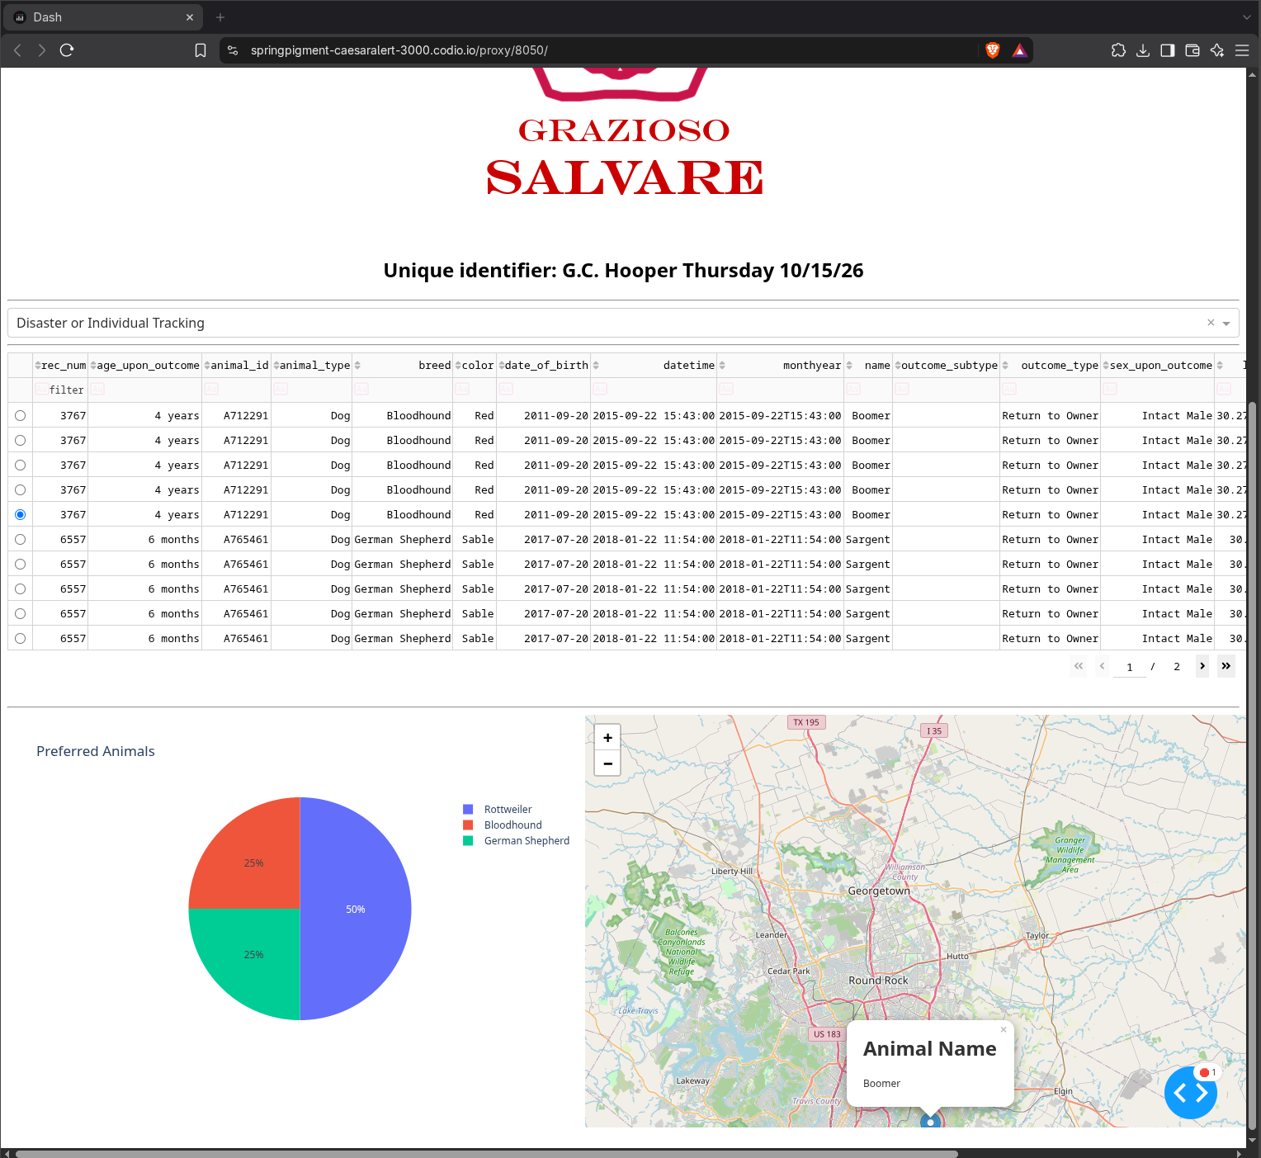
The following shows an example of the Disaster or Individual Tracking option being selected. The Dog with the name Boomer is also selected with its location shown in the map. Additionally, it is shown that 50% of dogs suitable for this type of rescue are Rottweilers, 25% are German Shepherds, and 25% are Bloodhounds.
Lastly, the following screenshot shows an example of the Reset option being selected. The pie chart shows the distribution of breeds across the entire animal shelter database. Additionally, the animal named Lucy is selected and its location is displayed on the map.
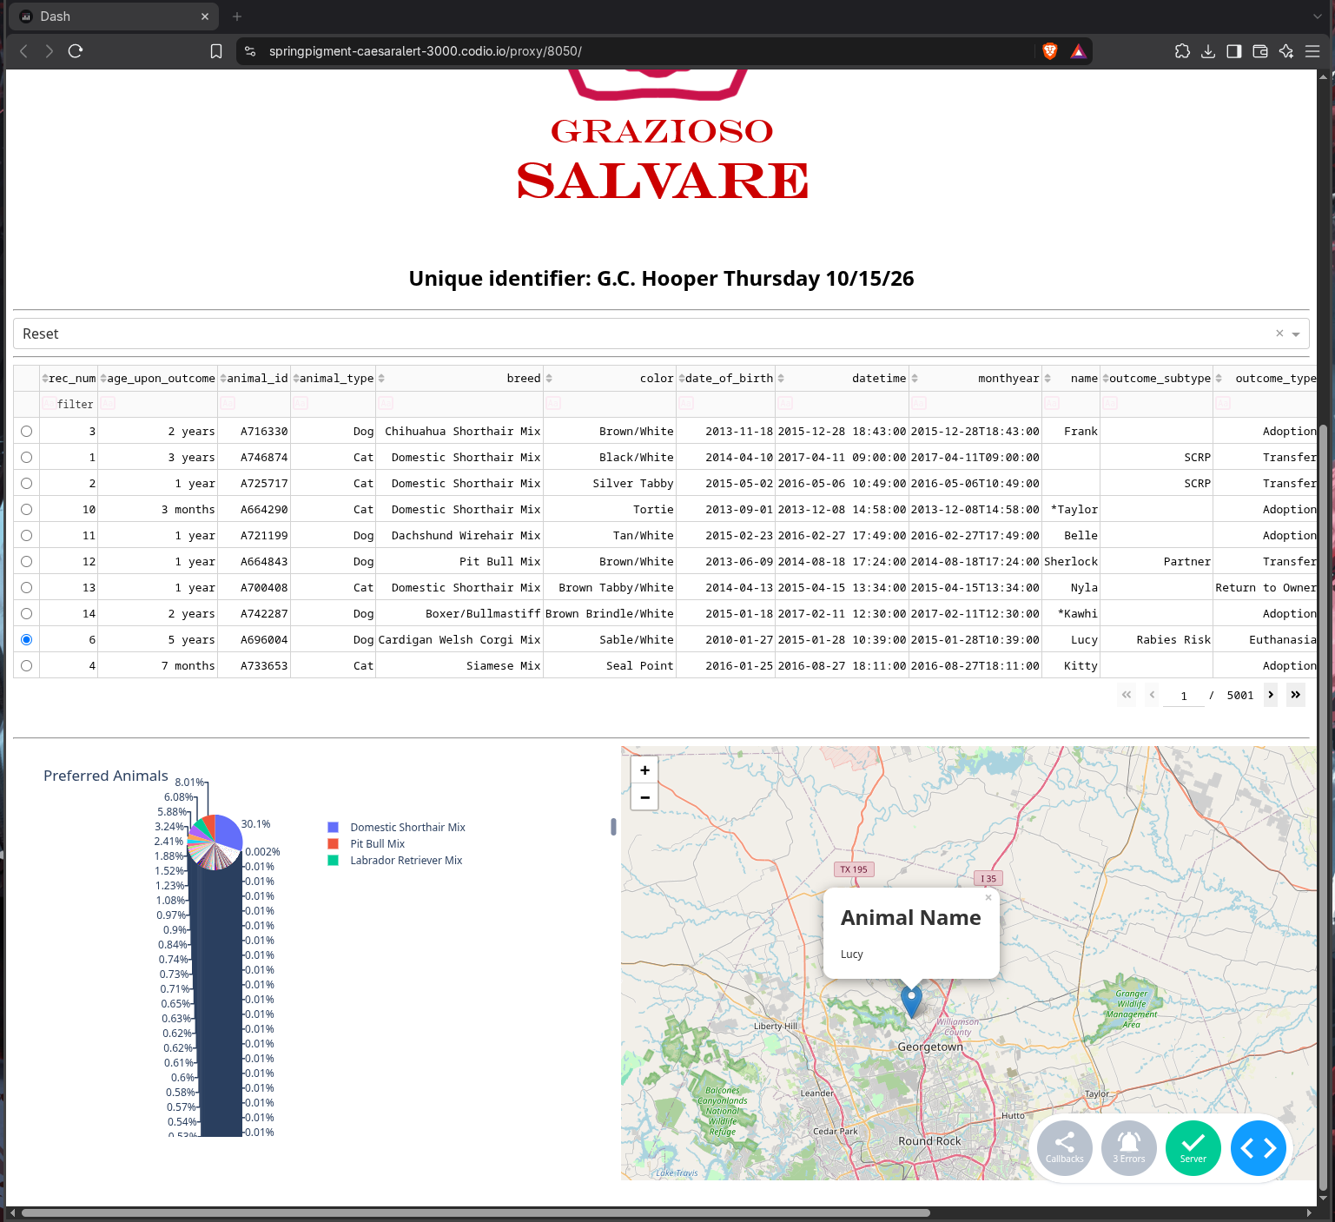
Challenges
One challenge faced when creating the Project 2 Dashboard was the creating the update_dashboard function. In this case, I struggled with the update_dashboard function crashing. I overcame this challenge by adding in code to drop the _id field from my results. Additionally, since the update_dashboard function returned a tuple with the data and columns, the callback function had to be modified accordingly.

Resources:
Python: https://pythongeeks.org/python-3-installation-and-setup-guide/
MongoDB: https://www.geeksforgeeks.org/python/mongodb-and-python/
Pymongo: https://www.mongodb.com/docs/languages/python/pymongo-driver/current/
Dash: https://www.geeksforgeeks.org/python/introduction-to-dash-in-python/
Dash: https://plotly.com/dash/
Dash Leaflet: https://plotly.com/dash/
JupyterLab: https://docs.jupyter.org/en/latest/install.html
JupyterDash: https://pypi.org/project/jupyter-dash/

Contact:
G.C. Hooper
Email: gunner.hooper@snhu.edu

