_ __ _ __ ___ __ _ _ __ __ _ _ __ ___ _ __ ___ (_)_ __ __ _
| '_ \| '__/ _ \ / _` | '__/ _` | '_ ` _ \| '_ ` _ \| | '_ \ / _` |
| |_) | | | (_) | (_| | | | (_| | | | | | | | | | | | | | | | (_| |
| .__/|_| \___/ \__, |_| \__,_|_| |_| |_|_| |_| |_|_|_| |_|\__, |
|_| |___/ |___/
_ _
__ _ ___ ___(_) __ _ _ __ _ __ ___ ___ _ __ | |_
/ _` / __/ __| |/ _` | '_ \| '_ ` _ \ / _ \ '_ \| __|
| (_| \__ \__ \ | (_| | | | | | | | | | __/ | | | |_
\__,_|___/___/_|\__, |_| |_|_| |_| |_|\___|_| |_|\__|
|___/
Q1 Beta-bernoulli Naive Bayes
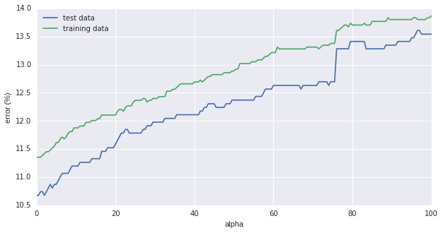
Error rates for both data sets increase with alpha,
- Plateaus at about 60
- Jumps discontinuously at 75. This reflects a sudden poor fit of some of the emails due to a gradual change in prior distribution. If the emails were evenly sampled in the feature space, this is unlikely to happen. This suggests the presence of emails having almost or completely similar feature vectors.

Error rates for alpha = 1, 10, 100
- Training : 11.35, 11.88, 13.87
- Testing: 10.74, 11.2, 13.54

Q2 Gaussian Naive Bayes
Error rates
- Z-normalised
- Training : 18.85
- Testing: 16.28
- Log-transformed
- Training: 17.26
- Testing: 15.95

Remarks
Error rates for test data are lower than training data,
This is counter-intuitive - I expected the training data to have a smaller error rate since the classifier was trained using this data.
We see this trend
- repeated when a different generative classifier is used (Gaussian Naive Bayes), with different pre-processing strategies
- not repeated for non-generative classifiers (Q3,4), and the various pre-processing strategies with the exception of the z-normalised data classifed by logistic-regression
Q3 Logistic Regression

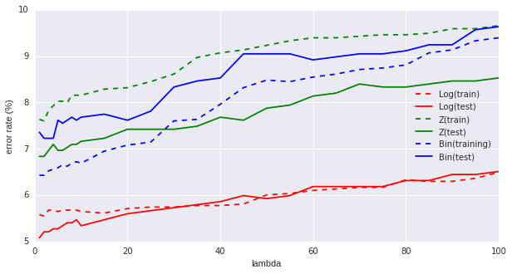
Pre-processing | Train | Test
Binarised | 6.43, 6.69, 9.40 | 7.36, 7.68, 9.64
Z-transformed | 7.63, 8.16, 9.66 | 6.84, 7.16, 8.53
Log-transformed | 5.58, 5.64, 6.50 | 5.08, 5.34, 6.51
Training and test error-rates for lambda = 1, 10, 100

Training and test error rates increase with lambda
– large lambdas causes ||w|| to tend to smaller values, in this case, too small perhaps, for accurate training.
- smaller lambdas allow ||w|| to take a larger range of values, whose effect is tantamount to switching off regularisation.
In this case, it seems that there is no risk of ||w|| ‘exploding’ as the error rates remain small.

Best pre-processing strategy
Error rates for log-transformed data produced the smallest error rates.
- The errors also converged for the test and training data for most values of lambda.

Q4 K-Nearest Neighbors
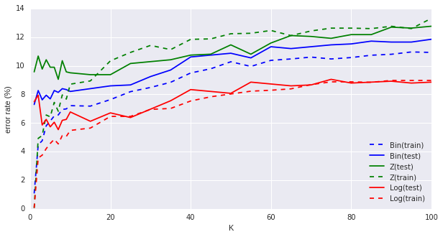

Pre-processing | Train | Test
Binarised | 1.08, 7.21, 10.93 | 7.29, 8.2, 11.85
Z-transformed | 0.07, 8.71, 13.31 | 9.57, 9.51, 12.76
Log-transformed | 0.07, 5.48, 8.97 | 7.49, 6.77, 8.85
Training and test error-rates for K = 1, 10, 100

Why error rate is non-zero when K=1
When K = 1, the first nearest-neighbor for any email in the training data is itself.
Typically, we do not expect any other email to be closer than itself, but for binarised data, the volume of the feature-space is much smaller than for continuous data, and so more than one email may have the same feature vector.
As such, the nearest neighbor may not be itself, but another mail, which could be categorised differently. Thus, the error is not zero when K=1.
For training data that are continuous (Z and log-transformed), it is highly unlikely that there are emails having the exact same feature vector, thus the error rate approaches 0 as K decreases.

In contrast, the first nearest-neightbor for any email in the test data cannot refer to itself when K=1 – this is because the nearest neighbors are from the test set. Thus, the error rates are higher.

Best pre-processing strategy
The log-transformed data has the lowest error-rate

Q5 Survey

About 3-4 hours was spent per question – it seems reasonble compared to the time spent on coding tasks of similar complexity.

Additional 4 hours was spent correcting data-formatting errors made in log-transformation,
and setting thresholds to favor categorising a mail to be not-spam in the event that Prob(spam)=Prob(not spam).

Acknowledgements
This work was discussed with Adrian Utama – we compared our error rates and had some discussions about the analysis.

