PCA
Visualize the projected data vector in 2d and 3d plots.
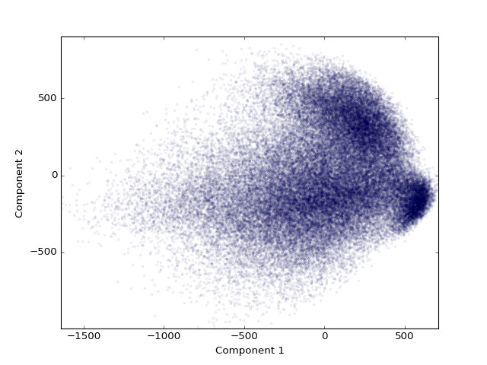 | 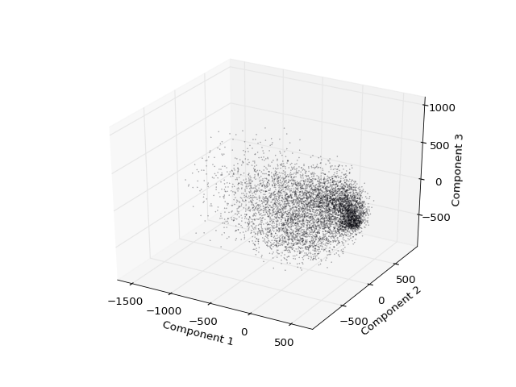

Also visualize the
eigenvectors of sample covariance matrix used in PCA.
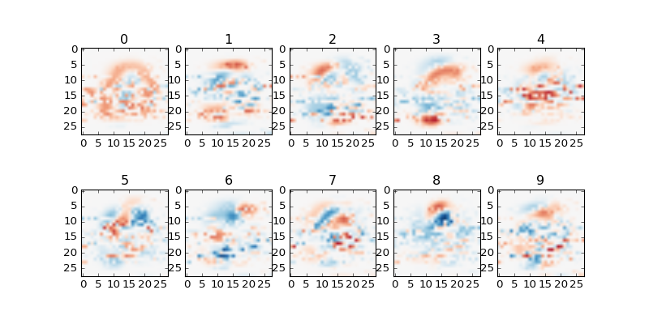 | 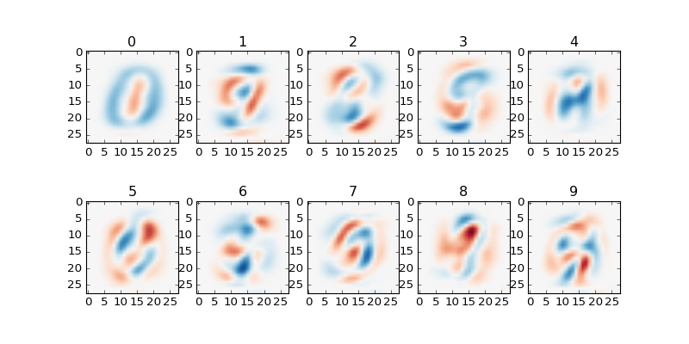
Using Eigenvalue decomposition | Using SVD
Interestingly, the eigenvectors obtained through SVD looks more continuous than the one obtained from eigenvalue decomposition. However, we use the latter method as that is the one used in the lectures.

Apply PCA to reduce the dimensionality of raw data from 784 to 40, 80 and 200 respec-
tively. Classifying the test images using the rule of nearest neighbor. Report the classification
accuracy.
Accuracy for 40, 80 and 200 components: 4.26%, 3.82%, 3.36%

Investigate what value of d preserves
over 95% of the total energy after dimensionality reduction.
153

Apply PCA to reduce the data
dimension to d and report classification results based on nearest neighbor.
3.54%: this result lies in between the accuracy obtained with 80 and 200 components, which is to be expected.

Can you devise other criteria for automatically determining the value of d?
We can progressively add components until the difference in fitting errors between each trail falls below a set threshold.

LDA
Visualize distribution of the
data with dimensionality of 2 and 3 respectively
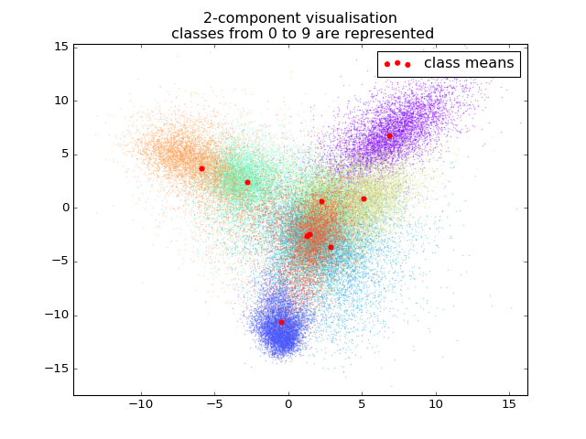 | 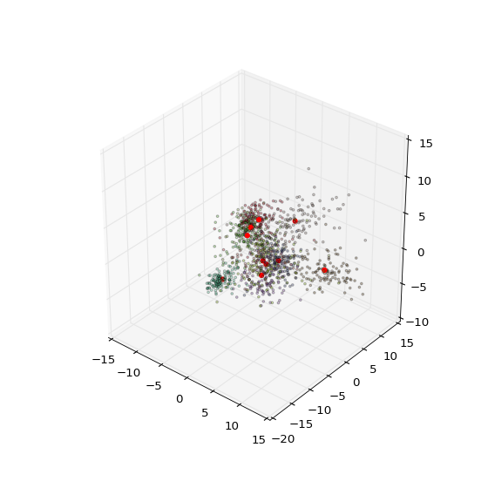

Report the classification accuracy for data with dimensions of 2, 3 and 9 respectively, based on nearest neighbor classifier.
47.41 %, 66.64 %, 89.5 %
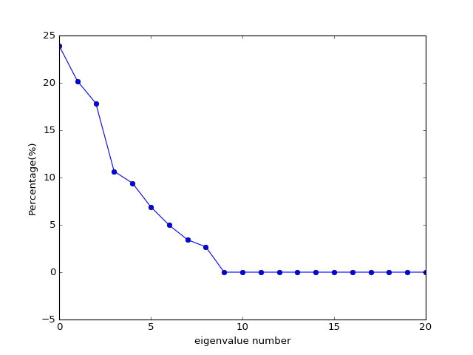
Test the maximal dimensionality that data can be projected to via LDA. Explain the reasons.
The graph above shows the size of each eigenvalue, as a percentage over all the eigenvalues. We observe that the maximum dimensionality which we should expect the data to be decomposed into is 8, as evidenced by the fact that the eigenvalues from 9 onwards are practically zero. This is due to the fact that there are only 9 classes, and thus there can only be 9-1 dimensions in which the data can be projected into which adequately distinguishes between them.

SVM
Report the classification accuracy with different
parameters and dimensions.
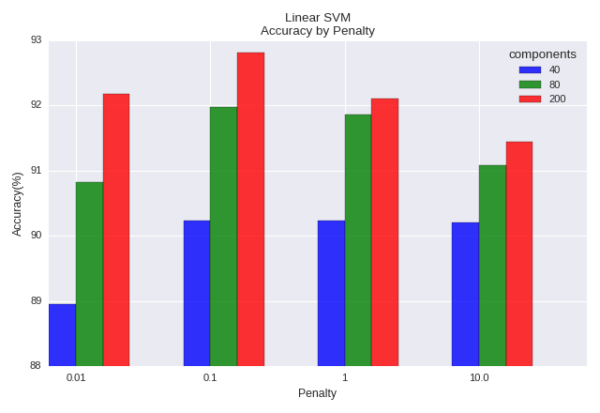
Explain the effect of data dimension and parameter C on the final classification accuracy.
- Accuracy tends to increase with number of components. This is expected since the data is better represented by a higher number of componenets.
- There is an optimum penalty value.
  - A lower margin of error at higher penalties means that there is a higher tendency for overfitting on the training set and hence poorer performance on the test set. This is further evidenced by the fact that the accuracy decreased most drastically with increasing penalty, for the training set with the fewest components (40).
  - A higher margin of error at too low a penalty means that classification errors increase for both data and test set.

Apply kernel SVM with radial basis kernel for classification. Tune the parameters and
report the parameters providing best classification performance.
We perform a trail runs over 10% of the training and test data in order to obtain the optimal parameters for the fit.
Components | 40 | 80 | 200
Parameters vs Accuracy Plot (for 10% of data) | 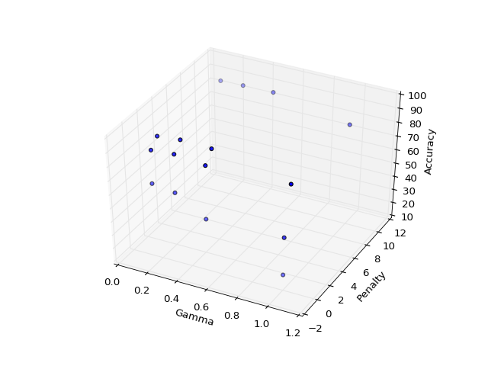 | 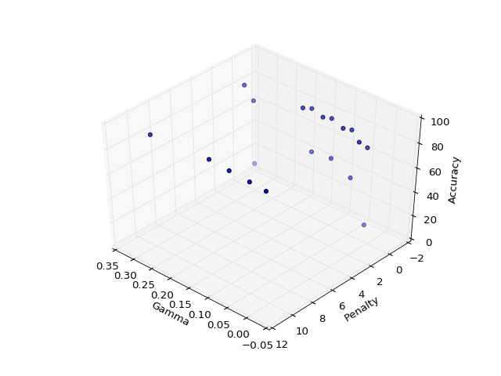 | 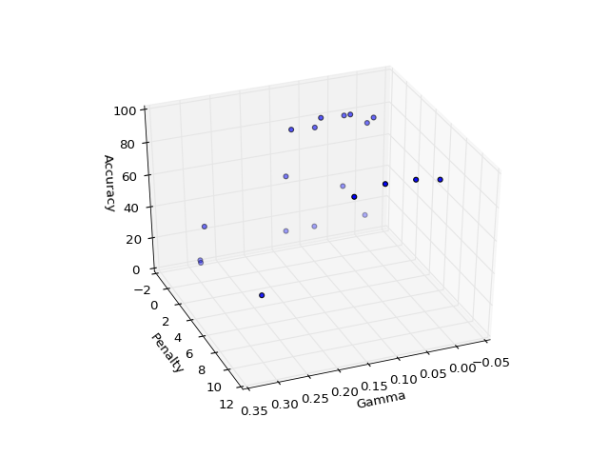
Optimum Accuracy (for 100% of data) | 96.63 | 98.1 | 94.24

Compare the results with the one given by linear SVM and explain the observations.
Radial SVM provided better fit accuracy compared to Linear SVM at its optimum parameterisation,
40 components having the largest accuracy boost.

This is likely due to the fact that for a linear SVM, the differences between data points are only partially represented by the dot product, whereas for a radial SVM, differences are represented by thier Euclidean distance, which better represents the distance between them in all available dimensions.

The drop in accuracy for the 200 component data could be explained by training the model to too many components, which added noise rather than improve accuracy during training.

CNN

Personal Notes – summarised from http://caffe.berkeleyvision.org/gathered/examples/mnist.html

Workflow
files, and some variables to note...
- Define layers in $CAFFE_ROOT/examples/mnist/lenet_train_test.prototxt
  - Input layer batch sizes (64)
- Define solver in $CAFFE_ROOT/examples/mnist/lenet_solver.prototxt
  - net: $CAFFE_ROOT/examples/mnist/lenet_train_test.prototxt
  - Max number of iterations (iterating over each batch) limits training data size. Currently set at 10k (640k training images)
  - Solver mode: CPU as I don’t have NVDIA card
- Run using ./examples/mnist/train_lenet.sh
  - input: ./examples/mnist/lenet_solver.prototxt
Architectures
http://cs231n.github.io/convolutional-networks/

Classification Performance
Change the network architecture
including the
number of layers,
type of layers,
number of nodes per layer
and report the performance provided by other CNNs with different architectures.
Analyze the performance vs. network architecture.

Run | Architecture  Details | Remarks | Accuracy (100 samples) | Accuracy (10k samples)
1 | 2*(CV>MaxPool)>FC>ReLU>Out  Cv n 20 k 5 s 1  Pool max k 2 s 2  Cv n 50 k 5 s 1  Pool max k 2 s 2  InnerProd n 500  ReLU  InnerProd n 10  Accuracy  Loss Softmax |  | 98.97 | 99.1
8 |  | Increasing the number of nodes per layer.
6 | 2*(CV>MaxPool)>FC>ReLU>Out  Cv n 20 k 3 s 1  Pool max k 2 s 2  Cv n 50 k 5 s 1  Pool max k 2 s 2  InnerProd n 500  ReLU  InnerProd n 10  Accuracy  Loss Softmax | Increasing the resolution of the first convolution by reducing the kernal size, might have caused lower losses from the first stage of convolution.  Decreasing the losses at earlier stages cascades to better accuracy in later layers. | 99.03 | 99.12
3 | (CV>MaxPool)>ReLU>  (CV>MaxPool)>FC>ReLU>Out  Cv n 20 k 5 s 1  Pool max k 2 s 2  ReLU  Cv n 50 k 5 s 1  Pool max k 2 s 2  InnerProd n 500  ReLU  InnerProd n 10  Accuracy  Loss Softmax | Additional ReLU non-linearlity might have helped to identify the presence of some basic features first, resulting in higher accuracy.  This approach follows Montufar et al as cited in the lecture notes. | 99.11 | 99.15
4 | (CV>MaxPool)>ReLU>  (CV>MaxPool)>2*(FC>ReLU)>Out  Cv n 20 k 5 s 1  Pool max k 2 s 2  ReLU  Cv n 50 k 5 s 1  Pool max k 2 s 2  InnerProd n 500  ReLU  InnerProd n 500  ReLU  InnerProd n 10  Accuracy  Loss Softmax | Introduction of additional FC+ReLU layer increased accuracy. | 99.22
7 | (CV>MaxPool)>ReLU>  (CV>MaxPool)>2*(FC>ReLU)>Out  Cv n 20 k 5 s 1  Pool max k 2 s 2  ReLU  Cv n 50 k 5 s 1  Pool max k 2 s 2  InnerProd n 500  ReLU  Dropout 0.5  InnerProd n 500  ReLU  InnerProd n 10  Accuracy  Loss Softmax | Introduction of dropout layer randomly removes half of the nodes, preventing overfitting (refer to Fig1a and 1b). | 99.24 | 99.24

__ = additional/changed layer
n = number of output nodes
k = kernal size
s = stride
* only 100 test samples were used to calculate this value
ref: http://tutorial.caffe.berkeleyvision.org/tutorial/interfaces.html

run accuracy for entire test set example:
./build/tools/caffe test -model examples/mnist/lenet_train_test_7.prototxt -weights examples/mnist/results/7/lenet_iter_10000.caffemodel -iterations 100

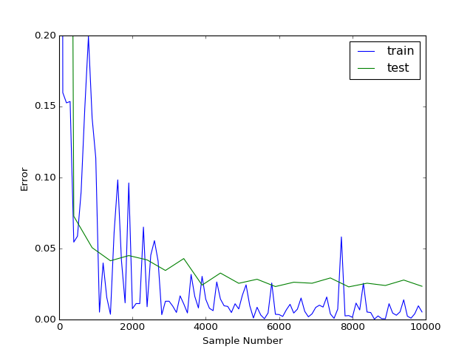 | 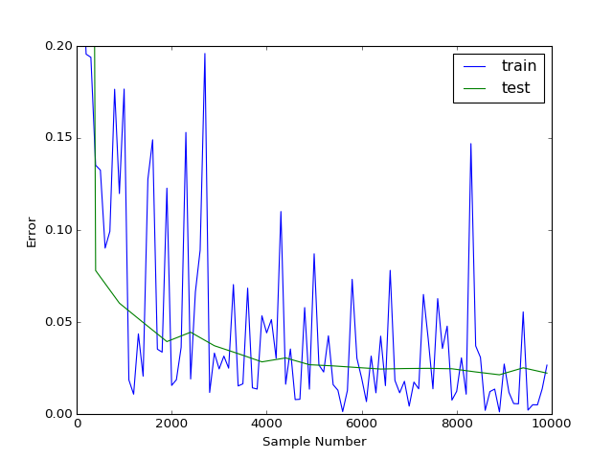
Fig 1a: Run #4 Error Rates as the CNN is trained with increasing number of image samples. | Fig1b Run #7: With additional dropout layer. We observe that the test error rate approaches the training error rate more than that in Run #4, indicating that overfitting was reduced.

Comparison with results on leading board

