**Photon number and timing resolution of a near-infrared continuous-wave source with a transition edge sensor**

**Jianwei Lee1, Lijiong Shen2, Brenda Chng1, Alessandro Cerè1, Christian Kurtsiefer1,2**

1Centre for Quantum Technologies, National University of Singapore

*2Deparment of Physics, National University of Singapore*

Abstract- The slow recovery time, on the order of microseconds, of Transition Edge Sensors (TES) [1] limits their number resolving and timing accuracy for high photon-flux detection. This is usually resolved by pulsing the light source or discarding overlapping signals, thereby limiting its applicability. In this work, we analyze the output signal when detecting a continuous wave source, and present a procedure to determine amplitude and timing of overlapping pulses. As a direct application, we measure the arrival-time difference distribution of a coherent source in a single spatial mode using a single detector.

The detection of a single photon by the TES produces a pulse with a fast rising edge of tens of nanoseconds, and a decay time of in the order of microseconds. This relatively slow timing characteristics is due to the limited bandwidth of the SQUID amplification necessary to amplify the signal.

Different triggering techniques can be used to associate an arrival time to a detection event, e.g., threshold crossing and constant fraction discriminator. These methods do not work when two pulses are overlapped, as the rising edge of the second pulse is obscured. This problems limits the applicability of TES for for high photon-flux detection.

In [2], Fowler et al. demonstrated how to estimate the arrival time of the second pulse by low-pass filtering and differentiating the signal. The proposed technique works well for the high signal-to-noise ratio typical of the detection of high energy photons (\gamma and X).

In the case of NIR photons, with lower signal-to-noise ratios, the differentiated signal often triggers on noise instead of the onset of a photon. Applying a low-pass filter to circumvent this decreases timing resolution. Our approach consists in identifying the detection events, and fit it with a model based on a linear superposition of single-photon traces.

In our experimental demonstration, we modulate a laser diode with central wavelength 810 nm to obtain light pulses of controlled duration in the order of nanoseconds and controlled intensity. Using trains of 4 ns long pulses with a repetition rate of 100kHz and average number of photons per pulse n_bar \approx 1 we obtain a collection of sample traces. We select traces corresponding to single photon events and use them to create a model for the single photon detection trace.

We then switch the laser diode to continuous wave, record the signal as 10 us long traces, and select all the traces containing two photons. If the individual photon detection events are sufficiently separated, we obtain an initial estimation of the arrival-time using a low-pass filter and differentiation. This estimated times are subsequently used to initialise a least-squares fit on the unfiltered trace.

For pulses separated by less than the rise time of the single photon event we perform a Monte-Carlo Markov Chain fit on the signal, including the expected amplitude distribution as priors.

In this way, arrival-time differences of $\approx$ 200 ns can be estimated with an accuracy of ~60 ns. We obtain an arrival-time difference distribution that agrees well with our prediction (see Figure 1).

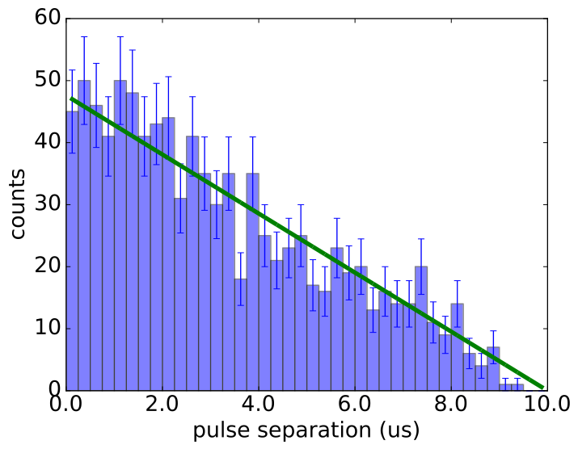

**Fig 1.** Arrival-time separation histogram of a continuously running LD. Bin size = 250~ns. Error bars indicate Poissonian standard deviation. Green line: Theoretical prediction. Due to the finite duration of our oscilloscope traces, the coincidence probability of two photons decreases with increasing separation.

**References**

1. A. E. Lita et al., "Superconducting transition-edge sensors optimized for high-efficiency photon-number resolving detectors," Proc. SPIE 7681, Advanced Photon Counting Techniques IV, 76810D, April 2010.
2. J. W. Fowler et al., "Microcalorimeter spectroscopy at high pulse rates: a multi-pulse fitting technique," ApJS 219, 35, August 2015.