# Title: 14 pt, Times New Roman: A template for SPW2017 abstracts

**First1, Second2, Third1 Author, etc. (Times New Roman, 9 pt)**

*1Affiliation: Times New Roman, 8pt, italicized, Institute, city/town, country*

Abstract. Times New Roman, 10 pt. One page, including references. Please send a finalized word or pdf copy of your abstract to: [spw2017@nist.gov](mailto:spw2017@nist.gov), with the subject: **SPW 2017 abstract**. Of course, you can create your abstract in latex. However, in this case please compile it to a 1-page pdf.

Body text. SPW 2017 is intended to bring together a broad range of scientists, engineers and newcomers in the field of single-photon generation and detection for fundamental science and applications. Researchers from universities, industry, and government will present their latest developments in single-photon devices and methods with a view toward improved performance and new application areas. It will be an exciting opportunity for those interested in single-photon technologies to learn about the state-of-the-art and to foster continuing partnerships with others seeking to advance the capabilities of such technologies. One day of the workshop will be devoted to lab-tours on the campus of NIST.

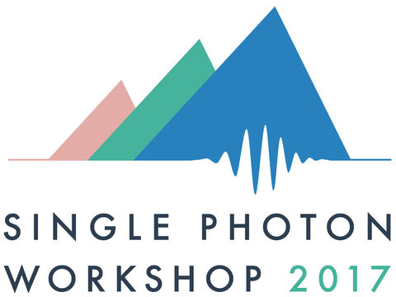

**Fig 1.** Figure caption: Times New Roman, 8 pt. The single photon workshop will be held in the week from July 31st 2017 through August 4th 2017 [1].

**Table 1:** Workshop topics

|  |  |  |  |
| --- | --- | --- | --- |
| **Single Photon Detectors** | **Single Photon Sources** | **Metrology** | **Applications of single photon technologies** |
| Single photon avalanche detectors | Spontaneous parametric downconversion and four-wave-mixing | Methods for characterizing single-photon detectors and sources | Quantum communication |
| Superconducting single photon detectors | NV centers | Quantum Sensing | Optical quantum-state generation |
| Single Photon Detector arrays | Quantum Dots | Weak measurements | Quantum random number generators |
| Photon-number-resolving detectors | On-demand single-photon sources | Novel measurement schemes | Biology/Chemistry |
| Integrated Single Photon Detectors | Integrated single-photon sources |  | Telecom |
| Entangled photon-pair sources. |  |  | Imaging and ranging |
|  |  |  | Spectroscopy |

**References**

[1] We are looking forward to seeing you in Boulder!