Google summer of Code - 2023

GFOSS – HELP

#### *Mentor :-*

***Christos Iossifidis***

**Basic** **Details**

- Name:- Vedant Palekar

- Email:- vedantpalekar12@gmail.com

- GitHub Username - <https://github.com/hoopinwhoopin>

- Your first language :- English

- Location :- India

- Time zone :- GMT +5:30

#### Your Motivation

- What is your motivation to take part in Google Summer of Code ?

This is one of the most exciting projects to work on , especially when it involves helping people in need , I am always biased on working towards it .In the past I have made various such projects on problem cases where the technology is responsible for the betterment and help of people . GSoc will be the best opportunity for me to be a part of OPEN-SOURCE COMMUNITY , GFOSS is the organisation I was looking for. I choose this project as we are in 2023 and the 911/112 emergency contact services are still the old methods have been using for decades , with advancements of technology we are also supposed to ensure advancements in emergency services as well.

- Why did you choose Sugar Labs ?

As an open-source enthusiast, I feel along with this idea Sugar labs is the best possible resource and platform that will help me in achieving in what I am aiming for.

Sugar Labs is a FREE OPEN-SOURCE community that helps learners with tools used to explore, discover , create, and reflect. It is a non-profit organisation which establishes a community of users and developers around the world to help learners “learn how to learn”

- Why do you want to work on this particular project ?

We are in the year 2023 and organizations over the world are already developing means to help people in need of emergencies at the easiest and fastest methods possible. With the availability of **HELP** which will be a **free open-source** platform across states that will unify the means of safety at their own accord.

THIS WILL BE A FREE OPEN-SOURCE SOFTWARE WITH

GNUS LISCENCE and anyone willing to work on this will be able to do so.

- What are your expectations from us during and after successful completion of the program ?

As I proceed with the development of this project , regular video calls will be scheduled at the end of every week to discuss the progress of the project. I will keep in contact with the mentors via chat to resolve any doubt in between.

After successful completion of the program I would love to keep contributing to this project and help in developing , so as it is open for the whole world to use and save as many people as possible

#### Project Details

- What are you making ?

As described in the description of this project, I will be making a Location Based Mobile Application (LBMA) , which will be integrated with emergency services like 911 or 112 for **free** in any emergency anywhere.

It is an app for the ease of communicating and making the respected authorities aware of any emergency that is needed in that moment.

This app is mainly designed to be as efficient as possible for the people that need help.

It has various features like sharing live location at any moment for the concerned authorities.

- How will it impact Open Technologies Alliance(GFOSS) ?

It will create an OPEN FREE FOR ALL through the

**GNU’s free for all licence** creating a workspace for all developers to work and help people in need of emergency services in need.

- What technologies (programming languages, etc.) will you be using ?

This app will be built in REACT-NATIVE and will have a python-based backend.

#### Timeline

- Break down the entire projects into chunks and tell us what you will work on each week.

- As the summer goes on, you and your mentor will adjust your schedule, but it's good to have a plan

1. **WEEK 1&2**

* **Discuss the approach of the project with the mentor.**
* **Discuss the expectations of this project.**
* **Discuss future with this project to deliver the best project that will meet the expectations.**

1. **WEEK 3&4**

* **Design and start implementing the drafted frontend of the APP.**

1. **WEEK 5&6**

* **Implement the backend of the project.**
* **Code various sections and features of the APP.**

1. **WEEK 7&8**

* **Integrate frontend with database.**
* **Implement the location services.**
* **Integrate it with the emergency contact services depending on the region of the app used.**

1. **WEEK 9&10**

* **Testing of the project**
* **Improving according to the tests**

1. **WEEK 11 & 12**

* **Implementing final deliverables of the project.**

- If you will be off-the-grid for a few days, then mention those in the timeline.

Completing this project will be my **TOP MOST** priority and I am someone who goes by my words of completing the particular task of the following week.

- GSoC has three evaluations, once after every 30 days. Highlight the work you plan to complete before each evaluation.

As discussed in my weeks plan

I have designed a coding sheet as well with all the necessary code-snippets that is going to be needed.

<https://docs.google.com/document/d/16xtiBaYFW-Ss9MQ6OTFjlBgqqIgcPGMvbc6IG6ejOT4/edit?usp=sharing>

**HERE ARE FEW SNIPPETS OF THE INSPIRATION OF OUR APP.**

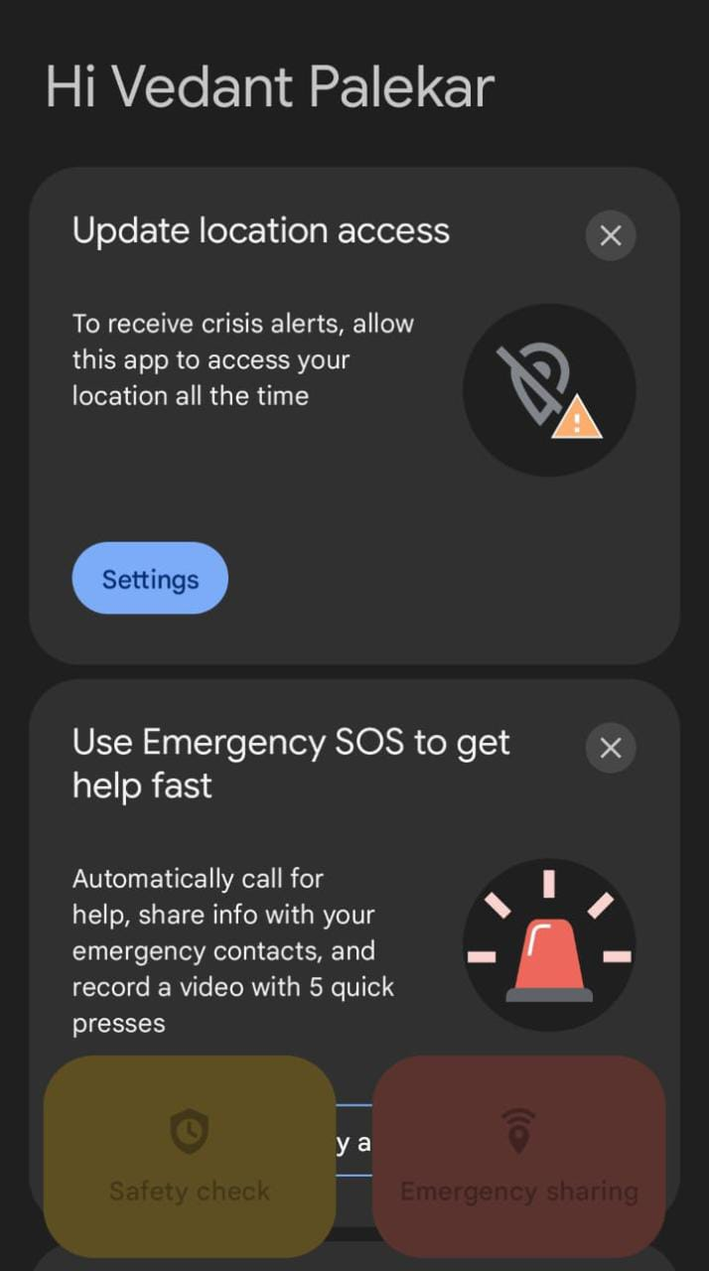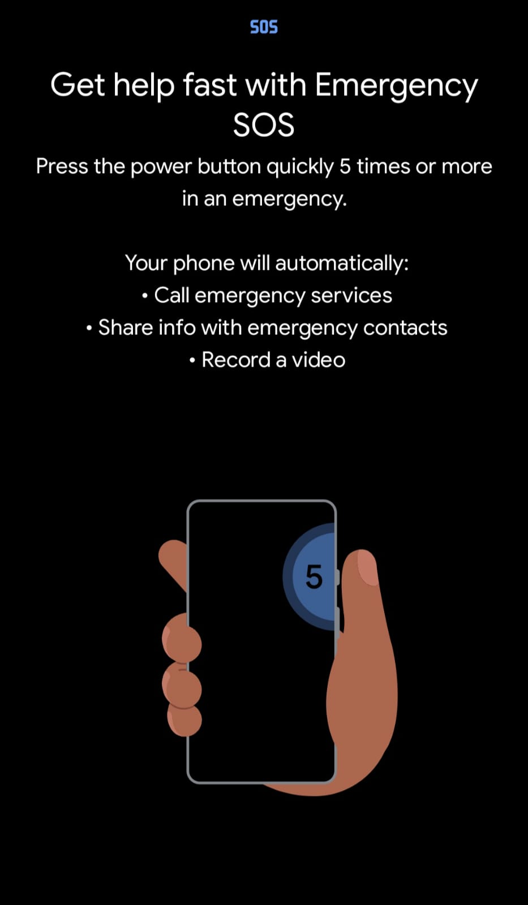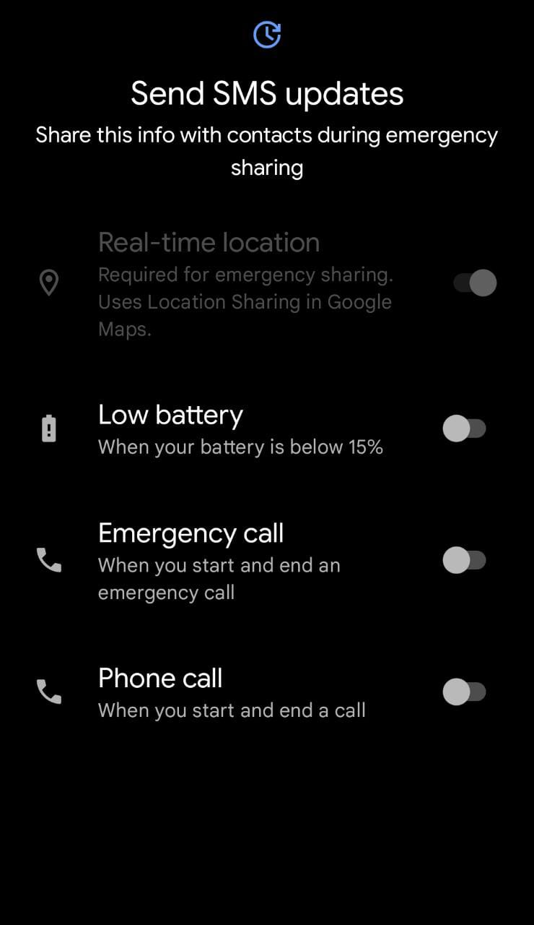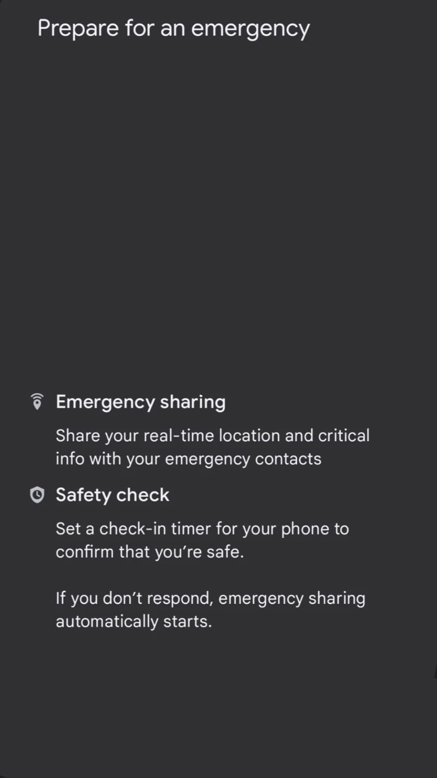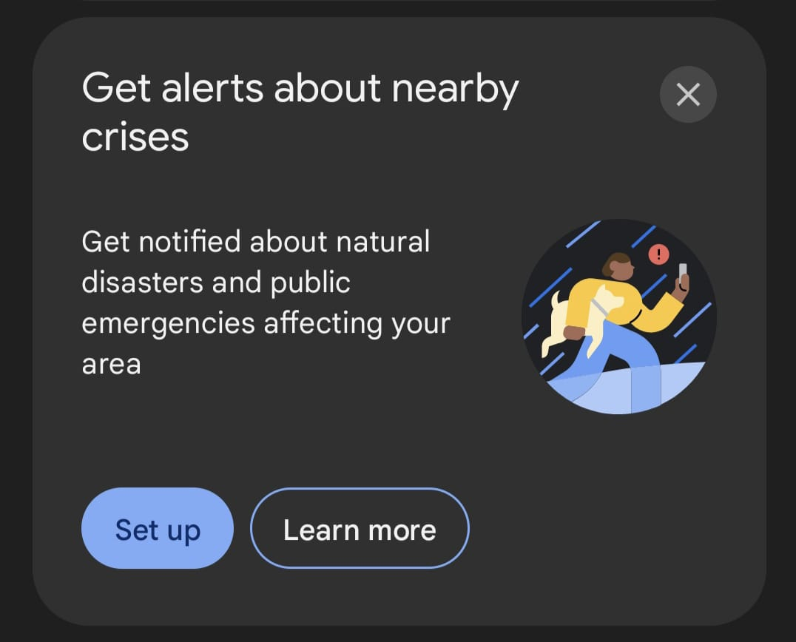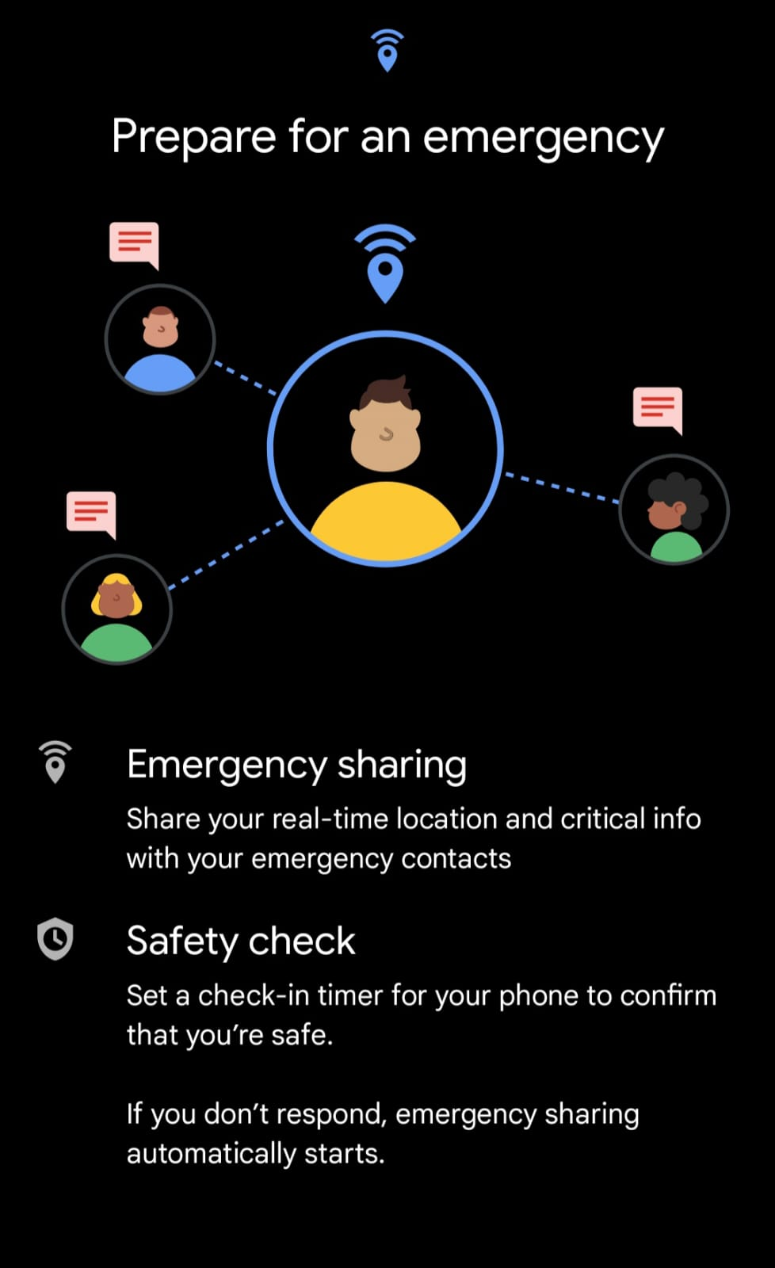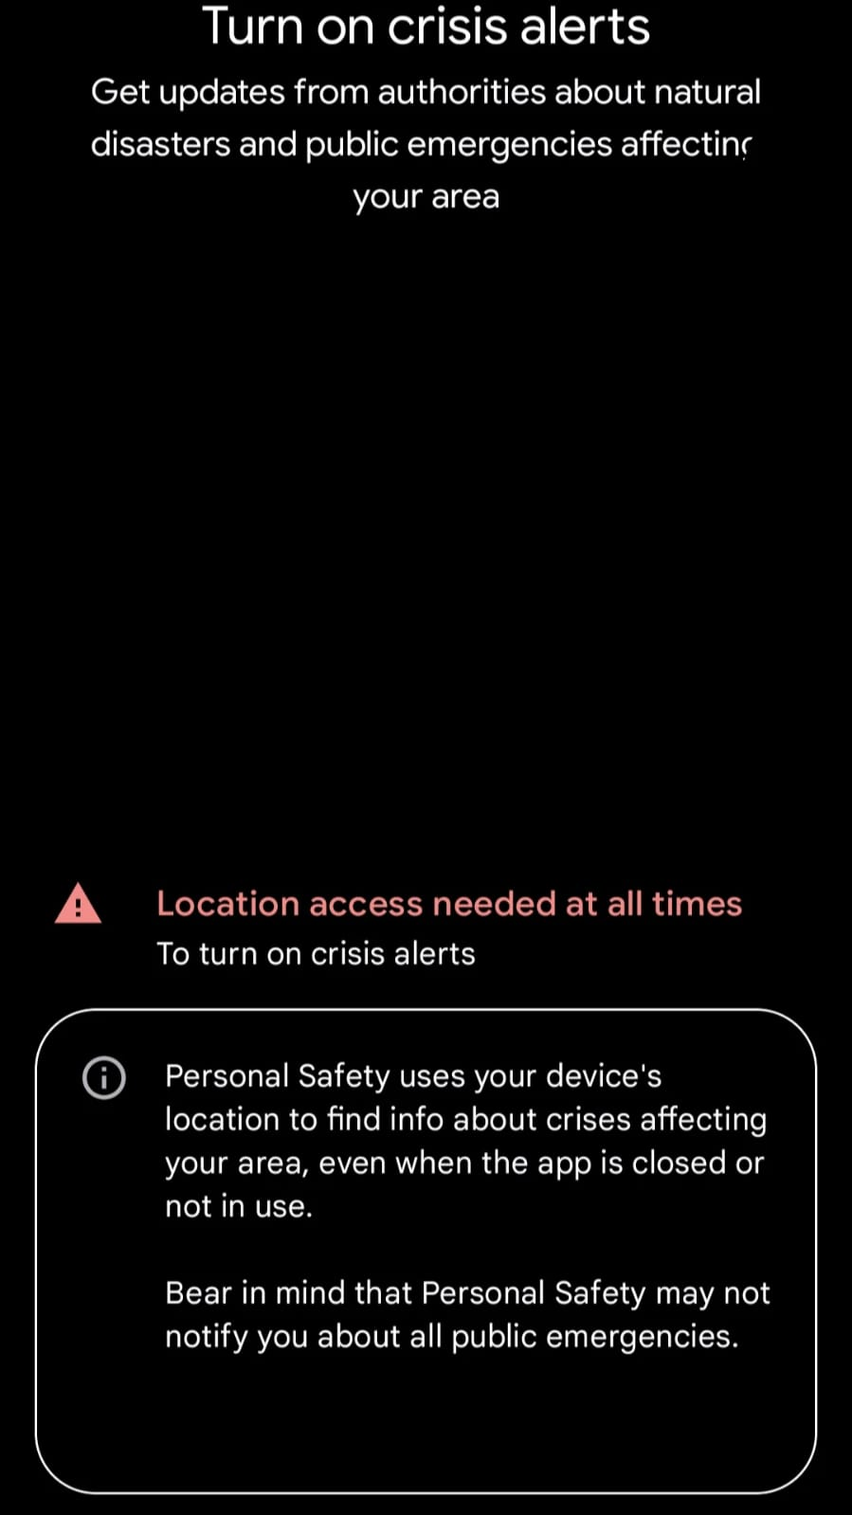

- **Also discuss your plans after the GSOC period ends**. Do you plan to continue working on the project after GSOC ends?

I will continue to work on this project as a MENTOR/CONTRIBUTOR to the **free open-source APP**.

- Mention how much time will you spend each week working on your project

This is a 175 hour project and I will be working around 14-15 hours per week on this project.

#### 

#### Motivation

- **Convince us that you will be a good fit** for the GFOSS project you have selected, by sharing links from [GFOSS Projects](https://ellak.gr/wiki/index.php?title=Google_Summer_of_Code_2019_proposed_ideas).

I have made 2-3 projects in the past 1 years which have been designed only to help the people in need .<https://ellak.gr/wiki/index.php?title=Google_Summer_of_Code_2023_proposed_ideas#HELP>

This project HELP will not only give me an opportunity to pursue what I love to do and am passionate about but also improving my problem solving skills.

- If your project is on an idea you proposed, convince us that the idea is useful to [**GFOSS**](https://gfoss.eu/)

.

The most dialled number in the entire world is the emergency contact number 911/112 and we are still stuck with the same old traditional methods of it , with advancements in technologies this also should be upgraded along with the resources we have. With the HELP initiative we are planning to provide an OPEN-SOURCE APP which will be developed by anyone contributor and made use of for the betterment of the world and ease of helpline numbers.