All In One Book

Authored By: Anish Dangol, John Engelhart, Ilma Sheriff, Alex Sorenson

V1.3 2/23/15

# **Preface**

“All In One Book” is a web application that provides quick access to the user’s feeds from popular websites such as Facebook, Twitter, Instagram, and more. The data is prioritized and ranked such that the user can quickly glance and go through the updates from the various content sources in one place instead of signing into every single application.

## Purpose of this Document

This document is a Requirements document for the Application “All in One Book”. This Project is for the course IT 484/584 - Software Engineering.

## Audience

This document is intended for the Development Team, QA Team and the Upper Management of “All In One Book” Application. This project also serves as good background and introduction for the Users.

## Version History

V 1.0 02/17/2015 - First Draft

V 1.1 02/21/2015 - Migrated to Google Drive. Fixed formatting

V 1.2 02/22/2015 - Fixed spelling and grammatical errors. Expanded on security of website.

V 1.3 02/23/2015 - Added competition, websites to implement, and website validation list.

# **Introduction**

The main purpose of creating this webpage is to link multiple social media web pages into one page. This aggregation of sites would make using multiple social media accounts easier. Basically it would show all the news feeds and notifications of social media websites the user chooses in a single live view. This web application will be written using Ruby on Rails.

In order to succeed and gain popularity we will create a user-friendly webpage in which we can link all of the social media sites. We will link to social media sites using APIs available online. We will focus on the user experience as much as possible. The web page will consist of a widget for each social media site, which will contain all of the notifications. As of right now we have planned it to be compatible only for desktops with potential future compatibility with mobile devices.

## Competitors:

* Overall it appears that the competitors already out in the market focus on creating a product for a business. Many of their end products are an aggregate of one entity. For example, they collect Twitter & Facebook posts, Instagram photos, and news articles all relating to Company X. Our focus will be on the user and their preferred list of channels on each social media site.
* Socioboard: <https://socioboard.codeplex.com/>
  + Desktop application focused on the analytics of a company’s corporate Facebook and Twitter account. Their focus is more on customer engagement and generating leads for a company.
* HTC BlinkFeed: <http://www.htc.com/us/smartphones/htc-one-m8/blinkfeed/>
  + Phone App similar to our product but is only available on HTC One devices.
* Juicer: <https://www.juicer.io/>
  + Focused on a company looking at their corporate social media accounts. Juicer’s end product mimics Pinterest where each object could be from a different social media site. Our’s will be better than Juicer by being more organized with one widget per social media site.
* Hub Media: <http://hubb.media/en/>
  + Hub Media focuses on company’s desire to increase engagement and generating leads. They are not free and their design mimics Pinterest where each object could be from a different social media site, which is less organized than what our end product will be.
* RSS Multi Importer: <https://wordpress.org/plugins/wp-rss-multi-importer/>
  + RSS allows you to organize all of your favorite social media sites on one page. They then display each article in a list. This tool is limited to Wordpress and once again combines all the social media sites into one list, which is opposite of what we will do. We will then organize each entity so it displays the information in one concise spot.
* Dialog Feed: <http://www.dialogfeed.com/>
  + Dialog Feed focuses on creating a social wall to be displayed on a corporate webpage. This product also is meant to show information about one brand, whereas our product will be focused on showing information from multiple channels. Dialog Feed is also not free.

# **Requirements**

* We have combined system and user requirements together for multiple reasons.
  + It is hard to differentiate between the two when the application is purely web-based.
  + In the current state we have no need for multiple permission levels. Thus not requiring a magnitude of different levels of access.
  + In future revisions we might add additional groups like administrators, marketing, analytics, advertisers, etc. At that given time, separating user and system requirements may be needed.
* Functional Requirements
  + The system shall allow users to decide which website’s information are displayed,
  + The system will notify users of new widgets that are available.
  + The system shall allow users to decide which channels on a website are displayed.
    - Think choosing the YouTube channels, Twitter accounts, etc. that show up.
  + The system shall have secure measures taken to ensure no data breaches occur.
    - Users will login with a username and password.
      * We’ll be using Ruby on Rails’ BCrypt for secure password storage.
    - As a user when I log out, I cannot access the website until I log back in.
  + The system’s homepage will prompt users to sign up or sign in.
  + The system will assist first time users on how to use to the website.
  + The system automatically reloads returning users to their current widget setup after login.
  + As a user I can resize each of my widgets to the sizes I prefer.
  + As a user I am allowed to decide which features of a widget I get.
* Non-functional Requirements
  + The website will refresh on a constant rate to get new information so the user does not have to refresh the page (live view)
  + Having All In One Book open will not slow down the performance of your machine or browser
  + The system will be able to scale appropriately with the user base
  + It will be available in English and eventually broaden the scope to multiple languages
  + As new social media outlets are created, we’ll add functionality for them as soon as possible
  + A simplistic UI will allow novice computer users the utilize our webapp
  + The website will follow current internet standards in terms of form, functionality and security
  + Each widget will have meet a certain standard of use and style before being deployed on the website
* Which websites users have to log into and verify account (e.g. Facebook )
  + As for now we are planning to use so far are:
    - YouTube, LinkedIn, Facebook, Reddit, Twitter, Instagram, Google+, Pinterest, Tumblr, RSS, Vine, Soundcloud, Flickr, Vimeo, MySpace, 9Gag, Weather Website
  + LinkedIn, Facebook, Instagram and Twitter requires users to put in their username and password at the very first time they set up their account, that would be the only time they are supposed to do so; thus making it very user friendly. Whereas other sites like YouTube, Reddit and weather websites are compatible to work without setting up the user initials.

**System Models**

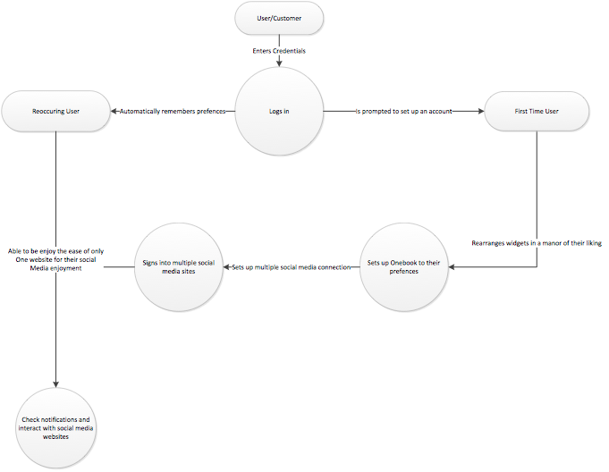

**System Evolution**

* System hardware may need to be improved as popularity and complexity increased
* Using a desktop computer
* Multiple browser support
  + Focus on Chrome, followed by Firefox, latest IE, Safari
  + Expand to other IE versions and Opera
* The user already has accounts (if necessary)
* Expanding to mobile
  + Explore mobile friendly page vs. native application
* Advertisement
* Analytics (which widgets are used and where they’re located)
* Adding new websites
  + Planned rollout of websites
    - V1
      * Twitter (Allow user to see timelines, post tweets, and all social data)
      * YouTube (Allow user to see recent uploads from certain channels)
      * Weather (Weather for current / user defined location(s))
      * News (RSS?)
    - V2
      * Facebook (Allow user to see current people, photos, and events)
      * Instagram (Allow user to see notifications and current pictures)
      * Vine (Allow user to see recent posts from users)
    - V3
      * Reddit (be able to follow your favorite posts/see who commented on your posts)
      * Google+ (See recent posts by individuals)
      * LinkedIn (Currently changing their API and their requirements to obtain an API Key)
      * Pinterest (Allow users to see what's new on their boards)