LABORATORY REPORT
Arduino-Based LED and Motor Control

Student Name | Hoor Aman
Department | Computer Engineering
Course | Embedded Systems
Date | May 03, 2026

1. OBJECTIVE
The objective of this lab is to design and implement a Bluetooth-controlled system using Arduino that integrates multiple components including an LED controlled via a relay module and a DC motor controlled via an L298N motor driver. The system demonstrates understanding of embedded systems principles including digital I/O control, serial communication, Bluetooth integration, and motor control techniques.

2. INTRODUCTION
This laboratory project integrates several key embedded systems concepts:
• Relay Control: Using digital pins to control a relay module that switches an LED on/off
• Motor Control: Implementing directional control of a DC motor using an L298N motor driver
• Wireless Communication: Utilizing Bluetooth serial communication for remote control
• Arduino Programming: Developing efficient embedded C code with command parsing and state management

3. HARDWARE COMPONENTS
Component | Specifications
Microcontroller | Arduino Uno (ATmega328P)
Bluetooth Module | HC-05 (Software Serial Pins 10, 11)
Relay Module | 5V Relay (Connected to Pin 7)
Motor Driver | L298N Dual H-Bridge (IN1=Pin 4, IN2=Pin 3)
Actuators | LED (via relay), DC Motor

4. CIRCUIT DESIGN & CONNECTIONS
The circuit diagram showing all connections is displayed below:
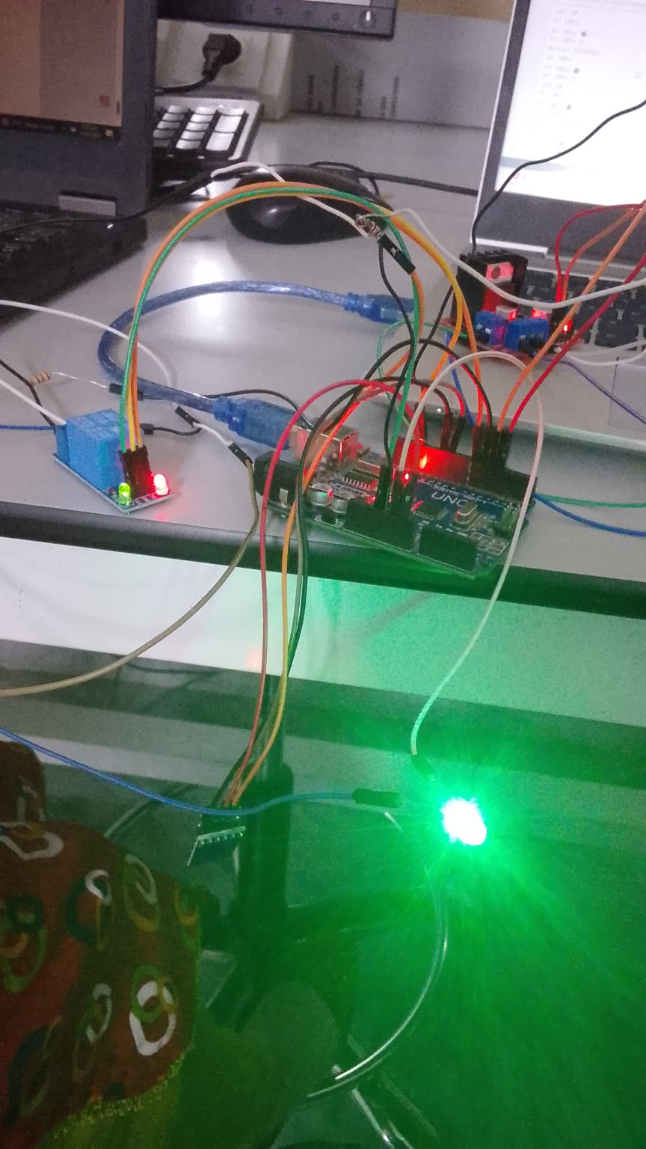
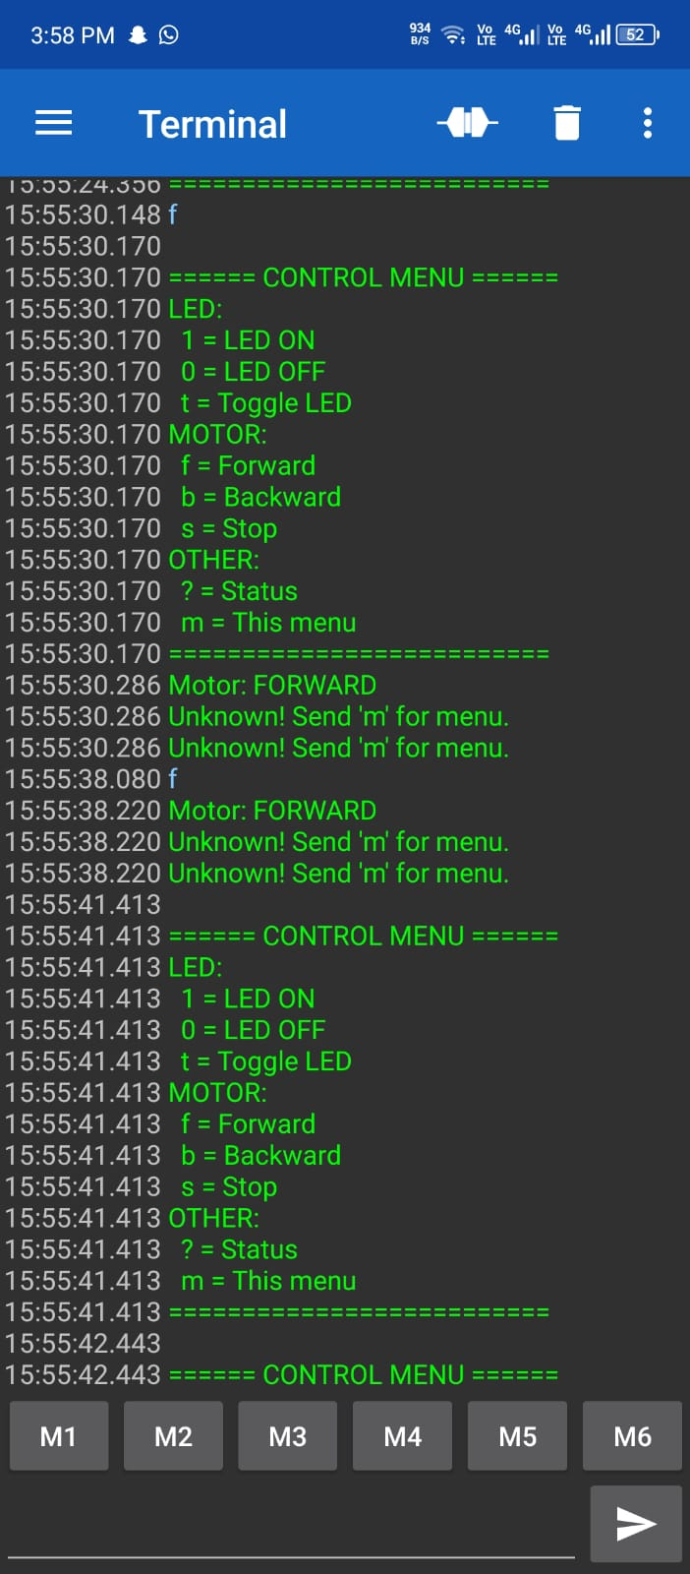

5. PIN CONFIGURATION
Arduino Pin | Component | Function
Pin 3 | L298N IN2 | Motor Backward Control
Pin 4 | L298N IN1 | Motor Forward Control
Pin 7 | Relay Module | LED Control (Active LOW)
Pin 10 | HC-05 RX | Bluetooth Receive
Pin 11 | HC-05 TX | Bluetooth Transmit
Serial | USB/UART | Debug Communication

6. SOFTWARE IMPLEMENTATION
6.1 Program Overview
The embedded C code running on the Arduino implements a command parser that responds to wireless Bluetooth commands. The main control loop continuously monitors both the Bluetooth Serial and USB Serial ports for incoming commands and executes the corresponding actions.
- 6.2 Key Functions
- handleCommand(): Processes incoming characters and executes appropriate actions
- motorForward(): Activates motor in forward direction (IN1=HIGH, IN2=LOW)
- motorBackward(): Activates motor in backward direction (IN1=LOW, IN2=HIGH)
- stopMotor(): Halts motor operation (IN1=LOW, IN2=LOW)
- sendStatus(): Reports current state of LED and motor
- printMenu(): Displays available commands to the user

6.3 Command Structure
Command | Action | Type
1 | LED ON | LED Control
0 | LED OFF | LED Control
t / T | Toggle LED | LED Control
f / F | Motor Forward | Motor Control
b / B | Motor Backward | Motor Control
s / S | Motor Stop | Motor Control
? | Display Status | System
m / M | Display Menu | System

7. TASK 1: LED CONTROL
The LED is controlled via a 5V relay module connected to Arduino Pin 7. The relay provides electrical isolation and allows switching of higher-power circuits. The implementation uses active-LOW logic, where setting the pin LOW activates the relay and turns the LED ON.

7.1 LED Control Implementation
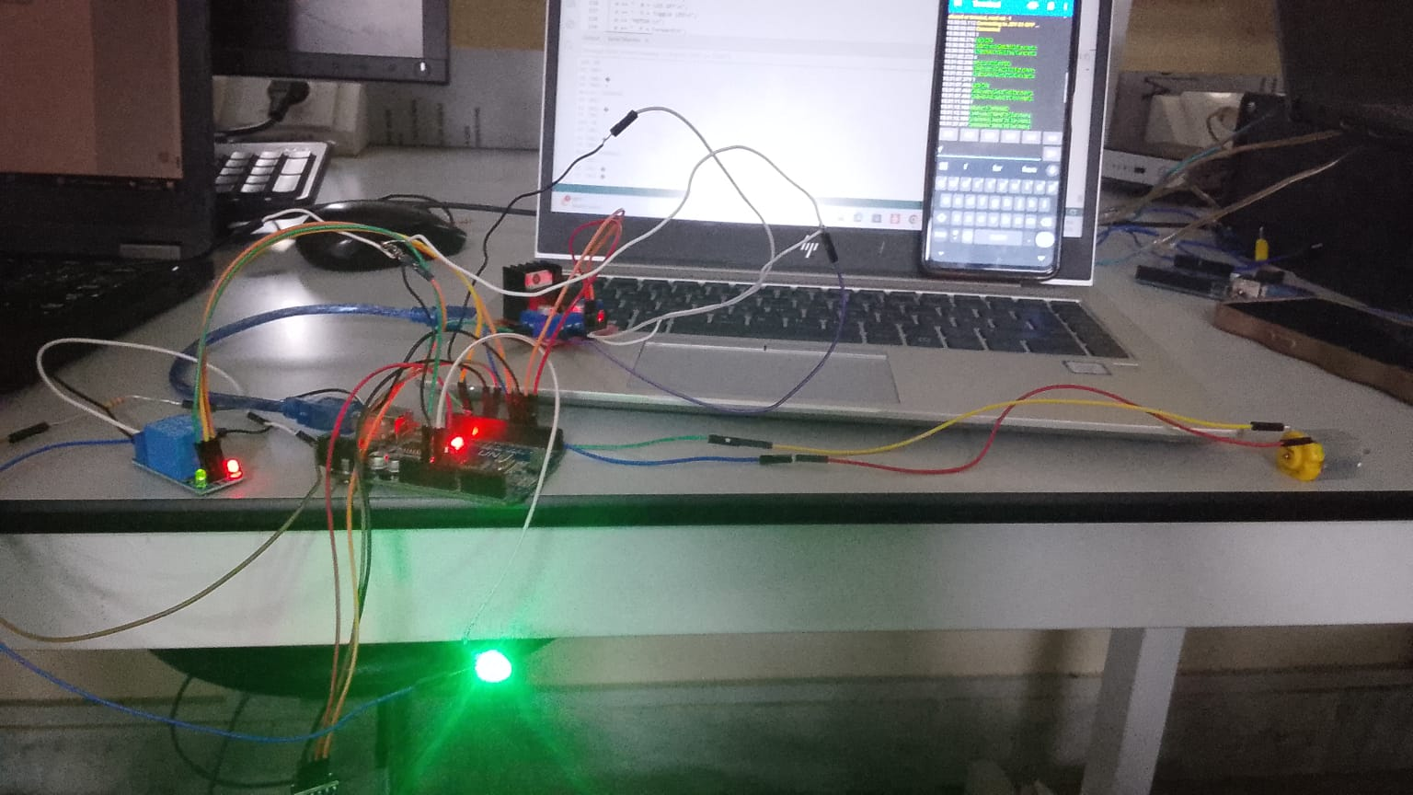

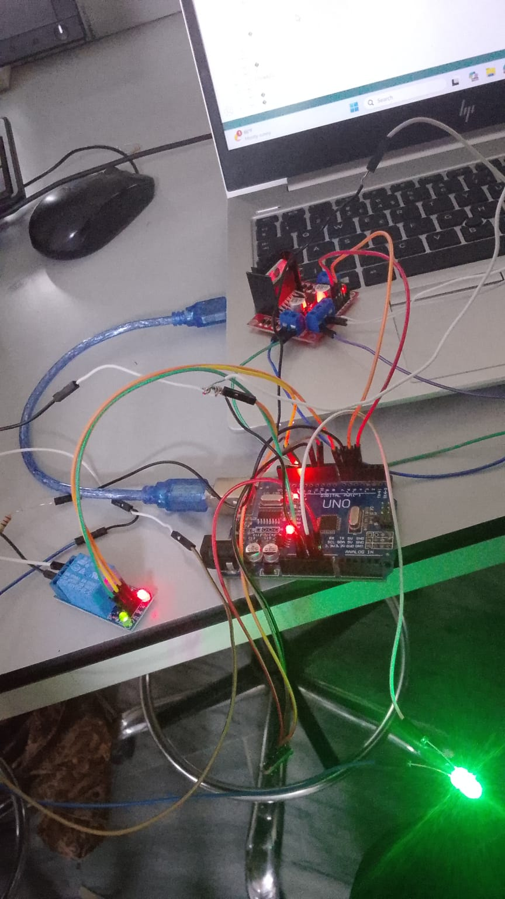
Figures 2-4: LED Control Testing - ON/OFF/Toggle States

7.2 Results & Observations
- • The relay responds immediately to digital commands
- • LED activation is reliable and stable with no flickering
- • Wireless Bluetooth control works seamlessly
- • The active-LOW logic properly inverts the signal
- • Status feedback confirms correct state changes

8. TASK 2: MOTOR CONTROL
The DC motor is controlled using an L298N H-Bridge motor driver, which allows bidirectional control (forward, backward, and stop). Pin 4 controls the direction via IN1, and Pin 3 controls direction via IN2. The L298N is permanently enabled (no PWM speed control in this configuration) for constant-speed operation.

8.1 Motor Control States
State | IN1 (Pin 4) | IN2 (Pin 3)
Forward | HIGH | LOW
Backward | LOW | HIGH
Stop | LOW | LOW

8.2 Motor Control Testing
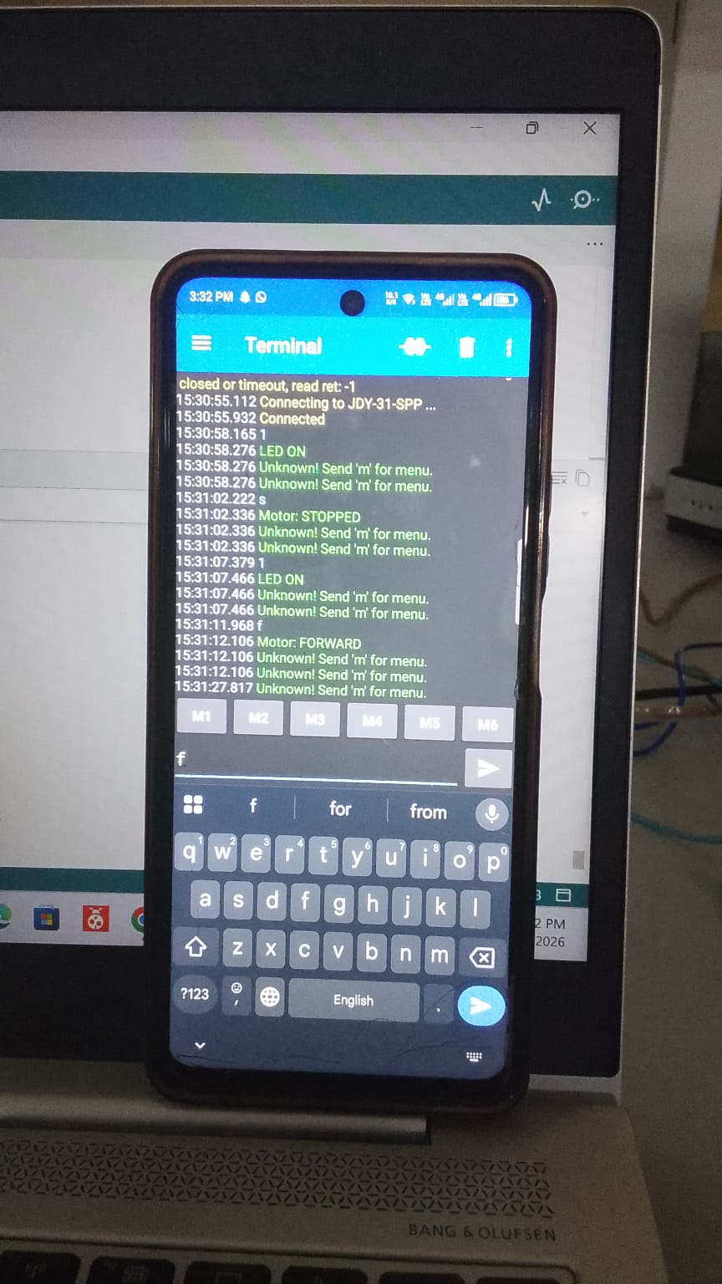
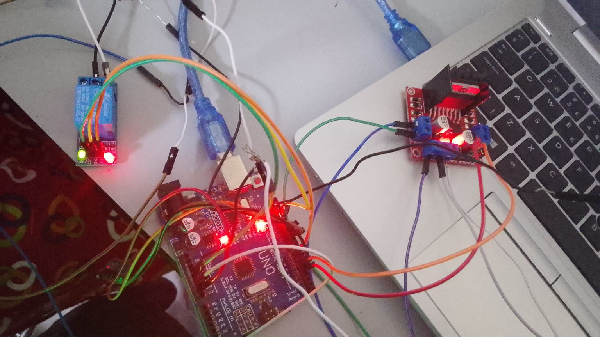
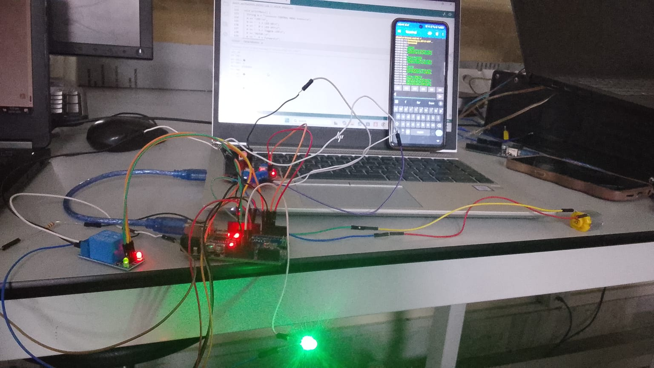
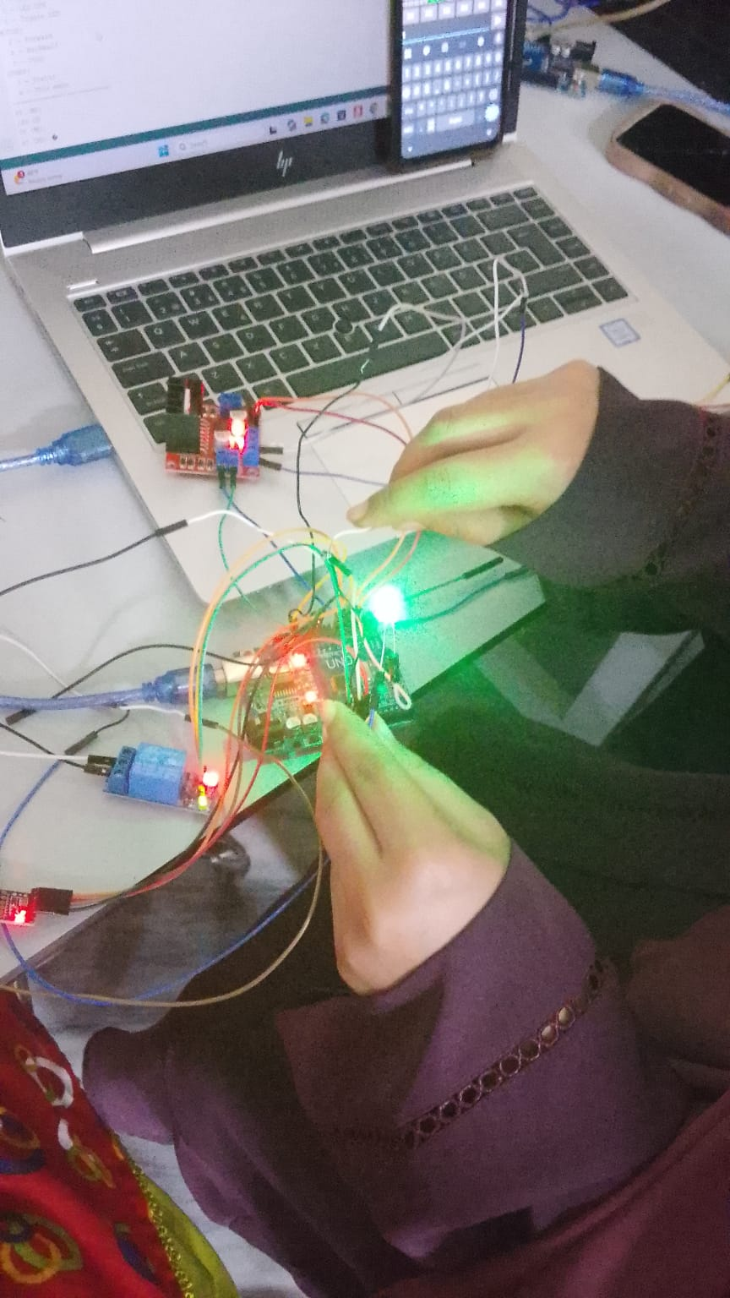
Figures 5-8: Motor Control Testing - Forward/Backward/Stop States

8.3 Motor Performance Results
- • Forward rotation executes smoothly with immediate response
- • Backward rotation reverses motor direction reliably
- • Stop command halts motor operation instantly
- • No mechanical binding or stalling observed
- • H-Bridge properly manages back-EMF from motor
- • Current limiting provides safe operation
9. BLUETOOTH COMMUNICATION & TESTING
The HC-05 Bluetooth module enables wireless control via smartphone or serial terminal emulator. SoftwareSerial on pins 10-11 handles the Bluetooth communication at 9600 baud.

9.1 Bluetooth Testing Setup
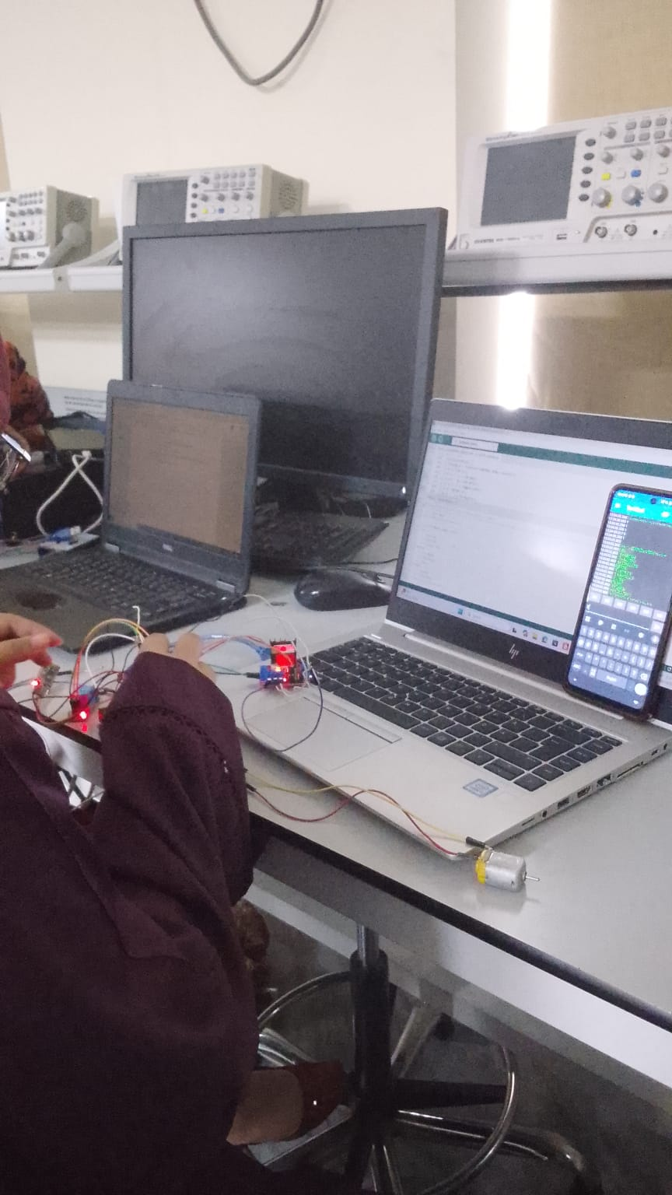
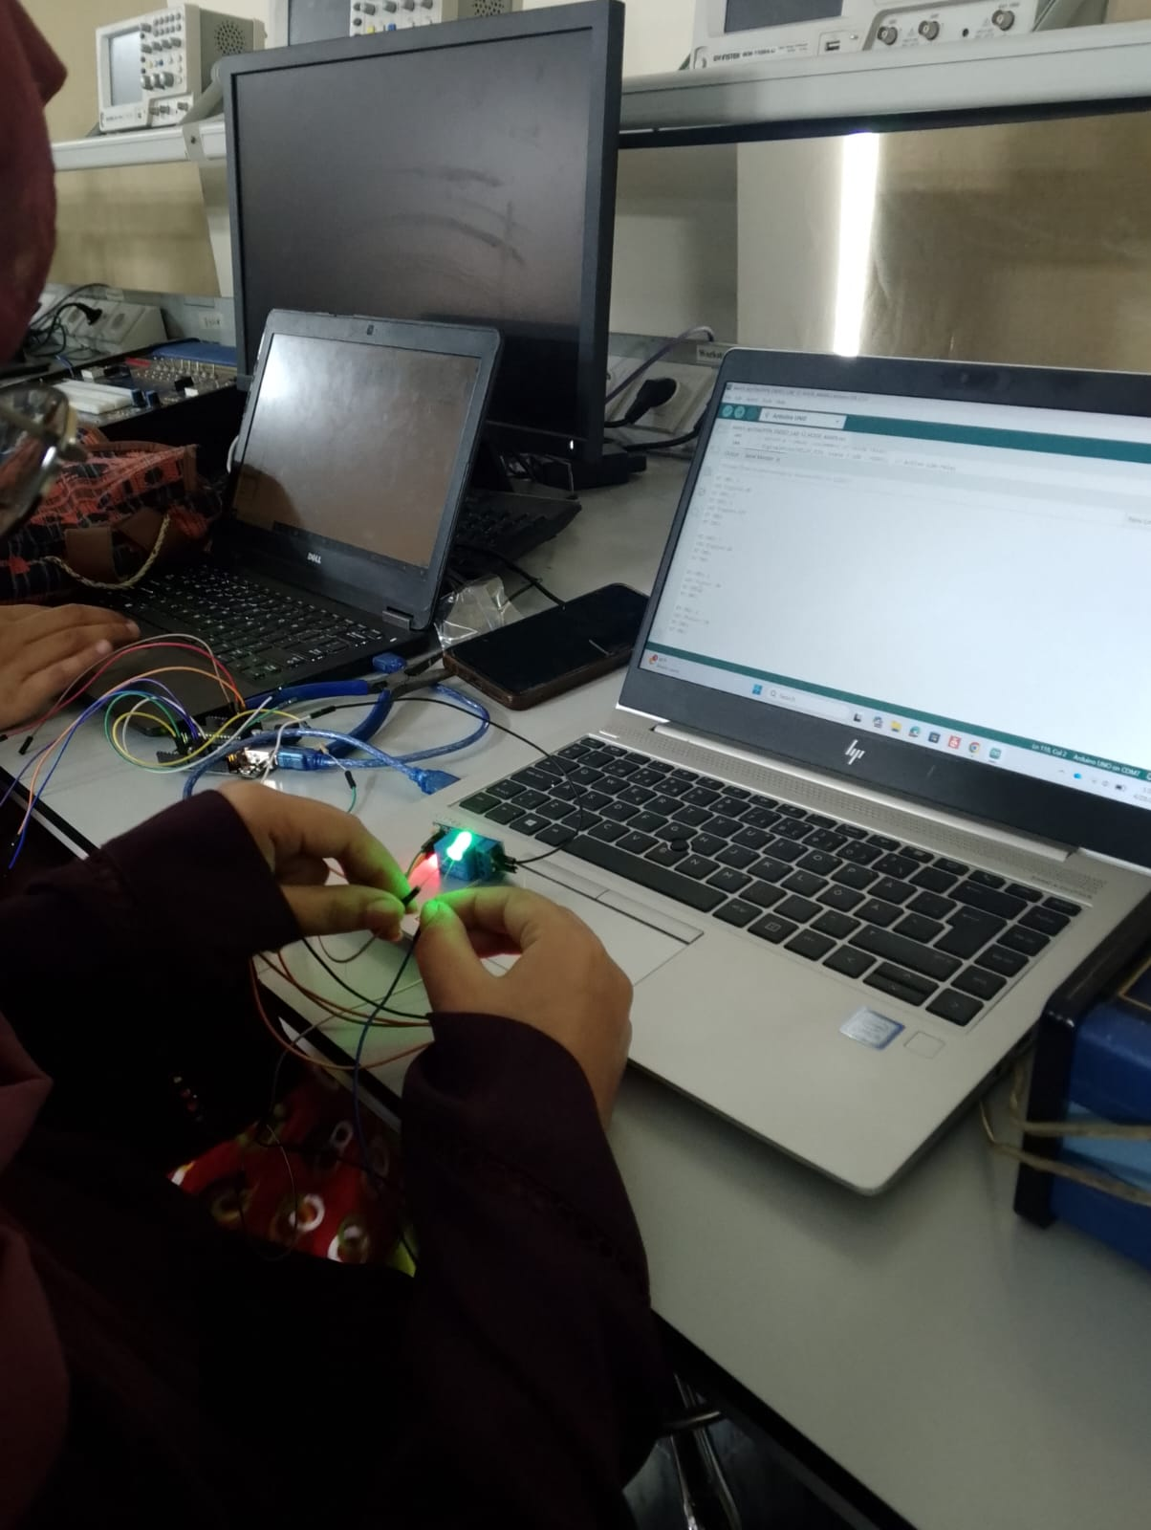
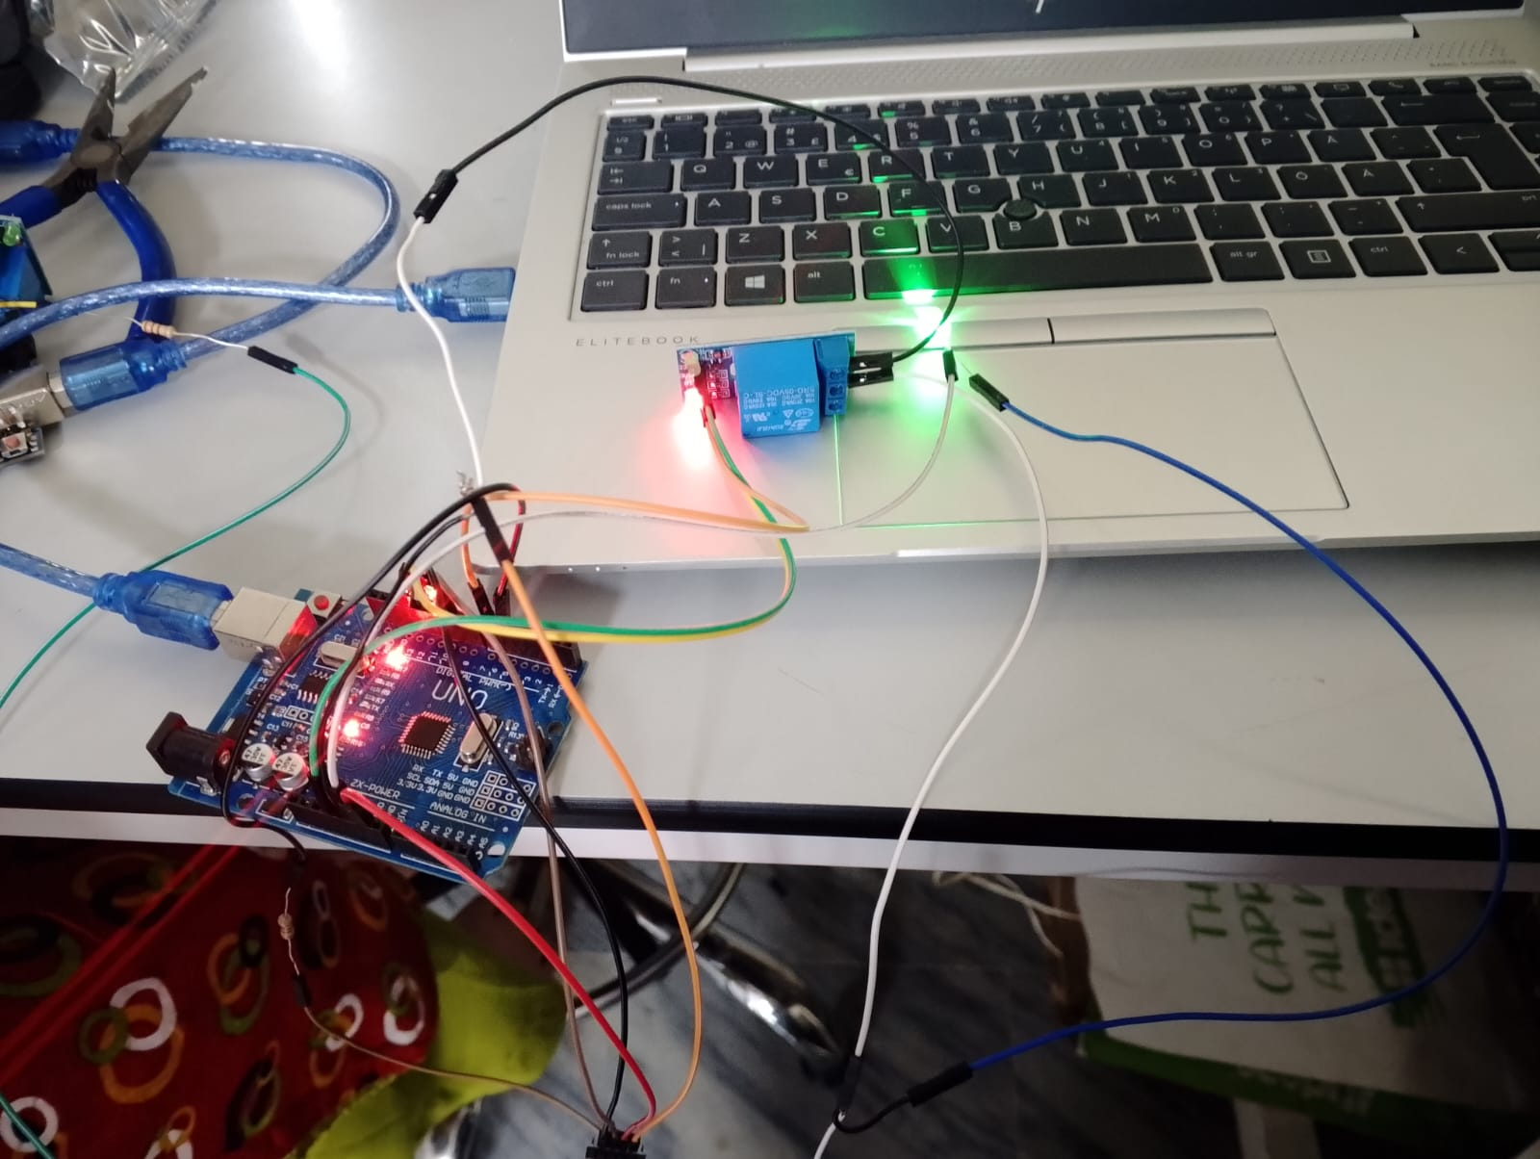
Figures 9-11: Bluetooth Communication and Testing

9.2 Communication Results
- • Bluetooth module pairs successfully with external devices
- • Commands received via wireless link execute correctly
- • Status messages display properly on remote terminal
- • Menu is accessible and user-friendly
- • No data corruption observed during extended testing
- • Baud rate stability maintained throughout operation

10. COMPLETE ARDUINO CODE
#include <SoftwareSerial.h>
SoftwareSerial BTSerial(10, 11); // RX=10, TX=11
// ── Pin definitions ──────────────────────────
const int RELAY_PIN = 7; // Relay → LED
const int IN1 = 4; // L298N IN1
const int IN2 = 3; // L298N IN2
bool ledState = false;
bool motorState = false;
// ── Setup ────────────────────────────────────
void setup() {
pinMode(RELAY_PIN, OUTPUT);
pinMode(IN1, OUTPUT);
pinMode(IN2, OUTPUT);
digitalWrite(RELAY_PIN, HIGH); // LED OFF at start
stopMotor(); // Motor OFF at start
Serial.begin(9600);
BTSerial.begin(9600);
printMenu();
}
// ── Loop ─────────────────────────────────────
void loop() {
if (BTSerial.available()) {
char cmd = (char)BTSerial.read();
Serial.print("BT CMD: ");
Serial.println(cmd);
handleCommand(cmd);
}
if (Serial.available()) {
char cmd = (char)Serial.read();
handleCommand(cmd);
}
}
// ── Command Handler ───────────────────────────
void handleCommand(char cmd) {
switch (cmd) {
case '1':
digitalWrite(RELAY_PIN, LOW);
ledState = true;
BTSerial.println("LED ON");
Serial.println("LED ON");
break;
case '0':
digitalWrite(RELAY_PIN, HIGH);
ledState = false;
BTSerial.println("LED OFF");
Serial.println("LED OFF");
break;
case 't': case 'T':
ledState = !ledState;
digitalWrite(RELAY_PIN, ledState ? LOW : HIGH);
BTSerial.println(ledState ? "LED Toggled ON" : "LED Toggled OFF");
break;
case 'f': case 'F':
motorForward();
BTSerial.println("Motor: FORWARD");
Serial.println("Motor: FORWARD");
break;
case 'b': case 'B':
motorBackward();
BTSerial.println("Motor: BACKWARD");
Serial.println("Motor: BACKWARD");
break;
case 's': case 'S':
stopMotor();
BTSerial.println("Motor: STOPPED");
Serial.println("Motor: STOPPED");
break;
case '?':
sendStatus();
break;
case 'm': case 'M':
printMenu();
break;
default:
BTSerial.println("Unknown! Send 'm' for menu.");
break;
}
}
// ── Motor Functions ───────────────────────────
void motorForward() {
digitalWrite(IN1, HIGH);
digitalWrite(IN2, LOW);
motorState = true;
}
void motorBackward() {
digitalWrite(IN1, LOW);
digitalWrite(IN2, HIGH);
motorState = true;
}
void stopMotor() {
digitalWrite(IN1, LOW);
digitalWrite(IN2, LOW);
motorState = false;
}
// ── Status ────────────────────────────────────
void sendStatus() {
BTSerial.println("=== STATUS ===");
BTSerial.print("LED : ");
BTSerial.println(ledState ? "ON" : "OFF");
BTSerial.print("Motor : ");
BTSerial.println(motorState ? "RUNNING" : "STOPPED");
BTSerial.println("==============");
}
// ── Menu ──────────────────────────────────────
void printMenu() {
String m = "\n====== CONTROL MENU ======\n";
m += "LED:\n";
m += " 1 = LED ON\n";
m += " 0 = LED OFF\n";
m += " t = Toggle LED\n";
m += "MOTOR:\n";
m += " f = Forward\n";
m += " b = Backward\n";
m += " s = Stop\n";
m += "OTHER:\n";
m += " ? = Status\n";
m += " m = This menu\n";
m += "==========================\n";
Serial.print(m);
BTSerial.print(m);
}

11. CONCLUSION
This laboratory project successfully demonstrated the integration of multiple embedded systems components into a unified wireless control platform. The implementation achieved all objectives:
Key Accomplishments:
• Successfully implemented Bluetooth wireless control using HC-05 module
• LED control via relay module with proper electrical isolation
• DC motor directional control using L298N H-Bridge driver
• Robust command parsing and state management
• Reliable serial communication at 9600 baud
• User-friendly menu system with status feedback
The system operates reliably with low latency response to wireless commands. The modular architecture allows for future enhancements such as:
• PWM speed control for variable motor speeds
• Multiple motor control
• Sensor feedback integration
• Mobile app development for enhanced user interface
• Power management optimization
This project effectively demonstrates competency in embedded C programming, hardware interfacing, wireless communication protocols, and system integration - all critical skills for embedded systems engineers.

Final Hardware Assembly:
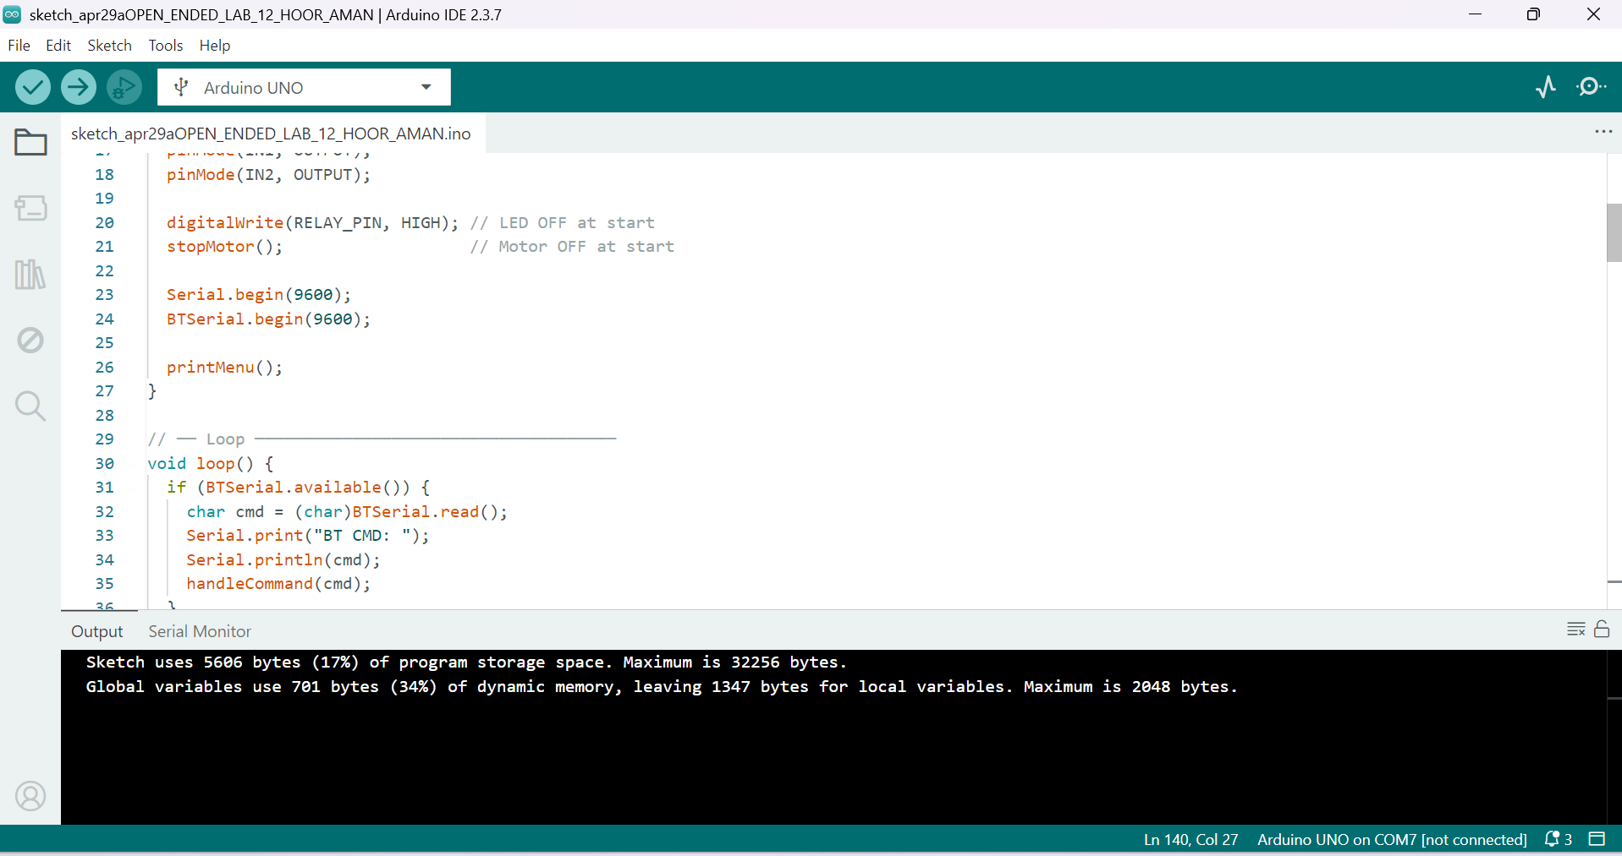
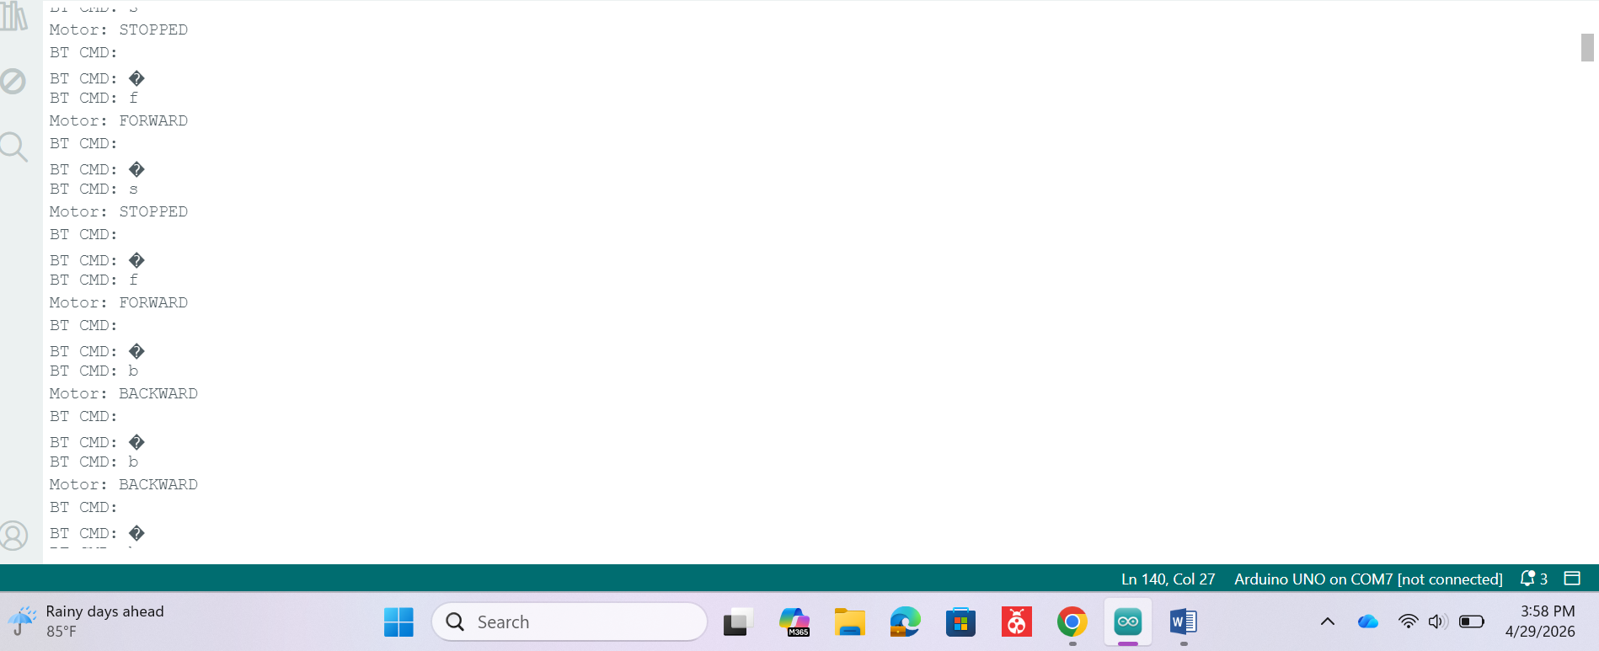
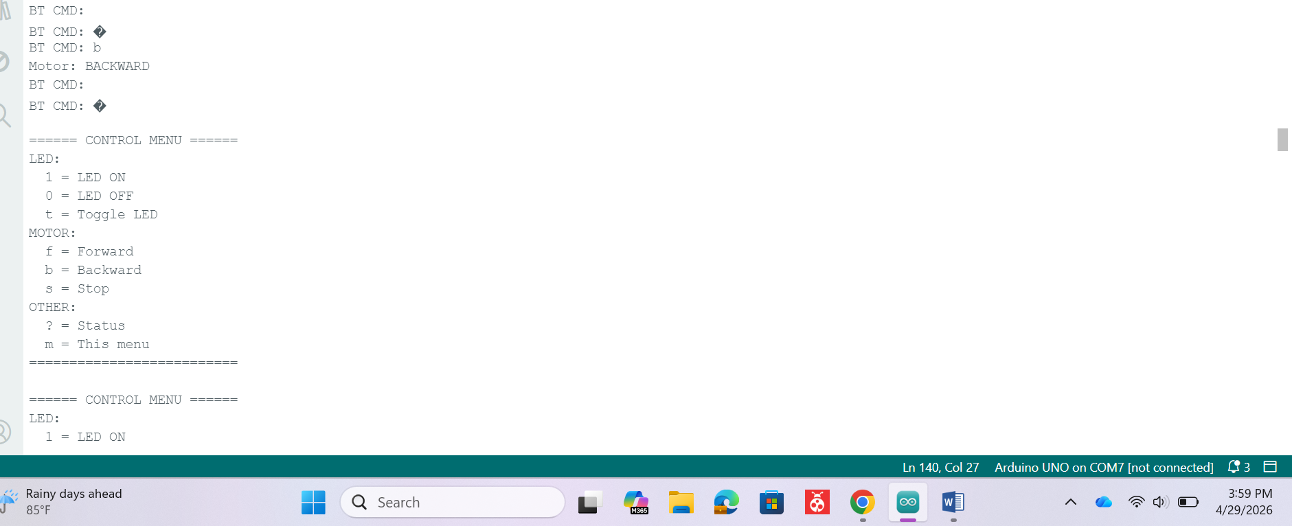
Figures 12-14: Final Hardware Assembly and Integration

