
CPISM E-PROJECT
Project Name: Moment
Submitted By:
Muhammad Ubaid Aftab
(Student id: 1693008)

Numrah Ahsan
(Student id: 1695385)

Subhan Ahmad Khan
(Student id: 1692438)

UMME MARIAM
(Student id: 1690751)
Syeda Hooriya Fatima
(Student id: 1695527)

Content
Abstract 1
Acknowledgement 2
Requirement 3
ScreenShot 4
Task Sheet 8

Abstract

This project, titled "Moment - Photography & Camera Hub", aims to provide a
modern, user-friendly online platform showcasing a curated range of high-end
camera brands including Canon, Nikon, Sony, Fujifilm, and Panasonic. The
website is designed with an emphasis on clean UI/UX principles to enhance the
browsing experience for photography enthusiasts. It features dynamic brand-based
filtering, stylish product cards, and a responsive layout that adapts seamlessly to
different devices.
Built using HTML, CSS, and JavaScript, the project focuses on both aesthetics and
functionality. Each brand's camera data is managed using JavaScript objects,
allowing for scalable and organized content management. The design reflects the
precision of photography equipment while ensuring ease of navigation. This
project serves as a foundation for potential future integration with e-commerce
features for photography gear.

Acknowledgement:

I would like to express my sincere gratitude to Ms. Anamta Asnain for her continuous support, guidance, and encouragement throughout the development of my project. Her valuable insights and feedback played a crucial role in the successful completion of this website.
I am also thankful to my institute, Aptech Metro Star Gate, for providing me with the opportunity and platform to work on this project titled “Moment”. This project not only enhanced my frontend development skills in HTML, CSS, and JavaScript, but also gave me a better understanding of UI/UX design.
The completion of this project would not have been possible without the support and motivation provided by my mentor and institute.

Requirements
The Web site is to be created based on the following requirements.
1) The Home Page should be created making use of Sections with a suitable
Logo, the header section can be added which will show images of related products.
2) The site must contain the links to navigate through any category for the information.
3) The site should display a menu which will have categories of all products.
Few products expected to be included are mentioned below, however more can be added
• Cameras: all types of cameras should be included
• Camera lenses: varieties of lenses to be included
• Pro audio: related audio accessories options to be included
• Memory cards &amp; media: related products
• Tripods &amp; supports
• Lighting &amp; Studio
• Camera bags &amp; cases
• Miscellaneous accessories

4) The site should contain the options for brief introduction about the various products available, location of the shop and any other information if required.
5) The information should be categorized according to the brand names of the products like if a User wants to see only “yashica” cameras or any other company products then he/she can click on a Link/button/menu etc and can company products then he/she can click on a Link/button/menu etc and can see only that Brand products.
6) When a user selects any particular brand, a list of products for that brand will be displayed
7) A brief summary of features of the respective item should be displayed on the Web Page along with the picture but detailed Features should be stored in Individual Word documents which can be downloaded or viewed by the User who wishes to see the same.
9 There should be a “Contact Us” page which will have the Address of the Company which should be displayed using Geolocation API (eg. Google Maps) and the email address which when clicked will invoke the local mail client from where they can send an email.

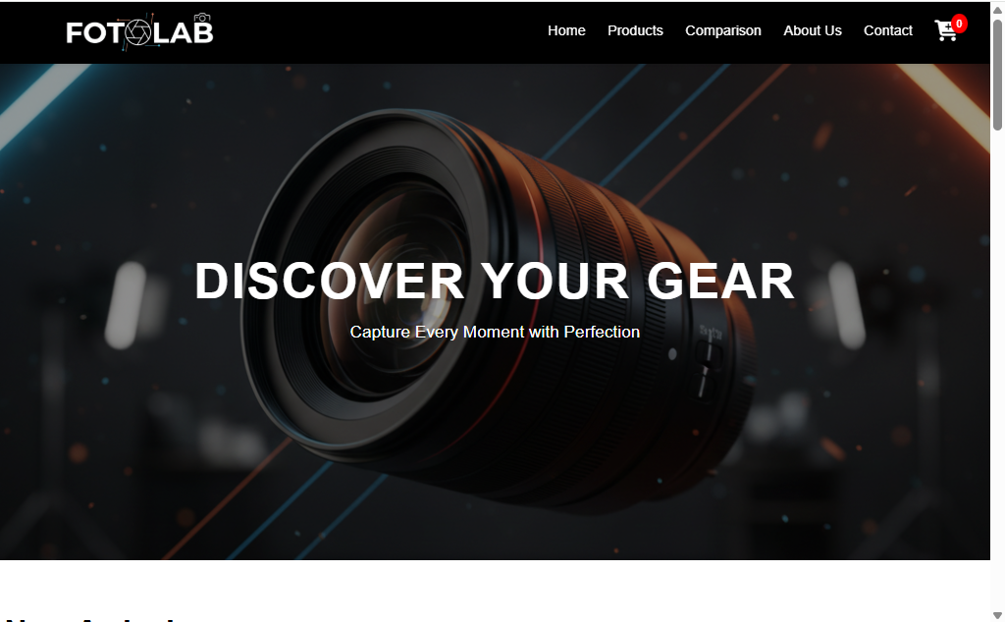
Screenshots:
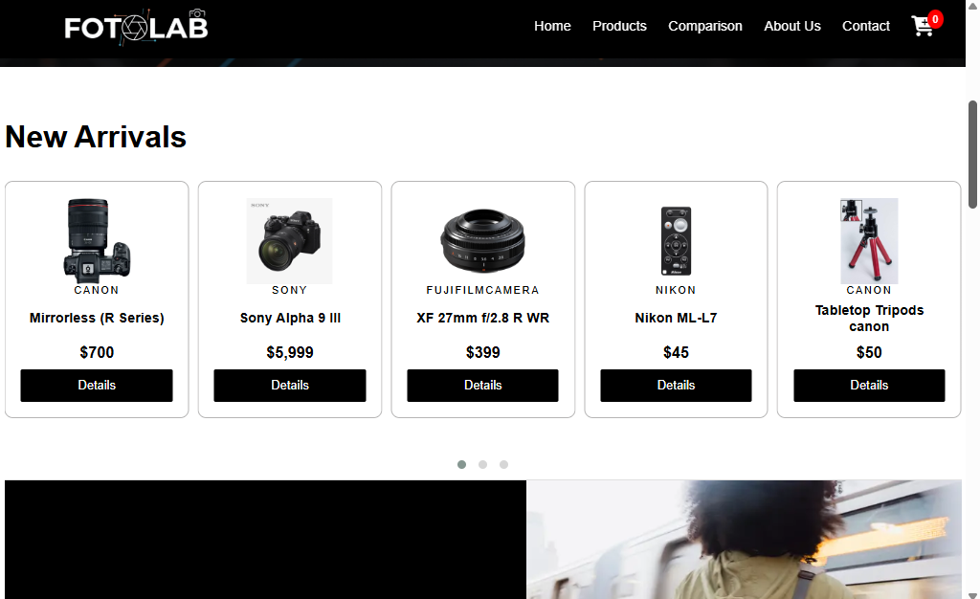

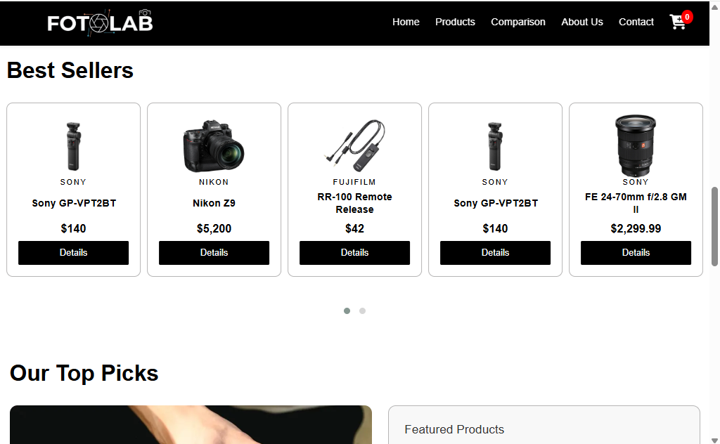
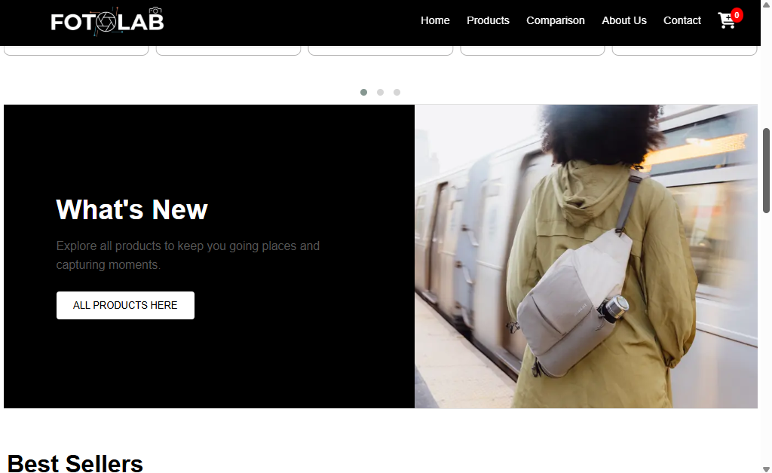
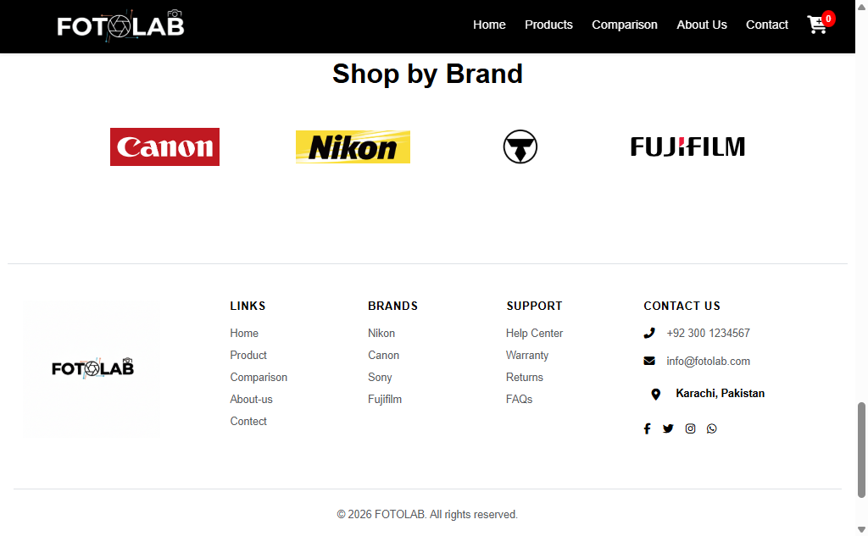
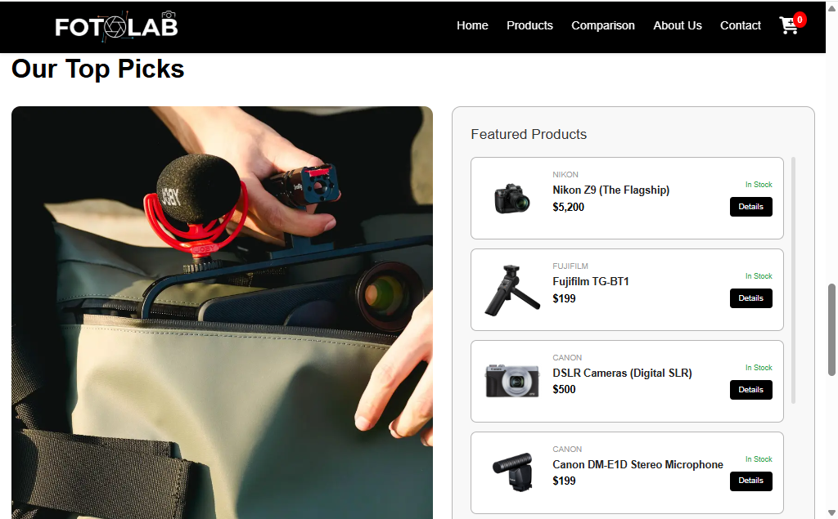
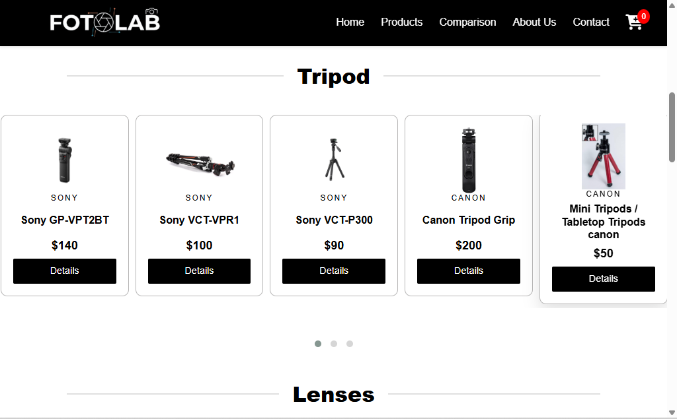
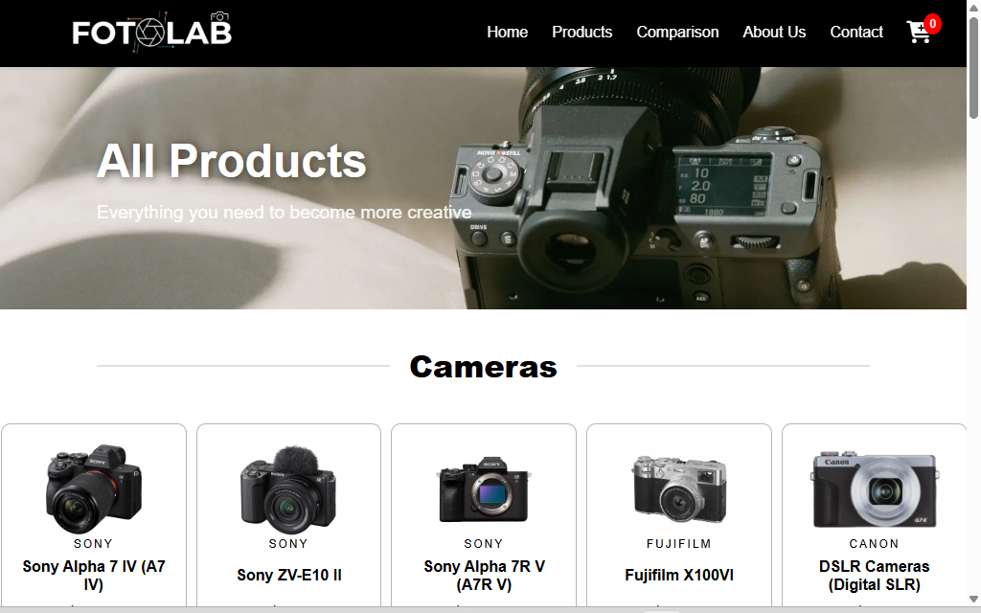

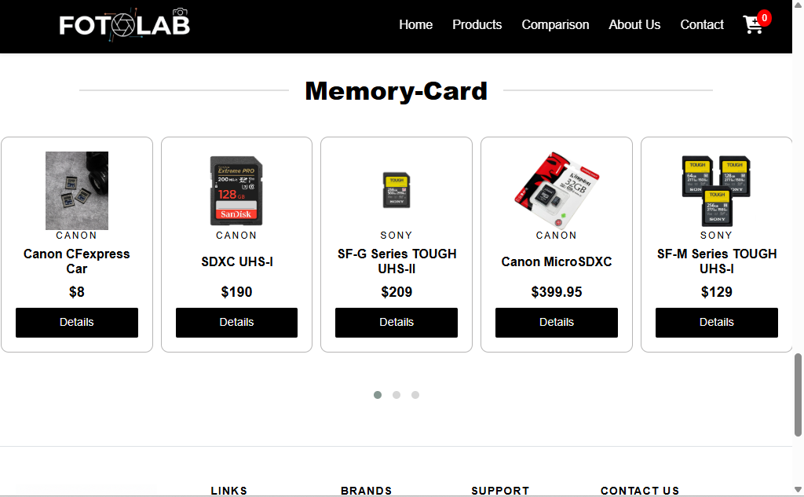
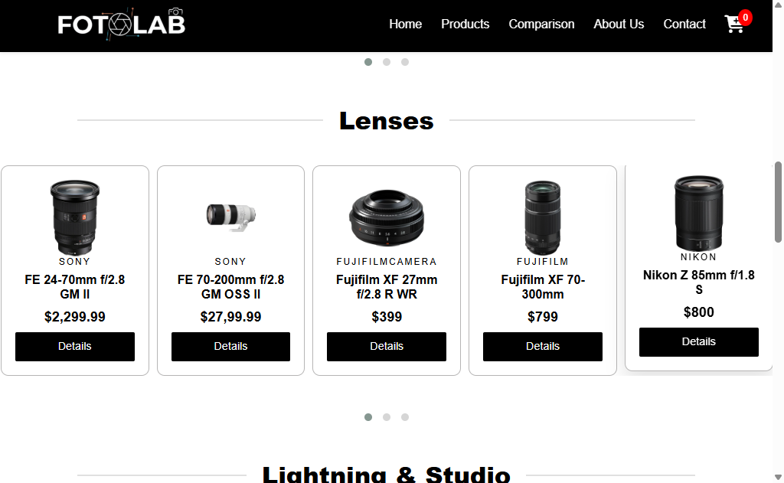
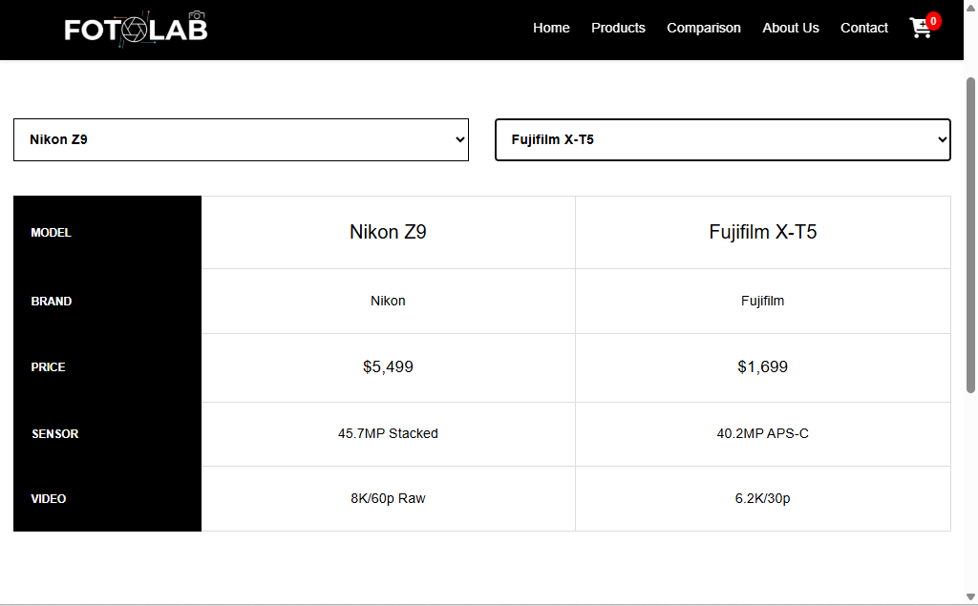
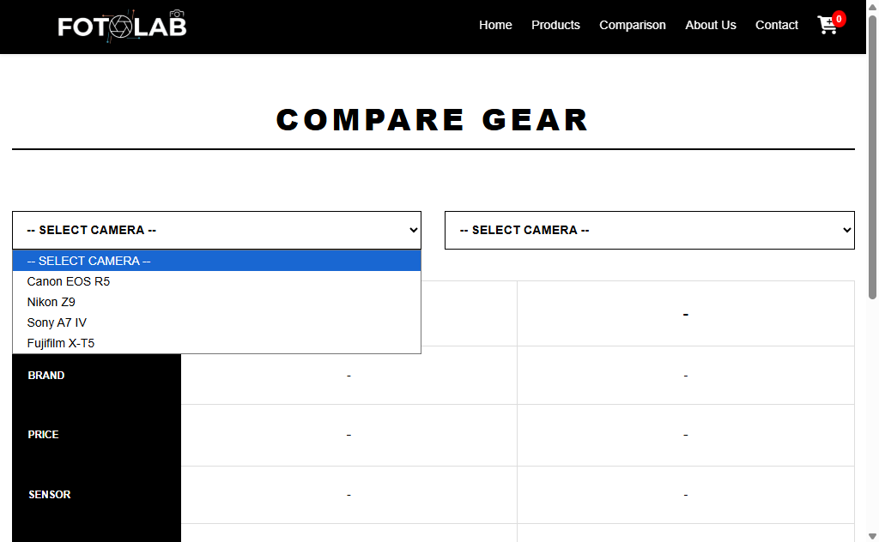

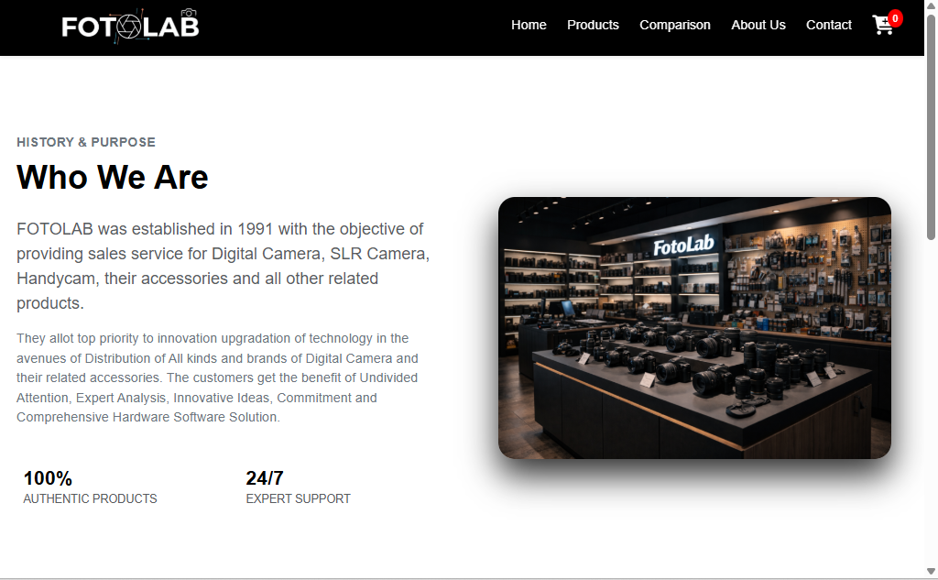
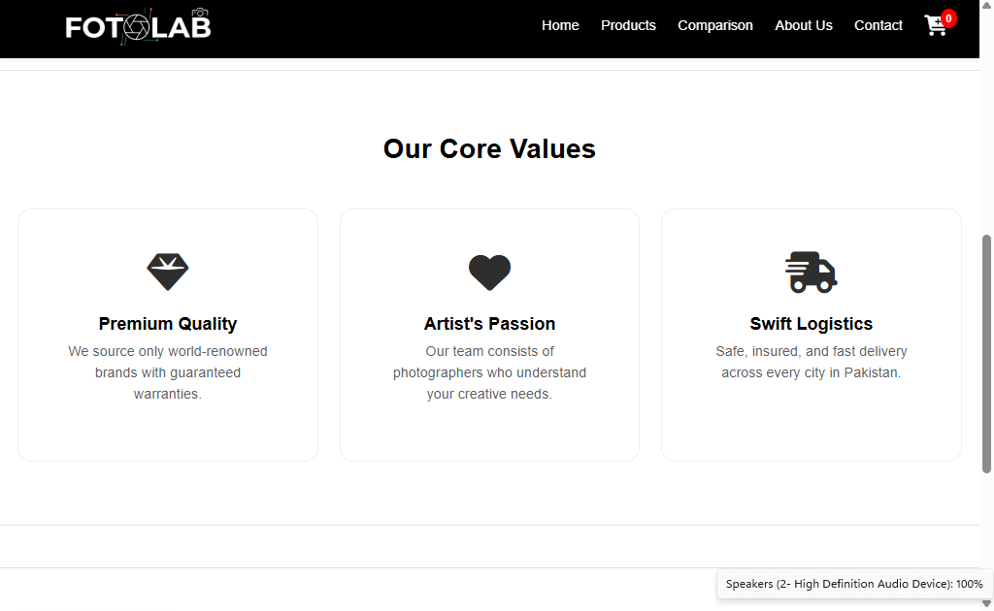

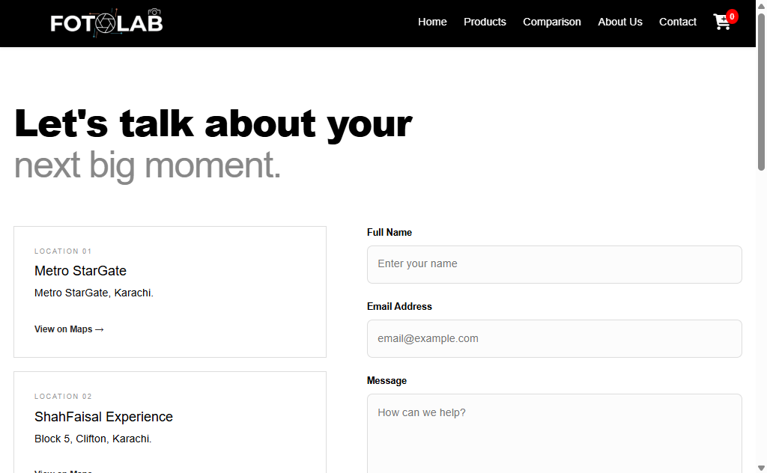
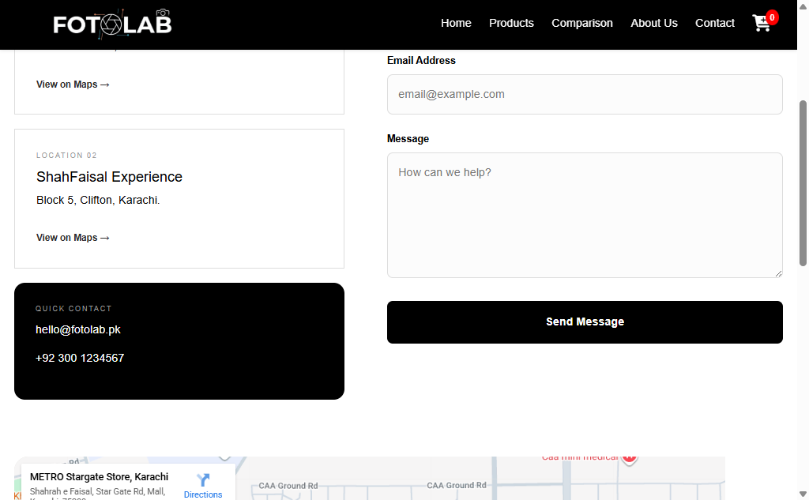
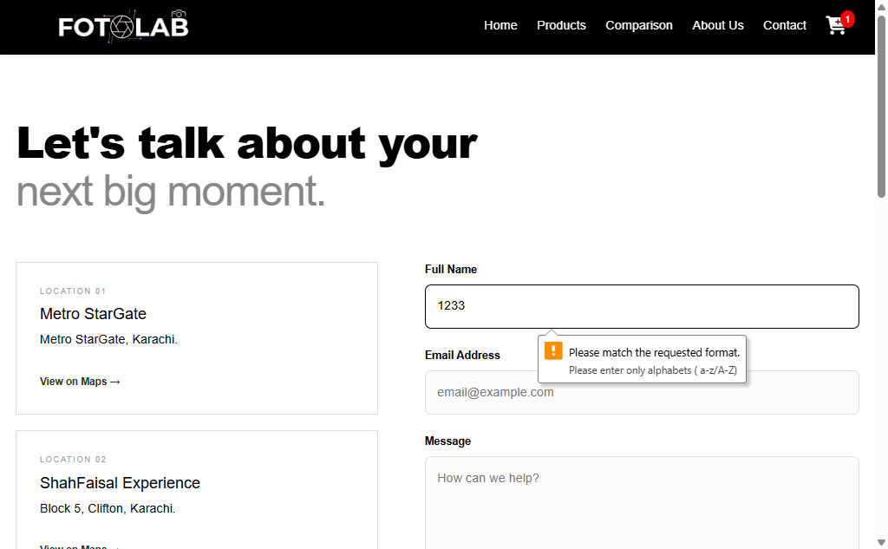
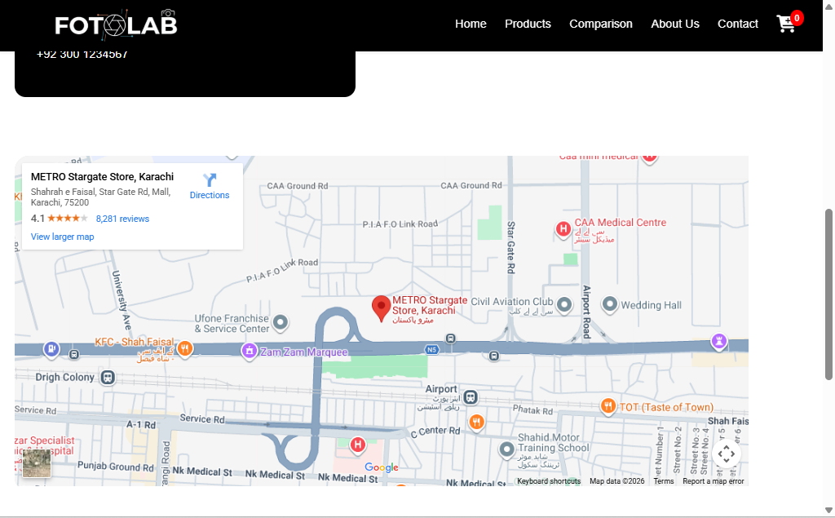
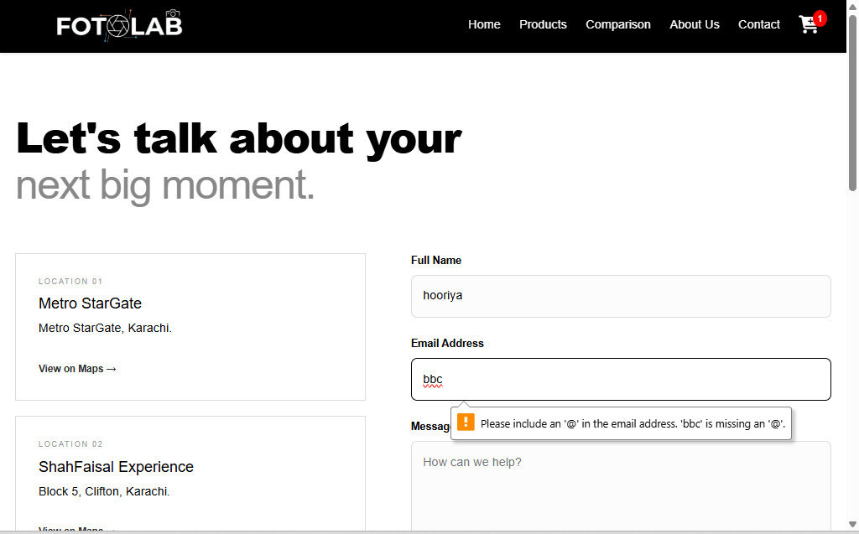

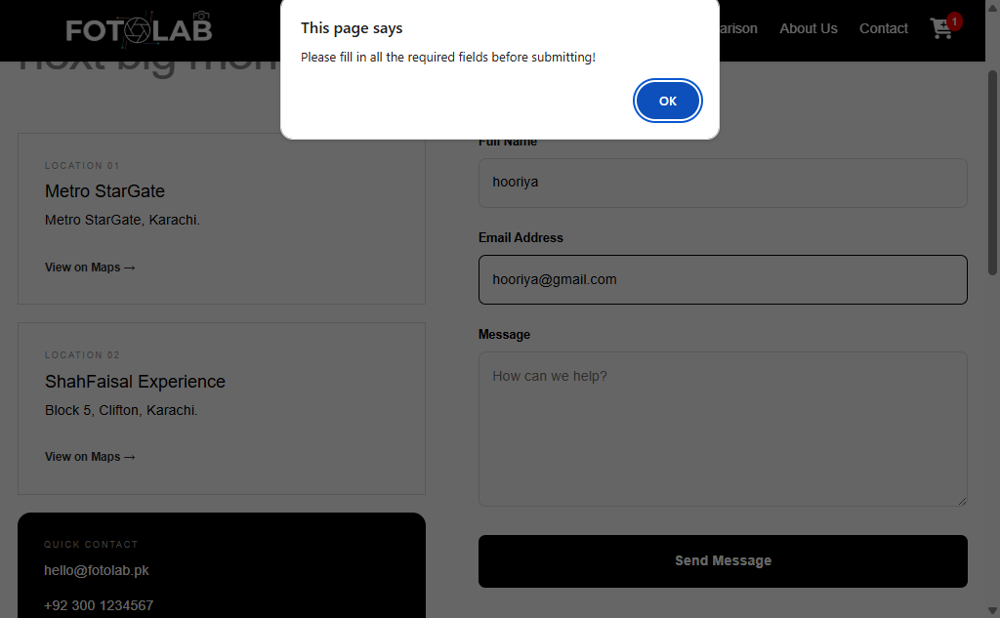
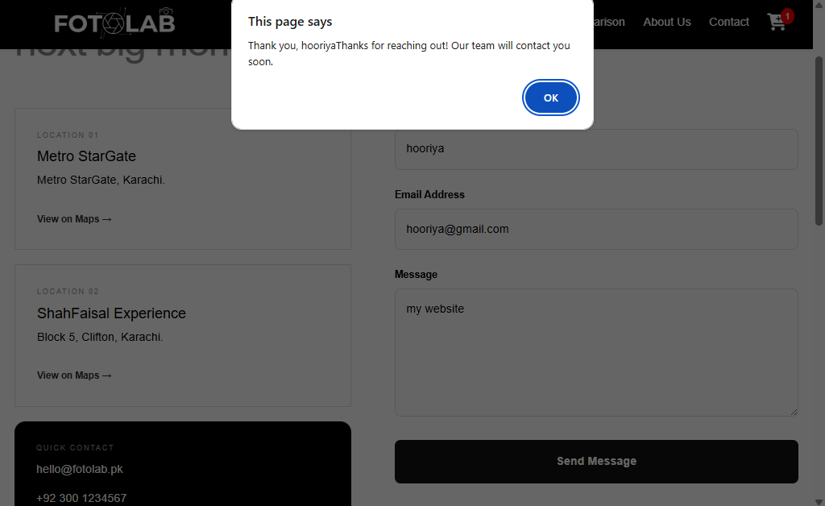
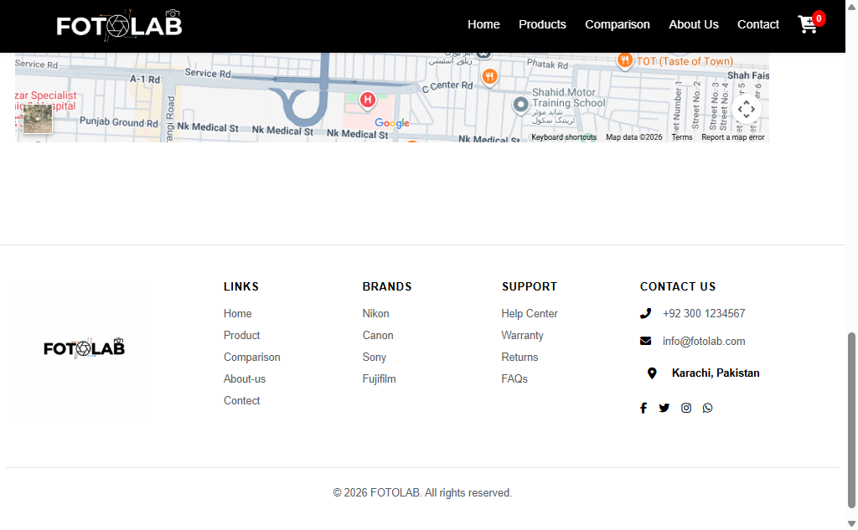

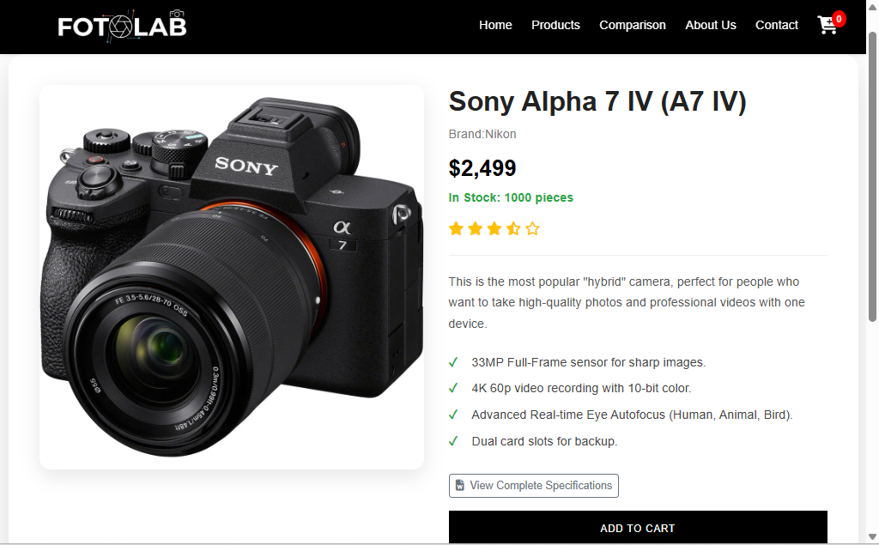
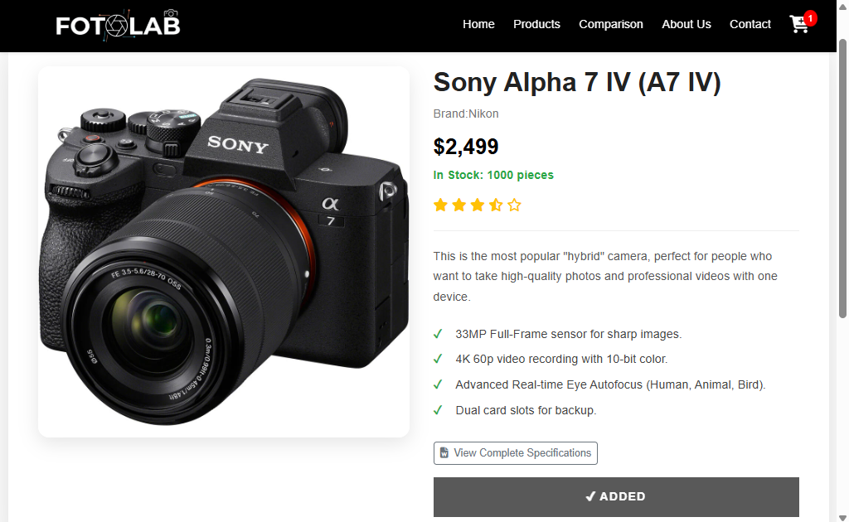

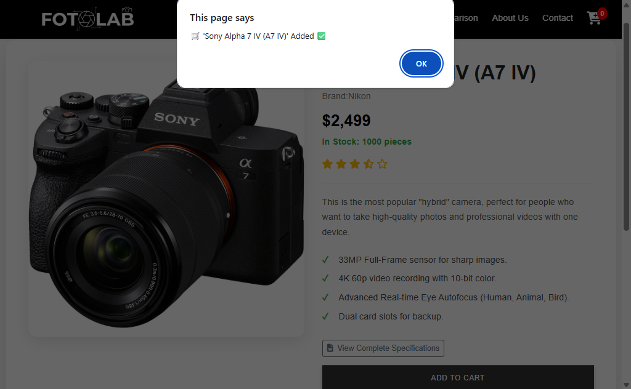
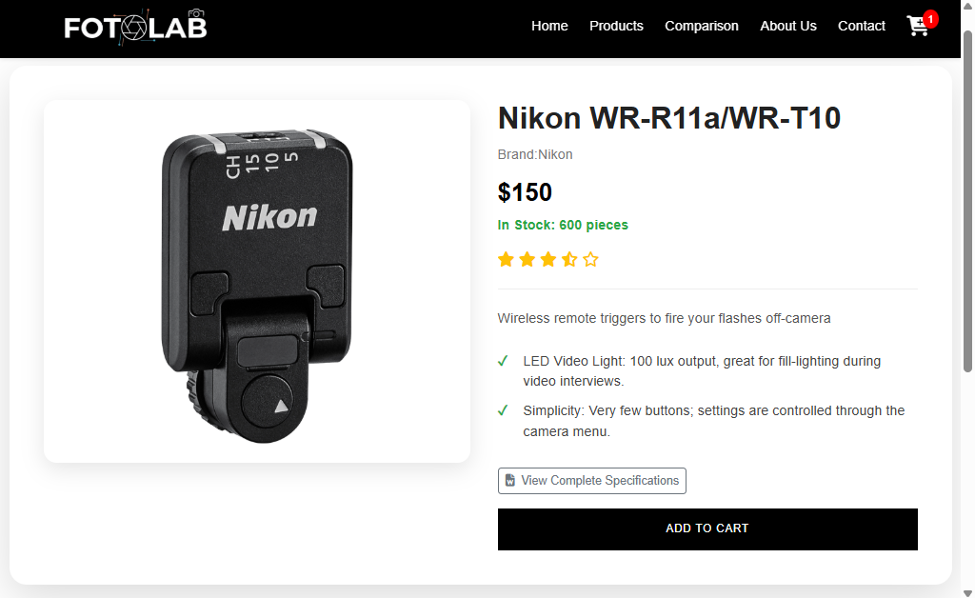

Task Sheet:

Task | Name | Days
Analyzing | Hooriya fatima | 03
Prototype | Hooriya fatima | 04
HTML Code | Hooriya fatima | 12
CSS Code | Hooriya fatima | 16
JAVASCRIPT | Hooriya fatima | 20

THANK
YOU

