MANAGEMENT SYSTEM
PROJECT DOCUMENTATION

Submitted By | [Syeda Hooriya Fatima]
Enrollment / Student ID | [Student 1695527]
Course / Batch | [ACCPAI2025 BATCH09C]
Submitted To | [Asif Ahmed Khan]

Academic Project • PHP • MySQL • HTML • CSS • JavaScript
Submission Date: [6/10/2026]

Project Information
Item | Description
Project Title | E-Vaccination Management System
Project Type | Web-based child immunization and appointment management application
Primary Users | System Administrator, Parent/Guardian, Hospital Staff
Backend | PHP 8.x with PDO database access
Database | MySQL — vaccination_management_system
Frontend | HTML5, CSS3, JavaScript, Bootstrap 5.3 and Bootstrap Icons
Local Development Environment | XAMPP (Apache and MySQL)
Project Purpose | Help manage child profiles, vaccine information, hospital availability, appointment requests and vaccination records.

Acknowledgement
First of all, I am thankful to Almighty Allah for giving me the strength and ability to work on and complete this project.
I would like to express my sincere gratitude to my respected teacher and supervisor for providing guidance, feedback and encouragement during the development of the E-Vaccination Management System. Their support helped me understand the process of planning, designing, developing and documenting a web-based application.
I am also grateful to my family and everyone who supported me during this project. This project has provided an opportunity to apply programming, database and web-development concepts to a practical scenario.

Abstract
The E-Vaccination Management System is a web-based application designed to organize information related to childhood immunization. It provides a public-facing portal for viewing vaccine and hospital information, alongside separate areas for parents, hospital staff and administrators. Parents can manage child profiles and request vaccination appointments. Hospital staff can manage appointment activity and vaccination records. Administrators can oversee users, hospitals, vaccines, bookings and reports. The application uses PHP for server-side processing and MySQL for persistent data storage, with HTML, CSS, JavaScript and Bootstrap supporting the user interface.

Table of Contents
- 1. Introduction
- 2. Problem Statement
- 3. Objectives and Scope
- 4. System Overview and User Roles
- 5. Functional Specifications
- 6. Non-Functional Requirements
- 7. Hardware and Software Requirements
- 8. System Architecture and Technology Stack
- 9. Database Details
- 10. Database Relationships
- 11. Installation and Setup
- 12. Testing and Validation
- 13. Limitations and Future Enhancements
- 14. Conclusion
- Appendix A: Screenshots to Include
- Appendix B: Project File Structure
Note: In Microsoft Word, an automatic table of contents can be inserted from References → Table of Contents if page numbers are required after final editing.

1. Introduction
Vaccination is an important part of preventive healthcare. Keeping track of children, recommended vaccines, appointments and completed doses can become difficult when information is stored in separate or paper-based records. The E-Vaccination Management System provides a centralized digital platform to support these routine administrative tasks.
The project combines a public information website with authenticated role-based portals. Its database stores user accounts, hospital profiles, child details, vaccine information, appointment requests, vaccination records and contact messages.

2. Problem Statement
Managing child immunization information manually can make it difficult to maintain accurate records, coordinate appointments with hospitals and retrieve a child’s vaccination history. Parents need a convenient way to review vaccine information, find participating hospitals and request appointments. Hospital staff need a structured way to review appointment requests and record vaccinations, while administrators need centralized oversight of users, hospitals, vaccines and system activity.
The proposed system addresses these needs through a web-based application that stores related information in a MySQL database and separates functions according to user roles. It is intended to improve organization, accessibility and consistency of records; it does not replace advice from qualified healthcare professionals.

3. Objectives and Scope

3.1 Objectives
- Provide public information about vaccines, hospitals and vaccination schedules.
- Allow parents or guardians to register and maintain child profiles.
- Allow parents to submit vaccination appointment requests.
- Provide hospital accounts with appointment and vaccination-record workflows.
- Give administrators tools to manage user accounts, hospitals, vaccines, appointments and reports.
- Store vaccination history and certificate codes in a centralized database.
- Use role-based access and database-backed forms to organize access to system functions.

3.2 Scope
The project scope includes account registration and login, public information pages, child-profile management, hospital and vaccine directories, appointment requests, appointment status handling, vaccination records, contact messages and administrative reporting. Clinical diagnosis, vaccine prescription and direct integration with external government health systems are outside the documented project scope.

4. System Overview and User Roles
Role / Area | Main Responsibilities
Public Visitor | Browse the home page, About page, vaccine directory, hospital directory, vaccination schedule, “How It Works” guide and contact page.
Parent / Guardian | Register and log in; manage child details; view child profiles and vaccination history; browse hospitals and vaccines; request appointments; review booking/request status.
Hospital Staff | Access the hospital dashboard; maintain profile details; review appointments; view available vaccines and manage vaccination-record workflows.
System Administrator | Manage users, hospitals, vaccines, children, bookings and requests; review reports; access administrative profile and dashboard functions.

4.1 Typical Workflow
- A parent creates an account and signs in.
- The parent adds a child profile with relevant details.
- The parent reviews the vaccine and hospital directories.
- The parent submits an appointment request for a child, vaccine, hospital, date and time.
- The appointment is reviewed and its status is updated through the relevant authorized workflow.
- After vaccination, an authorized hospital workflow records the vaccination details and certificate code.
- The parent can review the child’s vaccination history through the portal.

5. Functional Specifications

5.1 Public Website
- Home page presenting the system and its main navigation.
- About page with general information about the project/service.
- Vaccine directory for viewing vaccine descriptions, target diseases, recommended ages, dose counts and availability.
- Hospital directory for viewing hospital details and availability information.
- Vaccination schedule guide and “How It Works” information page.
- Contact form for submitting visitor inquiries.

5.2 Authentication and Accounts
- Login page for registered users.
- Registration page for parent and hospital account types.
- Logout functionality.
- Role-aware routing and access checks for administrator, parent and hospital areas.
- Account information stored in the users table, with a role and account status.

5.3 Parent / Guardian Functions
- View the parent dashboard.
- Add, view and edit child profiles.
- Browse hospitals and vaccine information.
- Submit vaccination appointment requests.
- Review appointment requests and their statuses.
- View child vaccination history and related vaccination-record details.
- Maintain parent profile information.

5.4 Hospital Functions
- View the hospital dashboard and profile.
- Review and manage appointment activity through the hospital appointments page.
- View vaccine information available to the hospital.
- Access vaccination-record workflows and record details of administered doses.
- Maintain hospital-facing account/profile information.

5.5 Administrator Functions
- View dashboard summaries.
- Manage users and child-related records.
- Manage hospital records and vaccine catalogue information.
- Review and manage bookings and appointment requests.
- View reports and immunization-related summaries.
- Maintain the administrator profile.

5.6 Key Data Captured
Data Group | Examples of Stored Information
User Account | Name, email, phone, password hash, role, status and timestamps
Hospital | Hospital name, linked user account, contact details, address, city, location, operating hours and status
Child | Parent link, name, date of birth, gender, blood group, birth weight, address and medical notes
Vaccine | Name, short code, description, target disease, recommended age, dose count, interval and availability
Appointment | Booking code, parent, child, hospital, vaccine, appointment date/time, status and notes
Vaccination Record | Child, vaccine, hospital, dose number, vaccination date, status, batch number, administrator and certificate code
Contact Message | Sender name, email, phone, subject, message, status and creation time

6. Non-Functional Requirements
Requirement | Description
Usability | Consistent navigation and role-specific dashboards help users locate common functions.
Security | Login and role checks are included. Sensitive operations should only be available to authorized roles.
Data Integrity | Primary keys, unique fields and foreign-key constraints connect related records and reduce orphaned data.
Maintainability | Shared layout and helper files are organized in an includes directory; role-specific pages are grouped into separate directories.
Compatibility | Designed for use in a modern web browser on a local XAMPP/PHP/MySQL environment.
Reliability | PDO database connection settings enable exception-based error handling and associative query results.
Privacy | Child and health-related information should be accessed only by authorized users and handled responsibly.

7. Hardware and Software Requirements

7.1 Hardware Requirements
- Computer or laptop capable of running a local web-development environment.
- Recommended: 4 GB RAM or more for comfortable use of a current operating system and browser.
- Sufficient disk space for XAMPP, project files, the MySQL database and uploaded hospital images.
- Keyboard, mouse/touchpad and display.

7.2 Software Requirements
Software | Purpose
Windows, Linux or macOS | Operating system
XAMPP | Local Apache web server and MySQL/MariaDB service
PHP 8.x | Server-side application logic
MySQL / MariaDB | Relational database storage
Web browser | Run and test the web application
Visual Studio Code or another code editor | Read and edit PHP, CSS, JavaScript and SQL files
phpMyAdmin | Import and inspect the project database

8. System Architecture and Technology Stack
Layer | Technologies / Files | Responsibility
Presentation | HTML5, CSS3, JavaScript, Bootstrap 5.3, Bootstrap Icons | Pages, navigation, forms, styling and client-side interactions
Application | PHP 8.x | Authentication, role-specific workflows, form handling and business logic
Database Access | PDO in config/database.php | Connects PHP pages to MySQL; configured to use exception mode and native prepared statements
Data Storage | MySQL database vaccination_management_system | Stores users, hospitals, children, vaccines, appointments, vaccination records and messages
Shared Components | includes/header.php, navbar.php, footer.php, sidebar.php, topbar.php, auth.php, functions.php | Reusable layout, navigation, authorization helpers and shared functions
Static / Uploaded Assets | assets/css, assets/js, assets/images, uploads/ | Stylesheets, JavaScript, visual assets and hospital images

The application follows a typical web-client architecture: a user interacts with a browser, PHP processes requests on the server, and PDO communicates with MySQL. The database returns records to the application, which prepares the response for the browser.

9. Database Details
The supplied SQL file creates the database named vaccination_management_system. It defines eight main tables. The schema uses primary keys, unique fields and foreign keys to link related records.
No. | Table | Purpose
1 | users | Stores administrator, parent and hospital user accounts, roles and account status.
2 | hospitals | Stores hospital profile and contact information linked to a user account.
3 | children | Stores child profiles linked to the parent account.
4 | vaccines | Stores the vaccine catalogue, recommended ages, target diseases, dose requirements and availability.
5 | hospital_vaccines | Links hospitals to vaccines and records hospital-specific availability.
6 | appointments | Stores appointment booking codes, parent/child/hospital/vaccine links, date/time, status and notes.
7 | vaccination_records | Stores administered-dose details, vaccination date, hospital, dose number and certificate code.
8 | contact_messages | Stores inquiries submitted through the public contact form and their response status.

9.1 Important Database Constraints
- users.email is unique to avoid duplicate email accounts.
- hospitals.user_id references users.id.
- children.parent_id references users.id.
- hospital_vaccines uses a unique hospital/vaccine pair and references hospitals and vaccines.
- appointments references the parent account, child, hospital and vaccine.
- vaccination_records references child, vaccine and hospital; its appointment link can be empty and is set to NULL if the linked appointment is deleted.
- vaccination_records.certificate_code is unique.

10. Database Relationships
Relationship | Type / Meaning
users → hospitals | A hospital profile is linked to a user account through hospitals.user_id.
users → children | A parent account can have multiple child records.
hospitals ↔ vaccines | The hospital_vaccines junction table records which vaccines are available at each hospital.
users / children / hospitals / vaccines → appointments | Each appointment links a parent, a child, a hospital and a vaccine.
children / vaccines / hospitals → vaccination_records | Each vaccination record identifies the child, vaccine and hospital involved.
appointments → vaccination_records | A vaccination record may be linked to an appointment; the appointment reference is optional.
contact_messages | Stores contact-form submissions independently of the other operational records.

For a database diagram, use phpMyAdmin Designer or a diagramming tool to create an ERD from the supplied SQL schema. Insert the final ERD in this section if your teacher requires a visual database relationship diagram.

11. Installation and Setup
The following steps reflect the project README and the supplied XAMPP-oriented configuration.
- Install XAMPP and open the XAMPP Control Panel.
- Start Apache and MySQL.
- Copy the project folder into the XAMPP htdocs directory. Keep the project folder name consistent with the local URL you will use.
- Open http://localhost/phpmyadmin in a browser.
- Choose the Import tab and select database/vaccination_system.sql from the project folder.
- Run the import and confirm that the vaccination_management_system database and its eight tables are present.
- Check config/database.php. The supplied local configuration uses host localhost, user root, an empty password and database vaccination_management_system; change these values if your local MySQL setup differs.
- Open the project in the browser, for example http://localhost/vcaccination-managment-system/ (adjust the URL if you use a different folder name).
- Use the login page to sign in with a test account, or register a new parent/hospital account.
- Test the public pages and the dashboard corresponding to the account role.

11.1 Demo Accounts
The project README lists these sample accounts for local testing. They are demonstration credentials only; do not use them on a public deployment, and change/remove seeded accounts before exposing the application online.
Role | Demo Email | Demo Password
System Administrator | admin@evaccine.com | Admin@123
Parent Account | sarah.jenkins@gmail.com | Parent@123
Hospital Staff | contact@citygeneral.org | Hospital@123

12. Testing and Validation
Use the following checklist to test the project locally. Record the actual result after running each test on your machine; do not mark a test as passed until it has been verified.
Test ID | Test Scenario | Expected Result | Actual Result
T01 | Open the public home page | Page loads and navigation links are visible. | [Pass / Fail]
T02 | Open the vaccine directory | Vaccine entries and their details are displayed. | [Pass / Fail]
T03 | Open the hospital directory | Hospital entries and available details are displayed. | [Pass / Fail]
T04 | Register a parent account | Valid form data creates an account or shows a clear validation message. | [Pass / Fail]
T05 | Log in with a valid account | User is directed to the appropriate role area. | [Pass / Fail]
T06 | Try opening another role’s page without authorization | Access is blocked or redirected according to the application’s authorization logic. | [Pass / Fail]
T07 | Add or edit a child profile as a parent | The child record is saved and shown in the parent area. | [Pass / Fail]
T08 | Submit an appointment request | The request is stored and its status is available for review. | [Pass / Fail]
T09 | Review an appointment as hospital/admin | Authorized user can view and process the appointment. | [Pass / Fail]
T10 | View vaccination history | Saved vaccination records are shown for the relevant child. | [Pass / Fail]
T11 | Submit the contact form | The message is saved or a validation message is displayed. | [Pass / Fail]
T12 | Stop MySQL and reload the app | The app shows a database connection/setup message rather than silently failing. | [Pass / Fail]

13. Limitations and Future Enhancements

13.1 Limitations
- The project is configured primarily for local development and requires correct PHP/MySQL setup.
- The provided database seed records are demo data and should not be treated as real medical records.
- The project does not itself provide clinical advice or validate a child’s medical eligibility for a vaccine.
- External SMS/email reminders, government health-system integrations and online identity verification are not documented as implemented features.

13.2 Future Enhancements
- Add automated appointment reminders through email or SMS.
- Add secure password-reset and account-verification workflows.
- Provide exportable vaccination summaries and printable certificates where appropriate.
- Improve audit logging for important administrative and vaccination-record changes.
- Add stronger deployment hardening, backups, HTTPS and environment-based database credentials.
- Add accessibility checks and broader browser/device testing.

14. Conclusion
The E-Vaccination Management System brings together parent/guardian, hospital and administrator workflows in a single PHP and MySQL web application. Its main functions cover child-profile management, vaccine and hospital information, appointment requests, vaccination records and administrative oversight. The project demonstrates the use of server-side programming, relational database design, role-based application areas and reusable web components. Further testing and security hardening would be needed before the application could be used with real health information in a production environment.

Figure A1 — Public Home Page
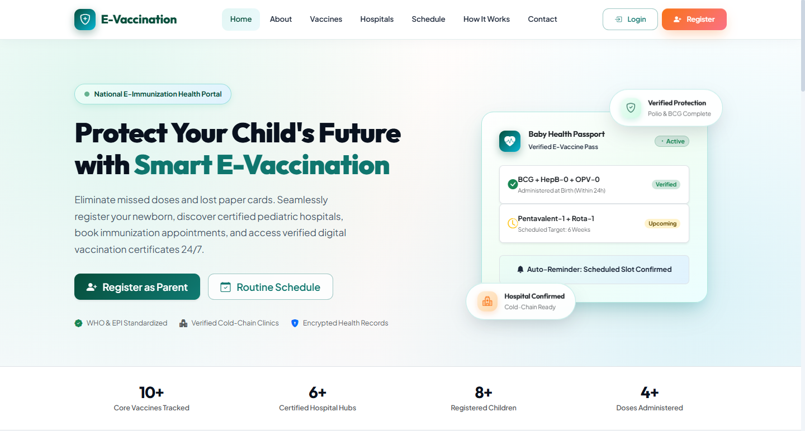
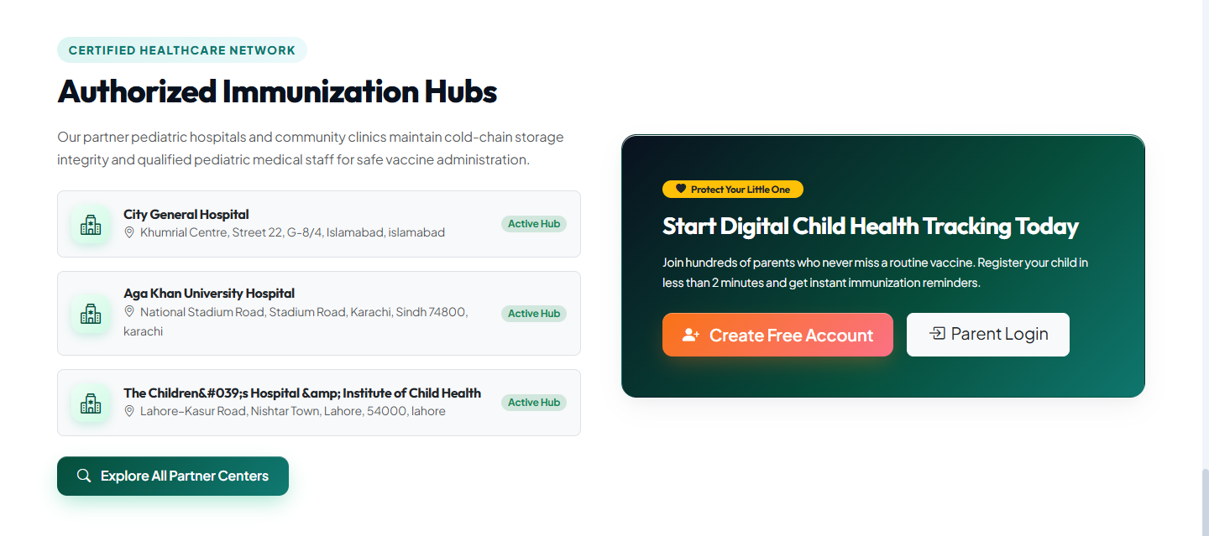
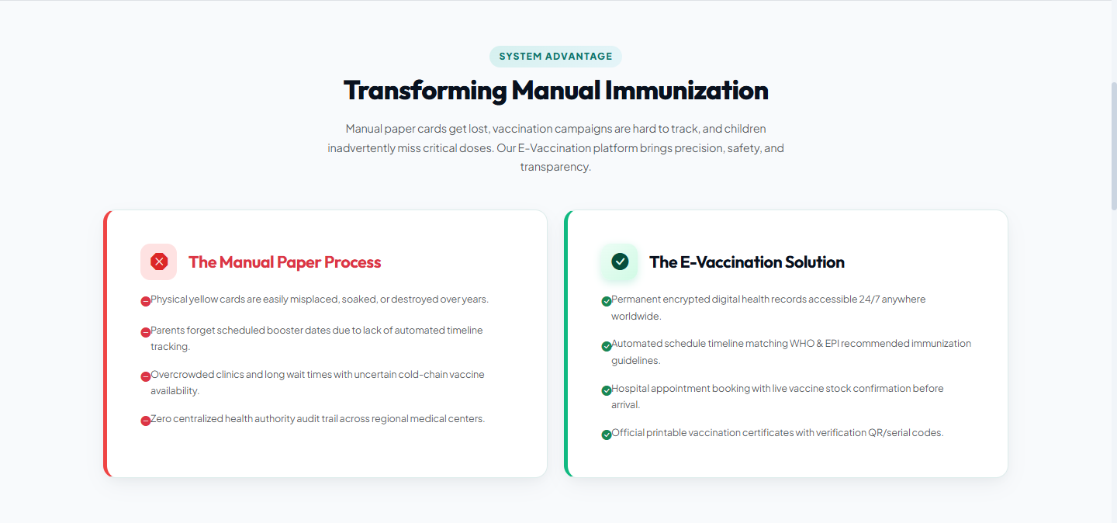
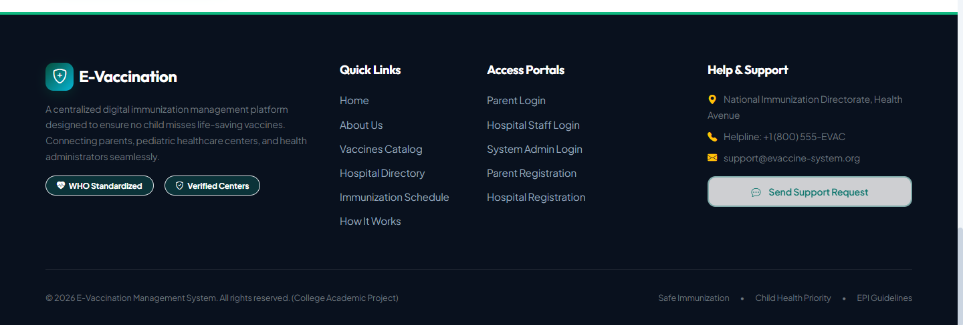

Figure A2 — Login / Registration

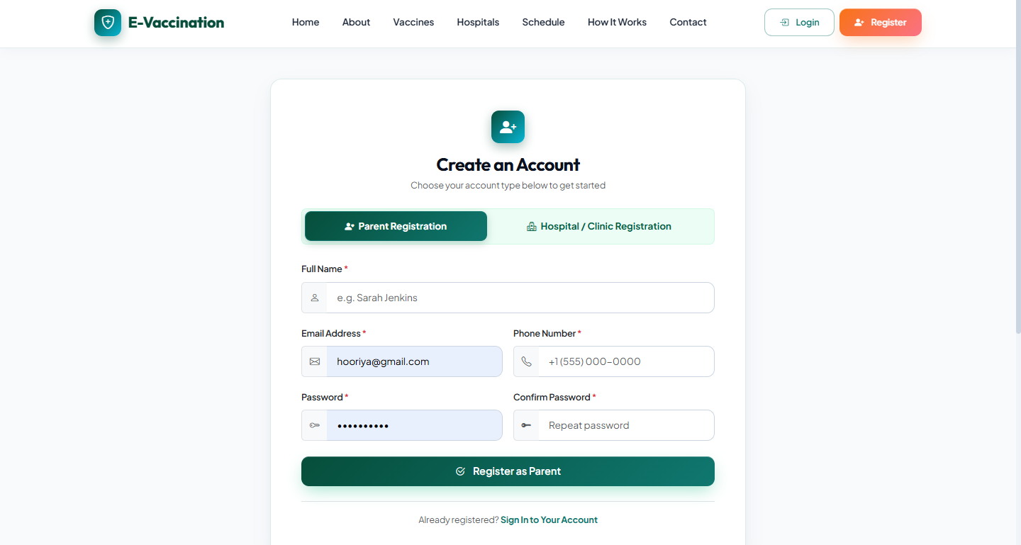
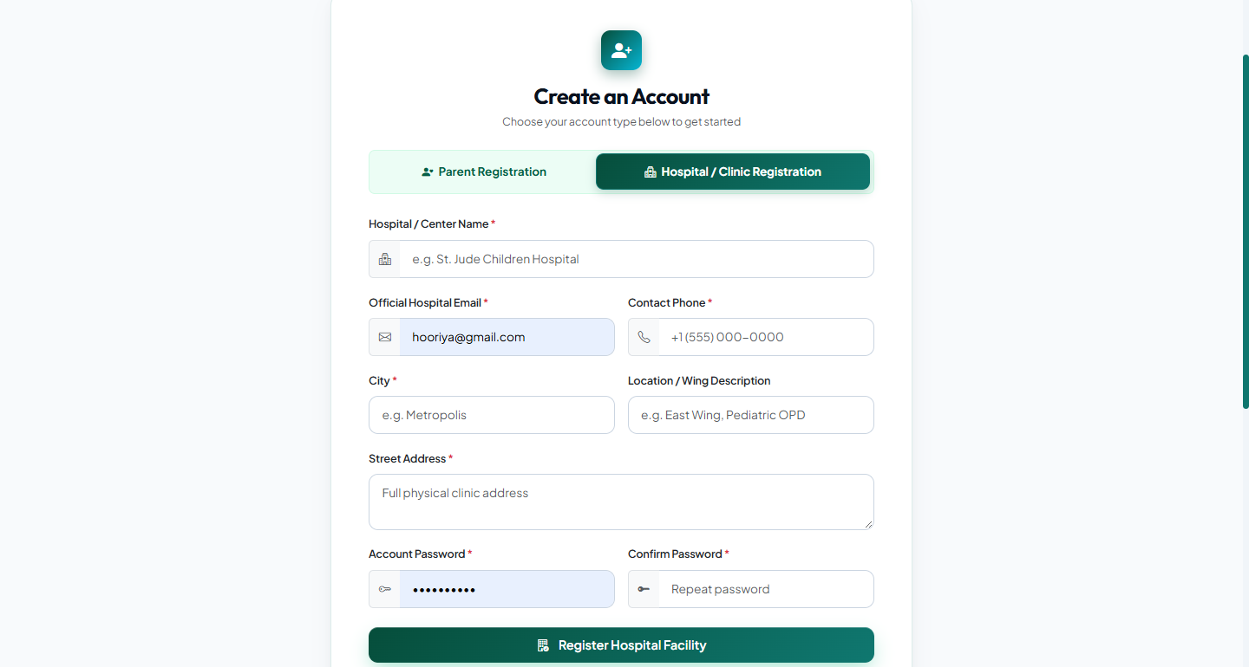
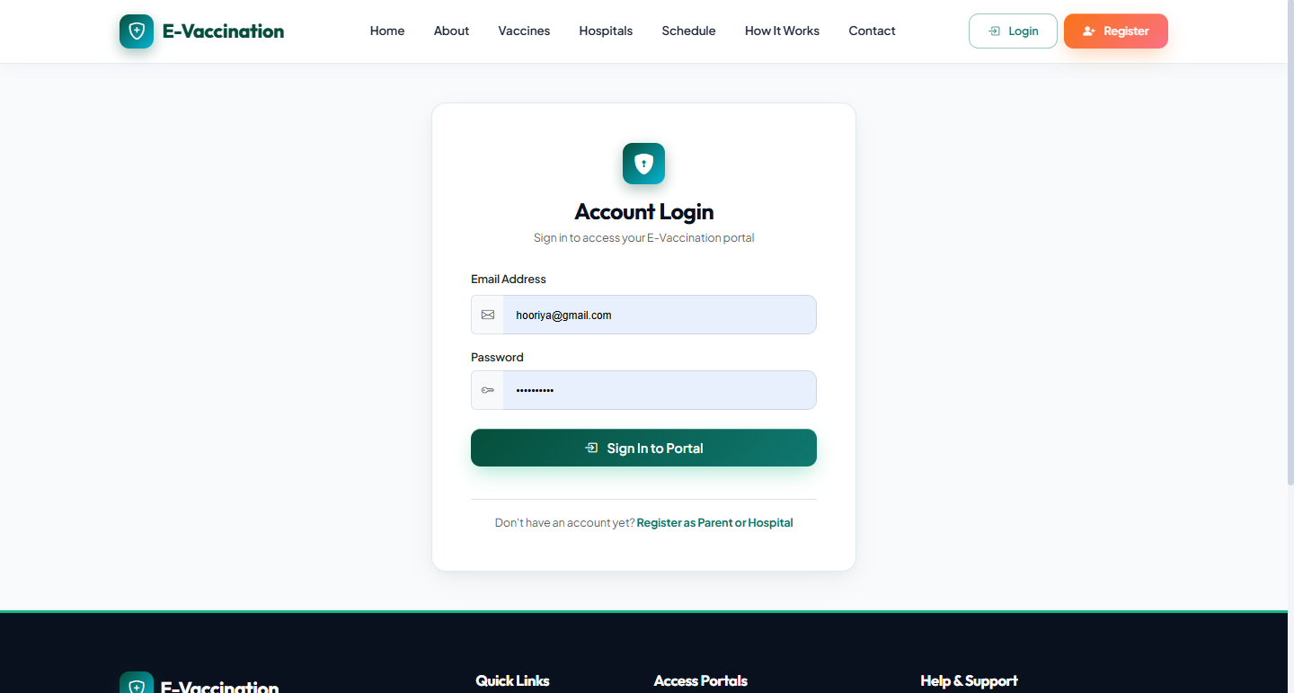

Figure A3 — Vaccine Directory

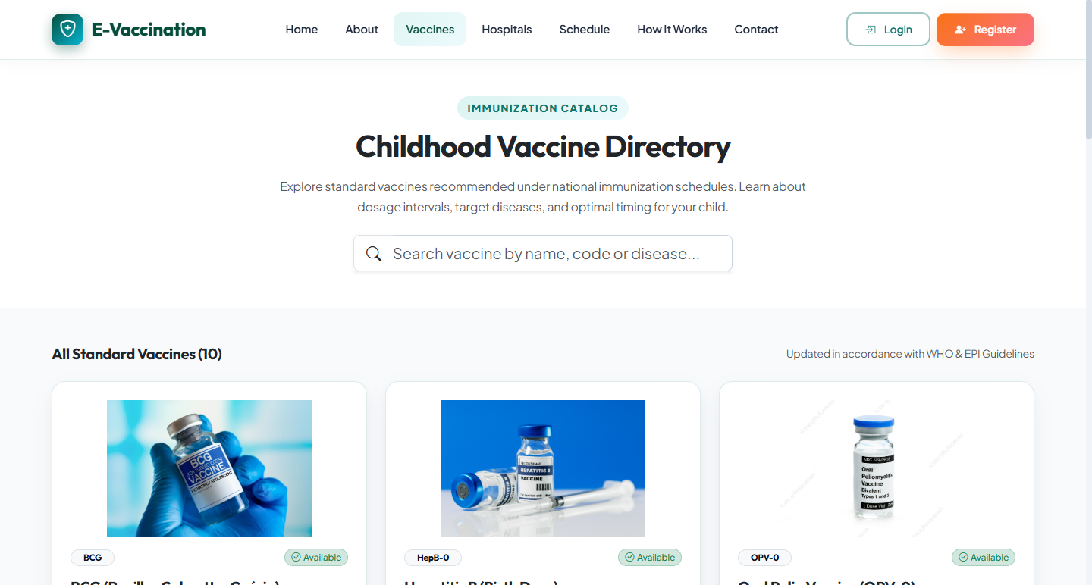
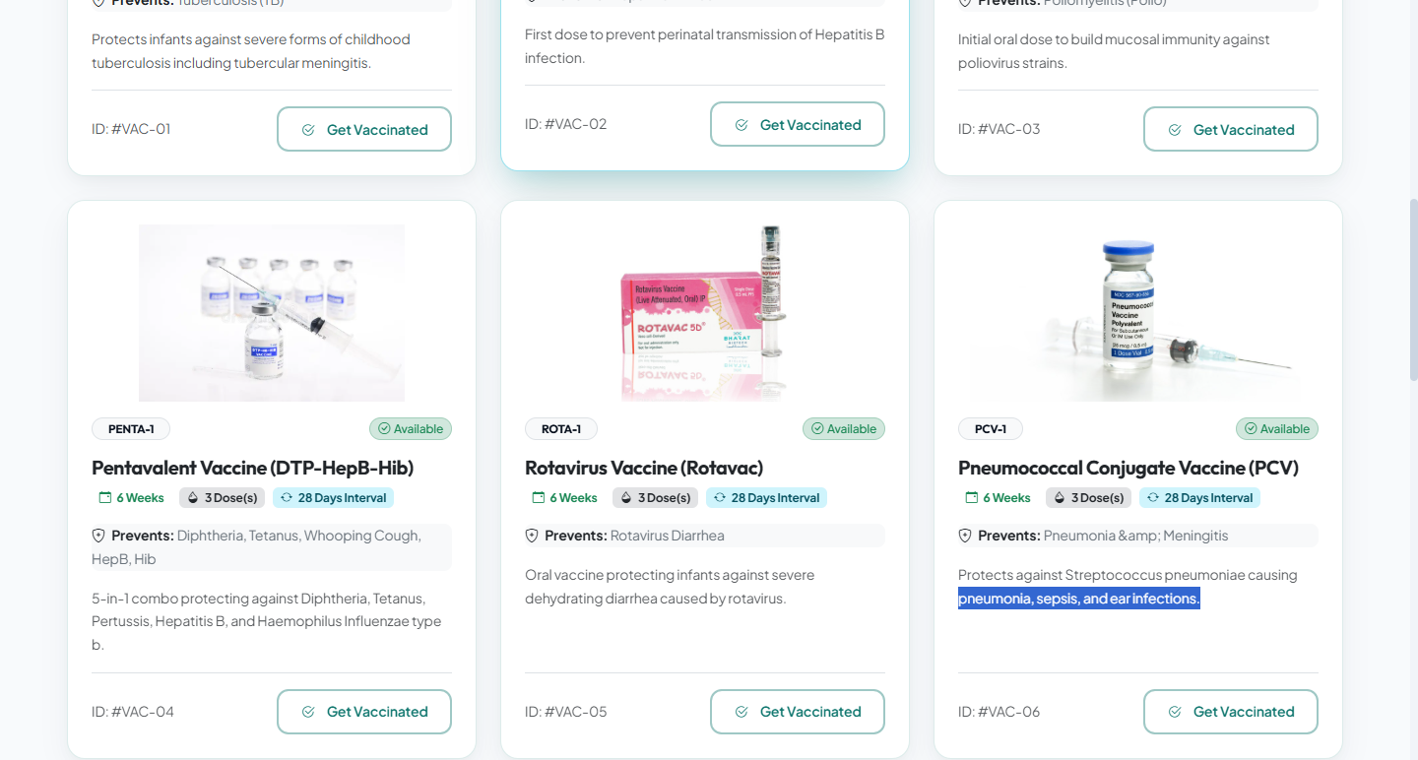

Figure A4 — Hospital Directory

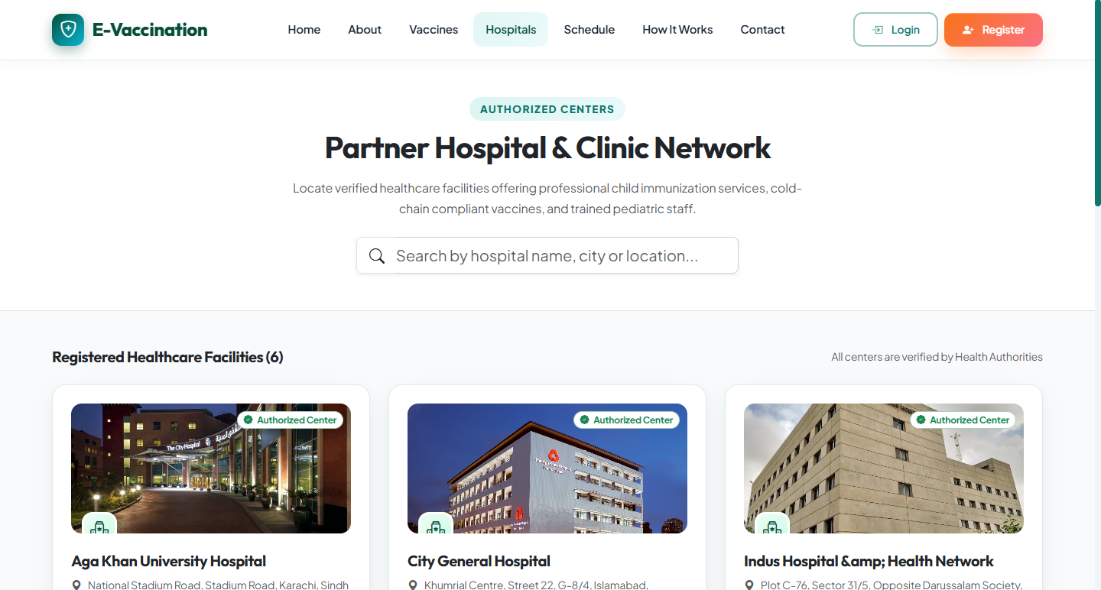
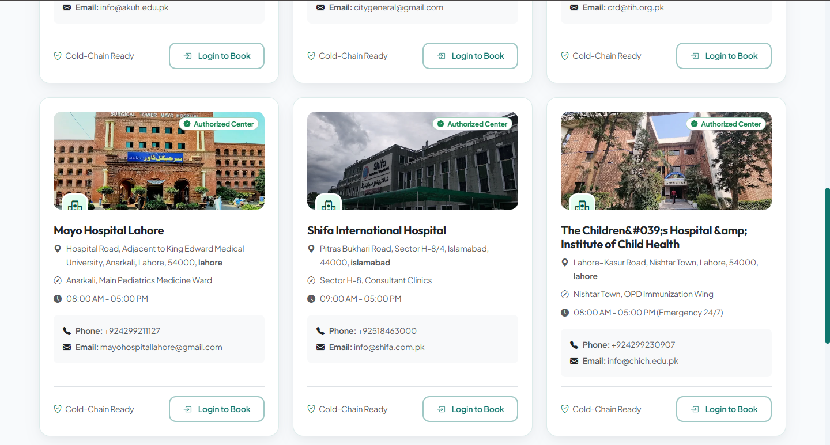

Figure A5 — Parent Dashboard
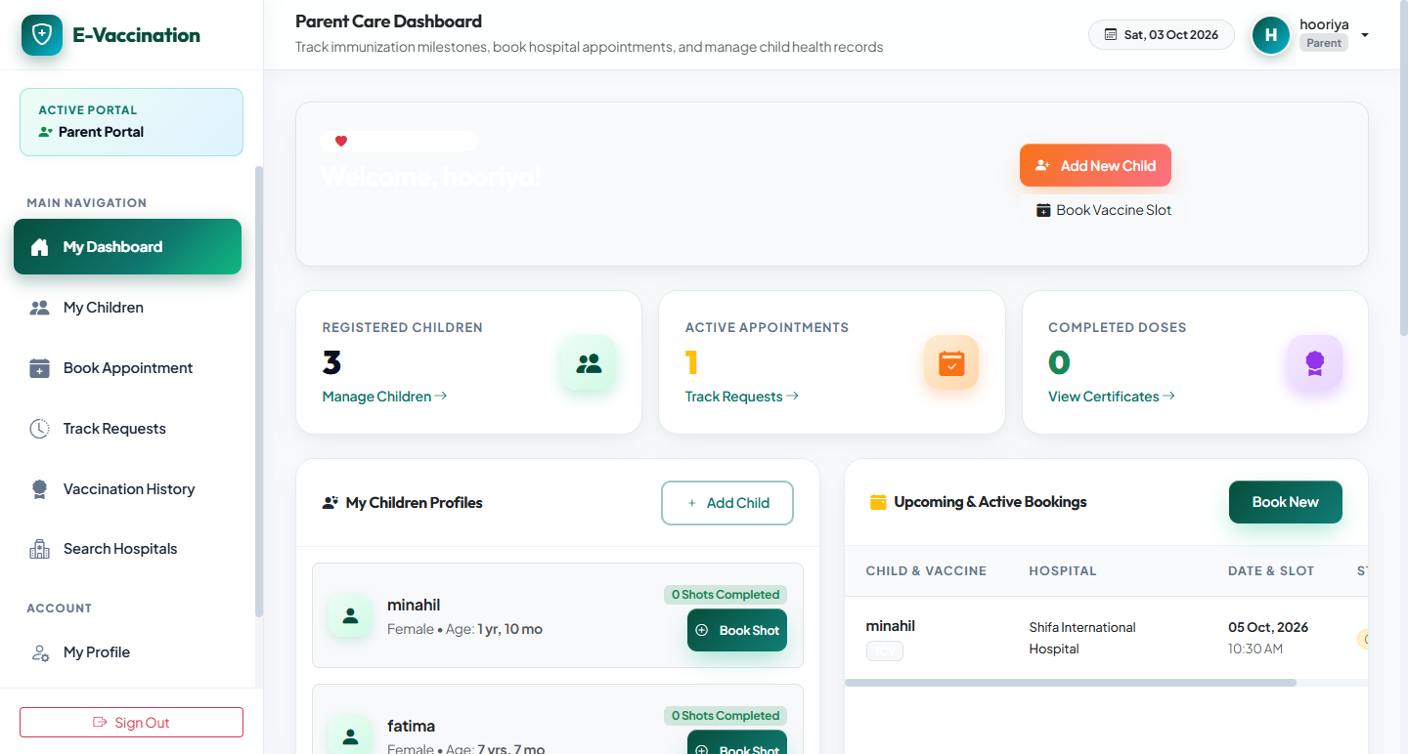

Figure A6 — Child Profile / Appointment Booking
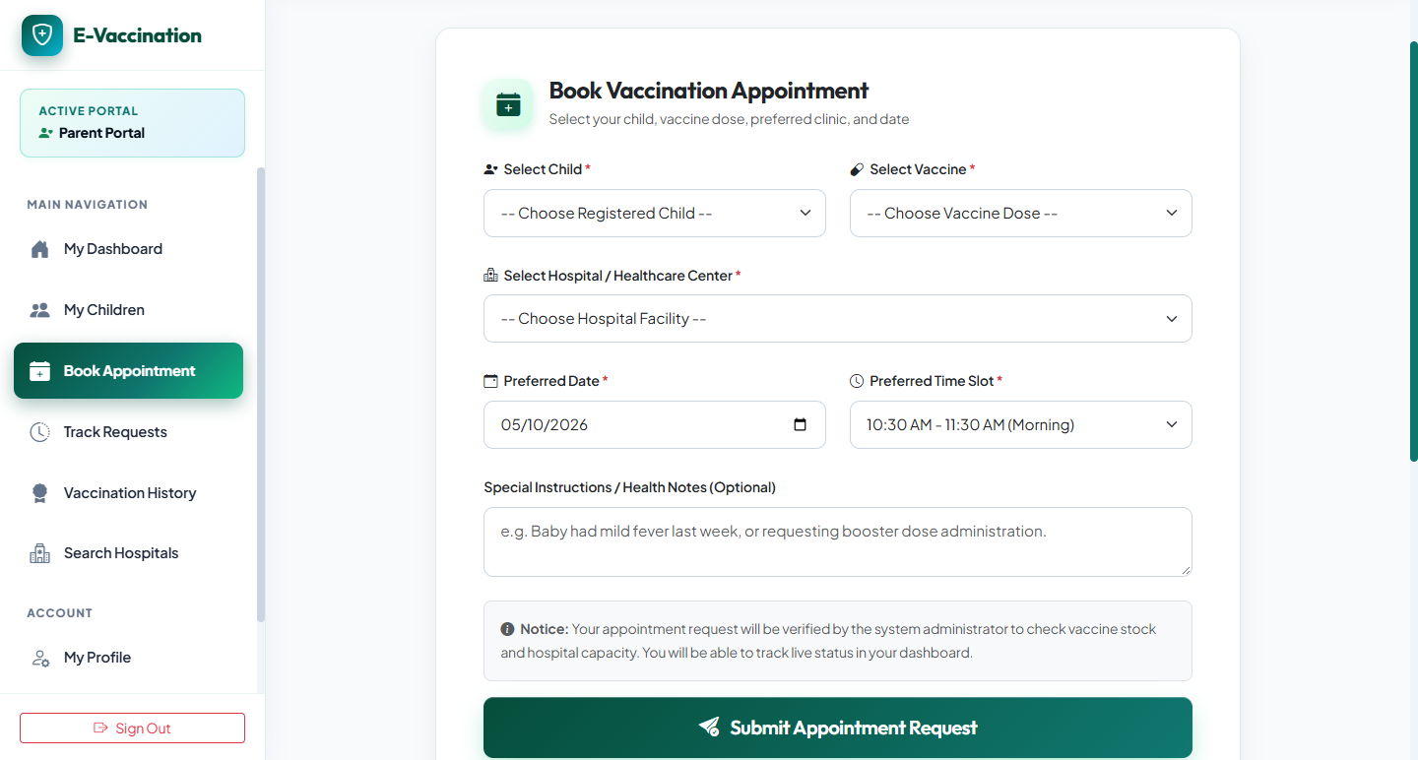

Figure A7 — Hospital Dashboard / Appointments

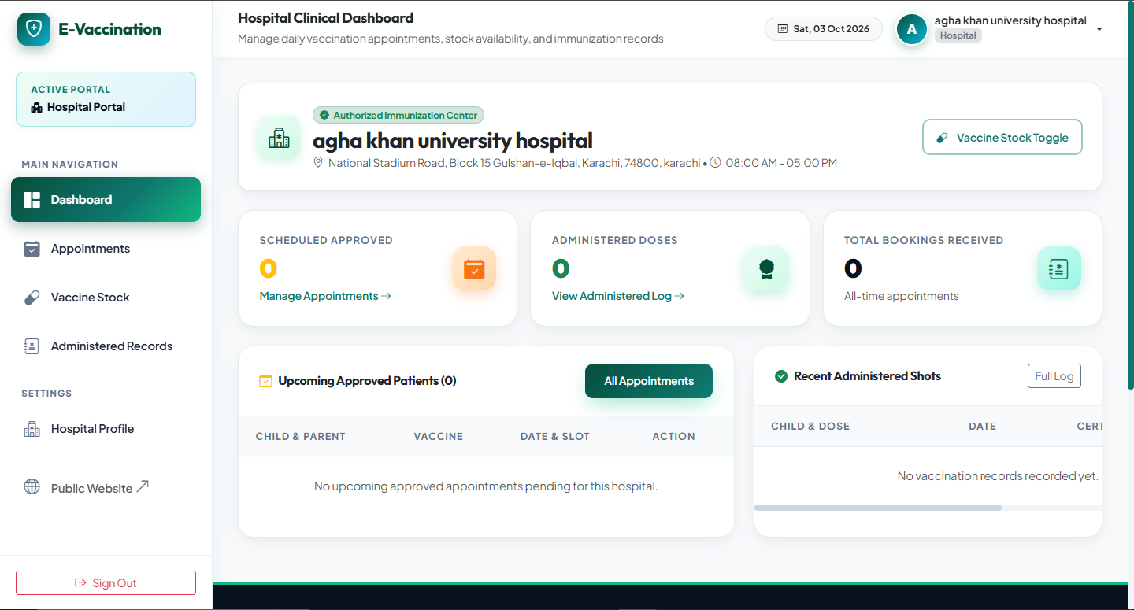
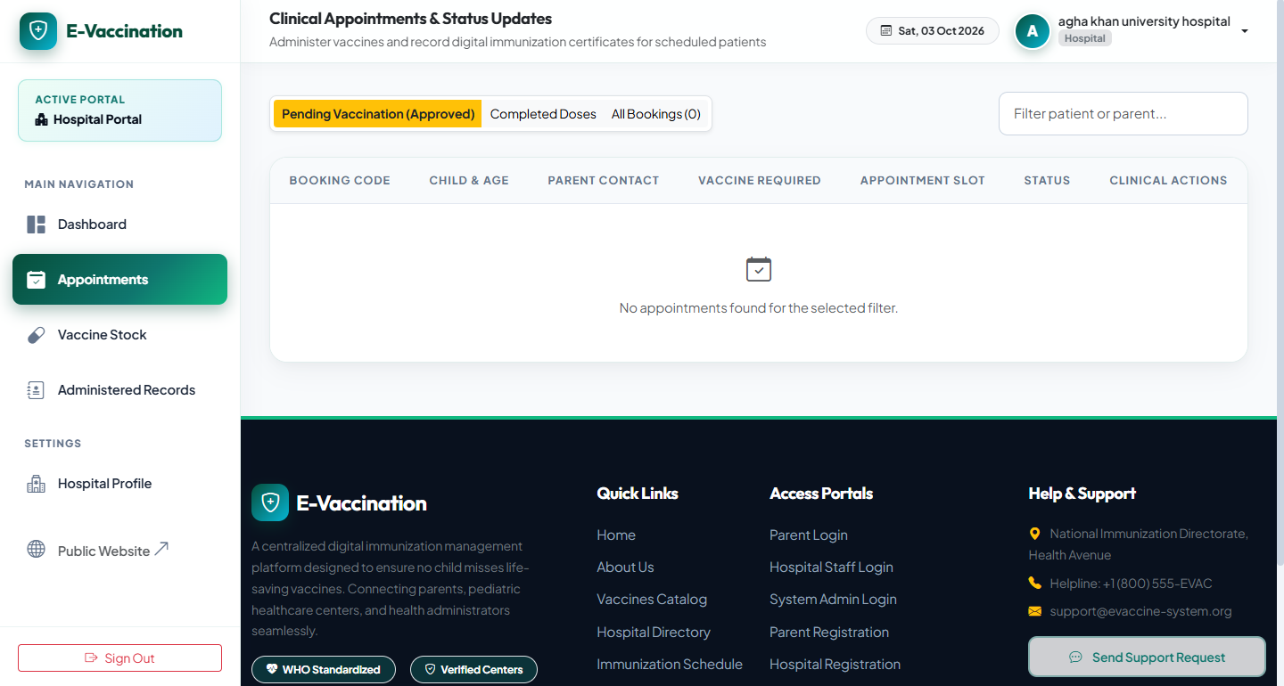
Figure A8 — Admin Dashboard / Reports
