

Ministry of Information Technology

Government of Pakistan

National Grassroots ICT Research Initiative – (2018-19)

Application Form for Funding of Final Year Project (FYP) Nominated by University/Institute

University/Institute Detail:

Name of |  |  |  |  | University/Campus
University/Institution |  |  |  | COMSATS University Islamabad | Address: | Near Officers Colony, Kamra Road ,Attock
Telephone & Fax No: |  |  |  | 057-9316330-1  057-9316329 | Department Name: | Computer Science
City: |  |  |  | Attock | Province: | Punjab
Nominated Project Details:-
 |  |  |  |  |  | Email:m.kamran@cuiatk.edu.pk
Project Supervisor |  |  |  | Muhammad Kamran | Contact Details: | Cell No: 03448213821
Name and |  |  |  | (Lecturer) |  | Off No:334
Designation:
 |  |  |  |  | No of Publications
Project Supervisor |  |  |  | MS Software Engineering | of Supervisors: | 1
Qualification:
Students Name(s): |  | - Hoor_un_Nisa  - Anum Mushtaq  - Bilal Saleem |  |  | Students Mobile | - 0307-5852893  - 0313-5139670  - 0332-5313632
 |  | - 3.24  - 2.4  - 2.08 |  |  | Students Email: | hoorunnisaa@gmail.com  khushbakht604@gmail.com  bilalsheikhatk@gmail.com
Students CGPA
Degree Program / |  | MCS |  |  | Area of
Title: |  |  |  |  | Specialization*: | Android Application

- Preferred areas are Artificial Intelligence, Cloud Infrastructure, Cyber Security, Internet of Things, Augmented and Virtual Reality, Wearable’s and Implantable, Shared Economy, Robotics, 3D/4D Printing, Neurotic and Block chain.
Final Year Project Details:

- Project Title: E-Folder

- Project Start Date:

- Project Finish Date:

P a g e 1 | 6
Ministry of Information Technology 

Government of Pakistan
- Project Summary (less than 200 words)

According to NCEAC requirement every faculty member needs to maintain his course folder for each course. Course folder contains all kind of course related information like quizzes, assignments and sessional marks etc. Currently all departments of the university use manual system to maintain course folder.
It is difficult for faculty to maintain folder for each course manually. It is also difficult for convener to check folders manually. The problem is that the manual system is an old method to keep record. It has many drawbacks like:
- Time consuming to keep record.
- Entering same data in different proforma.
- Difficult to track the status of folder.
- Searching for specific data is difficult.
This project is intended to develop for the solution of manual system using to create course folder because the university have no current technical process to maintain course folder’s data. Faculty members are dependent on manual system to maintain their folders.
It is an android application for all department of university. All faculty member have opportunity to select course and Admin of the university will assign them course.
The application will save the time and effort of employee in submitting the file by hand they can easily upload images and
Pdf files. They can also select the uploaded document which he want to print. It will also provide notification to the faculty member to remind them case of delay in submission of requested file.
Admin and HOD of the university can review folder during semester without waiting until the end of the semester. HOD can verify result online .
The application will be design as quick and easy interface for faculty members and accreditation committees.
Functional requirement of project:
View course:
All user of the project can view the course list provide by Admin before the semester start. Teacher can view their four
Courses assign by admin.
Course selection:
Faculty member have opportunity to select course from the course list and Admin can review their course selection.
Notification:
The system should provide notification to the faculty member about the last submission date of quizzes, assignments, and sessional etc.
Add faculty member:
System should have the functionality to add the new faculty member in the list. Admin can be add new faculty and assign them course.
Assign course:
System provide facility to admin to assign any course to the teachers from the course list. It must have constrained on assigning more than four courses to each teacher.

Convener complain:
The system have to provide facility to convener that they can remonstrate on missing folder or missing of any item related to the folder.
Uploading documents:
System must provide the functionality of uploading documents like quizzes, assignments
and sessional etc.
Login:
For login all faculty member must have their username and password.
Print required document:
System provide functionality that the user can select the uploaded documents which he want to print.
P a g e 2 | 6
Upload quizzes and assignments via picture ;
Faculty members will upload quizzes and assignments via pictures and such document will be stored in related box. Such related box contain all information about quizzes and assignments taken in the whole semester.
Duplication checking :
The application will automatically check for the duplication when a teacher uploads scanned quizzes. There will be predefined quiz format in the app. We will achieve this target through OCR technique using built-in libraries.
Online result verification :
System will allow the HOD to verify result online .Our system will provide checkbox to HOD for verification of result.

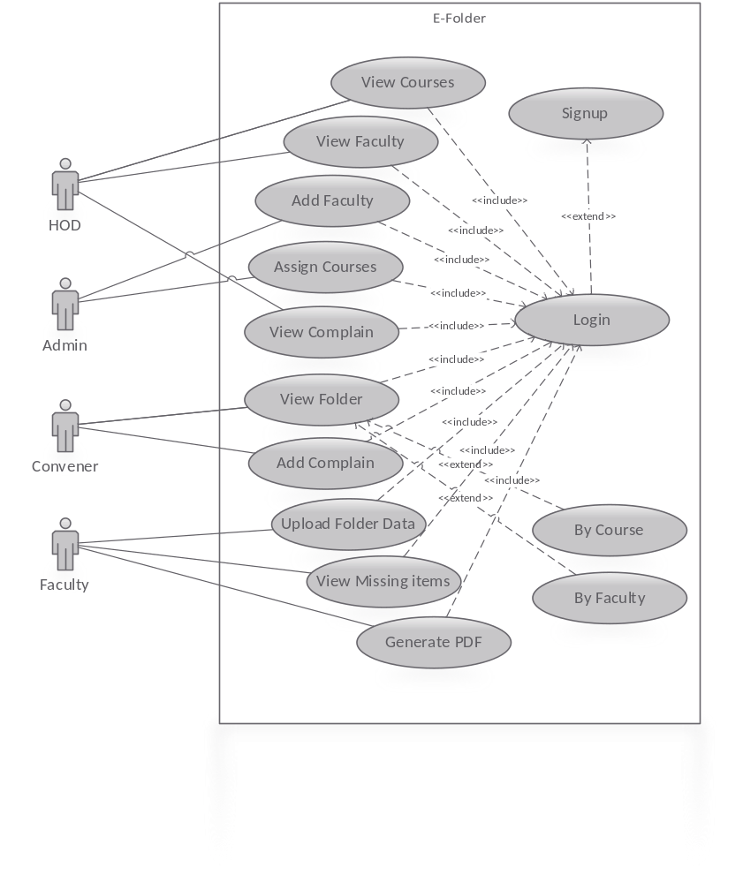

P a g e 3 | 6

E. Project Objectives:
- To facilitate faculty members to maintain their course folder easily
- To facilitate Convener to make reports for each course as well as for each faculty member
- Provide a facility to HOD to view all reports and complains added by convener.
- This Application will solve the problem of manual system by saving the time and effort of faculty members.
- It will provide secured platform to the faculty member. Accreditation and committee and Admin can review record during the semester.
- This application will keep record for long time with secured way because all faculty member and Admin have their specific username and password.

F. Project Implementation Method

Programming Language: Java, Xml

Tools: Android Studio, MYSQL

G. Key Milestones of the Project with dates

P a g e 4 | 6
Ministry of Information Technology

Government of Pakistan

K. Benefits of the Project
  - Upload data (quizzes, assignment) any time anywhere.
  - Time saving
  - Cost saving
  - Easy to maintain data
  - Electronic documents are more persistent and more difficult to destroy than paper documents
  - Faster to search
  - Save effort of the employees in submitting the files by hand
  - The members can access the system in a secured way with a user name and password.
  - Creating a good environment to the faculty and provide all the solutions to their problems.

It is certified that the FYP titled “E-Folder” has been approved and is being undertaken by the above mentioned students as their Final Year Project.

It is undertaken that the undersigned has understood and accepted the “terms & conditions” of the program, attached with this form and further reiterate that, if the subject FYP is approved, the reimbursement of Funds claimed through Expenditure Report shall be in accordance with the “terms & conditions” of the Program and the undersigned will be liable to return the unutilized amount and other cost not approved by the Ignite-National Technology Fund, if any.

It is further undertaken that Expenditure Report of approved FYPs shall be furnished along with the supporting documents as devised in attached Terms and Conditions of the Program and other required deliverables as and when required by Ignite.

- Name, Designation & Signature of Supervisor:______________________________

  - Name & Signatures of HOD:

-------------------------------------------------------------------------------------------------------------------------------

- For Office Use only:
(Please encircle the status of FYP)

Project Status | Approved |  | Not Approved
Evaluator’s Name------------------------
Evaluator’s Signatures ------------------------

P a g e 6 | 6

