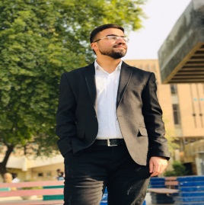
Yasser Sadiq Jassim
Personal: Single, Iraqi, 23 years,
Mobile: 07715701249
E-mail: www.yasserss1997@gmai.coml
www.linkedin.com/in/yassersjassim96
Objective:Seeking a challenging position, where I can contribute and expand my skills to the full, with opportunity for growth and career development.

Education:
- B.Sc. in Department of Computer Science.
AL-Mustansiriyah University, Baghdad – Iraq, (2015 – 2019).
- General Secondary Certificate, Scientific Stream.
AL Safa High School, Baghdad – Iraq, (2015).

Experience: Manages Tech GiGz Media/News, Iraq 30/1/2019 – Currently
www.techgigz.com
Responsibilities

- Writing articles on websites
- Development of Android applications such as: (Web applications and Firebase)
- Optimize websites for search engines to reach the first page or the first result in the search engine, and by many factors must be available in your site, to be able to climb your site, and improve the site to reach the best result.

Course:

- Digital Marketing Fundamentals Certified Google on 14/4/2019
- Entrepreneurship accredited by the Department of Quality Assurance in the Faculty of Education - University of Mustansiriya - on 30/4/2019
- Marketing research accredited by the Division of Quality Assurance in the Faculty of Education - University of Mustansiriya – on 25/2/2019

IT Skills:
- Design web HTML with CSS
- Object Oriented Programming with C++, Image Processing with MATLAB.
- Advance Database with Visual Basic and Microsoft Access, SQL
- Advance Microsoft office 2003 to 2016 experience.

Personal & Other Skills:
- Social media Expert & Editor of Techgigz.com Media/News Platform
- Designing Creative ideas by using Photoshop.
- Quick learner, Initiative, Self-motivated and Reliable.
- Creative solution provider.
- Trustworthy and enthusiastic person.
- Able to work on own initiative and as part of a team.
- Languages: Excellent English and Arabic native speaker.
- Enjoy being actively involved in sports , writing IT articles.

