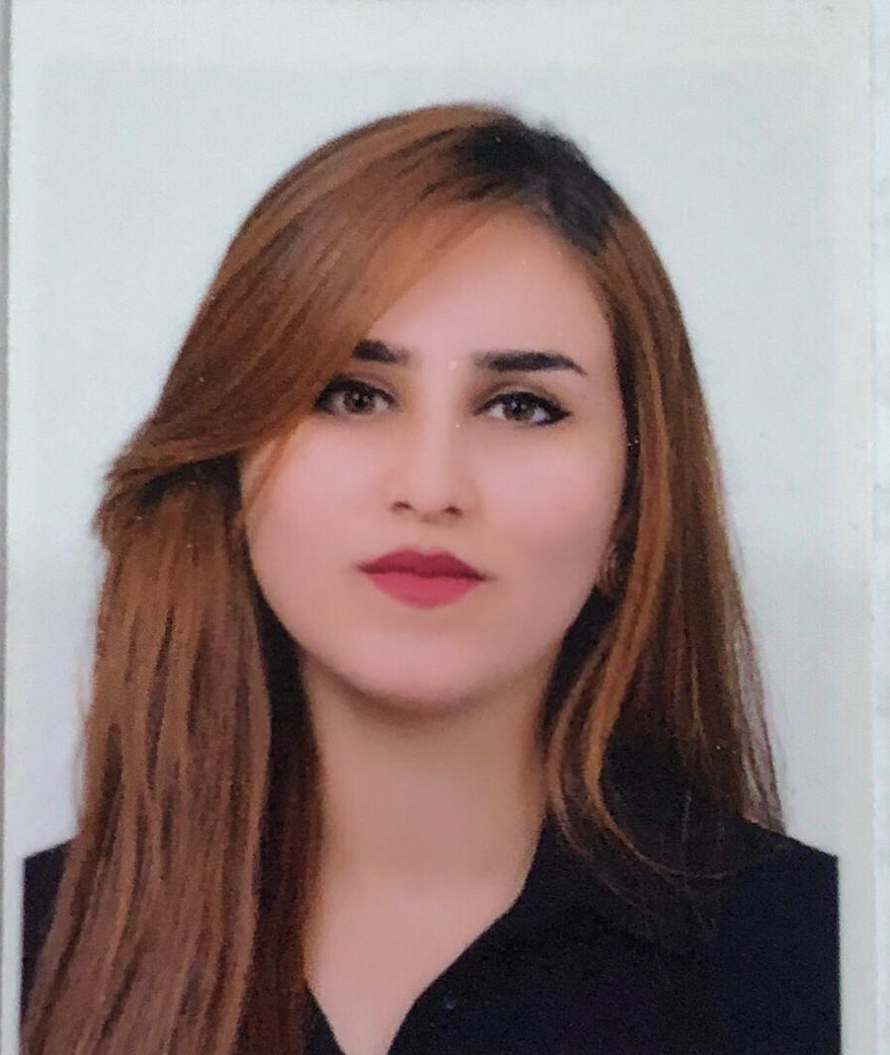
Sanarya Akram Hamad
Mobile: +964750 216 2665
Email: sanarya.akram96@gmail.com
Gender: Female
Address: Mntikawa 100 meter road, Erbil-Iraq
___________________________________________________________________________
Personal Statement:

A highly motivated, well aware and fast learning university graduated with very good interpersonal,
Administrative, Speaking and managerial skills that perform well working both in a team and individually.

Qualifications and languages
- 2015–2019 B.Sc. in Kurdish Education from Salahaddin University

EMPLOYMENT HISTORY

International Maarif Schools – Erbil
Kurdish Teacher

Job Responsibility
- Work with the lead teacher to monitor the class schedule.
- Assist teachers with lesson preparation by getting materials ready and setting up equipment.
- Revise lesson material with students individually or in small groups.
- Ensure the classroom environment is safe and clean.
- Oversee students during non-classroom times including in-between classes, during lunch, and on field excursions.
- Collaborate with lead teachers to recognize issues students are facing and recommend solutions.
- Document student progress and communicate with parents to keep them informed.

Khabat elementary school
Teacher (internship)

Job Responsibility
- Planning, preparing and delivering lessons
- Preparing teaching materials
- Helping pupils improve their skills via individual and group sessions
- Checking and assessing pupils' work
- Organising and running educational activities
- Attending social events

Volunteer activities and membership
- Member of Nishtiman Youth Network.
- Participating in preparation TEDx Nishtiman Conference at Erbil.
- Participated in Fund raising to Orphan children and Cancer patient with Komar University.
- Volunteer for International Youth Day Kurdistan (IYDK) Event

workshop and TRAINing
- English language course at Cambridge college elementary level
- Business Development Support – A three full day training.
- International Baccalaureate (IB)

LANGUAGES
- Kurdish Sorani (Native)
- English (good)
- Arabic (good)

computer and other skills
- Very good at Microsoft Office programs (Word, PowerPoint, and Excel).
- High performance in using Internet and Emailing.
- Very good typing skill on both English and Arabic keyboard (50 WPM).
- Very good communication skills
- Very good management skills
- Very good problem solving skills

REFEREEs
Available upon request

