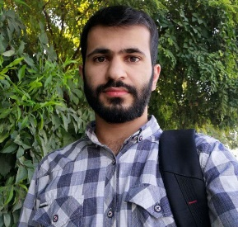Ahmed Masood Omer

Erbil, Kurdistan Region of Iraq

Nationality: Iraq

# **Personal Information**

|  |  |  |  |  |  |  |  |  |  |  |  |  |  |
| --- | --- | --- | --- | --- | --- | --- | --- | --- | --- | --- | --- | --- | --- |
| |  |  | | --- | --- | | Full name | Ahmed Masood Omer | | DOB | 2th Jan 1997 | | Address | Erbil | | Email | [ahmed.masuood91@mail.cm](mailto:ahmed.masuood91@mail.cm) | | Phone no. | 0750 398 98 21 | |  |  |  |
|  |  |  |  |
|  |  |  |  |

# **Education**

* **Undergraduate 4 at University of Slahaddin – College of software engineering.**

# **Work Experiences**

|  |  |
| --- | --- |
| 2015 – 2016 | GIZ – Supervisor  I was supervisor at GIZ organization for a couple of months. |
| 3 month | internship in dwrandaz software company. |

# **Objective**

I have always been a passionate in software engineering and it is my dream to be software developer. I am trying to keep develop myself in programming and find a carrier in programming.

# **Accomplishments-Projects**

* Simple front-end personal website.

# **Languages**

|  |  |  |  |
| --- | --- | --- | --- |
| Languages | Reading | Writing | Speaking |
| Kurdish (native) | Excellent | Excellent | Excellent |
| English | Good | Good | medium |
|  |  |  |  |

# **Computer Skills**

* **Database** (Access , sql-server).
* **Web design**
  1. HTML5
  2. CSS
  3. Js
  4. Jquery
  5. bootstrap 4
* **Back-end(asp.net Core)**
* **SQL Language**

**Reference:**

Zana Masuood Omer