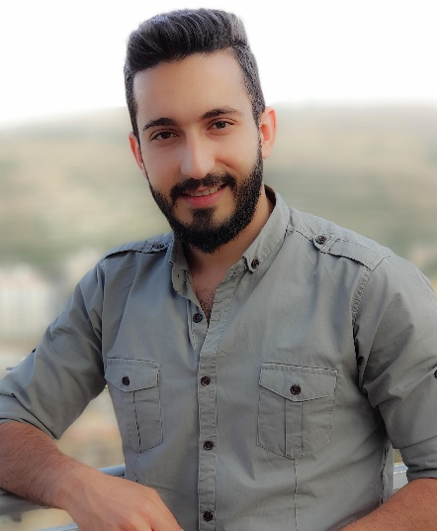

**Haidar al asmar**

OBJECTIVE

EXPERIENCE

SKILLS

EXPERTISE

EDUCATION

CONTACT

+963994100088

HaidarMasmar@gmail.com

Lattakia – المشروع العاشر

Computer and auto control engineering

Graduate from Tishreen University

Microsoft Office

* Microsoft Word
* Microsoft PowerPoint
* Microsoft Excel
* Microsoft Access
* Microsoft Outlook

LANGUAGES

* Building a special relationship with customers and maintain and increase its customer base.
* tact and good dealing with customers.
* individual capable of imposing respect / self-confident / convincing / organizer and good at time management and prioritization.
* Use of Computer in Excellent and professional.
* Contact center REP | lattakia | January 2017 To January 2018
* POS Representative | lattakia | January 2018 To March 2019

Syriatel company

* Teamwork and the ability to interact with others.
* Managing time and honoring appointments.
* The ability to adapt to difﬁcult or changing circumstances.
* The ability to solve problems creatively.
* Capacity for continuous learning and internal motivation.
* Work within the policy of the creative individual enthusiastic Research and planning skills.
* Sales and marketing
* Organized
* Adaptable
* Computer services and electronics.

حيدر محسن الأسمر

Communication skills

Arabic: Mother language

English: very good (Reading, writing and comprehension

* Marketing and Sales | lattakia |

Ematel company