Banking System

My project is a sort of banking system which allows users to log in and manipulate their bank accounts in a number of ways. Users are able to create new accounts that will either be Compound interest or Simple interest accounts. They will also be able to make deposits and withdrawals on their accounts

How To Use

Upon running this project, the use will be greeted with the login page:  
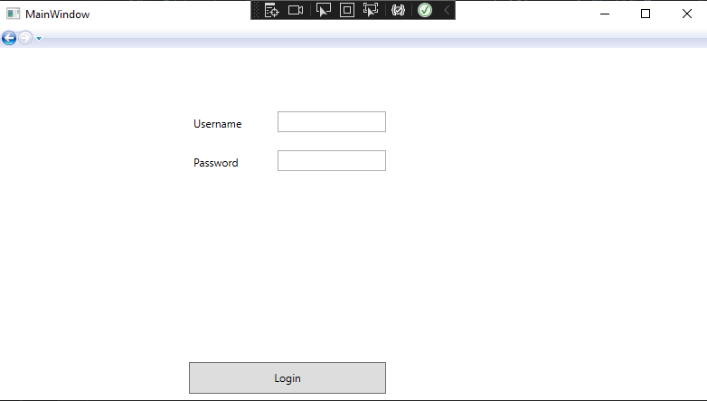  
To Access the bank page, the User will need to login using their username and password. (For testing and running the project, please use the following):  
 Username: Eric

Password: 1234

Upon logging in, the user is greeted with this bank page:

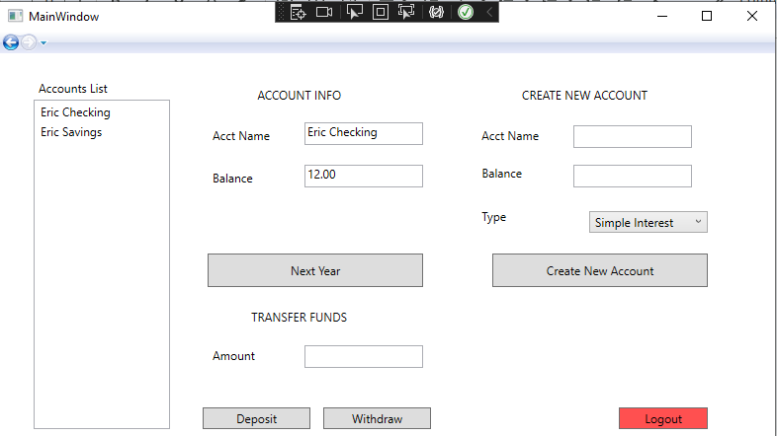

This features a few things.

1. An Account list that allows users to choose an account to transfer funds for or to view information
2. A ‘Next Year’ button that updates the account balances based off their interest types
3. Deposit and Withdraw buttons that manipulate the balance of an account
4. The ability to create a new account that is either a simple interest or compound interest account
5. A Logout button that brings users back to the login page